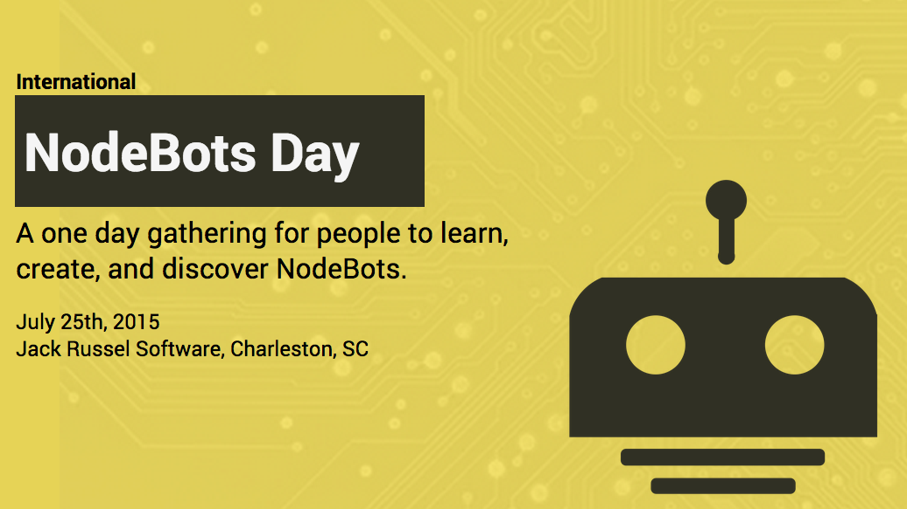

Have you always wanted to build a robot? Looking for a way to learn to code? Interested in seeing software and hardware come together, in the epic battle of the year?! You need to attend [NodeBots Day CHS](https://nodebotschs.github.io)!

The Charleston Tech Community will come together in honor of [International NodeBots Day](http://nodebots.io/) on Saturday, July 25th at Jack Russell Software - 494 C Wando Park Boulevard Mount Pleasant, SC 29464. NodeBots Day is an event where programmers of all levels come together to learn how to connect software and hardware using JavaScript and NodeJS. It is a family friendly event that is a ton of fun! We will have demos at the end of the event, with battlebots, art bots, races, and more. No need to have previous Robotics or Programming experience, just bring a laptop with NodeJS installed on it - we’ll teach you everything else you need to know! Kids are definitely welcome at this event as well!

To get your very own SumoBot + Lunch will be $62.49. You will get a robot kit and instructions on how to build and program the robot. For just a lunch ticket, (for those helping build another bot, kids, or someone just spectating) - those tickets are $11.24.

Register to attend here. Tickets are selling out fast, so register today!! <http://www.eventbrite.com/e/nodebotsday-charleston-tickets-17538209256>

“NodeBots Day is not a hackathon. There will be no prizes other than the satisfaction of making something awesome! There will be very little in the way of talks. We're going to get together, collaborate and hack. The focus of NodeBots Day is on sharing and enjoying each other's company. And JavaScript. Lots of JavaScript.”

Interested in sponsoring this super cool event? Email us at nodebotschs@gmail.com and let us know which tier below you or your company would like to commit to:

$100 - General Sponsorship - Logo on Website and Logo at the end of each video released, and mentioned at the beginning and end of the event

$250 (3) - Demo Sponsorship, you can sponsor the (battlebots, artbots, or creative bots) demos - logo on site, logo and presented by displayed on a video for the demo event - aaa presents NodeBots Day CHS 2015 BattleBots - play battle bot footage - thank you screen .

$500 (1) - Sponsor Lunch - this sponsorship will have signage at the lunch table and they will be mentioned and thanked at lunch break.

*Note: This is a profit zero event. Any sponsor money will go directly to offset the cost of the kits, supplies, production and food.

Have questions about the event? Email us at nodebotschs@gmail.com.

Please help spread the word through the Charleston Tech Community - this is an awesome opportunity come out and build/code robots! You will walk a way with some pretty sweet hardware - [particle.io](http://particle.io/) - a wifi like arduino. We hope to see you there!!

*"Something wonderful has happened… Number Five is ALIVE!"* - Short Circuit

Nodebots Day CHS Organization Team