Setting up

1 - install node js: node -v

2 – install angular cli

Angular CLI stands for Angular Command LineInterface. As the name implies, it is a command linetool for creating angular apps. It is recommended to use angular cli for creating angular apps as you don't need to spend time installing and configuring all the required dependencies and wiring everything together

Run the following command :

npm install @angular/cli –g

To check the different versions:

ng version

Angular CLI: 7.1.0
Node: 10.14.1
OS: win32 ia32
Angular:
...

Package Version
------------------------------------------------------
@angular-devkit/architect 0.11.0
@angular-devkit/core 7.1.0
@angular-devkit/schematics 7.1.0
@schematics/angular 7.1.0
@schematics/update 0.11.0
rxjs 6.3.3
typescript 3.1.6

Creating and running a project:

Execute the following command: it creates the project structure and download dependencies

C:\angular>ng new first-project

Open the project with visual studio code:

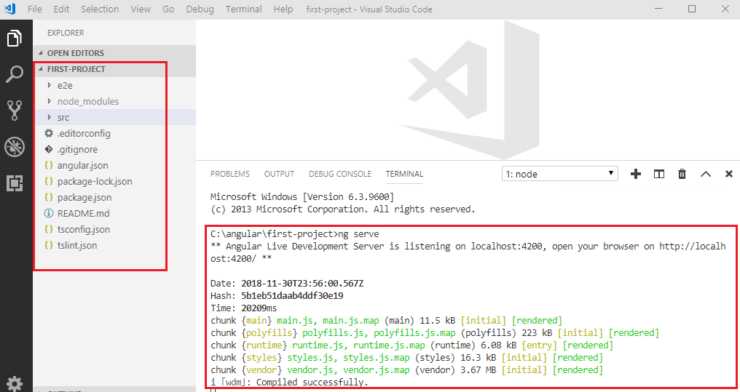

The ng serve create a web server, compile and deploy the project in it. (localhost:4200)

Introducing the app component

The main elements that render the page on localhost is the app.component.ts and the app.component.html

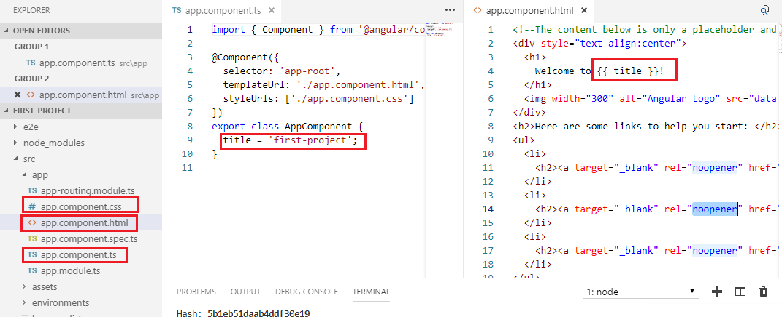

(title is binded in the html)
The server launches the index.html which calls the app component:
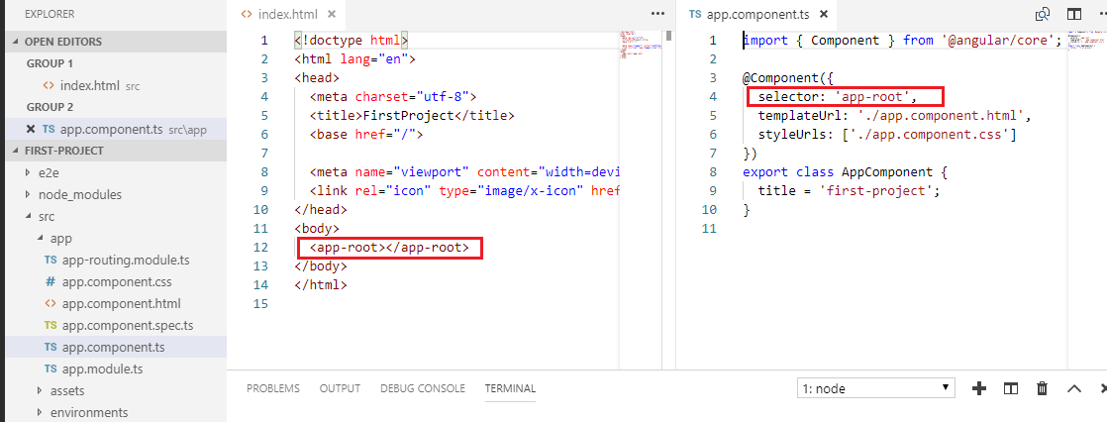

Creating your first component:

To create a new component type:

C:\angular\first-project>ng generate component hello-world
CREATE src/app/hello-world/hello-world.component.html (30 bytes)
CREATE src/app/hello-world/hello-world.component.spec.ts (657 bytes)
CREATE src/app/hello-world/hello-world.component.ts (288 bytes)
CREATE src/app/hello-world/hello-world.component.css (0 bytes)
UPDATE src/app/app.module.ts (493 bytes)

Let’s clean the app component in a way to display Hello, and call the hello-world component in it:

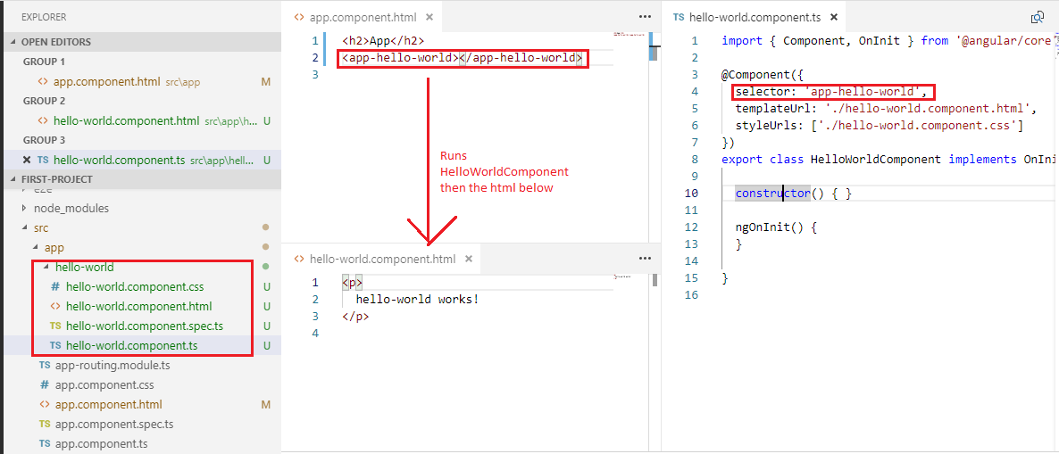

localhost:4200 would display:

App
hello-world works!

Anatomy of a component

Every Angular component is mainly a TypeScript class. Think of the HTML and CSS files as just extra “attachements” to the main TypeScript file.

Data binding is async

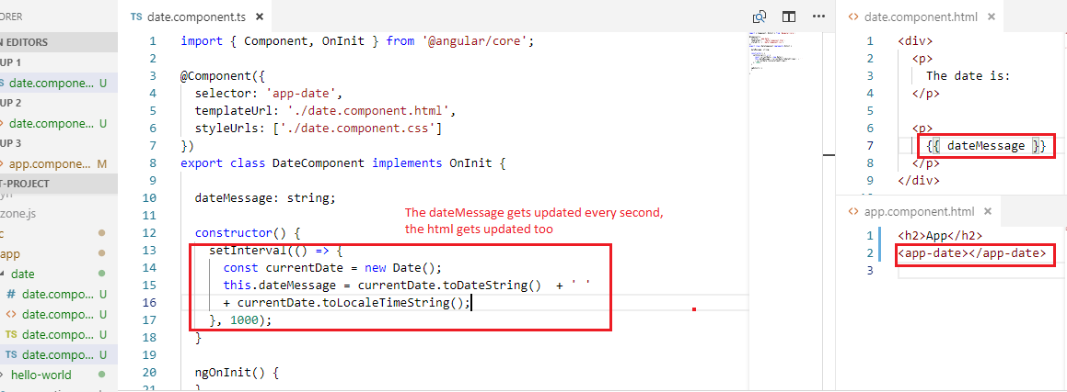

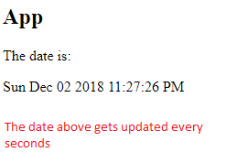
Template interpolation

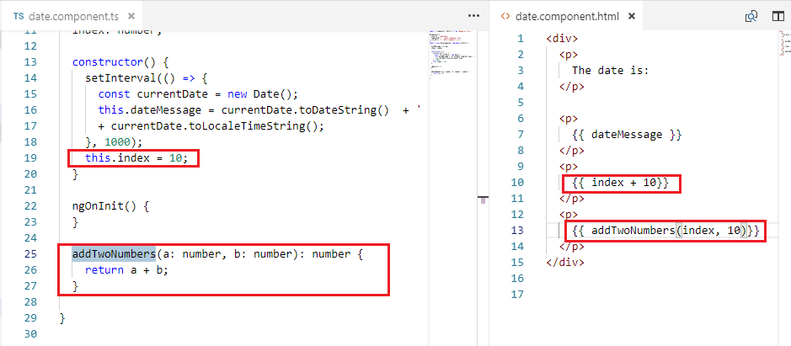

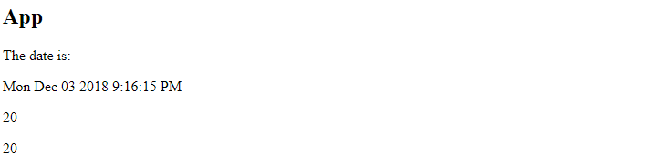

Looping with ngFor

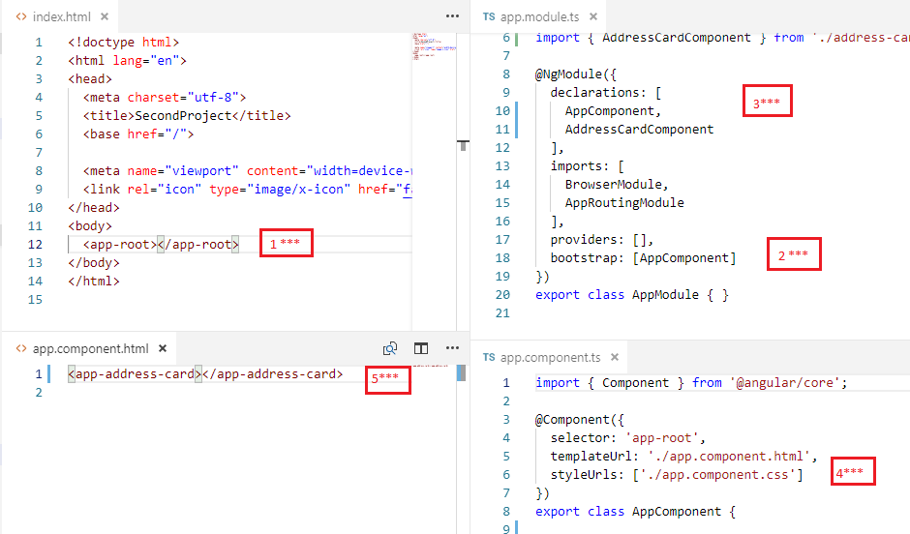
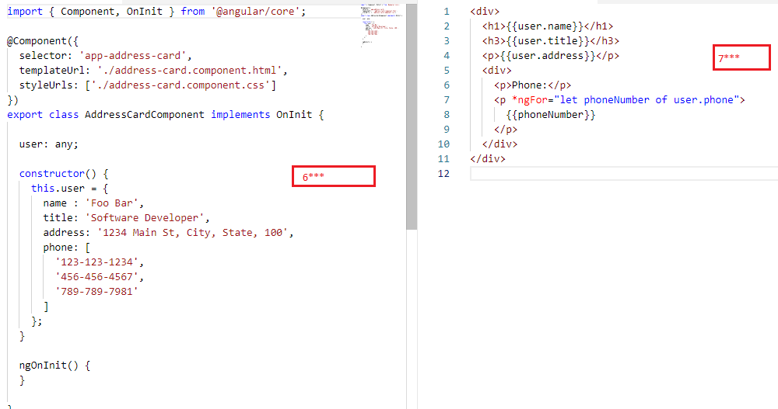

Using ngIf

Let’s substitute the phone property with a function:

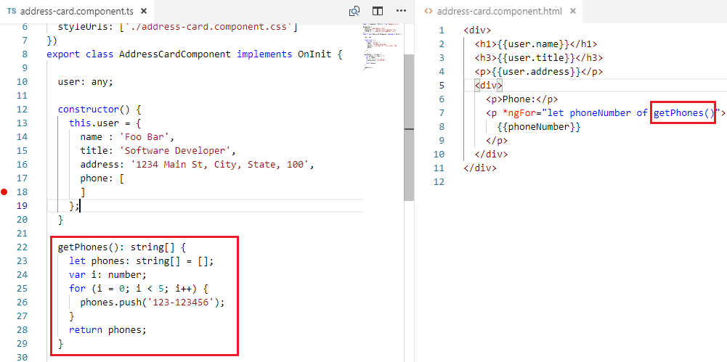

Suppose we comment lines so that the function returns an empty array

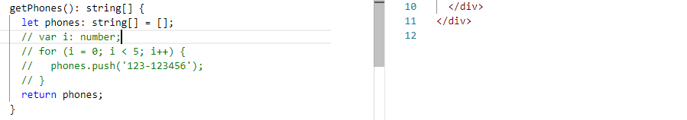

Let’s use the ngIf not to render the ‘Phone:’ label

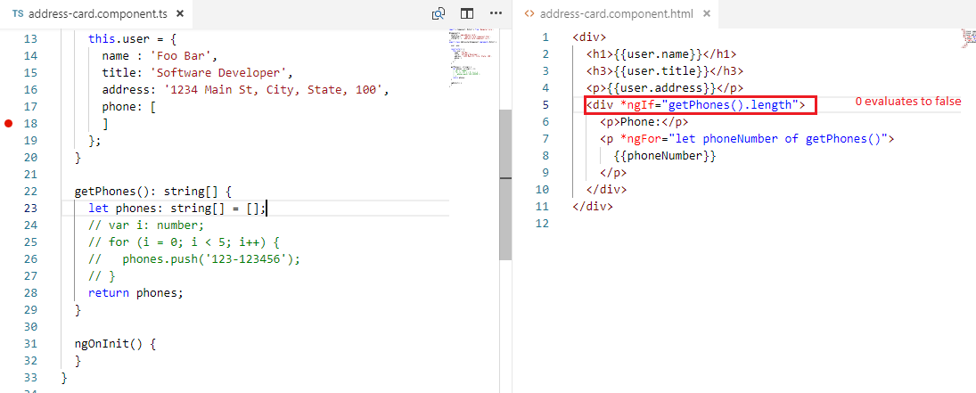

Passing inputs to components

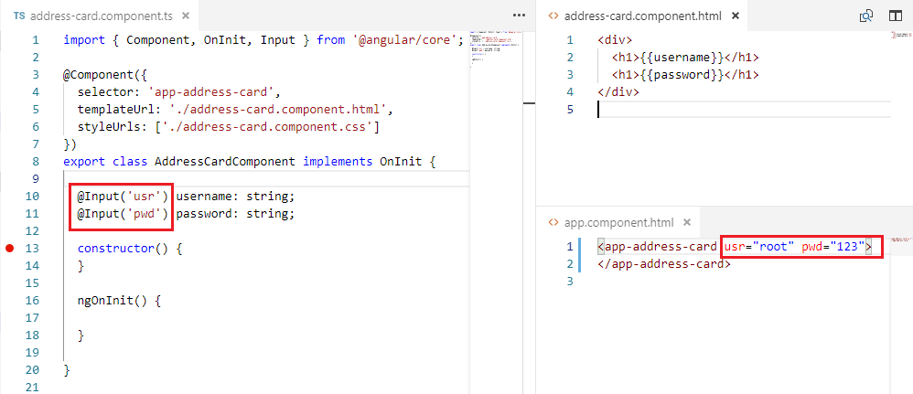
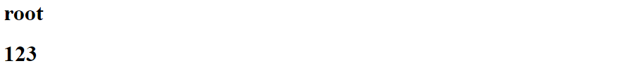

Using ngOnInit lifecycle hook

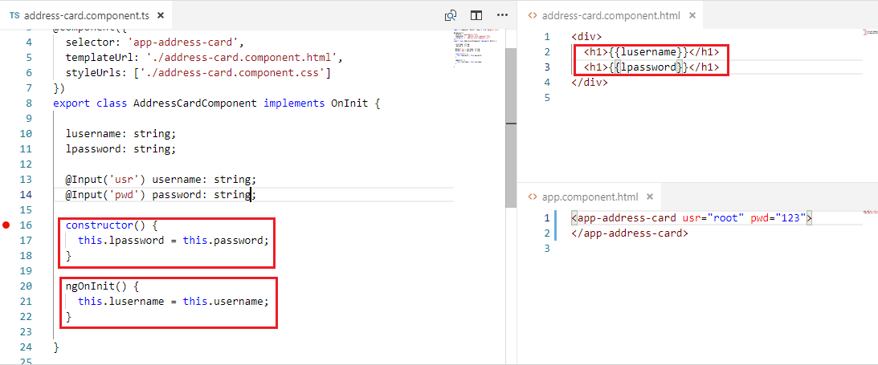

The password won’t display, because the passed inputs are setted after the constructor has finished, the ngOnInit runs only after the component is created and initialized

Notice that values passed to usr and pwd attributes are not evaluated, they are taken by the component as strings (we’ll talk about square brackets that allows evaluation)

Passing member variables to components

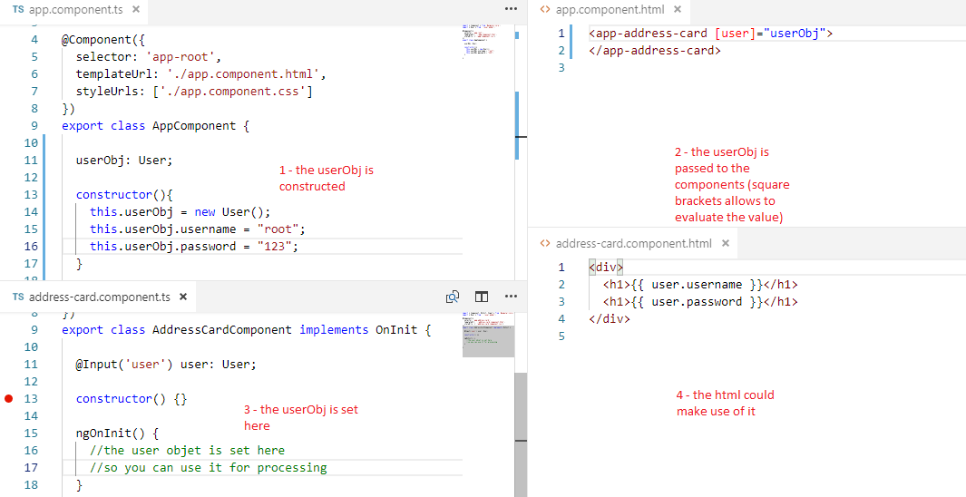

Styling

Every component has its own styling file, you don’t have to worry about uniqueness of class names, angular appends a generated identifier for each component, by the way there’s a styling file at the project’s root (style.css) where you can put global styles.

Handling click events

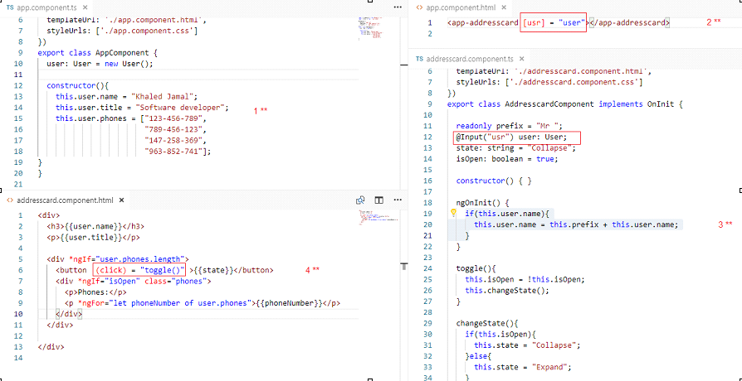

Two way data binding with ngModel

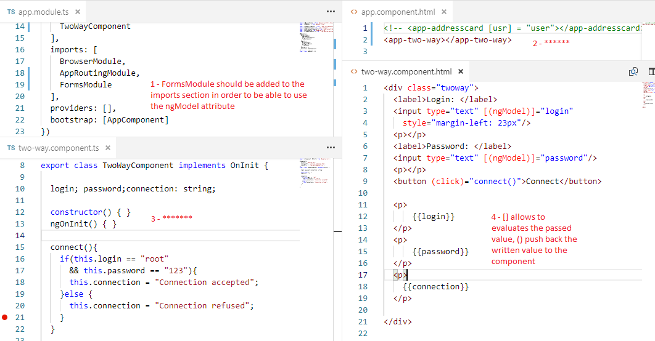

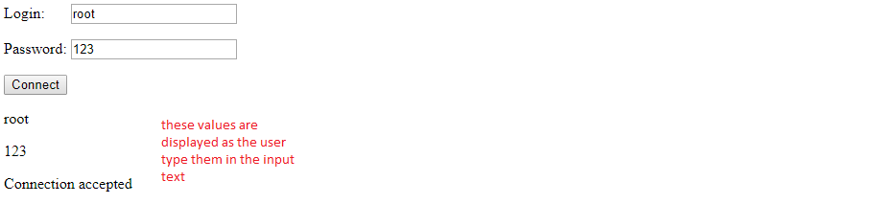
Creating and using multiple modules

A module is a container for a group of related components that provide a specific feature, anybody who needs that feature, simply imports that module

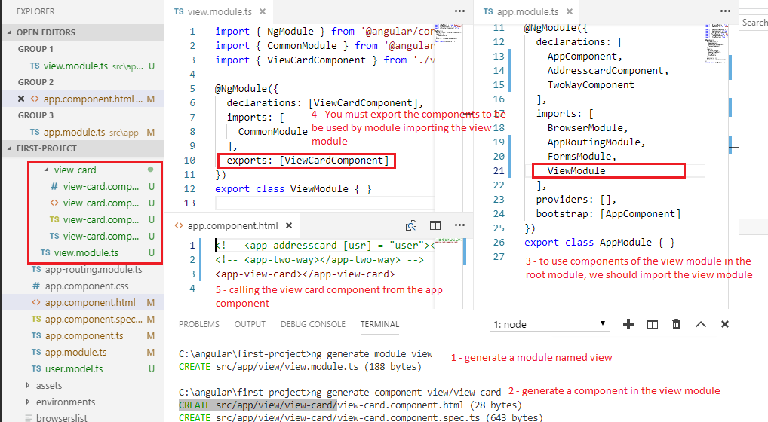

Services

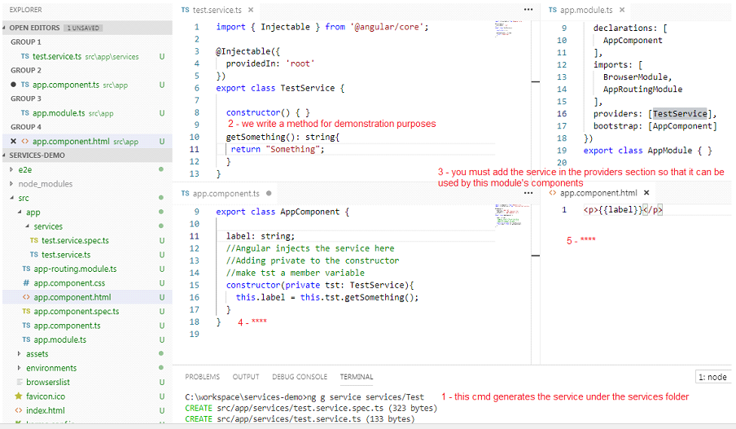

The service itself is a class that the CLI generated and that's decorated with @Injectable. By default, this decorator is configured with a providedIn property, which creates a provider for the service. In this case, providedIn: 'root' specifies that the service should be provided in the root injector.
When you add a service provider to the root application injector, it’s available throughout the app. Additionally, these providers are also available to all the classes in the app as long they have the lookup token.
You should always provide your service in the root injector unless there is a case where you want the service to be available only if the consumer imports a particular @NgModule.
Making REST calls

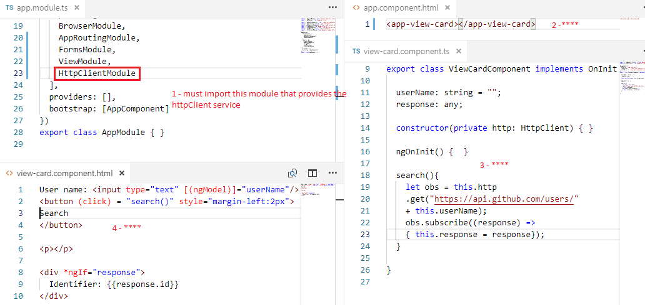

Routing
A single-page application (SPA) is a website that re-renders its content in response to navigation actions (e.g. clicking a link) without making a request to the server to fetch new HTML. (javascript manipulates the DOM)
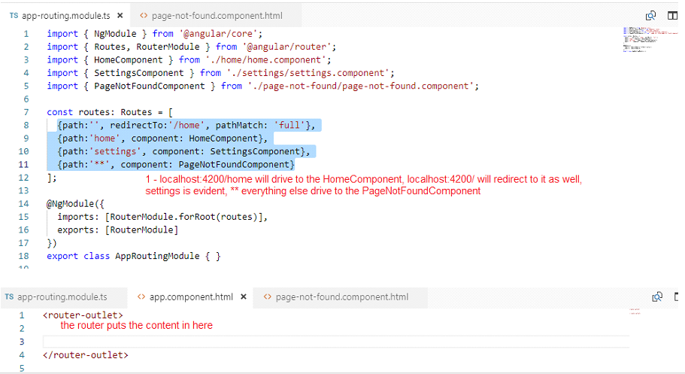

Child routes
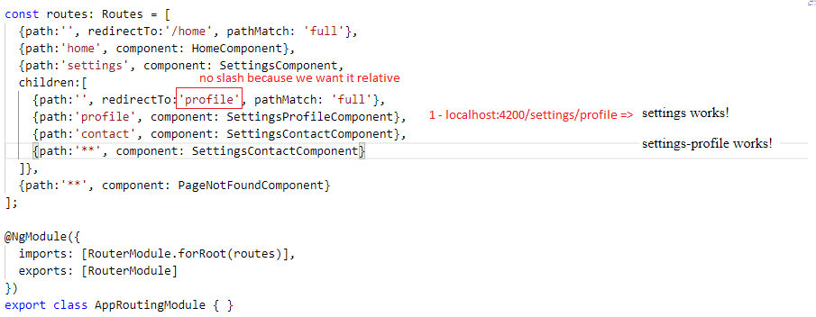
Notice that you should add an outlet in settings-components.html, this is where the children will be pluged
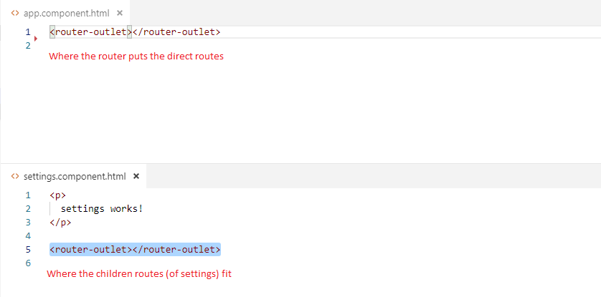
Navigation bar
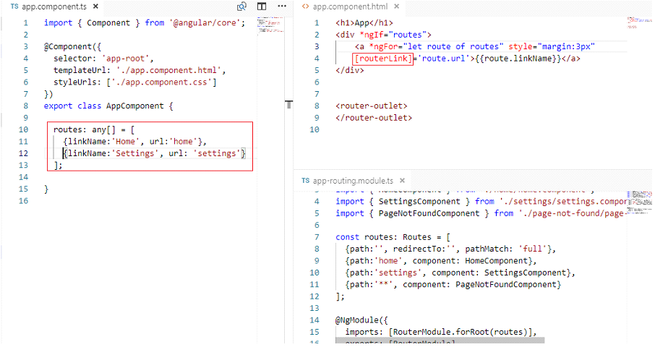
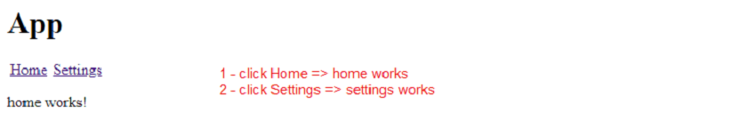
Creating an app
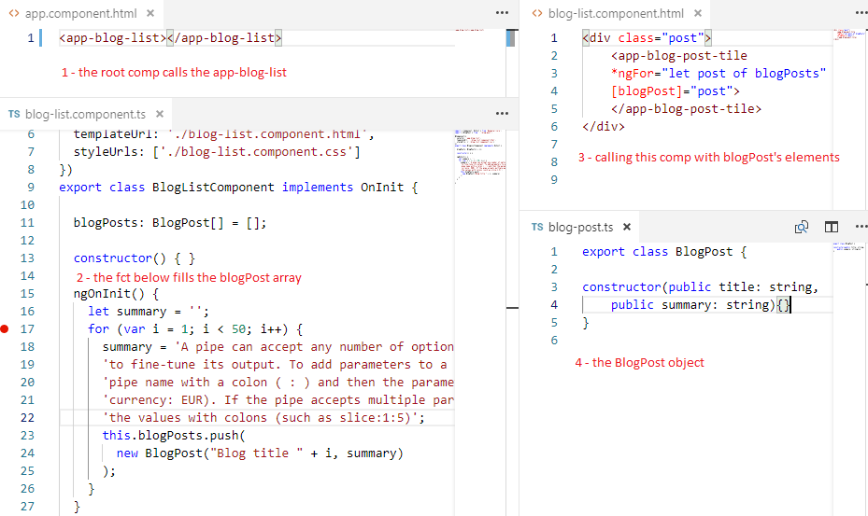
Let’s look at the app-blog-post-tile component :
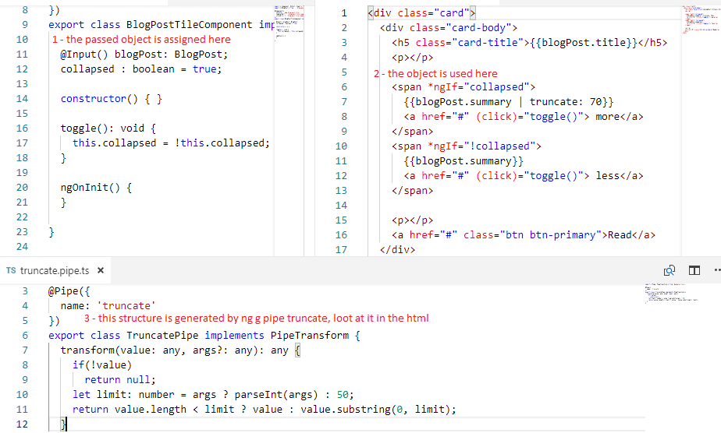
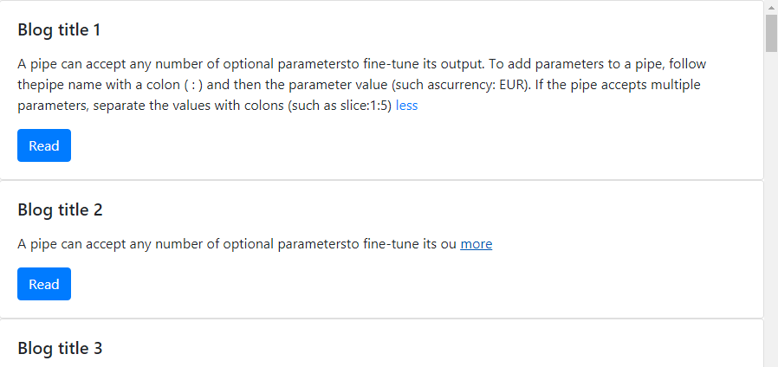
Pagination (Emitting events from child to parent components)
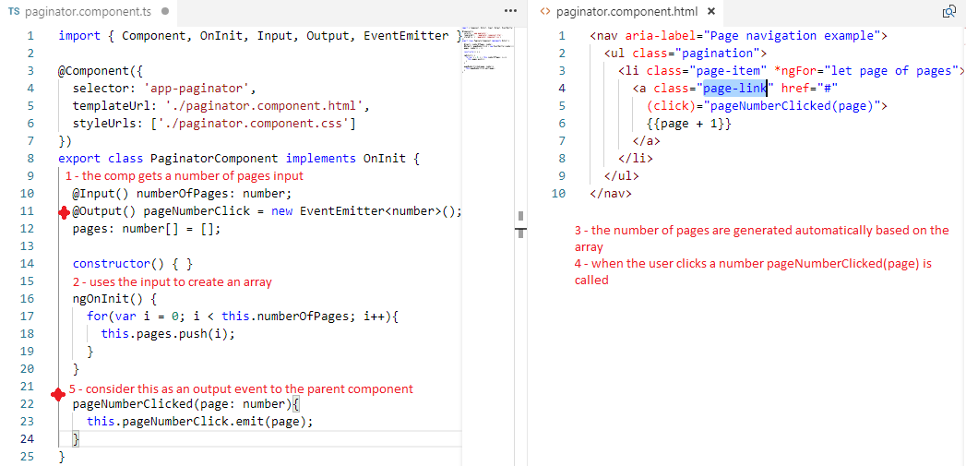
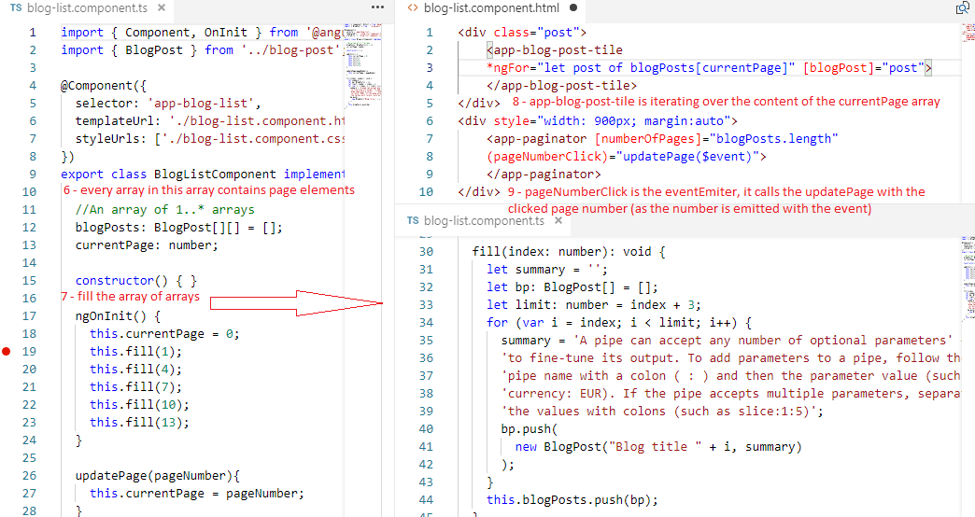
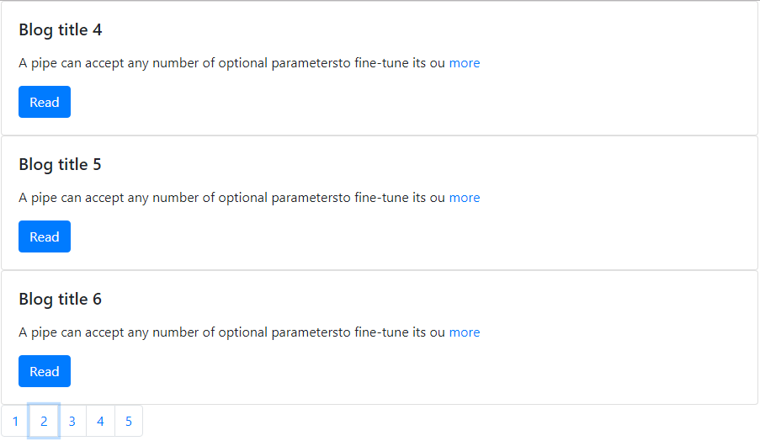
Using ViewChild and ViewChildren
Let’s add a button ‘Toggle All’ in the blogListComponent :
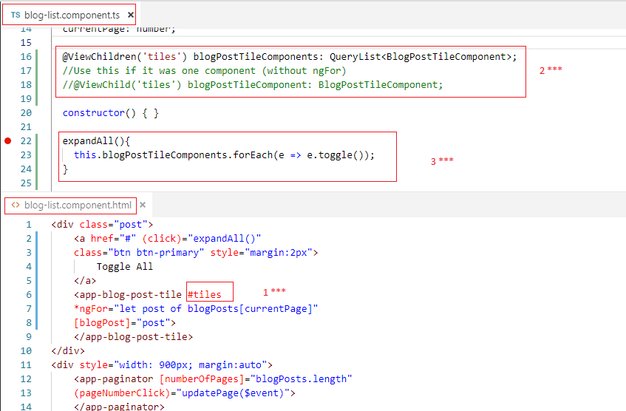

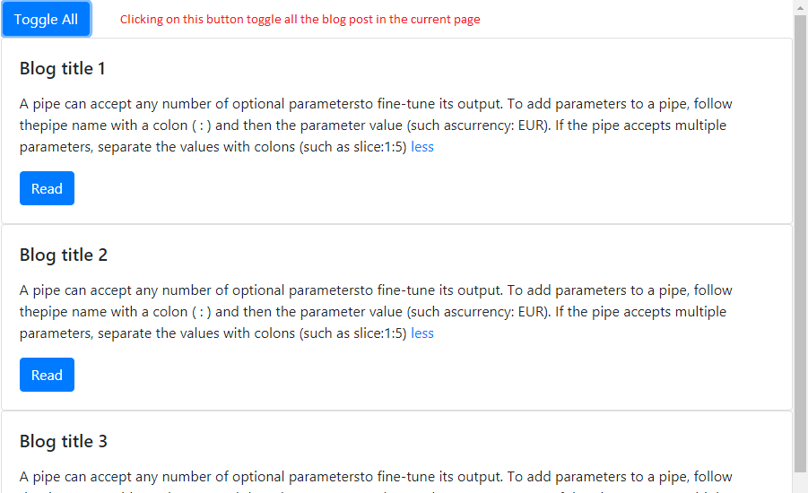

ngClass

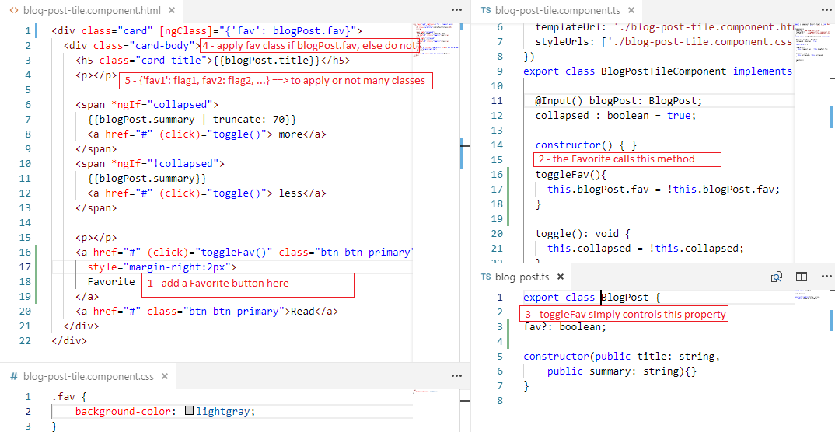

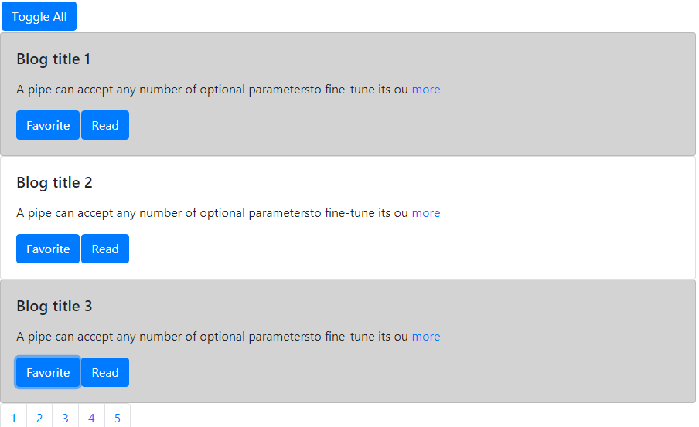
Directives

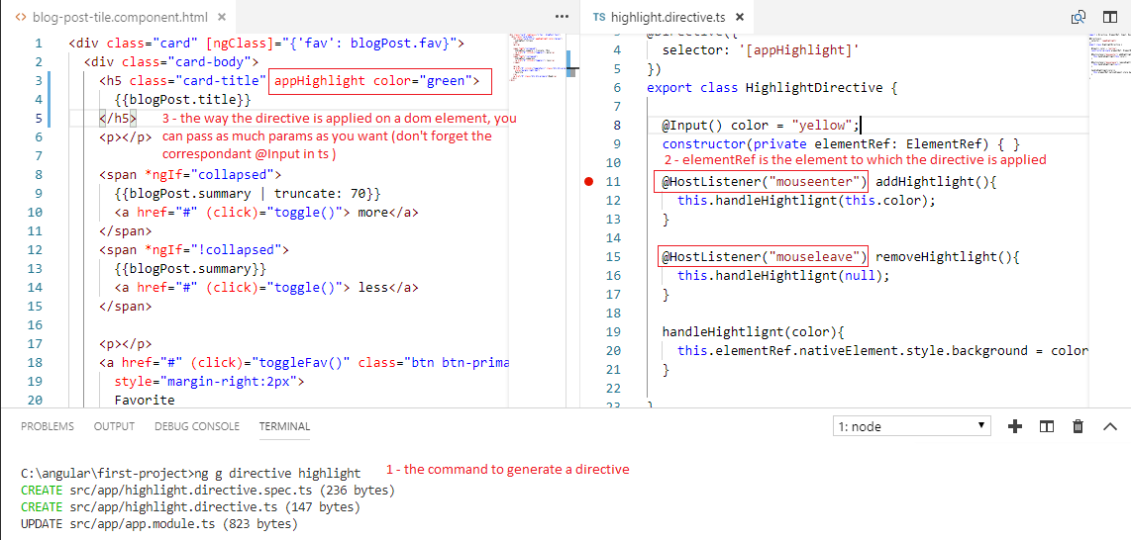
If you don’t pass an input, the color will be yellow, so directive is a way to build reusable code that can control the behaviour of a dom element
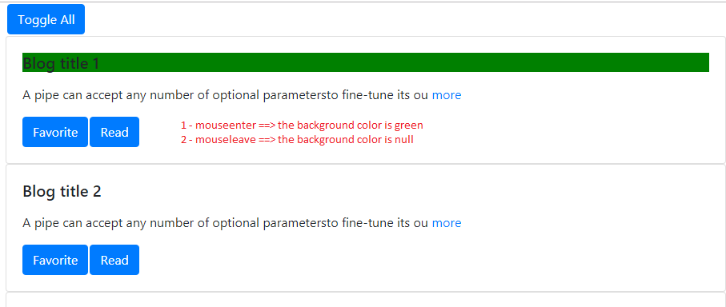
ng-content
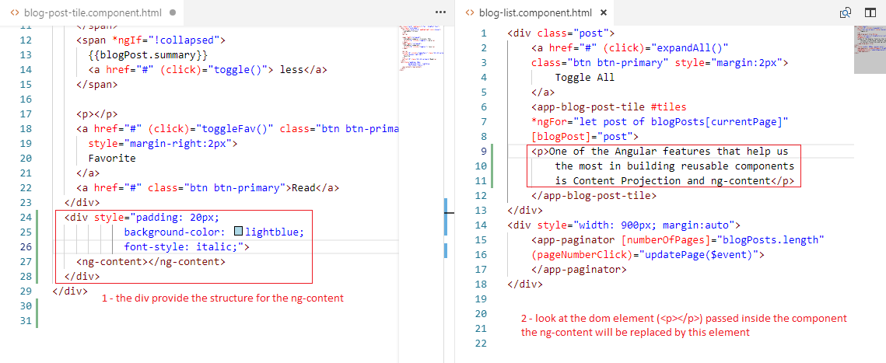
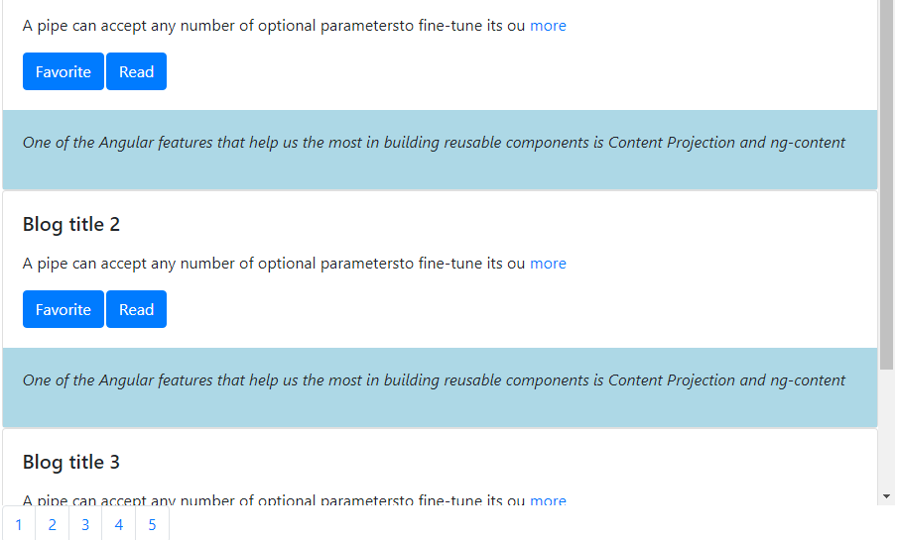

Multi slot content projection

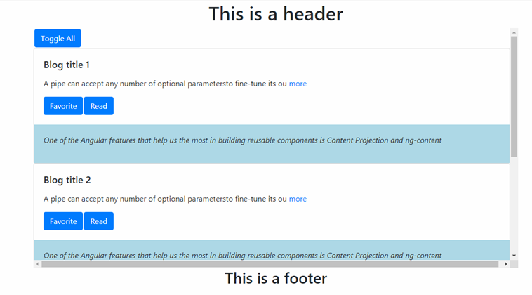
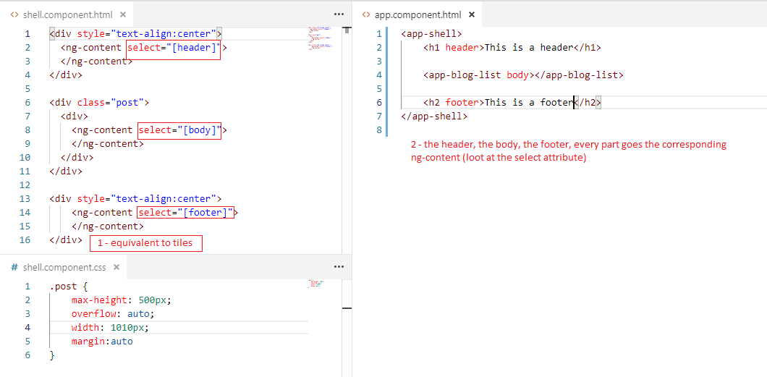
something

