Palcom Manager Improvements and Bug Report.
Graphing bug:
Not plotting correctly using Palcom Manager
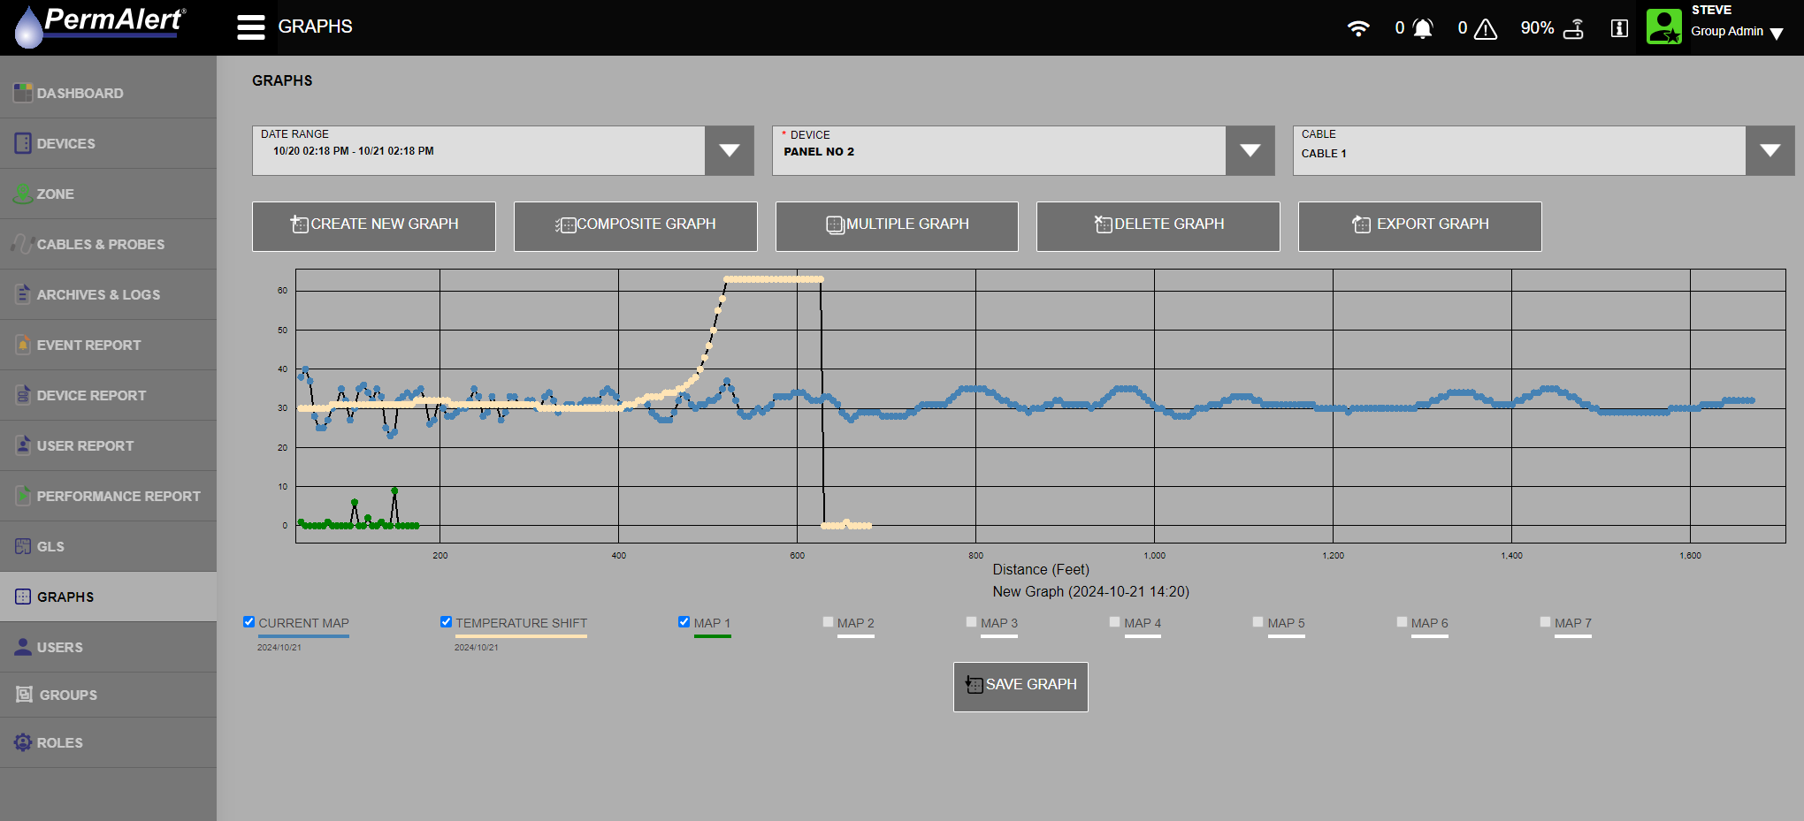

Plotted correctly using Palcom 10.
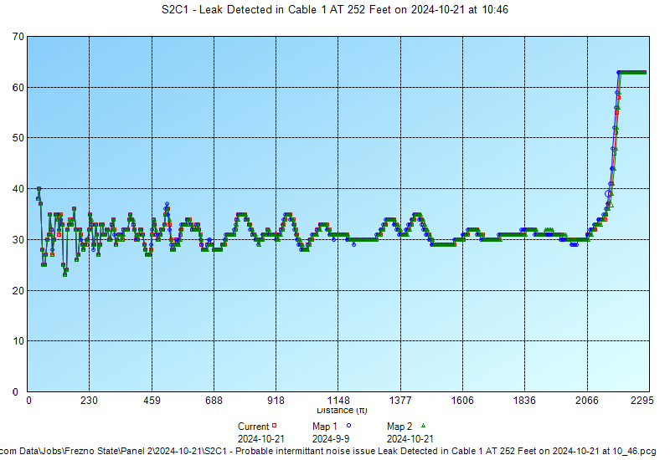

Palcom 10 will use the next higher map that is not asked for when prompted for the number of maps to download from the PAL-AT for the Temperature Map (Ram Map). The below Palcom 10 Graph shows Map 2 as a properly plotted Temperature Map.
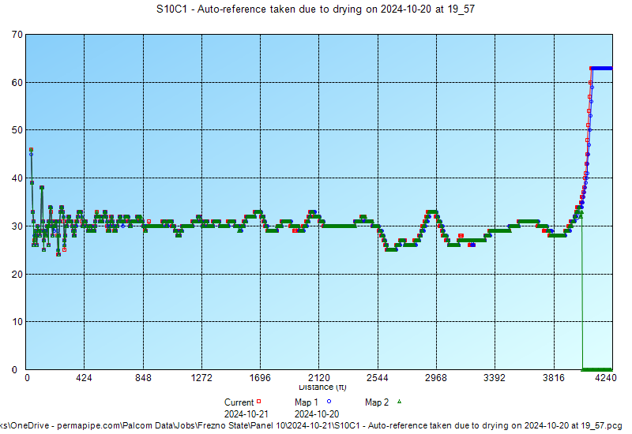

Palcom Manager Dashboard Total Alarms Graphs Bug:
The only alarms that are to be included in the following 2 bar graphs are Leak, Probe active, short, break, fault in first…, and no end found. See further information under Event Summary Improvement in next section.
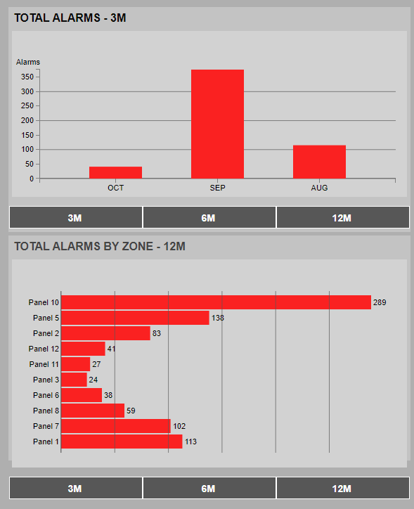

Palcom Manager Dashboard - Event Summary Improvement:
- Ability to hard acknowledge multiple events or all the events or archive then Hard acknowledge all events.
- Remove the “Referencing new map due to drying” or “Auto reference” from the dashboard event list. These are not events. They are side effects of events.

