Email Documentation

Step 1 : Open the Microsoft outlook . Click on next button.

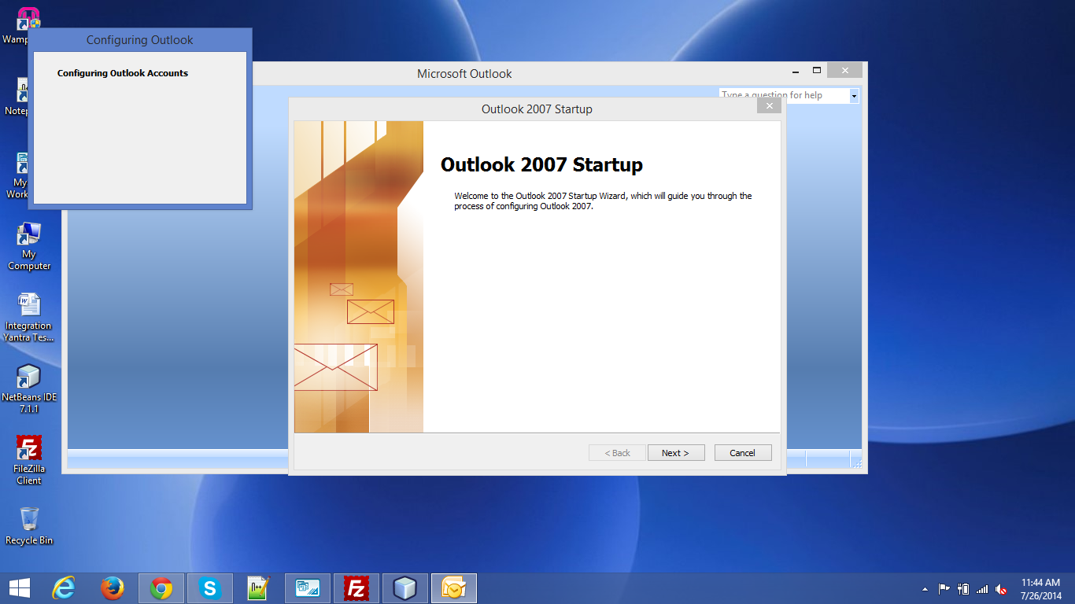

Step 2: Select “Yes” and press Next button.
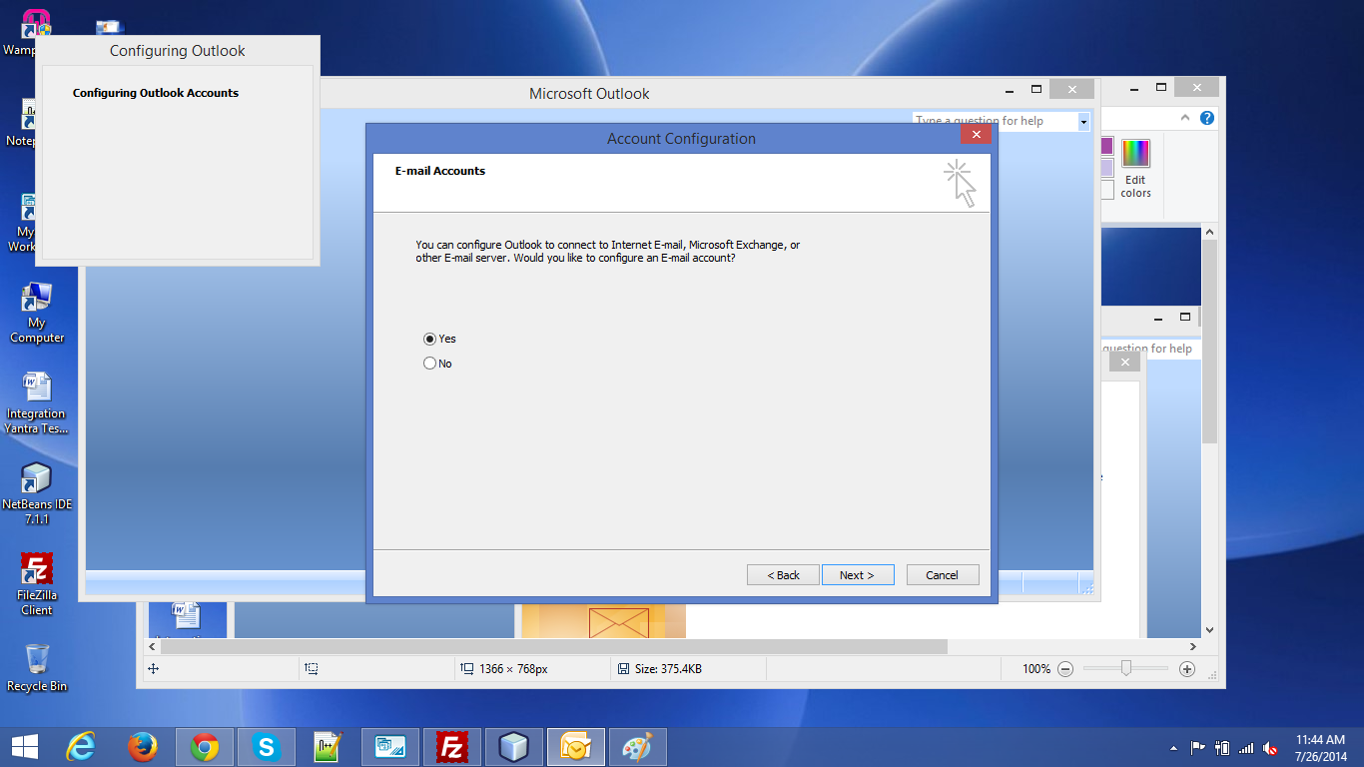

Step 3: : Fill the details and Check the check box at bottom of window and press next button.
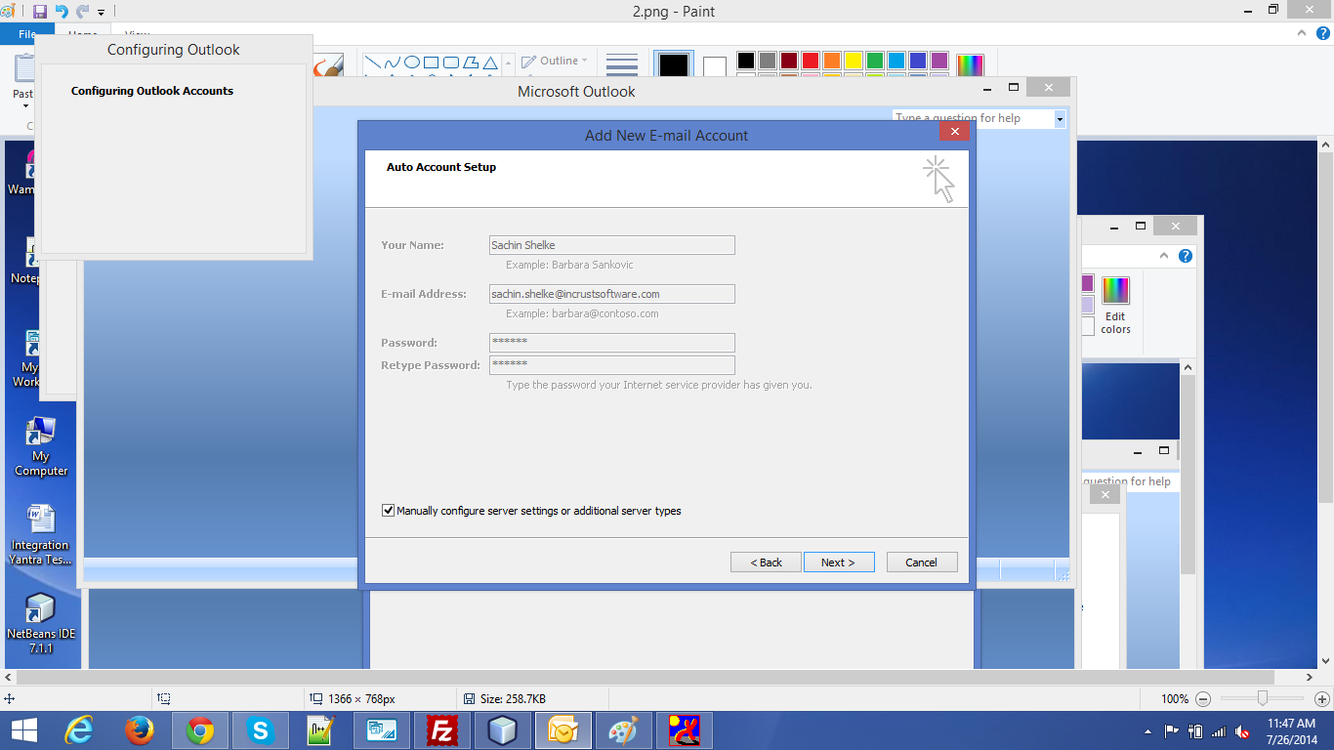

Step 4: Select Internet E-Mail and press next button.
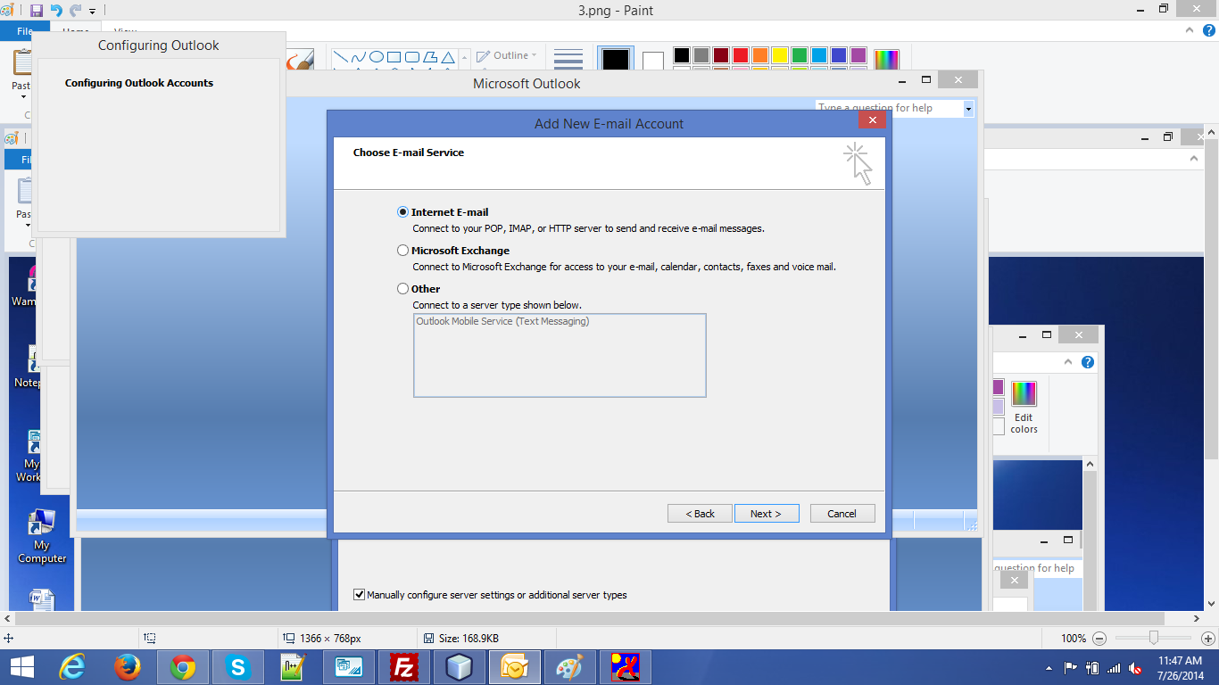

Step 5 : : Fill the details in above mentioned window and press “Test Account setting”
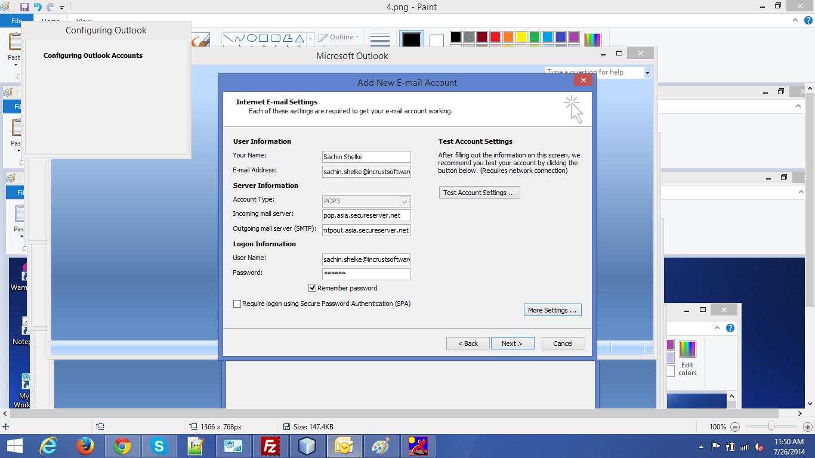

Step 6. : After popup Test Account Settings check status and close the window and press next button.

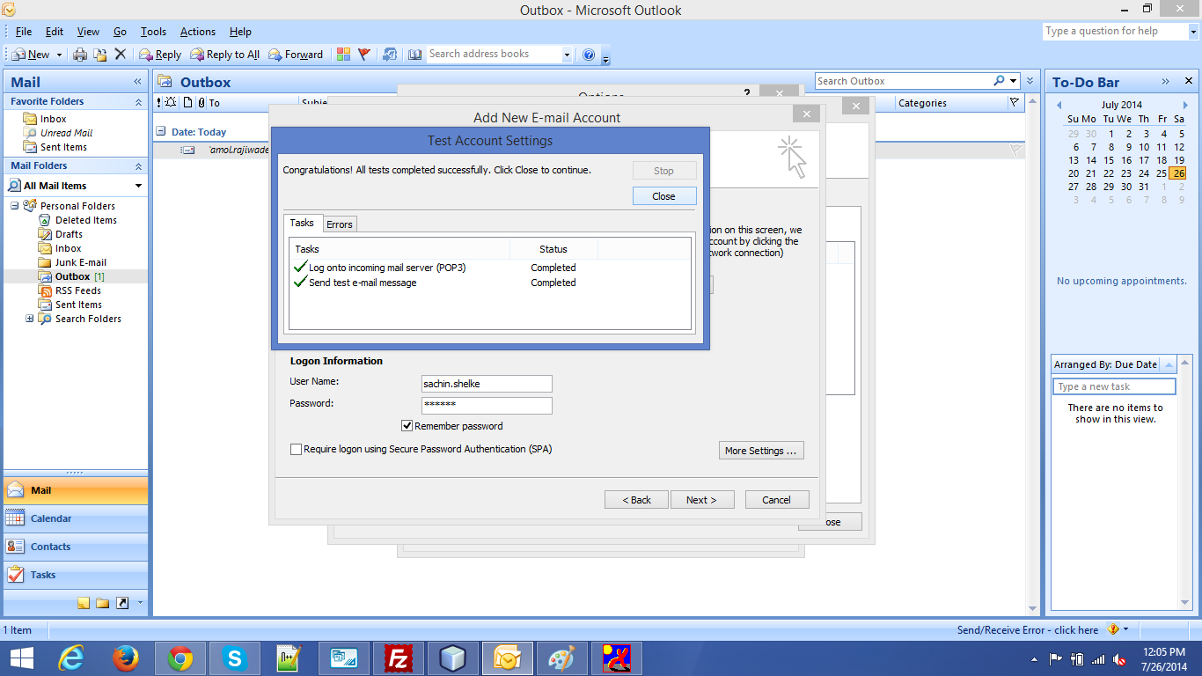

Step 7 : Your account is created successfully press “Finish” to continue.
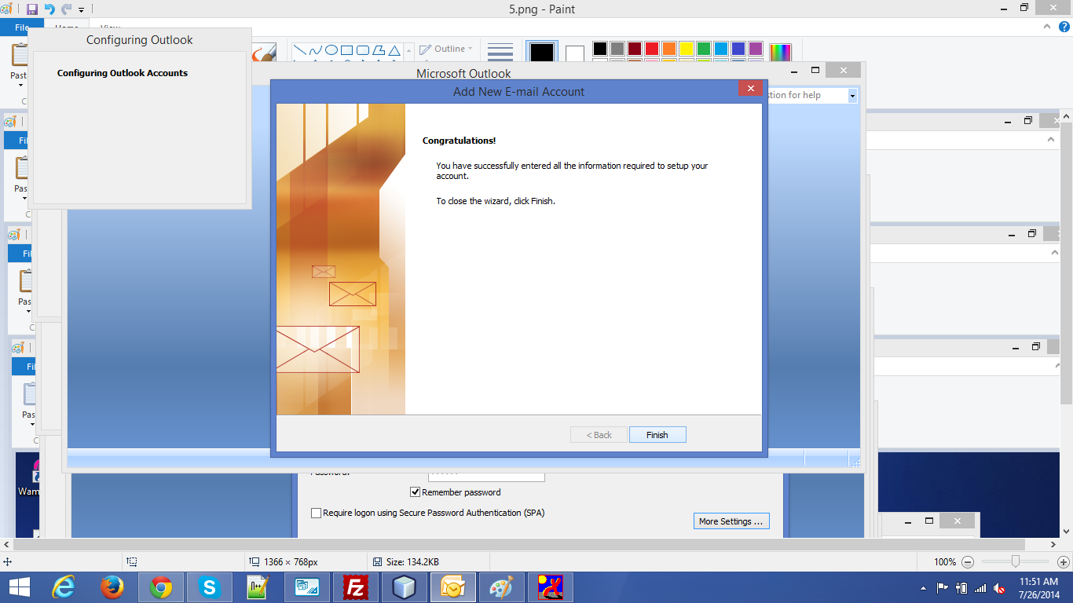
Step 8: Select New mail message and send test mail.
