TWUI -Grant Proposal:

For the new App School Live curriculum (as of 2024), students will iteratively build a board games as they navigate the Gall App curriculum. Currently, debugging and printing out to terminal (with %dill via %drum) is non-optimal.

We propose a Terminal-Web-User-Interface (TWUI) to assist students in their gall app projects. More specifically, students will use twui as a wrapper library around their app, which will display the state of their app via two Uis:

1) A Web UI: rendering the state of the app (such as a gameboard) in a Sail front end, which they may interact with.

2) A terminal UI: upon request, printouts of the app state are done via the command-line. Formatting logic in tui should make it more presentable.

Implementation and Technical Details:

- TWUI will be implemented as a wrapper library.

Passing the state as an argument can’t work! Here is why:

|%
+$ versioned-state
$% state-0
==
+$ state-0 appstate
:: A very basic state to test Sail with. $: [%0 board=boardmap bsize=dims] ==
+$ card card:agent:gall
--

=| state-0
=* state -

%+ agent:twui state

:: Our sample app starts here (10 arm door)
^- agent:gall
|_ =bowl:gall
+* this .
default ~(. (default-agent this %|) bowl)
++ on-init

1)We call the agent:twui arm, and pass in the state and the app as cell and code-as-data arguments, essentially.
2) Hoon is functional, has no pointers, and is pass-by-value.
3) So the state that is passed in, and the state that is associated with the app door itself, are separate (they are pbv copies!).
4) When we try to poke or manipulate state, and print our state in twui.hoon and app.hoon, we see the following output:
5) The two states are different. The gamestate ref’ed in TWUI is always bunted, and never changes. To test this I set the gamestate, and then called the %teststate poke to print it out. TWUI printed out its gamestate, and the app itself printed out its state using the on-poke arm. We see that twui’s state never changes.

So our simpler on-save solution before (although not so elegent) worked. Having just one state makes it easier.

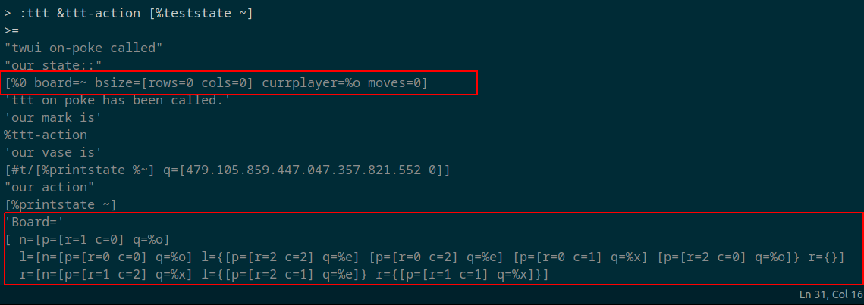

"twui on-init called"
eyre: replacing existing binding at /ttt
"twui on-watch called"
error in %ttt
%arvo-response
! /lib/default-agent/hoon:<[66 3].[66 5]>
! "unexpected system response %eyre to %ttt on wire /bind"
! /lib/default-agent/hoon:<[65 3].[66 5]>
! /lib/twui/hoon:<[147 28].[147 55]>
! /lib/twui/hoon:<[147 11].[147 69]>
! /lib/twui/hoon:<[146 11].[147 69]>
! /lib/twui/hoon:<[145 11].[147 69]>
! /sys/vane/gall/hoon:<[1.867 9].[1.867 47]>

