

INGLÉS IV
Week 17 - Task: Assignment - Final Assignment Part I

 | 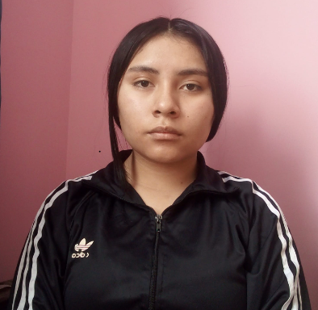
Marisol Consuelo Zarzosa Prudencio  Código: U24236339 | Nohelia Tinco Laure  Código: U24244700

TEACHER:

Araceli Masco Inga

Full time job
Dear judges of the prestigious school of Santo Tomas de Aquino
In this little card I want to say, why I could be the best option between the other to take the place of the teacher that will teach the elite of the students.
First, I have been teaching in many others schools with similar prestigious that you have there and in one of this I was named as the best teacher of the month from the students and the other teachers, so for that I received an award.
In this job I expect to be a good teacher and leadership, with my formation in civic and philosophy, my students won’t be alone or lost at any time, so they are going to have a complete formation to be a professional.
U24244700@gmail.com
910592998
Thank you so much

