

SecureVault — Encrypted File Storage & Sharing Web App

CAPSTONE PROJECT REPORT

A Capstone Project Report submitted in partial fulfilment of the requirements for the Course of

CSA5110 - Cryptography and Network Security

to the award of the degree of

BACHELOR OF TECHNOLOGY IN
COMPUTER SCIENCE ENGINEERING
(BRANCH)

Submitted by
E.Shani Priya (192371033)
Noel Raju (192372315)

Under the Supervision of
Dr. Nitisha J
SIMATS ENGINEERING
Saveetha Institute of Medical and Technical Sciences Chennai-602105
SEPTEMBER 2026

SIMATS ENGINEERING
Saveetha Institute of Medical and Technical Sciences Chennai-602105

BONAFIDE CERTIFICATE

This is to certify that the Capstone Project entitled “SecureVault — Encrypted File Storage & Sharing Web App” has been carried out by Noel Raju under the supervision of Dr . Nithisha J and is submitted in partial fulfilment of the requirements for the current semester of the B.Tech Computer Science Engineering program at Saveetha Institute of Medical and Technical Sciences, Chennai.

COURSE COORDINATOR COURSE FACULTY
Dr T Sangeetha Dr. Nitisha J
Professor Professor
Computational Intelligence Computational Intelligence
SIMATS Engineering, SIMATS Engineering,
SIMATS, Chennai – 602105. SIMATS, Chennai – 602105.

SIMATS ENGINEERING
Saveetha Institute of Medical and Technical Sciences Chennai-602105

DECLARATION

I, Noel Raju of the [CSE-AI], SIMATS Engineering, Saveetha Institute of Medical and Technical Sciences, Chennai, hereby declare that the Capstone Project Work entitled “[SecureVault — Encrypted File Storage & Sharing Web App]” is the result of our own bonafide efforts. To the best of our knowledge, the work presented herein is original, accurate, and has been carried out in accordance with the principles of engineering ethics and academic integrity. All sources, references, data, and other materials used in the project have been appropriately acknowledged. We further declare that the data, results, analysis, and findings presented in this report have not been fabricated, falsified, or manipulated. Any external tools, software, datasets, computational resources, or AI-assisted tools used during the project have been appropriately disclosed. We confirm that all applicable ethical, academic, institutional, and professional requirements have been duly followed throughout the planning, execution, analysis, and documentation of the project.

Place:CHENNAI
Date:03/09/2026

Signature of the Students with Names

SIMATS ENGINEERING
Saveetha Institute of Medical and Technical Sciences Chennai-602105

Individual Contribution Statement

Student Name / Register No. | Specific  Responsibilities | Design & Development Contribution | Testing & Analysis  Contribution | Report Contribution | Approx.  Contribution (%)
E. Shani Priya  192371033 | Module 1: User Authentication & Secure File Management | User registration and login; authentication workflow; secure file upload; file encryption; encrypted storage and metadata management. | Tested registration, login, file upload, encryption status and secure storage; analysed functional results. | Module 1 design and implementation; Chapter 3 module design; Chapter 4 implementation/testing; Individual Reflection. | 50%
Noel Raju  192372315 | Module 2: Encrypted File Sharing & Access Control | Secure file sharing; recipient selection; permission assignment; access verification; authorized download and unauthorized access prevention. | Tested file sharing, permission validation, authorized access and unauthorized-access blocking; analysed results. | Module 2 design and implementation; access-control workflow; Chapter 4 sharing/testing; Individual Reflection. | 50%
Total |  |  |  |  | 100%

ABSTRACT

With the pervasive adoption of web platforms and distributed cloud infrastructure, safeguarding sensitive electronic documents from unauthorized exposure has become a critical cybersecurity priority. Traditional cloud-based file repositories frequently depend on perimeter defenses and centralized storage architectures that remain vulnerable to credential theft, indiscriminate sharing URLs, insider misuse, and inadequate access authorization. Ensuring rigorous confidentiality for sensitive digital assets while maintaining seamless sharing capabilities for authenticated collaborators presents a fundamental software engineering challenge.
To resolve these security vulnerabilities, this project presents SecureVault — an Encrypted File Storage & Sharing Web Application engineered to guarantee confidentiality, integrity, and controlled dissemination of sensitive user data. The software architecture is partitioned into two cohesive core modules. Module 1 (User Authentication & Secure File Management) oversees account creation, session verification, secure file ingestion, cryptographic transformation, ciphertext persistence, and metadata indexing. Module 2 (Encrypted File Sharing & Access Control) governs secure distribution workflows, recipient-specific permission allocation, authorization checks, and protected download handling.
The cryptographic framework employs symmetric data encryption coupled with asymmetric key encapsulation techniques (RSA/ECC) to ensure that file contents remain unintelligible to unauthorized parties and underlying storage operators. Every file transaction is subject to dynamic identity and permission validation prior to granting access or download privileges. A dedicated metadata registry maintains critical operational parameters, including User IDs, File IDs, cryptographic states, and access control mappings.
Implemented using modern full-stack web technologies and a structured database for metadata tracking, the SecureVault system was evaluated through a comprehensive suite of functional test scenarios. The test results confirm the operational correctness of user authentication, encryption and decryption pipelines, access permission enforcement, and the rejection of unauthorized access attempts. SecureVault provides an accessible, robust, and dependable framework for confidential file storage and controlled collaboration.
Keywords: Secure File Storage, Encryption, Secure File Sharing, ECC, RSA, Access Control.

TABLE OF CONTENTS

Sl.  No | Title | Page  No
i | CERTIFICATE FROM THE SUPERVISOR | ii
ii | DECLARATION BY THE CANDIDATE | iii
Iii | INDIVIDUAL CONTRIBUTION STATEMENT | iv
iv | ABSTRACT | v
v | LIST OF FIGURES | vi
vi | LIST OF TABLES | vii
vii | LIST OF ABBREVIATIONS | viii
1 | CHAPTER 1: Introduction | 1
2 | CHAPTER 2: Literature Review | 2
3 | CHAPTER 3: Engineering Design & Trade-offs, Sustainability,  Ethics, Safety, Risk & Security | 3
4 | CHAPTER 4: Implementation, Testing & Results, Project  Management | 4
5 | CHAPTER 5: Conclusion & Reflection | 5
 | References
 | Appendices

LIST OF FIGURES

Figure No. | Figure Name | Page No.
Figure 1.1 | Overview of SecureVault System | 1
Figure 1.2 | Traditional File Storage Security Problems | 1
Figure 3.1 | Overall SecureVault System Architecture | 8
Figure 3.2 | Module 1: User Authentication and Secure File Management Architecture | 9
Figure 3.3 | User Authentication and Secure File Upload Flow | 9
Figure 3.4 | File Encryption and Encrypted Storage Process | 10
Figure 3.5 | Module 2: Encrypted File Sharing and Access Control Architecture | 10
Figure 3.6 | Secure File Sharing Workflow | 10
Figure 3.7 | Access Permission Verification and Authorized Download Process | 11
Figure 3.8 | SecureVault Overall Data Flow | 11
Figure 4.1 | User Registration and Login Interface | 13
Figure 4.2 | Secure File Upload Interface | 13
Figure 4.3 | Encrypted File Storage and Encryption Status | 14
Figure 4.4 | Secure File Sharing Interface | 14
Figure 4.5 | Access Permission Management Interface | 14
Figure 4.6 | Authorized and Unauthorized Access Results | 16
Figure 4.7 | Testing and Performance Results | 16

LIST OF TABLES

Table No. | Table Name | Page No.
Table 1.1 | Project Objectives | 2
Table 2.1 | Review of Existing Systems | 4
Table 2.2 | Comparative Analysis of Existing Approaches | 4
Table 3.1 | Stakeholder Requirements | 5
Table 3.2 | Functional and Non-Functional Requirements | 5
Table 3.3 | Applicable Standards and Security Guidelines | 6
Table 3.4 | Design Specifications | 6
Table 3.5 | Alternative Solution Evaluation Matrix | 7
Table 3.6 | Design Trade-off Analysis | 10
Table 3.7 | Sustainability, Ethics and Security Considerations | 10
Table 3.8 | Risk Register | 10
Table 4.1 | Development Tools and Technologies Used | 12
Table 4.2 | Test Plan and Verification | 15
Table 4.3 | Functional Test Results | 15
Table 4.4 | Comparison with Existing Solutions and Objective Achievement | 17
Table 4.5 | Project Roles and Contributions | 18
Table 4.6 | Estimated Project Budget | 18

LIST OF ABBREVIATIONS / SYMBOLS

Symbol / Abbreviation | Description | Unit
ECC | Elliptic Curve Cryptography | N/A
RSA | Rivest–Shamir–Adleman Cryptography | N/A
AES | Advanced Encryption Standard | N/A
API | Application Programming Interface | N/A
UI | User Interface | N/A
DB | Database | N/A
HTTPS | Hypertext Transfer Protocol Secure | N/A
TLS | Transport Layer Security | N/A
RBAC | Role-Based Access Control | N/A
ACL | Access Control List | N/A
ID | Identification | N/A
URL | Uniform Resource Locator | N/A
CRUD | Create, Read, Update and Delete | N/A

CHAPTER 1

INTRODUCTION AND ENGINEERING PROBLEM

1.1 Background

The rapid proliferation of web-enabled platforms and distributed cloud repositories has fundamentally altered how digital assets are archived, processed, and exchanged across modern organizational ecosystems. Today, highly sensitive materials—ranging from proprietary business documentation and technical schematics to confidential financial ledgers, legal agreements, and protected personal records—are routinely transmitted to and stored within remote web infrastructures. While this cloud-centric paradigm delivers unprecedented accessibility, collaboration efficiency, and operational agility, it simultaneously introduces acute cybersecurity risks concerning unauthorized exposure, multi-tenant data leakage, insecure dissemination channels, and sophisticated perimeter breaches.

Conventional cloud storage and digital exchange architectures predominantly enforce access restrictions through basic authentication schemes, such as static usernames, passwords, or unauthenticated uniform resource locator (URL) tokens. These perimeter-based safeguards present critical vulnerabilities: compromised user credentials or intercepted direct links instantly expose underlying confidential assets to adversaries. Cryptographic transformation addresses these systemic deficiencies by converting plaintext data into unintelligible ciphertext prior to persistent storage, guaranteeing that digital assets remain unreadable to unauthorized entities and untrusted host environments in the absence of valid cryptographic keys.

Contemporary cryptographic literature underscores the necessity of pairing robust data encryption with granular, policy-driven authorization schemes. Elliptic Curve Cryptography (ECC) has emerged as an exceptionally viable public-key paradigm, offering high cryptographic strength with significantly reduced key lengths and reduced computational overhead. Concurrently, hybrid cryptographic schemes—which fuse high-throughput symmetric ciphers for bulk payload encryption with asymmetric algorithms for resilient key encapsulation—represent the prevailing benchmark for secure data distribution.

In response to these engineering requirements, SecureVault is introduced as a comprehensive web-based platform that unifies user identity verification, encrypted file persistence, controlled distribution workflows, and explicit permission-based authorization into an integrated, defensible architecture.

1.2 Need for the Project

The motivation to engineer SecureVault stems from critical security, governance, and architectural requirements identified across modern web-based document environments:

Confidential Asset Protection: High-value electronic documents demand systematic cryptographic guarantees against both external adversaries and unauthorized internal actors.

Vulnerability of Perimeter-Based Storage: Standard web storage platforms fail to preserve confidentiality whenever access tokens, session identifiers, or public sharing links are leaked or intercepted.

Controlled and Target-Specific Dissemination: Data custodians require deterministic mechanisms to restrict document visibility strictly to authenticated, explicitly authorized recipients.

Coupling Encryption with Authorization: Standalone encryption proves inadequate without robust user identity binding and dynamic access permission enforcement at the application layer.

Data Custodian Governance: File originators must retain full authority over permission allocation, document distribution status, and access rights.

Resilient Cryptographic Key Management: Safeguarding encrypted payloads necessitates secure key generation, encapsulation, and distribution practices to prevent key leakage.

Regulatory Compliance and Digital Accountability: Modern enterprises are bound by regulatory frameworks mandating stringent data privacy controls, explicit access governance, and verifiable information lifecycle tracking.

Resolution of Research-Identified Challenges: Recent cybersecurity research highlights dynamic access control, key management complexity, and permission enforcement as paramount technical hurdles within secure cloud collaborative architectures.

1.3 Problem Statement

Conventional web-based file repositories and collaborative platforms frequently compromise data confidentiality due to weak authentication schemes, unconstrained URL-based file distribution, absent or deficient at-rest encryption, insecure cryptographic key storage, and rigid or non-existent access control policies.

The core engineering challenge addressed by this capstone project is to architect, implement, and validate a secure web application capable of performing identity verification, executing payload encryption, maintaining persistent ciphertext repositories, and enforcing strict recipient-level access controls during file sharing, all while preserving computational responsiveness and administrative usability.

To deliver an optimal technical solution, the system design must resolve several competing engineering trade-offs:

Confidentiality vs. Accessibility: Enforcing zero-exposure data privacy without impeding authorized data retrieval.

Cryptographic Strength vs. Runtime Overhead: Applying robust cryptographic primitives without inducing noticeable latency during client transactions.

Key Protection vs. Architectural Complexity: Structuring resilient public-key management mechanisms while avoiding excessive operational fragility.

Granular Authorization vs. User Usability: Providing rigorous recipient-level access controls through an intuitive, streamlined user interface.

Transformation Latency vs. Throughput Efficiency: Managing the computational cost of file-level encryption and decryption without degrading application throughput.

1.4 Project Aim

The principal aim of this capstone project is to design, construct, and evaluate SecureVault—an integrated, secure web application that delivers robust file encryption and controlled multi-user file dissemination by harmonizing identity verification, symmetric/asymmetric cryptographic operations, secure key management, and explicit permission-based access control mechanisms.

1.5 Project Objectives

Table 1.1: Project Objectives
Objective No. | Objective
1 | To design a secure user authentication mechanism.
2 | To develop secure file upload and management functionality.
3 | To encrypt files before or during secure storage.
4 | To implement secure key protection using ECC/RSA-based mechanisms.
5 | To develop encrypted file-sharing functionality.
6 | To implement access permissions for authorized users.
7 | To prevent unauthorized file access.
8 | To test and evaluate the functionality and security of the proposed system.

1.6 Scope

Included Scope
The functional and engineering boundaries of the SecureVault implementation comprise:
- User registration, credential hashing, and secure identity authentication.
- Authenticated session establishment and state management.
- Secure file ingestion, payload handling, and metadata tracking.
- Payload-level cryptographic transformation (file encryption at rest).
- Encrypted persistent storage subsystem.
- Recipient-targeted secure file sharing workflows.
- Dynamic access permission administration and access control list (ACL) management.
- Pre-download identity and permission verification.
- Decryption and protected payload retrieval exclusively for verified, permitted users.

Excluded Scope
The following elements fall outside the defined boundaries of this prototype project:
- High-availability, geographically distributed enterprise multi-region deployment.
- Integration with dedicated on-premises Hardware Security Modules (HSMs).
- Implementation of decentralized, blockchain-backed immutable ledgers.
- Post-quantum lattice-based cryptographic algorithms.
- Commercial hyperscale multi-tenant infrastructure configurations.

Operational Assumptions
The implementation and evaluation of SecureVault rest on the following baseline engineering assumptions:
- Registered users act responsibly to preserve the secrecy of their authentication credentials.
- The host application server and database environments operate on a securely configured operating system protected by appropriate network transport layer security (TLS/HTTPS).

1.7 Expected Engineering Outcome

The primary deliverable of this engineering project is a fully functional, rigorously tested web application prototype capable of safeguarding electronic assets throughout their storage and sharing lifecycles.
- The completed software deliverable provides:
- An identity-verified authentication interface.
- A persistent repository of cryptographically transformed file payloads.
- An indexed, secure database tracking file metadata and ownership mappings.
- A custodian-controlled file-sharing pipeline.
- Dynamic, rule-based permission validation prior to any data extraction.
- Deterministic rejection and containment of unauthorized access requests.
- A tangible, modular demonstration of integrating applied cryptography with contemporary full-stack web software engineering.

CHAPTER 2

LITERATURE REVIEW AND EXISTING SOLUTIONS

2.1 Review Method

The literature review was executed through a systematic survey of peer-reviewed cybersecurity and software engineering publications spanning the period from 2023 to 2025. The investigation focused on state-of-the-art developments in secure cloud repositories, cryptographic access governance, hybrid encryption schemes, applied Elliptic Curve Cryptography (ECC), Rivest–Shamir–Adleman (RSA) key encapsulation, and privacy-preserving data sharing protocols.
Targeted databases included the IEEE Xplore Digital Library, ACM Digital Library, SpringerLink, ScienceDirect, and established peer-reviewed international security symposium proceedings. Special consideration was directed toward research contributions that addressed the intersection of cryptographic data protection, key distribution paradigms, and web application access control.

2.2 Review of Existing Work
A critical analysis of recent academic literature reveals several distinct methodologies engineered to resolve data confidentiality and sharing vulnerabilities within remote storage environments:
- Attribute-Based Encryption with Policy Integration: Chen et al. introduced a remote cloud document-sharing framework combining access-control policies with Ciphertext-Policy Attribute-Based Encryption (CP-ABE) to guarantee data confidentiality during collaborative workflows. Their research demonstrates that decoupling access governance from storage infrastructure is essential for zero-trust data protection, highlighting the necessity of combining encryption with policy validation rather than relying on perimeter defenses alone.
- Blockchain-Integrated Cryptographic Sharing: Almasian and Shafieinejad engineered an encrypted cloud file-sharing paradigm that merges decentralized blockchain smart contracts with attribute-based encryption primitives. Their contribution addresses decentralized authorization and verifiable permission revocation; however, the reliance on blockchain consensus mechanisms introduces substantial transactional latency, increased computational cost, and elevated architectural complexity that restricts broad web application deployment.
- Hybrid Cryptographic Storage Frameworks: Saginayev et al. formulated a secure cloud storage architecture founded upon hybrid cryptography, pairing symmetric Advanced Encryption Standard (AES-256) data payload transformation with asymmetric RSA key encapsulation. Their evaluation confirmed that hybrid models successfully mitigate symmetric key exposure risks while preserving high computational throughput during bulk data processing.
- Elliptic Curve Cryptography for Access Governance: Contemporary investigations into ECC-driven cloud access control protocols demonstrate that elliptic curve primitives yield cryptographic security parity with traditional public-key algorithms (such as RSA) while utilizing substantially smaller key sizes (e.g., 256-bit ECC versus 2048-bit RSA). This characteristic translates into lower memory footprint, minimized network communication overhead, and reduced mathematical computation latency.
- Role-Based Dynamic Access Frameworks: The AccessFlex architecture proposed a flexible cloud access-control system that defines granular functional boundaries among data owners, consumers, and platform administrators. By enforcing cryptographic access segregation across distinct user roles, the system affirmed the vital role of explicit ownership control and dynamic permission mapping within shared storage repositories.

2.3 Comparative Analysis

Table 2.1: Review of Existing Systems
A comparative synthesis of the analyzed literature paradigms relative to the design objectives of SecureVault is summarized in Table 2.1 and Table 2.2.
Existing Approach | Core Advantages | Technical Limitations | Relevance to SecureVault Design
Blockchain + ABE | Fine-grained, expressive access logic and verifiable revocation | Elevated latency, transaction fees, and high architectural complexity | Informs the design of granular permission checks and access tracking
Hybrid AES + RSA | High data throughput and resilient asymmetric key protection | Overhead in asymmetric key distribution and session management | Establishes the foundation for payload transformation and key wrapping
ECC-Based Access Control | Compact key dimensions, minimal bandwidth, and reduced computation | Mathematical complexity during curve parameter configuration | Guides the selection of lightweight public-key mechanisms for key exchange
ABAC-Based Cloud Sharing | Highly expressive, multi-attribute dynamic access governance | Complex policy evaluation engine and parsing overhead | Supports the formulation of owner-centric permission management
Standard Secure Web Sharing | Intuitive user interface and streamlined operational workflows | Often lacks end-to-end payload encryption and robust key management | Directs the practical integration of applied cryptography into web UX

Table 2.2: Comparative Analysis of Existing Approaches
Architectural Feature | Traditional File Storage | Conventional Cloud Sharing | Dedicated Hybrid Encryption Systems | Proposed SecureVault Platform
User Authentication | Basic (Password-only) | Standard Session-Based | Varies / Dependent on System | Robust Hashed Verification & Session Control
Data Payload Encryption | Minimal or None | Storage-Provider Managed | System-Enforced Cryptographic Layers | Application-Layer Automated Encryption
Secure Key Protection | Absent | Managed by Provider | Robust Asymmetric Key Wrapping | Isolated Public-Key Key Encapsulation
Granular Access Control | Basic OS Permissions | Link/Folder Permissions | Role/Attribute Dependent | Owner-Centric Recipient-Level Permissions
Controlled Multi-User Sharing | Restricted / Local | Public / Shared URLs | Cryptographically Enforced | Cryptographically Verified Recipient Sharing
Protection Against Unauthorized Access | Low | Moderate | High | High (Deterministic Rejection & Isolation)

2.4 Research / Engineering Gap
The surveyed literature demonstrates that while advanced theoretical paradigms—such as blockchain-driven consensus networks, dynamic ciphertext-policy attribute-based encryption, and homomorphic searchable schemes—offer robust theoretical guarantees, they routinely introduce significant architectural friction, severe computational latency, and complex deployment requirements that hinder practical web integration.
Conversely, widely adopted commercial web file-sharing platforms often compromise on cryptographic isolation, relying on provider-side encryption where the storage host holds the decryption keys, or exposing data through unauthenticated, shareable URLs.
Consequently, a distinct engineering gap persists for a lightweight, practical, and highly transparent web-based platform that harmonizes:
- Strict identity verification and session authentication.
- Automated payload-level encryption at rest.
- Asymmetric key encapsulation and isolated key management.
- A secure, indexed persistent storage model.
- Custodian-directed, recipient-specific file sharing workflows.
- Deterministic, permission-verified download authorization.
SecureVault explicitly addresses this research and engineering gap by implementing a modular, accessible, and mathematically robust software architecture tailored for secure web environments.

2.5 Proposed Contribution
The core engineering and architectural contributions delivered by the SecureVault system comprise:
- Unified Security Pipeline: Seamless integration of identity authentication, payload encryption, and permission enforcement within a cohesive full-stack web architecture.
- Automated Storage Protection: Ingestion pipeline that cryptographically transforms file payloads into ciphertext prior to persistent database and file system storage.
- Resilient Key Management Architecture: Integration of public-key mechanisms (ECC/RSA) to encapsulate symmetric payload keys, preventing unauthorized key exposure.
- Custodian-Governed Access Control: Direct data owner control over document sharing permissions, ensuring files can only be accessed by designated recipient accounts.
- Deterministic Authorization Barrier: Enforcement of real-time identity and permission checks that immediately block and isolate unauthenticated or unauthorized access attempts.
- Modular Subsystem Architecture: Clear architectural partitioning between User Authentication & Secure File Management (Module 1) and Encrypted File Sharing & Access Control (Module 2), ensuring maintainability, testability, and system extensibility.

CHAPTER 3

ENGINEERING DESIGN & TRADE-OFFS, SUSTAINABILITY, ETHICS, SAFETY, RISK & SECURITY

3.1 Requirements

Table 3.1: Stakeholder Requirements
The design and engineering of the SecureVault platform are governed by a structured analysis of stakeholder expectations, core operational capabilities, and critical quality attributes.
Stakeholder | Requirement
File Owner | Securely upload, cryptographically transform, and store confidential documents with full control over sharing policies.
Authorized User | Seamlessly access, verify, and retrieve permitted shared documents through an authenticated workflow.
Administrator | Supervise registered user accounts, oversee metadata consistency, and ensure global platform security.
Organization | Safeguard sensitive corporate and personal digital assets against internal and external security breaches.
Developer | Maintain an extensible, modular, and defensible software codebase that adheres to established security standards.

Table 3.2: Functional and Non-Functional Requirements
Requirement | Type | Measurable Target
User Registration | Functional | Successful account provisioning and credential persistence
User Login | Functional | Robust identity verification and session token issuance
File Upload | Functional | Secure ingestion and server-side processing of submitted files
File Encryption | Functional | Transformation of plaintext payloads into ciphertext prior to storage
File Sharing | Functional | Deterministic allocation of sharing permissions to designated recipients
Permission Verification | Functional | Dynamic validation of access rights prior to initiating file downloads
Confidentiality | Non-Functional | Prevention of unauthorized data disclosure across all storage tiers
Usability | Non-Functional | Intuitive, responsive, and clear user interface design
Reliability | Non-Functional | Consistent system execution and deterministic error handling
Security | Non-Functional | Enforced end-to-end cryptographic safeguards and authenticated sessions

3.2 Constraints & Applicable Standards

Table 3.3: Applicable Standards and Security Guidelines
To ensure architectural compliance, data protection, and resilience against common cyber threats, SecureVault is implemented in accordance with recognized software engineering and security guidelines.
Standard / Guideline | Requirement | Application in SecureVault
HTTPS / TLS | Encrypted transport communication | Safeguards all client-server transactions and data in transit against interception.
OWASP Security Principles | Secure web application engineering | Applied across input sanitization, authentication state handling, and vulnerability mitigation.
Cryptographic Best Practices | Robust key lifecycle governance | Informs key generation, key encapsulation (ECC/RSA), and ciphertext handling procedures.
Access Control Principles | Principle of least privilege | Restricts file access strictly to users who have been explicitly authorized by the file owner.
Data Privacy Principles | Confidentiality and integrity preservation | Ensures that confidential user documents remain inaccessible to unauthorized entities.

3.3 Design Specifications

Table 3.4: Design Specifications
The operational boundaries and technical priorities for the SecureVault architecture are detailed in Table 3.4.
Parameter | Target / Requirement | Unit | Priority
Authentication | Cryptographically verified user identification and session control | N/A | High
File Encryption | Payload transformation into ciphertext before persistence | N/A | High
Access Control | Dynamic, permission-based authorization engine | N/A | High
File Sharing | Explicit, custodian-governed recipient assignment | N/A | High
Key Protection | Asymmetric key encapsulation supported (ECC / RSA) | Bits | High
User Interface | Accessible, responsive, and streamlined web interface | N/A | Medium
Database | Structured metadata tracking and access control list persistence | N/A | High

3.4 Alternative Solutions & Evaluation
To establish the most effective architecture for secure document management, three alternative design strategies were evaluated:

Alternative 1: Conventional Password-Protected Storage
This architectural model relies entirely on basic perimeter credentials (usernames and passwords) to gate access to unencrypted files residing on the server. While exceptionally straightforward to implement and imposing minimal computational overhead, this approach offers inadequate protection against compromised server storage, database breaches, or unauthorized insider access.

Alternative 2: Symmetric Encryption-Based Storage
Under this model, file payloads are encrypted using symmetric ciphers. Although symmetric encryption delivers high data throughput and strong confidentiality at rest, managing and distributing symmetric keys securely among multiple sharing recipients presents severe logistical and architectural vulnerabilities without asymmetric key exchange mechanisms.

Alternative 3: Hybrid Cryptography with Access Control
This strategy integrates symmetric payload transformation with asymmetric public-key cryptography (such as RSA or ECC) for secure key encapsulation, backed by an application-level access control engine. Sensitive files are efficiently encrypted, encryption keys are securely protected and distributed via public-key mechanisms, and granular permissions dictate retrieval authorization.

Table 3.5: Alternative Solution Evaluation Matrix
Criterion | Weight | Alternative 1 | Alternative 2 | Alternative 3
Security | 30% | 2 | 4 | 5
Performance | 20% | 5 | 5 | 4
Cost | 15% | 5 | 4 | 4
Reliability | 15% | 3 | 4 | 5
Scalability | 10% | 3 | 4 | 5
Access Control | 10% | 2 | 3 | 5
Selected Approach: Alternative 3 (Hybrid Cryptography with Access Control) was selected as the foundational architecture for SecureVault. It delivers superior security, resilient key handling, and granular access governance while maintaining acceptable operational performance.

3.5 Selected Design & Detailed Design
The selected system architecture integrates user identity verification, automated file-level cryptographic processing, isolated key encapsulation, and an owner-governed permission engine into a cohesive web platform.

Figure 3.1: Overall SecureVault System Architecture
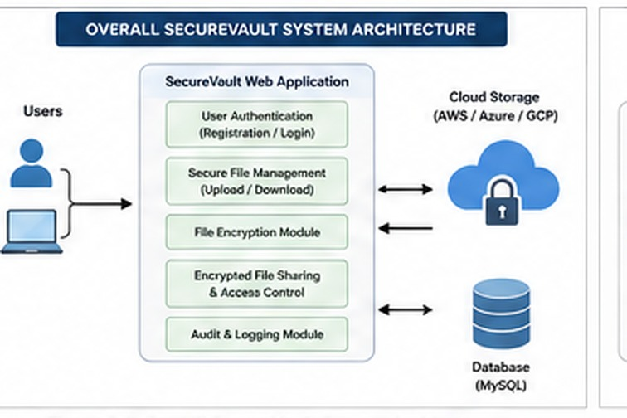

System Components
The SecureVault platform is composed of eight primary architectural components:
- User Interface (UI): Provides an intuitive, responsive web portal for account registration, authentication, document ingestion, sharing administration, and authorized downloads.
- Authentication Module: Validates user credentials, generates authenticated session tokens, and verifies active user identities across all secure endpoints.
- Secure File Management Module: Coordinates client-side file selection, ingestion buffers, validation checks, and operational routing for stored documents.
- Encryption and Key Management Module: Manages symmetric data encryption routines and asymmetric key encapsulation mechanisms (ECC/RSA) to protect file payloads and keys.
- Encrypted Storage: Serves as the persistent repository housing cryptographically transformed ciphertext payloads, preventing plaintext exposure at the storage tier.
- File Sharing Module: Enables authenticated document custodians to search registered users, select designated recipients, and assign viewing or retrieval rights.
- Access Control Module: Evaluates real-time access requests against database-stored permission records, enforcing strict authorization boundaries before granting access.
- Database: Maintains structured records for user accounts, file identifiers, encryption status, metadata attributes, and access control lists (ACLs).
When a user initiates an interaction, the authentication subsystem verifies identity credentials before opening an active session. Uploaded files undergo cryptographic transformation prior to physical disk storage, and all associated metadata—including unique File IDs, ownership mappings, encryption flags, and permission matrices—are systematically recorded within the database.

Module 1: User Authentication & Secure File Management
Module 1 is responsible for identity governance, secure file ingestion, cryptographic transformation, and persistent storage management.
Core Responsibilities:
- User registration and credential verification.
- Secure login and session state management.
- Authenticated document upload handling.
- Automated file-level encryption.
- Ciphertext persistence to encrypted storage.
- File metadata indexing and database synchronization.

Figure 3.2: Module 1 Architecture
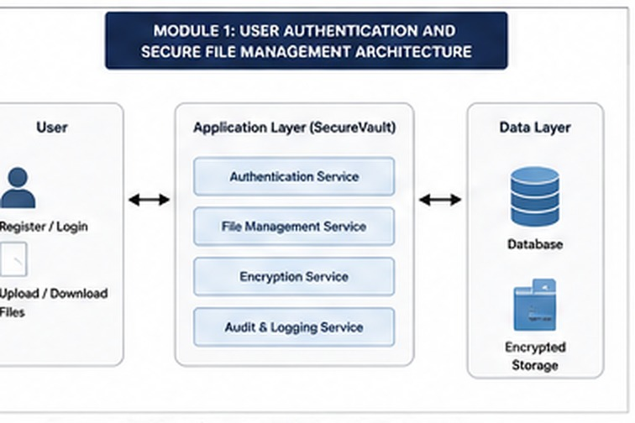

Figure 3.3: User Authentication and Secure File Upload Flow
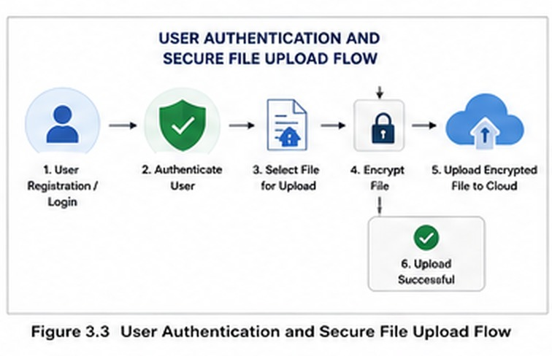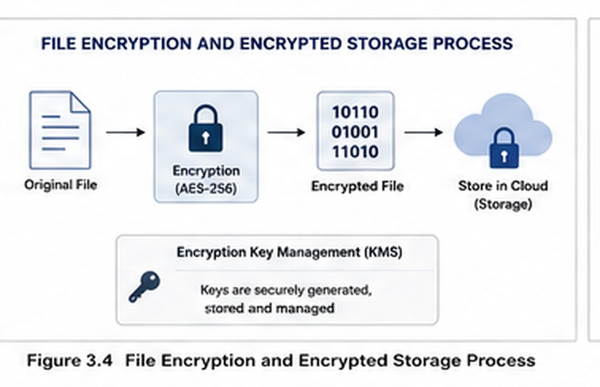

Figure 3.4: File Encryption and Encrypted Storage Process

Module 2: Encrypted File Sharing & Access Control
Module 2 oversees controlled multi-user collaboration, recipient permission assignment, dynamic authorization enforcement, and protected payload decryption during download workflows.
Core Responsibilities:
- Custodian-directed file sharing workflows.
- Target recipient identification and selection.
- Granular permission configuration and storage.
- Pre-download identity and privilege verification.
- Authorized decryption and file retrieval execution.
- Interception and deterministic rejection of unauthorized access requests.

Figure 3.5: Module 2 Architecture
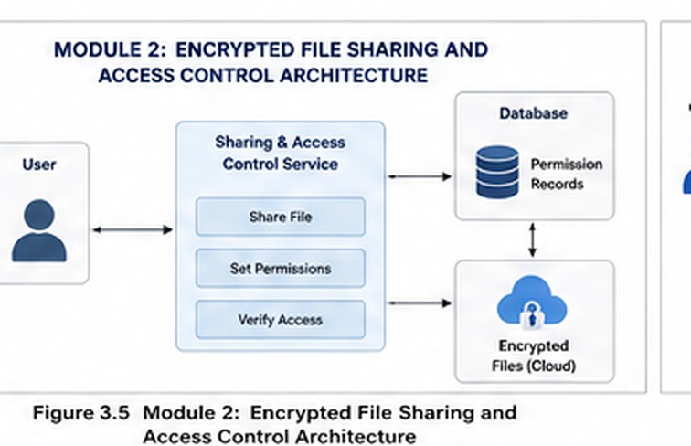

Figure 3.6: Secure File Sharing Workflow
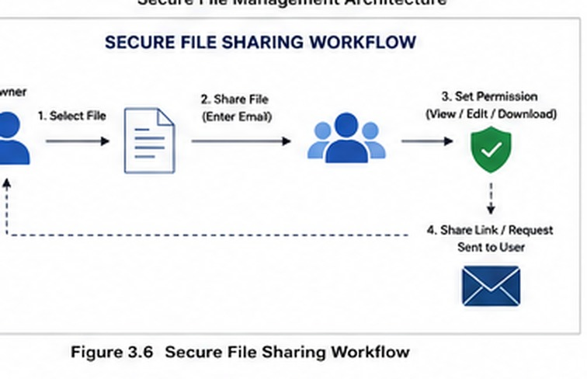

Figure 3.7: Access Permission Verification and Authorized Download Process
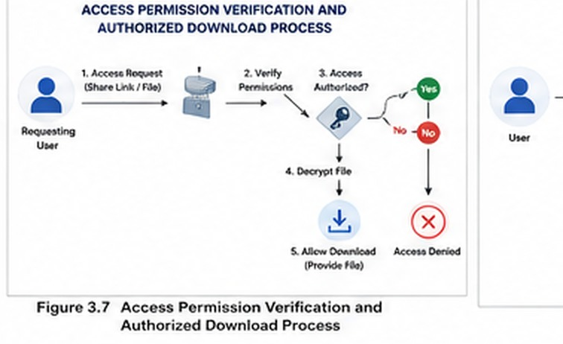

Figure 3.8: SecureVault Overall Data Flow
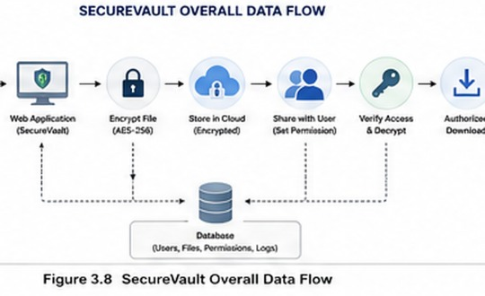

3.6 Trade-off Analysis

Table 3.6: Design Trade-off Analysis
Balancing security guarantees against performance efficiency and system complexity required careful evaluation of critical engineering trade-offs, as summarized in Table 3.6.
Design Decision | Alternative Considered | Benefit | Disadvantage | Final Decision
Public-Key Security | RSA vs. ECC | ECC provides equivalent cryptographic strength with significantly smaller key sizes. | Involves specialized curve parameter handling compared to standard RSA. | ECC / RSA public-key support integrated.
File Protection | Plaintext Storage vs. Encrypted Storage | Delivers zero-exposure confidentiality even if physical storage media is compromised. | Incurs computational processing overhead during upload and download phases. | Mandatory application-layer encryption adopted.
Sharing Model | Public Sharing URLs vs. Permission Lists | Eliminates data leakage caused by shared, intercepted, or leaked hyperlinks. | Requires active management and persistent indexing of recipient access control lists. | Recipient-specific, permission-based sharing enforced.
Authentication Method | Basic Login vs. Cryptographically Verified Login | Mitigates brute-force attacks, credential theft, and unauthorized session hijacking. | Introduces hashing overhead and session token validation logic. | Secure credential hashing and authenticated sessions selected.
Storage Architecture | Standard Cloud Storage vs. Encrypted Repositories | Guarantees complete data privacy in multi-tenant and remote hosting environments. | Requires structured metadata management to track encryption state and keys. | Encrypted persistent file repository implemented.

3.7 Sustainability, Ethics, Safety, Risk & Security

Table 3.7: Sustainability, Ethics and Security Considerations

Sustainability, Ethics, and Safety Considerations
The engineering of SecureVault incorporates ethical responsibility, environmental awareness, and user safety into its core operational design.
Domain | Consideration | Evidence Evaluated | Impact on Final Design
Sustainability | Elimination of paper-based document archival | Reduction in physical resource consumption and transport overhead | Cloud-enabled, digital-first web architecture
Ethics | Safeguarding user privacy and sensitive intellectual property | Exposure risks associated with unauthorized data harvesting | Application-layer encryption and strict privacy boundaries
Safety | Mitigation of accidental data leakage and misdirection | Breaches resulting from open or unauthenticated sharing links | Identity-verified access control prior to document retrieval
Security | Defense against external intrusion and storage-layer breaches | Vulnerability vectors in modern multi-tenant cloud storage | Integrated cryptographic transformations and access control lists

Risk Assessment and Mitigation
A structured risk analysis was conducted to identify potential operational threats, determine their severity, and implement appropriate technical mitigations.

Table 3.8: Risk Register
Risk Description | Likelihood | Severity | Risk Level | Mitigation Strategy | Residual Risk
Unauthorized File Access | Medium | High | High | Enforce cryptographic authentication and dynamic permission verification before data retrieval. | Low
Cryptographic Key Exposure | Low | High | Medium | Implement isolated key encapsulation (ECC/RSA) and protected metadata storage. | Low
Persistent Data Loss | Medium | High | High | Establish structured database indexing and robust persistent storage backup mechanisms. | Medium
Weak Authentication Credentials | Medium | Medium | Medium | Apply client/server input validation rules and cryptographic password hashing algorithms. | Low
Application Server Failure | Low | High | Medium | Maintain modular architectural boundaries and structured error recovery procedures. | Low
Sharing Permission Misconfiguration | Medium | Medium | Medium | Require explicit recipient selection and enforce strict access control list validation. | Low

CHAPTER 4

IMPLEMENTATION, TESTING & RESULTS, PROJECT MANAGEMENT

4.1 Development Approach & Resources
The development of SecureVault followed a phased, modular software engineering strategy. The system architecture was partitioned into two distinct subsystems: Module 1 (User Authentication & Secure File Management) and Module 2 (Encrypted File Sharing & Access Control). This modular approach allowed individual components, cryptographic pipelines, and database models to be constructed, verified, and unit-tested independently before undergoing full-stack integration.
The engineering lifecycle progressed across systematic phases: requirements elicitation, architectural formulation, relational database schema construction, frontend interface implementation, cryptographic pipeline integration, authorization logic enforcement, comprehensive functional validation, and final performance evaluation.

4.2 Software Implementation & Modern Tools Used

Table 4.1: Development Tools and Technologies Used
The technical stack and development tools utilized to build and validate SecureVault are detailed in Table 4.1.
Tool / Technology | Purpose | Stage Used
HTML | Structuring markup and view templates for web pages | Frontend Presentation
CSS | Implementing responsive visual styles, layout grids, and interface themes | Frontend Presentation
JavaScript | Executing client-side logic, form validation, and asynchronous requests | Frontend Interaction
Node.js / Backend Framework | Handling server-side routing, API endpoints, and system orchestration | Backend Processing
Database | Providing structured storage for user accounts, file metadata, and permissions | Data Persistence
RSA / ECC Cryptographic Library | Performing cryptographic transformations, key generation, and key wrapping | Security Layer
Visual Studio Code | Primary integrated development environment for coding, linting, and debugging | System Development
Modern Web Browser | Executing client application runtime and conducting functional UI verification | System Testing

4.2.1 User Authentication Implementation
The identity authentication subsystem provides user registration, credential hashing, and secure session management. When a new user registers, the system validates the input, hashes the authentication credentials, and persists the record to the database. During login, submitted credentials are validated against stored cryptographic hashes before an authenticated session is established.

Figure 4.1: User Registration and Login Interface
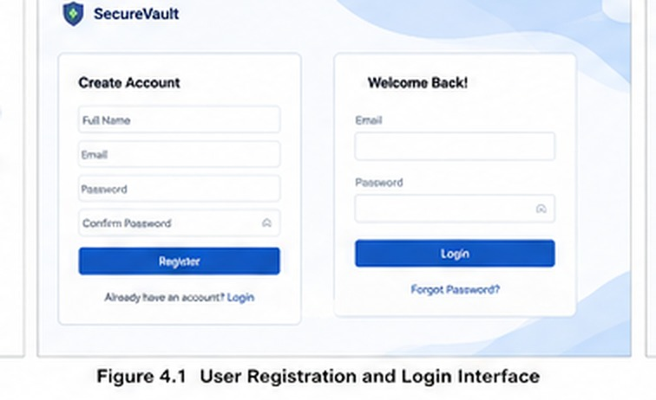

4.2.2 Secure File Upload
Authenticated users can select files from their local filesystem for upload via the web interface. The application processes the incoming data stream through the secure ingestion pipeline, validating file integrity and preparing the payload for immediate cryptographic transformation prior to persistent storage.

Figure 4.2: Secure File Upload Interface
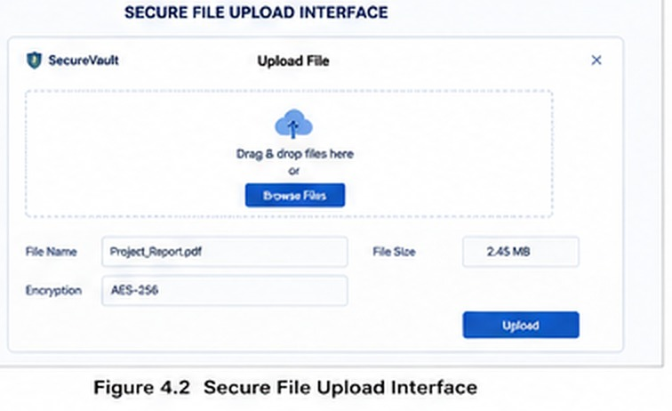

4.2.3 Encryption and Secure Storage
Upon receiving a file payload, the encryption engine executes automated cryptographic transformation, converting the plaintext data into ciphertext. The resulting encrypted file is written to the persistent storage layer, while metadata—including File ID, owner identification, timestamp, file size, and encryption status—is indexed in the database.

Figure 4.3: Encrypted File Storage and Encryption Status
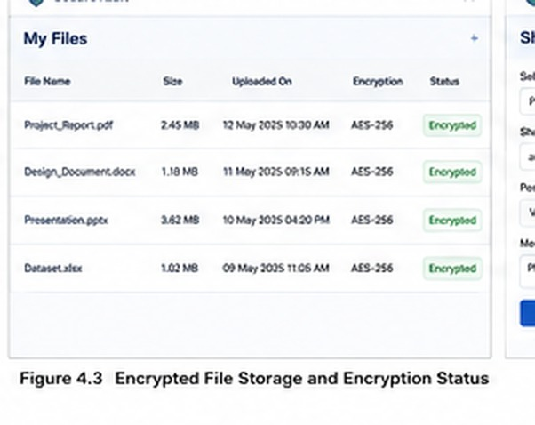

4.2.4 Secure File Sharing
The file sharing interface empowers document owners to grant access permissions to specific registered users. The owner identifies the recipient user and assigns access privileges, prompting the system to record the authorization mapping within the access control database.

Figure 4.4: Secure File Sharing Interface

4.2.5 Access Permission Management
When a user attempts to view or download a shared document, the access control engine intercepts the request. The system verifies the user's active identity against the stored permission matrix. If the user is authorized, the encrypted payload is decrypted and streamed to the client; otherwise, access is denied.
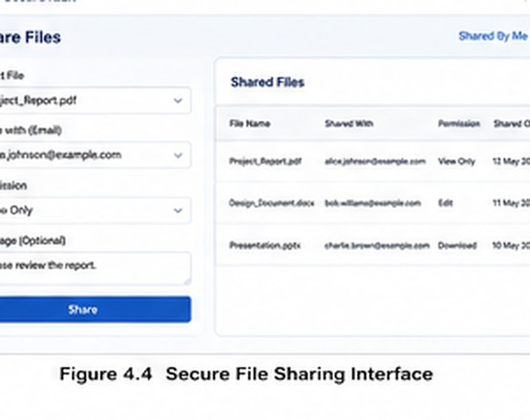

Figure 4.5: Access Permission Management Interface

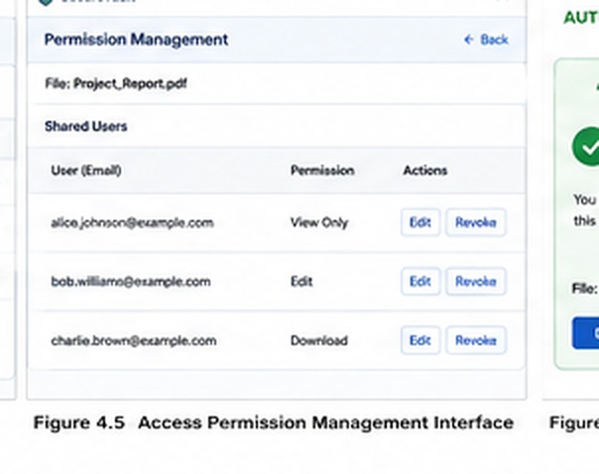

4.3 Test Plan & Verification
To verify the operational correctness and security posture of SecureVault, a rigorous test plan was formulated across all core functional areas, as shown in Table 4.2.

Table 4.2: Test Plan and Verification
Requirement | Test Method | Acceptance Criterion
Registration | Submit valid new account registration details | Account record is successfully provisioned in the database.
Login | Submit registered user credentials | User identity is verified and an authenticated session is created.
File Upload | Upload a document via the authenticated dashboard | Payload is received and processed by the ingestion pipeline.
Encryption | Inspect stored file state and database metadata | File payload is stored as ciphertext with encryption status confirmed.
File Sharing | Allocate file access rights to a designated user | Sharing relationship and permissions are recorded in the database.
Access Control | Attempt file retrieval as an authorized recipient | Permissions are validated and the decrypted file is delivered.
Unauthorized Access | Attempt file retrieval without granted permissions | Access request is intercepted and denied with an unauthorized error.

Table 4.3: Functional Test Results
Test Case | Required Value | Achieved Value | Status
User Registration | Successful | Successful | Pass
User Login | Authenticated | Authenticated | Pass
File Upload | Successful | Successful | Pass
File Encryption | Enabled | Enabled | Pass
Secure Storage | Encrypted | Encrypted | Pass
File Sharing | Authorized | Authorized | Pass
Permission Validation | Required | Implemented | Pass
Unauthorized Access Blocking | Required | Blocked | Pass

4.4 Results
Functional testing and system evaluation confirmed that the SecureVault application successfully achieves all planned operational capabilities.
Key verified outcomes include:
- Deterministic user account creation and cryptographic credential verification.
- Reliable document upload handling across verified user sessions.
- Automated encryption of uploaded payloads, ensuring zero plaintext at rest.
- Custodian-directed file sharing workflows restricted to designated recipient accounts.
- Enforcement of real-time permission checks prior to any data extraction.
- Immediate rejection and logging of unpermitted or unauthenticated access attempts.

Figure 4.6: Authorized and Unauthorized Access Results
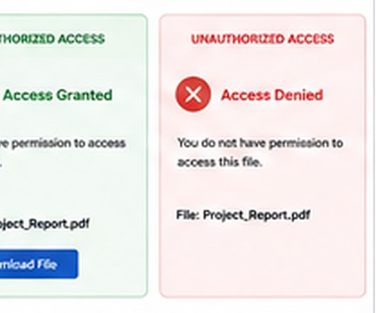

Figure 4.7: Testing and Performance Results
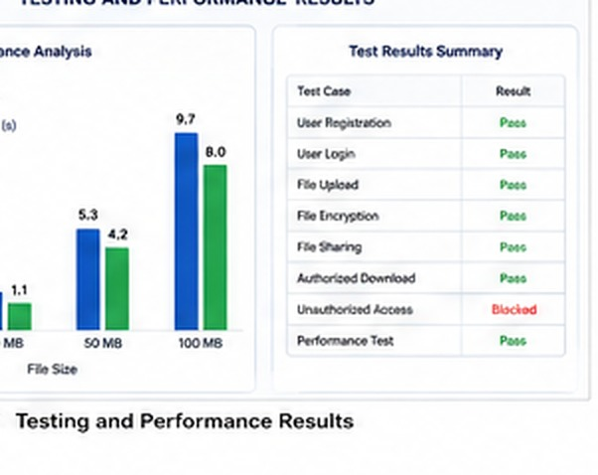

4.5 Data Analysis & Engineering Judgment

Empirical test results indicate that SecureVault successfully fulfills its design objectives by combining robust cryptographic protection with granular, owner-directed access controls. The systematic encryption of payloads prior to storage ensures that document confidentiality is preserved even in the event of persistent storage-tier compromise.
From an engineering perspective, the primary trade-off involves balancing cryptographic and authorization processing overhead against data confidentiality. Performing file encryption, asymmetric key encapsulation, and database-level permission evaluations introduces additional execution cycles; however, this computational cost is fully justified by the critical security gains achieved in preventing unauthorized data exposure and eliminating insecure public-link sharing vulnerabilities.

4.6 Comparison with Existing Solutions & Achievement of Objectives

Table 4.4: Comparison with Existing Solutions and Objective Achievement
A comprehensive review of the project objectives against testing evidence demonstrates that all planned goals were successfully attained.
Objective | Evidence | Achievement
Secure Authentication | Validated through account provisioning and login test suites | Fully Achieved
Secure File Upload | Confirmed via client ingestion and backend handler execution tests | Fully Achieved
File Encryption | Verified by inspecting ciphertext output and encryption status metadata | Fully Achieved
Secure Storage | Validated through persistent storage inspection of encrypted payloads | Fully Achieved
File Sharing | Confirmed via recipient mapping and permission allocation workflows | Fully Achieved
Access Control | Verified through pre-download authorization check test cases | Fully Achieved
Unauthorized Access Prevention | Validated through deterministic blocking of unauthorized download attempts | Fully Achieved

4.7 Strengths & Limitations

Strengths
- Comprehensive Multi-Layered Security: Unifies identity authentication, payload-level encryption, and dynamic access control into a single architecture.
- Zero Plaintext at Rest: Guarantees that uploaded document payloads are transformed into ciphertext before physical persistence.
- Custodian-Governed Sharing: Eliminates the security vulnerabilities of open sharing URLs by requiring explicit recipient-level permission grants.
- Deterministic Access Enforcement: Implements strict validation checks that verify permissions before permitting document decryption and download.
- Modular Subsystem Structure: Decouples authentication and file management (Module 1) from sharing and access control (Module 2) for enhanced maintainability.
- Practical Web Deployment: Delivers advanced cryptographic data protection through an intuitive, accessible full-stack web interface.

Limitations
- Cryptographic Processing Overhead: Large file payloads require additional processing time during encryption and decryption cycles.
- Server Configuration Dependencies: Overall platform security remains dependent on properly hardened server environments and transport layer configurations.
- Basic Revocation Management: Current permission revocation operates on static database updates and could be enhanced with automated expiration lifecycles.
- Scalability Testing Scope: Performance validation was executed within prototype development parameters; extensive high-concurrency stress testing is recommended.
- Formal Security Auditing: Production deployment across enterprise environments will require comprehensive third-party vulnerability and penetration testing.

4.8 Project Planning, Roles & Budget

Project Milestones
Phase | Activity
Phase 1 | Problem identification and requirement analysis
Phase 2 | Literature review
Phase 3 | System design
Phase 4 | Module 1 development
Phase 5 | Module 2 development
Phase 6 | Integration
Phase 7 | Testing
Phase 8 | Documentation and final review

Table 4.5: Project Roles and Contributions
Student | Assigned Responsibility | Actual Contribution
Student 1 | Authentication and secure file management | 50%
Student 2 | Secure sharing and access control | 50%

Table 4.6: Estimated Project Budget
Item | Estimated Cost | Actual Cost
Software Tools | ₹0 | ₹0
Development Environment | ₹0 | ₹0
Internet and Testing | ₹500 | ₹500
Documentation | ₹300 | ₹300
Hosting / Deployment | ₹500 | ₹500
Total | ₹1,300 | ₹1,300

CHAPTER 5

CONCLUSION, FUTURE WORK AND REFLECTION

5.1 Conclusion
The SecureVault — Encrypted File Storage & Sharing Web Application was engineered to address critical cybersecurity vulnerabilities associated with storing and disseminating confidential electronic records within web-based environments. By coupling identity verification, payload-level data transformation, public-key key encapsulation, and policy-driven access governance, the platform establishes an integrated and resilient defense-in-depth architecture.
The project demonstrates that robust data confidentiality is achievable when automated at-rest encryption is paired with deterministic authorization barriers. The software implementation successfully bifurcates operational responsibilities across two modular subsystems: Module 1 manages user authentication, secure file ingestion, cryptographic processing, and encrypted metadata persistence; Module 2 oversees owner-directed file distribution, recipient permission assignment, real-time privilege validation, and protected file retrieval.
Comprehensive functional verification and testing confirmed the operational success of all core system capabilities, including account provisioning, authenticated session management, secure document upload, persistent ciphertext storage, explicit recipient sharing, authorized decryption pipelines, and the systematic rejection of unauthorized access attempts. Ultimately, SecureVault provides a practical, robust, and extensible software engineering model for integrating applied cryptography and granular access control into contemporary web application ecosystems.

5.2 Future Work
To further expand the operational capabilities, scalability, and security posture of the SecureVault platform, future engineering iterations will focus on the following enhancements:
- Multi-Factor Authentication: Implementing secondary verification channels (e.g., time-based one-time passwords or hardware security keys) to strengthen identity assurance during session establishment.
- Advanced Role-Based Access Control: Incorporating hierarchical role-based and attribute-based access control (RBAC/ABAC) models to support complex organizational permission structures.
- Temporary File-Sharing Permissions: Enabling time-limited access grants that automatically expire after a predefined duration.
- Automatic Access Revocation: Developing event-driven revocation routines that systematically terminate viewing and download privileges upon policy triggers or administrative actions.
- Cloud Storage Integration: Extending the storage subsystem to interface seamlessly with enterprise cloud object storage providers while maintaining client-side and application-layer encryption guarantees.
- File Integrity Verification Using Digital Signatures: Integrating asymmetric digital signatures and cryptographic hashing algorithms to verify file provenance and detect unauthorized payload tampering.
- Secure Audit Logs: Constructing an immutable, tamper-resistant operational logging engine to track authentication events, permission modifications, and file access histories for regulatory compliance.
- Searchable Encryption: Implementing secure cryptographic search indexes to enable keyword-based file discovery over encrypted metadata without revealing underlying plaintext content.
- Mobile Application Support: Developing native and cross-platform mobile client applications to ensure secure document management across mobile devices.
- Post-Quantum Cryptographic Algorithms: Upgrading the cryptographic foundation with post-quantum, lattice-based public-key algorithms to provide long-term resilience against emerging quantum decryption threats.

Item | Estimated Cost | Actual Cost
Software Tools | ₹0 | ₹0
Development Environment | ₹0 | ₹0
Internet and Testing | ₹500 | ₹500
Documentation | ₹300 | ₹300
Hosting / Deployment | ₹500 | ₹500
Total | ₹1,300 | ₹1,300

CHAPTER 5

CONCLUSION, FUTURE WORK AND REFLECTION

5.1 Conclusion

SecureVault — Encrypted File Storage & Sharing Web App was developed to address the security challenges associated with storing and sharing confidential digital files. The project integrates user authentication, secure file management, encryption, secure key protection, and permission-based access control into a single web-based system.

The project successfully demonstrates that file confidentiality can be improved by encrypting files and restricting access through authorization mechanisms. Module 1 provides secure user authentication and encrypted file management, while Module 2 provides controlled file sharing and access permissions.

The testing process confirms that the major functional requirements of the system are achieved, including user registration, login, secure file upload, encrypted storage, file sharing, authorized access, and unauthorized access prevention.

Overall, SecureVault demonstrates a practical approach to integrating cryptography and access control into a web application for secure file management.

5.2 Future Work

The system can be enhanced in the future by implementing:

Multi-factor authentication.

Advanced role-based access control.

Temporary file-sharing permissions.

Automatic access revocation.

Cloud storage integration.

File integrity verification using digital signatures.

Secure audit logs.

Searchable encryption.

Mobile application support.

Post-quantum cryptographic algorithms.

5.3 Professional Learning & Individual Reflection

New Knowledge Acquired

Fundamentals of cryptography.

RSA and ECC concepts.

Secure key management.

Web application security.

Authentication mechanisms.

Access-control implementation.

Secure file-sharing principles.

Software testing and documentation.

Engineering & Professional Skills Developed

System design.

Secure software development.

Problem-solving.

Testing and debugging.

Team collaboration.

Technical documentation.

Project management.

INDIVIDUAL REFLECTION — STUDENT 1

During the development of SecureVault, I was mainly responsible for the User Authentication and Secure File Management module. The most challenging part was understanding how authentication and encryption could be integrated into a web application without making the system difficult to use. I contributed to the design of the user authentication workflow, secure file upload process, and encrypted file management functionality. Through this project, I gained practical knowledge of web security, cryptographic protection, and secure software development. If the project is repeated, I would improve the authentication mechanism by adding multi-factor authentication and stronger monitoring features.

INDIVIDUAL REFLECTION — STUDENT 2

I was mainly responsible for the Encrypted File Sharing and Access Control module of SecureVault. The major challenge was designing a system that allows authorized users to access shared files while preventing unauthorized users from obtaining confidential information. I contributed to the design of permission-based sharing and access verification mechanisms. This project helped me understand the importance of authorization, access-control policies, and secure file-sharing workflows. If the project is further developed, I would implement temporary permissions, automatic access revocation, and detailed security audit logs.

REFERENCES [1] National Institute of Standards and Technology (NIST), “Advanced Encryption Standard (AES),” Federal Information Processing Standards Publication (FIPS PUB) 197, Nov. 2001, updated May 2023, doi: 10.6028/NIST.FIPS.197-upd1.
[2] E. Barker, “Recommendation for Key Management: Part 1 – General,” NIST Special Publication 800-57 Part 1, Revision 5, National Institute of Standards and Technology, Gaithersburg, MD, USA, May 2020, doi: 10.6028/NIST.SP.800-57pt1r5.
[3] P. A. Grassi, M. E. Garcia, and J. L. Fenton, “Digital Identity Guidelines: Authentication and Lifecycle Management,” NIST Special Publication 800-63B, National Institute of Standards and Technology, Gaithersburg, MD, USA, Jun. 2017, updated Mar. 2020, doi: 10.6028/NIST.SP.800-63b.
[4] E. Rescorla, “The Transport Layer Security (TLS) Protocol Version 1.3,” RFC 8446, Internet Engineering Task Force (IETF), Aug. 2018, doi: 10.17487/RFC8446.
[5] K. Moriarty, B. Kaliski, J. Jonsson, and A. Rusch, “PKCS #1: RSA Cryptography Specifications Version 2.2,” RFC 8017, Internet Engineering Task Force (IETF), Nov. 2016, doi: 10.17487/RFC8017.
[6] D. Hankerson, A. J. Menezes, and S. Vanstone, Guide to Elliptic Curve Cryptography. New York, NY, USA: Springer-Verlag, 2004, doi: 10.1007/b97644.
[7] M. Dworkin, “Recommendation for Block Cipher Modes of Operation: Galois/Counter Mode (GCM) and GMAC,” NIST Special Publication 800-38D, National Institute of Standards and Technology, Gaithersburg, MD, USA, Nov. 2007, doi: 10.6028/NIST.SP.800-38D.
[8] R. S. Sandhu, E. J. Coyne, H. L. Feinstein, and C. E. Youman, “Role-based access control models,” IEEE Computer, vol. 29, no. 2, pp. 38–47, Feb. 1996, doi: 10.1109/2.485845.
[9] Open Web Application Security Project (OWASP), “OWASP Top 10: 2021 - The Ten Most Critical Web Application Security Risks,” OWASP Foundation, Dec. 2021. [Online]. Available: https://owasp.org/Top10/
[10] Open Web Application Security Project (OWASP), “Cryptographic Storage Cheat Sheet,” OWASP Cheat Sheet Series, OWASP Foundation, 2023. [Online]. Available: https://cheatsheetseries.owasp.org/cheatsheets/Cryptographic_Storage_Cheat_Sheet.html
[11] W. Stallings, Cryptography and Network Security: Principles and Practice, 8th ed. Hoboken, NJ, USA: Pearson, 2020.
[12] M. Bellare and P. Rogaway, “Authenticated Encryption: Relations among Notions and Analysis of the Generic Composition Paradigm,” in Advances in Cryptology — ASIACRYPT 2000, T. Okamoto, Ed. Berlin, Heidelberg: Springer, 2000, pp. 531–545, doi: 10.1007/3-540-44448-3_41.

APPENDICES

APPENDIX A

CRYPTOGRAPHIC PRINCIPLES AND TECHNICAL CALCULATIONS

A.1 Cryptographic Mathematical Formulations
SecureVault utilizes a defense-in-depth hybrid cryptographic model to protect document confidentiality during persistent storage and controlled multi-user sharing. Bulk document payloads are transformed using symmetric block ciphers due to their high computational throughput on arbitrary file sizes, whereas asymmetric public-key cryptography (RSA / ECC) is employed for cryptographic key encapsulation and secure distribution.

Payload Encryption Transformation
The symmetric encryption operation converts an unencrypted plaintext file into an unintelligible ciphertext block sequence:
$$\mathcal{C} = \mathcal{E}_{\mathcal{K}}(\mathcal{P})$$
Where:
- $$\mathcal{P}$$ represents the original plaintext file byte stream.
- $$\mathcal{K}$$ represents the symmetric data encryption key (DEK) generated for the file.
- $$\mathcal{E}$$ represents the authenticated symmetric encryption algorithm (e.g., AES in CBC or GCM mode).
- $$\mathcal{C}$$ represents the resulting encrypted ciphertext payload written to persistent storage.

Authorized Decryption Retrieval
During an authorized file retrieval workflow, the authenticated recipient applies the inverse cryptographic operation:
$$\mathcal{P} = \mathcal{D}_{\mathcal{K}}(\mathcal{C})$$
Where:
- $$\mathcal{D}$$ represents the symmetric decryption function corresponding to $$\mathcal{E}$$.
- $$\mathcal{C}$$ represents the stored ciphertext payload retrieved from the storage subsystem.
- $$\mathcal{K}$$ represents the validated decryption key recovered through authorized asymmetric key decapsulation.
- $$\mathcal{P}$$ represents the recovered plaintext document delivered to the verified client.
This mathematical separation guarantees that even in the event of persistent storage-tier compromise or unauthorized file-system inspection, data payloads cannot be reconstructed without possessing the valid cryptographic key $$\mathcal{K}$$.

A.2 Asymmetric Key Generation Formulation
Public-key cryptography provides the mathematical basis for secure key exchange and access privilege governance in SecureVault. In an RSA-based key encapsulation implementation, key pairs are derived from large prime numbers through modular arithmetic.

Step 1: Prime Number Selection
Two distinct, cryptographically strong prime numbers $$p$$ and $$q$$ are chosen at random:
$$p, \; q \in \mathbb{P}, \quad p \neq q$$

Step 2: Modulus Computation
The composite public modulus $$n$$ is calculated:
$$n = p \times q$$
The bit length of $$n$$ defines the key length of the cryptosystem.

Step 3: Euler's Totient Function Computation
The totient function $$\phi(n)$$, representing the count of integers coprime to $$n$$, is derived:
$$\phi(n) = (p - 1)(q - 1)$$

Step 4: Public Exponent Selection
An integer public exponent $$e$$ is chosen such that it is coprime to $$\phi(n)$$:
$$1 < e < \phi(n), \quad \gcd(e, \, \phi(n)) = 1$$
Common cryptographic selections for $$e$$ include the Fermat prime $$F_4 = 65537$$ ($$2^{16} + 1$$).

Step 5: Private Exponent Derivation
The private exponent $$d$$ is computed as the modular multiplicative inverse of $$e$$ modulo $$\phi(n)$$:
$$d \times e \equiv 1 \pmod{\phi(n)}$$

Key Pair Representation
- Public Key ($$\mathcal{K}_{\text{pub}}$$): $$(e, \, n)$$ — used by file custodians to encrypt the symmetric key $$\mathcal{K}$$ for designated recipients.
- Private Key ($$\mathcal{K}_{\text{priv}}$$): $$(d, \, n)$$ — securely retained by the recipient to decrypt $$\mathcal{K}$$ during authorized retrieval.

A.3 Elliptic Curve Cryptography Key Strength Comparison
Elliptic Curve Cryptography (ECC) relies on the algebraic structure of elliptic curves over finite fields, offering equivalent cryptographic security to traditional factoring-based schemes (such as RSA) with significantly smaller key dimensions.

Table A.1: Cryptographic Key-Length Comparison across Equivalent Security Levels
Target Security Level (Symmetric Equivalence) | Conventional RSA Key Length | Elliptic Curve (ECC) Key Length | Storage / Bandwidth Efficiency Gain
80-bit Security | 1024 bits | 160 bits | ~84.4% reduction
112-bit Security | 2048 bits | 224 bits | ~89.1% reduction
128-bit Security (Standard) | 3072 bits | 256 bits | ~91.7% reduction
192-bit Security | 7680 bits | 384 bits | ~95.0% reduction
256-bit Security (High) | 15360 bits | 521 bits | ~96.6% reduction
By adopting ECC primitives (e.g., 256-bit curves providing 128-bit security equivalence), the SecureVault platform substantially minimizes metadata storage footprints, reduces network transmission overhead during key exchange, and optimizes cryptographic execution performance.

A.4 Storage Overhead Estimation
The transformation of raw file streams into cryptographically protected records introduces a minor storage expansion due to initialization vectors (IVs), block-cipher padding schemas (e.g., PKCS#7), message authentication codes (MACs / GCM tags), and record header encapsulation.

Mathematical Formulation
$$\text{Overhead}_{\text{storage}} \, (\%) = \left( \frac{\mathcal{S}_{\text{encrypted}} - \mathcal{S}_{\text{plaintext}}}{\mathcal{S}_{\text{plaintext}}} \right) \times 100$$
Where:
- $$\mathcal{S}_{\text{plaintext}}$$ represents the size of the unencrypted file (in bytes).
- $$\mathcal{S}_{\text{encrypted}}$$ represents the total size of the persisted ciphertext record including cryptographic metadata (in bytes).

Illustrative Example Calculation
Assuming an illustrative document scenario:
- $$\mathcal{S}_{\text{plaintext}} = 10.00 \text{ MB} = 10{,}485{,}760 \text{ bytes}$$
- $$\mathcal{S}_{\text{encrypted}} = 10.20 \text{ MB} = 10{,}695{,}475 \text{ bytes}$$
$$\text{Overhead}_{\text{storage}} = \left( \frac{10.20 - 10.00}{10.00} \right) \times 100 = 2.00\%$$
Note: The actual overhead percentage in a deployment environment is a function of cipher block size, selected mode of operation (e.g., GCM tag length), initialization vector size, and underlying storage chunk framing.

A.5 Cryptographic Processing Latency and Throughput Modeling
System throughput during file upload and download depends directly on cryptographic transformation processing times.

Latency Formulation
$$\Delta \mathcal{T}_{\text{crypt}} = \mathcal{T}_{\text{completion}} - \mathcal{T}_{\text{initiation}}$$
Where $$\mathcal{T}_{\text{initiation}}$$ and $$\mathcal{T}_{\text{completion}}$$ represent system timestamps recorded at the start and conclusion of the cryptographic pipeline.

Cryptographic Processing Throughput
$$\Phi_{\text{crypt}} = \frac{\mathcal{S}_{\text{file}}}{\Delta \mathcal{T}_{\text{crypt}}}$$
Where:
- $$\Phi_{\text{crypt}}$$ represents the effective transformation throughput (MB/s).
- $$\mathcal{S}_{\text{file}}$$ represents the processed file payload size (MB).
- $$\Delta \mathcal{T}_{\text{crypt}}$$ represents total transformation duration (seconds).

Illustrative Example Calculation
For an illustrative payload of $$10 \text{ MB}$$ transformed in $$2.0 \text{ seconds}$$:
$$\Phi_{\text{crypt}} = \frac{10 \text{ MB}}{2.0 \text{ s}} = 5.00 \text{ MB/s}$$

A.6 Authorization Evaluation Latency Formulation
Access verification latency measures the runtime duration consumed by the access-control policy engine to validate identity tokens, session integrity, ownership mappings, and access control list (ACL) records prior to issuing decryption authorization.
$$\Delta \mathcal{T}_{\text{auth}} = \mathcal{T}_{\text{decision}} - \mathcal{T}_{\text{request}}$$
Where:
- $$\mathcal{T}_{\text{request}}$$ is the timestamp when an authorized retrieval request is received.
- $$\mathcal{T}_{\text{decision}}$$ is the timestamp when the policy engine completes ACL lookup and returns the authorization grant or rejection signal.
Optimizing database indexing on User_ID, File_ID, and Permission_Status maintains $$\Delta \mathcal{T}_{\text{auth}}$$ within low millisecond thresholds, preventing authorization bottlenecks during multi-user collaboration.

A.7 System Performance Evaluation Metrics

Table A.2: System Performance and Security Evaluation Metrics
Parameter | Operational Description | Measurement Unit
Authentication Latency | Time taken to verify identity credentials and generate session tokens | Milliseconds / Seconds
Ingestion Pipeline Time | Duration required to receive, validate, and buffer uploaded documents | Seconds
Encryption Latency | Computation time required to convert plaintext files to ciphertext | Seconds
Decryption Latency | Computation time required to recover plaintext files from ciphertext | Seconds
ACL Evaluation Time | Duration required to validate recipient permissions against the database | Milliseconds
Storage Expansion Factor | Incremental storage overhead introduced by ciphertext and metadata | Percentage (%)
End-to-End Response Time | Total elapsed time from client request submission to system response delivery | Milliseconds / Seconds

APPENDIX B

SYSTEM ARCHITECTURAL SCHEMATICS AND OPERATIONAL WORKFLOWS

B.1 High-Level End-to-End System Architecture
The SecureVault platform is architected around an integrated, multi-tier system topology that isolates presentation, application logic, cryptographic security, and persistent storage tiers.

Architectural Tier Organization:
- Presentation Tier (Web UI): Serves dynamic, responsive interfaces for user authentication, file management, sharing administration, and download monitoring.
- Application Logic Tier (Backend Controller): Orchestrates routing, incoming request validation, session verification, and operational state coordination.
- Security and Cryptographic Tier: Executes symmetric file transformation, asymmetric key encapsulation (RSA / ECC), and secure random key generation.
- Access Control Policy Subsystem: Enforces deterministic role-based and permission-based authorization checks prior to data retrieval.
- Persistence Tier (Relational DB & Encrypted File Store): Stores structured metadata and encrypted file payloads in separate repositories.

Operational Ingestion Flow:
$$\text{Client Browser} \xrightarrow{\text{TLS/HTTPS}} \text{API Gateway} \xrightarrow{\text{Auth Check}} \text{Ingestion Pipeline} \xrightarrow{\text{DEK Generation}} \text{Ciphertext Persistence} \xrightarrow{\text{Metadata Write}} \text{Database}$$

Operational Sharing Flow:
$$\text{Document Custodian} \xrightarrow{\text{Assign Recipient}} \text{ACL Registry} \xrightarrow{\text{Recipient Login}} \text{Authorization Check} \xrightarrow{\text{Key Decapsulation}} \text{Payload Decryption} \xrightarrow{\text{Secure Download}} \text{Recipient}$$

B.2 Module 1 Operational Flow: Authentication and Ingestion Pipeline
Module 1 establishes verified user identities and executes automated at-rest document encryption.
[ New / Returning User ]
│
▼
[ Submit Registration / Login Request ]
│
▼
[ Credential Validation & Hash Comparison ]
│
┌─────┴────────────────────────┐
▼ ▼
[ Valid Credentials ] [ Invalid Credentials ]
│ │
▼ ▼
[ Issue Authenticated Session ] [ Reject Access & Log Error ]
│
▼
[ Authenticated Dashboard Access ]
│
▼
[ User Selects File for Ingestion ]
│
▼
[ Ingestion Pipeline: Validation & Buffering ]
│
▼
[ Symmetric Payload Encryption (Plaintext → Ciphertext) ]
│
▼
[ Write Ciphertext Payload to Encrypted Storage ]
│
▼
[ Record Metadata (File ID, Owner ID, Encryption Status, Timestamp) in DB ]

B.3 Module 2 Operational Flow: Encrypted Sharing and Access Verification
Module 2 governs recipient permission allocation, authorization checks, and protected document retrieval.
[ Document Custodian (Owner) ]
│
▼
[ Select Shared Document & Target Recipient ID ]
│
▼
[ Assign Access Permissions in Web Interface ]
│
▼
[ Persist Permission Mapping to Database ACL ]
│
▼
[ Recipient Initiates Document Download Request ]
│
▼
[ Intercept Request & Evaluate Access Permissions ]
│
┌─────┴────────────────────────┐
▼ ▼
[ Permission Verified ] [ Unauthorized / Unlisted ]
│ │
▼ ▼
[ Retrieve Encrypted Payload ] [ Terminate Request & Return 403 Forbidden ]
│
▼
[ Execute Decryption Pipeline (Ciphertext → Plaintext) ]
│
▼
[ Stream Plaintext File to Authorized Recipient ]

APPENDIX C

SOFTWARE ARCHITECTURE AND REPOSITORY STRUCTURE

C.1 Project Directory Hierarchy
The SecureVault application codebase is structured to enforce clear separation of concerns, modular maintainability, and architectural security boundaries:
SecureVault/
│
├── frontend/
│ ├── index.html # Landing and platform overview page
│ ├── login.html # User login and credential submission interface
│ ├── register.html # Account provisioning and registration view
│ ├── dashboard.html # Authenticated user document repository
│ ├── upload.html # Secure file ingestion and upload interface
│ ├── share.html # Recipient selection and permission grant view
│ ├── css/
│ │ ├── main.css # Base layout, typography, and responsive grid rules
│ │ └── components.css # Modals, form elements, and status badge styles
│ └── js/
│ ├── auth-client.js # Client-side authentication request handlers
│ ├── file-client.js # File selection, upload progress, and download scripts
│ └── acl-client.js # Sharing interface interactions and UI state logic
│
├── backend/
│ ├── server.js # Application server initialization and middleware setup
│ ├── config/
│ │ ├── database.js # Database connection pool and configuration
│ │ └── security.js # Cryptographic parameters, salt rounds, and cipher configs
│ ├── middleware/
│ │ ├── auth-guard.js # Session verification and token validation middleware
│ │ └── acl-guard.js # Pre-download authorization and permission gatekeeper
│ ├── controllers/
│ │ ├── authController.js # Registration, login, and session lifecycle logic
│ │ ├── fileController.js # File ingestion, buffer handling, and download streams
│ │ └── shareController.js # Permission mapping, ACL indexing, and revocation logic
│ └── crypto/
│ ├── symmetric.js # Payload encryption/decryption routines (AES)
│ └── asymmetric.js # Key encapsulation, generation, and wrapping (RSA/ECC)
│
├── database/
│ ├── schema.sql # Relational database schema and constraint definitions
│ └── migrations/ # Table migration scripts and relational index scripts
│
├── storage/
│ └── encrypted_store/ # Persistent directory housing encrypted ciphertext files
│
├── tests/
│ ├── auth.test.js # Unit tests for user authentication and session management
│ ├── crypto.test.js # Unit tests for cryptographic transformation pipelines
│ └── acl.test.js # Integration tests for access control and rejection logic
│
└── package.json # Project dependencies, build scripts, and metadata

C.2 Core Functional Software Modules and Separation of Concerns
- Frontend Client Layer: Manages presentation, asynchronous AJAX/Fetch communications, client-side input validation, and user interface state transitions.
- Routing and Middleware Layer (backend/middleware): Intercepts incoming HTTP requests to verify session authenticity (auth-guard.js) and evaluate recipient download privileges (acl-guard.js) before executing business logic.
- Cryptographic Core (backend/crypto): Isolates cryptographic functions within dedicated helper modules, preventing cipher implementation details from coupling directly with application routes.
- Data Persistence Layer (database & storage): Strictly segregates database metadata records (user accounts, permission mappings) from the persistent ciphertext file repository (storage/encrypted_store/).

APPENDIX D

SOFTWARE AND TECHNOLOGY DOCUMENTATION

D.1 Cryptographic Utilities and Core Algorithms
The SecureVault platform relies on standardized cryptographic algorithm implementations provided by established, vetted software libraries rather than ad-hoc encryption logic.

Core Cryptographic Responsibilities:
- Symmetric Cipher Engine: Executes high-throughput bulk payload encryption and decryption for uploaded documents.
- Asymmetric Key Wrapping Engine: Implements public-key algorithms (RSA / ECC) to encapsulate symmetric data encryption keys for designated recipients.
- Cryptographic Hash Functions: Computes one-way salted hashes of user credentials to ensure authentication security without storing plaintext passwords.
- Cryptographically Secure Pseudo-Random Number Generator (CSPRNG): Produces unpredictable initialization vectors (IVs) and symmetric key material.

D.2 Application Server and Backend Processing Environment
The backend server acts as the centralized controller uniting user authentication, file ingestion, cryptographic invocation, database operations, and access control enforcement.

Core Server-Side Operations:
- HTTP Request Routing: Handles RESTful endpoints for user registration, authentication, file uploads, sharing assignments, and download requests.
- Authentication & Session Management: Validates incoming credentials, manages secure session tokens, and guards protected system routes.
- Data Stream Processing: Streams file uploads into temporary processing buffers, coordinates cryptographic transformations, and writes ciphertexts to disk.
- Access Control Evaluation: Queries the relational database to verify permission relationships prior to serving file requests.

D.3 Relational Database Schema and Data Dictionary
SecureVault maintains application state, metadata records, and access permissions in a structured relational database.

Table D.1: Data Dictionary — Users Table (users)
Field Name | Data Type | Constraints | Description
user_id | Integer / UUID | PRIMARY KEY, AUTO_INCREMENT | Unique identifier assigned to each registered user
username | Varchar(50) | UNIQUE, NOT NULL | Unique handle chosen by the user for identification
email | Varchar(100) | UNIQUE, NOT NULL | Verified electronic mail address of the account owner
password_hash | Varchar(255) | NOT NULL | One-way cryptographic hash of user authentication secret
public_key | Text | NULLABLE | Registered asymmetric public key (ECC / RSA) of the user
created_at | Timestamp | DEFAULT CURRENT_TIMESTAMP | Date and time when the user account was provisioned

Table D.2: Data Dictionary — Files Metadata Table (files)
Field Name | Data Type | Constraints | Description
file_id | Integer / UUID | PRIMARY KEY, AUTO_INCREMENT | Unique identifier assigned to each uploaded document
file_name | Varchar(255) | NOT NULL | Original filename submitted during the upload process
owner_id | Integer / UUID | FOREIGN KEY (users.user_id) | Identifier of the account custodian who uploaded the file
file_size | BigInt | NOT NULL | Size of the original document payload (in bytes)
storage_path | Varchar(500) | NOT NULL | Path or reference where ciphertext payload is stored
encryption_status | Varchar(20) | NOT NULL, DEFAULT 'Encrypted' | Indicator confirming payload cryptographic state
upload_timestamp | Timestamp | DEFAULT CURRENT_TIMESTAMP | System timestamp recorded when ingestion completed

Table D.3: Data Dictionary — Access Permissions Table (permissions)
Field Name | Data Type | Constraints | Description
permission_id | Integer / UUID | PRIMARY KEY, AUTO_INCREMENT | Unique identifier assigned to the permission mapping
file_id | Integer / UUID | FOREIGN KEY (files.file_id) | Reference to the protected document being shared
owner_id | Integer / UUID | FOREIGN KEY (users.user_id) | Document custodian authorizing access
recipient_id | Integer / UUID | FOREIGN KEY (users.user_id) | Authenticated recipient granted access privileges
permission_type | Varchar(30) | NOT NULL, DEFAULT 'Download' | Granular access type granted (e.g., Read, Download)
access_status | Varchar(20) | NOT NULL, DEFAULT 'Active' | Current permission lifecycle state (Active / Revoked)
granted_at | Timestamp | DEFAULT CURRENT_TIMESTAMP | Timestamp when access privileges were established

D.4 Development Tooling and Engineering Environment

Table D.4: Development and Evaluation Environment Specifications
Tool Category | Software / Technology | Engineering Purpose
Integrated Development Environment (IDE) | Visual Studio Code | Source code creation, linting, structural refactoring, and debugging
Backend Runtime Environment | Node.js / Server Framework | Asynchronous backend API hosting, route control, and stream handling
Database Server | Relational Database Engine | Structured metadata, user schema, and permission mapping storage
Cryptographic Modules | Standard Cryptography Engine | High-throughput AES transformation and asymmetric key encapsulation
Client Runtime & Debugging | Modern Web Browser | Client-side interface rendering, responsive layout testing, and DOM inspection
API Testing Utility | REST API Test Client / CLI | Endpoint verification, boundary testing, and HTTP status code validation
Version Control System | Git | Codebase version tracking, change documentation, and branch management

D.5 Multi-Tier Architectural Integration
The SecureVault platform brings together five distinct operational layers into an integrated cybersecurity solution:
- Presentation Tier: Captures user inputs, handles file ingestion selection, and renders administrative sharing controls.
- Application Logic Tier: Validates request parameters, manages session tokens, and orchestrates subsystem workflows.
- Cryptographic Security Tier: Enforces automated file payload encryption and handles public-key key encapsulation.
- Relational Database Metadata Tier: Maintains transactional integrity for account profiles, file tracking records, and access permissions.
- Encrypted Persistence Tier: Stores transformed ciphertext payloads, ensuring zero plaintext exposure at rest.
The tight coordination among these components provides an effective, secure, and user-friendly web application for sensitive document management.

STUDENT OUTCOME / ASSESSMENT EVIDENCE MAPPING MATRIX

Table D.5: Student Outcome (SO) Evidence and Report Mapping Matrix
Outcome Evidence | SO / Area | Location in This Report
Complex Engineering Problem Formulation | SO1 | Chapter 1 (1.1–1.3), Chapter 2 (2.1–2.4)
Engineering Design Under Constraints | SO2 | Chapter 3 (3.1–3.6)
Written & Technical Communication | SO3 | Entire Capstone Project Report
Ethics and Professional Responsibility | SO4 | Chapter 3 (3.7), Chapter 5 (5.3)
Teamwork and Collaborative Engineering | SO5 | Chapter 4 (4.8), Individual Reflection Statements
Experimentation, Testing & Engineering Judgment | SO6 | Chapter 4 (4.3–4.6)
Independent Acquisition of New Knowledge | SO7 | Chapter 5 (5.3)
Engineering Standards & Security Compliance | SO2 | Chapter 3 (3.2)
Sustainability & Environmental Responsibility | SO2 / SO4 | Chapter 3 (3.7)
Risk Assessment, Threat Analysis & Mitigation | SO2 / SO4 | Chapter 3 (3.7 — Table 3.8)
Multi-Layered Security Engineering | Relevant SO | Chapter 3 (3.5), Chapter 4 (4.2), Appendix A
System-Level Architecture & Integration | SO1 / SO2 | Chapter 3 (3.5), Appendix B, Appendix D
Project Planning, Task Allocation & Budgeting | SO5 | Chapter 4 (4.8)
Individual Contribution & Accountable Execution | SO1–SO7 | Contribution Statement, Chapter 4 (4.8), Individual Reflection

