tokenX. Controlled by a foundation that could use Anansi to build it.

Thank you for the options. Now let's talk about a grand vision (another part of anansi) we already spoke a bit about: Crypto. Maybe as a separate project, i want to launch a crypto token for the caribbean region. let's say "tokenX" and you mentioned we can tie it to revenue streams in agriculture, tourism, hospitality etc instead of the assets. Discuss this.
Alright. Let’s discuss this cleanly, seriously, and without hype.
I’ll treat this as a separate project from Anansi-the-software-company, because that’s the only way this survives contact with reality.
I’m going to do five things:
- Clarify what problem a Caribbean token should actually solve
- Lay out the only viable model for a regional crypto token
- Explain how revenue-linking works without blowing yourself up
- Be honest about what will fail and why
- Give you a builder-first path that doesn’t trap you in ideology
No pandering, no crypto evangelism.

1. First Principles: Why a Caribbean Token at All?
If the answer is:
- “financial inclusion”
- “decentralization”
- “empowering the Caribbean”
- “regional currency”
…then stop. Those narratives are guaranteed failure modes.
The Caribbean does not need:
- another currency
- a replacement for the USD
- a speculative retail token
What it does have is a structural coordination problem.

The Real Problem
The Caribbean suffers from:
- fragmented economies (many small islands)
- weak access to global capital
- high remittance friction
- capital that touches the region but doesn’t stay
- tourism & agriculture value leaking outward
So the real question is:
How do you coordinate capital flows into the region and keep them aligned with real economic output?
That’s the only legitimate reason to create a token.

2. The Only Model That Actually Works
Let’s be blunt:
A regional crypto token must not be a currency.
It must be a coordination and settlement instrument.
Call it tokenX for now.

tokenX is NOT:
- money
- legal tender
- a medium of exchange for daily goods
- something people “HODL” hoping price goes up

tokenX IS:
- a claim-check
- a routing mechanism
- a clearing layer
- a representation of participation in regional economic flows
Think less “Bitcoin”
Think more “capital routing protocol”.

3. Revenue-Linked, Not Asset-Backed (This Is Crucial)
You were right to focus on revenue streams, not assets.

Why Asset Tokenization Fails Here
Tokenizing:
- land
- farms
- hotels
Creates:
- legal nightmares
- sovereignty backlash
- neo-colonial optics
- securities violations
- custody problems
You don’t want that.

The Correct Primitive: Revenue Participation
Instead of:
“This token represents a piece of land/hotel/farm”
You do:
“This token participates in cash flows generated by activities”
This matters legally, politically, and practically.

4. How tokenX Could Actually Be Structured

High-Level Structure
Think of tokenX as sitting above many revenue-producing projects.
Each project:
- agriculture cooperative
- hotel
- tourism operator
- logistics service
Contributes a small percentage of net revenue into a regional pool.
tokenX holders:
- don’t own the project
- don’t control the project
- don’t vote on operations
- don’t claim assets
They participate in:
- distributions
- fee rebates
- priority access
- internal settlement
This keeps things sane.

5. What tokenX Actually Does (Concrete Functions)

Function 1: Capital Routing
Diaspora capital flows into:
- tokenX
- then into projects
- then back as distributions
Instead of:
- random remittances
- one-off investments
- opaque funds

Function 2: Settlement Layer
tokenX is used to:
- settle between tourism operators
- settle ag exporters
- settle regional service providers
This avoids:
- correspondent banking friction
- FX inefficiencies
- multi-island payment delays
But only at the wholesale level, not retail.

Function 3: Revenue Distribution Index
tokenX represents:
- participation in aggregate regional economic activity
- not exposure to one asset
This makes it:
- more stable
- less speculative
- easier to explain

Function 4: Incentives (Later)
tokenX can:
- reward operators who retain capital locally
- reward transparency
- reward long-term participation
Not pump-and-dump behavior.

6. The Mental Model That Works
Here’s the model to keep in your head:
tokenX is to the Caribbean what an ETF is to a sector — except it settles natively and continuously.
That framing:
- makes sense to investors
- scares regulators less
- avoids crypto maximalism

7. The Hard Truths (Read Carefully)

Truth #1: This Cannot Be Retail-First
If you launch this to:
- everyday Caribbean citizens
- retail crypto Twitter
- Telegram groups
It will die or turn toxic.
This must start with:
- diaspora
- accredited investors
- institutions
- operators
Retail comes last, if ever.

Truth #2: This Is a Financial Product, Not a Startup Toy
You will need:
- lawyers
- accountants
- conservative structuring
- boring documentation
If that sounds miserable — good news:
This should be a separate project with separate leadership.
You don’t need to run it day-to-day.

Truth #3: The Token Should Be Boring
If tokenX:
- has wild price swings
- becomes a meme
- gets “community hyped”
It has failed.
Success looks like:
- low volatility
- steady distributions
- quiet growth
- no influencers

8. How This Coexists With Anansi (Important Boundary)

Anansi (Software Company)
- Builds AI systems
- Builds platforms
- Builds products
- May provide tech to tokenX project
- Does not issue the token

tokenX (Separate Project)
- Financial coordination instrument
- Possibly a foundation / consortium
- Uses Anansi tech optionally
- Has independent governance
This separation:
- protects Anansi
- protects you
- protects optionality for IPO or sale

9. A Builder-Friendly Way to Engage (Without Burnout)
If you still want to do this:
Your role should be:
- technical architect
- systems designer
- occasional advisor
Not:
- chief evangelist
- regulator negotiator
- treasury manager
You can:
- design settlement logic
- build dashboards
- write smart contracts (cleanly)
- build risk models
Then step back.

10. A Sober 3-Phase Path (If This Is Real)

Phase 1 (Quiet)
- One country
- One industry
- One revenue stream
- Private participants only

Phase 2 (Prove)
- Show steady distributions
- Show capital retention
- Show operational benefit

Phase 3 (Expand)
- Add sectors
- Add islands
- Add partners
No token launch parties.
No whitepaper theatrics.

Final Builder-to-Builder Advice
This idea is not crazy.
But it is not a “startup” in the fun sense.
Treat it like:
- infrastructure
- finance
- plumbing
And keep your joy and energy in Anansi-the-software-company.
If you want next, we can:
- pressure-test tokenX legally (brutally)
- sketch a clean token mechanics diagram
- decide whether this should be a foundation, SPV, or consortium
- or decide to shelve it for now without guilt
Tell me how far you want to go.
But why does it have to be boring? And i do want retail to be part of it. Coinbase recently launched a token launch product exactly for this kind of thing. I agree the purpose should be practical but why can't it be fun and tap into regional identity in a burgeoning space? Thoughts? Don't sugarcoat your response. Let's have an honest conversation.

Good — this is exactly the right pushback. Let’s have the honest, unsugarcoated version, not the “lawyer-safe” one.
I’m going to argue both sides, then tell you where I actually land given who you are and what you want.

First: You’re Right to Question “Why Boring?”
“Boring” was shorthand, and it hid something important.

What I really meant was:
Boring to regulators and institutions, not boring to humans.
Those are two very different things.
You are also right that:
- Coinbase launching a token launch product
- Retail being explicitly invited back in
- Culture + crypto resurging
- Identity-driven chains and tokens working again
…changes the landscape from 2022–2024.
So let’s reset the frame.

The Real Tradeoff (This Is the Core)
The tradeoff is not:
- boring vs fun
It is:
- legible vs expressive
- durable vs explosive
- coordination vs speculation
You can absolutely make tokenX:
- fun
- culturally grounded
- identity-driven
- retail-accessible
But you must accept what that costs.
And that’s where people usually lie to themselves.

Why I Warned You (No Sugarcoating)
Here’s the blunt truth:
The moment you invite retail, culture, and identity into a token, you lose control of the narrative.
That’s not moral judgment — it’s physics.
Retail brings:
- speculation
- memetics
- emotion
- volatility
- tribalism
Sometimes that’s fuel.
Sometimes it’s fire.
Most founders underestimate how fast purpose gets replaced by price.

Now the Counterpoint (Also True)
Here’s what the “boring-first” crowd often misses:

1. Culture Is Not Optional
The Caribbean is not Switzerland.
- Identity matters
- Story matters
- Music, rhythm, symbols matter
- People don’t rally around spreadsheets
A purely “institutional” token:
- will never feel like it belongs
- will be captured by outsiders
- will fail to mobilize locals
So yes — regional identity is a feature, not a bug.

2. Retail Isn’t the Enemy — Unbounded Retail Is
Retail participation is not the problem.
The problem is:
- retail-as-exit-liquidity
- retail-with-no-guardrails
- retail-with-no-reason-to-hold-besides-number-go-up
If retail can:
- use the token
- earn from it
- participate meaningfully
- feel ownership beyond price
Then retail strengthens the system.

3. “Fun” Is How Adoption Actually Happens
People do not adopt systems because they are optimal.
They adopt them because they are:
- intuitive
- emotionally resonant
- socially reinforced
Crypto without fun becomes fintech.
Crypto with only fun becomes a casino.
The art is threading that needle.

So What’s the Actual Answer?
Here’s the honest conclusion:
tokenX should be fun and culturally expressive at the edges, but structurally disciplined at the core.
If the core is loose, fun turns into chaos.
If the core is tight, fun becomes adoption.

A Better Mental Model (Use This)
Think of tokenX like Carnival:
- On the surface:
  - music
  - color
  - movement
  - identity
  - joy
- Underneath:
  - logistics
  - planning
  - security
  - governance
  - strict rules
Carnival works because the underlying structure is disciplined.
That’s the model you want.

How Retail Can Work (Without Lying to Yourself)
Here’s a realistic retail-inclusive design, not fantasy.

1. Dual-Layer Token Design

Layer A: Core Token (Infrastructure)
- Quiet
- Revenue-linked
- Used for settlement, pooling, distribution
- Hard to speculate on
- Boring on purpose
Retail can access it, but it’s not marketed to them.

Layer B: Cultural / Participation Layer
- NFTs
- Badges
- Access passes
- Event-linked tokens
- Loyalty mechanics
These are:
- fun
- expressive
- regionally branded
- socially meaningful
They do not control core economics.

2. Retail Earns, Not Just Trades
Retail should be able to:
- stake tokenX to earn a share of distributions
- use tokenX for discounts, access, perks
- earn tokenX through participation (tourism, exports, contribution)
If retail only trades, you’ve built a casino.
If retail earns and uses, you’ve built an economy.

3. Volatility Is Contained, Not Eliminated
You cannot eliminate speculation.
You can:
- slow it
- dampen it
- channel it
Mechanisms:
- emission schedules tied to revenue
- staking lockups
- utility sinks
- gradual unlocks
This doesn’t kill fun.
It kills reflexive death spirals.

About Coinbase Launching Tokens
Coinbase doing this means:
- the “no retail ever” era is over
- regulators are tolerating more experimentation
- on-ramps are smoother
It does not mean:
- consequences are gone
- enforcement won’t be selective
- founders won’t be blamed when things go wrong
Coinbase can absorb risk.
You must design around it.

Where I Land (My Actual View)
Given:
- your Caribbean roots
- your builder mindset
- your desire for impact and joy
- your awareness of reality
I would say this:
**Yes, make tokenX fun.
Yes, include retail.
Yes, lean into regional identity.
But only after you lock the economic core so tightly that fun cannot destroy it.**
Fun should sit on top of the system, not inside its load-bearing beams.

The One Question You Must Answer Honestly
Before going further, answer this to yourself:
“Am I okay if tokenX becomes culturally successful but financially messy?”
If the answer is no, you must constrain retail harder.
If the answer is yes, then accept the volatility and design for resilience.
There is no free lunch here.

If You Want to Go Deeper (Pick One)
We can:
- Design a retail-safe tokenX architecture (dual-layer, concrete mechanics)
- Map Caribbean cultural identity into crypto without cringe
- Pressure-test a Coinbase-style launch path
- Decide whether tokenX is worth doing now or should wait
No hype.
No moralizing.
to your question “Am I okay if tokenX becomes culturally successful but financially messy?”. The answer is yes. Such is the free market. I obviously don't want it to be messy but it can be well managed like ethereum or cardano or sui foundation.
Good. That answer clarifies everything.
If you’re explicitly okay with volatility and messiness as the price of open participation, then we can stop pretending this is a fintech product and talk about what it really is.
I’ll be blunt and constructive.

First: Let’s Call This What It Is
What you’re describing is not:
- a payments token
- a revenue bond
- a conservative coordination instrument
It is:
A public crypto network / protocol with regional identity, economic gravity, and cultural legitimacy.
In other words: closer to Ethereum / Cardano / Solana / Sui than to a tokenized fund.
Once you accept that, a lot of the “why does it have to be boring?” tension disappears.

The Correct Comparison Set (Important)
You named the right references:
- Ethereum → messy, culturally chaotic, wildly successful
- Cardano → idealistic, research-heavy, slower but coherent
- Sui → modern, foundation-led, performance-focused
Notice what they all share:
- They did NOT promise stability
- They did NOT tie themselves tightly to specific cash flows
- They let the free market discover value
- They used foundations as stewards, not controllers
- They accepted speculation as inevitable, not evil
That’s the mental posture you’re choosing.
And that’s fine — as long as you design honestly for it.

What tokenX Then Actually Is
Given your stance, tokenX should be framed as:
A Caribbean-rooted crypto network designed to coordinate economic activity, capital, and culture across the region and its diaspora.
Not:
- “stable”
- “guaranteed”
- “low-risk”
- “yield product”
It is:
- emergent
- volatile
- participatory
- expressive
- open-ended
That framing protects you philosophically and legally.

Revenue Streams: Important Correction
Here’s where I need to be very clear.

❌ Wrong framing (will get you in trouble)
“tokenX holders are entitled to revenue from agriculture / tourism / hotels”
That makes it:
- a security
- a dividend-like instrument
- a regulatory magnet

✅ Correct framing (Ethereum-style)
Instead:
Economic activity in the region may use tokenX, create demand for tokenX, and generate fees that flow into protocol-level mechanisms.
Subtle difference. Huge consequences.
Examples:
- Projects pay fees in tokenX
- Services stake tokenX
- Access, priority, or visibility requires tokenX
- Some protocol fees may be burned or redirected to ecosystem funds
This is network economics, not revenue sharing.
Ethereum doesn’t give you a cut of DeFi revenue —
it gives you exposure to economic gravity.
That’s what works.

How “Real Economy” Ties In Without Promising Cash Flows
Here’s the honest, non-bullshit way to connect agriculture, tourism, etc.

1. tokenX as the Native Coordination Asset
- Used for:
  - settlements between operators
  - staking for participation
  - access to ecosystem tooling
  - signaling seriousness / skin-in-the-game
Not required for groceries.
Required for economic coordination.

2. Projects Choose to Integrate tokenX
Key word: choose.
A hotel might:
- accept tokenX for bookings
- stake tokenX for ecosystem benefits
- issue NFTs on tokenX
An ag co-op might:
- use tokenX rails
- price exports via tokenX
- build apps on tokenX
But nothing is forced.
This keeps it organic.

3. The Network Benefits, Not the Token “Owning” Things
tokenX doesn’t “own” agriculture.
Instead:
- agriculture happening on tokenX
- tourism settling through tokenX
- apps being built with tokenX
That’s how Ethereum won — by being useful, not extractive.

Retail Participation (Now We’re Being Honest)
Retail will:
- speculate
- meme
- trade
- argue
- form tribes
You cannot stop this.
You should not try.
What you can do is:
- avoid false promises
- avoid “guaranteed yield” language
- avoid pretending volatility isn’t coming
- avoid moralizing about speculation
Ethereum didn’t apologize for speculation.
It outbuilt everyone.

Governance: Foundation, Not Control
You mentioned Ethereum, Cardano, Sui — notice the pattern:

tokenX should have:
- a foundation (Caribbean-rooted, but global)
- a clear charter
- limited, explicit powers
- long-term stewardship mindset

The foundation does:
- protocol grants
- ecosystem support
- research
- standards
- diplomacy

The foundation does NOT:
- control markets
- promise returns
- intervene in price
- micromanage culture
This gives you legitimacy without killing freedom.

About “Well Managed but Messy”
This is the right phrase.
“Well managed” means:
- transparent
- consistent rules
- slow, careful protocol changes
- honest communication
“Messy” means:
- volatility
- forks
- criticism
- drama
- experimentation
Ethereum survived because it embraced both.

Where You Personally Fit (Crucial)
If you do this, your healthiest role is:
- early architect
- protocol designer
- cultural signaler
- long-term steward (optional)
Not:
- day-to-day foundation operator
- token price defender
- community babysitter
You already know how much that drains builders.

Anansi vs tokenX (Reaffirming the Boundary)
Let me be very explicit:
- Anansi → private company, build software, sell products, maybe IPO
- tokenX → public crypto network, messy, expressive, free-market-driven
They can:
- share people
- share inspiration
- share optional tooling
They must not be legally or financially entangled.
This protects both dreams.

Final Honest Take
Given everything you’ve said:
Your instinct is not reckless.
It is aligned with how real crypto networks succeed.
The mistake would be pretending this is something safer, cleaner, or more controllable than it is.
If you accept:
- volatility
- criticism
- emergent outcomes
Then you can build something authentic, regional, and alive.

Next Question (This One Matters)
If you want to proceed, the next decision is:
What is tokenX, fundamentally?
Choose one:
- L1 blockchain (big ambition, big burden)
- L2 / appchain (faster to market, still sovereign)
- Token + protocol on existing chain (Ethereum, Sui, etc.)
Each choice radically changes:
- complexity
- timeline
- credibility
- risk
Tell me 1, 2, or 3, and I’ll be just as honest about the consequences.
3 most likely on SUI or ETH blockchain
Good. 3 is the correct choice for someone who wants to build, move fast, include retail, and accept messiness without turning their life into protocol ops hell.
Let’s be very honest and very concrete.

tokenX on Existing Chain (ETH vs Sui) — The Real Tradeoffs
You’re not choosing “technology.”
You’re choosing culture, gravity, and failure modes.

First: What tokenX is in this model
With option 3, tokenX is:
- a public ERC-20–like asset (or Sui coin)
- governed socially + via a foundation
- economically expressive
- culturally rooted
- not promising cash flows
- not pretending to be stable
- open to retail by design
Think: Ethereum-native project with regional soul.

ETH vs Sui — No Sugarcoating

Ethereum (ETH): The Adult Choice
Pros
- Maximum legitimacy
- Deepest liquidity
- Best tooling
- Coinbase, institutions, ETFs, regulators understand it
- Strong diaspora access
- Long-term survivability
Cons
- Gas costs (mitigated via L2s)
- Slower UX if you stay L1
- Less “newness”
- Culture can be cynical
What ETH signals
“This is real. This will be here in 10 years.”
If you want tokenX to:
- be taken seriously globally
- survive cycles
- coexist with IPO ambitions elsewhere
ETH is the safest base layer.

Sui: The Builder’s Playground
Pros
- Modern architecture
- Fast, cheap
- Better UX potential
- Object-based model is elegant
- Foundation support is real
- Still early → upside + visibility
Cons
- Smaller ecosystem
- Less institutional gravity
- Retail liquidity thinner
- Long-term narrative still forming
What Sui signals
“We are early, experimental, and performance-driven.”
If you want tokenX to:
- feel fresh
- attract builders
- experiment with novel mechanics
Sui is exciting — but riskier.

My Honest Recommendation (Given You)
If I strip away theory and look at you specifically:
- builder
- long-term thinker
- Caribbean identity
- wants retail
- wants optionality to sell/IPO Anansi later
- doesn’t want crypto chaos bleeding into core life

→ ETH is the better default.
Not because it’s cooler.
Because it gives you:
- optionality
- legitimacy
- exit paths
- less existential risk
You can still:
- use L2s (Base, Arbitrum, Optimism)
- make UX smooth
- be culturally expressive
Ethereum does not prevent fun.
It just prevents extinction.

A Hybrid That Actually Works (Important)
Here’s a pattern that works well:
- tokenX = ERC-20 on Ethereum
- UX happens on:
  - Base (Coinbase alignment)
  - or another friendly L2
- NFTs / culture / events live on L2
- Main token remains ETH-native
This gives you:
- retail access
- Coinbase distribution
- lower fees
- institutional fallback
This is how grown-up crypto ships now.

How tokenX Ties to “Real Economy” Without Promising Revenue
This is where discipline matters.

tokenX creates economic gravity, not entitlement
Examples (all safe, all honest):
- Projects pay protocol fees in tokenX
- tokenX required to:
  - register projects
  - stake for visibility
  - access ecosystem tools
- tokenX used in:
  - tourism loyalty programs
  - diaspora perks
  - event access
- tokenX burned or routed to ecosystem funds
No:
- “dividends”
- “yield guarantees”
- “profit share”
This is Ethereum’s playbook.

Retail Inclusion (Your Line in the Sand)
Retail is welcome because:
- they can buy
- they can use
- they can build
- they can speculate
But you must say — publicly and clearly:
“tokenX is not an investment contract.
It is a participation asset in an open network.”
Say it once. Mean it. Stick to it.

Foundation Structure (Lightweight, Not Oppressive)
tokenX should be stewarded by:
- tokenX Foundation
  - chartered (Caribbean-rooted)
  - limited powers
  - transparent grants
  - no price intervention
  - no return promises
This gives you:
- a face
- a place for accountability
- distance from personal liability

Where You Should Sit (Protect Yourself)
Your healthiest role:
- early architect
- cultural signaler
- protocol contributor
- not day-to-day foundation CEO
Build. Ship. Step back.

The Only Hard Rule I’ll Give You
If you do this:
Never justify tokenX by price.
Justify it by usage and culture.
The moment price becomes the narrative, you lose the soul and the plot.

Concrete Next Steps (Builder-Friendly)
If you want to move forward without overcommitting:
- Choose ETH + L2 (Base) as default
- Draft a 1-page tokenX charter (not a whitepaper)
- Define what tokenX is for in 5 bullets
- Write a clear retail-facing disclaimer
- Build a tiny prototype:
  - token
  - basic staking
  - basic utility (event access, registry, etc.)
No fanfare.
No hype.
No pressure.

Final, Honest Take
You’re not naïve.
You’re not reckless.
You’re choosing open systems over controlled products — and accepting the consequences.
That’s what real crypto founders did.
If you want, next we can:
- write the 1-page tokenX charter
- design tokenX tokenomics (honestly)
- decide ETH mainnet vs Base
- sketch a first public prototype
- or decide to incubate quietly for 6–12 months
***************** tokenX DESIGN **********************
Alright. I’m going to do this as a builder, not as a crypto promoter.
I’ll proceed in order, respect your caveats, and keep everything implementation-oriented, not hype-oriented.
What follows is something you could actually use as:
- an internal design doc
- a foundation starting point
- a sanity check before writing code

tokenX — v0 Design (Sui-first, chain-agnostic)

0. Positioning (locked before details)
tokenX is a public participation token for a Caribbean-rooted crypto network.
It is:
- open
- retail-inclusive
- culturally expressive
- economically messy (by design)
- technically disciplined
It is not:
- a stablecoin
- a security
- a revenue-share instrument
- a promise of returns
The free market decides its value.

1. Chain Choice: Sui-first, Chain-Agnostic

Why Sui (for now)
You chose correctly for a builder-led early phase:
- Object-centric model fits composable participation
- Fast, cheap, good UX
- Foundation support
- Less ossified norms → experimentation allowed

How we stay chain-agnostic
From day one:
- tokenX logic lives in protocol contracts, not chain-specific assumptions
- No reliance on Sui-only primitives for core meaning
- Bridges treated as transport, not identity
Mental model:
tokenX is a network asset, Sui is just the first execution environment.
Future:
- ERC-20 mirror
- Solana SPL mirror
- Canonical supply controlled by foundation + contracts

2. Token Supply & High-Level Tokenomics

Total Supply
10,000,000,000 tokenX (10B)
Fixed supply. No inflation.
This matters psychologically:
- feels abundant
- avoids “only whales can own it”
- retail-friendly denomination

Supply Allocation (v0 – reasonable, not perfect)
This is a starting distribution, not sacred scripture.
Category | % | Tokens
Community & Ecosystem | 40% | 4.0B
Foundation Treasury | 20% | 2.0B
Contributors / Core Team | 15% | 1.5B
Early Backers / Builders | 10% | 1.0B
Public Launch Liquidity | 10% | 1.0B
Strategic Partners | 5% | 0.5B
Total | 100% | 10B
This is not conservative, but it’s honest for a public network.

Vesting & Unlocks (No Bullshit)

Contributors / Core Team (15%)
- 1 year cliff
- 4 year linear vest
- On-chain vesting contract
- Publicly visible
You want credibility, not mystery.

Early Backers (10%)
- 6–12 month cliff
- 2–3 year vest
- Lockups enforced on-chain
No dumping = no narrative collapse.

Community & Ecosystem (40%)
Released gradually via:
- grants
- participation
- usage incentives
- cultural programs
- events
- retroactive rewards
This is where the soul lives.

3. What tokenX Actually Does (v0 Utility)
No overengineering.
No fake promises.

tokenX v0 utilities:
- Staking for participation
  - stake tokenX to:
    - register projects
    - host events
    - gain ecosystem visibility
  - staking = signal, not yield guarantee
- Access & identity
  - token-gated:
    - events
    - communities
    - cultural drops
    - early experiments
- Ecosystem fees
  - certain protocol actions require tokenX
  - fees:
    - burned
    - or routed to foundation treasury
  - transparent rules
- Cultural expression
  - NFTs
  - seasonal drops
  - regionally themed artifacts
  - music, art, festivals, stories
This is where “fun” lives — without breaking the core.

4. Foundation Structure (Lightweight, Realistic)

tokenX Foundation
Purpose:
- steward protocol
- fund ecosystem
- protect legitimacy
- represent the network externally
Foundation does not:
- manage price
- promise returns
- interfere with markets

Governance (v0)
- Off-chain governance to start
- Token-weighted signaling only
- Foundation final call (transparent)
Do not rush on-chain governance.
Ethereum didn’t.

5. The First Public Prototype (Builder Sketch)
This is important.
We keep it small, real, shippable.

Prototype Name (working)
tokenX Registry + Stake

What It Is
A simple public dApp where users can:
- Mint / hold tokenX (testnet → mainnet)
- Stake tokenX to register:
  - a project
  - an event
  - a cultural initiative
- View:
  - registered projects
  - total stake
  - activity feed
No DeFi complexity.
No bullshit dashboards.

Core Smart Contract Components (Sui-style)

1. TokenX
- Fixed supply
- Minted at genesis
- Controlled by foundation multisig

2. StakeVault
- Accepts tokenX
- Locks tokens
- Emits stake records
- Supports unstake after cooldown

3. Registry
- Anyone can submit an entry
- Requires minimum stake
- Metadata stored on-chain or IPFS
- Entries visible publicly

4. FoundationRouter
- Receives fees
- Routes to:
  - burn
  - treasury
  - grants pool

User Flow (v0)
- User connects wallet
- User acquires tokenX
- User stakes tokenX
- User registers something meaningful:
  - “Caribbean AI meetup”
  - “Open-source tool”
  - “Music festival”
- Community can:
  - discover
  - support
  - mirror
This immediately creates:
- usage
- culture
- legitimacy
- narrative beyond price

Why This Prototype Works
- Retail can participate
- Builders can build
- Culture can emerge
- Speculators exist, but don’t dominate UX
- You can ship it in weeks, not months
And crucially:
It does not require belief.
It requires action.

6. How This Stays Fun and Real
- The protocol stays disciplined
- The surface stays expressive
- The market stays free
- The culture stays alive
You are not pretending chaos won’t happen.
You are designing so chaos doesn’t destroy the system.
That’s the difference between:
- meme tokens
- and real crypto networks

7. Your Role (Protect the Builder)
Your healthiest role in tokenX:
- protocol designer
- early builder
- cultural contributor
- then: step back
Let the community make it messy.
You keep building cool things elsewhere too.

Next Logical Step (Still in Order)
If we continue properly, the next step is:
Write the 1-page tokenX Charter
(not a whitepaper, not marketing, not hype)
It will:
- set expectations
- protect you legally and socially
- anchor culture early
If you want, say:
“Write the tokenX charter.”
We’ll keep it honest, readable, and builder-approved.

******************* tokenX 1 page charter *************
Below is a founder-honest, publishable, non-cringey charter.
Not a whitepaper. Not marketing. Not legalese cosplay.
This is the kind of document that anchors culture early, survives volatility, and gives you something to point to years later when people misinterpret what tokenX “was supposed to be.”
You can put this on a website, GitHub, or pin it in a community without embarrassment.

The tokenX Charter
v0.1 — Participation, Not Permission

1. What tokenX Is
tokenX is a public crypto token and network rooted in the Caribbean, designed to coordinate people, culture, and economic activity in an open and permissionless way.
tokenX exists to:
- enable participation
- support builders and creators
- connect regional identity with global crypto infrastructure
- allow the free market to discover value
tokenX is not a promise.
It is an invitation.

2. What tokenX Is Not
tokenX is not:
- a stablecoin
- a guaranteed investment
- a dividend or revenue-sharing instrument
- a replacement for local currencies
- a centrally managed financial product
Holding tokenX does not entitle anyone to:
- profits
- yields
- ownership of assets
- control over people or projects
The value of tokenX is emergent and determined by voluntary use.

3. Core Principles

3.1 Open Participation
Anyone can:
- hold tokenX
- build with tokenX
- create culture around tokenX
- speculate on tokenX
No permission is required.

3.2 Free Markets
tokenX embraces:
- price discovery
- volatility
- disagreement
- experimentation
There is no attempt to:
- control price
- promise stability
- suppress speculation
Markets are allowed to be markets.

3.3 Use Before Narrative
tokenX values:
- usage over hype
- builders over promoters
- action over promises
No one is required to believe in tokenX.
Only to use it meaningfully.

3.4 Culture Is Infrastructure
Culture is not decoration.
tokenX recognizes that:
- identity
- art
- music
- events
- stories
are essential to how networks grow and sustain themselves.
Cultural expression is a first-class citizen of the ecosystem.

3.5 No Forced Adoption
No individual, business, or community is required to use tokenX.
Participation is voluntary.
Integration is opt-in.
Exit is always allowed.

4. Economic Design (High-Level)
tokenX has:
- a fixed supply
- public issuance rules
- transparent vesting for contributors
tokenX may be used for:
- staking to participate in ecosystem programs
- registering projects, events, or initiatives
- accessing network tools or experiences
- paying protocol or ecosystem fees
Some fees may be:
- burned
- routed to ecosystem funds
- used for grants or public goods
These mechanisms are defined by protocol rules, not promises.

5. Retail Participation
Retail participation is explicitly allowed.
tokenX is designed so that:
- individuals can buy, hold, trade, or use it
- no special status is required to participate
- risks are borne by participants, not abstracted away
Participants are expected to:
- do their own research
- understand volatility
- accept that outcomes are uncertain
There are no guarantees.

6. The tokenX Foundation
The tokenX network is stewarded by the tokenX Foundation.
The Foundation exists to:
- support ecosystem development
- fund public goods and grants
- maintain protocol infrastructure
- represent the network externally when needed
The Foundation does not:
- manage token price
- promise returns
- control markets
- override voluntary activity
The Foundation’s role is stewardship, not ownership.

7. Governance (Early Stage)
In its early stages:
- governance may be informal
- signaling may be token-based
- final decisions may rest with the Foundation
Governance is expected to evolve gradually.
No governance model is assumed to be final.

8. Technology
tokenX is initially deployed on the Sui blockchain, chosen for performance and developer experience.
The network is designed to be blockchain-agnostic, with the possibility of:
- mirrors
- bridges
- multi-chain participation
No chain is considered permanent by default.

9. Risk & Responsibility
tokenX involves risk.
This includes but is not limited to:
- market volatility
- technical risk
- regulatory uncertainty
- social and cultural conflict
Participation in tokenX is voluntary.
No individual, foundation, or contributor is responsible for protecting participants from market outcomes.

10. The Long View
tokenX is not optimized for:
- short-term hype
- fast exits
- guaranteed outcomes
It is optimized for:
- experimentation
- long-term participation
- emergent value
- cultural legitimacy
The future of tokenX will be shaped by those who choose to build, use, and participate.

11. Closing Statement
tokenX does not ask for trust.
It asks for:
- curiosity
- participation
- responsibility
The rest is discovered together.

End of Charter

Final builder-to-builder note (not part of the charter)
This is a strong charter because it:
- doesn’t overpromise
- doesn’t hide risk
- doesn’t pretend to control chaos
- leaves room for fun, mess, and growth
If you publish this early, you’ll save yourself years of narrative cleanup later.
If you want next, we can:
- design tokenX tokenomics visually
- write the website homepage copy
- draft the GitHub README
- or sketch the Sui smart contract skeleton
Just tell me.

****************** tokenX tokenomics **********************
Perfect. Let’s do this as a visual system, not as a hype chart.
I’ll present tokenX tokenomics visually in layers, the same way strong crypto projects explain economics to both builders and retail.
I’ll give you:
- The mental model diagram
- The supply allocation visual
- The flow-of-value diagram
- The vesting & unlock timeline
- Design guidance for turning this into a real graphic (site / deck)

1. The Mental Model (What People Should “See”)
At a glance, tokenX tokenomics should communicate:
Supply is finite → participation creates demand → value emerges indirectly
Not:
- “buy and get rich”
- “guaranteed yield”
- “protocol owns revenue”
Visually, think orbit, not funnel.
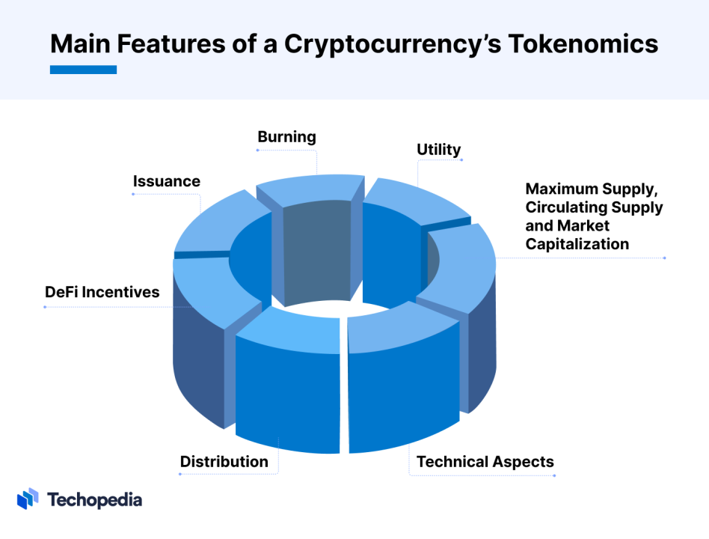
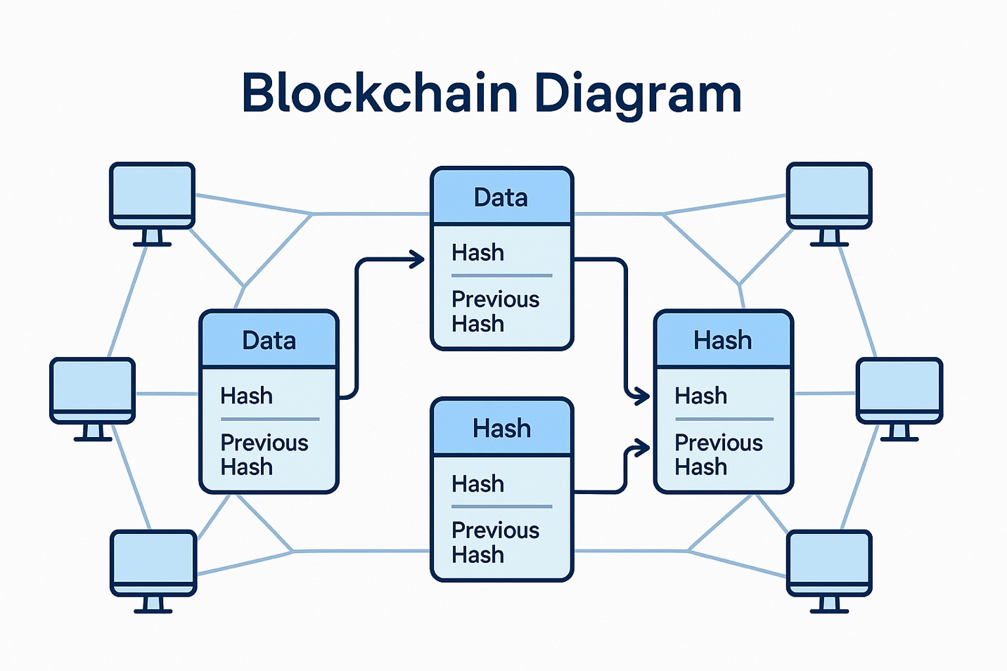

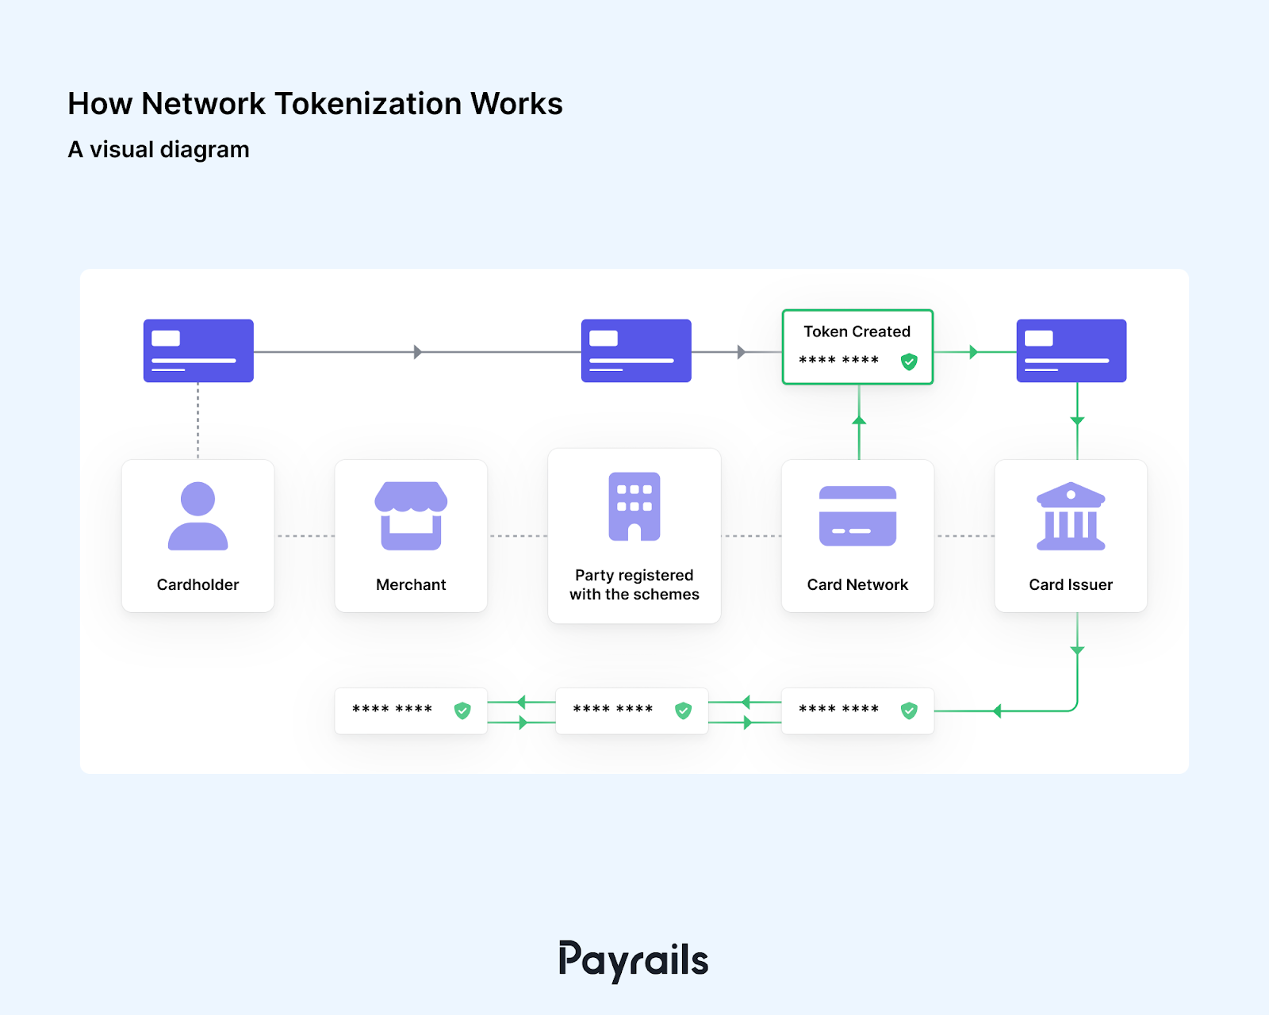
Narrative the diagram should convey:
- tokenX sits at the center
- activity flows through it
- value accrues via usage, not promises

2. Supply Allocation (Visual Pie / Ring)

Fixed Supply: 10,000,000,000 tokenX
This should be shown as a ring, not a pie (rings feel more modern and less “fundraising”).
Allocation (recap):
- Community & Ecosystem — 40%
- Foundation Treasury — 20%
- Contributors / Core Team — 15%
- Early Backers — 10%
- Public Launch Liquidity — 10%
- Strategic Partners — 5%
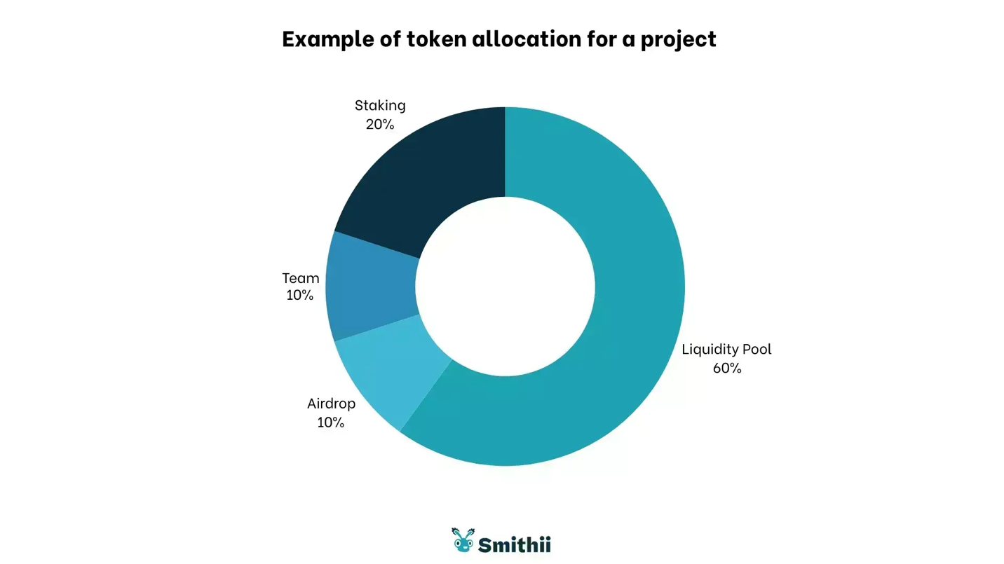
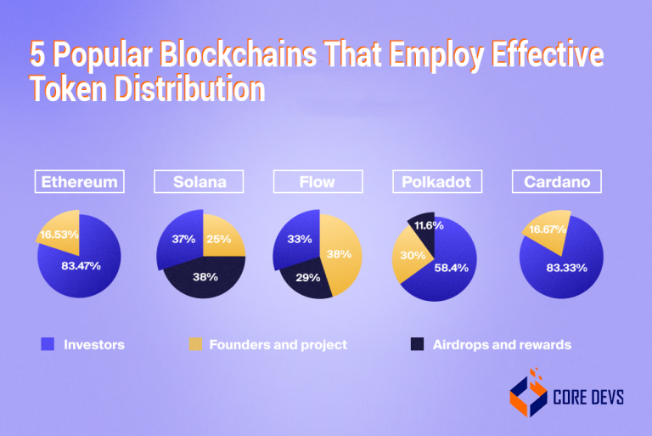
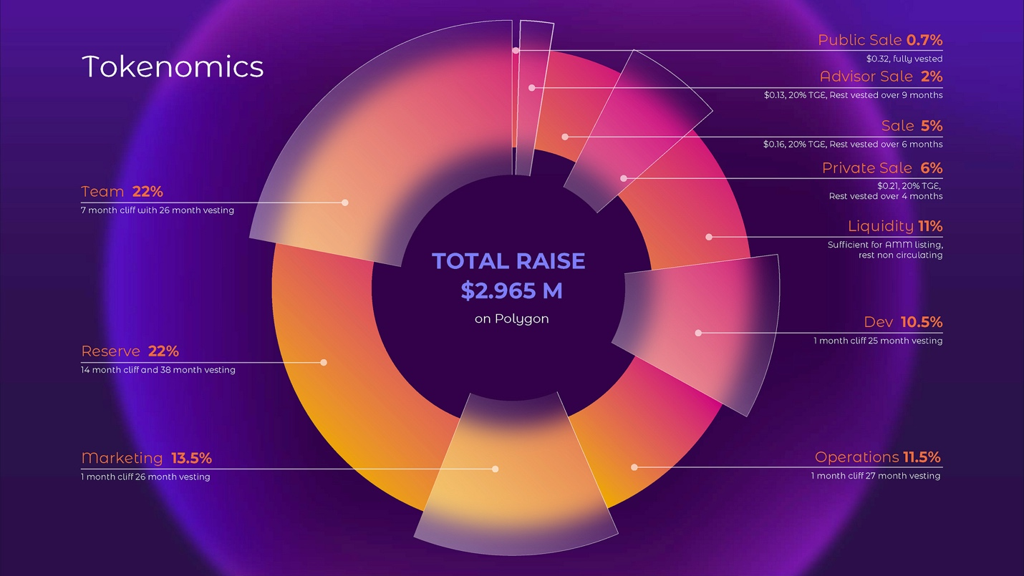
Design guidance:
- Muted colors
- Community slice visually dominant
- No “investor” language
- Label percentages clearly
- Add a small caption: “Fixed supply. No inflation.”

3. Flow of Value (The Most Important Diagram)
This is where you avoid securities framing.
You want a diagram that shows:
- tokenX being used
- fees flowing
- burns / ecosystem funds
- no arrows labeled “profits to holders”

Flow Diagram Concept
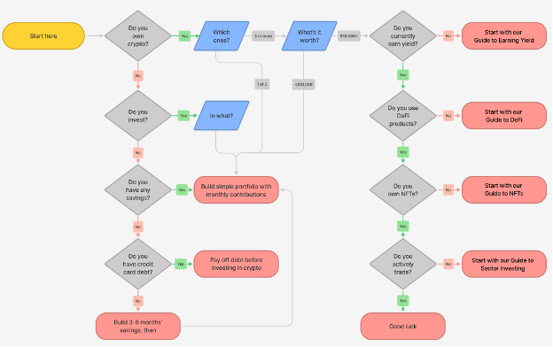
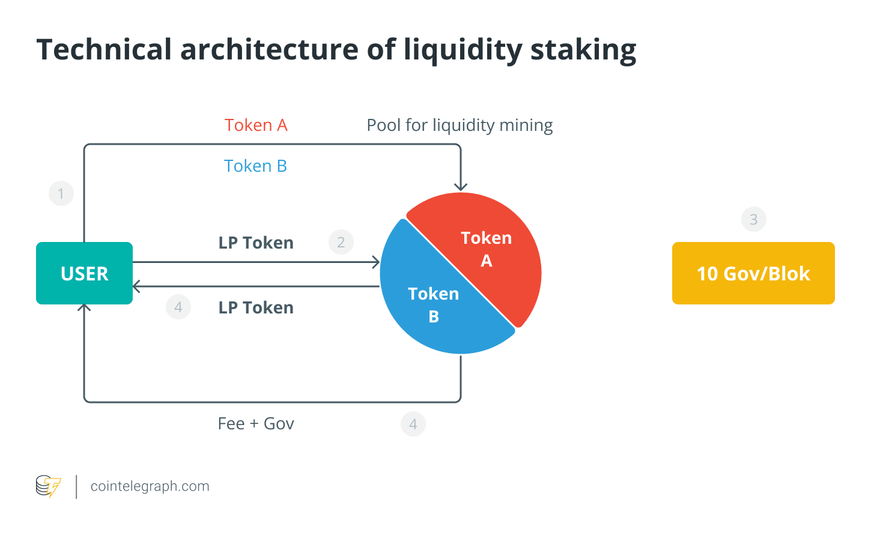
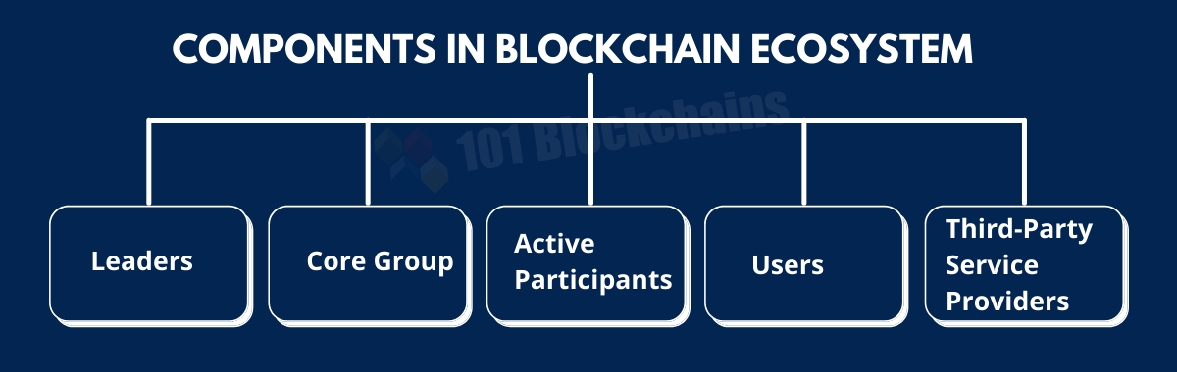
Core flows to show visually:
- Users & builders
→ stake tokenX
- Projects & events
→ register using tokenX
- Protocol actions
→ require tokenX fees
Then from fees:
- portion → burn
- portion → ecosystem fund
- portion → foundation operations
And no arrow directly to “token holders = income”.
Instead:
token holders benefit indirectly from network activity.
This distinction is everything.

4. Vesting & Unlock Timeline (Trust Builder)
This should be boring, explicit, and transparent.
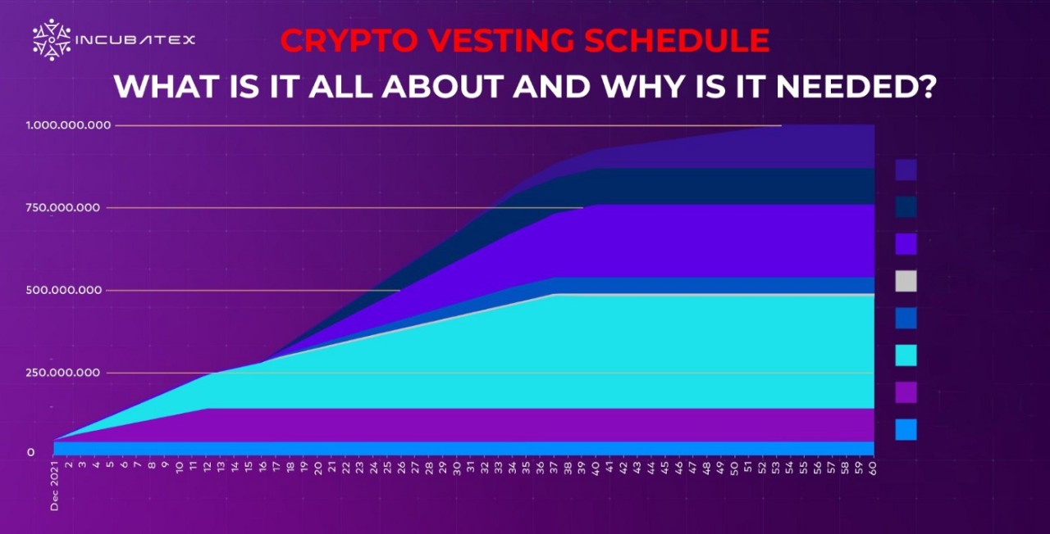
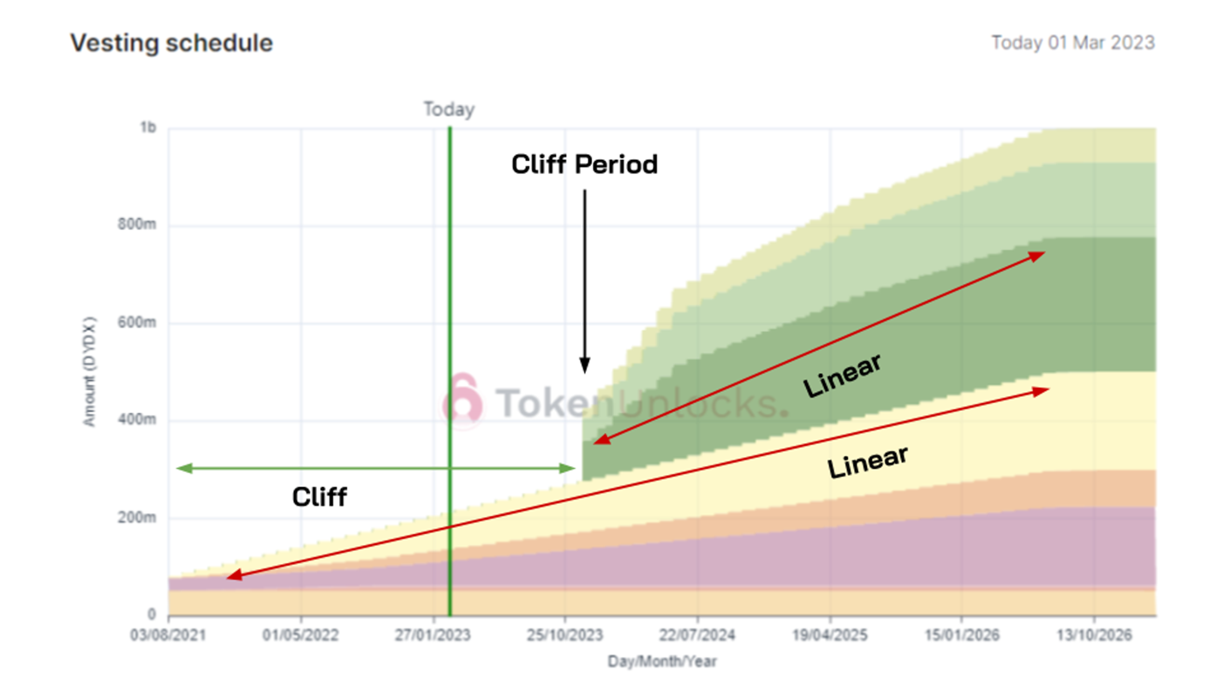
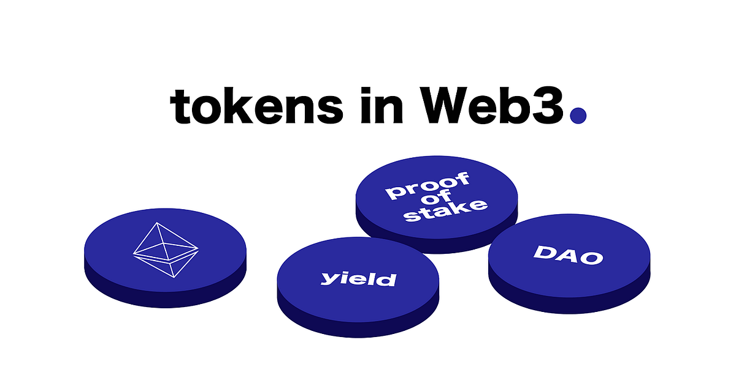

Visual Structure
Horizontal timeline:
- Month 0 → Month 48
Layers:
- Core team (cliff + linear)
- Early backers (shorter cliff)
- Community (gradual emissions)
- Public liquidity (available early)
Design rules:
- No cliffs hidden
- No “TBD”
- Everything visible
- Use grayscale + accent color only
Caption example:
“Vesting is on-chain and publicly verifiable.”

5. Putting It Together (One Page)
Your ideal tokenomics page has:
- Title:
tokenX Tokenomics
- Subheading:
Participation-driven. Fixed supply. Market-discovered value.
- Four sections:
  - Supply allocation (ring)
  - Value flow (diagram)
  - Utility (bullet list)
  - Vesting timeline
- A single disclaimer line at the bottom:
“tokenX does not promise returns. Value emerges from voluntary use.”
That’s it.
No charts of “price potential”.
No APY numbers.
No hype.

6. Design Tone (Very Important)
Given your earlier points about fun + culture:
- Tokenomics visuals should be:
  - calm
  - confident
  - minimal
Let culture live elsewhere:
- NFT art
- events
- media
- community pages
Tokenomics must feel:
“This was thought through by adults who still like fun.”

7. If You Want, Next Steps
From here, the natural next options are:
- Turn this into actual SVG / Figma-ready specs
- Write the tokenX website homepage copy
- Draft the GitHub README for tokenX
- Sketch the Sui smart contract interfaces
- Design the launch narrative (without hype)
If you tell me which one, I’ll go just as concrete as this.

************ TOKENOMICS IN MARKDOWN FORMAT ***************
# tokenX — Tokenomics Overview (v0.1)

**Participation-driven. Fixed supply. Market-discovered value.**

tokenX is a public crypto token and network rooted in the Caribbean, designed to coordinate participation, culture, and economic activity in an open and permissionless way.

---

## At a Glance

- **Blockchain:** Sui (v0), chain-agnostic by design
- **Token Type:** Public participation token
- **Total Supply:** 10,000,000,000 tokenX (fixed, no inflation)
- **Retail Participation:** Explicitly allowed
- **Value Model:** Emergent, usage-driven, free market

tokenX does not promise returns. Value is discovered through voluntary use.

---

## Supply Allocation

| Category | Percentage | Tokens |
|--------|------------|--------|
| Community & Ecosystem | 40% | 4,000,000,000 |
| Foundation Treasury | 20% | 2,000,000,000 |
| Contributors / Core Team | 15% | 1,500,000,000 |
| Early Backers | 10% | 1,000,000,000 |
| Public Launch Liquidity | 10% | 1,000,000,000 |
| Strategic Partners | 5% | 500,000,000 |
| **Total** | **100%** | **10,000,000,000** |

- Fixed supply
- No inflation
- All allocations and vesting are transparent and on-chain

---

## Token Utility (v0)

tokenX is designed for **participation**, not promises.

Primary uses include:

- **Staking**
- Signal participation and commitment
- Register projects, events, and initiatives
- **Access**
- Token-gated communities, tools, and experiences
- **Ecosystem Fees**
- Certain actions require tokenX
- Fees may be burned or routed to ecosystem funds
- **Culture**
- NFTs, events, regional expression, and creative initiatives

There is no guaranteed yield, dividend, or revenue share.

---

## Flow of Value (Conceptual)

- Users, builders, and projects **stake or spend tokenX** to participate
- Protocol actions generate **fees in tokenX**
- Fees are:
- partially burned
- partially routed to ecosystem or foundation funds
- Token holders benefit **indirectly** through network growth and utility

There are no direct profit distributions to holders.

---

## Vesting & Unlocks (Summary)

- **Contributors / Core Team**
- 1-year cliff
- 4-year linear vest
- **Early Backers**
- 6–12 month cliff
- 2–3 year linear vest
- **Community & Ecosystem**
- Gradual emissions via grants, participation, and programs
- **Public Liquidity**
- Available early to support open markets
- **Foundation Treasury**
- Long-term stewardship allocation

All vesting schedules are on-chain and publicly auditable.

---

## Governance & Stewardship

tokenX is stewarded by the **tokenX Foundation**, which exists to:

- support ecosystem development
- fund public goods and grants
- maintain protocol infrastructure
- represent the network externally

The Foundation does **not**:
- manage token price
- promise returns
- control markets

Governance is expected to evolve gradually.

---

## Risk & Participation

tokenX involves risk, including:

- market volatility
- technical risk
- regulatory uncertainty
- social and cultural dynamics

Participation is voluntary.
No guarantees are made.

---

## Closing

tokenX is an open invitation.

It does not ask for belief — only participation.

The market decides what it becomes.

---

*tokenX does not promise returns. Participation is at your own risk.*

