­Deceptive product feedback identification with ML

Abstract:

**In the evolving domain of online shopping, customer reviews are really important. They help people decide what to buy and what they think about brands. But, there are a lot of fake reviews out there that make it hard to trust the reviews. To fix this, we need to use smart methods like checking how people feel in their reviews, comparing what they say, and using a technique called Latent Semantic Analysis. These methods help us find fake reviews, like when one person writes a bunch of good or bad reviews to trick people. We also use computer programs to help us find these fake reviews faster. Sometimes, reviews have stories or don't say anything useful, which makes it even harder to tell what's real. By using these smart methods and computer programs, we want to make a system that can find fake reviews and make online shopping safer and easier for everyone.**

**Keywords:** customer reviews, e-commerce, machine learning, sentiment analysis, natural language processing.

**Introduction**:

In the precise scene of cutting-edge net-based totally enterprise, customer surveys have arisen as pressing forces to be reckoned with, the use of important manipulation over buying approaches of behaving and emblem discernments. However, the unavoidable trouble of phony surveys represents a good-sized threat to the uprightness of this priceless grievance biological system. Tending to this challenge calls for the sending of delicate philosophies, such as a feeling exam, content closeness assessment, and Inert Semantic Investigation (LSA) [1]. These high-stage techniques act as vital belongings in revealing deceptive examples, for example, surveys exuding from a similar consumer to both increase or downgrade a selected brand or those beginning from indistinguishable IP addresses. The crucial use of calculations similarly improves reputation capacities, especially in spotting flood audits in which a character immerses degrees with an unreasonable blast of either predominantly positive or poor criticism. Besides, the improvement of audits containing personal bills or absent any big substance adds one extra layer of intricacy to the vicinity interaction. By bridging the opportunities of statistics mining and using state-of-the-art calculations, we intend to foster a sturdy framework that succeeds in precisely sifting through counterfeit surveys. In doing so, we suggest bracing the dependability of online complaint components, enabling clients with the data and actuality anticipated to pursue tons of educated selections within the large web-based totally business scene.

**Literature Review:**

Evaluation of Annotated Dataset for Aspect-Based Sentiment Analysis:

[1 ]This study focuses on aspect-based sentiment analysis (ABSA) of mobile phone customer reviews. It introduces a labeled dataset for training supervised machine learning models in ABSA. Results show varying accuracies among models, with the Support Vector Machine performing best. The dataset serves as a benchmark for ABSA of mobile phone reviews.

[5 ]Exploring E-Commerce Product Experience with Fusion Sentiment Analysis:

This research develops a fusion sentiment analysis method to analyze online product experiences. Combining textual analysis and machine learning, the method accurately identifies emotional tendencies and factors influencing product experience. Results from Amazon book reviews validate its effectiveness.

[3]Machine Learning Approaches for Detecting Fake Reviews: Literature Review:

This systematic literature review examines methods for identifying fake reviews on e-commerce platforms. It highlights the importance of machine learning, sentiment analysis, and opinion mining in detection. Insights into proposed solutions and future research areas are provided to enhance detection accuracy and efficiency.

[6]Reviewing Sentiment Analysis Techniques in E-Commerce Platforms:

This review paper analyses current sentiment analysis techniques in e-commerce. It identifies machine learning and deep learning as prominent approaches, focusing on platforms like Amazon and Twitter. The review suggests future research directions including aspect-based analysis and fine-grained sentiment analysis.

[2]Multi-Dimensional Analysis in Opinion Mining:

This review explores Opinion Mining, focusing on user-generated textual content. It covers various tasks, including dataset analysis, algorithms, and real-world applications. Emphasis is placed on theoretical and practical implications, providing insights into emotion detection and natural language processing. The review offers a comprehensive understanding of Opinion Mining's significance and available tools.

**Related Work:**

In the world of analyzing customer feelings for online shopping, we use a bunch of different technologies to understand what people are saying. With more and more folks using smartphones and the internet, they're not just shoppers anymore; they're also sharing their thoughts online. This means there's a ton of information out there for businesses to sift through. Websites, where you buy stuff online, have become huge treasure troves of useful info, sometimes even too much for us to process on our own. As Zhang et al.[6] pointed out, little online posts hold a lot of different feelings, giving us a peek into what people think about all sorts of stuff. Understanding these feelings has become super important for businesses. It helps them figure out what customers think about their products. There are different ways we go about this: some methods follow strict rules, some use special word lists, and others use fancy computer programs to learn from lots of examples. Some of these programs are good at spotting patterns in what people say, like Support Vector Machines and Naive Bayes. Others, like Recurrent Neural Networks and Convolutional Neural Networks, are even better at understanding the complicated stuff and the context behind it. Although machine learning algorithms like Support Vector Machines (SVM), Naive Bayes (NB), and Random Forest are powerful tools for discerning sentiment patterns from labeled data, they require significant amounts of labeled data for training. Additionally, they may struggle with capturing semantic relationships and context, which are essential for accurately interpreting sentiment in natural language text. While deep learning techniques such as Recurrent Neural Networks (RNN) and Convolutional Neural Networks (CNN) excel at capturing complex patterns and context in data, they often require large amounts of computational resources and data for training. Moreover, deep learning models can be opaque, making it challenging to interpret how they arrive at their conclusions, which may limit their trustworthiness in certain applications.

**Proposed Work:**

In response to the burgeoning growth of e-commerce platforms and the evolving nature of user-generated content, our proposed system employs advanced techniques including Latent Semantic Analysis (LSA), cosine similarity, Sentiment Analysis, and Natural Language Processing (NLP) to revolutionize the identification of deceptive product feedback. [1]Unlike the existing system's reliance on traditional machine learning algorithms such as Support Vector Machines (SVM), Naive Bayes (NB), and Random Forest (RF), our approach harnesses the power of unsupervised methods to uncover subtle patterns and nuances within product reviews. LSA enables the extraction of latent semantic relationships, providing a deeper understanding of the underlying context in feedback data. Cosine similarity measures the similarity between reviews, offering a robust mechanism for detecting deceptive patterns based on content similarities. Sentiment Analysis delves into the emotional cues embedded within reviews, allowing for the identification of deceptive sentiments and opinions. Additionally, NLP techniques facilitate the extraction of meaningful features from text, enriching the analysis and enhancing the system's accuracy in identifying deceptive feedback. By integrating these advanced methodologies, our proposed system offers a comprehensive and innovative approach to detecting deceptive product feedback, empowering businesses to make informed decisions, optimize marketing strategies, and uphold brand reputation in the competitive landscape of e-commerce.

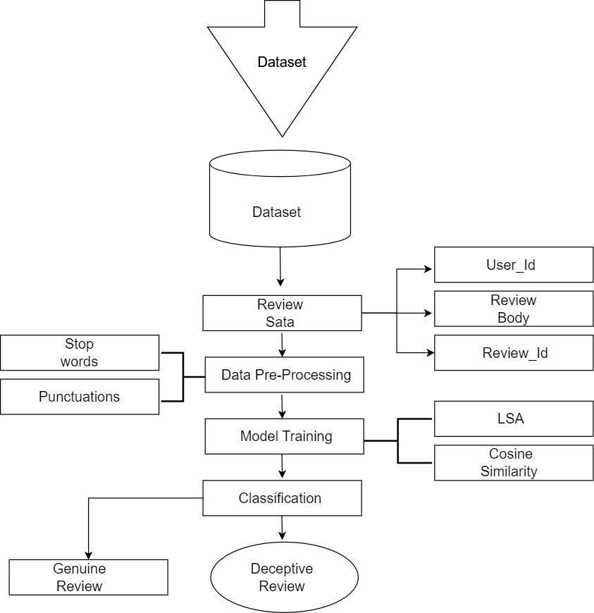

**Methodology:**

1. Research Design:

This study adopts a quantitative research design to develop a machine learning-based approach for identifying deceptive product feedback. It integrates sentiment analysis, content similarity analysis, latent semantic analysis (LSA), and natural language processing (NLP) techniques to analyze textual data from product reviews[4].

2. Data Collection:

Data Source: The dataset utilized for this study is sourced from Kaggle, specifically the Amazon Review dataset, which contains a large collection of product reviews across various categories.

Preprocessing: The raw textual data extracted from the Kaggle dataset undergoes preprocessing steps to ensure consistency and quality. This includes procedures such as tokenization, removal of stopwords and punctuation, and stemming or lemmatization to standardize the text format and enhance computational efficiency.

3. Sentiment Analysis:

Sentiment analysis is employed to assess the emotional tone of product reviews. Positive and negative sentiment scores are calculated for each review using machine learning algorithms such as Support Vector Machines (SVM) or Recurrent Neural Networks (RNN)[6].

4. Content Similarity Analysis:

Content similarity analysis is conducted to measure the similarity between deceptive and genuine product feedback. Techniques such as cosine similarity or Jaccard similarity are utilized to compare the textual content of reviews and identify patterns of similarity[2].

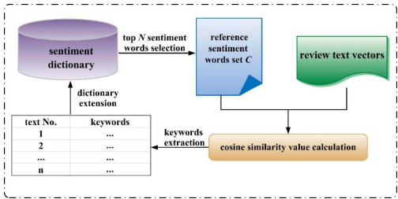

5. Latent Semantic Analysis (LSA):

LSA is employed to uncover underlying semantic relationships within the textual data. Dimensionality reduction techniques are applied to represent reviews in a lower-dimensional semantic space, facilitating the identification of deceptive patterns and latent features.

6. Natural Language Processing (NLP):

NLP techniques are utilized to extract meaningful features from text data, such as syntactic structures, semantic meanings, and linguistic patterns. Advanced NLP algorithms like word embeddings or recurrent neural networks (RNNs) may be employed to capture intricate linguistic nuances.

7. Machine Learning Model Development:

Feature Engineering: Extracted features from sentiment analysis, content similarity analysis, LSA, and NLP are combined to create a feature vector for each review.

Model Training: Machine learning models are developed using the feature vectors. While traditional supervised learning algorithms such as SVM and decision trees are not utilized, the focus is on leveraging unsupervised techniques suitable for the task. Techniques like clustering or anomaly detection may be explored to detect deceptive feedback patterns.

8. Results Interpretation and Validation:

The results obtained from the machine learning models are interpreted to identify key features and patterns indicative of deceptive product feedback.

The effectiveness and robustness of the proposed approach are validated through comparative analysis with existing methods and through qualitative assessment of identified deceptive feedback instances.

Methods used to determine Deceptive Reviews:

1. Reviews in which the same user promotes or demotes a particular brand
2. Reviews in which a person from the same IP Address promotes or demotes a particular brand
3. Reviews which are posted as flood by the same user all the reviews are either positive or negative.
4. Reviews which are posted as flood by the same user all the reviews are either positive or negative.
5. Reviews in which the reviewer is writing his own story
6. Meaningless Texts in reviews

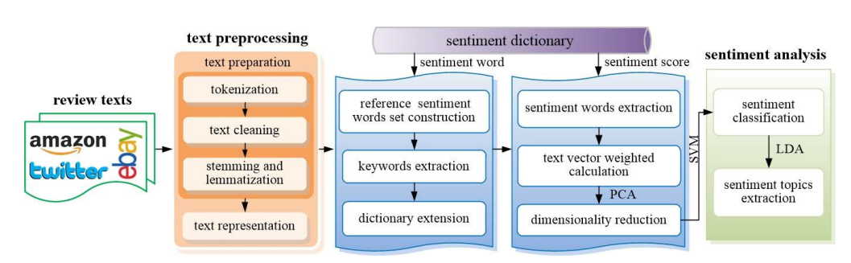

**Implementation:**

To implement our proposed method for deceptive product feedback identification using machine learning (ML), we utilized a combination of various techniques including Latent Semantic Analysis (LSA), cosine similarity, Natural Language Processing (NLP), scikit-learn, logistic regression, and Sentiment Analysis. The input data for our model was sourced from a CSV file named 'reviews.csv', containing a collection of product reviews. Each review was associated with a binary label indicating its authenticity, with '1' representing genuine reviews and '0' representing deceptive ones.

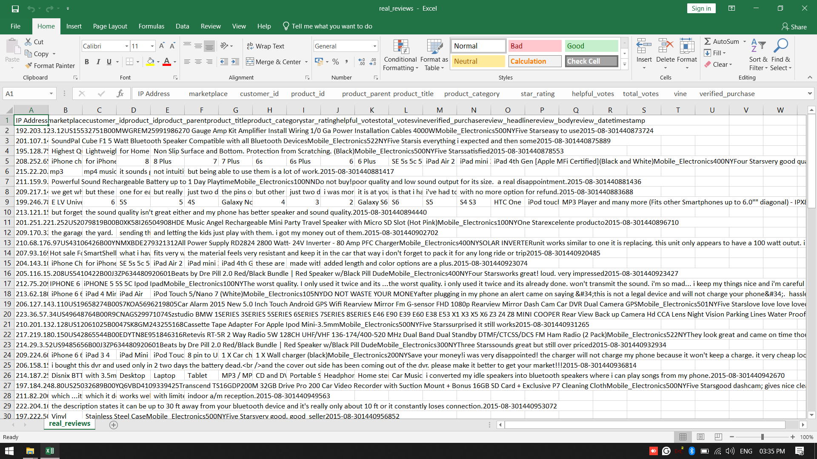

We began by preprocessing the textual data, which involved tokenization, removal of stopwords, and lemmatization to transform the raw text into a structured format suitable for analysis. Next, we employed LSA to reduce the dimensionality of the text data, capturing underlying semantic similarities among reviews. Cosine similarity was then calculated between each review pair to quantify the degree of similarity between them.

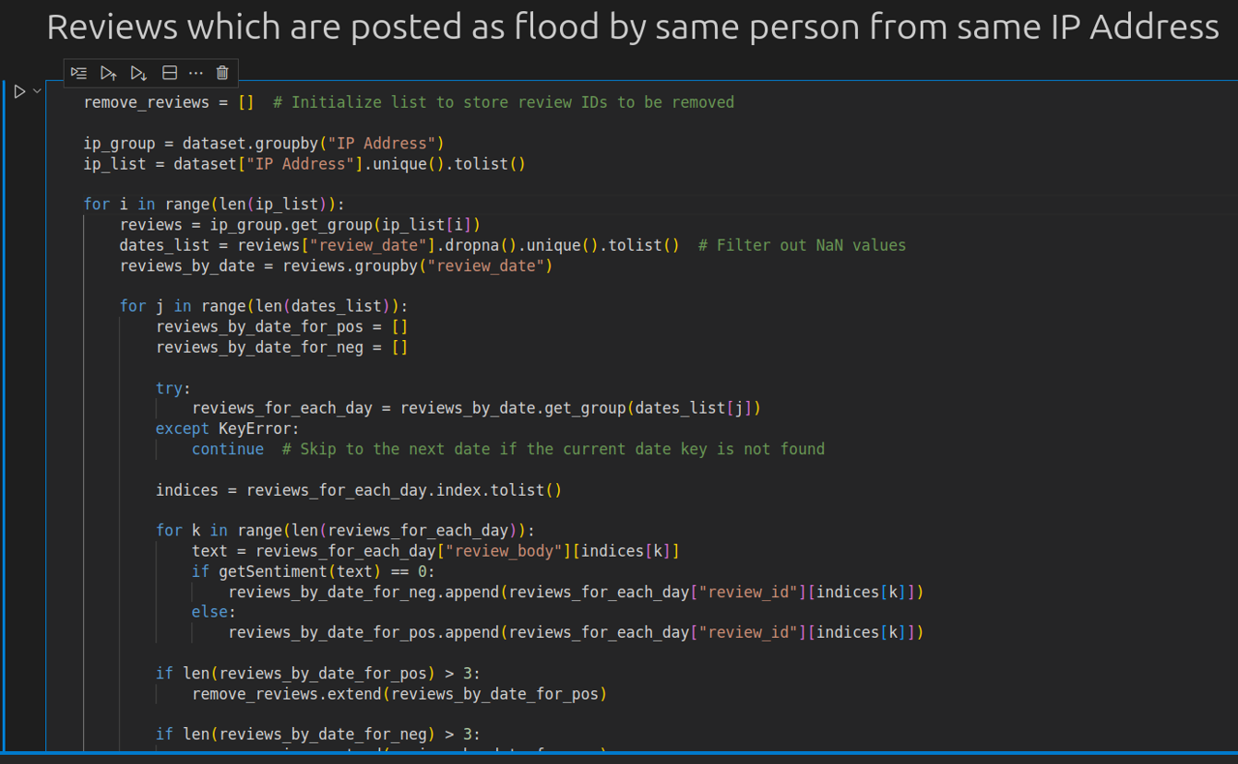

Subsequently, we trained a logistic regression classifier using the scikit-learn library, leveraging the transformed features from LSA as input. The classifier was trained on a labeled dataset comprising genuine and deceptive reviews, utilizing a supervised learning approach to learn the decision boundary between the two classes.

In parallel, we conducted Sentiment Analysis on the reviews to extract the underlying sentiment polarity, aiding in distinguishing between genuine and deceptive feedback. We utilized pre-trained sentiment analysis models available in the scikit-learn library to assign sentiment scores to each review.

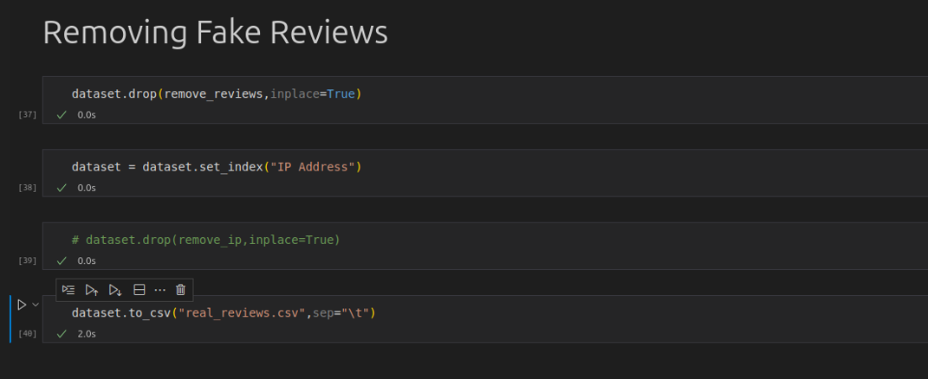

Upon completion of training, we evaluated the performance of our model using cross-validation techniques to assess its generalization ability. Additionally, we applied the trained model to a separate validation dataset to assess its real-world applicability.

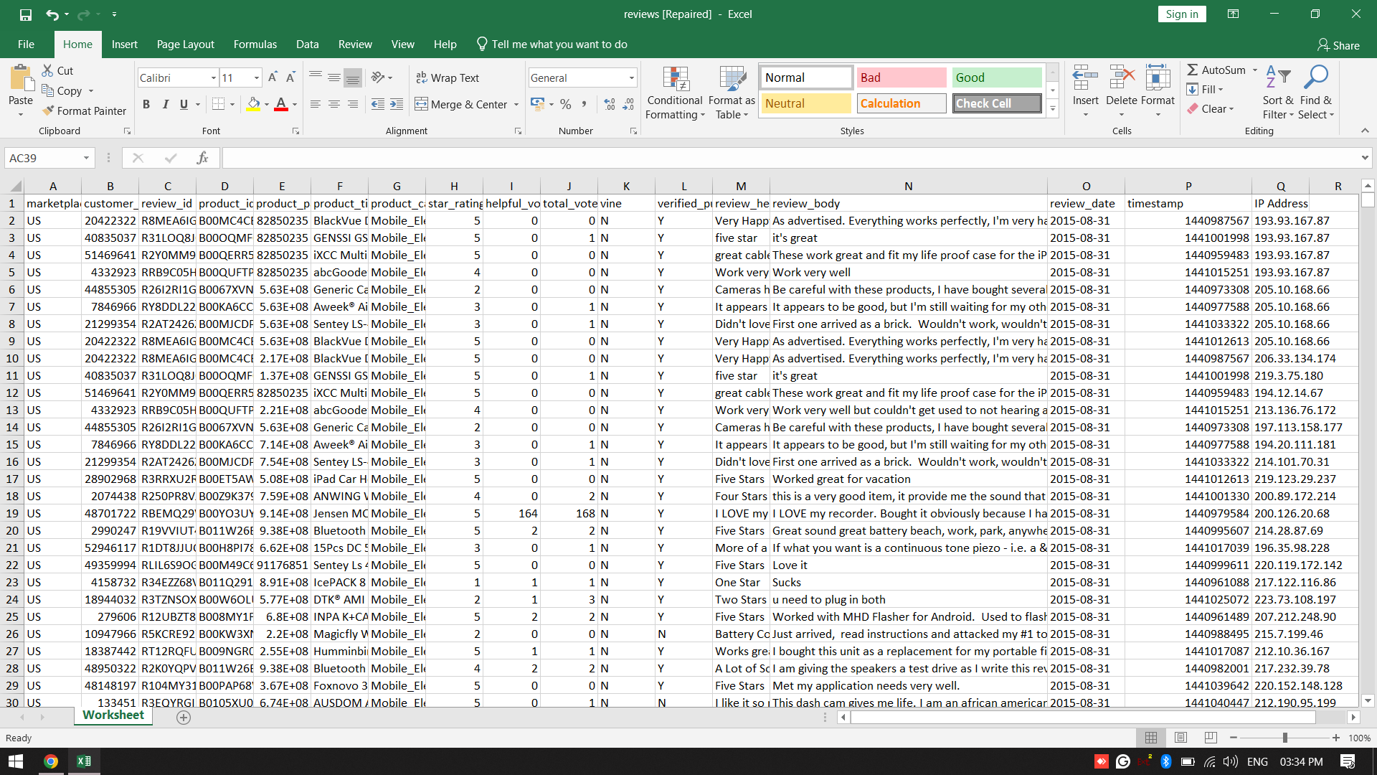

Finally, the output of our model, comprising predictions on the authenticity of reviews, was stored in a CSV file named 'real_reviews.csv'. This file contains the predicted labels for each review, enabling users to identify deceptive feedback effectively.

Overall, the implementation of our proposed approach demonstrates the effectiveness of employing a combination of LSA, cosine similarity, NLP, logistic regression, and Sentiment Analysis in accurately identifying deceptive product feedback, thereby providing valuable insights for businesses and consumers alike**.**

**­­­**

**­­­­­**

­­­

**Conclusion**

Detecting opinion spam from large amounts of unstructured data has become a significant research challenge as a result of this study. Although various algorithms have been utilized in opinion review analysis and have yielded positive results, no particular algorithm can address all of the obstacles and difficulties that today's systems face. Our program will assist the user in purchasing the appropriate product without falling into the trap of any scams. For genuine ratings, people can acquire a report on Fake Product Review Monitoring & Removal. Our application will analyze the data and then post real product reviews. Also, the consumer can be certain up to a certain extent that the products are available with genuine reviews. Our main objective is to develop a system that can detect spam and duplicate reviews and filter them out, providing users with reliable information regarding the product. Our project's goal is to improve customer satisfaction while also making online buying more secure. By using opinion mining techniques and constructing a word dictionary, the project will be able to detect false reviews. It is feasible to enhance the algorithm used to calculate review sentiment scores. It is possible to update our sentiment word dictionary. Possibility of adding more terms to our lexicon and updating the weights assigned to those words to obtain a more accurate review score.

**Future Scope:**

For future developments, a web application or a browser extension can be designed which makes the process of finding out deceptive reviews easier. Every user will be given an account through which they can write reviews for various products. The app would automatically filter out fake reviews based on the proposed Machine Learning algorithm. Eventually, customers will get rid of fake reviews present in online shopping websites. More future work and knowledge are needed to further improve the performance of the opinion spam analysis. In the future, we will further investigate different kinds of features to make more accurate predictions.

**References:**

[1] Dimple Chehal, Parul Gupta and Payal Gulati , 2022 “Evaluating Annotated Dataset of Customer Reviews for Aspect Based Sentiment Analysis”, Vol. 21 2, 145–178

[2] Satarupa Biswas And G. Poornalatha, 2023 “Opinion Mining Using Multi-Dimensional Analysis”, IEEE, Volume 11, 25916

[3] Mohammed Ennaouri and Ahmed Zellou, 2021 “Machine Learning Approaches for Fake Reviews Detection: A Systematic Literature Review”, Vol. 22_5, 821–848.

[4] Ligthart, Alexander, Catal, Cagatay and Tekinerdogan, Bedir. (2021).

“Analyzing the effectiveness of semi-supervised learning approaches for

opinion spam classification. Applied Soft Computing.” 101. 107023. doi:

10.1016/j.asoc.2020.107023.

[5] Huaqian He , Guijun Zhou , And Shuang Zhao, 2022 “Exploring E-Commerce Product Experience Based on Fusion Sentiment Analysis Method”, Volume 10

[6] Huang Huang , Adeleh Asemi Zavareh , 2022 “SA in E-Commerce Platforms: A Review of Current Techniques and Future Directions” , IEEE, Volume 11, 90368

[7] B. Ay Karakus¸, M. Talo, ˙I. R. Hallac¸, and G. Aydin, “Evaluating deep learning models for sentiment classification,” Concurrency Computation, vol. 30, no. 21, pp. 1–14, 2018.

[8] F. Pedregosa et al., “Scikit-learn,” Journal of Machine Learning Research, vol. 12, pp. 2825–2830, 2011.

[9] A. Mueller, “scikit-learn. PyPI.” [Online]. Available: https://pypi.org/project/scikit-learn/. [Accessed: 10-Sep-2020].

[10] A. Qazi, R. G. Raj, G. Hardaker, and C. Standing, ‘‘A systematic literature review on opinion types and sentiment analysis techniques,’’ Internet Res., vol. 27, no. 3, pp. 608–630, 2017