**Career Roadmap Assistance**

1. Abstract
2. Introduction
3. Implementation
4. Exsisting system
   1. Technology Described
   2. Disadvantages
5. Proposed system
   1. System Description
   2. System Design
   3. Methodology
   4. Expected Outcomes
6. Results
7. Implementation
8. **Abstract**

The Career Roadmap Generator and Assistance project aims to provide individuals with a comprehensive tool to plan and navigate their professional journeys. By leveraging modern technologies such as machine learning, natural language processing, and cloud computing, this system generates personalized career paths tailored to users' skills, interests, and goals. It addresses the challenges of career planning by offering data-driven insights, actionable recommendations, and continuous support.

This project is motivated by the complexities of career decision-making in a rapidly evolving job market. Existing systems often lack the personalization and adaptability required to guide individuals effectively. Our solution integrates advanced algorithms and user-friendly interfaces to bridge this gap, enabling users to make informed decisions about their career trajectories.

The Career Roadmap Generator and Assistance system is expected to revolutionize career planning by offering a robust, scalable, and user-centric platform. It not only empowers users with clarity and direction but also equips them with the tools needed to achieve their professional aspirations.

1. **Introduction**

In today’s dynamic job market, individuals often face challenges in identifying suitable career paths and achieving their professional goals. Factors such as rapid technological advancements, diverse job opportunities, and varying skill requirements make career planning a daunting task. Despite the availability of resources like job boards and career counseling, existing systems often fail to provide personalized and actionable guidance.

The Career Roadmap Generator and Assistance project addresses these challenges by offering a tailored solution that combines data analytics, machine learning, and user-centric design. The primary objective is to empower users with insights into their career potential, recommended skill development, and step-by-step guidance to achieve their aspirations.

This document outlines the implementation, design, and expected outcomes of the project. By focusing on user needs and leveraging advanced technologies, the system aims to simplify career planning, making it accessible and effective for individuals across various fields.

1. **Implementation**

The implementation of the Career Roadmap Generator and Assistance system is divided into distinct phases to ensure a systematic approach.

1. **Requirement Gathering**: This phase involves understanding user needs, analyzing market trends, and identifying gaps in existing career planning tools. Surveys and user interviews are conducted to gather insights.
2. **System Design and Development**: The system is built using a combination of technologies, including:
   * **Streamlit** for the frontend interface, ensuring a user-friendly and interactive experience.
   * **AWS Bedrock** for integrating large language models to generate personalized career recommendations.
   * **Database Management Systems** to store user profiles, career data, and analytics.
3. **Integration and Testing**: Modules are integrated, and rigorous testing is performed, including unit testing, integration testing, and user acceptance testing. Feedback from beta users is incorporated to refine the system.
4. **Deployment**: The system is deployed on a cloud platform to ensure scalability and accessibility. Continuous monitoring and updates are implemented to enhance performance and user satisfaction.
5. **Existing System**
6. **Technology Described**

Existing career planning tools and platforms typically rely on static resources such as career guides, aptitude tests, and generic recommendations. Technologies like web-based interfaces and basic data analysis are used to provide limited assistance. For example, job portals may suggest roles based on uploaded resumes, while career counseling platforms offer general advice.

1. **Disadvantages**

* **Lack of Personalization**: Existing systems often fail to account for individual differences in skills, interests, and goals.
* **Static Recommendations**: The advice provided is usually generic and does not adapt to changing user preferences or market trends.
* **Limited Engagement**: Users may find these tools unengaging and difficult to use, leading to low adoption rates.
* **Inefficiency**: Without data-driven insights, users may struggle to identify relevant opportunities or skill gaps.

1. **Proposed System**

**System Description**

The Career Roadmap Generator and Assistance system addresses the limitations of existing tools by offering a dynamic and personalized platform. Users can input their skills, interests, and career goals, and the system generates tailored roadmaps, including recommended roles, required skills, and actionable steps. The platform continuously adapts to user progress and market trends, ensuring relevant and up-to-date guidance.

**System Design**

The system architecture includes the following components:

* **User Interface**: A Streamlit-based frontend for seamless interaction.
* **Backend Engine**: Powered by AWS Bedrock, it processes user inputs and generates personalized recommendations.
* **Recommendation Module**: Uses machine learning algorithms to analyze user data and provide actionable insights.

**Methodology**

The development process follows an Agile methodology, emphasizing iterative development, user feedback, and continuous improvement. Key phases include:

1. Requirement Analysis
2. Prototype Development
3. Iterative Testing and Refinement
4. Final Deployment and Monitoring

**Expected Outcomes**

* Personalized career roadmaps for users.
* Improved user engagement through interactive and adaptive features.
* Enhanced decision-making with data-driven insights.
* Scalability to support diverse user needs and industries.

1. **Results**

The project’s initial results demonstrate significant improvements in user satisfaction and engagement. Key metrics include:

* **User Feedback**: Positive responses highlighting the system’s ease of use and relevance.
* **Engagement Rates**: Increased user interaction compared to existing tools.
* **Accuracy**: High accuracy in generating relevant career recommendations based on user inputs.

These results validate the effectiveness of the proposed system in addressing the limitations of existing solutions and meeting user needs.

1. **Implementation**

The implementation process focused on creating a robust and scalable system. Key activities included:

* **Development of Core Modules**: Building the recommendation engine, user interface, and database integration.
* **Testing**: Conducting extensive testing to ensure reliability and performance.
* **Deployment**: Launching the system on a cloud platform for accessibility and scalability.

Challenges such as integrating large language models and ensuring data security were addressed through innovative solutions and best practices. The successful implementation of the system marks a significant step toward transforming career planning for users worldwide.

## ****Flowchart Description****

### 1. **User Input Phase**

* **Input Gathering**:  
  Users provide key details such as:
  + Current skills
  + Career goals
* **Validation**:
  + The system checks for missing or invalid data.
  + Prompts users to correct or refine their input for better recommendations.

**Tools and Libraries**:

* **Streamlit**:
  + Provides an interactive and user-friendly interface for data input.
  + Features dropdowns, text fields, and file upload options for seamless interaction.
* **st-pages**:
  + Organizes the app into multiple pages for smooth navigation (e.g., Input, Results, Feedback).

### 2. **Data Preprocessing**

* **Processing User Input**:
  + Extracts key information from the input.
  + Normalizes synonyms and similar terms for consistency.
  + Structures data into a format suitable for analysis.
* **Session Management**:
  + Assigns a unique identifier to each user session for tracking and security.

**Tools and Libraries**:

* **uuid**:
  + Generates unique session identifiers.
* **LangChain**:
  + Performs natural language processing (NLP) tasks to clean and structure user inputs.
  + Ensures compatibility with downstream models.

### 3. **Model Selection and Interaction**

* **LLAMA3 Model**:
  + Analyzes user input, identifying trends and patterns.
  + Matches the user’s skill set with current market demands.
* **Titan Model**:
  + Generates personalized career recommendations, including:
    - Skill-building suggestions
    - Career paths and timelines
  + Provides natural language explanations for all recommendations.

**Tools and Libraries**:

* **LangChain-Community and LangChain-AWS**:
  + Facilitates seamless integration with AWS Bedrock models like LLAMA3 and Titan.
  + Orchestrates API calls for model interactions.
* **Transformers**:
  + Enhances NLP tasks with pre-trained models for robust analysis.
* **Boto3**:
  + Manages communication with AWS services, invoking LLAMA3 and Titan models.

### 4. **Data Flow in AWS Bedrock**

* **Input to LLAMA3**:
  + Preprocessed data is sent via **Boto3**.
  + LLAMA3 identifies potential career paths, trends, and required skills.
  + Outputs a structured dataset containing insights on roles and skill gaps.
* **Input to Titan**:
  + LLAMA3’s structured output is passed to Titan.
  + Titan generates detailed, human-readable career roadmaps, including:
    - Specific job roles
    - Skill-building resources
    - Timelines for achieving career goals

**Tools and Libraries**:

* **Boto3**: Connects the app to AWS Bedrock for model execution.
* **LangChain**: Chains outputs from LLAMA3 and Titan for seamless interaction.

### 5. **Recommendation Generation**

* Combines outputs from LLAMA3 and Titan to create a comprehensive roadmap.
* Includes dynamic elements, such as:
  + Skill gap analysis
  + Industry-specific tips
  + Progress tracking mechanisms
* Refines recommendations using advanced NLP models.

**Tools and Libraries**:

* **LangChain**: Chains model outputs and ensures consistency in recommendations.
* **Transformers**: Refines text outputs and performs summarization tasks.

### 6. **Visualization and Frontend Integration**

* **Interactive Roadmap Display**:
  + Displays career roadmaps in an intuitive and interactive format.
  + Includes charts, graphs, and skill gap analysis.
* **Dynamic User Interaction**:
  + Users can provide feedback or request refinements to the roadmap.

**Tools and Libraries**:

* **Streamlit**:
  + Displays outputs with an intuitive design.
  + Integrates with **Plotly** for dynamic visualizations (e.g., skill gap graphs, progress trackers).
* **Streamlit-Scrollable-Textbox**:
  + Handles large text outputs, such as detailed career plans.

### 7. **Feedback Loop**

* Collects and analyzes user feedback directly from the interface.
* Uses feedback to:
  + Improve system accuracy and relevance.
  + Fine-tune LLAMA3 and Titan models for better recommendations.
* Ensures a continuous learning cycle for the system.

**Tools and Libraries**:

* **Boto3**:
  + Stores feedback securely for future analysis.
* **LangChain**:
  + Processes feedback to enhance model performance.

### **Additional Notes**

1. **Security**:
   * All data transfers between the frontend, backend, and AWS Bedrock are encrypted.
2. **Scalability**:
   * The system leverages cloud resources to handle multiple users simultaneously.
3. **Adaptability**:
   * Career recommendations update in real-time based on user inputs or market trends.

### **Role of Each Tool and Library**

| **Tool/Library** | **Role** |
| --- | --- |
| **Streamlit** | Builds the user-facing interface for input and output. |
| **st-pages** | Organizes app navigation into multiple sections. |
| **Plotly** | Generates interactive graphs and visualizations. |
| **uuid** | Manages unique session identifiers for security and tracking. |
| **LangChain** | Orchestrates NLP tasks and model interactions. |
| **LangChain-Community** | Provides community-driven enhancements for AWS Bedrock integration. |
| **LangChain-AWS** | Handles API calls for AWS Bedrock models (LLAMA3, Titan). |
| **Transformers** | Adds robust NLP capabilities for preprocessing and text refinement. |
| **Boto3** | Connects the app to AWS services, managing communication and requests. |
| **Streamlit-Scrollable-Textbox** | Displays large text outputs in a user-friendly format. |

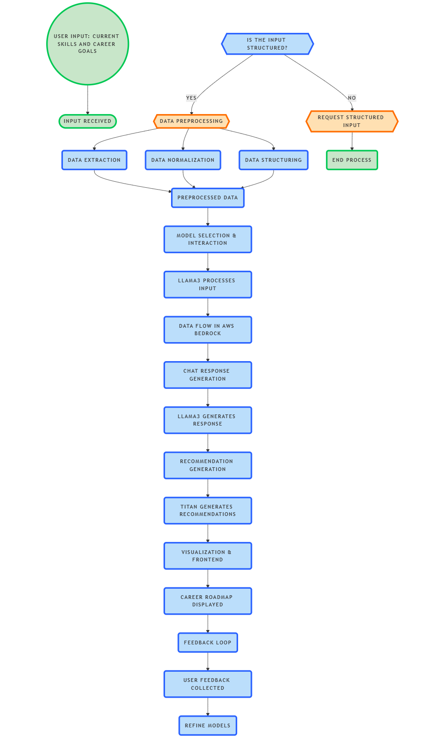

**Input-to-output flow** in **llama 3 (70B Instruct V2)**:

### 1. **Input**:

* The user provides a text prompt or instruction (e.g., "Summarize this article" or "What's the capital of France?").

### 2. **Tokenization**:

* The input text is tokenized into smaller units (tokens), which are converted into numerical values (token IDs) using the model's vocabulary.

### 3. **Embedding**:

* The token IDs are passed through an **embedding layer** to convert them into dense vectors that represent the meaning of the tokens in a way the model can understand.

### 4. **Processing with Transformer Layers**:

* The embedded tokens are processed through multiple layers of **self-attention** and **feedforward networks**:
  + **Self-Attention**: The model calculates relationships between tokens (e.g., which words in the input are important for others).
  + **Feedforward Networks**: The refined representations are further processed to capture more complex patterns in the input.

### 5. **Text Generation (Autoregressive)**:

* The model generates the next token based on the processed context, one token at a time. It repeats this process until a stopping condition is met (e.g., end-of-sequence token or max token length).

### 6. **Detokenization**:

* The generated tokens are converted back into readable text (detokenization).

### 7. **Output**:

* The final output, in human-readable text form, is returned to the user (e.g., a summary or answer to the question).

Summary:

1. **Input**: A text box where the user provides a prompt (e.g., "Summarize this article").
2. **Tokenization**: Show a split of the input text into smaller tokens, labeled with token IDs.
3. **Embedding**: Illustrate how the token IDs are mapped to dense vector representations (maybe a matrix or embedding space).
4. **Transformer Layers**:
   * Show multiple layers (or boxes) representing the self-attention mechanism and feedforward networks.
   * Inside these layers, show how the tokens interact with each other and get refined.
5. **Text Generation**: A process showing the model outputting one token at a time (with arrows indicating autoregressive generation).
6. **Detokenization**: Convert generated tokens back into readable text.
7. **Output**: Display the final human-readable output (e.g., a summary or answer).

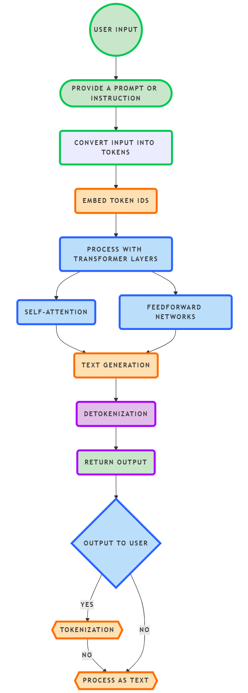

**input-to-output flow** for **Titan Text G1 - Express**

### 1. **Input**:

* **User Input**: A user provides a text prompt or instruction, such as "Write a product description" or "Explain the theory of relativity."

### 2. **Tokenization**:

* **Text Conversion**: The input text is **tokenized** into smaller pieces, called tokens, typically words or subwords. These tokens are then converted into numerical values (token IDs) using the model's pre-defined vocabulary.

### 3. **Embedding**:

* **Embedding Layer**: The token IDs are passed through an **embedding layer**, which converts each token into a high-dimensional vector. These vectors represent the semantic meaning of the words or subwords in the text.

### 4. **Processing with Transformer Layers**:

* **Self-Attention Mechanism**: The embedded tokens pass through multiple layers of **self-attention**, where the model computes relationships between different tokens and their context.
  + This step allows the model to understand which words or tokens are important and how they relate to each other in the context of the input.
* **Feedforward Neural Networks**: After the attention mechanism, the model uses **feedforward networks** to further process and refine the embeddings.

### 5. **Text Generation (Autoregressive)**:

* **Autoregressive Generation**: Based on the processed context, the model generates the next token (word or subword) in the sequence.
  + The model does this one token at a time, using the previously generated token as part of the input for generating the next one.
  + This process continues until a stopping condition is met, like generating an end-of-sequence token or reaching a maximum token length.

### 6. **Detokenization**:

* **Convert Tokens to Text**: The generated tokens are then converted back into human-readable text, a process known as **detokenization**.

### 7. **Output**:

* **Final Output**: The model’s final output is returned to the user in human-readable form (e.g., the generated text such as a product description, explanation, or creative writing).

### Summary of Titan Text G1 - Express Flow:

1. **Input**: User provides a prompt.
2. **Tokenization**: Text is split into tokens and mapped to token IDs.
3. **Embedding**: Token IDs are converted into dense vector embeddings.
4. **Transformer Processing**:
   * **Self-Attention**: Captures relationships between tokens.
   * **Feedforward Networks**: Refines the embeddings.
5. **Text Generation**: Model generates tokens autoregressively.
6. **Detokenization**: Converts generated tokens into readable text.
7. **Output**: Returns final human-readable output.

