I had created a ClientMeeting / Schedule Jira project for the final project

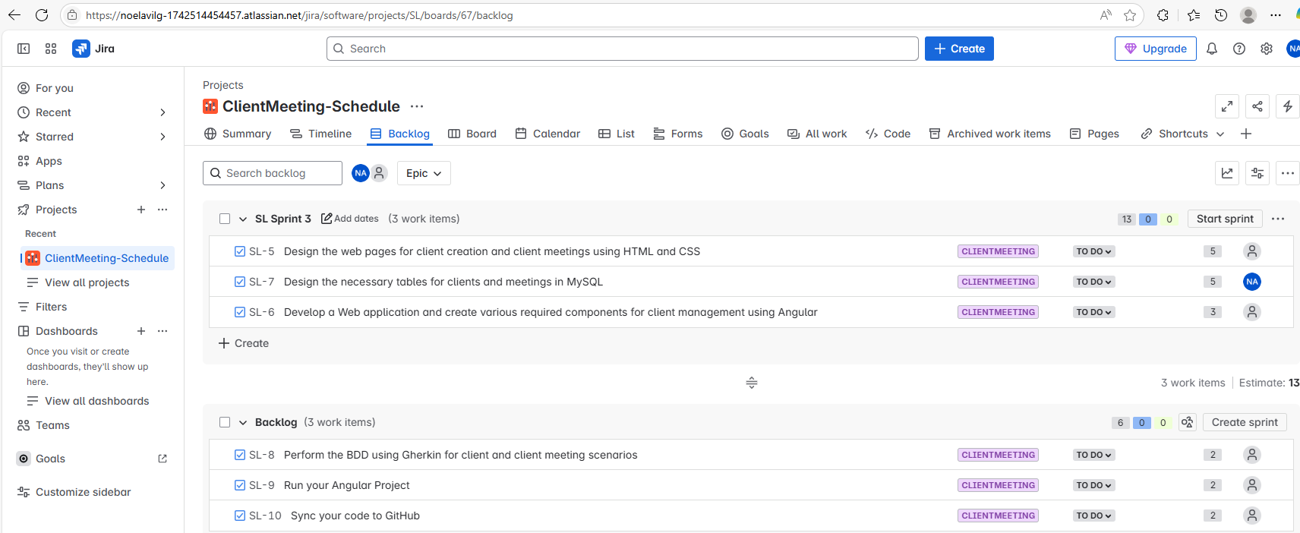

The page below show three section Project, clients and Schedule

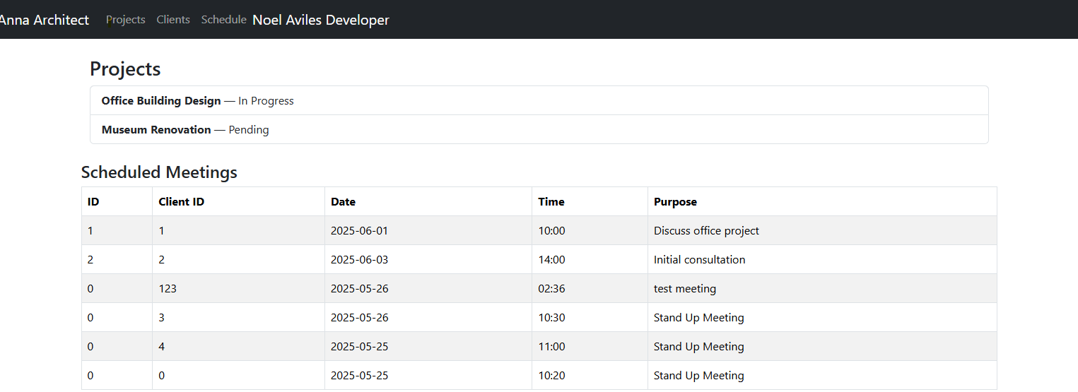

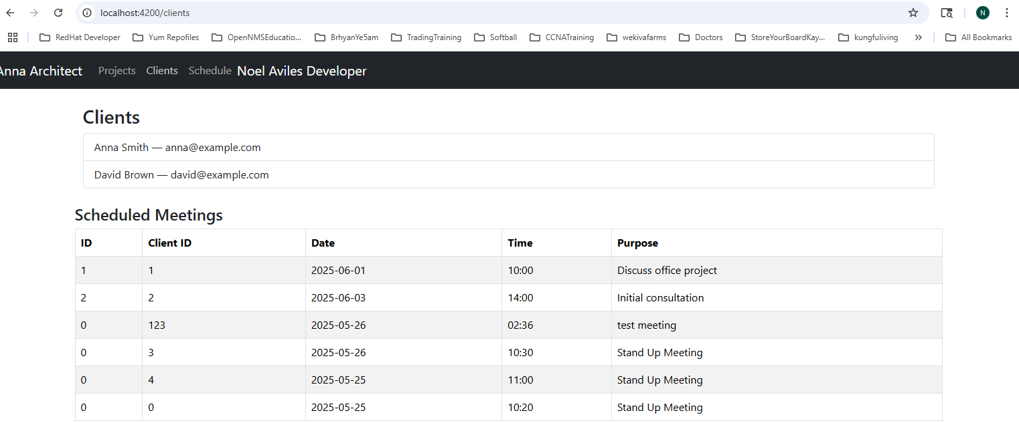

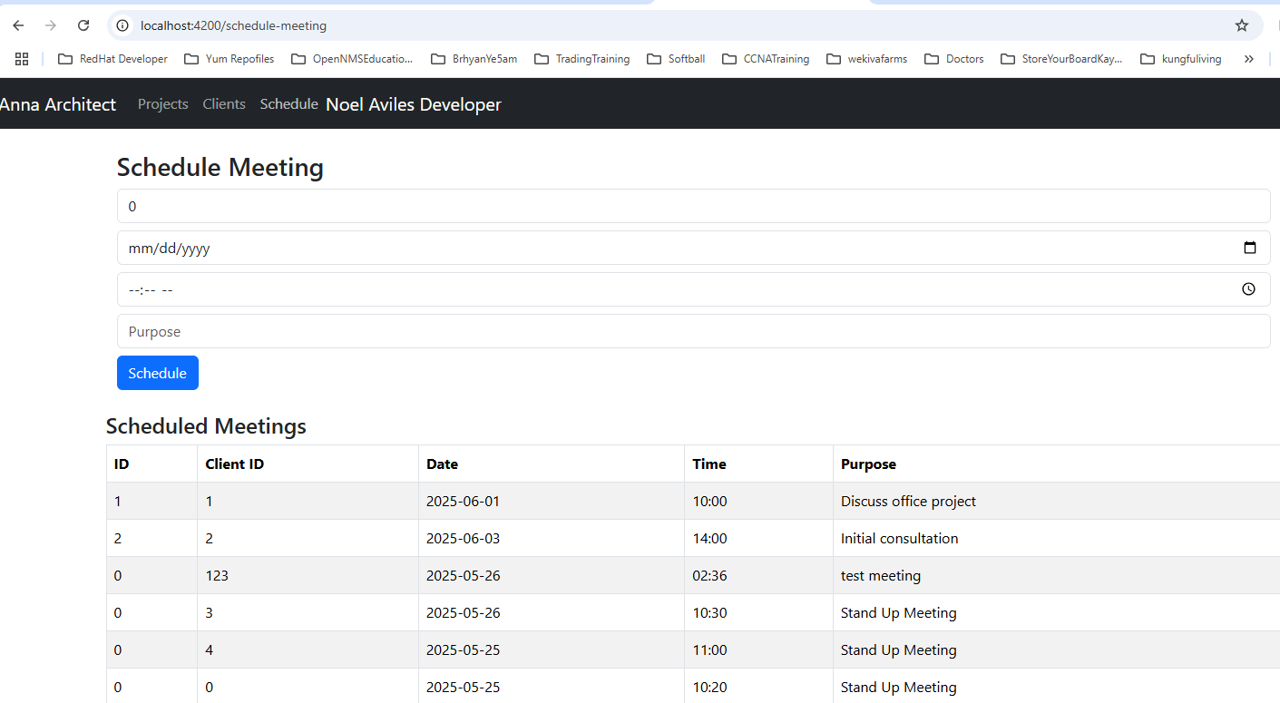
I have scheduled a meeting, please below and you can see the project and client was updated with the
record scheduled.

