NAME Noel Csomay-Shanklin SECTION N
Notes:
- Please highlight your responses questions.
- Use MATLAB to solve this homework.
- Submit any code used to generate your solutions at the end of the assignment. Please comment it appropriately.

For this block of labs, you will be evaluating a proposed SONAR system consisting of a signal generator, power amplifier, and speaker to provide an audio signal and a microphone attached to a boom with encoders to track its location to measure the signal reflection off of objects. A custom LabVIEW VI will be used to analyze the input and recorded signals. Last week you focused on characterizing the system capabilities including measuring the speed of sound, distance precision, and directionality. This week you will use the system to analyze and process signals recorded from reflected waves off a target object, determine its position, and characterize the precision of the calculated position.

Signal Processing
The raw signal collected during the SONAR experiments will have all the ambient noise within the operating range of the microphone making identifying the reflection off the target object difficult. Signal processing can help increase the signal to noise ratio so that key features such as when the acoustic wave passes by the microphone before and after reflection off the target can be identified (Figure 1). Averaging multiple signals (one of the settings in the VI) will cancel most of the ambient noise, however this will not eliminate all the extraneous data such as amplifier or speaker system dynamics or reflections from objects not of interest. Furthermore, since the sound pressure level decreases with distance, the magnitude of the reflected wave from the target object may be much smaller than that of the extraneous noise. An example of this is shown in Figure 2, where the wave initially passing the microphone is clearly visible but there are other features in the signal which could possibly be the target object reflection. Additional signal processing is required to positively identify the target object.
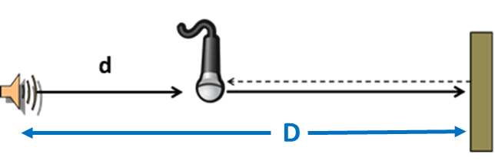
Figure 1: Schematic of one degree of freedom SONAR setup. The acoustic wave generated by the speaker passes by the microphone at distance away (d) on the way to the target. The wave reflects off the target object and will pass by the microphone a second time at a much lower sound pressure level. Using the time delay from the initial signal, the reflection, and the speed of sound, the distance to the target (D) can be calculated.
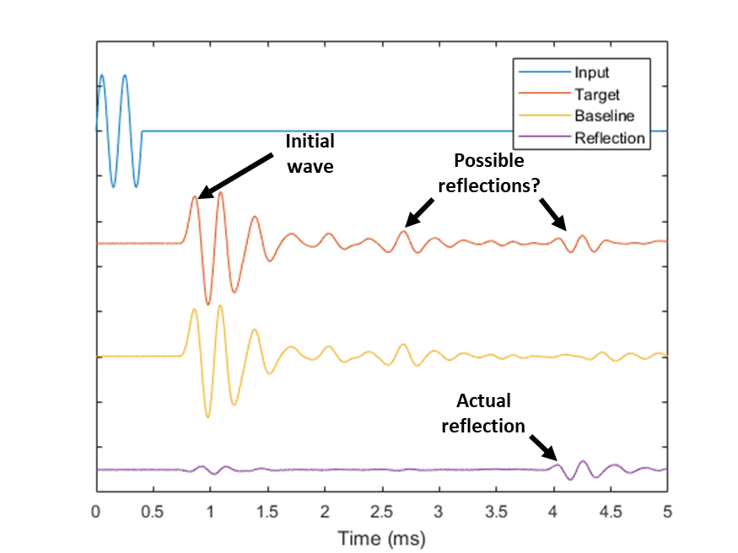
Figure 2: The raw microphone signal data from 1 DOF SONAR experiment can be difficult to analyze. The initial pass of the acoustic wave by the microphone is easily identifiable, however there are multiple features in the signal that look like they could represent the reflected wave. Comparative signal processing of the target signal versus a baseline signal can be used to help identify the target reflection.
One simple method to identify the target object reflection is to compare the signal with the target to a baseline signal without the target object. Removing the baseline noise from the signal will leave the reflected waveform. “SONAR1DOF.mat” contains a sample set of SONAR data with the input signal to the speaker (input_V), the baseline signal without the object (baseline_V), the target signal with the object (target_V), and the time (time_s). The microphone location was held constant for all the measurements and the microphone and target were located on the speaker centerline (similar to the Figure 1 schematic).

- What was the time delay from when the wave was generated at the speaker to when it first reached the microphone using the baseline signal in milliseconds? (HINT: A simple method for finding the time values is plotting the input and baseline signal versus time and using the data cursor. More rigorous methods can be used if you like. The time delay should be between 0.5 and 1 ms.)
∆ T_mic =0.8559 ms

- What was the time delay from when the wave was generated at the speaker to when the reflection from the target reached the microphone in milliseconds? (HINT: Subtract the baseline signal from the target signal. The time delay should be between 1.5 and 2 ms.)
∆ {T}_{reflection} =1.8940 ms
- Create a figure similar to Figure 2 showing the input signal, the raw target signal (target_V), the baseline signal, and the reflection signal (target_V-baseline_V) versus time in milliseconds. (NOTE: For the SONAR calculations we are mainly concerned with the time the signal takes to reach the microphone, with the voltage of the signal only being used to determine the time of features of interest. By offsetting each of the signals in the figure, it allows for easier visual comparison. You can use the command set(gca,'YTickLabel',[]) to turn off the values on the y-axis of your figure so that only the time aspect of the signal is emphasized. Additionally, for your reports you may want to think about how you can add labels to features or points of interests, though it is not required here.)

SONAR – 1 Degree of Freedom
- If the speed of sound was found to be 344 m/s, what is the distance from speaker sound source to the microphone in meters?
{d}_{mic} =0.2944 m

- What is the distance from speaker sound source to the target in the first location in meters? (HINT: It should be between 0.3-0.5 m.)
D=0.4730m

SONAR – 2 Degrees of Freedom
In the previous case, the target object was known to be on the axis of the speaker and could be located by just calculating the distance (1 degree of freedom). In most SONAR applications the direction to the object will be unknown (3 degrees of freedom). For this lab, the target object will be at approximately the same height as the speaker, and therefore only two spatial coordinates must be solved (2 degrees of freedom). Since we can only measure time delay in our signals with our system, two different reflection measurements must be made to solve for the target coordinates. This will be accomplished by moving the microphone to known directions from the speaker axis (±30⁰).

- In the figure below, draw the path of the sound (speaker-object-microphone) on the figure above, for both microphones.

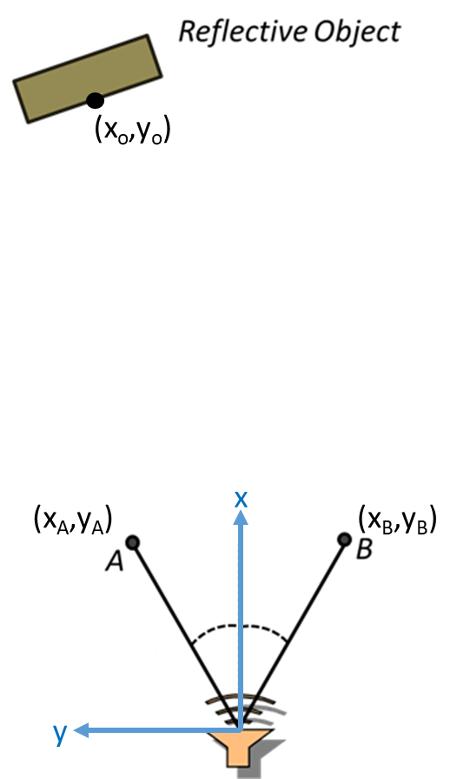
- If the object is located at and the speaker is located at origin, what is the equation for the distance that the sound traveled from the speaker to the object?
{d}_{O} = sqrt( x0^2 + y0^2 )

- If the object is located at and the microphone at position A is located at , what is the equation for the distance that the sound traveled from the object to position A?
{d}_{O → A} = sqrt((x_0-x_a)^2+(y_0-y_a)^2)

- What is the total distance the sound traveled from the origin to the object and then to the microphone at position A?
D_a = d_0 + d_{0 →A} = sqrt( x0^2 + y0^2 ) + sqrt((x_0-x_a)^2+(y_0-y_a)^2)
- Similarly, what is the total distance the sound traveled from the origin to the object and then to the microphone at position B, ?
D_b = d_0 + d_{0 →B} = sqrt( x0^2 + y0^2 ) + sqrt((x_0-x_b)^2+(y_0-y_b)^2)

“SONAR2DOF.mat” contains a sample set of 2 DOF SONAR data with the input signal to the speaker (input_V), the baseline signal at microphone position A without the object (baselineA_V), the target signal at microphone position A with the object (targetA_V), the baseline signal at microphone position B without the object (baselineB_V), the target signal at microphone position B with the object (targetB_V), and the time for each signal (time_s). Using analysis of the signals similar to the 1 DOF case, this data can to be used to determine the distances traveled by the sound to the microphone in positions A and B. For your calculations assume that the measured speed of sound is 344 m/s.

- What are the distances to the microphone in positions A and B using the respective baseline data in meters? (HINT: Both are between 0.25 and 0.35 meters.)
d_A = 0.3227 m
d_B = 0.3202 m

- What are the coordinates of the microphone at position A and B in meters if and?
(x_a, y_a) = (d_A*cos(30), d_A*sin(30)) = (0.2795, 0.1613)
(x_b, y_b) = (d_B*cos(30), d_B*sin(30)) = (0.2773, 0.1601)

- What is the total distance that the reflective sound traveled from the origin to the object and then to the microphone at positions A and B in meters? (HINT: Both are between 1.4 and 1.7 meters.)

- Using the calculated microphone coordinates and distances from problems 12 and 13, the only unknowns now in the distance equations from problems 9 and 10 are the object coordinates, . What are the coordinates of the target object in meters? (HINT: Try using the vpasolve() function in MATLAB to numerically solve the problem. Use the online help resources if you are unfamiliar with the function. There are multiple numerical solutions to this problem, but only one physical one. You may need to supply a reasonable guess to the solver and should verify the answer it returns makes physical sense.)

- If the actual speed of sound was 1 m/s faster than the measured speed of sound, what is the error in the calculated coordinates in meters?

MATLAB CODE

