# 1.Provisioning an azure VM through terraform and adding ADDS roles to it:

## 1.Creating an Azure VM through Terraform

## 2.Adding the ADDS role to the VM

# 2.Creating Linux and Windows client VMs:

## a. Creating Windows client

## b. Creating Linux client

## c. Joining them to the domain created in Task 1

For accomplishing all these tasks, the following steps should be followed:

1. First, terraform should be installed on your local system, along with Azure CLI to connect your Azure account to Terraform and Visual Studio Code to get a better overview of what you are running.
2. The second step is to open the provided folder in Visual Studio Code and change the variables defined in variables.tf, this step is however completely optional and tinkering with it might arise some unforeseen problems.

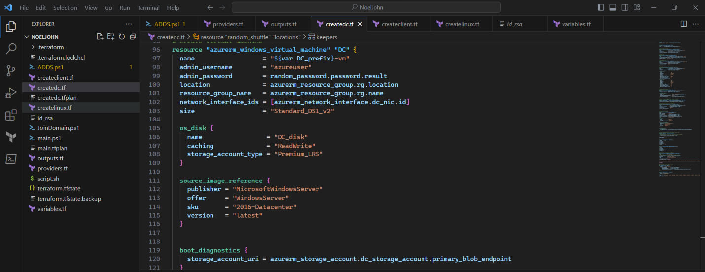



1. Third step is running the command “terraform -init” in the Visual Studio Code terminal to initialize terraform.



1. Next, run the command “terraform plan -out main.tfplan”.



1. Finally run the command “terraform apply main.tfplan”, to start the procedure of creating the domain controller, Windows client and Linux client joining them. A picture containing text, screenshot

   Description automatically generated



1. It will take quite some time, almost 15-20 minutes to get the VMs up and running.
2. After that it will give you the outputs which will be mostly passwords and public_ips of the machines.

**Note: It won’t give you the cleartext passwords right away, instead it will show the password variable name, and then you will have to run “echo $(terraform output -raw pswd_var_name)”**

**to get the cleartext password. Replace pswd_var_name with the password variable name.**

1. Now you can go to the azure portal sign in with your account, go to the virtual machines tab and select the VM you want to view. Click on it, and click on connect, it will present you the option of downloading the RDP file. After you have downloaded the RDP file, connect with the VM through the username “azureuser” and password from step 7.

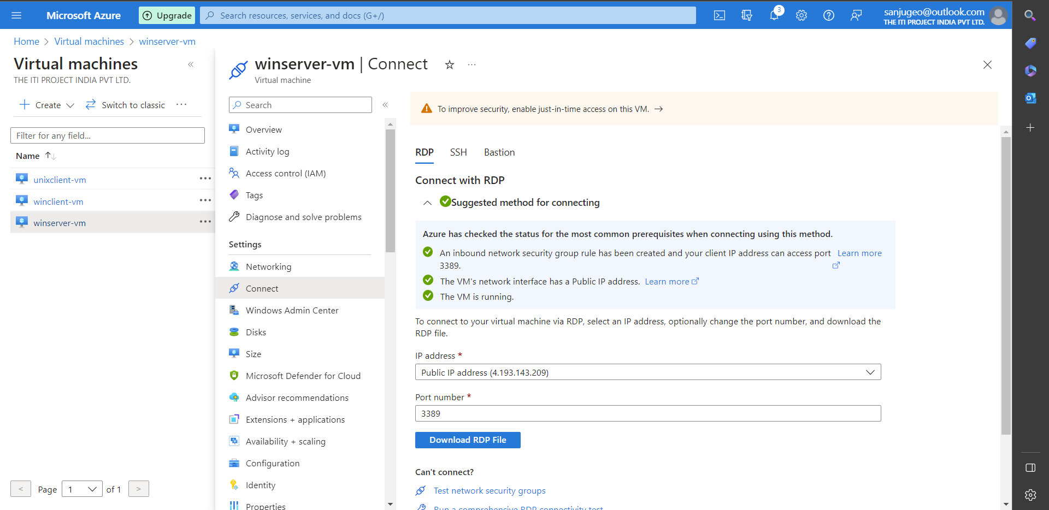

1. Now you can verify that the terraform script worked.
2. Similarly, you can repeat steps 7-9 and verify for windows client also.
3. Now at the time of writing, the Linux VM will not be automatically domain joined, so you will have to manually add it to the domain. Follow the steps below to join it:

1.First go the terminal where you ran terraform and run this command:

“echo $(terraform output -raw tls_private_key) > id_rsa”

2.Now also note the public_ip of the linux VM using this command:

“echo $(terraform output -raw unixclient_public_ip)”

3. Head to WSL on windows or terminal on mac and transfer the file id_rsa to the working directory of the terminal or WSL instance.

4.Next connect to the azure vm using:

“ssh -i id_rsa azureuser@ip_from_step_2”

5. Now follow the steps mentioned in [this](https://learn.microsoft.com/en-us/azure/active-directory-domain-services/join-ubuntu-linux-vm) Microsoft Documentation starting from the section “Install required packages”.

6. After following the steps, you can verify that the VM was added to the domain by connecting to the winserver-vm machine and seeing the computers OU in Active Directory Users and Computers.