|  |  |  |
| --- | --- | --- |
| Website Development Proposal/Initial Design Report | February 14  2016 | |
| Student Name: Noel Grace  Student Number: 20009643  Course: Higher Diploma in Business Systems Analysis  Year: 5 | | Module: Website Development |

Contents

1. Introduction 2

2.0 Proposed Project Title 2

3.0 Proposed Project Description 2

4.0 Initial Design 3

4.1 Wireframe 3

4.2 Architecture Diagram 4

4.3 ER Diagram & Database 4

5. Conclusion. 5

7. Abbreviations/Synonyms 6

**Table of Figures**

*Figure 1 Wireframe……………………………………………………………………………………………………………………………4*

Figure 2 Architecture Diagram…………………………………………………………………………………………………………..5

Figure 3 ER Diagram …………………………………………………………………………………………………………………………6

# 1. Introduction

This document entails the proposal for the initial design of a Kilkenny hurling website called *Black & Amber*.

# 2.0 Proposed Project Title

The Black & Amber website was initially developed as part of the module HCI & Website Design in semester one of the course Higher Diploma in Business Systems Analysis. It is proposed to develop the pre-existing *Black & Amber* website further in semester two of the course as part of the Website Development Module. *Black & Amber* are the traditional colours of the Kilkenny hurling team and indeed these are the colours present on the county flag. The website is dedicated to Kilkenny hurling greats during the Brian Cody era of 1999 to present date. The current Kilkenny team which has and continues to be managed by Brian Cody has been described as the greatest team of all time. Kilkenny have won an unprecedented 36 **All-Ireland** Senior Titles including a historic four in a row **2006-2009** and the lead the roll of honour.

# 3.0 Proposed Project Description

Development of the *Black & Amber* website involves three stages:

1. Stage 1 – Pre-existing *Black & Amber* website from semester one of the course Higher Diploma in Business Systems Analysis (HTML & CSS)
2. Stage 2 – Incorporating Bootstrap and JavaScript into the website in semester two of the course Higher Diploma in Business Systems Analysis
3. Stage 3 – Incorporating PHP, MySQL (database) and deployment in semester two of the course Higher Diploma in Business Systems Analysis

Initially *Black & Amber* was designed using HTML & CSS at stage 1.

The pre-existing website (stage 1) will be developed further in stage 2 to incorporate further elements of HTML, CSS and also at this stage will include the additions of Bootstrap and JavaScript. The website will be developed with the concept of mobile first. Meaning that firstly, the website will be developed with the mobile screen size in mind, and then adapted to larger screen sizes from there. There will also be a responsive design element to the website. The website will adapt to being viewed on different devices such as laptops, desktops, tablets and Apple iPads. Bootstrap components like Buttons, Tables, Navigation bars, Modals, Accordions, Carousels and Dropdowns and many other features will be used. Bootstrap will also be used to address typography and colour schemes for the website. The responsive layout of the site will be managed using the Bootstrap grid system. The viewport meta tag will be used to enable the website to identify the width of any device, and then appropriately adapt itself to the width of that device. Navigation throughout the site will also be handled with Bootstrap.

In stage 2 JavaScript will also be incorporated into the *Black & Amber* website in order to make the website interactive. Tables, forms and buttons will be made interactive. JavaScript, JQuery and Bootstrap's JS component methods will be used to control the behaviour of the components of the website such as posting/displaying messages to user’s profiles, controlling forms, handling events such as displaying error messages or messages to the user when they log into the site/register.

In stage 3 a database back-end will be incorporated into the website. Forms will be used that will allow users to post/delete/update/receive messages to/from user profile pages. Forms will be used to befriend/unfriend users. The database will be used to store data related to the user profiles such as how many messages a user has sent or received, the text of messages, the lists of friends a user has. The database will also manage ticket sales. PHP scripts will be used to connect the database with the web front-end. The website will be hosted online using a service such as x10hosting.com or Heruko.

# 4.0 Initial Design

## 4.1 Wireframe

A Wireframe is"A basic visual guide used to suggest the layout of fundamental elements in a web interface." 1 The ClickCharts software provided free by NCH software <http://www.nchsoftware.com/chart/> was used in the creation of the wireframe (figure 1) for this site and will be adhered to across all pages on the site.

#### Figure 1 Wireframe

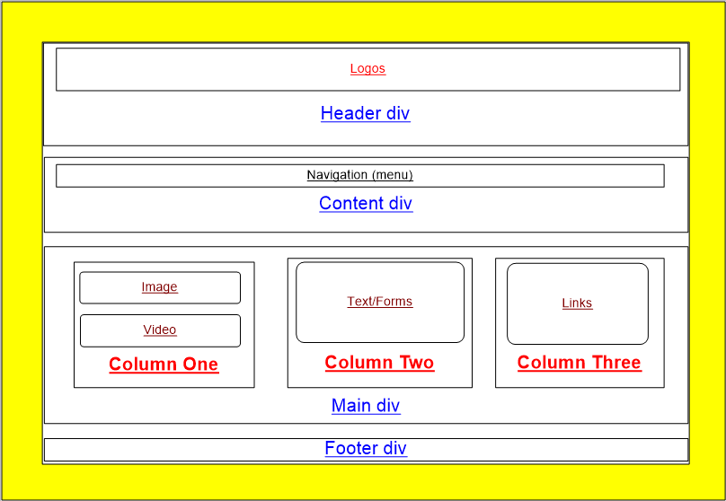

## 4.2 Architecture Diagram

The site will be used for people intending on visiting Kilkenny, interested in hurling or more generally supporters of the Kilkenny hurling team. It is intended in semester two of the course to develop the website further so that there will be a database element to the website. Although the website is still in the early stages of development it is intended in semester two to allow users to create accounts, usernames, passwords and post messages to forums so that other users can reply and add comments. At the moment the site consists of information about the Kilkenny hurling team and players. The content of the site includes images, videos, text and links to other sites based on Kilkenny city.

#### Figure 2 Architecture Diagram

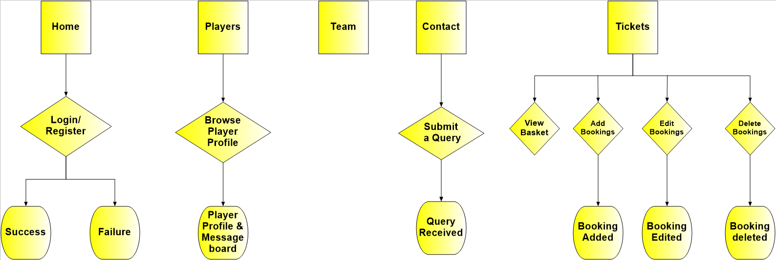

## 4.3 ER Diagram & Database

The header div consisted of logos/images which are symbolic of Kilkenny hurling, the GAA, Leinster and Irish sport and have captions describing the logos.

The content div consists of a navigation div which is displayed consistently across all pages using CSS. The menu/navigation bar which is an unordered list item is placed horizontally. The content div also contains a text section which includes tables on some pages and contact details on the content page.

The main div is divided up into a three column layout consistently across the site using CSS and this structure was observed to have been adhered to across several different devices and on different web browsers. The first column includes images/maps/videos. The second column includes a text section which also includes a form for the purpose of sending messages/comments to the site administrator and also includes a drop down menu list for the purpose of users voting their choice of best Kilkenny hurler. Finally the third column consists of links to other sites which are related to Kilkenny, the Kilkenny hurling team, GAA and local newspapers.

The footer div consists uniquely of the copyright and also a logo to identify the fact that the website has met all the criteria for CSS validation which is discussed in section 4.2 CSS Validation.

#### Figure 3 ER Diagram

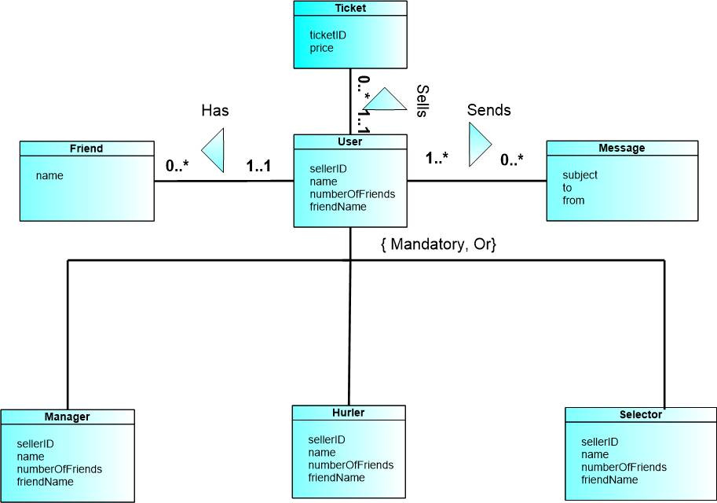

# 5. Conclusion.

The pre-existing *Black & Amber* website (stage 1) will be adapted to incorporate *Bootstrap & JavaScript during stage 2. During stage 3 a database element will be added to the website using MySQL and PHP scripts will be used to connect the database to the front end. The Wireframe diagram* will be used as a guideline in the development of the website to create a consistent layout which will include some Bootstrap elements. The ER diagram is intended to show the interactions between the classes and the multiplicities of the relationships. The architecture diagram is intended to show the pathways of the website and the pages that will interact with the database. An interactive and responsive website will be developed. The website accessibility and validation will be tested to ensure the site is fully compliant, browser independent. The website will also be tested to ensure it is device independent.

# 7. Abbreviations/Synonyms

**CSS** Cascading Style Sheets.

**Div** Division

**HTML** Hyper Text Markup Language

**GAA** Gaelic Athletic Association