|  |  |  |
| --- | --- | --- |
| Website Development Final Report | April 25  2016 | |
| Student Name: Noel Grace  Student Number: 20009643  Course: Higher Diploma in Business Systems Analysis  Year: 5 | | Module: Website Development |

Contents

1. Introduction 2

2.0 URL of the website 2

3.0 Brief Overview of the website 3

3.1 Guidelines for first time users 4

4.0 Usernames and Passwords 4

5.0 Evaluation of the web development project 5

5.1 Poblems encountered/solutions 5

5.1.1 Merging the original CSS template with Bootstrap. 5

5.1.2 Correcting errors in the JavaScript Code 5

5.1.3 Chrome Auto save ……………………………………………………………………………………………………………………6

5.1.4 SQL …………………………………………………………………………………………………………………………………………..6

5.1.5 Hosting Online …………………………………………………………………………………………………………………………8

6.0 Learning Experience …………………………………………………………………………………………………………………10

6.1 Merging the original CSS template with Bootstrap …………………………………………………………………10

6.2 SQL………………………………………………………………………………………………………………………………………….10

6.3 JavaScript…………………………………………………………………………………………………………………………………10

7 Abbreviations/Synonyms …………………………………………………………………………………………………………..11

8 Conclusion………………………………………………………………………………………………………………………………..11

**Table of Figures**

Figure 1: [http://noelgrace.x10host.com/test/manger.php................................................*…………………*](http://noelgrace.x10host.com/test/manger.php................................................…………………)*3*

Figure 2 Secure Login at noelgrace.x10host.com/test/login_success.php …………………………………………4

Figure 3 Auto-Increment.………………………………………………………………………………………………………………….7

Figure 4 Unique Keyword ………………………………………………………………………………………………………………….7

Figure 5 Error……………….. ………………………………………………………………………………………………………………….8

Figure 6 Navbar on [http://noelgrace.x10host.com/test/..........................………………………………………….9](http://noelgrace.x10host.com/test/.............................………………………………………….7)

Figure 7 Navbar on <http://localhost/blackandamber/submitted/BlackAndAmber_submitted/>……… 10

# 1. Introduction

This document entails a brief report on a Kilkenny hurling website called *Black & Amber*.

# 2.0 URL of the website

The Black & Amber website has been hosted online at the URL http://noelgrace.x10host.com/test/. The website was initially developed as part of the module HCI & Website Design in semester one of the course Higher Diploma in Business Systems Analysis. The website was developed further in semester two of the course as part of the Website Development Module with the incorporation of Bootstrap, JavaScript, PHP and SQL. *Black & Amber* are the traditional colours of the Kilkenny hurling team and are the representative colours of the county flag and jerseys. The website is dedicated to Kilkenny hurling greats during the Brian Cody era of 1999 to present date. The current Kilkenny team which has and continues to be managed by Brian Cody has been described as the greatest team of all time. Kilkenny have won an unprecedented 36 **All-Ireland** Senior Titles including a historic four in a row **2006-2009** and the lead the roll of honour.

#### Figure 1: http://noelgrace.x10host.com/test/manger.php

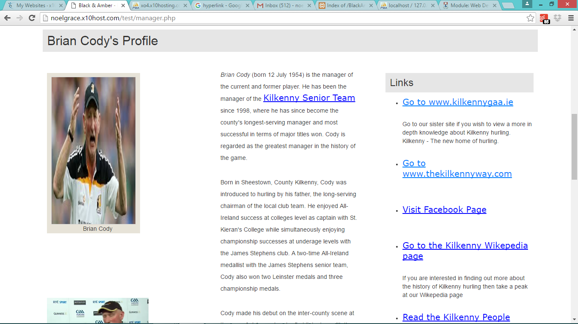

# 3.0 Brief Overview of the Website (guidelines for first time users)

Development of the *Black & Amber* website involved three stages:

1. Stage 1 – Pre-existing *Black & Amber* website from semester one of the course Higher Diploma in Business Systems Analysis (HTML & CSS)
2. Stage 2 – Incorporating Bootstrap and JavaScript into the website in semester two of the course Higher Diploma in Business Systems Analysis
3. Stage 3 – Incorporating PHP, MySQL (database) and deployment in semester two of the course Higher Diploma in Business Systems Analysis

Initially *Black & Amber* was designed using HTML & CSS at stage 1.

The pre-existing website (stage 1) was developed further in stage 2 by incorporating further elements of HTML, CSS and also at this stage there was the additions of Bootstrap and JavaScript. The website was developed with the concept of mobile first. Meaning that firstly, the website was developed with the mobile screen size in mind, and then adapted to larger screen sizes from there. There is a responsive design element to the website. The website adapts to being viewed on different devices such as laptops, desktops, tablets and Apple iPads. The responsive layout of the site is managed using the Bootstrap grid system. The viewport meta tag enables the website to identify the width of any device, and then appropriately adapt itself to the width of that device. Navigation throughout the site will also be handled with Bootstrap.

In stage 2 JavaScript was incorporated into the *Black & Amber* website in order to make the website interactive. Tables, forms and buttons were made interactive. JavaScript, JQuery and Bootstrap's JS component methods were used to control the behaviour of the components of the website such as posting queries to the website, controlling forms and handling events such as displaying error messages or messages to the user when they log into the site/register.

In stage 3 a database back-end was incorporated into the website. Forms were used to allow users to post queries to the website which are stored in the database by use of SQL. The database also manages the bookings for matches. PHP scripts are used to connect the database with the web front-end. The website is hosted online using the service x10hosting.com.

## 3.1 Guidelines for First Time Users

Users who wish to book a seat at a match will need to create an account on the website. The registration page allows users to register with the site. Once a user is registered they can use their user name and password to log into the site securely. Only registered users will be able to login.

# 4.0 Usernames and Passwords

There is added security to the Black and Amber site. Usernames and passwords are required to access restricted areas of the site. When a user logs in successfully they are redirected to the login_success.php page. The site was made secure by adding the following code to checklogin.php. This takes the variables from the form and saves them; then stripslashes() and mysql_real_escape_string() remove any special characters. This removal of special was necessary to prevent against SQL injection attacks. If a user inadvertently uses incorrect login details then they will be given an error message to notify them of this and advised to click on the login hyperlink that will direct the user back to the login page. When a user logs out they will no longer have access to restricted areas of the site unless they choose to log in again. Logged in users can view, edit or delete their own bookings but will not have access to view, edit or delete other users bookings.

#### Figure 2 - Secure Login at noelgrace.x10host.com/test/login_success.php

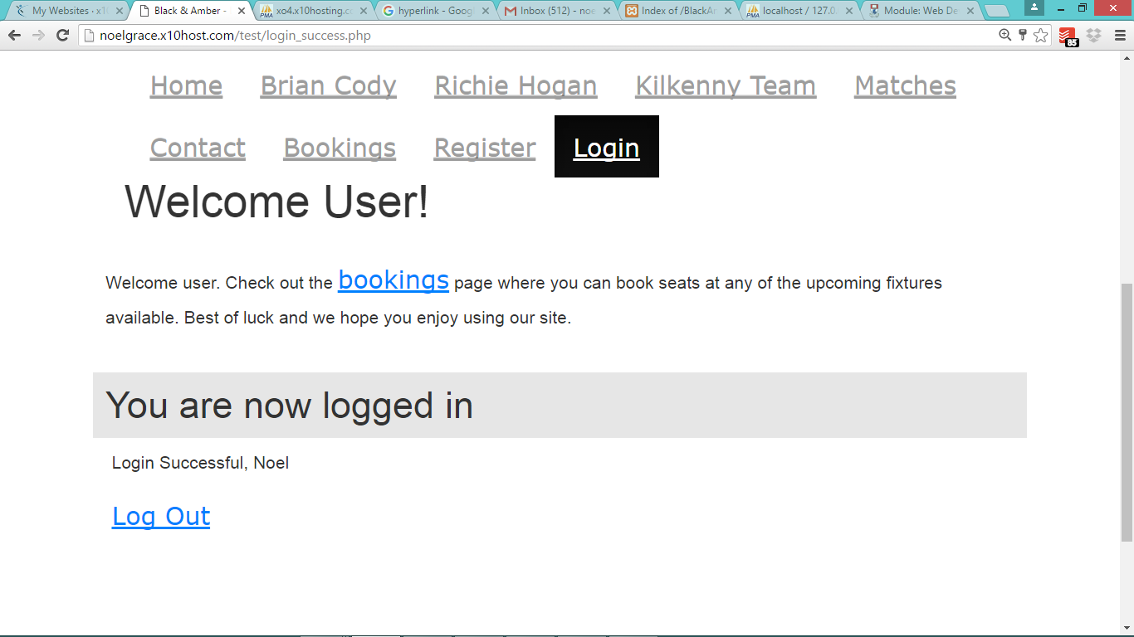

# 5. Evaluation of web development project

The pre-existing *Black & Amber* website (stage 1) was adapted to incorporate Bootstrap & JavaScript during stage 2. During stage 3 a database element was added to the website using MySQL and PHP scripts were used to connect the database to the front end. The Wireframe diagram in the Website Proposal/Initial Design Report was used as a guideline in the development of the website to create a consistent layout which include some Bootstrap elements. The ER diagram also in the Website Proposal/Initial Design Report showed the interactions between the classes and the multiplicities of the relationships. The architecture diagram in the Website Proposal/Initial Design Report showed the pathways of the website and the pages that interact with the database. An interactive and responsive website was developed. The website accessibility and validation were tested to ensure the site is fully compliant and browser independent. The website was also be tested to ensure device independence.

## 5.1 Problems encountered/solutions to problems

1. Merging the original CSS template with Bootstrap
2. Correcting errors in the JavaScript code
3. Chrome auto save
4. SQL
5. X10hosting.com

### 

### 5.1.1 Merging the original CSS template with Bootstrap

On initially attempting to merge the original CSS template used during semester one with Bootstrap there was some distortions to the layout and font size. The fig captions were appearing outside of the figures that were used in the logos in the header section and the images weren’t being displayed clearly. The same also occurred in the column that was originally identified the main div but with the incorporation of the bootstrap grid has been identified as sections <div class="row"> and <div class="col-sm-6">. To counteract the resizing effect bootstraps 12 column grid system was used. All four logos were placed inside the same row: <div class="row">. It was decided to have each logo occupy 4 columns of the row using <div class="col-sm-3"> and this also allowed for a gutter between each logo (a small white margin) which helped to space out the section evenly. This was then adapted so that the logos would display neatly for tablet users also to <div class="col-sm-6 col-md-3">. Images in the three column layout of the main div had to be resized as there width appeared to be going outside of the boundaries of the width that bootstraps grid column layout had allowed for this section. Again a different grid layout was required for tablet users as the three columns were overlapping in the tablet view. This was changed to <div class="col-sm-12 col-md-4">.

### 5.1.2 Correcting errors in the JavaScript code

Correcting errors in the JavaScript code proved at times to be tricky as sometimes when I was tired I found the errors difficult to find but after a rest or early in the morning when my mind was at its best they seemed easier to spot. I had not great experience with JavaScript prior to commencement of the course but learned it very quickly. I found it easier the JavaScript part of the website easier and quicker to complete than I found the task of merging the original CSS template with Bootstrap. It was surprising how quickly I complete this part of the website.

### 5.1.3 Chrome Auto save

The chrome auto save proved to be a hindrance as when I was creating users and passwords it auto saved the incorrect passwords into the password fields but this was quickly resolved by typing in passwords rather than using the passwords that chrome has inserted for me.

### 5.1.4 SQL

I received a few error messages when I was trying to complete bookings using the website and I received error messages such as “Notice: Trying to get property of non-object in C:\xampp\htdocs\BlackAndAmber\BlackAndAmber_v5d\bookings.php on line 240 " which related to the line of code "if ($result->num_rows > 0)". That error message usually comes up when the SQL query hasn’t worked – it hasn’t gotten anything out of the database so then it isn’t able to perform the ‘num_rows’ function. In order to rectify the situation I carefully read through the SQL code in all the pages related to bookings including those used to register and login users. I made sure that all fields used in the database matched the SQL code used on the php pages. This took some time to complete and fortunately was completed correctly. I chose to use lowercase with no underscores for most of the column names in the database and had to be careful that when an underscore was included for column names in the database e.g. booking_id that this underscore was also included in the php pages. One other issue with using the xampp database I had was that it will only allow one attribute to have the auto increment function.

In the case of the bookings table I have assigned the auto increment function to the primary key which in this case is booking_id. Unfortunately xampp and the x10hosting database would not allow me to assign the auto-increment function to seat_number aswell (see figure 5). This meant that users were being assigned duplicate seat numbers for the same booking which wouldn’t be very pleasant for the users when they go to see the matches. In an attempt to rectify the situation I assigned the key word ‘Unique’ to the seat_number attribute. However this did not rectify the situation as I received the error code (figure 7) ‘duplicate entry 0 for key seat number. A few ideas to rectify the situation would be to:

1. remove the seat_number attribute
2. Write a line of code that will print users are only allowed to book one ticket for each match
3. Place seat number as the primary key instead of booking_id which I could delete and adjust the SQL code throughout the php pages

Finally I decided to delete the seat_number attribute from both databases that are using xampp and x10hosting. This prevented users booking the same seat number as other users and it is assumed that at these matches the users may sit wherever they like. The booking_id will allow the site to monitor how many bookings can be made so as to prevent overcrowding in the stadiums and avoiding customers booking the same seat.

### Figure 3 Auto-Increment

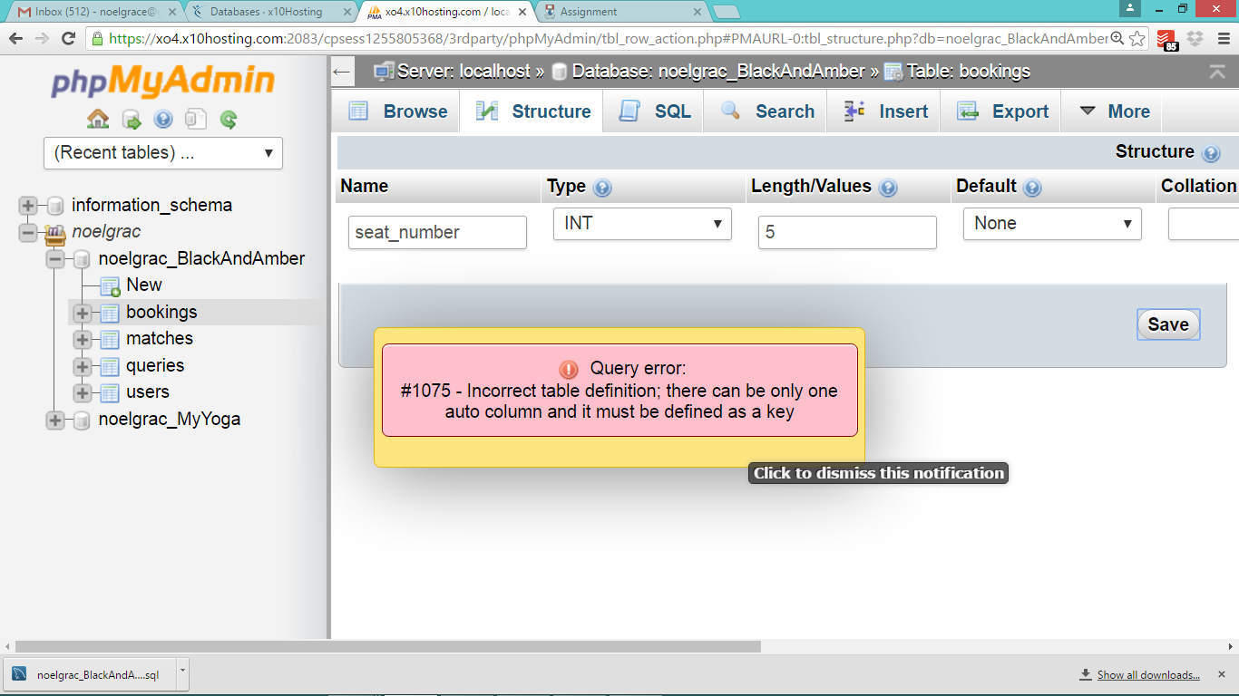

### Figure 4 Unique Key word

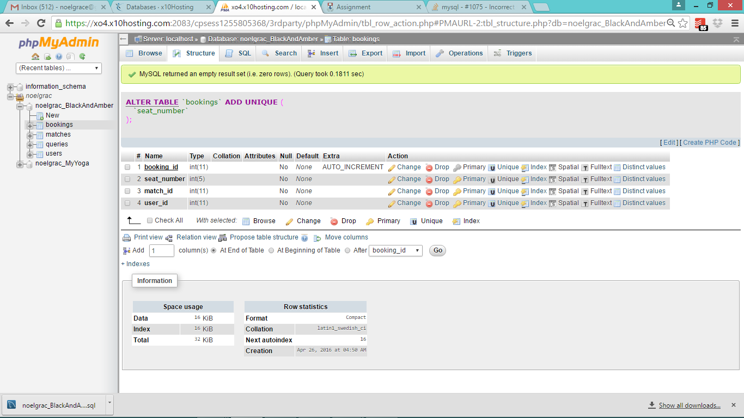

### Figure 5 Error

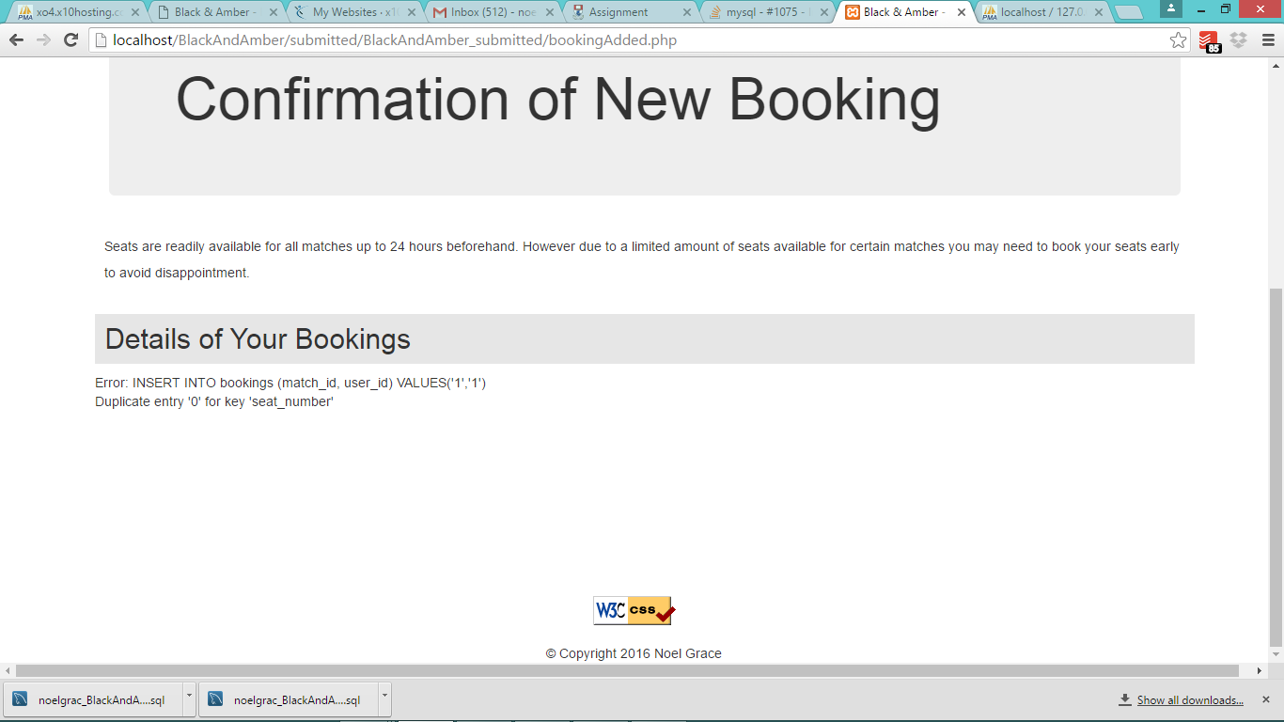

### Hosting Online

It proved relatively straight forward to host the website online. The website was hosted at the URL <http://noelgrace.x10host.com/test/> and the files were transferred using FTP (File Transfer Protocol). The only difference when viewing the website on this site was that the navbar which was black is now displayed white.

### Figure 6 Navbar on <http://noelgrace.x10host.com/test/>

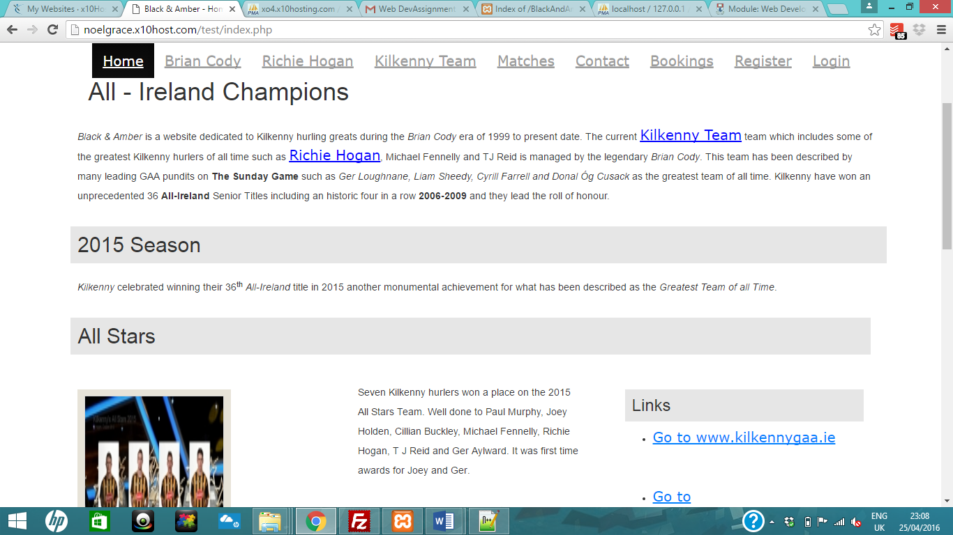

### Figure 7 Navbar on http://localhost/blackandamber/submitted/BlackAndAmber_submitted/

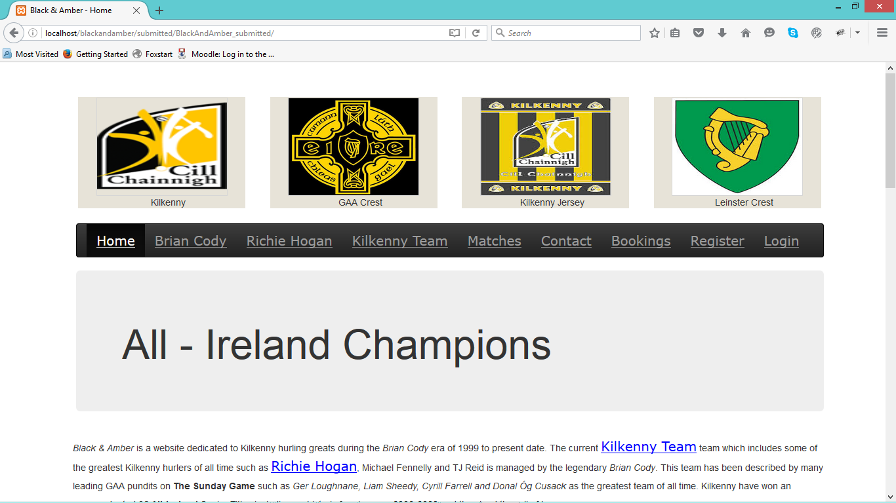

# 6.0 Learning Experience

Great experience was gained from completing the web development project particularly with the use of Bootstraps grid layout, JavaScript, PHP, SQL, hosting a website online and using the database. There are also a number of things that I would do differently such as:

1. Using the original CSS template entirely
2. SQL
3. Additional JavaScript

## 6.1 Merging the original CSS template with Bootstrap

I found it a time consuming effort to merge the original CSS template with Bootstrap as it seemed to adapt more to being viewed on a tablet device. In hindsight it might have made things easier if I had stuck with the original CSS template entirely or else to have abandoned this template and gone completely with Bootstrap which would have allowed me more time to focus on the JavaScript content. Nevertheless it was a valuable learning experience.

## 6.2 SQL

I gained the experience of using SQL in web pages and connecting a database to a website using php.

## 6.3 JavaScript

If I was to complete the website again I would look at more ways of including JavaScript into the website such as getting images to change their display when user hovers over them. I used JavaScript to display links when a user hovers over, or moves the mouse off links.

# 7. Abbreviations/Synonyms

**CSS** Cascading Style Sheets.

**Div** Division

**HTML** Hyper Text Mark-up Language

**GAA** Gaelic Athletic Association

**FTP** File Transfer Protocol

**SQL** Structured Query Language

# 8. Conclusion

The web development project allowed me to gain experience in developing a website using JavaScript, PHP, Bootstrap and SQL. Further I gained experience of connecting the website to a database back end using SQL and PHP. If I was to redo a similar web development project then I would resist trying to merge a CSS template with Bootstrap i.e. use entirely CSS or Bootstrap.