#DB

CREATE DATABASE IF NOT EXISTS EcoSave_Construction;

USE EcoSave_Construction;

#Table 1

CREATE TABLE IF NOT EXISTS Country

(

CountryID INT (3) not null AUTO_INCREMENT,

CountryName VARCHAR (50) NOT NULL,

CountryCapital VARCHAR (50) unique,

Constraint Pk_CountryID Primary key (CountryID)

);

#Insert Values Table 1

Use ecosave_construction;

Insert into Country (CountryName, CountryCapital) values ("Ireland", "Dublin");

Insert into Country (CountryName, CountryCapital) values (“England”, “London”);

Insert into Country (CountryName, CountryCapital) values (“Wales”, “Cardiff”);

Insert into Country (CountryName, CountryCapital) values (“Scotland”, “Glasgow”);

# View Table 1

SELECT * FROM `country`;

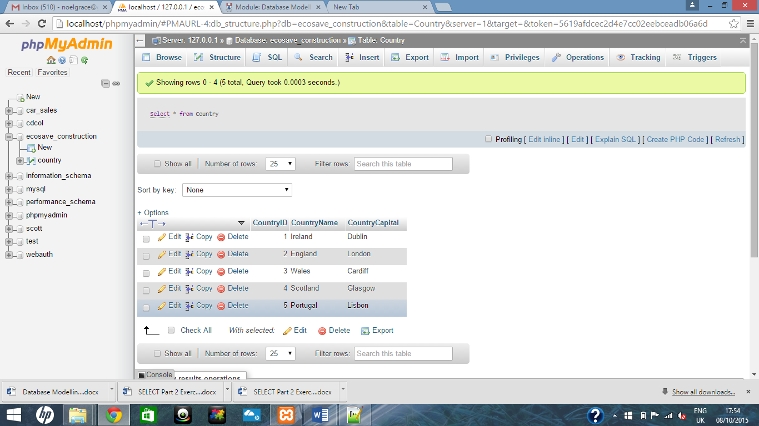

#Table 2

CREATE TABLE IF NOT EXISTS Branch

(

BranchID Int (3) NOT NULL,

PRIMARY KEY(BranchID),

BranchName VARCHAR (50) not null,

BranchAddress Varchar (50) not null,

BranchEmail Varchar (50) NOT NULL,

BranchPhone Int (10) not null,

B_CountryID Int (3) not null,

CONSTRAINT FK_CountryID FOREIGN KEY (B_CountryID)

REFERENCES Country (CountryID)

);

# Insert values table 2

Insert into Branch values (1, "Sisk", "Dublin", "dublin@ecosave.com", 0123456789, 1);

Insert into Branch values (2, "Grace", "England", "london@ecosave.com", 0223456789, 2);

Insert into Branch values (10, "Morrissey", "Wales", "cardiff@ecosave.com", 0323456789, 3);

Insert into Branch values (100, "Ryan", "Scotland", "glasgow@ecosave.com", 0423456789, 4);

Insert into Branch values (102, "Kelly", "Portugal", "lisbon@ecosave.com", 0523456789, 5);

#View Table 2

select * from branch;

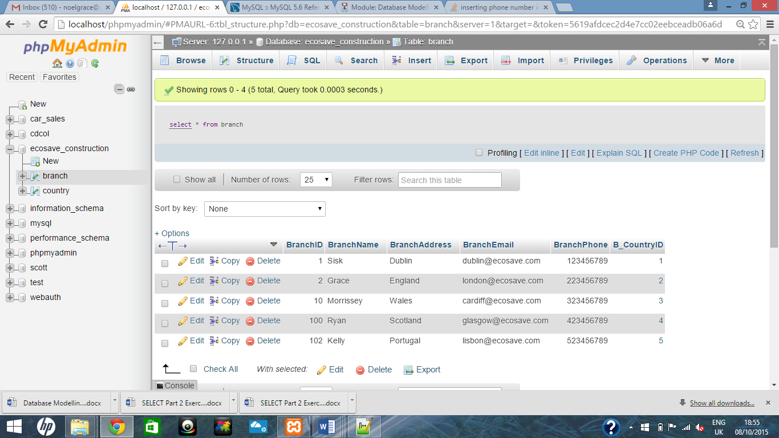

#Table 3

CREATE TABLE IF NOT EXISTS Building

(

BuildingID Int (3) NOT NULL,

BuildingName VARCHAR (50) unique,

BuildingType default "Two Storey",

BuildingHeight INT (4) not null,

Constraint PK_BUILDING PRIMARY KEY(BuildingID)

);

# Add enum Values

ALTER TABLE `building` CHANGE `BuildingType` `BuildingType` ENUM("Apartments", "Two Storey Detached", "one Storey", "Two Storey", "Townhouse", "Semi Detached") CHARACTER SET latin1 COLLATE latin1_swedish_ci NOT NULL;

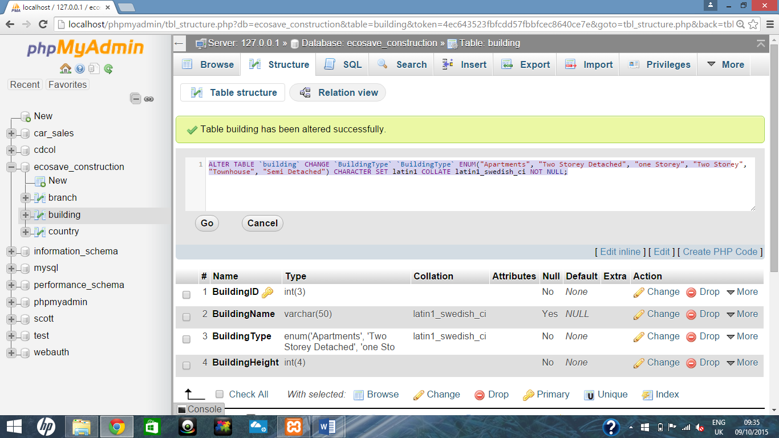

# Table 3 Values

Insert into Building values (200, "Charlefield", "Two Storey", 50); # 1 row affected.

Insert into Building values (250, "Graceland", "Semi Detached", 25); # 1 row affected.

Insert into Building values (002, "Grace Dieu", "Townhouse", 25); # 1 row affected.

Insert into Building values (999, "Adel", "One Storey", 25); # 1 row affected.

Insert into Building values (777, "Samson House", "Apartments", 4000); # 1 row affected.

# Table 3 Building

Select * from Building;

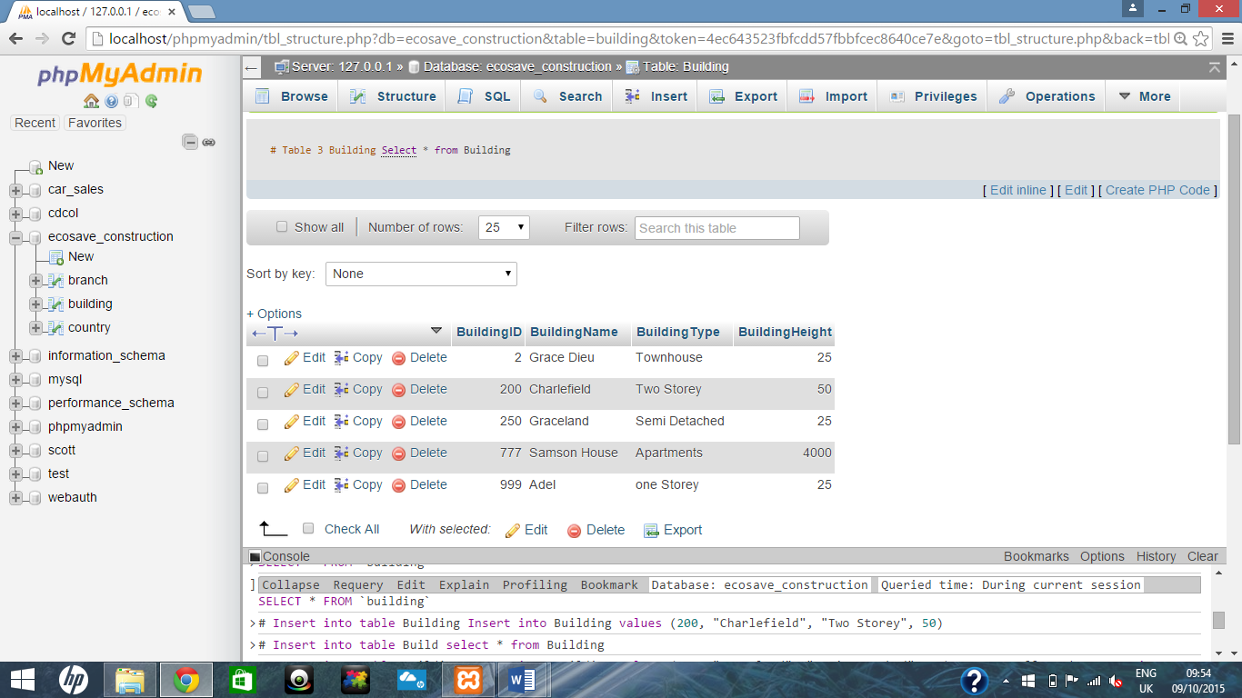

#Table 4

CREATE TABLE IF NOT EXISTS Roof

(

RoofID Int (3) NOT NULL,

RoofType enum("Flat", "Pitched", "Vaulted") default "Pitched",

RoofAngle Int (3) not null default 45,

RoofSoilDepth INT (5) not null,

Constraint PK_Roof PRIMARY KEY(RoofID)

);

# Table 4 Values

Insert into Roof (RoofID, RoofSoilDepth) values (501, 6000);

Insert into Roof values (200, "Flat", 30, 5000);

Insert into Roof (RoofID, RoofSoilDepth) values (506, 9999);

Insert into Roof (RoofID, RoofSoilDepth) values (888, 9987);

Insert into Roof values (524, "Vaulted", 60, 5000);

# Table 4

Select * from Roof;

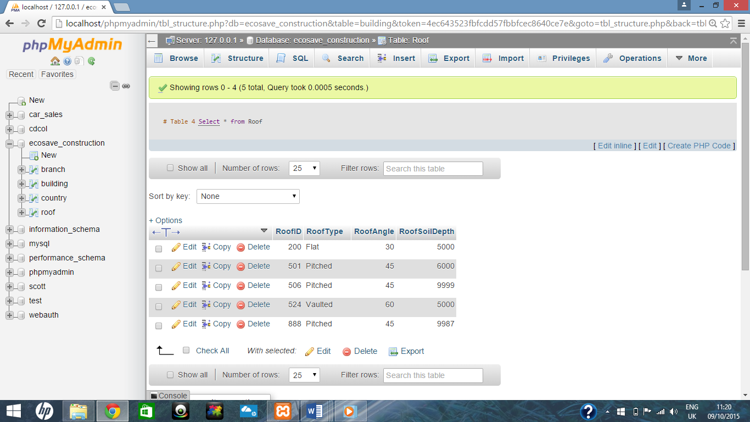

# Create Table 5

CREATE TABLE IF NOT EXISTS Client

(

ClientID Int (5) NOT NULL,

PRIMARY KEY(ClientID),

ClientName VARCHAR (50),

ClientAddress varchar (50) not null,

ClientEmail varchar (30) not null,

ClientPhone Int (10) not null,

ClientVatNum Int (10) Unique,

CompanyName Varchar (50),

CompanyDesc enum("SME", "Multinational")

);

# Insert values Table 5

Insert into client values (50001, "Noel Grace", "Tinnislatty, The Rower, Co. Kilkenny", "noelgrace@gmail.com", 0851267976, 1111111111, "Redhat", "SME");# 1 row affected.

INSERT INTO `client` VALUES (60001, 'Michael Grace', 'Tinnislatty, The Rower, Co. Kilkenny', 'mickeygmart@msn.com', 872729040, 1111111119, 'Intreo', 'SME'); # 1 row affected.

Insert into client values (60003, "Paddy Walsh", "Michael St, New Ross, Co. Wexford", "pwalsh@yahoo.co.uk", 0872727777, 1111111889, "Apex", "SME");# 1 row affected.

Insert into client values (60333, "Anna McGrath", "Haggard, Ramsgrange, Co. Wexford", "annamc@msn.ie", 0563411564, 1111113000, "Novartis", "Multinational");# 1 row affected.

Insert into client values (60555, "Rose Mansfield", "Michael St, Kilkenny, Co. Kilkenny", "rosem@msn.com", 0563478956, 1111500000, "An Post", "Multinational");# 1 row affected.

# View Table 5

Select * from client;

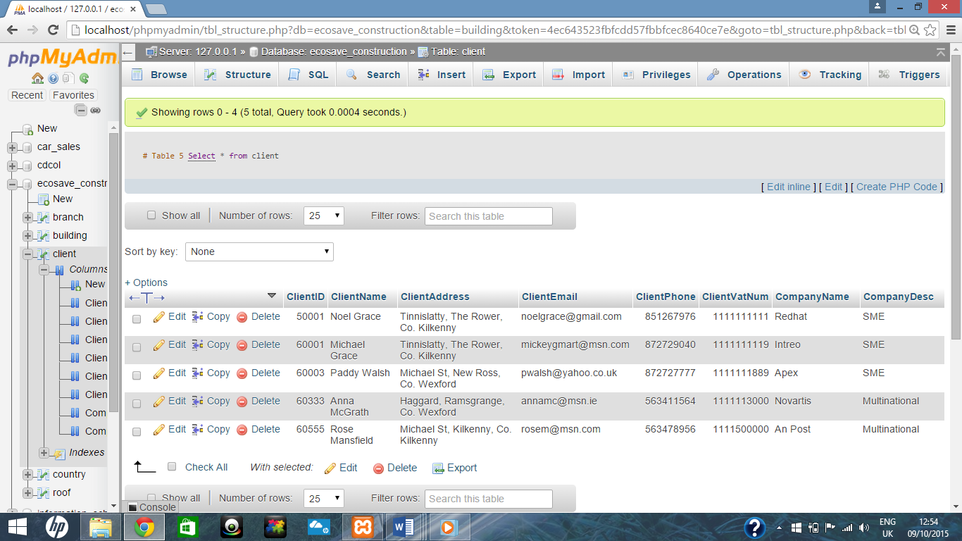

# Insert values Table 6

INSERT INTO `site` (`SiteID`, `StartDate`, `SiteAddress`, `EndDate`, `S_BranchID`, `S_RoofID`, `S_BuildingID`, `S_ClientID`) VALUES

(235, '2015-10-12', 'Edinburgh', '2047-10-12', 100, 524, 777, 60555),

(236, '2015-09-22', 'Edinburgh', '2015-10-07', 102, 888, 999, 60333),

(237, '2016-01-14', 'Edinburgh', '2015-07-07', 102, 200, 999, 60333),

(239, '2015-10-12', 'Edinburgh', '2047-10-12', 100, 524, 777, 60555),

(600, '2015-10-09', 'Dublin', '2015-10-26', 1, 501, 200, 50001),

(677, '1982-12-01', 'London', '2015-12-01', 2, 200, 250, 60001),

(888, '1981-07-22', 'Cardiff', '2015-12-01', 10, 506, 2, 60003);

# View Table 6

SELECT * FROM `site`;

