About Alli

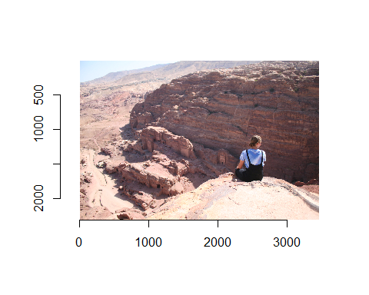

Alli is from Eagle, Idaho She is 5’7" and really cute Alli’s favorite hobbies are

* sleeping on buses
* going to the temple
* canyoneering with her BF
* wiping bums
* shooting bears
* dating long distance

Alli is planning on working at Geico and is currently finishing a nursing degree from Nursing

