QRM II Graded Assignment (5)
  - Period 1, 2026
Group-20, – Stefan Rares Ratiu, Iann Soffried, Noel Kona, Sofia Tataryn, Hashim Aburumman
27-09-2026

Introduction
This assignment is to be completed in groups of 4-5. Further, all students in your group need to be assigned to the same R tutorial group (Friday’s tutorial). You can sign yourself up for a group on Canvas. Please do so You can use the Discussion Board in Canvas if you do not have a group yet or if your group is incomplete.
The assignment has 5 parts, and each part corresponds to the course material of that week (with the exclusion of week 6, for which there is no R programming material).
You are supposed to hand in these assignments on Canvas at the following dates:
- Deadline 1 Sunday September 27th, at 23:59pm: you are supposed to hand in weeks 1, 2, and 3 of this assignment. This will determine 18% of your overall course grade
- Deadline 2 Sunday October 11th, at 23:59pm: you are supposed to hand in weeks 4, and 5 of this assignment. This will determine 12% of your overall course grade
The R tutorials (each Friday) will consist of two halves. During the first half, you will discuss the tutorial exercises. These can be downloaded separately from Canvas. During the second half, you can work on this graded assignment within your own group. The purpose is that you find out how to work with R for doing statistical analyses by yourself. The tutorial exercises are meant to teach you basic commands to get you started, but to answer the problem sets in this assignment, you might need to research your own solutions, and use functions and commands not described in the tutorial exercises. Learning how to solve your own research problems is integral part of learning R. When you and your group get stuck on how to approach an exercise, the hierarchy in finding your way is as follows:
- use the concepts from the tutorial exercises;
- use the cheat sheets available on Canvas;
- use Google, YouTube, StackOverflow, or another website;
- ask the teacher.
The use of generative AI is permitted and may result in a grade of 0. See the AI protocol in the course manual for details.
To answer the assignment, you can simply fill out this R markdown document. There are designated places which you can fill with R code. There are also designated spaces for you to answer each question. Often, the structure of an answer will be as follows. First, you type the R code in the designated box. This will show how you analyzed the data to get the answer to the question. Below the box for the R code, you will then summarize your answer to the question, i.e. what are the conclusions that you draw from the data analysis?
When handing in, you are supposed to submit this .Rmd file, and a knitted version of this document. You can knit this document to pdf, word, or html. Knitting to pdf requires you to have a .tex distribution installed on your computer. Knitting to Word requires you to have Word installed.
The exercises are designed such that you should be able to finish the majority of them during the tutorial each week. If you are not able to finish them fully during that time, you are expected to work on it in your own time using the computers on campus or your own device. It is best to meet as a group in-person when working together. If you want to work remotely, github is a good platform to guarantee smooth collaboration. Alternatively, you can email this .Rmd file back and forth to one another as a group, but this is not recommended as it is more cumbersome.
We encourage you to keep your code blocks, printing statements, and final answers, as short as possible. In any case, there is a page limit of 6 pages per week, which encompasses the total length of this document which consists of the questions, your coding lines, and your answers. When your answers to questions of the respective week exceed this page limit, they will not be graded, resulting in zero points.
Each week consists of 1, 2, or 3 subquestions. The total amount of points you can earn per week is 20 points.

Week 1
- Find the dataset “movies4.tsv” on Canvas. Describe your data set: How many observations does it have. How many variables are there? How many subjects? What consists of a subject?
movies <- read.csv("movies4.tsv", sep = "\t")
dim(movies)
## [1] 808 19
length(unique(movies$title))
## [1] 808
Your Answer:
The data set has 808 observations and 19 variables, such as budget, popularity, genre, runtime etc. There are 808 subjects and one subject is a movie. Every title appears only once, so each row is a different movie, and this is why the number of observations is equal to subjects.
- Which of the following types of variables are present in your data set? (i) nominal; (ii) ordinal; (iii); interval; (iv) ratio. If present, name one example of such a variable present in your data set.
str(movies)
## 'data.frame': 808 obs. of 19 variables:
## $ index : int 2256 2473 1514 1512 395 3156 4753 4590 1665 2714 ...
## $ budget : num 0.0 1.5e+07 3.2e+07 3.2e+07 8.5e+07 0.0 6.0e+04 0.0 0.0 1.4e+07 ...
## $ keywords : chr NA "barcelona spain menage a trois author" "gunslinger revenge prairie shootout pistol" "robbery double life dual identity small town indiana" ...
## $ original_language : chr "en" "en" "en" "en" ...
## $ title : chr "The Oogieloves in the Big Balloon Adventure" "Vicky Cristina Barcelona" "The Quick and the Dead" "A History of Violence" ...
## $ popularity : num 0.286 32.758 16.473 34.629 44.967 ...
## $ release_date : chr "2012-08-29" "2008-08-15" "1995-02-09" "2005-09-23" ...
## $ revenue : num 0.00 9.64e+07 1.86e+07 6.07e+07 1.94e+08 ...
## $ runtime : int 88 96 107 96 136 92 93 97 138 149 ...
## $ vote_average : num 2.2 6.7 6.3 6.9 6.7 7.1 5.1 5.6 6.7 6.1 ...
## $ vote_count : int 8 1020 427 832 1225 83 6 4 144 86 ...
## $ genre : chr "Family" "Drama" "Action" "Drama" ...
## $ release_year : int 2012 2008 1995 2005 2006 2011 2012 2004 2004 2011 ...
## $ release_month : int 8 8 2 9 12 8 10 9 9 9 ...
## $ release_day : int 29 15 9 23 8 4 13 23 3 30 ...
## $ first_actor : chr "Christopher Lloyd" "Scarlett Johansson" "Sharon Stone" "Viggo Mortensen" ...
## $ first_actor_gender : chr "male" "female" "female" "male" ...
## $ director_first_name: chr "Matthew" "Woody" "Sam" "David" ...
## $ director_gender : chr "male" "male" "male" "male" ...
Your Answer:
All four types of variables are present in the data set. The firs type is nominal, where genre is included in this variable type. The second type is ordinal, where vote_average is included in this variable type. The third is interval, where release_year is included in this variable type. The fourth is ratio, where budget is included in this variable type.
- A movie studio wants to know which types of movies give maximal profit. Perform the following steps to provide the movie studio with an analysis which corresponds to their request:
- Create the variable profits as the revenue of a movie minus its budget. Report its mean, median, maximum, and minimum.
- Which movie has the highest profits in your data set and how much are these profits. Which movie has the lowest and how much are its profits? If multiple movies have the exact same highest or lowest profits, give only one example.
- Create a boxplot of the variable profits. Make sure it has an appropriate title, and appropriate titles and labels for the x- and y-axis. Give Q1, Q2, Q3, and Q4. What does this tell you about the nature of making money in the movies industry?
- Add a new variable to your data set the log of profits. When creating this variable, what happens to movies for which profits is zero or negative? What then happens when you calculate the mean of log of profits?
- For movies that have a profit of zero or less, replace log of profits with “NA”. What is now the mean of log of profits? Create a boxplot for log of profits, again with an appropriate title, x- and y-axis labels. How does it compare to the boxplot you made under c.)?
- Create a scatterplot of with the runtime of movies on the x-axis and the average vote of movies on the y-axis. What do you conclude from the scatterplot? Are movies with a longer runtime considered worse or better by the audience, or does the audience not have a preference? Why do you think this is the case?
For each step, you should provide first all the code you used to answer the question and then formulate an answer using full sentences.
Step a
moviesprofits<-movies$revenue - movies$budget
summary(moviesprofits)
## Min. 1st Qu. Median Mean 3rd Qu. Max.
## -150000000 -1849854 0 52885669 49711134 1299557910
Your Answer:
The mean profit is 52885669, which is around 52.9 million, and the median profit is 0. The highest profit or the maximum is 1299557910, which is around 1.3 billion, and the lowest or the minimum is -150000000, which is a loss of 150 million. Th mean is far above the median, so profits are right-skewed, which means that a few hits pull the average or mean up. The median is 0 because some of the movies have both a budget and revenue of 0, which probably means the data is missing.
Step b
movieprofits<-movies$revenue-movies$budget
movies$title[movieprofits == max(movieprofits)]
## [1] "The Avengers"
max(movieprofits)
## [1] 1299557910
movies$title[movieprofits == min(movieprofits)]
## [1] "The Wolfman"
min(movieprofits)
## [1] -1.5e+08
Your Answer:
The movie with the highest profit is The Avengers, with 1299557910, which is around 1.3 billion. The movie with the lowest profit is The Wolfman, with -150000000, which is a loss of 150 million. The Wolfman has the lowest profit because the revenue is recorded as 0 and the the budget is 150 million, so the revenue may be missing from the data.
Step c
movies$profits<-moviesprofits
ggplot(movies, aes(y = profits / 1000000)) +
geom_boxplot() +
labs(title = "Boxplot of profits for the movies",
x = "All movies" , y = "Profits")
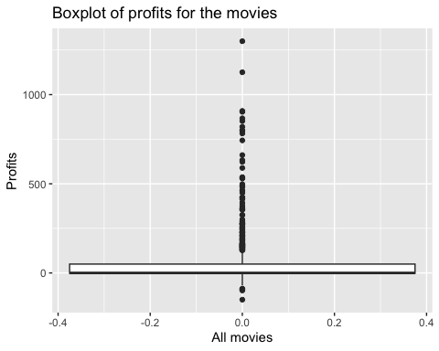
quantile(moviesprofits)
## 0% 25% 50% 75% 100%
## -150000000 -1849854 0 49711134 1299557910
Your Answer:
The quartiles of profits are Q1 = -1849854, Q2/median = 0, Q3 = 49711134, and Q4/maximum = 1299557910. The interpretation of the quartiles is that more than a quarter of movies lose money, and half make no profit at all. The box is small and sits near zero, but there are many large outliers above it. This shows that making money in movies is very risky and depends on a few hits.
Step d
movieslogprofits<-log(moviesprofits)
## Warning in log(moviesprofits): NaNs produced
mean(movieslogprofits)
## [1] NaN
Your Answer:
For the movies with a 0 profit it returns -Infinity, because log(0) goes to -infinity. For the movies with negative profit it returns NaN, because the log of a negative number does not exist. The log is defined only for positive numbers. The mean of log of profits return NaN. So the mean cannot be computed until these values are dealt with.
Step e
movieslogprofits[moviesprofits <= 0] <- NA
mean(movieslogprofits, na.rm = TRUE)
## [1] 17.33131
movies$log_profits<-movieslogprofits
ggplot(movies, aes( y = log_profits)) +
geom_boxplot() +
labs(title = "Boxplot of log of movie profits",
x = "Movies with positive profits", y = "Log of profits")
## Warning: Removed 407 rows containing non-finite outside the scale range
## (`stat_boxplot()`).
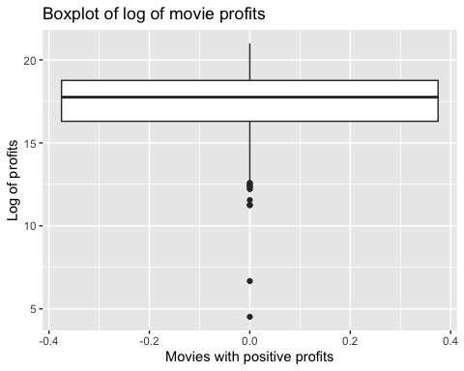
Your Answer:
After replacing the log of profits with NA for movies with negative or 0 profit, the mean log of profits is 17.33, which is calculated over the profitable movies. If we convert the mean is about 33.6 million. This boxplot is much more symmetric, compared with the boxplot in c). Now the box is visible and the median is in the middle. In c) the box was near to 0 and and there were many outilers at the top. Taking the log compresses the very large values, so the huge movies no longer dominate the plot. The downside of this exercise is that the movies with a loss or 0 profit are left out, so this plot describes only movies that were profitable.
Step f
ggplot(movies, aes(x = runtime, y = vote_average)) +
geom_point() +
geom_smooth(method = "lm") +
labs(title = "Runtime vs. average vote of movies",
x = "Runtime (minutes)", y = "Average vote (0-10)")
## `geom_smooth()` using formula = 'y ~ x'
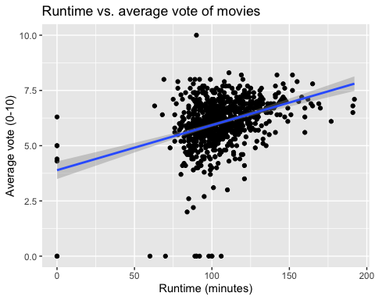
cor(movies$runtime,movies$vote_average)
## [1] 0.3550796
Your Answer:
The scatterplot shows a weak to moderate positive relationship between runtime and average vote, the correlation is equal to 0.36. Most of the movies last between 90 and 120 minutes and have a score between 5 and 7. The trend line slopes upward, which means movies shorter than 90 minutes score about 5.6 on average, while movies over 150 minutes score about 6.9. Longer movies tend to be rated better by the audience, although there is a lot of spread around the line. The audience might prefer longer movies because of the big budgets, better story and actors, while short movies have lower budgets.

Week 2
1 Is your dataset movies4.tsv the full population, or is it a sample of a larger population? If the latter, how would you describe the full population?
Your Answer:
It is the sample of a larger population. This data set consists primarily of widely distributed, mostly mainstream English-language and major international commercial movies. The full population would represent all commercially distributed movies throughout cinematic history.
2
- For which actor in your data set do you observe the most movies?
- What is the average revenue of the movie in which this actor plays and does the revenue lie above or below the revenue of an average movie according to your data set?
- How trustworthy do you consider your conclusion to answer 2b? Use the term “law of large numbers” in your explanation.
step a
top_actor_summary <- movies %>%
filter(!is.na(first_actor)) %>%
count(first_actor, sort = TRUE)
top_actor_name <- top_actor_summary$first_actor[1]
Your Answer:
With 9 movies, Bruce Willis is the actor with the most movies in the data set.
step b
avg_bruce<- movies %>%
filter(first_actor=="Bruce Willis" & revenue > 0) %>%
summarise( avg_rev = mean(revenue), na.rm=T) %>%
pull(avg_rev)
avg_rev_ovr<-mean(movies$revenue, na.rm=T)
Your Answer:
Bruce Willis has an average revenue of $255,7 million in his movies in this data set, lying over the overall average of the population of $82,7 million.a
step c
bruce_stats <- movies %>%
filter(first_actor == "Bruce Willis" & revenue > 0 & !is.na(revenue)) %>%
summarise(
sample_size = n(),
mean_revenue = mean(revenue),
sd_revenue = sd(revenue))
print(bruce_stats)
## sample_size mean_revenue sd_revenue
## 1 9 255652124 244997333
Your Answer:
The conclusion is not trustworthy due to the very small sample size and extreme variance. According to the law of large numbers, as a sample size becomes larger, the sample mean converges closer to the true population mean. In the filtered dataset, it is only possible to observe a sample size of 9 movies where Bruce Willis is listed as the “first_actor”. Because the standard deviation ($245 million) is nearly as large as the sample mean ($255 million), individual blockbuster outliers impact the average heavily. While the sample mean is large enough that Bruce Willis’ average likely remains above the overall dataset average ($82.7 million), 9 is far too small for the law of large numbers to ensure that this sample mean is an accurate estimate of his true career population average.
3 For this question, you will assume that your data set is the full population.
- Recode profits such that it is expressed in millions. What is the variance of the variable profits (in millions) in your data set?
- Create a new data set, called movies_sample. Make sure that it is a random sample of your data set of 25 movies. What is the variance of profits in this random sample? How does it compare to the variance of profits in 2a?
- In a for loop, create 100 different samples of 25 movies, as in b, and estimate the variance within each sample. Save the variance of each sample in a vector called sample_vars. So the first position of the vector would have the variance of the first sample, the second position the variance of the second sample, etc. Print the start of this vector.
- Summarize and make a histogram of sample_vars. What is the mean, standard deviation and shape of its distribution?
- In your opinion, is a sample of 25 movies sufficient to get a reliable estimate of the population variance of profits, using the sample variance? Explain?
step a
movies<- movies %>%
mutate( profit = (revenue - budget) / 1000000)
pop_var_profit<- var(movies$profit, na.rm=T) * ((nrow(movies)-1)/nrow(movies))
Your Answer:
After recoding profits to millions, the variance of profit_millions in the full dataset is approximately $20.245,47, depending on exact dataset row counts and handling of zero values).
step b
set.seed(9849)
movies_sample <- movies %>%
filter(!is.na(profit)) %>%
slice_sample(n = 25)
sample_var_profit <- var(movies_sample$profit)
Your Answer:
Due to sampling variability, the variance in a single small sample of 25 movies can differ substantially from the population variance found in 3a. Depending on whether high-budget blockbusters or major box-office flops were randomly selected into this specific sample, the sample variance could be significantly higher or lower than the overall population variance. In this case it was $17.408, lower than the population variance.
step c
set.seed(9849)
n_simulations <- 100
sample_vars <- numeric(n_simulations)
for (i in 1:n_simulations) {
current_sample <- movies %>% slice_sample(n = 25)
sample_vars[i] <- var(current_sample$profit)
}
head(sample_vars)
## [1] 17408.060 55120.157 19341.454 7620.101 4789.374 7268.688
Your Answer:
The first few values of sample_vars display noticeable variation across iterations, showing how much sample variance fluctuates from one random sample of 25 movies to another.
step d
mean_sample_vars<-mean(sample_vars)
sd_sample_vars<-sd(sample_vars)
hist(sample_vars,
main="Distribution of Sample Variances (n=25)",
xlab="Sample Variance of Profits(millions)"
)
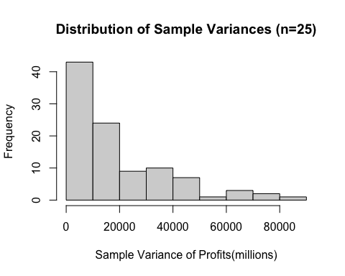
Your Answer:
Across our 100 random samples, the mean of the sample variances sits around 19340, but the standard deviation is huge at roughly 18590.
Looking at the histogram, the distribution is heavily skewed to the right. Most samples give a pretty modest variance, but sometimes a sample happens to draw a couple of massive blockbusters, which spikes that sample’s variance way out to the right and creates a long tail.
step e
Your Answer:
No, a sample size of 25 movies really isn’t enough to get a reliable estimate of the population variance.
First off, our results from step 3d show that the sample variances swing wildly from one sample to the next—the standard deviation of those variances is huge.
The main issue is how heavily right-skewed box office data is. Movies have extreme outliers, like massive blockbusters or high-budget flops. So even though sample variance is technically an unbiased estimator on average, any single random sample of 25 movies is just too small to give you a trustworthy estimate of the true population variance.

Week 3
For the next part of the assignment, assume that the movies in your data frame are a random sample of a larger population of movies.
1
- Create a new data set that only includes movies that are of the genre “Thriller”. For these thriller movies, give a 99 percent confidence interval for the variable runtime. Interpret the result.
- Now, assume that the variance of runtime amongst thriller movies in your data is exactly the same as the variance of runtime in the population. Under this assumption, give a 99 percent confidence interval for the variable runtime among thriller movies. Interpret the result. Is you confidence interval wider or less wide than the one you found under question 1a? Why is that the case?
step a
thriller<-movies%>%
filter(genre=="Thriller")
t1<-t.test(thriller$runtime,conf.level=0.99)
print (t1$conf.int)
## [1] 100.5517 109.8965
## attr(,"conf.level")
## [1] 0.99
Your Answer:
With the sample provided, there is a 99% confidence that the average runtime of thriller movies lies between 100.55 and 109.9
step b
mean_runtime<-mean(thriller$runtime)
sigma<-sd(thriller$runtime)
n<-length(thriller$runtime)
z_a2<-qnorm(0.995)
error<-z_a2*sigma/sqrt(n)
LOW<-mean_runtime-error
UP<-mean_runtime+error
print(c(LOW,UP))
## [1] 100.6292 109.8191
Your Answer:
Under the given assumption, the 99% confidence interval for the mean runtime of thriller movies is 100.63 and 109.82 minutes. This confidence interval is narrower than the one from question 1a since the population variance is known. With a known population variance there is less uncertainty when estimating, so the normal distribution is used rather than the t distribution.
2
- Using an appropriate five-step procedure, set up a test for the null hypothesis that the variance of runtime equals $500$. Clearly state your null hypothesis, alternative hypothesis your test statistic, your critical value, and your conclusion.
- For the validity of your test in 2a, what assumption about the distribution of revenue needs to hold? Make an appropriate plot to test this assumption. What do you conclude?
step a
s2<-var(thriller$runtime)
h0<-500
df<-length(thriller$runtime)-1
chisq<-df*s2/h0
chi_low<-qchisq(0.025,df)
chi_high<-qchisq(0.975,df)
print(chisq)
## [1] 84.90034
print(c(chi_low,chi_high))
## [1] 87.21279 146.57105
Your Answer:
The null hypothesis is H₀: σ² = 500 The alternative hypothesis is H₁: σ² ≠ 500. The test statistic is the calculated chi-square statistic, and the two critical values are given by the lower and upper critical values.The null hypothesis is rejected if the test statistic lies outside the two critical values. In this case, the test statistic is 84.9 and the two critical values are 87.21 and 146.57, so the test statistic is outside the critical region and we reject the null hypothesis. Therefore, given the significance level of 5% we can infer that there is sufficient statistical evidence to prove that the population variance of thriller movies runtime differs from 500.
step b
hist(thriller$runtime,
main="Distribution of Thriller Runtime",
xlab="Runtime")
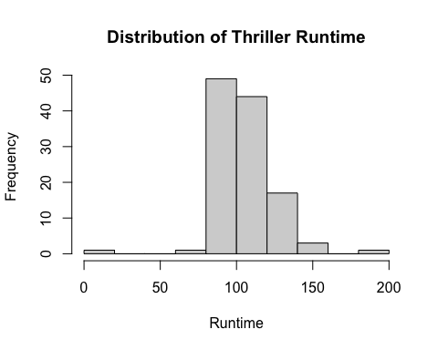
Your Answer:
For the validity of the chi square test for a population variance, the assumption that needs to hold is that the variable is normally distributed. The histogram depicts the distribution of thriller movie runtimes. The distribution appears more or less normal, so the normality assumption is reasonably satisfied.9
- There is an argument going on in the movie studio. Bob claims that they should make higher-quality movies, as this will bring in more profits. Chantal disagrees. She tells Bob that mediocre movies bring in the most profits. You are asked to advise on who is right.
- Create a new variable called vote_average_rounded. Make sure this variable is the same as vote_average, but without any decimals (i.e., a 6.3 becomes a 6, a 8.7 an 8, etc.). Display a histogram of vote_average_rounded.
- Create a scatter plot with vote_average_rounded on the x axis and the mean of profits within each category of vote_average_rounded on the y-axis. Make sure it has an appropriate title, and appropriate titles and labels for the x- and y-axis. At which rating of movies are profits the highest?
- Recreate the scatter plot with year on the x axis and mean_profits on the y-axis, but now add bars around each point, indicating the 95% confidence interval.
- Write an advice to settle the argument between Bob and Chantal.
step a
movies<-movies%>%
mutate(vote_average_rounded=floor(vote_average))
hist(movies$vote_average_rounded,
main="Distribution of Rounded Movie Ratings",
xlab="Rounded Vote Average")
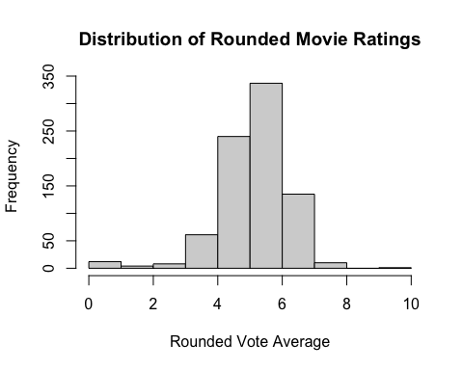
Your Answer:
The variable vote_average_rounded was created by removing the decimals of the original vote average. The histogram depicts the distribution of these rounded ratings.
step b
movies<-movies%>%
mutate(profit=(revenue-budget))
mean_profits<-tapply(movies$profit,
movies$vote_average_rounded,mean,na.rm=TRUE)
print(mean_profits)
## 0 2 3 4 5 6
## -0.25 374996.75 -15156533.38 -3283506.84 24557416.21 61782686.81
## 7 8 10
## 103150179.76 241184708.60 -1.00
plot(mean_profits,
main="Mean Profit by Movie Rating",
xlab="Rounded Vote Average",
ylab="Mean Profit")
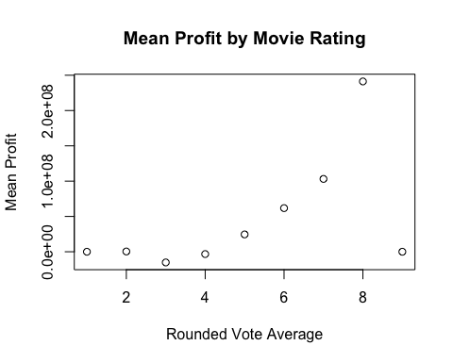
Your Answer:
The scatter plot illustrates how much profit a film earns in each particular vote-average category. The most profitable category is the one with a rating of 8. Thus, based on the given data regarding films, the movies with this rating have the maximum average profit earned.
step c
mean_profits<-tapply(movies$profit,
movies$release_year,
mean,
na.rm=TRUE)
years<-sort(unique(movies$release_year))
lower<-c()
upper<-c()
for(i in 1:length(years)){
profits<-movies$profit[movies$release_year==years[i]]
profits<-profits[!is.na(profits)]
t1<-t.test(profits)
lower[i]<-t1$conf.int[1]
upper[i]<-t1$conf.int[2]
}
plot(years,
mean_profits,
main="Mean Movie Profit by Year",
xlab="Release Year",
ylab="Mean Profit")
arrows(years,lower,
years,upper,
angle=90,
code=3,
length=0.05)
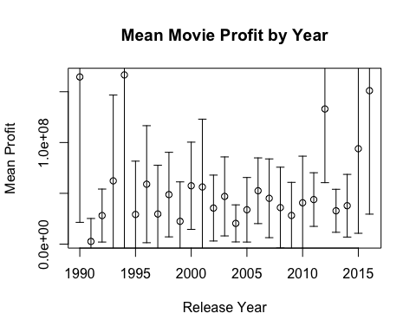
Your Answer:
The chart depicts the average earnings of films for each year in the records while also showing the 95% confidence intervals. The dots indicate the calculated average earnings of films for each year, and the spikes reflect the uncertainty regarding those calculations. The width of the confidence intervals differs from year to year due to different quantities of films and their variability in different years.
step d
Your Answer:
The data suggests that average earnings change depending on the movie rating, where one category has the highest average earnings. However, this does not imply that movie quality influences the earnings since the relationship observed could be confounded by other factors like budget, popularity, type, actors, or the year of release. Thus, the results of this study can hardly indicate whether high-quality films or ones of mediocre quality earn the most. It is advisable for the company to consider the uncertainty in calculations and other factors before making conclusions.

Week 4
- There is another argument going on in the movie studio. Bob claims that production budgets are getting out of hand, and that the studio should focus on making cheaper movies. Chantal disagrees. She tells Bob that ``Every dollar we spend on movie production is more than offset by the increase in movie profits’’.
- Set up a regression model to test Chantal’s claim, and estimate it. That is, estimate:
$${\text{Profits}}_{i}=β_{0}+β_{1}{\text{Budget}}_{i}+ε_{i}.$$
- Print a summary of your estimated model.
- What is the estimated value of $β_{1}$ and how do you interpet it?
- Test for the null hypothesis that $β_{1}≥0$. Report the p-value and state your conclusion.
- Next, estimate the model
$${\text{Log Profits}}_{i}=β_{0}+β_{1}{\text{Log Budget}}_{i}+ε_{i}.$$
- When creating the variables Log Profits and Log Budget, make sure that movies with a Revenue or Budget of zero are assigned the value “NA”. Print a summary of your estimated model
- What is the estimated value of $β_{1}$ and how do you interpet it?
- Which model has better fit? The level-level model or the log-log model? Explain.
- Who do you think is correct? Bob or Chantal? What would you advise the movie studio to do?
step a
#WRITE YOUR CODE HERE
Your Answer:
Write your formulated response here.
step b
#WRITE YOUR CODE HERE
Your Answer:
Write your formulated response here.
step c
#WRITE YOUR CODE HERE
Your Answer:
Write your formulated response here.
step d
#WRITE YOUR CODE HERE
Your Answer:
Write your formulated response here.
step e
#WRITE YOUR CODE HERE
Your Answer:
Write your formulated response here.
step f
#WRITE YOUR CODE HERE
Your Answer:
Write your formulated response here.
step g
#WRITE YOUR CODE HERE
Your Answer:
Write your formulated response here.
2
- Make a plot with a 95% confidence interval with the mean log of budget on the y-axis, and whether the first actor of the movie is male or female on the x-axis. What do you conclude?
- Estimate the following simple OLS model: $log(budget)_i=\beta_0+\beta_1 \text(FirstActorMale)_i + \varepsilon_i.$ Is the estimated coefficient for $β_{1}$ significantly different from zero? How do you interpret its estimate, and how does this relate to your conclusion in 2a?
- Now, have a close look at your data frame. Can you find any instances of male first actors who are wrongly labeled as being female, or vice versa? What would such mislabelling mean for the coefficient you estimated under 2b?
step a
#WRITE YOUR CODE HERE
Your Answer:
Write your formulated response here.
step b
#WRITE YOUR CODE HERE
Your Answer:
Write your formulated response here.
step c
#WRITE YOUR CODE HERE
Your Answer:
Write your formulated response here.

Week 5
- Create a plot of the mean profits by month of release. Do you see any indication that month of release matters to the profits of the movie?
- Estimate an OLS model which has as dependent variable the log of profits of a movie, and as independent variable the log of budget, a dummy for whether the movie was released in english or not, and a linear term for the month of release. Show a summary of the resulting model and interpret each coefficient.
- Test for the hypothesis that the coefficient that belongs to month of release is zero.
- Based on your plot in a.) do you consider the choice that month of release enters the model linearly under b.) reasonable? Estimate a specification that allows for a more flexible curve. In this new specification, test for the null hypothesis that month of release does not impact profits. This might require testing multiple terms at once.
- One executive at the studio wants to time the release of the movie to a specific month of the year such that they can maximize revenue. Based on your model under d.), What would you advise the movie studio regarding the timing of the release of the movie?
The movie studio that you work at is releasing a new movie in 2026. It will be an English-spoken Thriller movie with a budget of 40,000,0000.
- Estimate a model that is able to predict the revenue of this movie. Give its predicted revenue and include a 99% prediction interval.
step a
#WRITE YOUR CODE HERE
Your Answer:
Write your formulated response here.
step b
#WRITE YOUR CODE HERE
Your Answer:
Write your formulated response here.
step c
#WRITE YOUR CODE HERE
Your Answer:
Write your formulated response here.
step d
#WRITE YOUR CODE HERE
Your Answer:
Write your formulated response here.
step e
#WRITE YOUR CODE HERE
Your Answer:
Write your formulated response here.
step f
#WRITE YOUR CODE HERE

