**Week1**

**Design Principles and Patterns**

**HandsOn**

**1.Singleton**

Code:

class Logger {

private static Logger instance;

private Logger() {

System.out.println("Logger initialized");

}

public static Logger getInstance() {

if (instance == null) {

instance = new Logger();

}

return instance;

}

public void log(String message) {

System.out.println("[LOG]: " + message);

}

}

public class Main {

public static void main(String[] args) {

Logger logger1 = Logger.getInstance();

Logger logger2 = Logger.getInstance();

logger1.log("This is the first log message.");

logger2.log("This is the second log message.");

if (logger1 == logger2) {

System.out.println("Only one instance of Logger exists.");

} else {

System.out.println("Different instances exist (ERROR).");

}

}

}

Output:

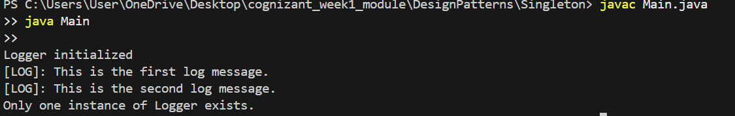**2.Factory**

Code:

interface Document {

void open();

}

class WordDocument implements Document {

public void open() {

System.out.println("Opening Word document...");

}

}

class PdfDocument implements Document {

public void open() {

System.out.println("Opening PDF document...");

}

}

class ExcelDocument implements Document {

public void open() {

System.out.println("Opening Excel document...");

}

}

abstract class DocumentFactory {

public abstract Document createDocument();

}

class WordFactory extends DocumentFactory {

public Document createDocument() {

return new WordDocument();

}

}

class PdfFactory extends DocumentFactory {

public Document createDocument() {

return new PdfDocument();

}

}

class ExcelFactory extends DocumentFactory {

public Document createDocument() {

return new ExcelDocument();

}

}

public class Main {

public static void main(String[] args) {

DocumentFactory factory;

factory = new WordFactory();

factory.createDocument().open();

factory = new PdfFactory();

factory.createDocument().open();

factory = new ExcelFactory();

factory.createDocument().open();

}

}

Output:

