Data Cleaning- Summer 2024 Research Project
Noelle Tanaka
2025-10-07

Variable Types
bigdata <- read.csv("tanaka_photoperiod_experiment_summer_2024 .csv",
strip.white = TRUE,
check.names = TRUE)
names(bigdata)
## [1] "id.number" "beetle.number"
## [3] "replicate" "day.of.experiment"
## [5] "photoperiod" "light.status"
## [7] "dispersal" "burial"
## [9] "perched.on.stick.in.water" "perched.on.stick.out.of.water"
researchdata <- data.frame(
id.number = bigdata$id.number,
beetle.number = bigdata$beetle.number,
replicate = bigdata$replicate,
day.of.experiment = bigdata$day.of.experiment,
photoperiod = bigdata$photoperiod,
light.status = bigdata$light.status,
dispersal = bigdata$dispersal,
burial = bigdata$burial,
perched.on.stick.in.water = bigdata$perched.on.stick.in.water,
perched.on.stick.out.of.water = bigdata$perched.on.stick.out.of.water
)
researchdata$photoperiod <- as.factor(researchdata$photoperiod)
researchdata$light.status <- as.factor(researchdata$light.status)
researchdata$light.status <- fct_recode(researchdata$light.status,
"On" = "1",
"Off" = "0")
researchdata$dispersal <- as.factor(researchdata$dispersal)
researchdata$dispersal <- fct_recode(researchdata$dispersal,
"Yes" = "1",
"No" = "0")
researchdata$burial <- as.factor(researchdata$burial)
researchdata$burial <- fct_recode(researchdata$burial,
"Yes" = "1",
"No" = "0")
researchdata$perched.on.stick.in.water <- as.factor(researchdata$perched.on.stick.in.water)
researchdata$perched.on.stick.in.water <- fct_recode(researchdata$perched.on.stick.in.water,
"Yes" = "1",
"No" = "0")
researchdata$perched.on.stick.out.of.water <- as.factor(researchdata$perched.on.stick.out.of.water)
researchdata$perched.on.stick.out.of.water <- fct_recode(researchdata$perched.on.stick.out.of.water,
"Yes" = "1",
"No" = "0")
str(researchdata)
## 'data.frame': 1200 obs. of 10 variables:
## $ id.number : int 1 2 3 4 5 6 7 8 9 10 ...
## $ beetle.number : int 1 2 3 4 5 6 7 8 9 10 ...
## $ replicate : int 1 2 3 4 5 6 7 8 9 10 ...
## $ day.of.experiment : int 1 1 1 1 1 1 1 1 1 1 ...
## $ photoperiod : Factor w/ 5 levels "0","8","12","16",..: 5 5 5 5 5 5 5 5 5 5 ...
## $ light.status : Factor w/ 2 levels "Off","On": 2 2 2 2 2 2 2 2 2 2 ...
## $ dispersal : Factor w/ 2 levels "No","Yes": 1 1 1 2 2 1 1 1 1 1 ...
## $ burial : Factor w/ 2 levels "No","Yes": 2 1 2 1 1 1 1 1 1 1 ...
## $ perched.on.stick.in.water : Factor w/ 2 levels "No","Yes": 1 2 1 1 1 1 1 1 2 1 ...
## $ perched.on.stick.out.of.water: Factor w/ 2 levels "No","Yes": 1 1 1 1 1 1 1 1 1 1 ...

Clean up Numeric Variables
summary(researchdata)
## id.number beetle.number replicate day.of.experiment
## Min. : 1.0 Min. : 1.00 Min. : 1.00 Min. : 1.00
## 1st Qu.: 300.8 1st Qu.: 25.75 1st Qu.: 5.75 1st Qu.: 3.75
## Median : 600.5 Median : 50.50 Median :10.50 Median : 6.50
## Mean : 600.5 Mean : 50.50 Mean :10.50 Mean : 6.50
## 3rd Qu.: 900.2 3rd Qu.: 75.25 3rd Qu.:15.25 3rd Qu.: 9.25
## Max. :1200.0 Max. :100.00 Max. :20.00 Max. :12.00
## photoperiod light.status dispersal burial perched.on.stick.in.water
## 0 :240 Off:960 No :649 No :1133 No :1145
## 8 :240 On :240 Yes:551 Yes: 67 Yes: 55
## 12:240
## 16:240
## 24:240
##
## perched.on.stick.out.of.water
## No :1144
## Yes: 56
##
##
##
##

Visualize Variables-Dispersal per Photoperiod Treatment
# Dispersal Mosaic - Filtered for rows 1102 to 1201
# Filter data for specified rows and remove NA values
filtered_data <- researchdata[1101:1201, ] %>%
filter(!is.na(photoperiod) & !is.na(dispersal))
# CHI-SQUARE TEST AND ASSUMPTIONS CHECKING
# 1. Check data structure and create contingency table
contingency_table <- table(filtered_data$photoperiod, filtered_data$dispersal)
print("Contingency Table:")
## [1] "Contingency Table:"
print(contingency_table)
##
## No Yes
## 0 10 10
## 8 7 13
## 12 10 10
## 16 9 11
## 24 13 7
# 2. Check sample size assumption (n >= 30)
total_n <- sum(contingency_table)
cat("\nTotal sample size:", total_n)
##
## Total sample size: 100
if(total_n >= 30) {
cat(" ✓ Sample size assumption met (n >= 30)\n")
} else {
cat(" ✗ Sample size assumption NOT met (n < 30)\n")
}
## ✓ Sample size assumption met (n >= 30)
# 3. Check independence assumption
cat("\nIndependence Assumption:")
##
## Independence Assumption:
cat("\n- Observations should be independent")
##
## - Observations should be independent
cat("\n- Each subject should contribute to only one cell")
##
## - Each subject should contribute to only one cell
cat("\n- Random sampling should be used")
##
## - Random sampling should be used
cat("\n✓ Assumed met based on experimental design\n")
##
## ✓ Assumed met based on experimental design
# 4. Check expected frequency assumption (all expected frequencies >= 5)
expected_freq <- chisq.test(contingency_table)$expected
print("\nExpected Frequencies:")
## [1] "\nExpected Frequencies:"
print(round(expected_freq, 2))
##
## No Yes
## 0 9.8 10.2
## 8 9.8 10.2
## 12 9.8 10.2
## 16 9.8 10.2
## 24 9.8 10.2
min_expected <- min(expected_freq)
cat("\nMinimum expected frequency:", round(min_expected, 2))
##
## Minimum expected frequency: 9.8
if(min_expected >= 5) {
cat(" ✓ Expected frequency assumption met (all cells >= 5)\n")
} else {
cat(" ✗ Expected frequency assumption NOT met (some cells < 5)\n")
cat("Consider using Fisher's Exact Test instead\n")
}
## ✓ Expected frequency assumption met (all cells >= 5)
# 5. Check for cells with expected frequency < 1
cells_less_than_1 <- sum(expected_freq < 1)
cat("Cells with expected frequency < 1:", cells_less_than_1)
## Cells with expected frequency < 1: 0
if(cells_less_than_1 == 0) {
cat(" ✓ No cells with expected frequency < 1\n")
} else {
cat(" ✗ Some cells have expected frequency < 1\n")
}
## ✓ No cells with expected frequency < 1
# 6. Perform Chi-square test
chi_test <- chisq.test(contingency_table)
print("\nChi-square Test Results:")
## [1] "\nChi-square Test Results:"
print(chi_test)
##
## Pearson's Chi-squared test
##
## data: contingency_table
## X-squared = 3.7615, df = 4, p-value = 0.4392
# 7. Calculate effect size (Cramér's V)
cramers_v <- sqrt(chi_test$statistic / (total_n * (min(dim(contingency_table)) - 1)))
cat("\nCramér's V (effect size):", round(cramers_v, 3))
##
## Cramér's V (effect size): 0.194
if(cramers_v < 0.1) {
cat(" (negligible effect)")
} else if(cramers_v < 0.3) {
cat(" (small effect)")
} else if(cramers_v < 0.5) {
cat(" (medium effect)")
} else {
cat(" (large effect)")
}
## (small effect)
# 8. Alternative tests if assumptions are violated
if(min_expected < 5 || cells_less_than_1 > 0) {
cat("\n\nAlternative Test (Fisher's Exact Test):")
if(nrow(contingency_table) == 2 && ncol(contingency_table) == 2) {
fisher_test <- fisher.test(contingency_table)
print(fisher_test)
} else {
cat("\nFisher's Exact Test not available for tables larger than 2x2")
cat("\nConsider Monte Carlo simulation or combining categories")
}
}
# 9. Summary of results
cat("\nChi-square statistic:", round(chi_test$statistic, 3))
##
## Chi-square statistic: 3.762
cat("\np-value:", round(chi_test$p.value, 4))
##
## p-value: 0.4392
if(chi_test$p.value < 0.05) {
cat("\n✓ Significant association between photoperiod and dispersal (p < 0.05)")
} else {
cat("\n✗ No significant association between photoperiod and dispersal (p >= 0.05)")
}
##
## ✗ No significant association between photoperiod and dispersal (p >= 0.05)
cat("\nEffect size (Cramér's V):", round(cramers_v, 3))
##
## Effect size (Cramér's V): 0.194
# Create summary data for plotting
mosaic_data <- filtered_data %>%
group_by(photoperiod, dispersal) %>%
summarise(count = n(), .groups = 'drop') %>%
group_by(photoperiod) %>%
mutate(prop = count / sum(count),
total = sum(count))
ggplot(mosaic_data, aes(x = factor(photoperiod), y = prop, fill = factor(dispersal))) +
geom_col(position = "stack", color = "white", size = 0.5) +
labs(
title = "Dispersal Proportions by Photoperiod (Rows 1102-1201)",
x = "Photoperiod (Hours of Light per Day)",
y = "Proportion",
fill = "Dispersal"
) +
theme_minimal() +
theme(
plot.title = element_text(size = 16, hjust = 0.5, margin = margin(b = 20)),
axis.title = element_text(size = 12),
axis.text = element_text(size = 11),
legend.title = element_text(size = 12),
legend.text = element_text(size = 11),
panel.grid.major.x = element_blank(),
panel.grid.minor = element_blank(),
plot.background = element_rect(fill = "white", color = NA),
panel.background = element_rect(fill = "white", color = NA)
) +
scale_fill_manual(values = c("No" = "orchid", "Yes" = "#4ECDC4")) +
scale_y_continuous(labels = scales::percent_format())
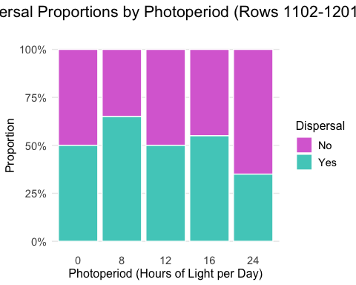
# Load required libraries
library(survival)
library(survminer)
## Loading required package: ggpubr
##
## Attaching package: 'survminer'
## The following object is masked from 'package:survival':
##
## myeloma
# Create survival object using researchdata
researchdata$dispersal_numeric <- ifelse(researchdata$dispersal == "Yes", 1, 0)
# Adjust the Event column:
# - 1 = dispersed
# - 0 = censored (death or no event)
researchdata$AdjustedEvent <- ifelse(researchdata$dispersal == "Yes", 1, 0)
# Set 12-hour photoperiod as the reference level
researchdata$photoperiod <- relevel(researchdata$photoperiod, ref = "12")
# Check the structure again
table(researchdata$AdjustedEvent, researchdata$photoperiod)
##
## 12 0 8 16 24
## 0 130 135 105 121 158
## 1 110 105 135 119 82
# Create the survival object
surv_obj <- Surv(time = researchdata$day.of.experiment, event = researchdata$AdjustedEvent)
#Check for assumptions !!!!!
res.cox1 <- coxph(surv_obj ~ photoperiod, data = researchdata)
res.cox1
## Call:
## coxph(formula = surv_obj ~ photoperiod, data = researchdata)
##
## coef exp(coef) se(coef) z p
## photoperiod0 -0.04730 0.95380 0.13644 -0.347 0.7288
## photoperiod8 0.23008 1.25870 0.12846 1.791 0.0733
## photoperiod16 0.08792 1.09190 0.13227 0.665 0.5063
## photoperiod24 -0.31906 0.72683 0.14591 -2.187 0.0288
##
## Likelihood ratio test=17.05 on 4 df, p=0.001888
## n= 1200, number of events= 551
res.zph1 <- cox.zph(res.cox1)
# Fit Cox Proportional Hazards Model
cox_model <- coxph(surv_obj ~ photoperiod, data = researchdata)
# View summary of the model
cox_model
## Call:
## coxph(formula = surv_obj ~ photoperiod, data = researchdata)
##
## coef exp(coef) se(coef) z p
## photoperiod0 -0.04730 0.95380 0.13644 -0.347 0.7288
## photoperiod8 0.23008 1.25870 0.12846 1.791 0.0733
## photoperiod16 0.08792 1.09190 0.13227 0.665 0.5063
## photoperiod24 -0.31906 0.72683 0.14591 -2.187 0.0288
##
## Likelihood ratio test=17.05 on 4 df, p=0.001888
## n= 1200, number of events= 551
# Create survival object
surv_obj <- Surv(time = researchdata$day.of.experiment,
event = researchdata$dispersal_numeric)
# Fit survival curves by photoperiod
surv_fit <- survfit(surv_obj ~ photoperiod, data = researchdata)
# Create the plot
ggsurvplot(
surv_fit,
data = researchdata,
conf.int = TRUE, # Add confidence intervals
xlab = "Days", # X-axis label
ylab = "Proportion Not Dispersed", # Y-axis label
palette = "jco", # Use a predefined color palette
font.x = 14, # Increase X-axis font size
font.y = 14, # Increase Y-axis font size
font.tickslab = 12, # Increase tick label font size
legend.title = "Photoperiod (Hours)", # Add legend title
ggtheme = theme_minimal(base_size = 8) # Apply theme directly
)
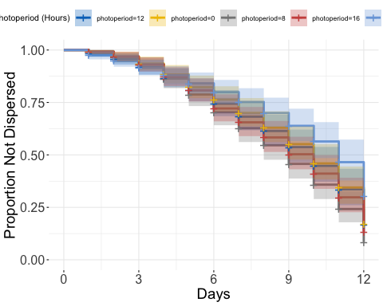
#Check for assumptions !!!!!
res.cox1 <- coxph(surv_obj ~ photoperiod, data = researchdata)
res.cox1
## Call:
## coxph(formula = surv_obj ~ photoperiod, data = researchdata)
##
## coef exp(coef) se(coef) z p
## photoperiod0 -0.04730 0.95380 0.13644 -0.347 0.7288
## photoperiod8 0.23008 1.25870 0.12846 1.791 0.0733
## photoperiod16 0.08792 1.09190 0.13227 0.665 0.5063
## photoperiod24 -0.31906 0.72683 0.14591 -2.187 0.0288
##
## Likelihood ratio test=17.05 on 4 df, p=0.001888
## n= 1200, number of events= 551
res.zph1 <- cox.zph(res.cox1)
res.zph1
## chisq df p
## photoperiod 2.74 4 0.6
## GLOBAL 2.74 4 0.6

Visualize Variables-Burial per Photoperiod Treatment- day 3
# Filter data to only include Day 3
day3_data <- researchdata %>%
filter(day.of.experiment == 3)
# Create summary data for mosaic plot
mosaic_data <- day3_data %>%
group_by(photoperiod, burial) %>%
summarise(count = n(), .groups = 'drop') %>%
group_by(photoperiod) %>%
mutate(prop = count / sum(count),
total = sum(count))
# Plot
ggplot(mosaic_data, aes(x = factor(photoperiod), y = prop, fill = factor(burial))) +
geom_col(position = "stack", color = "white", size = 0.5) +
labs(
title = "Burial Proportions by Photoperiod on Day 3",
x = "Photoperiod (Hours of Light per Day)",
y = "Proportion",
fill = "Burial"
) +
theme_minimal() +
theme(
plot.title = element_text(size = 16, hjust = 0.5, margin = margin(b = 20)),
axis.title = element_text(size = 12),
axis.text = element_text(size = 11),
legend.title = element_text(size = 12),
legend.text = element_text(size = 11),
panel.grid.major.x = element_blank(),
panel.grid.minor = element_blank(),
plot.background = element_rect(fill = "white", color = NA),
panel.background = element_rect(fill = "white", color = NA)
) +
scale_fill_manual(values = c("No" = "orchid", "Yes" = "#4ECDC4")) +
scale_y_continuous(labels = scales::percent_format())
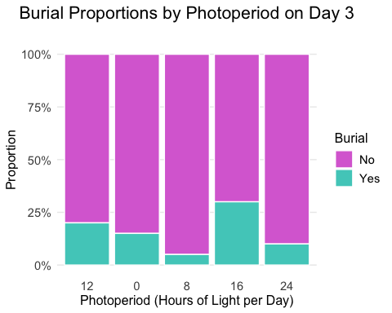
# CHI-SQUARE TEST AND ASSUMPTIONS CHECKING FOR BURIAL ON DAY 3
# 1. Check data structure and create contingency table
contingency_table <- table(day3_data$photoperiod, day3_data$burial)
print("Contingency Table:")
## [1] "Contingency Table:"
print(contingency_table)
##
## No Yes
## 12 16 4
## 0 17 3
## 8 19 1
## 16 14 6
## 24 18 2
# 2. Check sample size assumption (n >= 30)
total_n <- sum(contingency_table)
cat("\nTotal sample size:", total_n)
##
## Total sample size: 100
if(total_n >= 30) {
cat(" ✓ Sample size assumption met (n >= 30)\n")
} else {
cat(" ✗ Sample size assumption NOT met (n < 30)\n")
}
## ✓ Sample size assumption met (n >= 30)
# 3. Check independence assumption
cat("\nIndependence Assumption:")
##
## Independence Assumption:
cat("\n- Observations should be independent")
##
## - Observations should be independent
cat("\n- Each subject should contribute to only one cell")
##
## - Each subject should contribute to only one cell
cat("\n- Random sampling should be used")
##
## - Random sampling should be used
cat("\n✓ Assumed met based on experimental design\n")
##
## ✓ Assumed met based on experimental design
# 4. Check expected frequency assumption (all expected frequencies >= 5)
expected_freq <- chisq.test(contingency_table)$expected
print("\nExpected Frequencies:")
## [1] "\nExpected Frequencies:"
print(round(expected_freq, 2))
##
## No Yes
## 12 16.8 3.2
## 0 16.8 3.2
## 8 16.8 3.2
## 16 16.8 3.2
## 24 16.8 3.2
min_expected <- min(expected_freq)
cat("\nMinimum expected frequency:", round(min_expected, 2))
##
## Minimum expected frequency: 3.2
if(min_expected >= 5) {
cat(" ✓ Expected frequency assumption met (all cells >= 5)\n")
} else {
cat(" ✗ Expected frequency assumption NOT met (some cells < 5)\n")
cat("Consider using Fisher's Exact Test instead\n")
}
## ✗ Expected frequency assumption NOT met (some cells < 5)
## Consider using Fisher's Exact Test instead
# 5. Check for cells with expected frequency < 1
cells_less_than_1 <- sum(expected_freq < 1)
cat("Cells with expected frequency < 1:", cells_less_than_1)
## Cells with expected frequency < 1: 0
if(cells_less_than_1 == 0) {
cat(" ✓ No cells with expected frequency < 1\n")
} else {
cat(" ✗ Some cells have expected frequency < 1\n")
}
## ✓ No cells with expected frequency < 1
# 6. Perform Chi-square test
chi_test <- chisq.test(contingency_table)
print("\nChi-square Test Results:")
## [1] "\nChi-square Test Results:"
print(chi_test)
##
## Pearson's Chi-squared test
##
## data: contingency_table
## X-squared = 5.506, df = 4, p-value = 0.2392
# 7. Calculate effect size (Cramér's V)
cramers_v <- sqrt(chi_test$statistic / (total_n * (min(dim(contingency_table)) - 1)))
cat("\nCramér's V (effect size):", round(cramers_v, 3))
##
## Cramér's V (effect size): 0.235
if(cramers_v < 0.1) {
cat(" (negligible effect)")
} else if(cramers_v < 0.3) {
cat(" (small effect)")
} else if(cramers_v < 0.5) {
cat(" (medium effect)")
} else {
cat(" (large effect)")
}
## (small effect)
# 8. Alternative tests if assumptions are violated
if(min_expected < 5 || cells_less_than_1 > 0) {
cat("\n\nAlternative Test (Fisher's Exact Test):")
if(nrow(contingency_table) == 2 && ncol(contingency_table) == 2) {
fisher_test <- fisher.test(contingency_table)
print(fisher_test)
} else {
cat("\nFisher's Exact Test not available for tables larger than 2x2")
cat("\nConsider Monte Carlo simulation or combining categories")
}
}
##
##
## Alternative Test (Fisher's Exact Test):
## Fisher's Exact Test not available for tables larger than 2x2
## Consider Monte Carlo simulation or combining categories
# 9. Summary of results
cat("\nChi-square statistic:", round(chi_test$statistic, 3))
##
## Chi-square statistic: 5.506
cat("\np-value:", round(chi_test$p.value, 4))
##
## p-value: 0.2392
if(chi_test$p.value < 0.05) {
cat("\n✓ Significant association between photoperiod and burial (p < 0.05)")
} else {
cat("\n✗ No significant association between photoperiod and burial (p >= 0.05)")
}
##
## ✗ No significant association between photoperiod and burial (p >= 0.05)
cat("\nEffect size (Cramér's V):", round(cramers_v, 3))
##
## Effect size (Cramér's V): 0.235

Visualize Variables- Amount Perched on the Stick in Water per Photoperiod Treatment- day 3
# Perched on the stick in water Mosiac
# Filter data to only include Day 3
day3_data <- researchdata %>%
filter(day.of.experiment == 3)
# Create summary data for mosaic plot
mosaic_data <- day3_data %>%
group_by(photoperiod, perched.on.stick.in.water) %>%
summarise(count = n(), .groups = 'drop') %>%
group_by(photoperiod) %>%
mutate(prop = count / sum(count),
total = sum(count))
ggplot(mosaic_data, aes(x = factor(photoperiod), y = prop, fill = factor(perched.on.stick.in.water))) +
geom_col(position = "stack", color = "white", size = 0.5) +
labs(
title = "Perched on the Stick in Water Proportions by Photoperiod on Day 3",
x = "Photoperiod (Hours of Light per Day)",
y = "Proportion",
fill = "Perched on the Stick in Water"
) +
theme_minimal() +
theme(
plot.title = element_text(size = 16, hjust = 0.5, margin = margin(b = 20)),
axis.title = element_text(size = 12),
axis.text = element_text(size = 11),
legend.title = element_text(size = 12),
legend.text = element_text(size = 11),
panel.grid.major.x = element_blank(),
panel.grid.minor = element_blank(),
plot.background = element_rect(fill = "white", color = NA),
panel.background = element_rect(fill = "white", color = NA)
) +
scale_fill_manual(values = c("No" = "orchid", "Yes" = "#4ECDC4")) +
scale_y_continuous(labels = scales::percent_format())
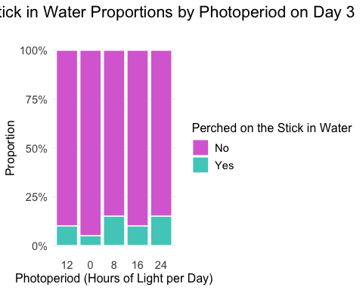
# CHI-SQUARE TEST AND ASSUMPTIONS CHECKING FOR BURIAL ON DAY 3
# 1. Check data structure and create contingency table
contingency_table <- table(day3_data$photoperiod, day3_data$perched.on.stick.in.water)
print("Contingency Table:")
## [1] "Contingency Table:"
print(contingency_table)
##
## No Yes
## 12 18 2
## 0 19 1
## 8 17 3
## 16 18 2
## 24 17 3
# 2. Check sample size assumption (n >= 30)
total_n <- sum(contingency_table)
cat("\nTotal sample size:", total_n)
##
## Total sample size: 100
if(total_n >= 30) {
cat(" ✓ Sample size assumption met (n >= 30)\n")
} else {
cat(" ✗ Sample size assumption NOT met (n < 30)\n")
}
## ✓ Sample size assumption met (n >= 30)
# 3. Check independence assumption
cat("\nIndependence Assumption:")
##
## Independence Assumption:
cat("\n- Observations should be independent")
##
## - Observations should be independent
cat("\n- Each subject should contribute to only one cell")
##
## - Each subject should contribute to only one cell
cat("\n- Random sampling should be used")
##
## - Random sampling should be used
cat("\n✓ Assumed met based on experimental design\n")
##
## ✓ Assumed met based on experimental design
# 4. Check expected frequency assumption (all expected frequencies >= 5)
expected_freq <- chisq.test(contingency_table)$expected
print("\nExpected Frequencies:")
## [1] "\nExpected Frequencies:"
print(round(expected_freq, 2))
##
## No Yes
## 12 17.8 2.2
## 0 17.8 2.2
## 8 17.8 2.2
## 16 17.8 2.2
## 24 17.8 2.2
min_expected <- min(expected_freq)
cat("\nMinimum expected frequency:", round(min_expected, 2))
##
## Minimum expected frequency: 2.2
if(min_expected >= 5) {
cat(" ✓ Expected frequency assumption met (all cells >= 5)\n")
} else {
cat(" ✗ Expected frequency assumption NOT met (some cells < 5)\n")
cat("Consider using Fisher's Exact Test instead\n")
}
## ✗ Expected frequency assumption NOT met (some cells < 5)
## Consider using Fisher's Exact Test instead
# 5. Check for cells with expected frequency < 1
cells_less_than_1 <- sum(expected_freq < 1)
cat("Cells with expected frequency < 1:", cells_less_than_1)
## Cells with expected frequency < 1: 0
if(cells_less_than_1 == 0) {
cat(" ✓ No cells with expected frequency < 1\n")
} else {
cat(" ✗ Some cells have expected frequency < 1\n")
}
## ✓ No cells with expected frequency < 1
# 6. Perform Chi-square test
chi_test <- chisq.test(contingency_table)
print("\nChi-square Test Results:")
## [1] "\nChi-square Test Results:"
print(chi_test)
##
## Pearson's Chi-squared test
##
## data: contingency_table
## X-squared = 1.43, df = 4, p-value = 0.839
# 7. Calculate effect size (Cramér's V)
cramers_v <- sqrt(chi_test$statistic / (total_n * (min(dim(contingency_table)) - 1)))
cat("\nCramér's V (effect size):", round(cramers_v, 3))
##
## Cramér's V (effect size): 0.12
if(cramers_v < 0.1) {
cat(" (negligible effect)")
} else if(cramers_v < 0.3) {
cat(" (small effect)")
} else if(cramers_v < 0.5) {
cat(" (medium effect)")
} else {
cat(" (large effect)")
}
## (small effect)
# 8. Alternative tests if assumptions are violated
if(min_expected < 5 || cells_less_than_1 > 0) {
cat("\n\nAlternative Test (Fisher's Exact Test):")
if(nrow(contingency_table) == 2 && ncol(contingency_table) == 2) {
fisher_test <- fisher.test(contingency_table)
print(fisher_test)
} else {
cat("\nFisher's Exact Test not available for tables larger than 2x2")
cat("\nConsider Monte Carlo simulation or combining categories")
}
}
##
##
## Alternative Test (Fisher's Exact Test):
## Fisher's Exact Test not available for tables larger than 2x2
## Consider Monte Carlo simulation or combining categories
# 9. Summary of results
cat("\nChi-square statistic:", round(chi_test$statistic, 3))
##
## Chi-square statistic: 1.43
cat("\np-value:", round(chi_test$p.value, 4))
##
## p-value: 0.839
if(chi_test$p.value < 0.05) {
cat("\n✓ Significant association between photoperiod and perched on stick in water (p < 0.05)")
} else {
cat("\n✗ No significant association between photoperiod and perched on stick in water (p >= 0.05)")
}
##
## ✗ No significant association between photoperiod and perched on stick in water (p >= 0.05)
cat("\nEffect size (Cramér's V):", round(cramers_v, 3))
##
## Effect size (Cramér's V): 0.12

Visualize Variables- Amount Perched on the Stick out of Water per Photoperiod Treatment- day 3
# Perched on the Stick out of Water Mosiac
# Filter data to only include Day 3
day3_data <- researchdata %>%
filter(day.of.experiment == 3)
# Create summary data for mosaic plot
mosaic_data <- day3_data %>%
group_by(photoperiod, perched.on.stick.out.of.water) %>%
summarise(count = n(), .groups = 'drop') %>%
group_by(photoperiod) %>%
mutate(prop = count / sum(count),
total = sum(count))
ggplot(mosaic_data, aes(x = factor(photoperiod), y = prop, fill = factor(perched.on.stick.out.of.water))) +
geom_col(position = "stack", color = "white", size = 0.5) +
labs(
title = "Perched on the Stick out of Water Proportions by Photoperiod on Day 3",
x = "Photoperiod (Hours of Light per Day)",
y = "Proportion",
fill = "Perched on the Stick out of Water"
) +
theme_minimal() +
theme(
plot.title = element_text(size = 16, hjust = 0.5, margin = margin(b = 20)),
axis.title = element_text(size = 12),
axis.text = element_text(size = 11),
legend.title = element_text(size = 12),
legend.text = element_text(size = 11),
panel.grid.major.x = element_blank(),
panel.grid.minor = element_blank(),
plot.background = element_rect(fill = "white", color = NA),
panel.background = element_rect(fill = "white", color = NA)
) +
scale_fill_manual(values = c("No" = "orchid", "Yes" = "#4ECDC4")) +
scale_y_continuous(labels = scales::percent_format())
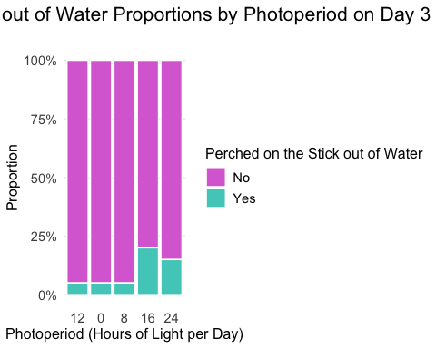
# CHI-SQUARE TEST AND ASSUMPTIONS CHECKING FOR BURIAL ON DAY 3
# 1. Check data structure and create contingency table
contingency_table <- table(day3_data$photoperiod, day3_data$perched.on.stick.out.of.water)
print("Contingency Table:")
## [1] "Contingency Table:"
print(contingency_table)
##
## No Yes
## 12 19 1
## 0 19 1
## 8 19 1
## 16 16 4
## 24 17 3
# 2. Check sample size assumption (n >= 30)
total_n <- sum(contingency_table)
cat("\nTotal sample size:", total_n)
##
## Total sample size: 100
if(total_n >= 30) {
cat(" ✓ Sample size assumption met (n >= 30)\n")
} else {
cat(" ✗ Sample size assumption NOT met (n < 30)\n")
}
## ✓ Sample size assumption met (n >= 30)
# 3. Check independence assumption
cat("\nIndependence Assumption:")
##
## Independence Assumption:
cat("\n- Observations should be independent")
##
## - Observations should be independent
cat("\n- Each subject should contribute to only one cell")
##
## - Each subject should contribute to only one cell
cat("\n- Random sampling should be used")
##
## - Random sampling should be used
cat("\n✓ Assumed met based on experimental design\n")
##
## ✓ Assumed met based on experimental design
# 4. Check expected frequency assumption (all expected frequencies >= 5)
expected_freq <- chisq.test(contingency_table)$expected
print("\nExpected Frequencies:")
## [1] "\nExpected Frequencies:"
print(round(expected_freq, 2))
##
## No Yes
## 12 18 2
## 0 18 2
## 8 18 2
## 16 18 2
## 24 18 2
min_expected <- min(expected_freq)
cat("\nMinimum expected frequency:", round(min_expected, 2))
##
## Minimum expected frequency: 2
if(min_expected >= 5) {
cat(" ✓ Expected frequency assumption met (all cells >= 5)\n")
} else {
cat(" ✗ Expected frequency assumption NOT met (some cells < 5)\n")
cat("Consider using Fisher's Exact Test instead\n")
}
## ✗ Expected frequency assumption NOT met (some cells < 5)
## Consider using Fisher's Exact Test instead
# 5. Check for cells with expected frequency < 1
cells_less_than_1 <- sum(expected_freq < 1)
cat("Cells with expected frequency < 1:", cells_less_than_1)
## Cells with expected frequency < 1: 0
if(cells_less_than_1 == 0) {
cat(" ✓ No cells with expected frequency < 1\n")
} else {
cat(" ✗ Some cells have expected frequency < 1\n")
}
## ✓ No cells with expected frequency < 1
# 6. Perform Chi-square test
chi_test <- chisq.test(contingency_table)
print("\nChi-square Test Results:")
## [1] "\nChi-square Test Results:"
print(chi_test)
##
## Pearson's Chi-squared test
##
## data: contingency_table
## X-squared = 4.4444, df = 4, p-value = 0.3492
# 7. Calculate effect size (Cramér's V)
cramers_v <- sqrt(chi_test$statistic / (total_n * (min(dim(contingency_table)) - 1)))
cat("\nCramér's V (effect size):", round(cramers_v, 3))
##
## Cramér's V (effect size): 0.211
if(cramers_v < 0.1) {
cat(" (negligible effect)")
} else if(cramers_v < 0.3) {
cat(" (small effect)")
} else if(cramers_v < 0.5) {
cat(" (medium effect)")
} else {
cat(" (large effect)")
}
## (small effect)
# 8. Alternative tests if assumptions are violated
if(min_expected < 5 || cells_less_than_1 > 0) {
cat("\n\nAlternative Test (Fisher's Exact Test):")
if(nrow(contingency_table) == 2 && ncol(contingency_table) == 2) {
fisher_test <- fisher.test(contingency_table)
print(fisher_test)
} else {
cat("\nFisher's Exact Test not available for tables larger than 2x2")
cat("\nConsider Monte Carlo simulation or combining categories")
}
}
##
##
## Alternative Test (Fisher's Exact Test):
## Fisher's Exact Test not available for tables larger than 2x2
## Consider Monte Carlo simulation or combining categories
# 9. Summary of results
cat("\nChi-square statistic:", round(chi_test$statistic, 3))
##
## Chi-square statistic: 4.444
cat("\np-value:", round(chi_test$p.value, 4))
##
## p-value: 0.3492
if(chi_test$p.value < 0.05) {
cat("\n✓ Significant association between photoperiod and perched on stick out of water (p < 0.05)")
} else {
cat("\n✗ No significant association between photoperiod and perched on stick out of water (p >= 0.05)")
}
##
## ✗ No significant association between photoperiod and perched on stick out of water (p >= 0.05)
cat("\nEffect size (Cramér's V):", round(cramers_v, 3))
##
## Effect size (Cramér's V): 0.211
environmentdata <- read.csv("Noelle_Tanaka_Photoperiod_evnironmental_var Summer 2024 - Photoperiod environmental variables.csv",
strip.white = TRUE,
check.names = TRUE)
environmentdata$Photoperiod <- as.factor(environmentdata$Photoperiod)
# Create the plot without Time.of.day
ggplot(environmentdata, aes(x = Day,
y = temperature,
group = Photoperiod,
color = factor(Photoperiod))) +
geom_line(size = 1.2) +
labs(title = "Temperature Across Days by Photoperiod",
x = "Day",
y = "Temperature (°C)",
color = "Photoperiod") +
theme_minimal()
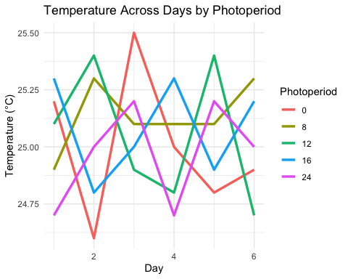
environmentdata$Photoperiod <- as.factor(environmentdata$Photoperiod)
environmentdata$Day <- as.factor(environmentdata$Day) # or leave numeric if continuous
# One-way ANOVA for Temperature by Photoperiod
# Make sure your data is loaded first
# Run one-way ANOVA
anova_result <- aov(temperature ~ Photoperiod, data = environmentdata)
# Display ANOVA table with p-values
summary(anova_result)
## Df Sum Sq Mean Sq F value Pr(>F)
## Photoperiod 4 0.1047 0.02617 0.422 0.791
## Residuals 25 1.5500 0.06200
# Alternative: You can also use oneway.test() for a one-way ANOVA
oneway.test(temperature ~ Photoperiod, data = environmentdata)
##
## One-way analysis of means (not assuming equal variances)
##
## data: temperature and Photoperiod
## F = 0.57359, num df = 4.000, denom df = 12.246, p-value = 0.687
# For more detailed output, you can also use:
anova(anova_result)
## Analysis of Variance Table
##
## Response: temperature
## Df Sum Sq Mean Sq F value Pr(>F)
## Photoperiod 4 0.10467 0.026167 0.422 0.7912
## Residuals 25 1.55000 0.062000
# To check assumptions:
# 1. Check normality of residuals
shapiro.test(residuals(anova_result))
##
## Shapiro-Wilk normality test
##
## data: residuals(anova_result)
## W = 0.97222, p-value = 0.6014
# 2. Check homogeneity of variances
bartlett.test(temperature ~ Photoperiod, data = environmentdata)
##
## Bartlett test of homogeneity of variances
##
## data: temperature by Photoperiod
## Bartlett's K-squared = 3.019, df = 4, p-value = 0.5546
# Repeated Measures ANOVA using base R
# Replace "Subject" with the column identifying each participant or replicate
anova_rm <- aov(temperature ~ Photoperiod, data = environmentdata)
# View results
summary(anova_rm)
## Df Sum Sq Mean Sq F value Pr(>F)
## Photoperiod 4 0.1047 0.02617 0.422 0.791
## Residuals 25 1.5500 0.06200
# Create the plot without Time.of.day
ggplot(environmentdata, aes(x = Day,
y = humidity,
group = Photoperiod,
color = factor(Photoperiod))) +
geom_line(size = 1.2) +
labs(title = "Humidity Across Days by Photoperiod",
x = "Day",
y = "Humidity",
color = "Photoperiod") +
theme_minimal()
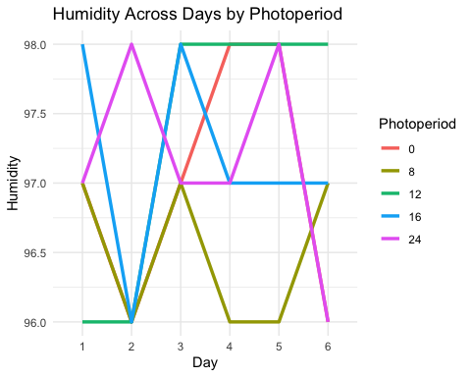
environmentdata$Photoperiod <- as.factor(environmentdata$Photoperiod)
environmentdata$Day <- as.factor(environmentdata$Day) # or leave numeric if continuous
# One-way ANOVA for Humidity by Photoperiod
# Make sure your data is loaded first
# Run one-way ANOVA
anova_result <- aov(humidity ~ Photoperiod, data = environmentdata)
# Display ANOVA table with p-values
summary(anova_result)
## Df Sum Sq Mean Sq F value Pr(>F)
## Photoperiod 4 2.467 0.6167 0.934 0.46
## Residuals 25 16.500 0.6600
# Alternative: You can also use oneway.test() for a one-way ANOVA
oneway.test(humidity ~ Photoperiod, data = environmentdata)
##
## One-way analysis of means (not assuming equal variances)
##
## data: humidity and Photoperiod
## F = 1.253, num df = 4.00, denom df = 12.34, p-value = 0.3396
# For more detailed output, you can also use:
anova(anova_result)
## Analysis of Variance Table
##
## Response: humidity
## Df Sum Sq Mean Sq F value Pr(>F)
## Photoperiod 4 2.4667 0.61667 0.9343 0.4602
## Residuals 25 16.5000 0.66000
# To check assumptions:
# 1. Check normality of residuals
shapiro.test(residuals(anova_result))
##
## Shapiro-Wilk normality test
##
## data: residuals(anova_result)
## W = 0.90884, p-value = 0.01391
# 2. Check homogeneity of variances
bartlett.test(humidity ~ Photoperiod, data = environmentdata)
##
## Bartlett test of homogeneity of variances
##
## data: humidity by Photoperiod
## Bartlett's K-squared = 1.9489, df = 4, p-value = 0.7452
# Repeated Measures ANOVA using base R
# Replace "Subject" with the column identifying each participant or replicate
anova_rm <- aov(temperature ~ Photoperiod, data = environmentdata)
# View results
summary(anova_rm)
## Df Sum Sq Mean Sq F value Pr(>F)
## Photoperiod 4 0.1047 0.02617 0.422 0.791
## Residuals 25 1.5500 0.06200
# Repeated Measures ANOVA using base R
# Replace "Subject" with the column identifying each participant or replicate
anova_rm <- aov(humidity ~ Photoperiod, data = environmentdata)
# View results
summary(anova_rm)
## Df Sum Sq Mean Sq F value Pr(>F)
## Photoperiod 4 2.467 0.6167 0.934 0.46
## Residuals 25 16.500 0.6600
save(researchdata, file = "Summer_2025_Research_Tanaka.RData")

