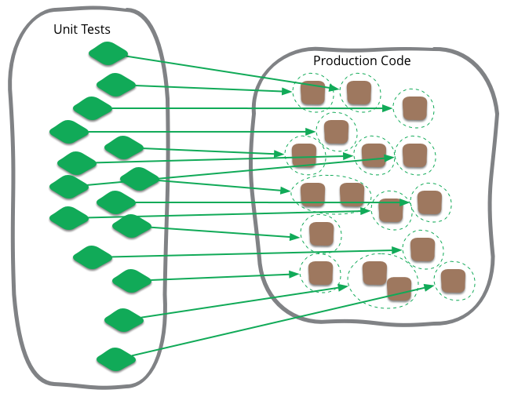
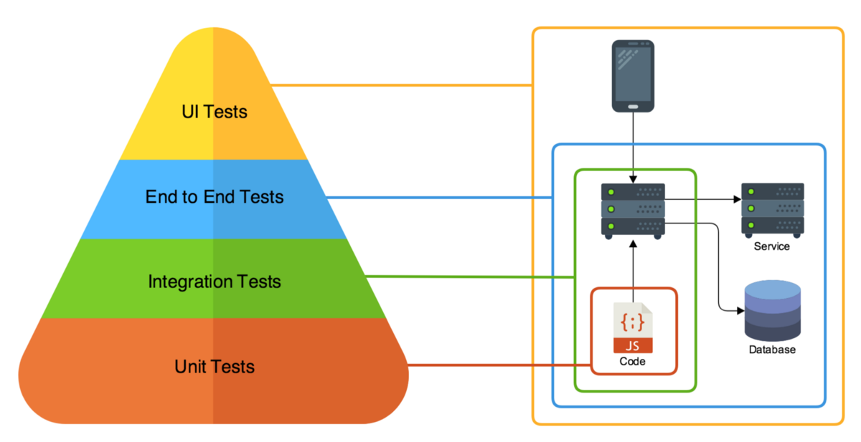
SDV-502 Assessment 1
Ali Kahwaji – 2021

Application Testing

Noel Williams
NMIT
Table of Contents
SDV502 Unit Test Assignment 1 – Noel Williams 2
Ticket Pricing: 2
Public decimal Adult_Before_5() 3
Public decimal Adult_After_5() 4
Public decimal Adult_After_5() 5
Public decimal Adult_After_5() 6
Public decimal Adult_After_5() 7
Public decimal Adult_After_5() 8
Public decimal Adult_After_5() 9
Public decimal Adult_After_5() 10
Public decimal Adult_After_5() 11

SDV502 Unit Test Assignment 1 – Noel Williams

Ticket Pricing:
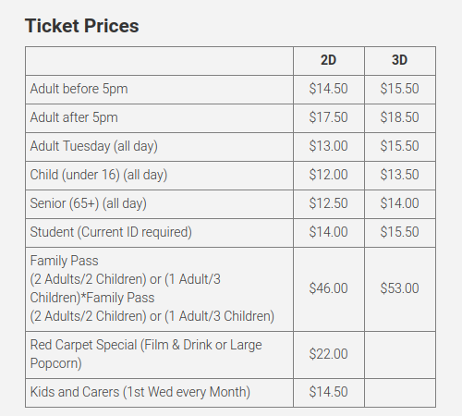

Public decimal Adult_Before_5()
Inputs – int quantity, str person, str day, decimal time
Output – dec total_price
Equivalence Partitioning & Boundaries
Status | Quantity | Person | Day | Time
Acceptable | >0 | Adult | Mon, Wed,  Thurs,  Fri,  Sat,  Sun | Less than or equal to 5pm
Unacceptable | <=0 | Child,  Student,  Senior,  Family | Tues | Greater than 5pm

Test Schedule
Use Case | Quantity | Person | Day | Time | Expected | Result
1.One adult, normal day,before 5 | 1 | Adult | Mon | 4.30 | 14.50 | Pass
2.Two adults, normal day, before 5 | 2 | Adult | Mon | 4.30 | 29.00 | Pass
3.Zero Adults, normal day, before 5 | 0 | Adult | Mon | 4.30 | 0.00 | Pass
4.One student, normal day, before 5 | 1 | Student | Mon | 4.30 | 0.00 | Pass
5.One adult, tuesday, before 5 | 1 | Adult | Mon | 4.30 | 0.00 | Pass
6.One adult, normal day, after 5 | 1 | Adult | Mon | 5.30 | 0.00 | Pass

Public decimal Adult_After_5()
Inputs – int quantity, str person, str day, decimal time
Output – dec total_price
Equivalence Partitioning & Boundaries
Status | Quantity | Person | Day | Time
Acceptable | >0 | Adult | Mon, Wed,  Thurs,  Fri,  Sat,  Sun | Greater than or equal to 5pm
Unacceptable | <=0 | Child,  Student,  Senior,  Family | Tues | Less than 5pm

Test Schedule
Use Case | Quantity | Person | Day | Time | Expected | Result
1.One adult, normal day, after 5 | 1 | Adult | Mon | 6.30 | 15.50 | Pass
2.Two adults, normal day, after 5 | 2 | Adult | Mon | 6.30 | 31.00 | Pass
3.Zero Adults, normal day, after 5 | 0 | Adult | Mon | 6.30 | 0.00 | Pass
4.One student, normal day, after 5 | 1 | Student | Mon | 6.30 | 0.00 | Pass
5.One adult, tuesday, after 5 | 1 | Adult | Tues | 6.30 | 0.00 | Pass
6.One adult, normal day, before 5 | 1 | Adult | Mon | 3.30 | 0.00 | Pass

Public decimal Adult_After_5()
Inputs – int quantity, str person, str day, decimal time
Output – dec total_price
Equivalence Partitioning & Boundaries
Status | Quantity | Person | Day | Time
Acceptable | >0 | Adult | Mon, Wed,  Thurs,  Fri,  Sat,  Sun | Greater than or equal to 5pm
Unacceptable | <=0 | Child,  Student,  Senior,  Family | Tues | Less than 5pm

Test Schedule
Use Case | Quantity | Person | Day | Time | Expected | Result
1.One adult, normal day, after 5 | 1 | Adult | Mon | 6.30 | 15.50 | Pass
2.Two adults, normal day, after 5 | 2 | Adult | Mon | 6.30 | 31.00 | Pass
3.Zero Adults, normal day, after 5 | 0 | Adult | Mon | 6.30 | 0.00 | Pass
4.One student, normal day, after 5 | 1 | Student | Mon | 6.30 | 0.00 | Pass
5.One adult, tuesday, after 5 | 1 | Adult | Tues | 6.30 | 0.00 | Pass
6.One adult, normal day, before 5 | 1 | Adult | Mon | 3.30 | 0.00 | Pass

Public decimal Adult_After_5()
Inputs – int quantity, str person, str day, decimal time
Output – dec total_price
Equivalence Partitioning & Boundaries
Status | Quantity | Person | Day | Time
Acceptable | >0 | Adult | Mon, Wed,  Thurs,  Fri,  Sat,  Sun | Greater than or equal to 5pm
Unacceptable | <=0 | Child,  Student,  Senior,  Family | Tues | Less than 5pm

Test Schedule
Use Case | Quantity | Person | Day | Time | Expected | Result
1.One adult, normal day, after 5 | 1 | Adult | Mon | 6.30 | 15.50 | Pass
2.Two adults, normal day, after 5 | 2 | Adult | Mon | 6.30 | 31.00 | Pass
3.Zero Adults, normal day, after 5 | 0 | Adult | Mon | 6.30 | 0.00 | Pass
4.One student, normal day, after 5 | 1 | Student | Mon | 6.30 | 0.00 | Pass
5.One adult, tuesday, after 5 | 1 | Adult | Tues | 6.30 | 0.00 | Pass
6.One adult, normal day, before 5 | 1 | Adult | Mon | 3.30 | 0.00 | Pass

Public decimal Adult_After_5()
Inputs – int quantity, str person, str day, decimal time
Output – dec total_price
Equivalence Partitioning & Boundaries
Status | Quantity | Person | Day | Time
Acceptable | >0 | Adult | Mon, Wed,  Thurs,  Fri,  Sat,  Sun | Greater than or equal to 5pm
Unacceptable | <=0 | Child,  Student,  Senior,  Family | Tues | Less than 5pm

Test Schedule
Use Case | Quantity | Person | Day | Time | Expected | Result
1.One adult, normal day, after 5 | 1 | Adult | Mon | 6.30 | 15.50 | Pass
2.Two adults, normal day, after 5 | 2 | Adult | Mon | 6.30 | 31.00 | Pass
3.Zero Adults, normal day, after 5 | 0 | Adult | Mon | 6.30 | 0.00 | Pass
4.One student, normal day, after 5 | 1 | Student | Mon | 6.30 | 0.00 | Pass
5.One adult, tuesday, after 5 | 1 | Adult | Tues | 6.30 | 0.00 | Pass
6.One adult, normal day, before 5 | 1 | Adult | Mon | 3.30 | 0.00 | Pass

Public decimal Adult_After_5()
Inputs – int quantity, str person, str day, decimal time
Output – dec total_price
Equivalence Partitioning & Boundaries
Status | Quantity | Person | Day | Time
Acceptable | >0 | Adult | Mon, Wed,  Thurs,  Fri,  Sat,  Sun | Greater than or equal to 5pm
Unacceptable | <=0 | Child,  Student,  Senior,  Family | Tues | Less than 5pm

Test Schedule
Use Case | Quantity | Person | Day | Time | Expected | Result
1.One adult, normal day, after 5 | 1 | Adult | Mon | 6.30 | 15.50 | Pass
2.Two adults, normal day, after 5 | 2 | Adult | Mon | 6.30 | 31.00 | Pass
3.Zero Adults, normal day, after 5 | 0 | Adult | Mon | 6.30 | 0.00 | Pass
4.One student, normal day, after 5 | 1 | Student | Mon | 6.30 | 0.00 | Pass
5.One adult, tuesday, after 5 | 1 | Adult | Tues | 6.30 | 0.00 | Pass
6.One adult, normal day, before 5 | 1 | Adult | Mon | 3.30 | 0.00 | Pass

Public decimal Adult_After_5()
Inputs – int quantity, str person, str day, decimal time
Output – dec total_price
Equivalence Partitioning & Boundaries
Status | Quantity | Person | Day | Time
Acceptable | >0 | Adult | Mon, Wed,  Thurs,  Fri,  Sat,  Sun | Greater than or equal to 5pm
Unacceptable | <=0 | Child,  Student,  Senior,  Family | Tues | Less than 5pm

Test Schedule
Use Case | Quantity | Person | Day | Time | Expected | Result
1.One adult, normal day, after 5 | 1 | Adult | Mon | 6.30 | 15.50 | Pass
2.Two adults, normal day, after 5 | 2 | Adult | Mon | 6.30 | 31.00 | Pass
3.Zero Adults, normal day, after 5 | 0 | Adult | Mon | 6.30 | 0.00 | Pass
4.One student, normal day, after 5 | 1 | Student | Mon | 6.30 | 0.00 | Pass
5.One adult, tuesday, after 5 | 1 | Adult | Tues | 6.30 | 0.00 | Pass
6.One adult, normal day, before 5 | 1 | Adult | Mon | 3.30 | 0.00 | Pass

Public decimal Adult_After_5()
Inputs – int quantity, str person, str day, decimal time
Output – dec total_price
Equivalence Partitioning & Boundaries
Status | Quantity | Person | Day | Time
Acceptable | >0 | Adult | Mon, Wed,  Thurs,  Fri,  Sat,  Sun | Greater than or equal to 5pm
Unacceptable | <=0 | Child,  Student,  Senior,  Family | Tues | Less than 5pm

Test Schedule
Use Case | Quantity | Person | Day | Time | Expected | Result
1.One adult, normal day, after 5 | 1 | Adult | Mon | 6.30 | 15.50 | Pass
2.Two adults, normal day, after 5 | 2 | Adult | Mon | 6.30 | 31.00 | Pass
3.Zero Adults, normal day, after 5 | 0 | Adult | Mon | 6.30 | 0.00 | Pass
4.One student, normal day, after 5 | 1 | Student | Mon | 6.30 | 0.00 | Pass
5.One adult, tuesday, after 5 | 1 | Adult | Tues | 6.30 | 0.00 | Pass
6.One adult, normal day, before 5 | 1 | Adult | Mon | 3.30 | 0.00 | Pass

Public decimal Adult_After_5()
Inputs – int quantity, str person, str day, decimal time
Output – dec total_price
Equivalence Partitioning & Boundaries
Status | Quantity | Person | Day | Time
Acceptable | >0 | Adult | Mon, Wed,  Thurs,  Fri,  Sat,  Sun | Greater than or equal to 5pm
Unacceptable | <=0 | Child,  Student,  Senior,  Family | Tues | Less than 5pm

Test Schedule
Use Case | Quantity | Person | Day | Time | Expected | Result
1.One adult, normal day, after 5 | 1 | Adult | Mon | 6.30 | 15.50 | Pass
2.Two adults, normal day, after 5 | 2 | Adult | Mon | 6.30 | 31.00 | Pass
3.Zero Adults, normal day, after 5 | 0 | Adult | Mon | 6.30 | 0.00 | Pass
4.One student, normal day, after 5 | 1 | Student | Mon | 6.30 | 0.00 | Pass
5.One adult, tuesday, after 5 | 1 | Adult | Tues | 6.30 | 0.00 | Pass
6.One adult, normal day, before 5 | 1 | Adult | Mon | 3.30 | 0.00 | Pass

