SUM-159 Ploidy × Gemcitabine In-Vivo Study

1 Overview
This project compares near-diploid (2N) and near-tetraploid (4N) variants of the SUM-159 TNBC cell line in an orthotopic mouse model under different gemcitabine (Gem) dosing regimens. We have already quantified survival kinetics and defined copy-number (CN) based clonal structure using single-cell technologies. The next phase is to interrogate gene-expression programs and link them to the CN landscape.

2 Experimental Design
Factor | Details
Cell source | * Parental cultures: SUM-159_NLS_2N_A6M (≈2 N) and SUM-159_NLS_4N_A4M (≈4 N).
Injection | 1 × 10^6 cells injected orthotopically per mouse (5 sites per ploidy group: O, R, L, RR, RL). R code block shows inject(... strain = 133, injection_type = 23).
Gemcitabine arms | Doses parsed from seed IDs → 0 mg kg⁻¹ (vehicle), 30 mg kg⁻¹, 60 mg kg⁻¹, 120 mg kg⁻¹.
Timeline | Seeding 22 Aug 2024 → first Gem dose 17 Sep 2024 → serial tumour measurements Day 0–38 → harvest or end-point.
Endpoints | - Primary: time from seeding to harvest (proxy for survival).
- Secondary: tumour volume trajectory (columns Day_0…Day_38). | | Molecular profiling | ✔ scRNA-seq (10× v3 dual species; manifest scRNAseq_CICPT-4990…xlsx).
✔ Metaphase karyotyping (B02_Karyotyping/ CSV files).
✔ Numbat CN inference (A03_Numbat/). | | Sample IDs | Spreadsheet dt_Gem_VT_20241223_v4.xlsx maps each harvested tumour to its sequencing ID and dose group. Two extra rows correspond to bulk cell-culture controls (2N-Cell-Culture, 4N-Cell-Culture). |

Cohort summary
- 2N group: 20 mice (5 × 0 mg/kg, 5 × 30 mg/kg, 5 × 60 mg/kg, 5 × 120 mg/kg).
- 4N group: 20 mice with identical dosing schema.
- Sequenced tumours: 17 total (all 0 mg arm + selected high-dose failures). See column Sequencing IDs for exact mapping.

3 Completed Analyses (code base)

3.1 Survival / tumour kinetics (Gem_InVivo_SurvivalAnalysisPloidy.R)
- Pulled seeding & harvest events from the CLONEID SQL “Passaging” table (media = 133 = Gem regimen).
- Computed Kaplan–Meier curves with survival/survminer; stratification is currently ploidy only (2N vs 4N).

3.2 Copy-number clone discovery (Manager.R, Utils.R)
- scRNA-seq CNV inference – wrapper NumbatPostProcess() converts Numbat joint-posterior calls to absolute CN matrices centred to ploidy (2 or 4).
- Metaphase CN quantification – batch pipeline reads CSVs, builds whole-chromosome matrices, and estimates absolute ploidy per cell.
- Alignment & integration – alignCNmatrices() harmonises scRNA-seq (high-resolution) and karyotype (arm-level) CN matrices into a common feature space, then hierarchical clustering (Ward-D², weighted Manhattan distance) defines ~8 clones.
- Visual outputs – heatmaps (scRNA, karyotype, combined) are written to ~/Downloads/*.pdf; colours track either biological origin or clone membership (example in Figure 1).
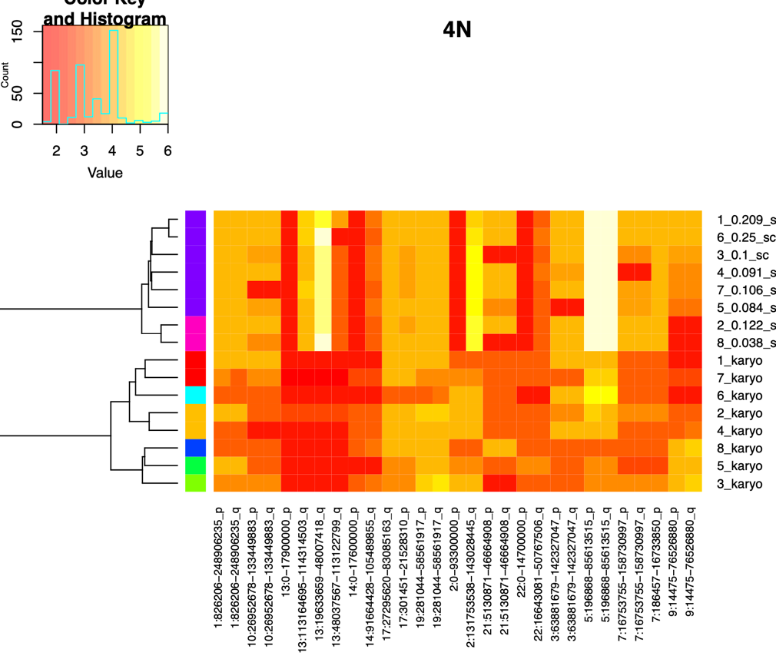
Figure 1: Example of combined copy number heatmap comparing scRNA-seq and karyotyping derived copy number profiles. Every row is a cluster of cells from either karyotyping or scRNAseq of 4N SUM159 cells.

4 Next Steps

4.1 Ideas for gene-expression analysis
- Pre-QC: verify cell × gene UMI matrices (Cell Ranger outs) align with Sequencing IDs. Flag multiplet-rich libraries (Fraction GEMs with > 1 cell > 0.3) for doublet removal.
- Normalisation & integration: use Seurat v5 or Scanpy with SCTransform/SCVI as preferred. Keep annotation of clones (cluster labels already derived)
- Differential expression:
  - Between ploidy lineages (2N vs 4N).
  - Between Gem doses within each ploidy.
  - Clone-specific DE to identify CN-driven expression programmes.
- Pathway & signature scoring: GSEA, msigdb Hallmark, cell-cycle & stress signatures. Relate to Gem response.

4.2 Ideas for integration with CN data
- Overlay DE results onto the combined CN heatmap (e.g. annotate clones with up-regulated pathways).
- Explore correlation of arm-level CN gain/loss with expression of resident genes.
- Build joint latent representations (e.g. MOFA 2) to capture variance shared between CN and transcriptome.

4.3 Ideas for link to in-vivo phenotypes
- Couple clone abundance and expression signatures to survival (deltaDays) using Cox models.
- Re-evaluate Gem dose effect after adjusting for clone composition.

4.4 Milestones
- Reproduce CN heatmaps; produce Seurat object with clone labels.
- DE & pathway analyses; draft figures.
- Integrative model (CN + RNA ↔ survival); slide deck summarising results.

5 Key Resources
- Code repository: ~/Repositories/Gemcitabine-model/Code/in-vivo/
  - Gem_InVivo_SurvivalAnalysisPloidy.R – survival pipeline
  - Manager.R – CN integration master script
  - Utils.R – helper functions (CNV parsing, alignment)
- Raw data:
  - Tumour metrics ✚ treatment: Data/in-vivo/dt_Gem_VT_20241223_v4.xlsx
  - scRNA-seq QC: Data/in-vivo/scRNAseq_CICPT-4990-…Manifest.xlsx
  - Karyotypes: B02_Karyotyping/ CSVs
  - Numbat outputs: A03_Numbat/ per sample
- Database: CLONEID MySQL credentials in lab KeePass; table Passaging holds seeding/harvest records.

