A Delta-Hedged Uniswap v3 Liquidity Position, Backtested on Real Data

A guide for an options trader who has never touched a blockchain
Written 2026-09-06 against the deployed application at https://backtest-lp-production.up.railway.app/ (commit e1bb6e7, "ux updates", 2026-08-31) and the real August 2026 data described in section 2. Every number in this guide was produced by running the application's own code in this session. Nothing is synthetic. The raw output behind every number is in docs/guide/raw/, the data checks in DATA.md, every scenario in SCENARIOS.md, every widget in APP_MAP.md, every formula check in SOURCES.md, and the environment in ENVIRONMENT.md.
The answer, up front. A 1,000,000 USD position in the ETH/USDC 0.05% pool with a ±15% range, delta-hedged with a Binance perpetual on a 3% band, lost 11,592 USD over the 31 days of August 2026 on a capital base of 1,198,120 USD. Annualised, −11.39%. Fees were 28,956 USD. The gamma cost of the hedged inventory was 37,962 USD. ETH rose 32% in the month with 52% realised vol. Sections 7 to 9 say what that does and does not tell you.

0. What this is and how to run it

0.1 The application
The application is a web page that backtests one strategy: provide liquidity to a Uniswap v3 pool inside a price band and short the position's delta on a perpetual future. It asks one question and answers it with a green or red banner: do the fees cover the cost of running the position hedged.
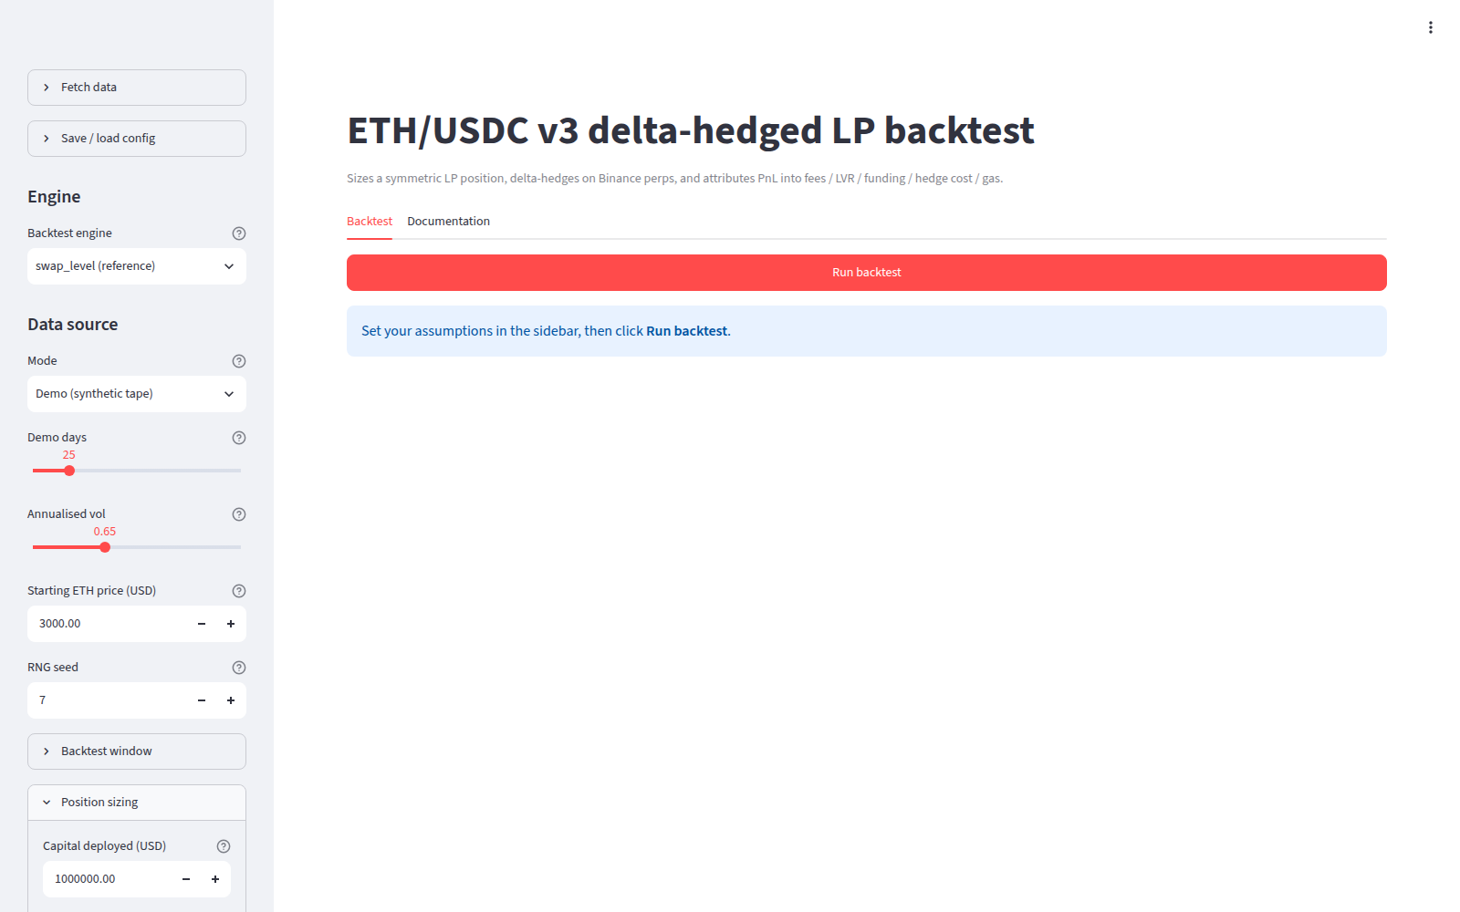
Figure 1. The live deployment as first loaded. Sidebar on the left with the data and assumption controls; the main area shows the Backtest tab with a Run backtest button and no results yet.
The first screen shows a sidebar with collapsed sections named Fetch data, Save / load config, then Engine, Data source, Backtest window, Position sizing, Hedge policy, Cost model, Mechanics (advanced), Analysis + Run, and a main area with two tabs, Backtest and Documentation. The engine defaults to swap_level (reference) and the data source to Demo (synthetic tape). Nothing runs until Run backtest is clicked.
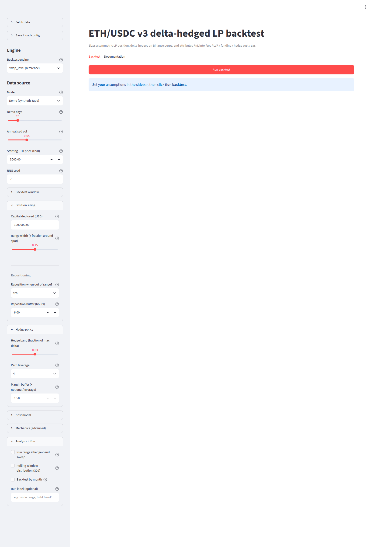
Figure 2. The Backtest tab before any run.

0.2 Running it yourself
The deployment runs the code in the repository https://github.com/nhaga/backtest-lp (this guide was produced in the fork noemonf1/backtest-lp). To run it locally:
git clone https://github.com/nhaga/backtest-lp
cd backtest-lp
git checkout e1bb6e786aef0ba025b260b288943c4b01c04d1a
pip install "streamlit==1.61.1" "plotly==6.9.0" "pyarrow==24.0.0" "pandas==3.0.2" "numpy==2.4.4" requests pytest
python3 -m pytest tests/ -q # 39 passed in 8.02s
streamlit run app.py --server.headless true --server.port 8501
The page is then at http://127.0.0.1:8501. The repository's requirements.txt pins pandas==3.0.5 and numpy==2.5.1, which do not exist on PyPI; the versions above are the ones that install and pass the test suite (ENVIRONMENT.md). Python 3.11.15 was used.

0.3 The sidebar, top to bottom
Each expander is a group of controls. The full table of all 59 widget call sites with their defaults, ranges and the code that consumes each one is Appendix A.
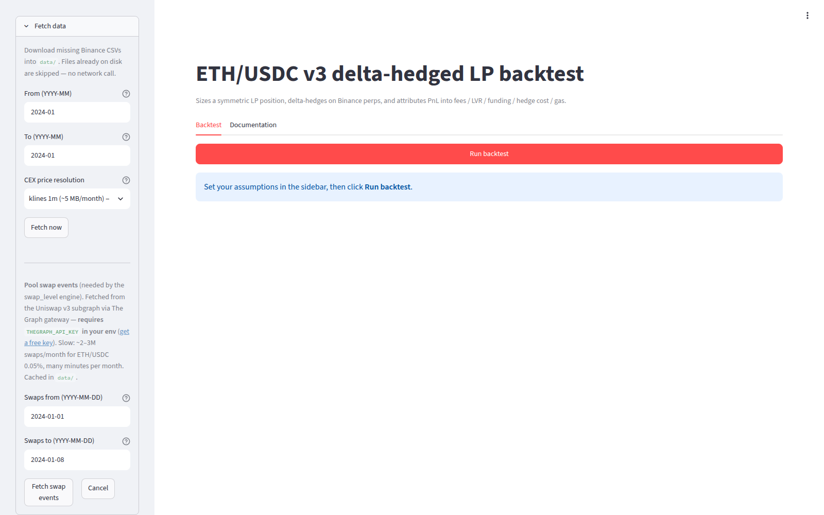
Figure 3. Fetch data expander on the live deployment: month range for Binance downloads, CEX price resolution, Fetch now, swap event date range, Fetch swap events, Cancel.
Fetch data downloads the price and funding files from Binance's public archive and the swap events from a public index of the Ethereum chain. Section 0.4 walks through it.
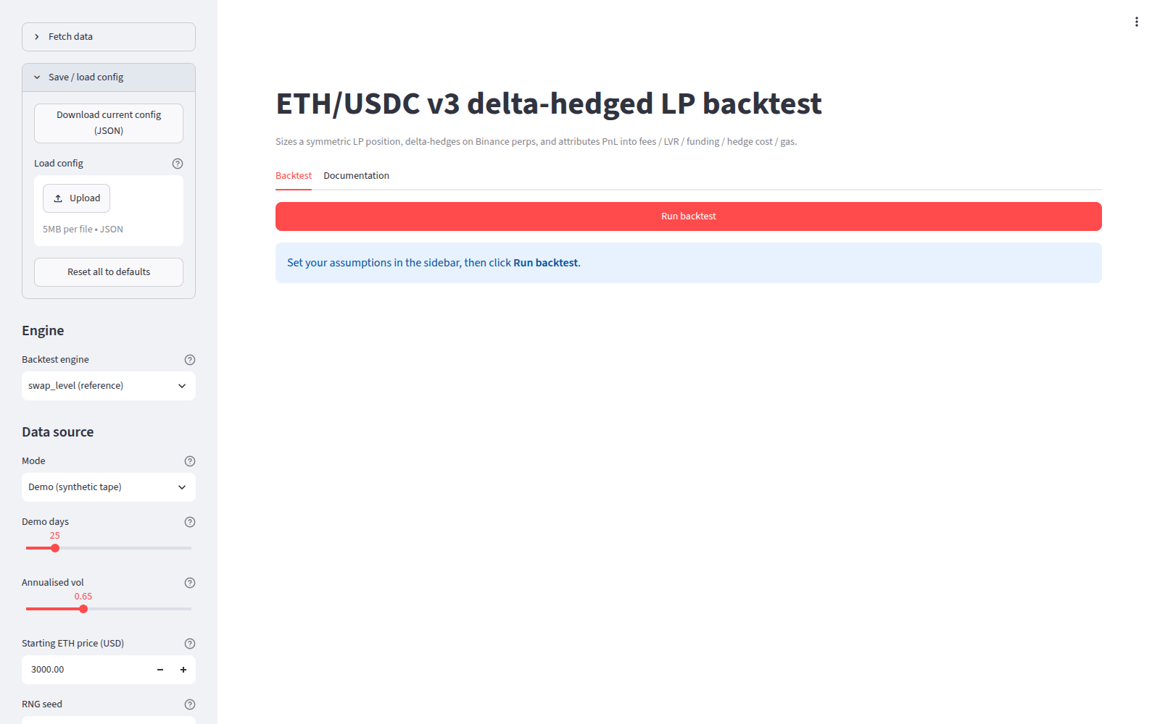
Figure 4. Save / load config expander: download the current assumptions as JSON, upload one, reset to defaults.
Save / load config writes the 24 assumption fields to a JSON file or reads one back (APP_MAP.md section 4.4).
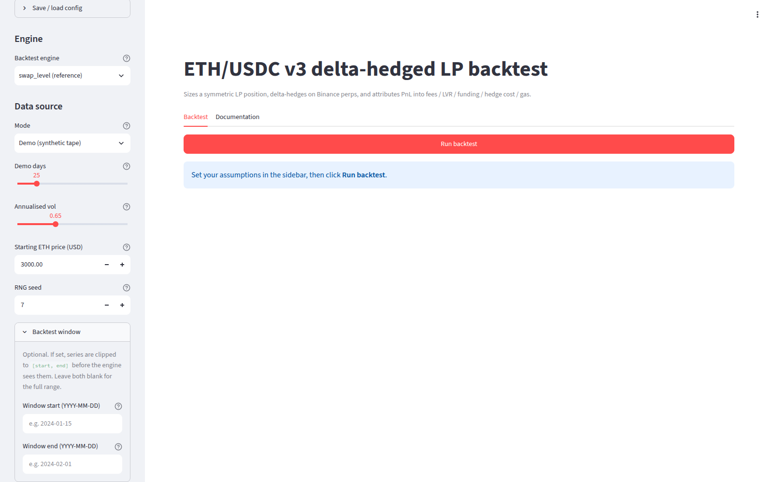
Figure 5. Backtest window expander: optional start and end dates that clip the loaded data.
Backtest window clips the loaded series to a date range. Both fields default to empty, which means the whole file. The end date is exclusive of the day named (APP_MAP.md contradiction C8).
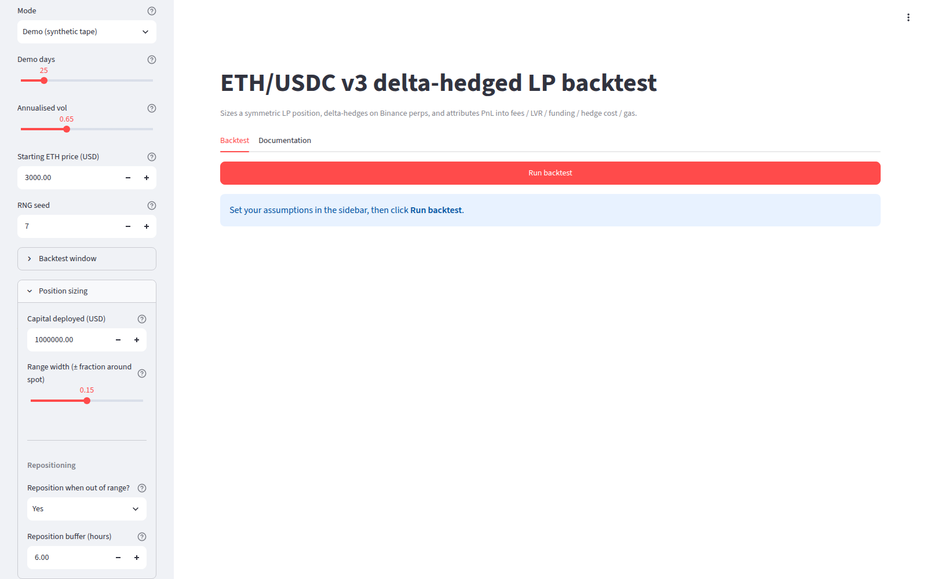
Figure 6. Position sizing expander: capital deployed, range width, reposition switch and buffer.
Position sizing holds the capital (default 1,000,000 USD), the range width as a fraction around the entry price (default ±15%), whether to re-centre the range after the price leaves it (default yes) and how long the price must stay outside before re-centring (default 6 hours).
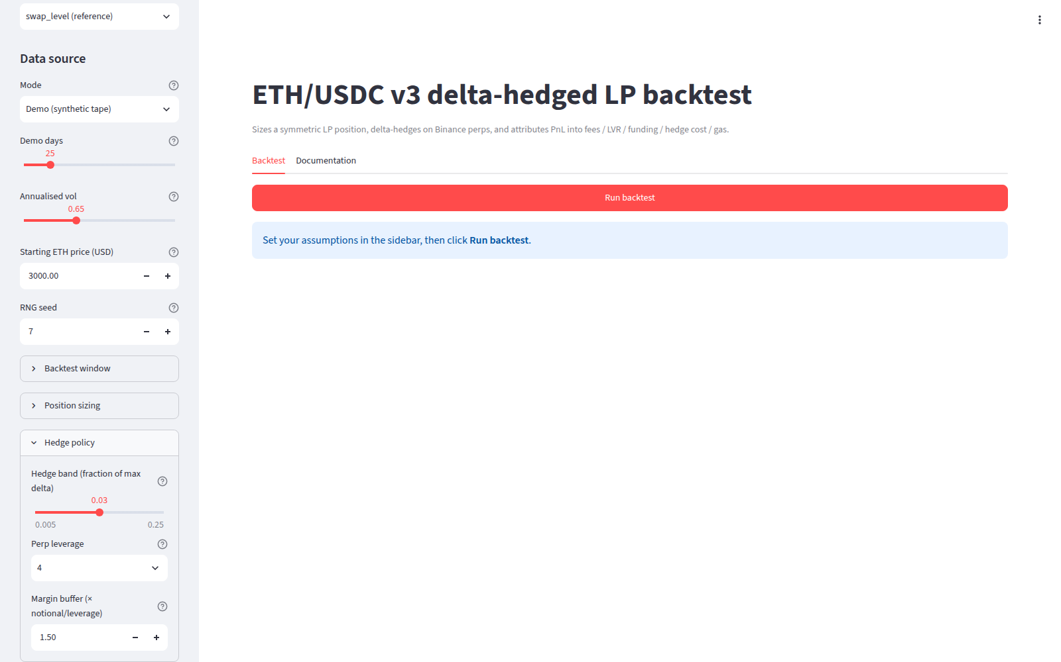
Figure 7. Hedge policy expander: hedge band, perp leverage, margin buffer.
Hedge policy holds the rehedge band (default 3% of the position's maximum delta), the leverage used to compute the margin (default 4x) and a margin buffer multiplier (default 1.5).
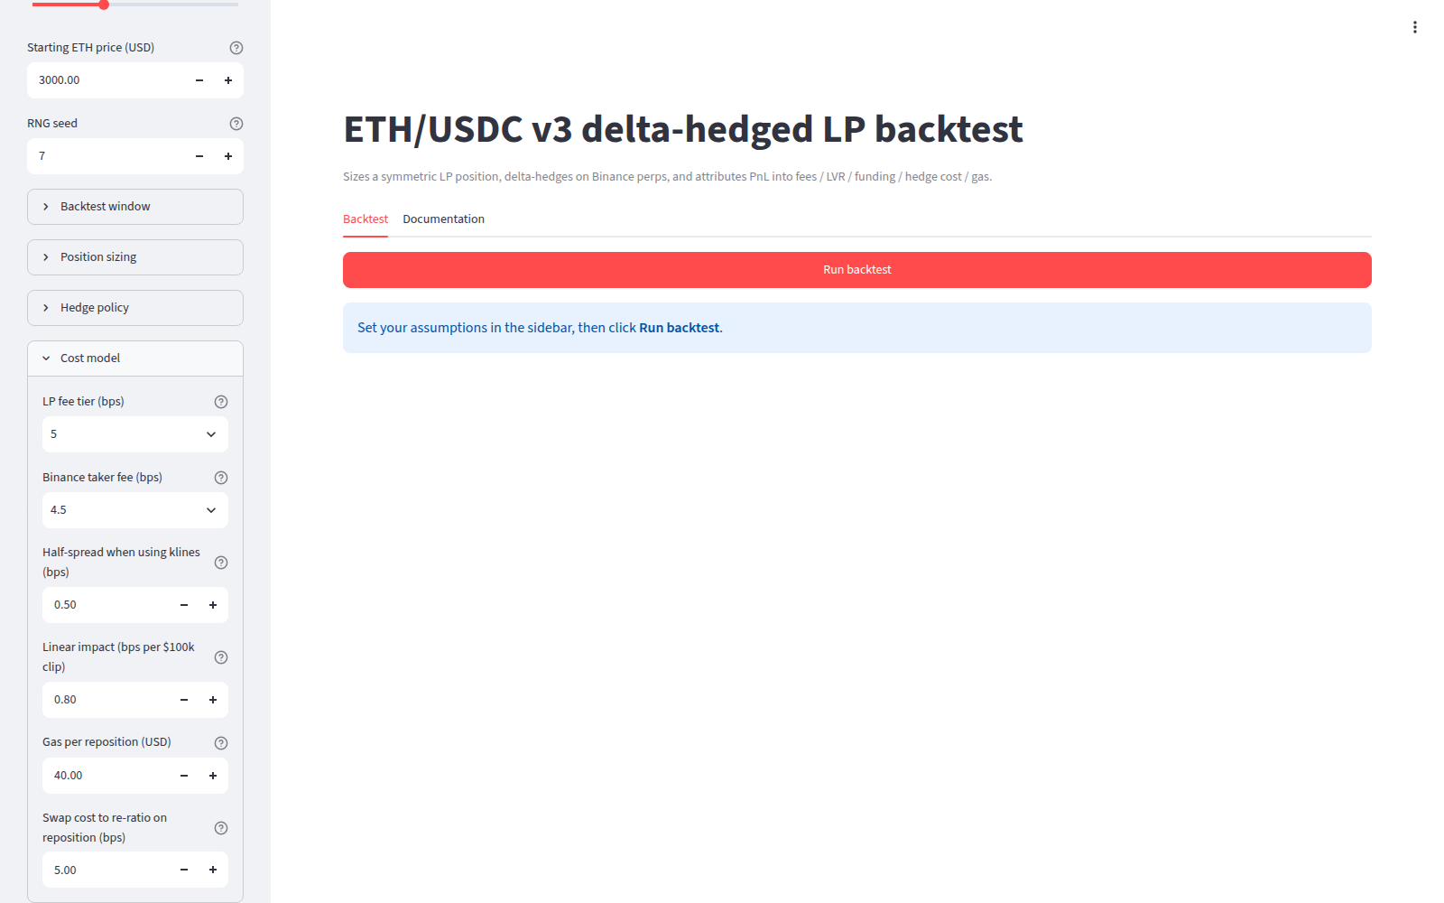
Figure 8. Cost model expander: LP fee tier, Binance taker fee, half-spread, linear impact, gas per reposition, swap cost to re-ratio.
Cost model holds the pool's fee tier (default 5 bps), the perp taker fee (4.5 bps), a half-spread (0.5 bps), an impact coefficient (0.8 bps per 100,000 USD clip), the gas paid per reposition (40 USD) and the cost of re-ratioing the two tokens when repositioning (5 bps of capital).
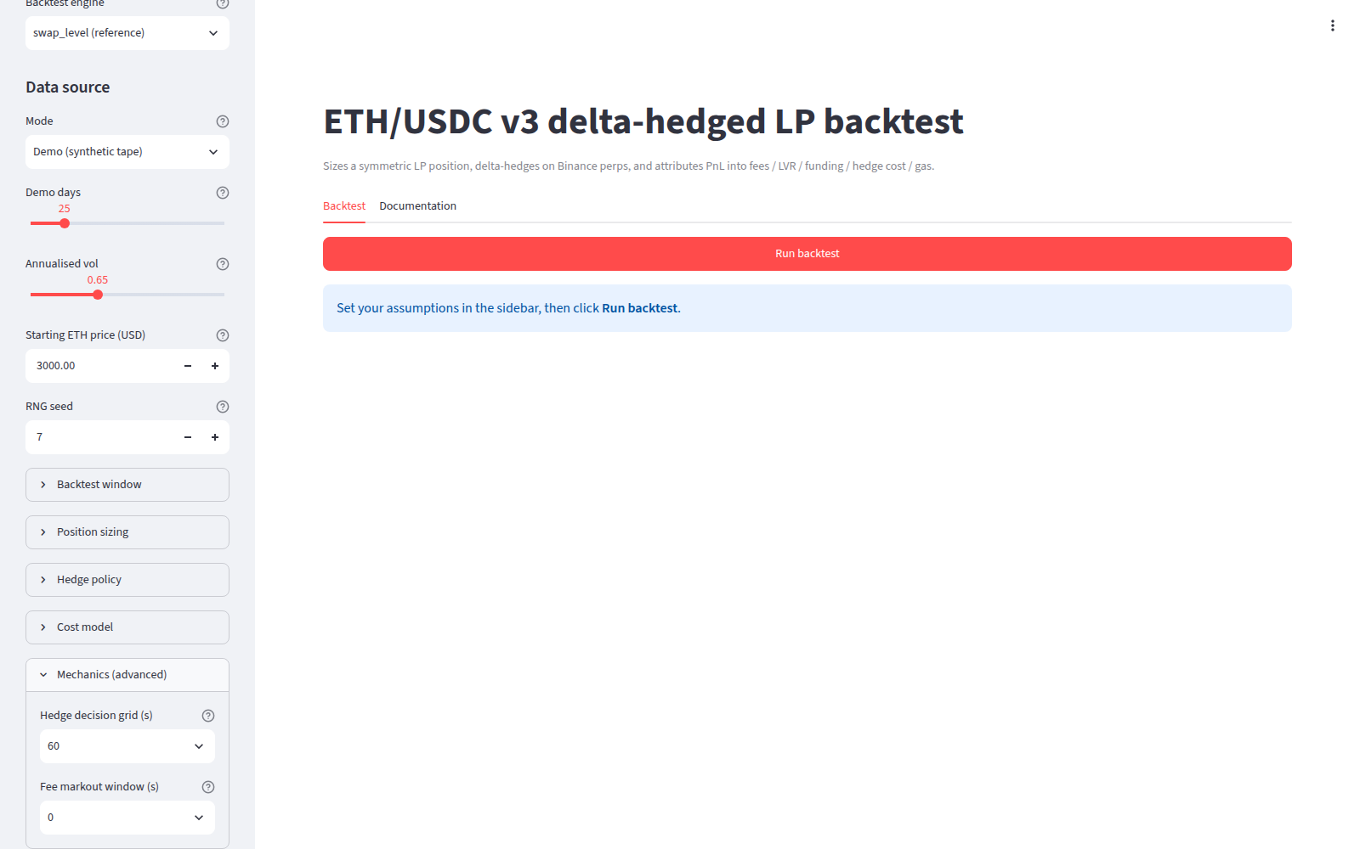
Figure 9. Mechanics (advanced) expander: hedge decision grid in seconds, fee markout window.
Mechanics (advanced) holds the hedge decision interval (60 s) and the markout window used to mark each swap against the exchange price (0 s).
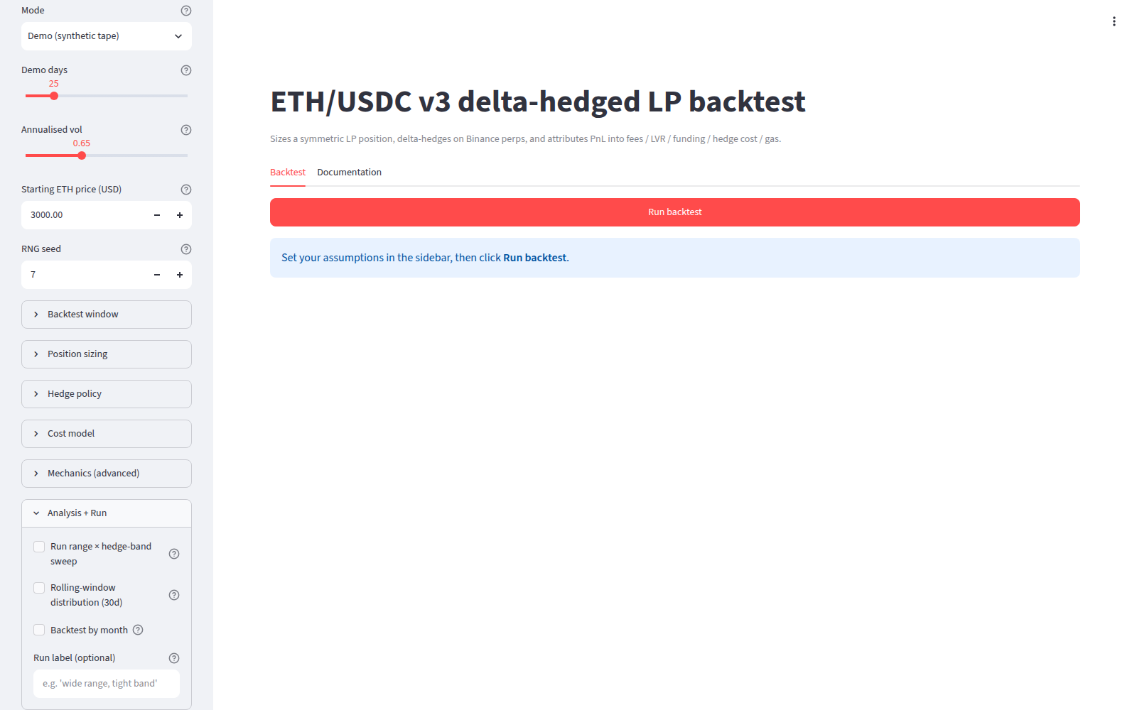
Figure 10. Analysis + Run expander: sweep, rolling-window distribution, backtest by month, run label.
Analysis + Run switches on three optional analyses (a two-axis parameter sweep, a 30-day rolling distribution, a by-month breakdown) and takes a label for the run. The Run backtest button is in the main area.

0.4 Loading real data through the sidebar
The repository ships no data. The data/ directory is created on first download. Three files are needed for the reference engine: the swap events, an exchange price series, and the funding prints.
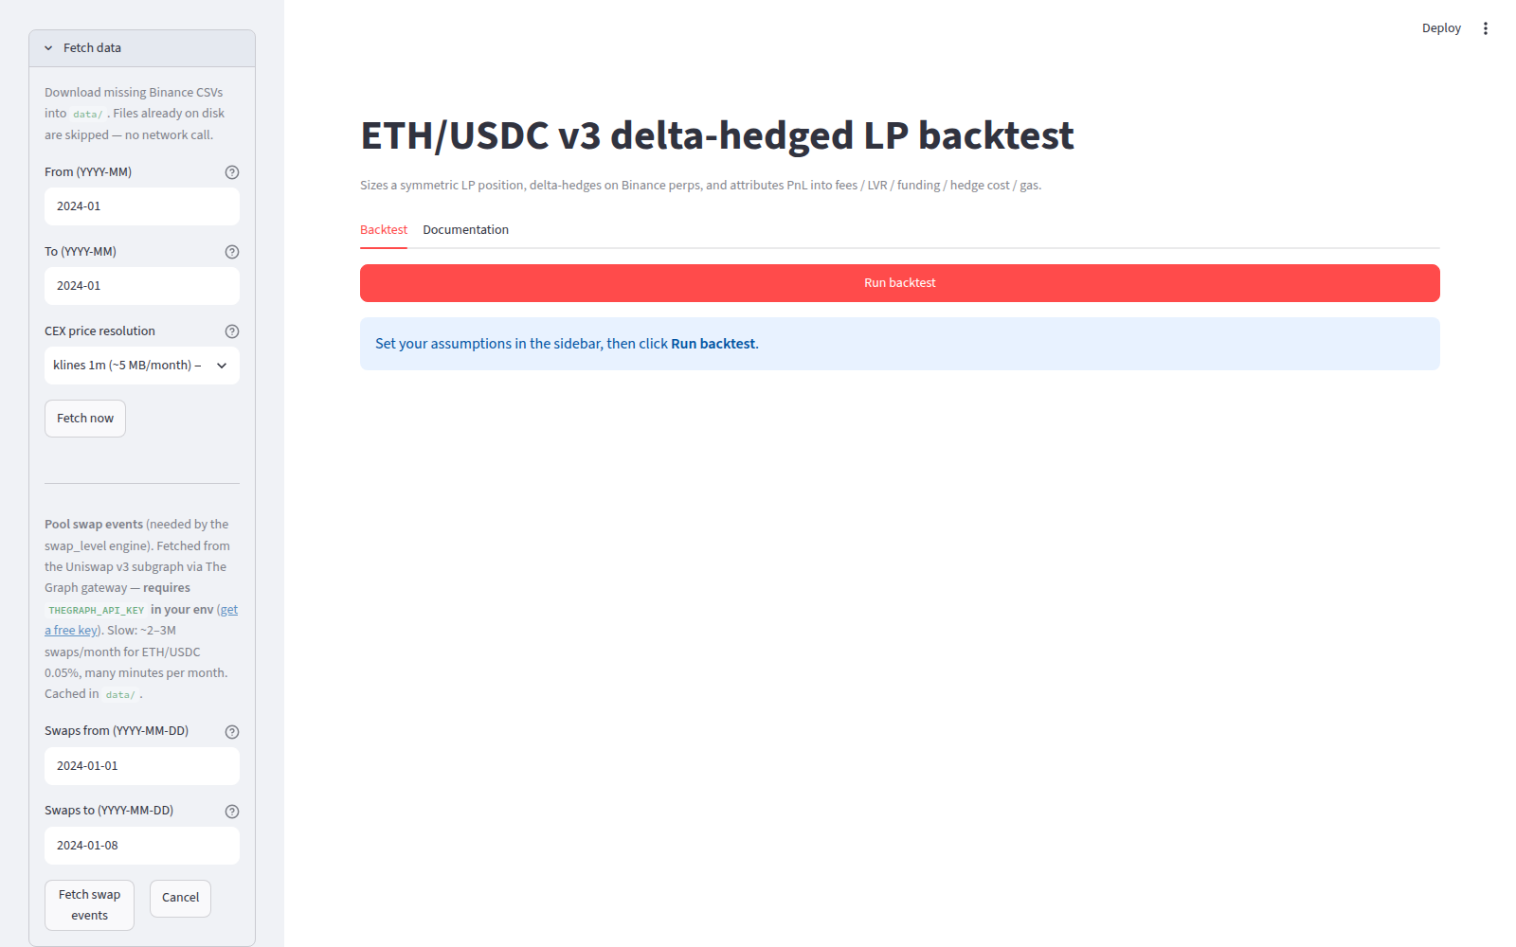
Figure 11. Fetch data expander on the local app. The cached files are not listed here; the expander only shows the download controls.
Binance files: set From (YYYY-MM) and To (YYYY-MM) to 2026-08, leave CEX price resolution at klines 1m (~5 MB/month) — recommended, click Fetch now. The app calls backtest.ensure_all_data (app.py:246-252), which downloads ETHUSDT-1m-2026-08.zip and ETHUSDT-fundingRate-2026-08.zip from data.binance.vision, unzips them into data/ETHUSDT-klines-1m-2026-08.csv and data/ETHUSDT-fundingRate-2026-08.csv, and reports Binance: 2 downloaded, 0 already present. Files already on disk are skipped.
Swap events: set Swaps from and Swaps to, click Fetch swap events. This needs an API key for The Graph, a public indexing service for Ethereum, in the environment variable THEGRAPH_API_KEY; the app refuses without it (app.py:297-302). On the deployed commit this button fails against the current index: the query requests a field liquidity on each swap that the index no longer exposes, and the app shows Type Swap has no field liquidity. It also stores two columns as Python integers that overflow the file format on any real month. DATA.md section 3 documents both and the script used instead. The result of that script is data/swaps_0x88e6a0_2026-08-01_2026-08-31.parquet, which is the file name the sidebar would produce for those dates, and the app finds it.
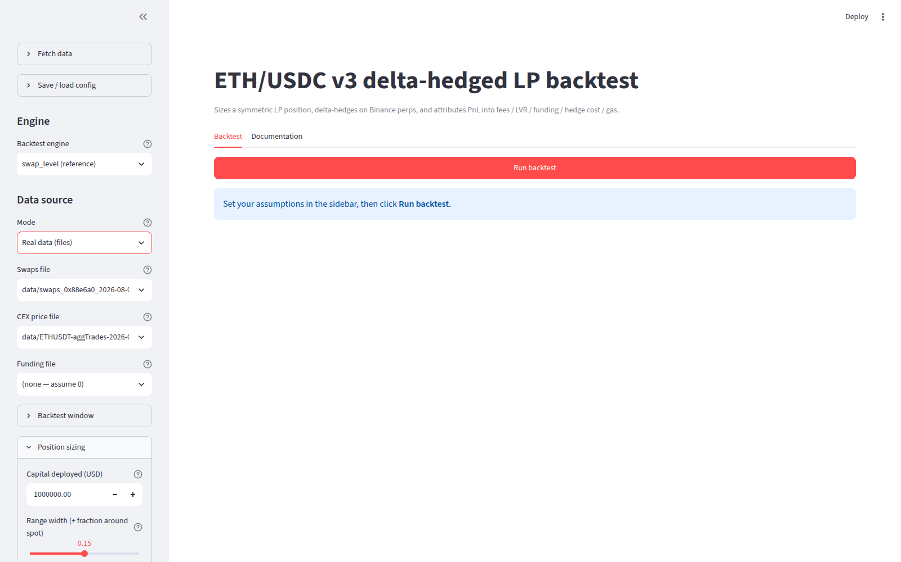
Figure 12. Data source in Real data (files) mode on the local app, as it first appears: the app pre-selects the aggTrades file and no funding file.
Real data (files) detection: Mode set to Real data (files) makes three selectboxes appear. Swaps file lists every *.parquet or *.csv under data/ or the repo root whose name contains "swap" (app.py:132-143). CEX price file lists *aggTrades*.csv then *klines*.csv under data/ and pre-selects the first, so when an aggTrades file exists it wins. Funding file lists (none — assume 0) first and pre-selects it. The guide's runs use the 1-minute klines and the funding file:
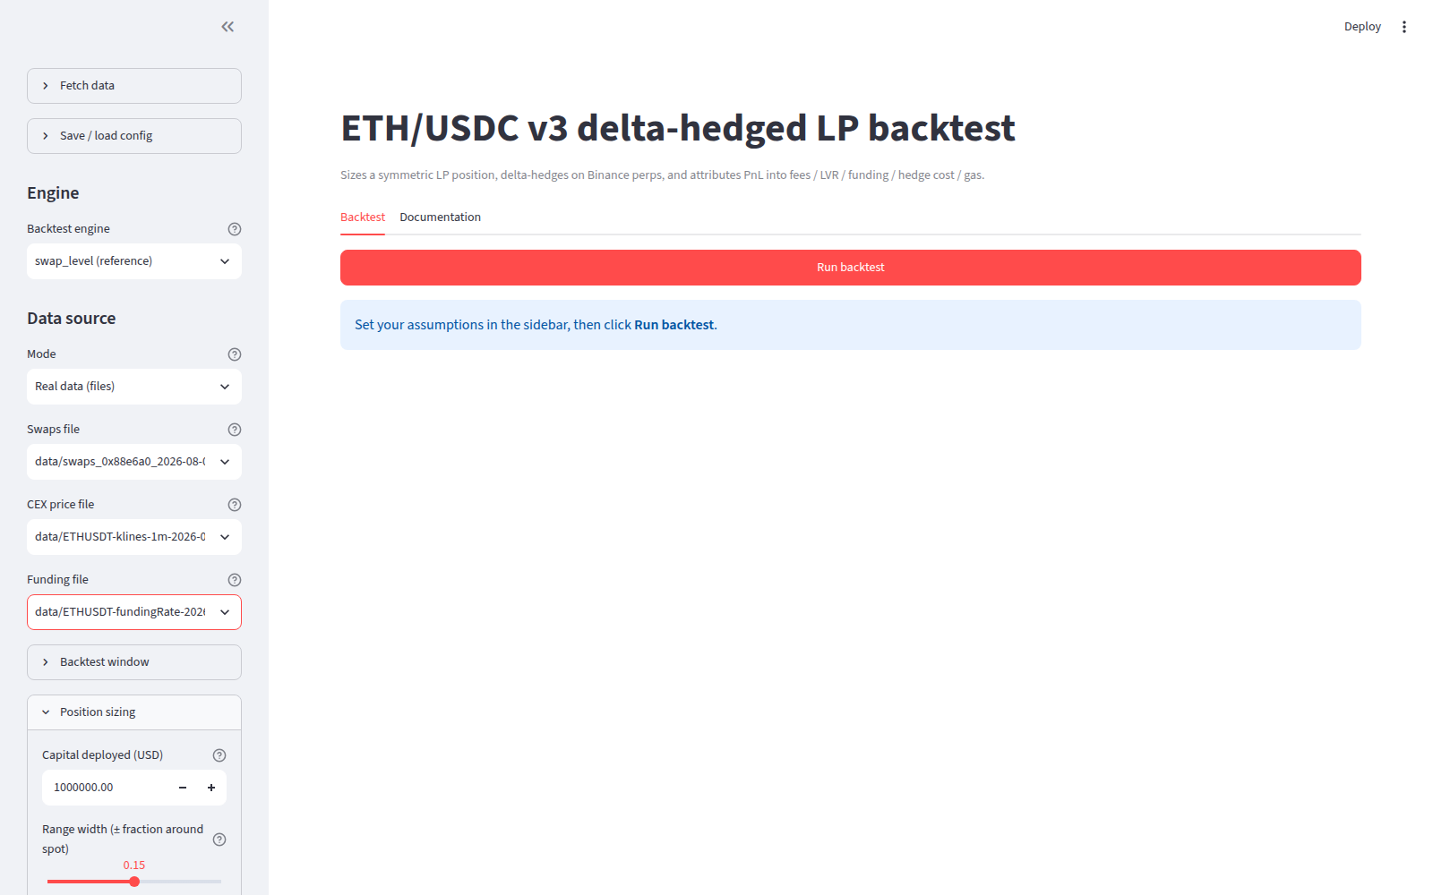
Figure 13. Data source with the three file selectboxes set to the swap parquet, the 1-minute klines and the funding CSV.

0.5 Where every headline number appears
After Run backtest the main area shows, in order: a verdict banner with the net APR, engine name and day count; a caption with the capital base; five metric tiles (Net PnL, Fees APR, LVR APR, Funding APR, Hedge cost APR); four more (Fees / LVR, % time in range, Sharpe, Max drawdown); two download buttons; a Cumulative PnL chart; a PnL attribution section with Cumulative and Daily bars tabs; an ETH price and LP delta section with two charts; the optional rolling section; two expanders Full summary and Timeseries (first 500 rows); the optional by-month and sweep sections; and the Run comparison section once two runs exist. Section 7 walks through each with the real numbers.

0.6 Exporting
Download summary (JSON) serves the summary dictionary (the 26 fields of section 7.4). Download timeseries (CSV) serves the 60-second grid frame, 44,640 rows for August with 11 columns (price, lp_value, lp_delta, hedge_delta, fee_usd, lvr_usd, funding_usd, hedge_cost_usd, gas_usd, net_usd, cum_net). In the browser sandbox used for this guide the downloads are inert; the same frames were written directly from Python into docs/guide/raw/default/.

0.7 The optional analyses
Run range × hedge-band sweep runs one backtest per cell of a grid (default 5 hedge bands × 6 range widths, 30 runs, 15.8 s on the August tape) and shows a heatmap plus a Full sweep table expander. Rolling-window distribution (30d) shows the net APR of each trailing 30-day window; with 31 days of data that is 2 windows. Backtest by month runs one backtest per calendar month; with one month of data it shows Loaded data spans only 1 month — need at least 2. The stress test lives in the same expander but only appears when the hourly engine is selected; it is a synthetic price shock applied to the last N days and is discussed in section 8.11.

0.8 The engine from Python in five lines
import backtest as bt
swaps = bt.load_swaps("data/swaps_0x88e6a0_2026-08-01_2026-08-31.parquet")
cex = bt.load_cex_prices("data/ETHUSDT-klines-1m-2026-08.csv")
funding = bt.load_funding_series("data/ETHUSDT-fundingRate-2026-08.csv")
res = bt.run_swap_level(bt.Assumptions(), swaps, cex, funding) # res.summary, res.timeseries, res.attribution
res.summary["net_usd"] is −11592. Appendix C gives the command for every table in this guide.

1. The instruments, translated

1.1 A block
Ethereum is a shared ledger. Transactions are collected into batches called blocks, and a block is appended every 12 seconds by design. Every swap in the dataset carries the number of the block it was included in and that block's timestamp. In the August tape, 92,532 distinct blocks carried swaps, numbered 25,656,296 to 25,878,704. Between consecutive swap-bearing blocks the spacing per block has a median of 12.0 seconds, a mean of 12.044 and a 1st and 99th percentile both of 12.0. For the 47,661 pairs of adjacent block numbers, 99.65% are exactly 12 s apart and 167 are 24 s apart, which is one skipped slot (DATA.md section 5). So the tape ticks every 12 seconds, and a swap's timestamp is the block's, not the moment the trader sent it. Everything the pool does between two blocks is invisible; there is no intra-block price.

1.2 A token, a pool, a swap
A token is a balance on that ledger. USDC is a token redeemable one-for-one for a dollar; WETH is ether wrapped as a token. A pool is a smart contract, which is a program on the ledger that holds token balances and executes fixed rules. A swap is a transaction that sends one token to the pool and receives the other at the price the rules dictate. The dataset has one row per swap: block number, timestamp, the signed amount of each token (positive when the pool received it), the pool's price after the swap, and the pool's liquidity.

1.3 A perpetual future and funding
The hedge instrument is the Binance USD-M ETHUSDT perpetual. It is a linear future with no expiry, margined in USDT, that stays pinned to spot by a periodic cash transfer between longs and shorts called funding. Funding replaces the carry that an expiry would embed in the basis. Binance settles it every 8 hours, at 00:00, 08:00 and 16:00 UTC; the August file has 93 prints, all with funding_interval_hours = 8, 31 at each of those three times. The rate is a fraction of notional per settlement. A positive rate means longs pay shorts.
The real arithmetic from the first stamp: the file's first row is calc_time 1785542400001 (2026-08-01 00:00:00.001 UTC), rate 0.00006744. At that stamp the engine's hedge is short 249.2467 ETH at 1,862.68, notional 464,266.87 USD. The code computes cash = -(hedge × price) × rate (run_claude.py:656): −(−249.2467 × 1,862.68) × 0.00006744 = +31.31 USD, credited to the short, and the timeseries row for 00:00 carries funding_usd = 31.31 (raw/guide_derivations.txt). Over the month the mean rate was +0.0000519 per 8 h, which annualises to 5.68% (0.0000519 × 3 × 365); 88 prints were positive and 5 negative; the sum of the 93 rates is +0.4828%, so a 1 USD short collected 0.48 cents. The engine collected 1,495 USD on the varying hedge. For an options trader: funding is the carry on the hedge, it was positive carry for the short in August, and it is small next to the gamma cost.

1.4 An AMM versus a limit order book
On an exchange a market maker quotes and can pull the quote. In a Uniswap pool the liquidity provider does not quote. The provider deposits two tokens and the contract commits them to a price schedule: the pool's price after a swap is a deterministic function of the reserves, and any taker who sees the exchange price move can trade against the pool at the stale price until the pool catches up. The provider is passively picked off, every block, by whoever arrives first. The pool charges every swap a fee (0.05% in this pool) that goes to the providers. The provider's business is therefore: sell the fee stream, pay the adverse selection.

1.5 A concentrated range as a short strangle
In Uniswap v3 a provider chooses a price band. Inside the band the position holds both tokens and its composition slides from all-USDC at the top of the band to all-ETH at the bottom. Outside the band it holds only one token and does nothing. The value function of the position against the ETH price is concave, flat outside the band, with kinks at the two bounds. Its delta falls as the price rises and rises as the price falls: short gamma. There is no premium; the fee stream is the premium, paid continuously and only while the price is inside the band. A ±15% range around 1,862.68 is a position that is short gamma between 1,583 and 2,143 and has no exposure at all beyond those two strikes. The hedge shorts the delta on the perp. What is left is the gamma bleed, called LVR below, against the fees.

1.6 A tick
The pool does not store a price; it stores a square root of price in fixed point, sqrtPriceX96, and an integer tick such that the price lies in [1.0001^tick, 1.0001^(tick+1)). Positions can only start and end on ticks that are multiples of the pool's tick spacing, 10 for this fee tier, so the band's bounds are quantised to 0.1% steps. The pool's price is in raw units, token1 per token0, which for this pool is WETH per USDC; the ETH price in dollars is 1e12 / P_raw (run_claude.py:126-128), and a higher ETH price means a lower tick.
Verified on the first swap of the window (block 25,656,296, 2026-08-01 00:00:47): sqrtPriceX96 = 1836535346318371944277253759023295. P_raw = (sqrtPriceX96 / 2^96)^2 = 5.373279e8. floor(ln(5.373279e8) / ln(1.0001)) = 201031, and the stored tick is 201031. The ETH price is 1e12 / 5.373279e8 = 1,861.06 USDC per ETH; Binance's 1-minute close for that minute was 1,862.68. The same check holds on four other swaps spread across the month and on all 721 rows of the hourly pool file (DATA.md section 6, SOURCES.md 3a).

1.7 LVR versus impermanent loss
Impermanent loss is the difference between the value of the position and the value of having held the two tokens, evaluated at the exit price. It depends on where the price ends and not on the path. Loss-versus-rebalancing (Milionis, Moallemi, Roughgarden and Zhang, arXiv:2208.06046) is the running cost of the position against a continuously rebalancing portfolio at the exchange price. It accrues along the path at rate ½σ²P²|V''(P)| and it is exactly what a delta-hedged provider pays: the hedge removes the price exposure and leaves the gamma bleed. This guide measures LVR three ways on real data (section 6) and never uses impermanent loss; the app does not compute it either.

2. The data
Window: 2026-08-01 00:00:00 to 2026-08-31 23:59:59 UTC, 31 days. Pool: 0x88e6a0c2ddd26feeb64f039a2c41296fcb3f5640, Uniswap v3 ETH/USDC 0.05%, Ethereum mainnet. Hedge: Binance USD-M ETHUSDT perpetual.
Series | Source | File | Rows | Check
Swap events | The Graph gateway, Uniswap v3 subgraph 5zvR82Qo…, fetched with the stock pagination and repaired (DATA.md 3-4) | data/swaps_0x88e6a0_2026-08-01_2026-08-31.parquet | 159,990 | sha256 3e28bbf3…
Pool hourly aggregates | same subgraph, poolHourDatas | data/pool_hourly_0x88e6a0_2026-08-01_2026-09-01.parquet | 745
Exchange price, 1 minute | data.binance.vision monthly klines | data/ETHUSDT-klines-1m-2026-08.csv | 44,640 | no missing minutes
Exchange price, every trade | data.binance.vision monthly aggTrades | data/ETHUSDT-aggTrades-2026-08.csv | 33,010,405 | 2.19 GB
Funding | data.binance.vision monthly fundingRate | data/ETHUSDT-fundingRate-2026-08.csv | 93 | 8 h, 00/08/16 UTC

The checks (DATA.md section 5), in the order a sceptic would ask:
- Is the swap file complete? Summing |amount0| over the swaps gives 2,422,599,886 USD of volume for the month; the pool's own hourly volumeUSD sums to 2,422,385,371. Ratio 1.00009. Per hour the ratio has median 1.00006, 1st percentile 0.99869, 99th 1.00129, and no hour is outside [0.9, 1.1]. The stock code's pagination dropped 192 rows (0.12%) at page boundaries, which were recovered by re-querying each boundary second.
- Does the pool trade at the exchange price? Basis of the pool price after each swap against the Binance 1-minute close: mean −0.65 bps, median −0.54, standard deviation 11.1 bps, 1st percentile −24.9, 99th +19.6 over all 159,990 swaps. Taking the last swap of each minute (38,092 minutes): mean −0.93 bps, standard deviation 5.2, 97.3% within 10 bps. The pool quotes USDC, the perp quotes USDT; the two dollars traded at par.
- Is the chain clock what it should be? Section 1.1: 12 seconds, 99.65% exact.
- Is funding what it should be? Section 1.3: 93 prints, 8 h, +5.68% annualised mean.
Deviations from the stock code, both forced by the live index: liquidity is not available per swap and was filled from the pool's hourly liquidity of the containing hour, so the position's fee share is computed against hourly rather than per-swap pool depth; and the stock writer overflows on real amounts, so amounts are stored as floats, which is what the engine converts them to on load anyway (DATA.md section 3).

2.1 Tape statistics and what they mean for a short-gamma book
From the 44,639 one-minute log returns:
Statistic | Value
Month open / close | 1,861.68 / 2,466.53 (+32.49%)
High / low | 2,566.40 (Aug 27 09:27) / 1,820.61 (Aug 1 18:50)
Realised annualised vol, 1-minute returns | 51.77%
Realised annualised vol, daily returns (30) | 67.82%
Largest absolute 1-minute move | +3.4753% at 2026-08-19 15:27 (2,046.42 to 2,118.79 in one minute)
Excess kurtosis / skew | 264.59 / +2.43
Minutes with a move over 0.5% / over 1% | 56 / 12
Lag-1 autocorrelation, absolute returns / signed returns | 0.431 / −0.010

For a short-gamma position: the drift does not matter after hedging, the realised variance does, and August's was 52% at the hedge frequency and 68% at daily frequency. Daily vol above minute vol says the month trended; the position paid gamma bleed at 52% and then paid a second time at the band, because the price left the ±15% range on Aug 19 and the position was re-struck. The 3.48% minute is a 48.7-standard-deviation move at the one-minute scale (per-minute standard deviation 0.071% at 52% vol) and 1.3 daily standard deviations; the hedge grid is 60 s, so the hedge could not trade inside it. Kurtosis of 265 says the tape is nothing like the diffusion the closed-form LVR assumes, and yet the closed form and the path-exact loss agree to 2% over the month (section 6), because the integral is dominated by the many small moves.

2.2 Demo mode
The app's default data source is Demo (synthetic tape). It generates a geometric Brownian price path and a simulated stream of swaps from an arbitrageur plus Poisson noise flow (run_claude.py:363-455) and runs the same engine on it. It shows a yellow banner Synthetic tape — numbers do NOT reflect real ETH/USDC PnL. It exists to exercise the code. This guide does not use it; the only place its numbers appear is the engine self-test in ENVIRONMENT.md.

3. The position at t0
build_position (run_claude.py:211-234) takes the first price on the 60-second hedge grid, 1,862.68 (the Binance close of the first minute), the ±15% width and the capital, and returns (raw/default/diag.json, position_t0):
Item | Value
Entry price | 1,862.68
Lower bound / upper bound in ETH price | 1,582.93 / 2,143.12
Ticks (pool frame; low tick is the high ETH price) | 199,620 / 202,650
Liquidity L, raw on-chain units | 1.588442e17
USDC leg | 535,733.13
ETH leg | 249.2467 ETH = 464,266.87 USD
Position value | 1,000,000.00
Delta (ETH held) | 249.2467 ETH
Maximum delta (all ETH, at the lower bound) | 561.2421 ETH
Hedge at t0 | short 249.2467 ETH, notional 464,266.87 USD
Rehedge band (3% of max delta) | 16.84 ETH

The bounds are not exactly ±15% because they are rounded outward to tick multiples of 10 (run_claude.py:223-228): 1,862.68 × 0.85 = 1,583.28 becomes 1,582.93 and × 1.15 = 2,142.08 becomes 2,143.12.
Why the composition is 53.6% USDC and 46.4% ETH despite a symmetric band. Write L_h for the liquidity in human units (L × 1e6 / 1e18, 158,844.24 here). The two legs are (SOURCES.md 3d, 4a):
USDC = L_h × (√P − √P_lo)
ETH = L_h × (1/√P − 1/√P_hi)
At P = 1,862.68: √P = 43.1588, √P_lo = 39.7861, √P_hi = 46.2939. The USDC leg is 158,844.24 × 3.3727 = 535,733.13. The ETH leg is 158,844.24 × (1/43.1588 − 1/46.2939) = 249.2467 ETH, worth 464,266.87 (raw/guide_derivations.txt). The band is symmetric in price but the position lives in the square root of price, which is concave: √P − √P_lo = 3.3727 is larger than √P_hi − √P = 3.1351. More of the liquidity's "distance" sits below spot than above, so more of the value sits in the USDC leg. The delta at entry, 249.25 ETH, is 44.4% of the maximum 561.24, not 50%, for the same reason.
The value of L is set so that the position is worth exactly the capital at the entry price: L = capital / value(L = 1) (run_claude.py:232-234). A narrower band gives a larger L for the same capital, which is the lever behind the range sweep in section 8.

4. What the engine does, step by step
run_claude.run_backtest (run_claude.py:674-781), in execution order, with the number each stage produced on the default run.
Ingest and clip. load_swaps maps the parquet onto the canonical columns and casts amounts to float (run_claude.py:253-273): 159,990 rows. load_cex_prices takes the 1-minute close stamped at close_time, resamples to 1 second and forward-fills (295-315): 2,678,341 seconds from 2026-08-01 00:00:59 to 2026-08-31 23:59:59. load_funding (318-324): 93 prints. With an empty Backtest window nothing is clipped. The app's loaders are the same functions behind a cache (app.py:158-175).
The hedge grid. The 1-second series is resampled to grid_seconds = 60 with the last price in each bucket (548, 596): 44,640 rows from 00:00 on Aug 1 to 23:59 on Aug 31. Every decision, mark and aggregation below happens on this grid. With 1-minute klines the price changes once per grid row; a 10 s grid would see the same 44,640 distinct prices (SCENARIOS.md section 5).
Position build and schedule. build_position_schedule (543-580) builds the section 3 position at the first grid price, then walks the grid: whenever the price has been outside the band for at least reposition_buffer_hours = 6, it values the position at that price, deducts 5 bps and 40 USD, and builds a new ±15% position with the remainder. On August's tape that happened once, at 2026-08-20 02:50, at 2,251.02: value at exit 1,033,724.78, minus 516.86 and 40, new capital 1,033,167.92, new band 1,912.23 to 2,588.96, new L 1.4929e17.
Per-swap fee attribution and the liquidity share. attribute_swaps (458-535) assigns each swap to the position in force, marks it against the exchange price at block_time + markout_seconds (491-496), and tests whether the swap's tick is inside the position's band (502-504): 157,051 of 159,989 swaps (98.16%) were. For in-range swaps the share is L_you / (L_active + L_you) (505-506): mean 2.655%, min 0.33%, max 4.13% as the pool's own liquidity moved between 1.85e18 and 4.51e19 during the month. The fee on each swap is fee_tier × the gross input token, converted to USD at the mark if the input was ETH (511-513), times the share. The pool as a whole earned 1,167,990 USD of fees on 2,335,160,984 USD of in-range volume at 5 bps; the position's share was 28,955.80 USD, which is 2.48% of the pool's fees.
LVR on the fee-net execution price. For the same swap the taker's execution price is formed from the amounts after the fee has been stripped from the input leg (517-522); the taker's profit is ± eth_qty × (p_cex − p_exec) with the sign set by which way the ETH went (523-525), and the position's LVR is its share of that (526). The fee is stripped first because it is already booked as fee_usd; measuring the taker's edge on the gross amount would charge the fee twice. The gross markout, fee-inclusive, is kept as markout_usd (528-533) and the identity fee_usd − lvr_usd = markout_usd holds on every row: 28,955.80 − (−4,134.05) = 33,089.85. Section 6 explains why lvr_usd came out negative on the 1-minute mark and what it is on a fresh mark.
The hedge loop. simulate_hedge (588-668) computes the position's delta on every grid row from L and the band, lp_delta = L × (√P_clipped − √P_lo) in the pool frame (607), sets the initial hedge to minus that delta before the loop (614), then on each row trades only when the residual lp_delta + hedge exceeds the band, 3% of max delta = 16.84 ETH (615-619). Result: 150 trades in 31 days, the first at 2026-08-01 18:30 for −18.40 ETH, total turnover 2,845.55 ETH = 6,355,283 USD, mean clip 18.97 ETH = 42,369 USD. The largest clip was 441,856 USD: the re-hedge at the reposition, when the delta jumped from 0 (all USDC above the old band) to 212.54 ETH inside the new one. The initial hedge is not counted as a trade and is not charged.
Execution cost and the quadratic impact term. Each trade costs notional × (half_spread + taker) / 1e4 + notional × (notional / 1e5) × impact / 1e4 (623-625). With 0.5 + 4.5 bps and 0.8 bps per 100k: the linear part summed to 3,177.64 USD, the quadratic part to 362.02, total 3,539.66. The quadratic term equals the linear one when a clip reaches 5 / 0.8 × 100,000 = 625,000 USD. At the mean clip of 42,369 the impact is 1.44 USD against 21.18 of spread and fee; at the 441,856 clip it is 156 against 221. Impact only bites at 3M and above in the capital sweep (section 8.7).
Hedge mark-to-market. hedge_pnl = hedge[t−1] × (p[t] − p[t−1]) (630-631): −101,437.47 USD over the month for a short in a rising market. The LP's inventory, marked by the same value function at the grid price (664-668), gained 63,474.93 including the 556.86 write-down at the reposition. Hedged inventory: −37,962.54.
Funding accrual. Each of the 93 stamps is placed on the grid row at or before it and cash = −(hedge × price) × rate is added there (645-660): +1,494.55 USD.
Reposition trigger, buffer and gas. Back in run_backtest, for each reposition after the first position, the grid row at that time gets gas_usd += 40 + capital_usd × 5 bps = 540 (690-695). The schedule already wrote the capital down by 556.86 at the same moment, and that write-down flows into lp_pnl_usd; net_usd then subtracts gas_usd as well (706). One reposition costs 556.86 in fact and 1,096.86 in net_usd (SCENARIOS.md section 9). Note also that gas_usd uses the initial capital, not the current one.
The summary. net_usd = lp_pnl + hedge_pnl + fee + funding − hedge_cost − gas on every row (699-707), summed: 63,474.93 − 101,437.47 + 28,955.80 + 1,494.55 − 3,539.66 − 540 = −11,591.86, rounded to −11,592. decomp_usd = fee − lvr + funding − hedge_cost − gas (709-715): 30,504.73. Capital base = 1,000,000 + margin, margin = max_notional / leverage × margin_buffer = 528,320.22 / 4 × 1.5 = 198,120 (719-722). APRs divide by the base and by 31/365 (729-731). Sharpe is the daily net P&L mean over its standard deviation times √365 (760-767): −5.55. Max drawdown is the worst peak-to-trough of cumulative net (759, 769): −13,161. The 26 fields are in section 7.4.

5. P&L term by term
Default run, 31 days, capital base 1,198,120 USD.
Term | USD | APR | What it is to an options trader
Fees | +28,956 | +28.46% | The premium stream. Paid per swap while in range, proportional to the position's share of pool liquidity.
Hedged inventory (LP value + perp mark) | −37,963 |  | The gamma bleed of a short strangle rehedged every minute. This is LVR measured path-exact.
Funding | +1,495 | +1.47% | Carry on the hedge. Positive: the short collected.
Hedge execution | −3,540 | −3.48% | Slippage on 150 rehedges: spread plus fee plus impact.
Gas and re-ratio | −540 |  | Transaction cost of re-striking the position once, counted a second time (section 4).
Net | −11,592 | −11.39%

Fees. fee_usd = share × fee_tier × gross input per swap. Worked example: a taker sends 100,000 USDC into the pool while the position holds 2.655% of in-range liquidity: fee = 100,000 × 0.0005 × 0.02655 = 1.33 USD. Over 157,051 in-range swaps and 2,335,160,984 USD of volume the sum is 28,955.80. Per day, 934 USD on average, 511 in the calmest week and 1,536 in the busiest (SCENARIOS.md section 10).
LVR. Path-exact: 37,962.54 USD, from the hedged inventory. Closed form, Σ ½ σ²_step P² |V''(P)| over the grid with σ²_step the variance of 60-second log returns (5.0988e-7, which annualises to 51.77%): 37,263 USD. Per-swap with a fresh mark (aggTrades tape): 34,360. The three agree to within 10%. What a trader should read: the position was short roughly 38,000 USD of gamma over the month on 1,000,000 of capital, 3.8% a month, against 2.9% of fees.
Funding. Section 1.3. 93 stamps, 1,494.55 USD; the largest single stamp +47.95 USD at 2026-08-20 08:00 and the smallest −4.18 USD at 2026-08-03 08:00 (raw/guide_derivations.txt).
Hedge execution. 150 trades, 6,355,283 USD of turnover, 5 bps linear plus the impact term: 3,539.66 USD, 5.57 bps of turnover. Turnover per day 91.8 ETH against a position of 249 to 287 ETH: the book turned over roughly a third of its delta every day.
Gas. One reposition: 40 USD of gas and 5 bps of capital to swap the tokens back to the new ratio; 540 booked, plus the 556.86 write-down already inside the inventory term.
The hedge band and rehedge frequency. The band is 3% of the position's maximum delta, 16.84 ETH, a fixed dead zone in ETH, not in dollars or in delta-fraction. In an options book this is rehedging when the residual delta exceeds a fixed number of contracts. Tightening it to 0.5% (2.8 ETH) gave 3,218 trades and 13,390 USD of execution cost; widening it to 10% (56 ETH) gave 15 trades, 1,492 USD, and a worse drawdown (SCENARIOS.md section 4). The gamma cost itself does not move with the band on this tape by more than 4,000 USD across the grid; the execution cost moves by 12,000. August rewarded the widest band tested.

6. The two reconciliation controls
Control 1: path-exact `net_usd` against attribution `decomp_usd`. The engine reports both. net_usd is what the book made: inventory marked at the exchange price, plus the perp, plus fees, funding and costs. decomp_usd replaces the inventory and the perp with −lvr_usd, the per-swap measure. If the per-swap measure is right, the two agree up to the discrete-hedge error, which is the residual delta between rehedges times the price moves. The engine reports the gap as discrete_hedge_error_usd.
On the default run the gap is −42,097 USD on a net of −11,592. That is not hedge error. Per-swap LVR came out at −4,134 (a gain) while the hedged inventory lost 37,963. The cause is the mark. The 1-minute kline close is stamped at the end of its minute and forward-filled, so a swap at second 17 is marked against a price up to 59 seconds old. Arbitrage swaps move the pool to the new exchange price; against the old one they look like taker losses. Three runs replace the stale mark (SCENARIOS.md section 1):
Mark | lvr_usd | gap net − decomp
1-minute close, forward-filled, markout 0 (default) | −4,134 | −42,097
same tape, markout 60 s | +36,655 | −1,307
same tape, markout 300 s | +35,024 | −2,939
aggTrades resampled to 1 s, markout 0 | +34,360 | −3,602

With a fresh mark the gap collapses to 1,300 to 3,600 USD, which is the discrete-hedge error proper: 0.1% to 0.3% of capital over a month at a 60-second, 16.8-ETH band. The app's default file pick when an aggTrades file is present is the aggTrades file, so a user who downloads it gets the fresh mark; a user who follows the sidebar's own recommendation (klines 1m — recommended) gets the stale one and an LVR APR tile of +4.06% with Fees / LVR reading nan.
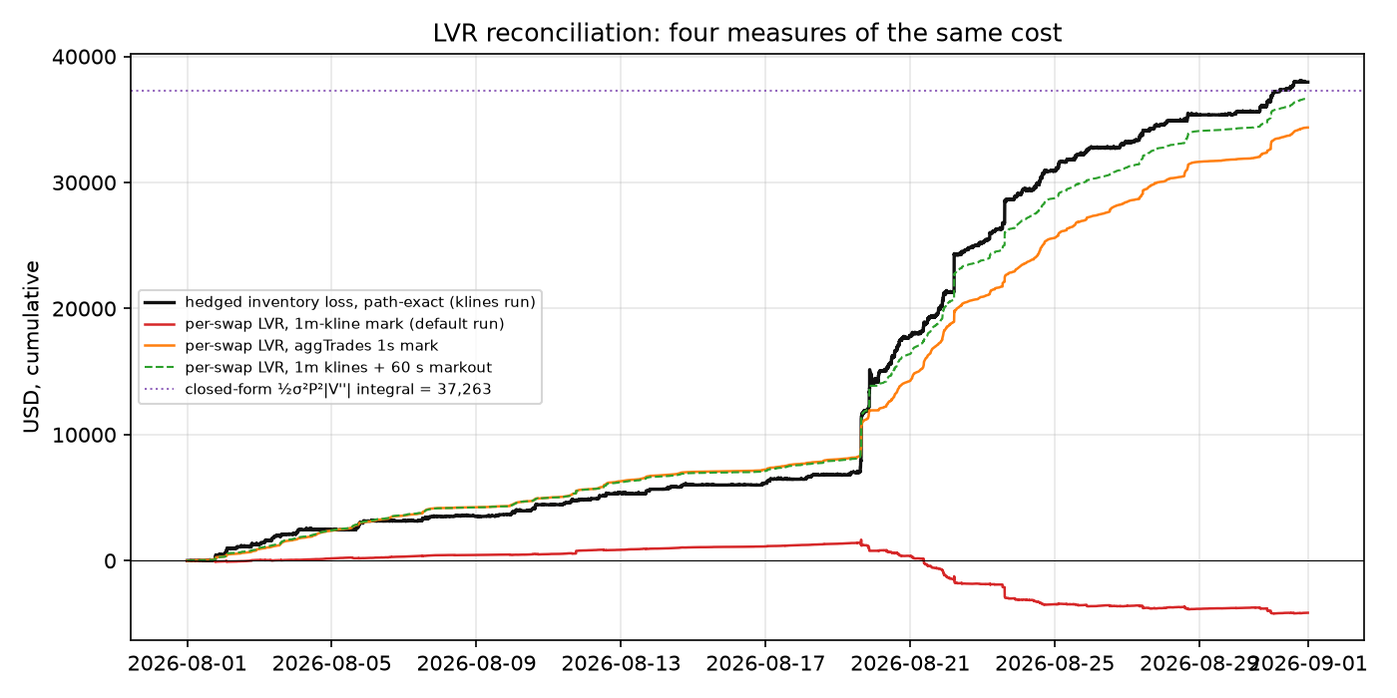
Figure 14. Four measures of the same cost over the month: the path-exact hedged inventory loss, the per-swap LVR on the stale 1-minute mark, the per-swap LVR on the aggTrades 1-second mark, the per-swap LVR with a 60-second markout, and the closed-form integral as a horizontal line.
Control 2: path LVR against the closed form. _closed_form_lvr (run_claude.py:785-800) computes Σ ½ × var_step × P² × |dΔ/dP| over the grid, with var_step the sample variance of the 60-second log returns of the grid price over the whole window and dΔ/dP a finite difference of the position's delta against price. The σ is therefore the realised 1-minute vol of the perp over August, 51.77% annualised, held constant, not an implied vol and not a local estimate. It gives 37,263 USD against the path-exact 37,963: a 1.8% gap. The closed form assumes a diffusion; the tape has kurtosis 265 and a 3.5% minute. The agreement says the gamma bleed of this position over this month is explained by the realised variance at the hedge frequency, and that the position's gamma profile in the code is the right one (SOURCES.md 1c verifies |V''| = L_h / (2 P^1.5) inside the band against the finite difference to 1e-6).
Why a trader should care that both gaps exist. The first gap is a data-quality alarm: when it is large, the attribution tiles are wrong even though the headline is right, and the sign of LVR APR flips. The second gap is a model check: if the closed form and the path disagreed by a factor, either σ or the value function would be wrong, and every sweep in section 8 would be uninterpretable. On August's data the first alarm fires on the recommended file and the second check passes.

7. The default run, screen by screen
Local app, swap_level, Real data (files), swaps parquet, 1-minute klines, funding file, every other control at its default. The same run through the test harness (raw/apptest/default_ui_metrics.json) and through Python (raw/default/summary.json) gives the same 26 fields (SCENARIOS.md section 1).
<!--SHOTS:results-->

7.1 Verdict banner and capital base
FEES DO NOT COVER THE COST — net -11.39% APR · engine: swap_level · 31 days. Red because net_apr_pct ≤ 0 (app.py:1263-1268). The day count is (last grid row − first) / 86400 = 31.0. Below it: Capital base = LP $1,000,000 + hedge margin $198,120 = $1,198,120 (denominator for all APRs below). The margin is the peak perp notional over the month, 528,320 USD when the short reached 286.9 ETH at 18:46 UTC on Aug 1, near the month's low, divided by 4x leverage and multiplied by the 1.5 buffer. If the window were under 30 days the banner would read INSUFFICIENT WINDOW in orange instead (app.py:1259-1262), which is what every weekly run in section 8.10 shows.

7.2 The nine tiles
Tile | Shown | How computed | Read it as
Net PnL (USD) | $-11,592 | sum of net_usd over 44,640 grid rows | the book's P&L
Fees APR | 28.46% | 28,956 / 1,198,120 / (31/365) | premium income on the whole capital base including margin
LVR APR | 4.06% | −(−4,134) / base / yrs | wrong sign on this file (section 6); −33.8% to −36.0% on a fresh mark (the app shows LVR APR negative when LVR is a loss)
Funding APR | 1.47%, "collected (perp paid you)" | 1,495 / base / yrs | carry on the short
Hedge cost APR | −3.48% | −3,540 / base / yrs | execution
Fees / LVR | nan | fees / lvr only when lvr > 0 (run_claude.py:750) | undefined on this file; 0.84 on the aggTrades mark (28,947 / 34,360)
% time in range | 98.2% | share of swaps whose tick was inside the band (747-749), not a share of time | the position was live for 98% of the flow
Sharpe (daily) | −5.55 | mean / std of the 31 daily net sums × √365 | a consistent daily loss, not a volatile one
Max drawdown | $-13,161 | min of cum_net − cummax(cum_net) | the loss was monotone: drawdown ≈ total loss

7.3 The charts
Cumulative PnL plots cum_net. It is flat to slightly positive for the first two weeks, then falls from Aug 19. PnL attribution, Cumulative tab, plots the running sums of fees, −LVR, funding, −hedge cost and −gas; on the stale mark the −LVR line rises, which is the sign problem of section 6 made visible. Daily bars shows the same five terms per day. ETH price and LP delta plots the grid price and then lp_delta against hedge_delta; the two mirror each other with a 16.8-ETH dead zone, drop to zero together when the price leaves the band on Aug 19, and jump back at the reposition on Aug 20.
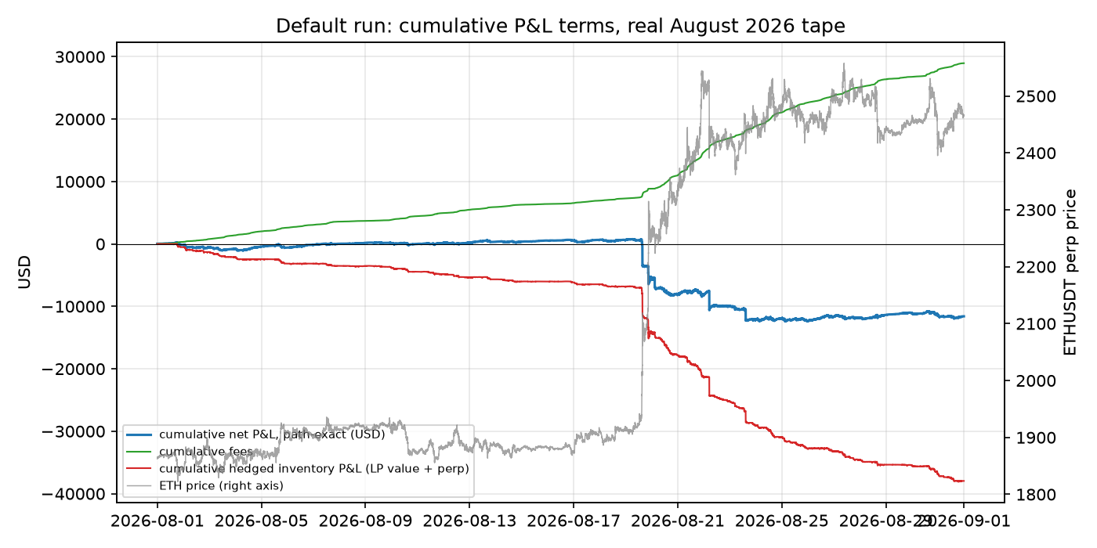
Figure 15. Default run, computed directly from the raw timeseries: cumulative net, cumulative fees, cumulative hedged inventory P&L, with the ETH price on the right axis.
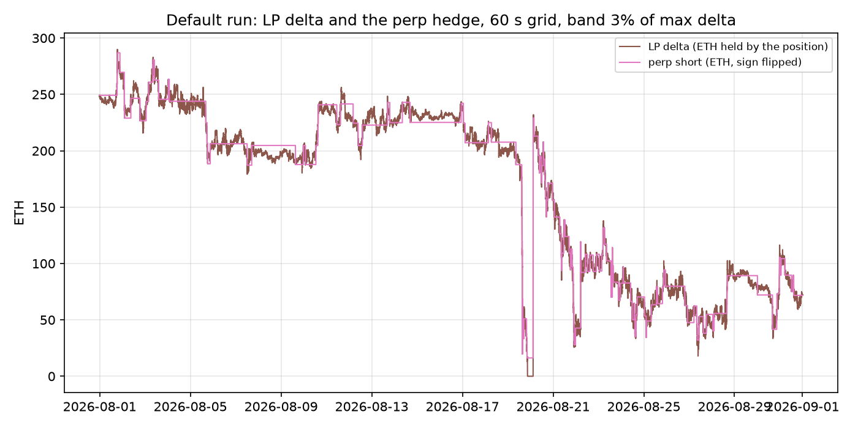
Figure 16. Default run: the position's delta and the perp short on the 60-second grid.
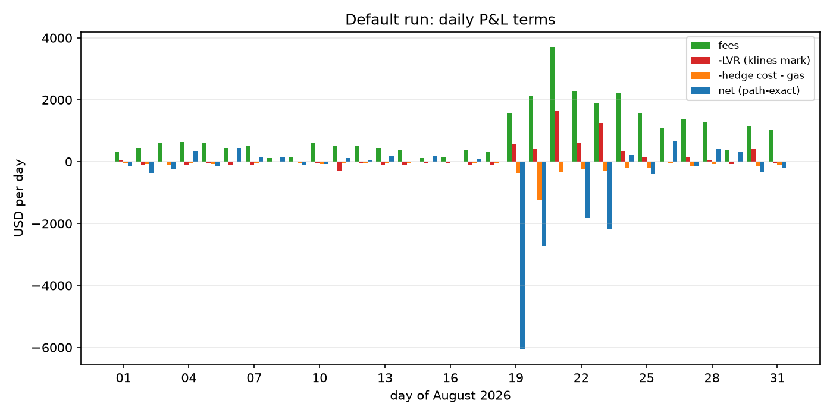
Figure 17. Default run: daily fees, −LVR (stale mark), −hedge cost −gas, and net.

7.4 Full summary
The Full summary expander shows the 26 fields:
Field | Value | Field | Value
days | 31.0 | fees_usd | 28956
capital_lp_usd | 1000000.0 | lvr_usd | −4134
margin_usd | 198120 | fee_over_lvr | NaN
capital_base_usd | 1198120 | funding_usd | 1495
range_width | 0.15 | hedge_cost_usd | 3540
hedge_band | 0.03 | gas_reposition_usd | 540
n_repositions | 1 | net_usd | −11592
n_hedge_trades | 150 | fee_apr_pct | 28.46
pct_time_in_range | 98.2 | lvr_apr_pct | 4.06
mean_liquidity_share_pct | 2.655 | funding_apr_pct | 1.47
sharpe | −5.55 | hedge_cost_apr_pct | −3.48
max_drawdown_usd | −13161 | net_apr_pct | −11.39
discrete_hedge_error_usd | −42097 | closed_form_lvr_usd | 37263

Timeseries (first 500 rows) shows the first 500 grid rows of the 11-column frame; row 0 is 2026-08-01 00:00 with price 1862.68, lp_value 1,000,000, lp_delta 249.25, hedge_delta −249.25, funding_usd 31.31.

7.5 Rolling, by-month, sweep, comparison
30-day rolling APR on 31 days of data has two windows: min −11.62%, median −11.59%, max −11.57%, std 0.03. Backtest by month shows Loaded data spans only 1 month — need at least 2 for a monthly breakdown. The sweep and the comparison are in section 8.12 and section 0.7.

8. Scenarios
Every table below is in SCENARIOS.md with its raw directory; the verdict line says whether the result is a property of the strategy or of the 31 days.

8.1 The default and its two file-pick variants
Run | net | net APR | fees | LVR (as reported)
1m klines + funding (this guide's default) | −11,592 | −11.39% | 28,956 | −4,134
aggTrades + funding (the app's default file pick) | −11,601 | −11.40% | 28,947 | +34,360
1m klines, no funding (the app's default funding pick) | −13,086 | −12.86% | 28,956 | −4,134

Verdict: the headline is robust to the price file; the attribution is not. Property of the data pipeline.

8.2 The hourly engine on the same window
The hourly (fast fallback) engine in Local CSV files mode reports net +69,274 USD (+84.34% APR) with fees 0. Fees are zero because the mode sets the volume to zero before calling the engine (app.py:1137-1138). The net is positive because the engine's realised hedge P&L carries the wrong sign: a short bought back above its average price is booked as a gain (kimi/uniswap_delta_hedge_backtest.py:393). On the first reducing trade it books −92.03 USD where +92.03 is correct; over a month in which ETH rose 32% it books +106,112 on a short where the correct figure is −45,646 (raw/hourly_hedge_sign_check.txt). With the correct hedge P&L the same run is −82,485 USD. The engine's pool_share default of 0.001 is 27× below the measured 0.02655 for this position; its pool_volume_multiplier default of 0.08 is 7.8× above the measured pool-to-Binance volume ratio of 0.01023. Its PnL attribution charts also show the hedge cost 319× too large because of a cumulative-versus-per-bar mix-up in the columns (SCENARIOS.md section 2). Verdict: do not use this engine for a number. Property of the code.

8.3 Range width
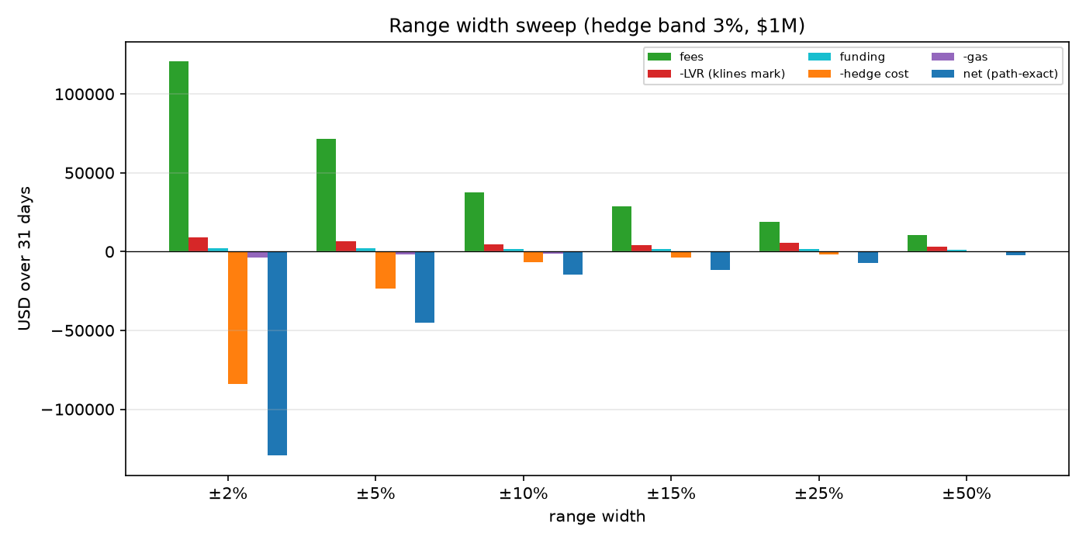
Figure 18. Range width sweep, five P&L terms and net, USD over 31 days.
range | fees | hedge cost | trades | repositions | in range | net | net APR | closed-form LVR
±2% | 120,556 | 84,110 | 3,549 | 7 | 82.3% | −129,455 | −110.75% | 240,399
±5% | 71,555 | 23,542 | 1,075 | 3 | 93.2% | −45,228 | −38.76% | 105,348
±10% | 37,330 | 6,713 | 292 | 2 | 90.1% | −14,513 | −13.53% | 59,048
±15% | 28,956 | 3,540 | 150 | 1 | 98.2% | −11,592 | −11.39% | 37,263
±25% | 18,730 | 1,800 | 68 | 1 | 98.3% | −7,275 | −7.28% | 22,578
±50% | 10,262 | 342 | 13 | 0 | 100.0% | −2,436 | −2.49% | 11,779

Narrowing the band multiplies L for the same capital, so fees rise 4.2× from ±15% to ±2%, the gamma cost rises 6.5× and the hedge turnover 24×, with 7 re-strikes. Every width loses. Verdict: the ordering is the strategy (concentration raises fee and gamma together, and the gamma won at 52% realised vol); the size of the loss is the data (a trending month with a re-strike at the band).

8.4 Hedge band
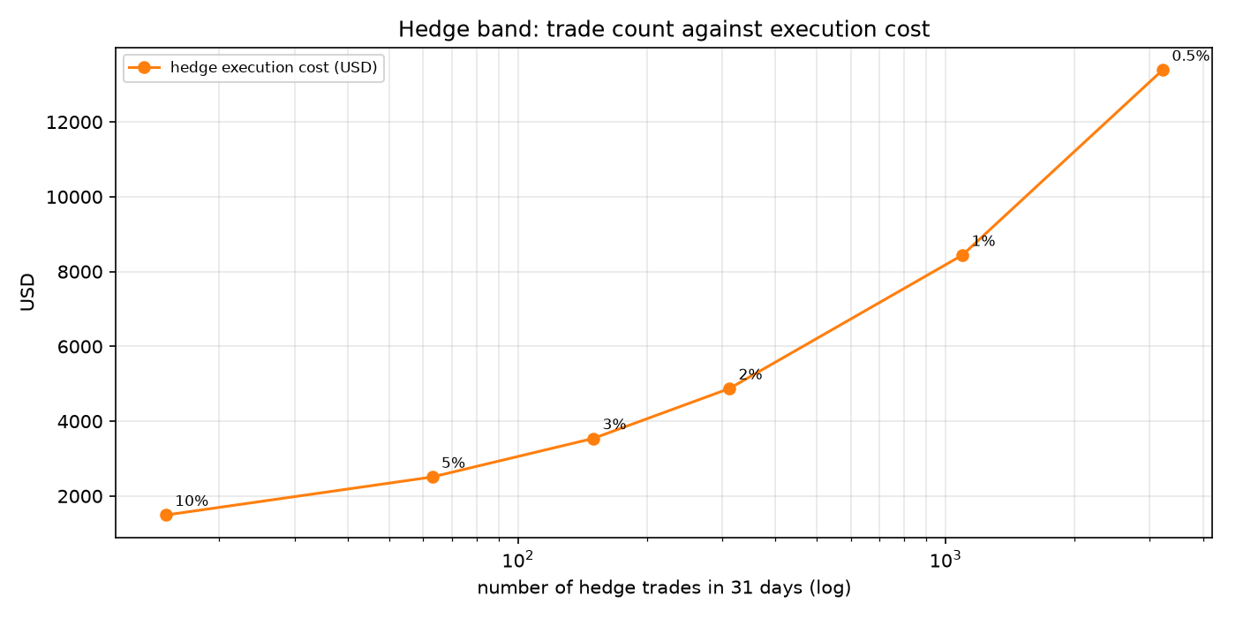
Figure 19. Hedge band sweep: trade count against execution cost.
band | trades | hedge cost | net | net APR | max drawdown
0.5% | 3,218 | 13,390 | −21,367 | −21.02% | −21,487
1% | 1,094 | 8,439 | −16,633 | −16.34% | −16,768
2% | 312 | 4,873 | −12,670 | −12.50% | −13,322
3% | 150 | 3,540 | −11,592 | −11.39% | −13,161
5% | 63 | 2,509 | −11,299 | −11.14% | −13,278
10% | 15 | 1,492 | −9,327 | −9.27% | −17,026

Fees, LVR and gas are identical in every row; only the hedge loop changes. Verdict: the shape (execution cost falls with the band, unhedged gamma rises) is the strategy; the location of the optimum is the data.

8.5 Hedge grid
grid | trades | net | net APR | closed-form LVR
10 s | 150 | −11,623 | −11.42% | 0
30 s | 150 | −11,623 | −11.42% | 0
60 s | 150 | −11,592 | −11.39% | 37,263
120 s | 135 | −9,792 | −9.64% | 38,742
300 s | 129 | −7,910 | −7.76% | 36,852

10 s and 30 s equal each other and 60 s to within 31 USD because the price file only changes once a minute. The closed form reads 0 at 10 s and 30 s because the finite-difference gamma is NaN wherever the price repeats and the sum skips NaN (run_claude.py:788-790). Verdict: a property of the data resolution, not of the strategy.

8.6 Fee tier
fee tier | fees | LVR (stale mark) | net | net APR
0.01% | 5,791 | −27,299 | −34,756 | −34.16%
0.05% | 28,956 | −4,134 | −11,592 | −11.39%
0.30% | 173,735 | 140,645 | +133,187 | +130.89%
1.00% | 579,116 | 546,026 | +538,568 | +529.27%

Not economically coherent: the flow in the tape is the flow that chose a 0.05% pool. At 1.00% the engine charges 579,116 USD of fees on 2.34 billion USD of volume that would not have routed through a 1% pool, and imputes a fee-net execution price 95 bps from the one the taker paid, so its LVR jumps to 546,026 and the net-versus-decomposition gap to 508,064. fee − lvr stays at 33,090 in every row because that is the taker's markout against the price actually paid. Verdict: the only coherent row is the pool's own tier.

8.7 Capital: does it scale
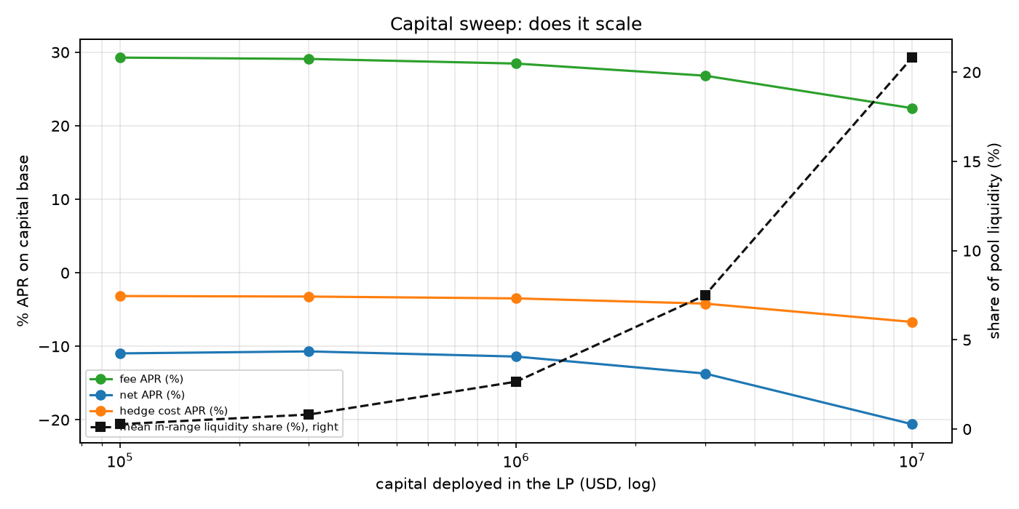
Figure 20. Capital sweep: fee APR, net APR, hedge cost APR, and the position's mean share of pool liquidity.
capital | share of pool | fees | fee APR | hedge cost (of which impact) | net | net APR
100k | 0.273% | 2,978 | 29.27% | 321 | −1,115 | −10.96%
300k | 0.814% | 8,879 | 29.09% | 986 | −3,265 | −10.69%
1M | 2.655% | 28,956 | 28.46% | 3,540 (362) | −11,592 | −11.39%
3M | 7.499% | 81,842 | 26.81% | 12,791 | −41,816 | −13.70%
10M | 20.817% | 227,868 | 22.39% | 67,982 (36,204) | −209,481 | −20.59%

Fee APR falls from 29.3% to 22.4% across two decades because the position dilutes itself in a pool whose mean in-range liquidity was 8.8e18 (a 10M position is a fifth of it). Hedge cost grows faster than linearly through the quadratic impact term: mean clip 42,369 USD at 1M, 423,696 at 10M, largest 4.42M. Verdict: the dilution curve is the strategy in this pool; the impact curve is an assumption (0.8 bps per 100k), not a measurement.

8.8 Leverage
leverage | margin | capital base | net | net APR
1x | 792,480 | 1,792,480 | −11,592 | −7.61%
2x | 396,240 | 1,396,240 | −11,592 | −9.78%
3x | 264,160 | 1,264,160 | −11,592 | −10.80%
5x | 158,496 | 1,158,496 | −11,592 | −11.78%
10x | 79,248 | 1,079,248 | −11,592 | −12.65%

Leverage enters only the margin denominator (run_claude.py:720). No liquidation, no margin call. Verdict: a presentation choice, not a risk model.

8.9 Reposition on and off
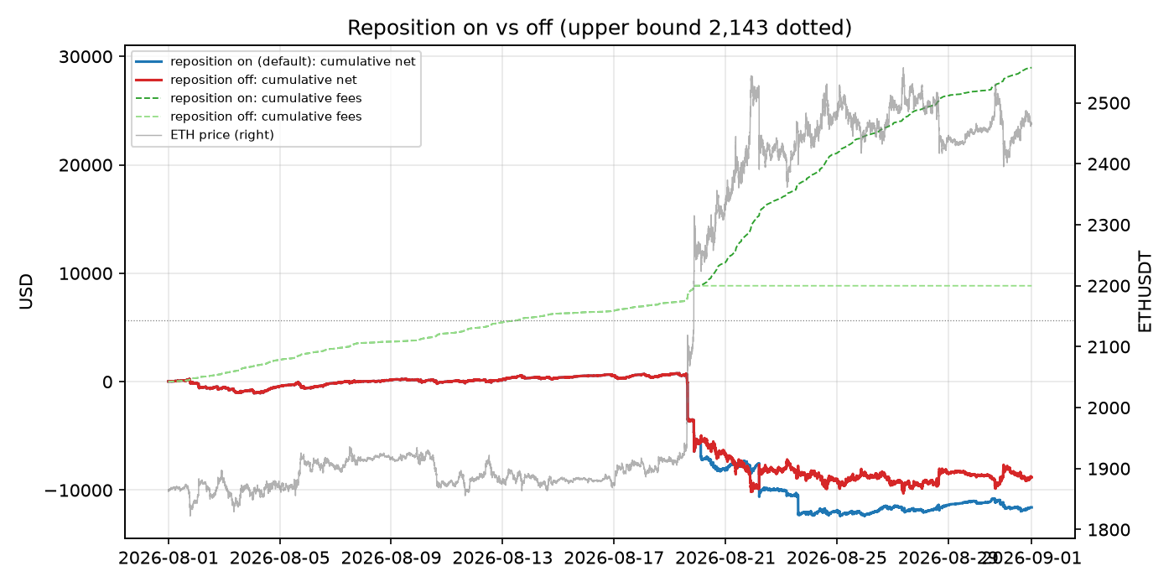
Figure 21. Reposition on vs off: cumulative net and fees, with the ETH price and the original upper bound.
 | fees | hedge cost | gas | in range | net | net APR
on (default) | 28,956 | 3,540 | 540 | 98.2% | −11,592 | −11.39%
off | 8,846 | 1,085 | 0 | 44.5% | −8,812 | −8.66%

ETH crossed 2,143 on Aug 19 and stayed above. Off: the position sat in USDC above the band for 55% of the swaps, earned no fees, carried no delta, and lost less. On: the re-strike at 2,251 bought a second helping of short gamma at a higher strike. Verdict: the re-strike rule is a momentum re-entry and August trended; property of the data. The rule is also the only reason the position stayed live for 98% of the flow.

8.10 Weekly sub-windows
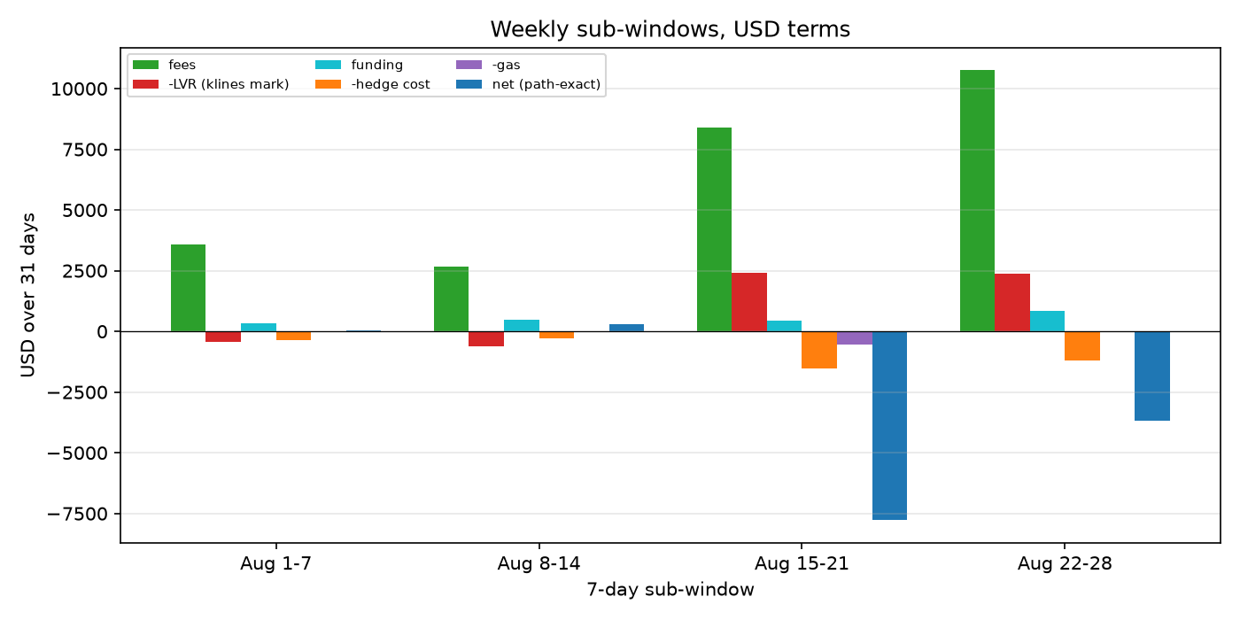
Figure 22. Weekly sub-windows, USD terms.
week | swaps | fees | closed-form LVR | hedge cost | net | net APR
Aug 1-7 | 29,289 | 3,576 | 4,132 | 365 | +29 | +0.13%
Aug 8-14 | 25,236 | 2,664 | 2,314 | 275 | +312 | +1.35%
Aug 15-21 | 36,170 | 8,388 | 13,807 | 1,540 | −7,778 | −34.00%
Aug 22-28 | 49,769 | 10,751 | 13,726 | 1,205 | −3,667 | −15.44%

Two flat weeks ended within 312 USD of zero. The week with the 3.48% minute, the exit through the band and the re-strike lost 7,778. Verdict: a short strangle that collects about 500 USD a day in calm weeks and gives back two and a half months of it in one trending week. Property of the strategy; the frequency of such weeks is the data.

8.11 Stress shock (hourly engine only)
The stress test rewrites the OHLC bars of the last N days by a linear ramp or a step and reruns the hourly engine (app.py:1876-1905, 1944-1954); the swap tape and fees are untouched, so it does not exist for the reference engine. At the sidebar defaults (−20% linear over the last 7 days) the hourly engine reports net +65,320; at −30% over 1 day, +63,269 (linear) and −15,947 (step). The 79,216 USD difference between the last two for the same end price is the hourly engine's sign error acting on 24 partial buy-backs versus one. Verdict: a synthetic overlay on the engine with the defect; not evidence about anything.
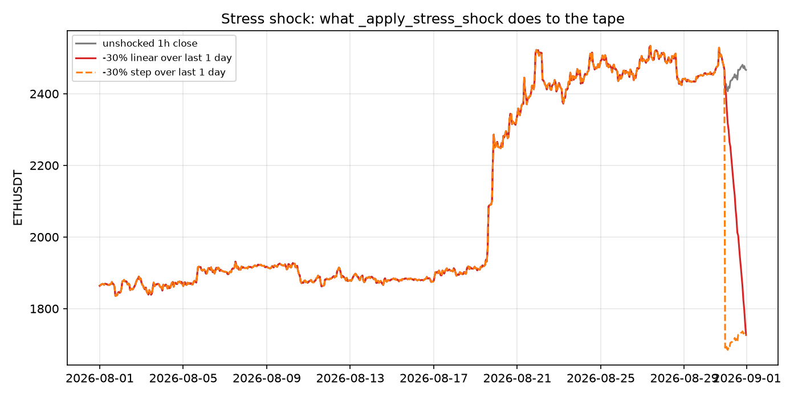
Figure 23. What the stress shock does to the price tape: unshocked, −30% linear over the last day, −30% step.

8.12 The app's own sweep
Run range × hedge-band sweep at the default grid: 30 cells, 15.8 s. The app's callout reads Best cell: Range width (±) 50% × Hedge band 5.0% → net APR 1.50%, Sharpe 0.77. That cell made 4 trades in 31 days; the neighbouring cell at band 10% made 2 and shows −8.73%. One trade's timing against a 32% trend separates them. The full 30-row table is in SCENARIOS.md section 12. Every cell with more than 25 trades is negative.

9. What this tells you and what it does not
What 31 real days demonstrate.
- A ±15% ETH/USDC 0.05% position, hedged every minute on a 3% band, ran at 28.5% fee APR and paid 37,963 USD of gamma in a month of 52% realised vol and a 32% trend. Fees covered 76% of the gamma before funding and execution. Net −11.4% annualised.
- The gamma cost is real and is measured three independent ways on real data to within 10% of each other. It is not a modelling artefact.
- The fee stream is real and is measured per swap against the pool's own volume, which reconciles to the chain's hourly aggregates to 0.01%.
- The position's fee APR falls as it grows because the pool is shallow: 2.7% of in-range liquidity at 1M, 21% at 10M.
- The band, grid and leverage controls move the answer by a few points; the range and the data move it by tens of points.
What they do not demonstrate.
- Whether the strategy is profitable. One month, one trend, one re-strike. The two flat weeks were flat, not profitable: 511 USD a day of fees against 590 USD a day of closed-form gamma in the first week. Nothing in the sample shows a week where fees beat gamma by a margin.
- Anything about a different pool, fee tier or month. Section 8.6 shows why the fee-tier sweep is not a substitute.
- Execution at size. The impact term is an assumption. The fill on the 441,856 USD re-hedge clip is a formula.
- The attribution tiles on the recommended price file. The LVR APR sign and the Fees / LVR tile are wrong on 1-minute klines (section 6).
- Anything from the hourly engine or the stress test (section 8.2, 8.11).
- Tail behaviour between blocks and between minutes. The 3.48% minute happened inside one hedge interval; the engine does not see what the fill would have been.
Before a trader sizes anything off this: a run of at least 6 to 12 months with the aggTrades tape so the attribution is clean; the same run through a calm quarter, because the sample has none; an impact model calibrated to the perp's book at the clip sizes the band produces; a liquidity-share model at swap resolution rather than hourly; and a fix for the reposition double count, which costs 540 USD per re-strike in net_usd today. The path-exact net_usd from the reference engine on real files is the one number in the app that survives all of the above unchanged.

10. Glossary
Crypto term | Maps to | Introduced
Block | A 12-second batch of transactions; the tape's clock tick | 1.1
Token (USDC, WETH) | A balance on the ledger; USDC is a dollar, WETH is ether | 1.2
Smart contract | A program on the ledger that holds balances and executes fixed rules | 1.2
Pool (Uniswap v3) | A passive market maker committed to a price schedule; the LP sells a fee stream and is picked off | 1.4
Swap | A trade against the pool; one tape row | 1.2
Liquidity provider (LP) | The holder of the short-gamma position in the pool | 1.4
Liquidity L | The position's size parameter; value = L × f(√P); a narrower band gives larger L per dollar | 3
Range, tick, tick spacing | Strikes of the strangle; quantised to 0.1% steps of price | 1.5, 1.6
sqrtPriceX96 | The pool's price state, √P in 96-bit fixed point | 1.6
In range | Between the strikes; the only state that earns fees or carries gamma | 1.5
Reposition | Rolling the strangle to new strikes around spot, at a cost | 4
Perpetual future | A linear future with no expiry pinned to spot by funding | 1.3
Funding | Carry on the perp, paid every 8 hours; positive rate = longs pay shorts | 1.3
LVR | The gamma bleed of the hedged position, ½σ²P²abs(V'') integrated along the path | 1.7, 6
Impermanent loss | Divergence loss versus holding, evaluated at exit; path-independent; not used here | 1.7
Subgraph / The Graph | A public index of chain events, queried for the swap tape | 2
Klines | Binance's OHLC bars | 2
aggTrades | Binance's trade-by-trade tape | 2
Gas | The transaction fee paid to the chain | 4
Markout | The taker's edge against the exchange price at a horizon after the trade | 4, 6

Appendix A. Widget map
APP_MAP.md section 1 lists all 59 sidebar widget call sites (56 distinct labels; 33 to 38 rendered at once depending on engine and mode) and the 9 main-area widgets, each with label, key, type, default, range, the config field it writes, the function that consumes it, and whether it reaches an engine computation. The ones that do not reach any computation in some mode: Perp leverage and Margin buffer in the hourly engine (never passed to it); Our share of pool active liquidity and Pool volume as fraction of Binance quote volume in hourly Local CSV mode (volume is zeroed first); Backtest window in hourly Live mode. APP_MAP.md section 3.7 lists 23 places where the app's Documentation tab contradicts the code, including the Swaps to (inclusive) help text, the "2-3M swaps/month" caption, the claim that the legacy subgraph endpoint still works, and the claim that the hourly engine's Local CSV mode earns fees.

Appendix B. File map of the repository
File | Role
app.py (2,186 lines) | The Streamlit page: sidebar, run flow, renderers, documentation tab
backtest.py | The adapter: Assumptions dataclass, run_swap_level, run_hourly, data loaders, Binance and subgraph fetchers
run_claude.py | The reference engine: position math, per-swap attribution, hedge loop, summary, closed-form LVR, demo tape
kimi/uniswap_delta_hedge_backtest.py | The hourly engine (DeltaHedgeBacktest) and the live Binance fetcher (blocked from US addresses, 451)
run_kimi.py, run_perplexity.py, run1.py | Standalone scripts imported by nothing (APP_MAP.md 2.4)
tests/ | 39 tests, all passing
requirements.txt, nixpacks.toml, railway.toml, Procfile, DEPLOY.md | Deployment on Railway
data/ (gitignored) | Downloaded files; data-cache/ in this branch holds the small ones
docs/guide/ | This guide, its raw outputs, charts and screenshots

Appendix C. Reproduction commands
From the repository root with the data files in place (cp data-cache/* data/, then download the aggTrades file with the first command if wanted):
Table or figure | Command
ENVIRONMENT.md self-test | python3 -c "import backtest as bt; s,c,f=bt.make_demo_tape(days=25,s0=3000.0,vol_annual=0.65,seed=7); print(bt.run_swap_level(bt.Assumptions(),s,c,f).summary)"
Binance files | python3 -c "import backtest as bt; bt.ensure_all_data(start='2026-08',end='2026-08',cex_kind='klines',klines_interval='1m',include_pool_hourly=True); bt.ensure_all_data(start='2026-08',end='2026-08',cex_kind='klines',klines_interval='1h'); bt.ensure_binance_csvs(['2026-08'],kinds=('aggTrades',))"
Swap tape (needs THEGRAPH_API_KEY) | python3 docs/guide/raw/fetch_swaps.py && python3 docs/guide/raw/repair_swaps.py
Section 2 checks and tape statistics | python3 docs/guide/raw/data_checks.py
Sections 3-6, 8.1, 8.3-8.10 (all swap_level runs) | python3 docs/guide/raw/run_scenarios.py
Section 8.2 and 8.11 (hourly engine, stress) | python3 docs/guide/raw/run_hourly_stress.py && python3 docs/guide/raw/hourly_hedge_sign_check.py
Section 7 through the UI, rolling, by-month, section 8.12 sweep | python3 docs/guide/raw/apptest_runs.py
Section 3 derivations | python3 docs/guide/raw/guide_derivations.py
Charts | python3 docs/guide/raw/make_charts.py
Screenshots | python3 docs/guide/raw/shots_*.py (Playwright; see screenshots/INDEX.md)
Formula checks (SOURCES.md) | python3 docs/guide/raw/sources_check.py
This document as .docx | python3 docs/guide/raw/build_docx.py

