**Web-based Ordering & Ingredient Estimating for Bakery Manufacturer**

Project Management Plan

By

**Miss. Nontra Mahachanont 542115026**

**Mr. Parinya Panyanak 542115034**

Department of Software Engineering

College of Arts, Media and Technology

Chiang Mai University

Project Advisor

________________________

**Mr.Phudinan Singkhamfu**

**Document History**

|  |  |  |  |  |  |  |
| --- | --- | --- | --- | --- | --- | --- |
| **Document Name** | **Version** | **Status** | **Date** | **Viewable** | **Reviewer** | **Responsible** |
| **Documents** | | | | | | |
| Web-based Ordering & Ingredient Estimating for Bakery Manufacturer – PMP_V.0.1.docx | V.0.1  - Add Chapter 1  - Fix inappropriate words | Draft | 08-04-2014 | NM, PP, PS | NM, PP | NM, PP |
| Web-based Ordering & Ingredient Estimating for Bakery Manufacturer – PMP_V.0.3.docx | V.0.3  - Add Chapter 2  - Adjust Deliverables  - Adjust Acronyms & Definitions  - Fix inappropriate words | Draft | 10-04-2014 | NM, PP, PS | NM, PP | NM, PP |
| Web-based Ordering & Ingredient Estimating for Bakery Manufacturer – PMP_V.0.4.docx | V.0.4  - Add Chapter 3  - Adjust Deliverables  - Adjust Non-Deliverables  - Adjust Acronyms & Definitions  - Fix inappropriate words | Draft | 11-04-2014 | NM, PP, PS | NM, PP | NM, PP |
| Web-based Ordering & Ingredient Estimating for Bakery Manufacturer – PMP_V.0.6.docx | V.0.6  - Add Chapter 4  - Add Chapter 5  - Adjust Deliverables  - Adjust Chapter 3  - Fix inappropriate words | Draft | 12-04-2014 | NM, PP, PS | NM, PP | NM, PP |
| Web-based Ordering & Ingredient Estimating for Bakery Manufacturer – PMP_V.0.7.docx | V.0.7  - Add Chapter 6  - Add Chapter 7  - Adjust Quality Factors  - Fix inappropriate words | Draft | 13-04-2014 | NM, PP, PS | NM, PP | NM, PP |
| Web-based Ordering & Ingredient Estimating for Bakery Manufacturer – PMP_V.0.9.docx | V.0.9  - Add Chapter 8  - Add Chapter 9  - Adjust Configuration Item Table  - Fix inappropriate words | Draft | 15-04-2014 | NM, PP, PS | NM, PP | NM, PP |
| Web-based Ordering & Ingredient Estimating for Bakery Manufacturer – PMP_V.1.0.docx | V.1.0  - Adjust Project Responsibility  - Adjust Testing  - Adjust Hardware  - Adjust Project Schedule | Released | 10-05-2014 | NM, PP, PS | NM, PP | NM, PP |

**\*NM = Nontra Mahachanont**

**\*PP = Parinya Panyanak**

**\*PS = Phudinan Singkhamfu**

**Table of contents**

**Chapter One | Introduction** 5

1.1 Identification 5

1.2 Scope 5

1.3 Document Overview 5

1.4 Objective 6

1.5 Work Products to be Develop 6

1.5.1 Deliverables and Delivery Instruction 6

1.5.2 Non-Deliverables 8

1.6 Acronyms and Definitions 9

1.6.1 Acronyms 9

1.6.2 Definitions 9

**Chapter Two | Infrastructure** 13

2.1 Software Development Life Cycle 13

2.2 Software Acquisition Plans 14

2.2.1 Design Tools 14

2.2.2 Development Tools 14

2.2.3 Configuration Management Tools 14

2.2.4 Document Tools 14

2.2.5 Operating System 14

2.3 Hardware and Material Resources 15

**Chapter Three | Management Procedures** 16

3.1 Project Team Structure 16

3.2 Project Responsibility 16

3.3 Change Management 16

**Chapter Four | Quality Standard** 17

3.1 ISO29110 for Very Small Entity (VSE) 17

3.1.1 Project Management Process 17

3.1.2 Software Implementation Process 17

**Chapter Five | Quality Planning** 18

4.1 Quality Factors 18

4.2 Reviews/Responsibility 20

4.3 Testing 21

**Chapter Six | Schedule and Milestones** 22

6.1 Project Schedule 22

**Chapter Seven | Software Configuration Management** 28

7.1 Software Configuration Management 28

7.2 Filename Format 28

7.3 Project Repository 28

7.4 Software Configuration Item Table 29

**Chapter Eight | Risk Management** 30

8.1 Risk Management Process 30

8.2 Risk Identification and Solutions 31

**Chapter Nine | References** 32

# 

# **Chapter One | Introduction**

Project Name: Web-based Ordering & Ingredient Estimating for Bakery Manufacturer

As a result of quantity demand, bakery manufacturer becomes an important source among wholesalers. Some bakery manufacturer has many wholesalers and orders, for example, many branches ordered bakery products more than ten thousand baths. This leads to the problems that the bakery manufacturer cannot manage or handle the information easily because of many factors such as time, communication and system. So we have an idea to create a new system that able to manage information easily and provide convenient order process for the wholesale side. These will make the managing process become more reliable and convenient because the system provides managing system function such as manage order, manage bakery product detail, manage member, manage bakery ingredient detail, estimate ingredient usage, record history and convert to graph.

## 1.1 Identification

This document is the software project management plan, which described the process of the Web-based Ordering & Ingredient Estimating for Bakery Manufacturer. This document included planning, scheduling, activities, evaluating overall of the project and the risk that may possible for managing the software process activities.

## 1.2 Scope

Web-based Ordering & Ingredient Estimating for Bakery Manufacturer is a management system that helps the admin to manage ordering information and estimate ingredient usage. Then the system also helps the wholesaler to manage order and record ordered history. The project focuses on implementation of general order management system. The objective of this project is to develop management system that used with bakery manufacturer. Another objective is to develop a system that support web-based ordering for wholesaler.

## 1.3 Document Overview

The purpose of the Web-based Ordering & Ingredient Estimating for Bakery Manufacturer development plan is to guide the developer while develop the system. This project has been developed with the process of making the project and all documents according to the software quality assurance. In this project will use the ISO29110 standard that suit with very small entity.

## 1.4 Objective

Firstly, the implement a software management system which would be include many management features, such as member management, order management, ingredient estimation, report management and etc.

Second objective is to develop web-base online ordering for wholesale. This objective is to provide member management system and other service support wholesale side.

Where the last objective is to study the iterative development process and adapt the software engineering methodologies and knowledge that we have learned from the previous courses for the project.

## 1.5 Work Products to be Develop

### 1.5.1 Deliverables and Delivery Instruction

|  |  |  |  |  |
| --- | --- | --- | --- | --- |
| **No.** | **Deliverable** | **Media** | **No. of Copies** | **Date** |
| 1 | The Project Proposal | Document | 3 | 26 March 2014 |
| 2 | The Progress Report I   * Project Plan V.1.0 * Web-based Ordering & Ingredient Estimating for Bakery Manufacturer Web Application V.1.0   **Progress I**: Web-based Ordering & Ingredient Estimating for Bakery Manufacturer web application provides member management system and order management system functions  Features   * Login to web application * View users verification status of users * Logout from web application * Add user information;   - username  - password  - first name  - last name  - phone number  - address  - e-mail  - profile picture  - description  - user type   * View users information;   - username  - password  - first name  - last name  - phone number  - address  - e-mail  - profile picture  - description  - user type  - last sign in  - register date   * Edit users information;   - username  - password  - first name  - last name  - phone number  - address  - e-mail  - profile picture  - description  - user type   * Remove existing users * Search users information;   - username  - first name  - last name  - phone number  - address  - e-mail  - user type  - last sign in  - register date   * Add bakery product information;   - bakery product ID  - name  - description  - price  - category  - bakery product picture   * Edit existing bakery product information;   - bakery product ID  - name  - description  - price  - category  - bakery product picture   * View existing bakery product information;   - bakery product ID  - name  - description  - price  - category  - bakery product picture   * Remove existing bakery product * Search bakery product information;   - bakery product ID  - name  - price  - category   * Select existing bakery product * Select repeat ordered of bakery list * Save unfinished order list of bakery product * Edit ordered bakery product list * Remove ordered bakery product from list * View total price of ordered bakery list * Send finished order list of bakery product * View ordered successful notification * View ordered bakery list * Process checkout status * View checkout status   Documentation   * Software Requirement Specification Document V.1.0 * Software Design Document V.1.0 * Software Test Plan Document V.1.0 * Software Test Record V.1.0 * Traceability Record V.1.0 | Document  Software  Document  Document  Document  Document  Document | 3  1  3  3  3  3  3 | 28 May 2014  28 May 2014  28 May 2014 |

### 1.5.2 Non-Deliverables

|  |  |  |  |  |
| --- | --- | --- | --- | --- |
| **No.** | **Non-Deliverable** | **Media** | **No. of Copies** | **Date** |
| 1 | 30 Seconds Video Presentation | File | 1 | 11 September 2014 |
| 2 | Poster Presentation | Poster | 1 | 11 September 2014 |
| 3 | 5 Minute Video Presentation | File | 1 | 11 September 2014 |

## 1.6 Acronyms and Definitions

### 1.6.1 Acronyms

SRS Software Requirement Specification

URS User Requirement Specification

SDD Software Design Document

OS Operation System

VSE Very Small Entity

PMP Project Management Plan

SI Software Implementation

IDP Iterative Development Process

SCI Software Configuration Item

SCM Software Configuration Management

SEI Software Engineering Institute

EPG Engineering Process Group

SMM Software Measurement and Metrics

SQA Software Quality Assurance

AD Activity Diagram

UC Use Case

IEEE Institute of Electrical and Electronics Engineers

RTM Requirement Traceability Matrix

UI User Interface

UTR Unit Testing Record

STR System Testing Record

### 1.6.2 Definitions

Acceptance test Test activities for sample checks to verify that has the right quality for deployment or usage. Often acceptance test is done by the customer. [IEEE90]

Feature Transformation of input parameters to output parameters based on a specified algorithm. It describes the functionality of the product in the language of the product. Used for requirements analysis, design, coding, testing or maintenance. [IEEE90]

IEEE Institute for Electrical and Electronics Engineers. Biggest global interest group for engineers of different branches and computer scientists. [IEEE90]

Plan A documented series of tasks requires meeting and objective, typically including the associated schedule, budget, resources, organizational description and work breakdown structure. [IEEE90]

Project Management The application of knowledge, skills, tools, and techniques to project activities in order to meet or exceed stakeholder needs and expectations from a project. [IEEE90]

Project Plan A formal, approved document used to guide both project execution and project control. The primary uses of the project plan are to document planning assumptions and the decision, to facilitate communication among stakeholders, and to document approved scope, cost and schedule baseline. [IEEE90]

Risk An uncertain event or condition that, if it occurs, has a positive or negative effect on the project’s objectives. It is a function of the probability of a given threat’s occurrence. [IEEE90]

Risk Management The systematic application of management policies, procedures and practices to the tasks of identifying, analyzing, evaluating treating and monitoring risk. [IEEE90]

Traceability The ability to trace the history, application or location of an item or activity, or work products or activities, by means of recorded identification. The establishment and maintenance of relationships between such items. Horizontal traceability describes the relationship between work products of the same type (e.g., customer requirements). Vertical traceability describes the relationship between work products which build upon each other or are derived from each other (e.g., from customer requirements to qualification test cases). Bidirectional reliability allows to directly following relationship in both directions. [IEEE90]

Unit Test A test of individual programs of modules in order to remove design or programming errors. [IEEE90]

Validation Confirmation by examination and provision of objective evidence that the particular requirements of a specified intended use are fulfilled. Part of quality control. [IEEE90]

Verification Confirmation at the end of the process by examination and provision of objective evidence that specified requirements to the process has been fulfilled. Part of quality control. [IEEE90]

Configuration Management A discipline applying technical and administrative direction and surveillance to: identify and document the functional and physical characteristics of configuration item, control change processing implementation status, and verify compliance with specified requirements. [IEEE90]

Design The period of time the software life cycle during which the design for architecture, software components, interfaces, and design are created, documented, and verified to satisfy requirement. [IEEE90]

Implementation The period of time the software life cycle during which a software product is created from documentation and debugged. [IEEE90]

Work Product Any tangible item that results from a project function, activity, or task. Examples of work products include customer requirement, project plan, design documents, source and object code, user’s manuals.

Software Computer programs, procedures, and associated documentation and data pertaining to the operation of a computer system. [IEEE90]

Software Engineering The application of a systematic, disciplined, quantifiable approach to the development, operation, and maintenance of software; that is, the application of engineering to software. [IEEE90]

Quality Assurance (1) A planned and systematic pattern of all actions necessary to provide adequate confidence that an item or product conforms to established technical requirement. [IEEE90]

(2) A set of activities designed to evaluate the process by which producers are developed or manufactured. [IEEE90]

Admin The person is responsible for the installation, configuration, upgrade, administration, monitoring and maintenance. (Abbreviated admin)

# **Chapter Two | Infrastructure**

## Software Development Life Cycle

The Iterative model is iterating on steps as the project development with requirements. Iterative model iterates Requirement, Design, Development (Implement), Test phases and Deployment (Evaluate, Feedback) for each requirement and builds up quality until complete. The advantage of iterative model is building and improving the product step by step. Thus, developer can track the defects at early stages and avoid flow of defects.

Web-based Ordering & Ingredient Estimating for Bakery Manufacturer project using iterative development process, because it does not attempt to start with a full specification of requirements. We needed to develop the iterative way for review and improve the software and its documents for each development progress until it has finished.

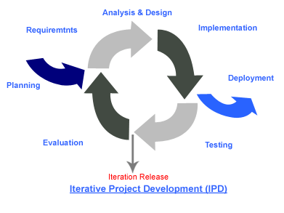

**Figure 1: Iterative Development Model [1]**

## Software Acquisition Plans

### 2.2.1 Design Tools

* Smart Draw CI
* Visual Paradigm for UML 10.2
* Adobe Photoshop Elements 7.0
* Paint

### 2.2.2 Development Tools

* NetBeans IDE 8.0
* Adobe Dreamweaver CC
* MySQL Query Browser

### 2.2.3 Configuration Management Tools

* Github
* Google Chrome

### 2.2.4 Document Tools

* Microsoft Office Word
* Microsoft Office PowerPoint
* Notepad ++
* Adobe Reader 9

### 2.2.5 Operating System

* Windows 7, Window 8

## 2.3 Hardware and Material Resources

* Computers
* **Name:** Sony VAIO-VAIO

**Processor:** Intel® Pentium® Processor T4300 (2.10 GHz)

**Memory:** 2.00 GB

**Graphics:** Intel® Graphics Media Accelerator HD

**Operating System:** Window® 7 Home Basic (64-bit)

* **Name:** Sony VAIO

**Processor:** Intel® Core (TM) I3-3120M (2.5 GHz)

**Memory:** 4.00 GB

**Graphics:** Radeon Graphics System

**Operating System:** Window® 8 Based Processor (64-bit)

# **Chapter Three | Management Procedures**

## 3.1 Project Team Structure

|  |  |  |
| --- | --- | --- |
| **No.** | **Participants** | **Roles** |
| 1 | Miss. Nontra Mahachanont | Development Team Member |
| 2 | Mr. Parinya Panyanak | Development Team Member |
| 3 | Aj. Phudinan Singkhamfu | Project Advisor |

## 3.2 Project Responsibility

|  |  |  |
| --- | --- | --- |
| **No.** | **Participants** | **Responsibility** |
| 1 | Miss. Nontra Mahachanont | Feasibility Study |
| All members | Project Proposal |
| Miss. Nontra Mahachanont | Project Requirements Specification |
| Miss. Nontra Mahachanont | Project Plan |
| Mr. Parinya Panyanak | Project Design Document |
| Mr. Parinya Panyanak | Implementation |
| Mr. Parinya Panyanak | Test Report |
| 2 | Aj. Phudinan Singkhamfu | Review Document |
| Approve The Document |
| Approve Change Document |

## 

## 3.3 Change Management

Change Management manages all of the changes in the project during the development process. All of the change requests will be recording into the change management document.

We have the strategy for manage the changes by following these rules:

* Create requirement traceability to trace change document.
* Specify version of each document.
* Determine baseline document version.
* Approving the change request by project advisor.

# **Chapter Four | Quality Standard**

## 4.1 ISO29110 for Very Small Entity (VSE)

ISO29110 is a guide applies to a Very Small Entity (VSE), enterprise, organisation, department or project up to 25 people, dedicated to software development. The Guide provides Project Management and Software Implementation processes which integrate practices based on the selection of ISO/IEC 12207 - *Systems and Software Engineering — Software Life Cycle Processes* and ISO/IEC 15289 *Software Engineering – Software Life Cycle Process – guidelines for the content of software life cycle process information products (documentation)* standards elements.

### 4.1.1 Project Management Process

The purpose of the Project Management Process is to improve the success rate of projects in all areas of knowledge, which allows complying with the project’s objectives in the expected quality, time and cost.

**Activities**

* Project Planning Process
* Project Plan Execution Process
* Project Assessment and Control Process
* Project Closer Process

### 4.1.2 Software Implementation Process

The purpose of the Software Implementation process is the systematic performance of the analysis, design, construction, integration and tests activities for new or modified software products according to the specified requirements.

**Activities**

* Software Implementation Initiation Process
* Software Requirements Analysis Process
* Software Architectural Design Process
* Software Construction Process
* Software Integration and Test Process
* Software Delivery Process

# **Chapter Five | Quality Planning**

## 5.1 Quality Factors

|  |  |
| --- | --- |
| **User Requirement Specification** | **Quality Factors** |
| Admin can activate member | Reliability, Efficiency, Integrity |
| Admin can add member information | Correctness, Efficiency, Maintainability, Flexibility, Portability |
| Admin can delete member | Correctness, Efficiency, Maintainability, Flexibility, Portability |
| Admin can update member information | Correctness, Maintainability, Flexibility, Testability |
| Admin can display member list | Correctness, Efficiency, Maintainability, Flexibility, Portability |
| Admin can view member information | Usability, Reliability, Integrity, Correctness |
| Admin can search member by username, name, phone number, address, email, user type, last sign in date and register date | Correctness, Efficiency, Maintainability, Flexibility, Portability |
| User can login to the system | Reliability, Integrity, Correctness |
| User can view verification notification | Usability, Reliability, Integrity, Correctness |
| User can logout from the system | Reliability, Integrity, Correctness |
| User can update personal information | Correctness, Maintainability, Flexibility, Testability |
| User can display personal information | Correctness, Efficiency, Maintainability, Flexibility, Portability |
| User can view personal information | Usability, Reliability, Integrity, Correctness |
| Admin can add bakery product information | Correctness, Efficiency, Maintainability, Flexibility, Portability |
| Admin can delete bakery product | Correctness, Efficiency, Maintainability, Flexibility, Portability |
| Admin can update bakery product information | Correctness, Maintainability, Flexibility, Testability |
| Admin can display bakery product list | Correctness, Efficiency, Maintainability, Flexibility, Portability |
| Admin can display bakery product information | Correctness, Efficiency, Maintainability, Flexibility, Portability |
| User can search bakery product by bakery product ID, bakery product name, price and category | Correctness, Efficiency, Maintainability, Flexibility, Portability |
| User can view bakery product list | Usability, Reliability, Integrity, Correctness |
| User can view bakery product information | Usability, Reliability, Integrity, Correctness |
| Wholesaler can add bakery product to order list | Correctness, Efficiency, Maintainability, Flexibility, Portability |
| Wholesaler can delete bakery product from order list | Correctness, Efficiency, Maintainability, Flexibility, Portability |
| Wholesaler can edit bakery product in order list | Correctness, Maintainability, Flexibility, Testability |
| Wholesaler can repeat ordered list | Usability, Reliability, Integrity, Correctness |
| Wholesaler can save unfinished order list | Usability, Reliability, Integrity, Correctness |
| Wholesaler can display bakery product in order list | Correctness, Efficiency, Maintainability, Flexibility, Portability |
| Wholesaler can view list of bakery product in order list | Usability, Reliability, Integrity, Correctness |
| Wholesaler can view total price of order list | Usability, Reliability, Integrity, Correctness |
| Wholesaler send order list | Usability, Reliability, Integrity, Correctness |
| Wholesaler can view confirmation notification | Usability, Reliability, Integrity, Correctness |
| Admin can view order information | Usability, Reliability, Integrity, Correctness |
| Admin can process order list checkout | Correctness, Maintainability, Flexibility, Testability |
| Wholesaler can view checkout status of order list | Reliability, Integrity, Correctness |
| Admin can add ingredient detail of bakery recipe | Correctness, Efficiency, Maintainability, Flexibility, Portability |
| Admin can delete ingredient of bakery recipe | Correctness, Efficiency, Maintainability, Flexibility, Portability |
| Admin can update ingredient detail of bakery recipe | Correctness, Maintainability, Flexibility, Testability |
| Admin can display list of ingredient detail in bakery recipe | Correctness, Efficiency, Maintainability, Flexibility, Portability |
| Admin can display amount of ingredient from ingredient name | Correctness, Efficiency, Maintainability, Flexibility, Portability |
| Admin can search bakery recipe by bakery product ID, bakery product name, category, ingredient list and amount | Correctness, Efficiency, Maintainability, Flexibility, Portability |
| Admin can view list of ingredient in bakery recipe | Usability, Reliability, Integrity, Correctness |
| Admin can view amount of each ingredient | Usability, Reliability, Integrity, Correctness |
| Admin can select date of ordered information to calculation | Correctness, Efficiency, Maintainability, Flexibility, Portability |
| Admin can select bakery product type to calculation | Correctness, Efficiency, Maintainability, Flexibility, Portability |
| Admin can view the amount of ingredient usage | Usability, Reliability, Integrity, Correctness |
| Admin can add summary report information | Correctness, Efficiency, Maintainability, Flexibility, Portability |
| Admin can delete summary report | Correctness, Efficiency, Maintainability, Flexibility, Portability |
| Admin can update summary report information | Correctness, Maintainability, Flexibility, Testability |
| Admin can display summary report list | Correctness, Efficiency, Maintainability, Flexibility, Portability |
| Admin can display summary report information | Correctness, Efficiency, Maintainability, Flexibility, Portability |
| User can search summary report information by name and user type | Correctness, Efficiency, Maintainability, Flexibility, Portability |
| User can select type of summary report | Correctness, Efficiency, Maintainability, Flexibility, Portability |
| User can view summary report | Usability, Reliability, Integrity, Correctness |
| User can search history by username, day, month and year | Correctness, Efficiency, Maintainability, Flexibility, Portability |
| User can view history of own information | Usability, Reliability, Integrity, Correctness |
| User can select graph type | Correctness, Efficiency, Maintainability, Flexibility, Portability |
| User can save report file with PDF format | Usability, Reliability, Integrity, Correctness |
| User can print out the report | Usability, Reliability, Integrity, Correctness |

## 5.2 Reviews/Responsibility

|  |  |  |  |  |
| --- | --- | --- | --- | --- |
| **Stage Exit Review** | | | | |
| **No.** | **Stage** | **Review Item** | **Responsibility** | **Reviewer** |
| 1 | Project Planning | Project Management Plan | NM | All members  Advisor |
| 2 | Requirements Specification | Project Proposal | All members | All members  Advisor |
| Software Requirement Specification | NM | All members  Advisor |
| 3 | Architecture and Detailed Design | Software Design Document | PP | All members  Advisor |
| 4 | Development | Implementation | PP | All members  Advisor |
| Unit Test Report | PP | All members  Advisor |
| 5 | Software Testing | System Test Report | PP | All members  Advisor |
| 6 | Project Monitoring and Control | Traceability Record | NM | All members  Advisor |
| Project Status Report | NM | All members  Advisor |
| Change Request | NM | All members  Advisor |

## 5.3 Testing

|  |  |  |  |
| --- | --- | --- | --- |
| **Test Process** | | | |
| **No.** | **Test** | **Verification** | **Responsibility** |
| 1 | Unit Testing | All members  Advisor | Parinya Panyanak |
| 2 | System Testing | All members  Advisor | Parinya Panyanak |
| 3 | Acceptance Testing | All members  Advisor | Nontra Mahachanont |

# **Chapter Six | Schedule and Milestones**

## 6.1 Project Schedule

According from Figure 2 to Figure 5 was show the schedule and milestones of Web-based Ordering & Ingredient Estimating for Bakery Manufacturer. During period of time, there are work terminologies. And the description is shown below that:

* **Feature#1:** Member Management System

**-** Admin can activate member.

**-** Admin can manage member information.

**-** Admin can specify user’s type within the system.

**-** Admin can display member list.

**-** Admin can view member information.

**-** Admin can search member by username, name, phone member, address, email, user type, register date and last sign in date.

- User can login to the system.

- User can view verification notification.

- User can log out from the system.

- User can edit own profile.

- User can display personal information.

- User can view personal information.

- An application provides member management system.

- An application provides member information such as first name, last name, phone number, address, user type and email.

* **Feature#2:** Order Management System

- Admin can manage bakery product details.

- Admin can display bakery product list.

- Admin can display bakery product information.

- User can search bakery product by bakery product ID, category and price.

- User can view bakery product list.

- User can view bakery product information.

- Wholesaler can manage bakery product in order list.

- Wholesaler can repeat the ordered list from own history.

- Wholesaler can save unfinished order list of bakery product.

- Wholesaler can display bakery product list that ordered.

- Wholesaler can view bakery product list that ordered.

- Wholesaler can view the total price of ordered list.

- Wholesaler can send order list.

- Wholesaler can receive confirmation notification by alert message on the screen.

- Admin can view order information.

- Admin can process order list checkout.

- Wholesaler can view checkout status of own ordered list.

- An application provides order management system.

- An application provides order information such as product ID, product name, price, category and amount.

* **Feature#3:** Ingredient management System
* Admin can manage details of bakery recipe by provide the bakery product ID, bakery product name, category, ingredient list and amount.
* Admin can display ingredient information list in bakery recipe.
* Admin can display the amount of ingredient from ingredient name.
* Admin can search bakery recipe by bakery product ID, bakery product name, category, ingredient name and amount.
* Admin can view a list of ingredient in bakery recipe.
* Admin can view the amount of each ingredient in bakery recipe.
* Admin can select date of ordered information to calculation.
* Admin can select bakery product type to calculation.
* Admin can view the amount of ingredient usage in calculation.
* Admin can view the actual number of bakery product after the finished.
* An application provides ingredient management system.
* An application provides ingredient information such as bakery product ID, bakery product name, category, ingredient list and amount.
* **Feature#4:** Summary Report System
* Admin manage summary report information.
* Admin can display summary report list.
* Admin can display summary report information.
* User can search summary report information by name and user type.
* User can select a summary report type.
* User can view a summary report.
* User can search history by username, day, month and year.
* User can view history information.
* User can select graph type.
* User can save a file as a PDF format.
* User can print own report.
* An application provides summary report system.
* An application provides report information such as report name and user type.

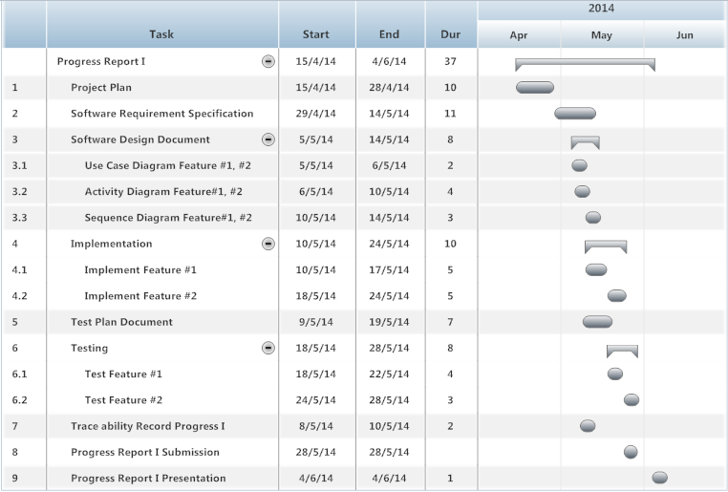

**Figure 2: Progress Report I Milestone**

As shown in figure 2, We will start develop the feature#1 and #2. In addition we will also start to do the development plan, quality plan, software requirement specification, software design, test plan and traceability record which represent by form of start date, end date and duration.

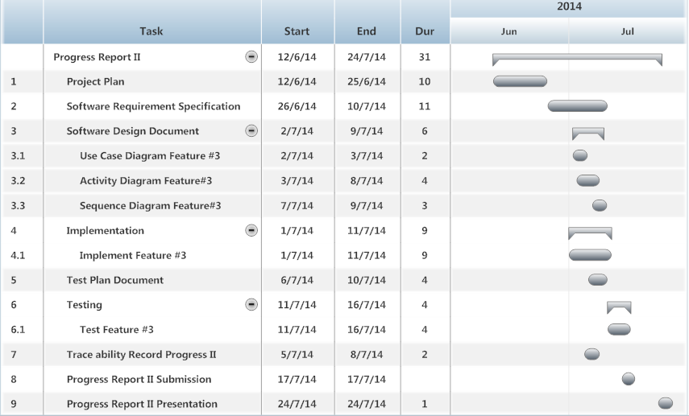

**Figure 3: Progress Report II Milestone**

As shown in figure 3, We will start develop the feature#3. In addition we will also start to do the development plan, quality plan, software requirement specification, software design, test plan and traceability record which represent by form of start date, end date and duration.

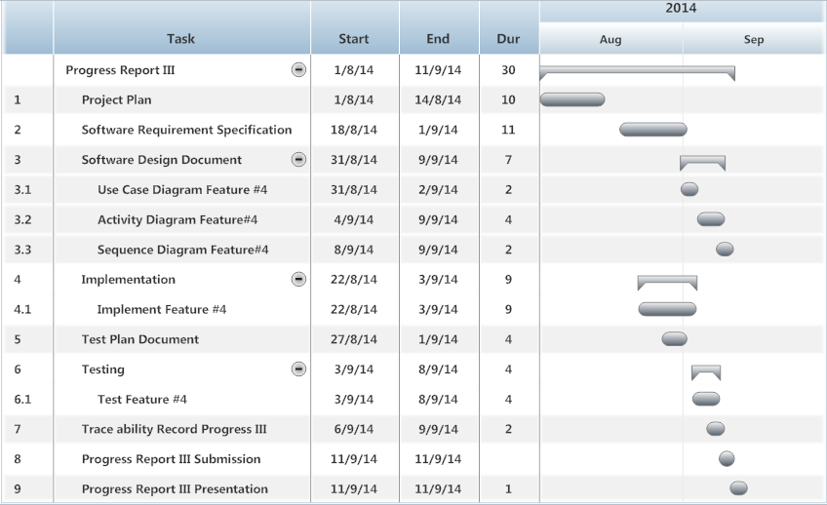

**Figure 4: Progress Report III Milestone**

As shown in figure 4, We will start develop the feature#4. In addition we will also start to do the development plan, quality plan, software requirement specification, software design, test plan and traceability record which represent by form of start date, end date and duration.

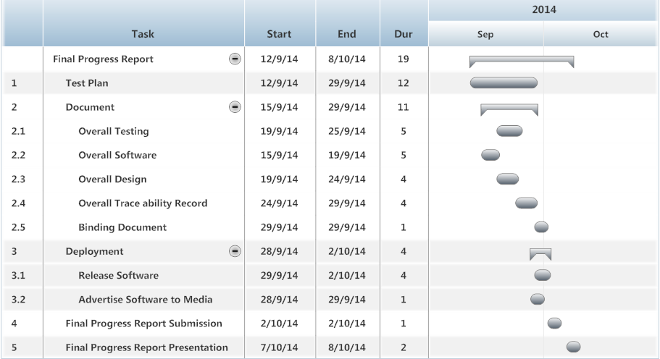

**Figure 5: Final Progress Report Milestone**

As shown in figure 5, We will start to do the development, test plan and deployment which represent by form of start date, end date and duration.

# **Chapter Seven | Software Configuration Management**

## 7.1 Software Configuration Management

Software Configuration Management is a set of activities designed to control change by identifying the work products that are likely to change, establishing relationships among them, defining mechanisms for managing different versions of these work products, controlling the changes imposed, and adding and reporting on the changes made. In other words, SCM is a methodology to control and manage software development project.

## 7.2 Filename Format

For the filename format that we using for all project document is: [Project name]-[Document name]_[Version].file type

## 7.3 Project Repository

C:\Users\VAiO\Desktop\Senior Project

|  |  |  |  |  |  |  |
| --- | --- | --- | --- | --- | --- | --- |
| **No.** | **Item name** | **File name** | **File Type** | **Owner (Role)** | **Repository (Path)** | **Baseline Version** |
| 1 | Project Proposal | Web-based Ordering & Ingredient Estimating for Bakery Manufacturer – Project Proposal_V.1.4 | .docx | PP, NM | C:\Users\VAiO\Desktop\Senior Project\Project Plan | 1.4 |
| 2 | Project Management Plan | Web-based Ordering & Ingredient Estimating for Bakery Manufacturer – PMP_V.1.0 | .docx | PP, NM | C:\Users\VAiO\Desktop\Senior Project\PMP | 1.0 |
| 3 | Software Requirement Specification | Web-based Ordering & Ingredient Estimating for Bakery Manufacturer – SRS_V.1.0 | .docx | PP, NM | C:\Users\VAiO\Desktop\Senior Project\SRS | 1.0 |
| 4 | Software Design Document | Web-based Ordering & Ingredient Estimating for Bakery Manufacturer – SDD_V.1.0 | .docx | PP, NM | C:\Users\VAiO\Desktop\Senior Project\SDD | 1.0 |
| 5 | Test Plan | Web-based Ordering & Ingredient Estimating for Bakery Manufacturer – Test Plan_V.1.0 | .docx | PP, NM | C:\Users\VAiO\Desktop\Senior Project\Test Plan | 1.0 |
| 6 | Traceability Record | Web-based Ordering & Ingredient Estimating for Bakery Manufacturer – TR_V.1.0 | .docx | PP, NM | C:\Users\VAiO\Desktop\Senior Project\TR | 1.0 |
| 7 | Software Source Code | Web-based Ordering & Ingredient Estimating for Bakery Manufacturer – Code_V.1.0 | .zip | PP, NM | C:\Users\VAiO\Desktop\Senior Project\Code | 1.0 |
| 8 | 30 Seconds Video | Web-based Ordering & Ingredient Estimating for Bakery Manufacturer – VDO_V.1.0 | .avi | PP, NM | C:\Users\VAiO\Desktop\Senior Project\VDO | 1.0 |
| 9 | Poster Size A1 | Web-based Ordering & Ingredient Estimating for Bakery Manufacturer – Poster_V.1.0 | .png | PP, NM | C:\Users\VAiO\Desktop\Senior Project\Poster | 1.0 |
| 10 | Software Product | Web-based Ordering & Ingredient Estimating for Bakery Manufacturer – Software_V.1.0 | .zip | PP, NM | C:\Users\VAiO\Desktop\Senior Project\Software | 1.0 |

## 7.4 Software Configuration Item Table

# **Chapter Eight | Risk Management**

Risk management is concerned with identifying risks and drawing up plans to minimize their effect on the project.

A risk is probability that some adverse circumstance will occur.

- Project risks effect schedule or resources.

- Product risks affect the quality or performance of the software being developed.

- Business risks affect the project team during developing or procuring the software.

Identified risks at the start of the project and at the start of the development phase. All identified risks are documented and assessed in the Risk Management Process by the Project Team. In the Risk Management Process defines the possible risks and solution of them, and who is responsible for.

## 8.1 Risk Management Process

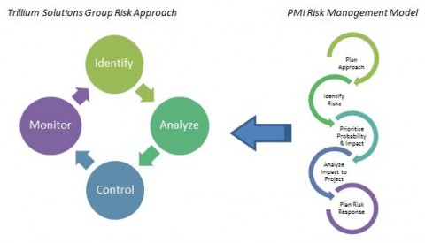

**Figure 6: Risk Management Process Model [2]**

1. Risk identify: identify project, product and business risks.

2. Risk analyze: Assess the likelihood and consequences of the risks.

3. Risk controlling: Draw up plans to avoid or minimize the effects of the risks.

4. Risk monitoring: Monitor the risks throughout the project.

## 8.2 Risk Identification and Solutions

|  |  |  |  |
| --- | --- | --- | --- |
| **No.** | **Risk Statement** | **Risk Solution** | **Priority** |
| 1 | The requirements might be change. | * Meeting and discuss the impact from the changed requirements with the team member and project advisor. * Design system which changed requirements and related with the other requirements. * Use software configuration management and follow change management step. | High |
| 2 | During the implementing, the internet maybe out of order or slow. | * Change the working place. | Medium |
| 3 | The deliverables maybe delay. | * Try to study more hard than previous work. * Ask a professional to make faster understand. * Try to follow the schedule and milestone. | High |
| 4 | Team member maybe get engaged and can’t develop the project. | * Assign a work to left team member who doesn’t get involved. | Low |
| 5 | Budget of developing may not enough. | * Ask for more budgets from project advisor. | Medium |
| 6 | Work products are not submitted on time. | * Establish the project plan. * Develop project follow the project plan. | High |
| 7 | Work products are not traceable. | * Create the traceability record. | Medium |
| 8 | Team member lack skill and knowledge. | * Team member is tutoring implementation. * Ask for assistance and support from textbooks, websites, experienced developer and advisor. | High |
| 9 | Ambiguous responsibility. | * Always discuss the work together. | Medium |
| 10 | Team member misunderstand system work. | * The member’s review system before development phase and use diagram to explain system working. | High |
| 11 | Human resource not enough. | * Planning schedule and hard working. | Medium |
| 12 | Unfamiliar with testing process. | * Study testing technique during the test design. | Medium |
| 13 | The computer Crash. | * Save file in Github. | Medium |
| 14 | Bad communication between team members | * Try to understand each other and exchange more information together. | Medium |

# **Chapter Nine | References**

[1] “Iterative Development Model” [Image]. (2008). Retrieved 17 April 2014, from <http://www.testingexcellence.com/iterative-model/>

[2] “Risk Management Model” [Image]. (2012). Retrieved 6 May 2014, from <http://trilliumsg.com/insights/2012/06>

[3]  Wikipedia “Project Management Process” [Online]. (2009). Retrieved 17 March 2014, from <http://en.wikipedia.org/wiki/Project_Management_Professional>

[4]  “Software Implementation Process” [Online]. (n.d.). Retrieved 17 March 2014, [http://profs.etsmtl.ca/claporte/English/VSE/Deploy-Pack/Entry%20Profile-DP](http://profs.etsmtl.ca/claporte/English/VSE/Deploy-Pack/Entry%20Profile-DP-Software)