**Chapter Two | Literature Review**

1. **Business Review**

**Overview**

**MFF (**Manufacturing forecasting) is a web application derived by JSP, HTML5, and CSS3 to create a web for help The Company forecast about how much to produce the product, when the produce is finish or how much ingredient needs to used.

**Target**

* The Main target of MFF is to forecast order from the customer for manage manufacturing, stock and also analyze how many ingredients needs to use.

**Benefit**

* + The Company can really know how many products should be produce.
  + The Company can control the usage of ingredient.
  + The company can produce enough for customer order.

1. **Software Review**

**2.2.1 PDP Inventory Control**

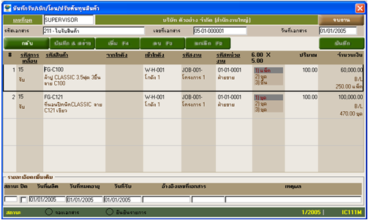

**Software description**

PDP Inventory Control is a program to control inventory. It used to manage stock, check in/out product

**Pros**

* Have function to calculate cost.
* Support products that have serial No. and Barcode.
* Have multiple inventories.
* Can transfer products between inventories.
* Can estimate the ingredient that needs to use per one time

**Cons**

* no order system support
* no member system support

**2.2.2 Absolute |Solutions|**

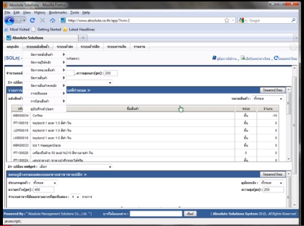

**Software description**

Absolute |Solutions| is a stock management web application that using technology cloud computing that provides Server, Database, IT expert.

**Pros**

* Save investment.
* Have alert message with SMS and Email.
* Security from virus on machine.
* Support with every operation systems.

**Cons**

* no order system support
* no member system support
* Cannot estimate the ingredient that needs to use per one time

**2.2.2 Absolute |Solutions|**



**Software description**

Absolute |Solutions| is a stock management web application that using technology cloud computing that provides Server, Database, IT expert.

**Pros**

* Save investment.
* Have alert message with SMS and Email.
* Security from virus on machine.
* Support with every operation systems.

**Cons**

* no order system support
* no member system support
* Cannot estimate the ingredient that needs to use per one time

**2.2.3 CD Organizer**

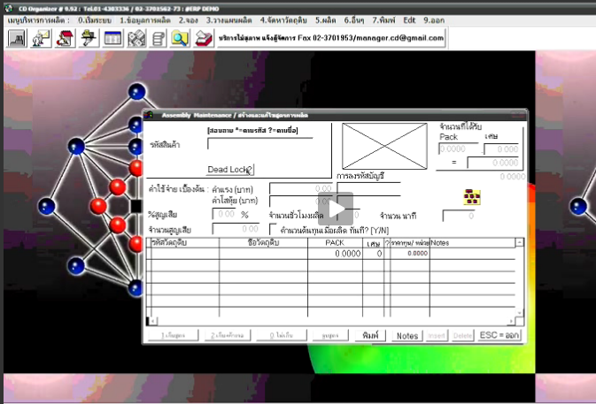

**Software description**

CD Organizer is a program management in the enterprise. It’s has many feature to support such as purchase system, debtor system, inventory control system, pay roll system, etc.

**Pros**

* Have hot key using to work fast.
* Online interactive
* Can show report in other program such as Microsoft word, Excel
* Too many report type

**Cons**

* Not support customer side
* No member system

1. **Technology Review**

**2.3.1 Spring Framework**



**Figure 2.6 HTML5 Review**

## Technology Detail

The spring framework is an open source development tool for developing enterprise. This framework used to develop any java application and make J2EE easy to use.

**Alternative Technology**

* ASP .NET Framework

## The selection of this technology

## Support MVC pattern.

## Support .Net and Java.

* Easy to connect with another system such as Web Service, JMS, Email.
* The unit test can split it to another part with JUnit.

**2.3.2 HTML5**



**Figure 2.6 HTML5 Review**

## Technology Detail

HTML5 is lasts version of HTML. It is markup language used to create User interface for present content of web browser.

## Alternative Technology

* Another HTML version
* XHTML

## The selection of this technology

* + Easy to handle error
  + Reduce the external plugin such as flash
  + The <canvas> element for 2D drawing
  + The <video> and <audio> elements for media playback
  + Support for local storage
  + New content-specific elements, like <article>, <footer>, <header>, <nav>, <section>
  + New form controls, like calendar, date, time, email, url, search

**2.3.3 CSS3**

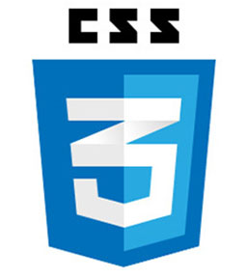

**Figure 2.6 HTML5 Review**

## Technology Detail

CSS3 is a last version of CSS. It is a Cascading Style Sheets used to design element of website such as layout, color, size or font of website.

## The selection of this technology

The feature more than old version such as Combinatory, CSS Selectors, Pseudo-elements, Style properties

1. **Development tool Review**

**2.4.1 Adobe Dreamweaver**



## Technology Detail

Adobe Dreamweaver is a tool for design and develop website

**Alternative Technology**

* Notepad + +

### CoffeeCup Free HTML Editor

### PageBreeze

## The selection of this technology

## Can switch code view and design view or both view

* Work with offline
* Support with layout tool

**2.4.2 Net bean**



## Technology Detail

NetBeans is an open-source program to integrated development environment for developing with any language such as Java, PHP, C++, and other programming languages. NetBeans is referred to developing Java desktop applications and also develop web application.

**Alternative Technology**

* Eclipse
* IntelliJ IDEA

## The selection of this technology

* Natively supports Ant and Maven- no custom built system that only works in the IDE.
* NetBeans 7.3 includes new features for editing/debugging HTML5
* NetBeans is written using Swing
* Built-in support for version control systems plugins. For example, it can be a nightmare to get SVN configured correctly on 64 bit systems.

**2.3.3 MySQL workbench**

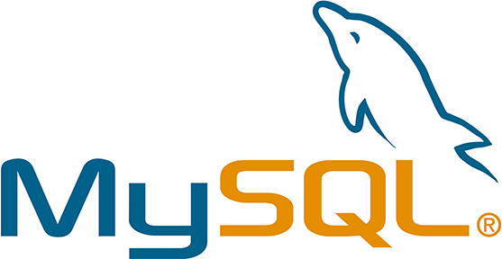

**Technology Detail**

MySQL Workbench is a tool for develop database architects. It can do such as provides data modeling, comprehensive administration tools for server configuration, SQL development, user administration, backup, and etc.

**Alternative Technology**

* Appserv
* Microsoft Access
* SQLite
* Tomcat

## The selection of this technology

## Many development tool can support

* To many feature support
* More Security
* Can visualize table relationships.