We have updated the project’s target platform from iOS and Apple Watch to Android and a compatible smartwatch to better align with the devices available to our team and support prototype development and testing within the project timeline.
Functional Requirements
1- User Registration
The system shall allow users to create an account using an email address and password.
2- User Login and Logout
The system shall allow registered users to log in using their email address and password and securely log out.
3- Password Recovery
The system shall allow users to reset their password through their registered email address.
4- Personal and Health Profile
The system shall allow users to enter and update their name, date of birth, supported medical conditions, and relevant medications. The system shall calculate the user’s age from their date of birth.
5- User Consent and Permissions
The system shall obtain the user’s consent before collecting health data and request the permissions required for heart rate monitoring and notifications.
6- Smartwatch Connection
The system shall communicate with a supported smartwatch paired with the Android phone and display its connection status.
7- Automatic Heart Rate Collection
The system shall automatically receive new heart rate readings and their measurement timestamps from the connected smartwatch, without requiring users to start a monitoring session or manually upload files.
8- AI-Based Heart Rate Classification
The system shall use a trained and evaluated machine learning model to classify valid heart rate data as High, Low, or Normal within the project’s defined scope.
9- Alert Generation and Notifications
The system shall generate an alert when valid heart rate readings meet predefined alert conditions, considering their persistence and available contextual information. It shall display a phone notification that opens the alert details and related instructions when selected.
10- Symptom Reporting
The system shall allow users to report symptoms associated with an alert and use this information when selecting guidance according to predefined rules.
11- Personalized Health Instructions
The system shall display general health instructions selected according to the alert type, reported symptoms, and relevant profile information, based on documented health sources.
12- Personal Dashboard
The system shall provide a dashboard displaying the latest valid heart rate reading received from the smartwatch, its measurement time, the classification of the most recent 10-minute window, the smartwatch connection status, and a heart rate trend chart based on 10-minute window summaries.
13- Heart Rate and Alert History
The system shall allow users to view their previous heart rate history as 10-minute window summaries, and their previous alerts, including timestamps, classifications, and associated instructions.
14- Data Storage
The system shall store each user’s health profile, 10-minute heart rate window summaries, classification results, and alert history under that user’s account. Raw readings are kept temporarily on the phone only until their window closes.
15- Connection Loss and Recovery
The system shall indicate when the smartwatch connection is lost or readings become outdated, attempt to reconnect, and resume receiving readings when the connection is restored.
16- Account and Data Deletion
The system shall allow users to request deletion of their account and associated personal and health data, with confirmation before deletion.

Project Tasks and Team Responsibilities
Task ID | Task Name | Subtasks | Deliverable | Assigned To | Due Date | Status
T1 | Requirements Analysis & Platform Update  (Revised) | 1- Review and finalize functional and non-functional requirements.  2- Define target users, use of medical history, application limitations, and monitoring mode.  3- Update the proposal and SP-I report from Apple Watch to Android / Wear OS (Galaxy Watch) and state the reason for the change. | Finalized requirements, project scope, and updated proposal/report. | Nofe |  | Done
T2 | Smartwatch Connectivity & Background Monitoring  (Revised) | 1- Implement a watch app to request permissions and read heart rate.  2- Transfer heart rate readings and timestamps to the phone.  3- Implement continuous background monitoring when the app is closed or the watch screen is off.  4- Test connection recovery, battery use, and data transfer delay. | Working prototype that transfers real heart rate readings continuously in the background. | Nofe |  | Done
T3 | UI/UX Design | 1- Define user flows and screen navigation.  2- Design phone screens and the basic watch display.  3- Design loading, missing-data, connection, and error states.  4- Build and review an interactive prototype. | Complete interface designs and an interactive navigation prototype. | Nofe |  | Done
T4 | User Accounts and Health Profile | 1- Implement registration, login, logout, and password recovery.  2- Implement personal and health profile creation and editing.  3- Implement consent recording and permission requests.  4- Implement account and associated data deletion with confirmation. | Working user accounts and editable health profiles, including consent and account deletion features. | Rawan |  | Done
T5 | Database Development | 1- Design the database schema and relationships.  2- Create storage for profiles, readings, classifications, alerts, and instructions.  3- Implement user-specific access controls and secure data communication.  4- Test data saving, retrieval, updating, and deletion. | Implemented database with a schema diagram and tested access controls. | Rawan |  | Done
T6 | Public Dataset Acquisition & Exploratory Analysis  (NEW) | 1- Download the Galaxy Watch Active2 4-week dataset (Figshare, doi:10.6084/m9.figshare.28509740) and GalaxyPPG (Zenodo, record 14635823).  2- Explore each dataset: fields, sampling rate, participants, missing values, and heart rate distributions.  3- Analyze heart rate against activity level, steps, and time of day to confirm the context features.  4- Align both datasets to a common resolution (e.g., 5-minute windows) and document licenses and limitations. | Exploratory data analysis (EDA) report with cleaned, aligned public datasets. | Lyan, Abrar |  | Done
T7 | Self-Collected Data Collection  (NEW) | 1- Prepare a participant consent form and data collection protocol.  2- Collect heart rate data using the team’s Galaxy Watch7 and the T2 app for at least 2 weeks per member.  3- Record context tags (rest, walking, exercise, sleep) with each session.  4- Store, anonymize, and document the collected data. | Anonymized self-collected Galaxy Watch7 dataset with consent forms and a collection report. | Lyan, Nofe |  | Done
T8 | Data Processing & Feature Extraction  (Revised) | 1- Validate readings and handle missing, invalid, or duplicate data.  2- Extract features per time window: mean HR, SD, deviation from personal baseline, steps/activity level, time of day, and abnormal duration.  3- Apply the same pipeline to public data, self-collected data, and live app readings. | Shared data-processing pipeline producing model-ready features. | Abrar |  | Done
T9 | Evaluation Set & Labelling  (Revised) | 1- Define abnormal heart rate events using clinical rules plus context (e.g., resting HR > 100 or < 50 bpm for ≥ 10 minutes).  2- Inject synthetic anomalies with known locations into real normal data.  3- Mark normal high-HR activity periods (jogging, running, exercise) from GalaxyPPG and self-collected data to measure false alarms.  4- Split data into training, validation, and testing sets without participant or time-window overlap. | Documented, labelled evaluation dataset with train/validation/test splits. | Abrar |  | Done
T10 | Baseline & Context-Aware Model (XGBoost / Random Forest)  (NEW) | 1- Implement the fixed-threshold method (> 100 / < 60 bpm) as the baseline.  2- Train XGBoost and Random Forest to predict the expected heart rate from activity, steps, time of day, and personal baseline.  3- Flag anomalies when the actual heart rate deviates significantly from the predicted value; tune the deviation threshold.  4- Explain predictions using feature importance / SHAP. | Trained context-aware model with the baseline implementation and explanation of results. | Rehab |  | Done
T11 | Unsupervised Anomaly Detection (Isolation Forest)  (NEW) | 1- Train Isolation Forest on normal data using the extracted features.  2- Build personal models by fine-tuning on the first week of each user’s data.  3- Tune contamination and decision thresholds on the validation set. | Trained and tuned Isolation Forest model with personalization results. | Abrar |  | Done
T12 | Time-Series Model (LSTM Autoencoder) – Advanced  (NEW) | 1- Prepare sequential windows from the Galaxy Watch Active2 data.  2- Train an LSTM Autoencoder on normal sequences.  3- Flag anomalies using reconstruction error and tune the threshold.  4- Implement only after T10 and T11 are completed. | Trained LSTM Autoencoder with results (optional extension). | Rawan, Lyan |  | Done
T13 | Model Evaluation, Comparison & Integration  (NEW) | 1- Compare all models with the fixed-threshold baseline.  2- Measure Precision, Recall, and F1-score on injected anomalies.  3- Measure the false alarm rate on normal high-HR activity periods.  4- Test on self-collected Galaxy Watch7 data, select the best model, and integrate it into the app.  5- Export the selected model (ONNX / TensorFlow Lite) with scaler parameters (JSON) and verify that Python and Android outputs match on the same samples. | Comparative evaluation report and the selected model integrated into the app. | Rehab, Abrar |  | Not started
T14 | Alerts and Notifications | 1- Implement alert conditions based on the model output and persistence rules.  2- Implement symptom reporting and link alerts to relevant instructions. | Tested alert and notification system with symptom reporting and linked instructions. | Rawan |  | Not started
T15 | Personalized Health Instructions | 1- Prepare an instruction library using documented health sources (e.g., WHO, AHA, Saudi MOH).  2- Define selection rules using the detected condition, reported symptoms, and relevant profile data. | Reviewed instruction library with tested personalization rules. Rule-based decision table (condition + symptoms + profile → instruction) | Rehab +Nofe |  | Not started
T16 | Dashboard and History | 1- Display the latest valid reading, timestamp, and classification.  2- Implement the heart rate trend chart.  3- Implement reading and alert history with access to event details. | Working dashboard with a heart rate chart and reading and alert history. | Lyan |  | Not started
T17 | System Integration and Testing | 1- Integrate the watch app, phone app, database, model, and alert logic.  2- Test the complete workflow using real readings and clearly labelled simulated scenarios.  3- Test permissions, disconnections, background monitoring, account isolation, and data deletion. | Integrated application with a test report documenting results and remaining issues. | Nofe (lead), Rawan |  | Not started
T18 | Documentation and Final Presentation | 1- Update the report to match the implemented system, evaluation results, and limitations.  2- Prepare installation instructions, the user guide, and organized submission files.  3- Prepare and rehearse the presentation, live demonstration, and backup video. | Final report, source code, installation files, user guide, presentation. | All members |  | Not started

Task 1: Requirements Analysis and Project Scope
Our project aims to build an app that connects to a smartwatch and automatically receives heart rate readings. The app will classify these readings as High, Low, or Normal and alert users when needed, providing guidance and advice for each situation. Users will also be able to view their readings and history on a personal dashboard.
Target Users
The app is designed for adults aged 18 and above who want to keep track of their heart rate for general health and fitness. Users can enter their medical history to help the app select relevant general guidance.
Supported Health Conditions
The app is designed to support heart rate monitoring, fitness, and general wellness. It is not intended to diagnose medical conditions, provide medical consultations, or recommend treatments for specific diseases. It provides alerts and general guidance on possible next steps based on heart rate readings and relevant information from the user’s reported medical history. This guidance does not replace advice or care from a qualified healthcare professional.
Monitoring and Data Collecting
The app will receive heart rate readings automatically from the connected smartwatch, along with the time of each reading. Users will not need to enter the readings themselves or upload any files. If the watch disconnects, the app will let the user know and start receiving new readings again when the connection returns.
Task 2: Smartwatch–Phone Integration Prototype
We built a simple prototype using Android Studio and Kotlin to connect a Galaxy Watch7 to an Android phone. After the user grants permission to read heart rate, the watch app displays the readings and automatically sends the latest reading and its measurement time to the phone through the Wear OS Data Layer API. We tested the prototype with both apps open and confirmed that the readings updated on the phone without any manual input. So far, we have tested this while both apps are open; monitoring when the apps are closed or the watch screen is off is still to be developed.

Figure 1: Heart rate reading on the smartwatch and its synchronized display on the Android phone.
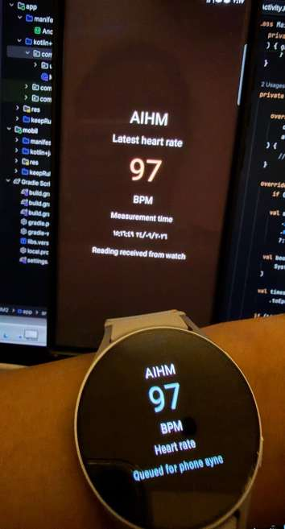

User Flow Diagram
[ Start ]
↓
[ Open AIHM App ]
↓
[ Connect to Smartwatch ]
↓
[ Measure Heart Rate ]
↓
[ Send Heart Rate Data ]
↓
[ Mobile App Receives Data ]
↓
[ Display BPM + Measurement Time ]
↓
[ Classify Heart Rate ]
↓
[ Low ] [ Normal ] [ High ]
This diagram shows the user flow of the AIHM prototype. The smartwatch measures the user’s heart rate and sends the data to the mobile application. The app then displays the heart rate (BPM) and the measurement time, and classifies the reading as Low, Normal, or High.

Figure 2: AIHM phone app prototype showing the latest heart rate reading and its classification.
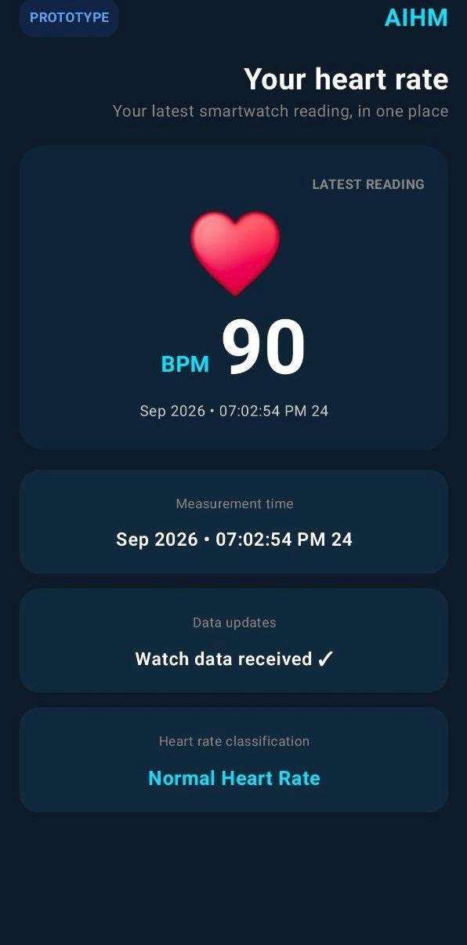

Task 4: User Accounts and Health Profile

We built the account and profile features of the phone app using Android Studio, Kotlin, and Jetpack Compose. Firebase Authentication handles user accounts, and Cloud Firestore stores each user's data. A new user can register with an email address and password, log in, log out, and reset a forgotten password through their registered email. When the app opens, it checks whether the user is already logged in and shows the login screen only if they are not.

Figure 3: Login and registration screens of the phone app

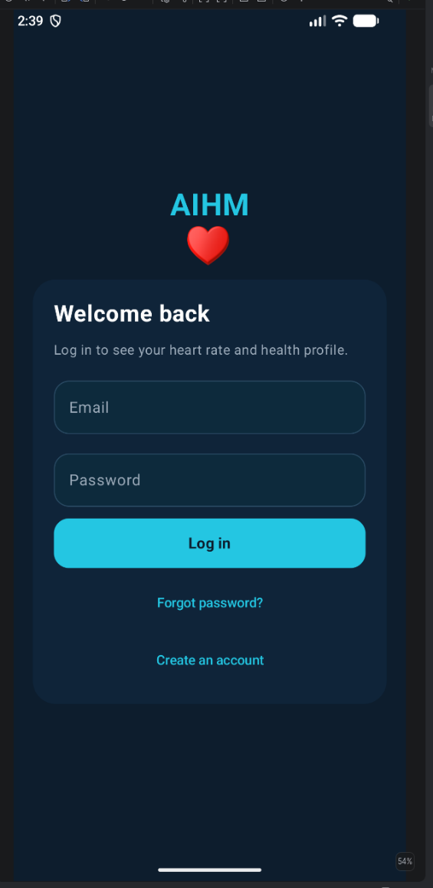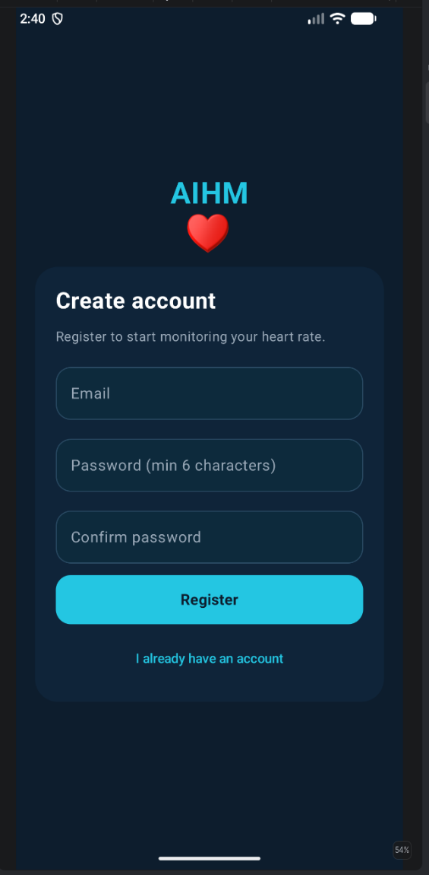
After registering, the user sees a consent screen that explains what data the app collects and states that the app does not give medical advice or a diagnosis. The user must accept two statements, one for storing health data and one for heart rate monitoring, before continuing. Each agreement is saved with a timestamp under the user's account.

Figure 4: Consent screen and the saved consent records in Cloud Firestore.

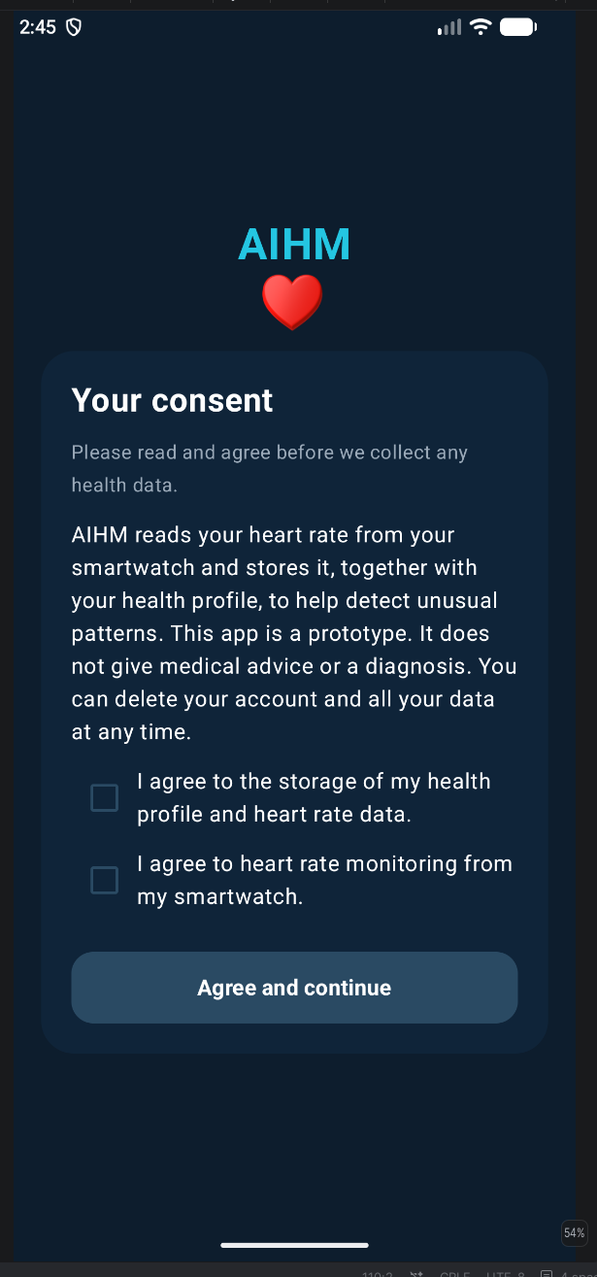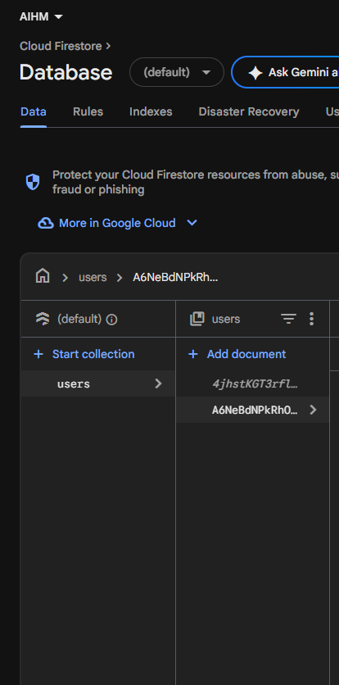
The user then fills in a health profile with their name, date of birth, gender, medical conditions, medications, and an emergency contact. They can edit the profile later from the dashboard, and the saved values load back automatically.

Figure 5: Health profile screen and the saved profile in Cloud Firestore.

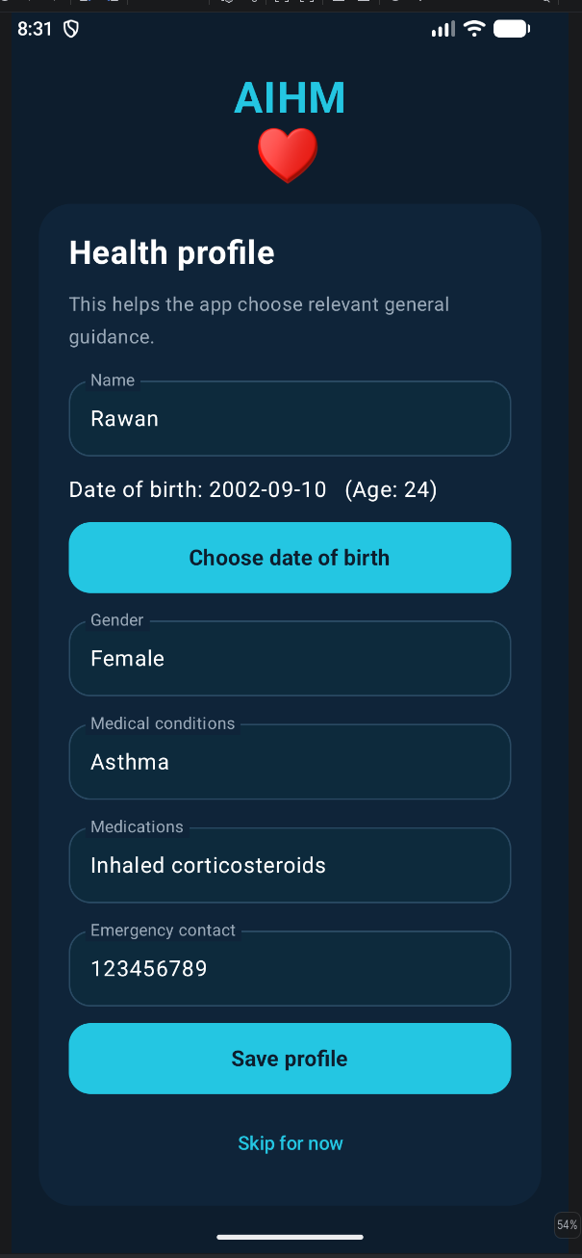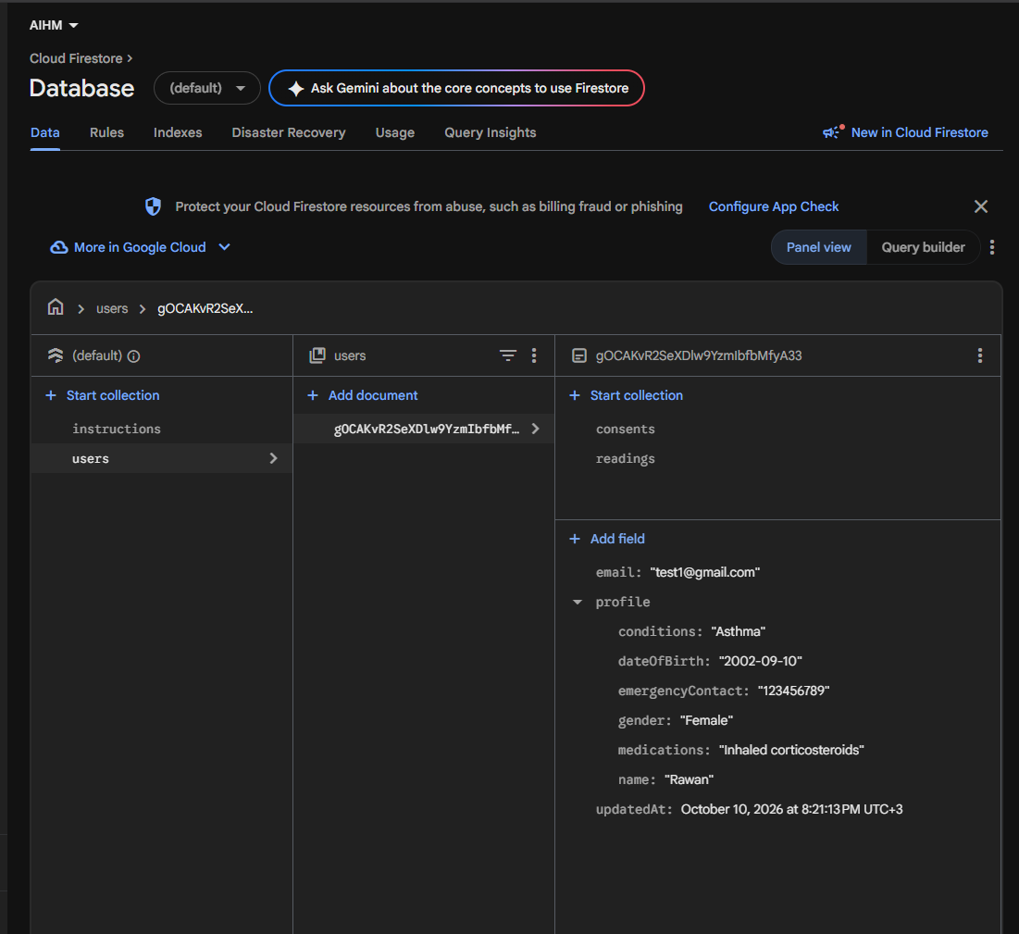
Users can also delete their account from the dashboard. The app asks for a confirmation and the user's password, then permanently deletes the profile, consent records, heart rate readings, and login account. We tested this with a wrong password, which was rejected, and with the correct password, after which the user disappeared from both Authentication and Firestore.

Figure 6: Account deletion confirmation, the wrong-password check, and the data removed after deletion.

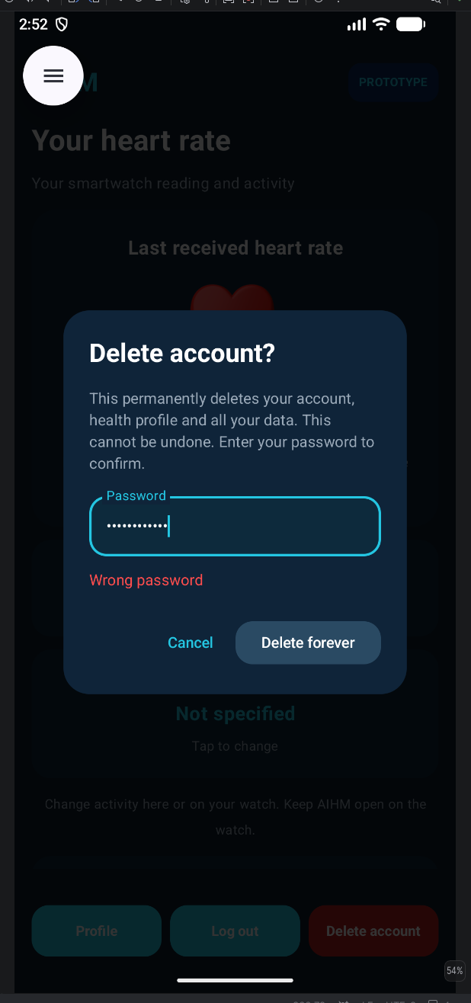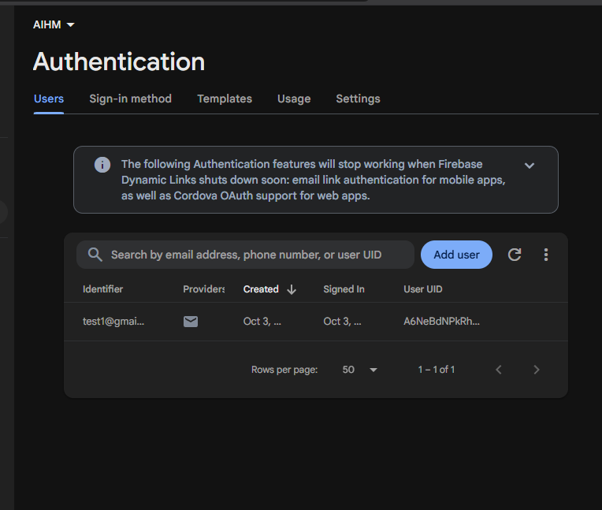
The app requests the notification permission after the user gives consent. The heart rate permission is requested on the smartwatch app. The profile stores the user’s date of birth, selected from a calendar, and the app calculates the age from it. Users must be 18 or older.

Figure 7: Notification permission request shown after the user gives consent.

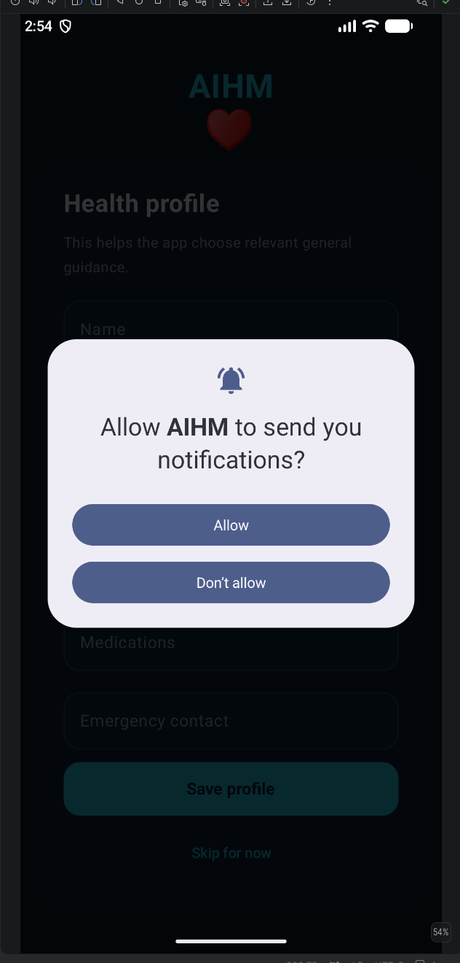
We tested the access rules in the Firestore Rules Playground. A read request to a user's document from a different user was denied, while the same request from the owner was allowed.

Figure 8: Firestore Rules Playground showing access denied for a different user and allowed for the document owner.

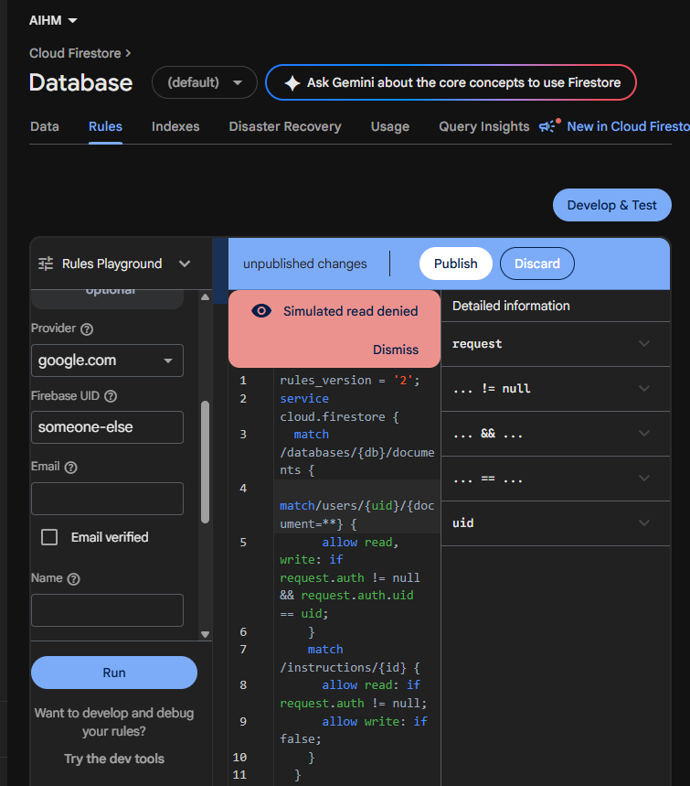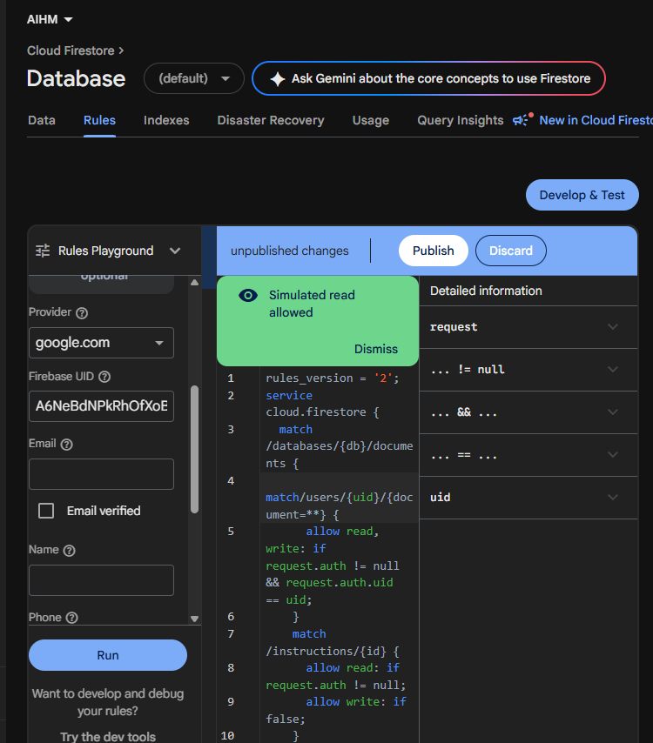

Task 5: Database Development
We used Cloud Firestore as the project database. Each user’s data is stored under a document in the users collection, identified by the user’s Firebase Authentication ID. The health profile is stored inside this document, and consent records are stored in a consents sub-collection. The readings collection holds only raw measurements from the smartwatch (heart rate, timestamp, activity, and device ID); it contains no model output. To follow the 10-minute storage rule, the app will group readings into 10-minute windows and store one summary per window (mean, minimum and maximum heart rate, and reading counts) in a windows sub-collection. A classification is the heart-rate level (High, Low, or Normal) of one window. It describes the heart rate, not a medical condition or diagnosis. An alert is created when consecutive abnormal windows occur. The shared instructions collection holds general advice, which the app selects according to the alert type, the symptoms the user reports, and relevant profile information. A 10-minute average can hide a brief spike, which is an accepted trade-off of the persistence rule.

Addressing the 10-Minute Storage Rule. The smartwatch sends heart rate readings continuously, but the app does not save each reading permanently. Readings are kept temporarily on the phone while a 10-minute window is open. When the window closes, the app calculates the mean, minimum and maximum heart rate and the number of valid readings, and saves one summary document to the windows sub-collection. The classification (High, Low, or Normal) and any alert are based on these windows, so an alert is created only when consecutive windows are abnormal. This means Firestore receives at most one summary every 10 minutes, which keeps storage within the free limits. The trade-off is that a 10-minute average can hide a brief spike. This is accepted because the alert rule is designed to detect persistent abnormal heart rates rather than short-lived changes.

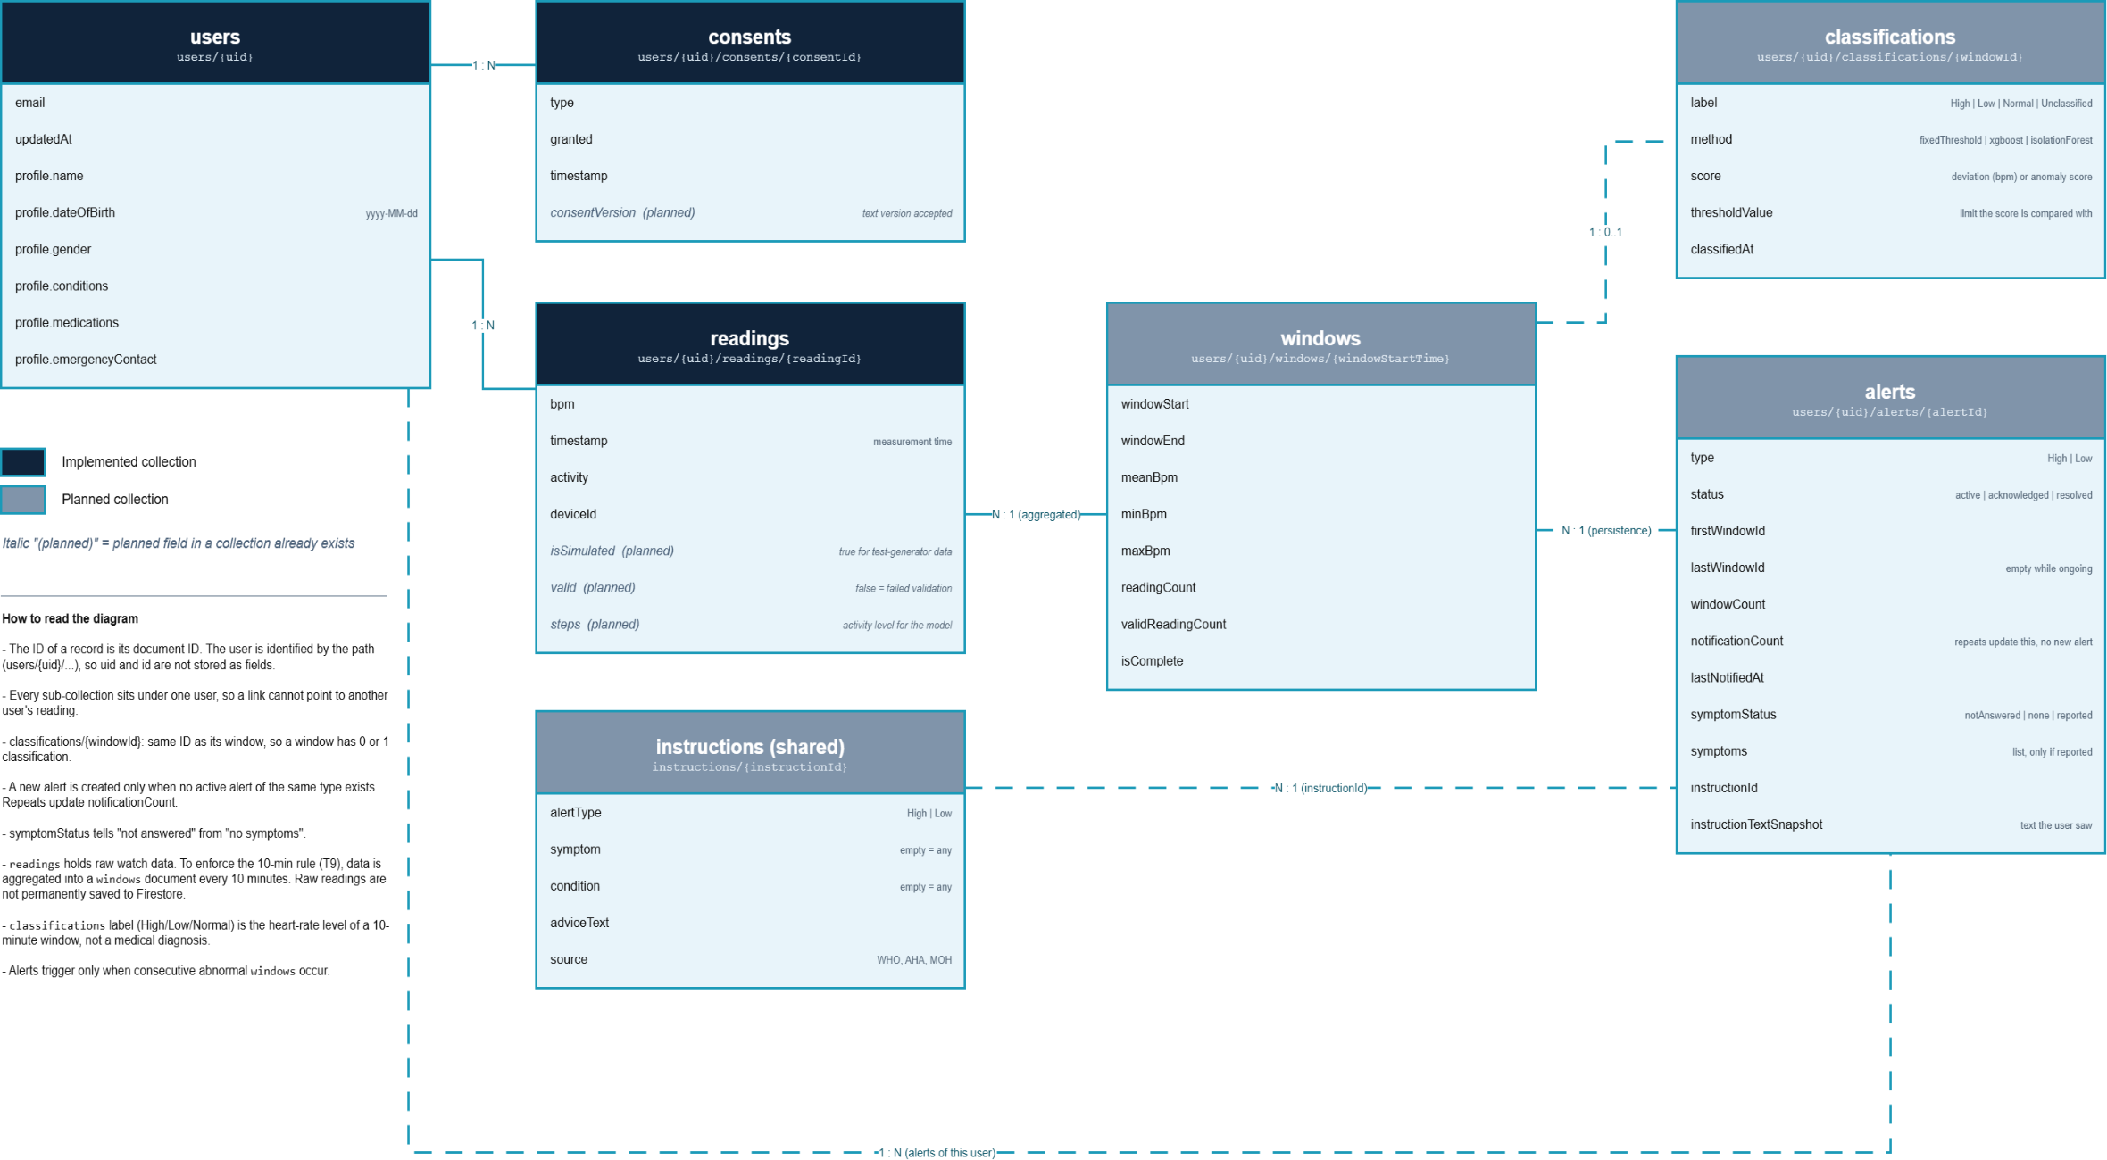
Figure 9: Entity-relationship diagram of the AIHM database. Dark navy headers are implemented collections; blue-grey headers are planned. Raw readings are aggregated into 10-minute windows, and classifications and alerts are based on windows.

To control access, we wrote Firestore security rules. A signed-in user can read and write only the documents under their own ID, and no user can modify the instructions collection, which is read-only. All communication between the app and Firebase uses HTTPS. We tested the rules in the Firestore Rules Playground: a read request from a different user was denied, while the same request from the document owner was allowed (Figure 8).

We also tested saving, retrieving, updating, and deleting data through the app.

Table 1: Database test results
Test | Action | Expected result | Result
Save | Save a new health profile | Profile appears in Firestore under the user's ID | Passed
Save | Accept the consent statements | Two consent records with timestamps are created | Passed
Save | Receive a simulated reading from the watch | A reading document with bpm, timestamp, activity, and deviceId is created | Passed
Save | Save a profile with a date of birth | dateOfBirth appears in Firestore and the age is calculated from it | Passed
Retrieve | Open the Profile screen | Saved values load into the form | Passed
Update | Edit the profile and save again | Firestore shows the new values and a new updatedAt | Passed
Delete | Delete the account with the correct password | User, profile, and consents are removed | Passed
Delete | Delete with a wrong password | Request rejected, nothing deleted | Passed
Delete | Delete an account that has saved readings | Readings are removed along with the user, profile and consents | Passed
Access control | Read another user's document | Access denied | Passed
Access control | Read own document | Access allowed | Passed
Validation | Save with an under-18 date | Rejected with a message | Passed

Figure 10: Updated health profile in Cloud Firestore.
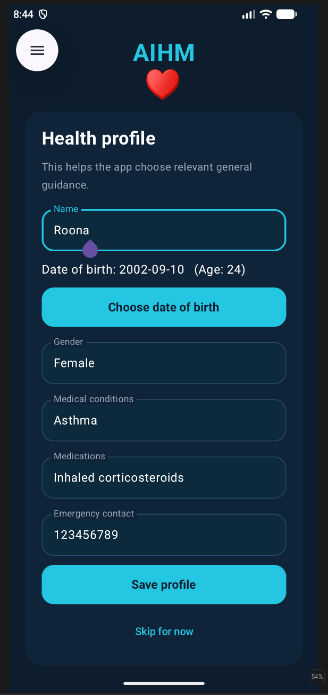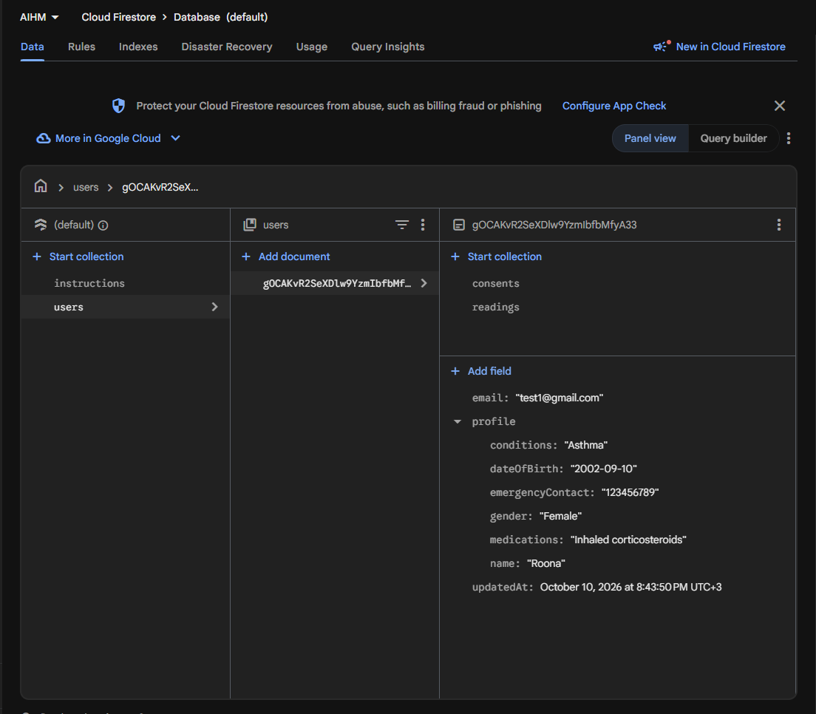
So far, the database stores profiles, consent records, and heart rate readings. The collections for window summaries, classification results, alerts, and instructions are defined in the schema and covered by the same security rules, and they will be filled by the data-processing pipeline (T8), the model (T13), the alert logic (T14), and the instruction library (T15) as those tasks are completed.
Figure 11: Heart rate reading saved in Cloud Firestore.
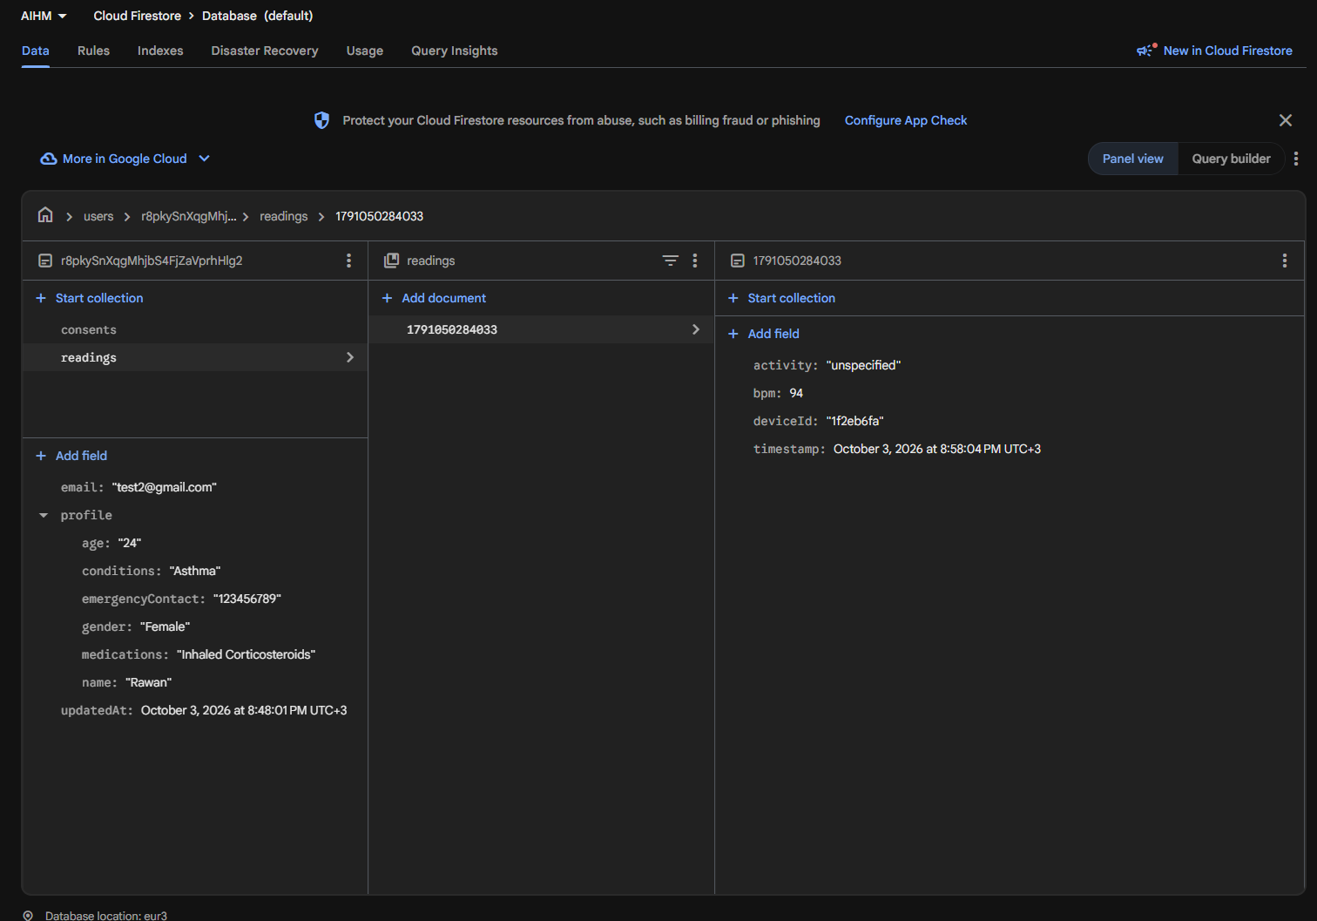
Heart rate readings received from the smartwatch are saved in a readings sub-collection under the user's account. Each reading stores the heart rate, the measurement time, the selected activity, and the ID of the source device. In the current prototype, test readings are saved to Firestore about every 5 seconds for development. These values come from the watch app’s test generator, so they are placeholders and not real heart rate measurements. In the final design, raw readings are kept only until their 10-minute window closes, and Firestore stores the window summary.
Classmates’ Review Comments on the Database Schema
These comments were written on the earlier version of the schema and Figure 9, before the revision described above.
AIHM Database Schema Review and Suggested Improvements
Name: nofe Abdulrahman
AIHM Database Schema Review
After reviewing Figure 9 and the Firestore screenshot in Figure 11, I noticed a few details that could make the design clearer. These are suggestions and points to check, not confirmed errors in the code.
1. Clarifying the Identifiers
My observation → The diagram shows uid and id as fields inside readings. In the screenshot, the user is identified through the document path, and the reading is identified by its document ID.
My suggestion → Explain this in the diagram so it matches how the data is stored. We do not need to repeat these identifiers inside the document just to match the drawing.
2. Saving Readings Before Classification
My observation → The diagram shows one classification for each reading. However, a reading may be saved before the model finishes classifying it.
My suggestion → If each reading is classified once, allow it to have zero or one classification. This means a reading can stay in the database while it waits for its result.
3. Separating New Alerts from Repeated Notifications
My observation → Sending another notification for the same alert does not always mean that a new event has happened.
My suggestion → Define when the app should create a new alert and when it should only repeat a notification. This would help prevent the same event from appearing several times in the alert history.
4. Keeping the Original Instruction Text
My observation → If an instruction is changed later, an old alert might show the updated text instead of what the user originally saw.
My suggestion → Save a copy of the displayed instruction in instructionTextSnapshot inside the alert. This would keep the original text available when the user opens an old alert.
5. Distinguishing No Answer from No Symptoms
My observation → A user who has not answered the symptom question is different from a user who has answered that they have no symptoms.
My suggestion → Make this difference clear in the saved data. A missing answer should not be treated as “no symptoms,” especially when the answer affects which instructions are shown.
6. Explaining the threshold Field
My observation → The classifications collection includes threshold, but its meaning is not clear in the diagram.
My suggestion → Explain whether it is a heart rate limit or a threshold for the model’s anomaly score. Its meaning should match the method used by the model.
7. Checking That Linked Records Belong to the Same User
My observation → An alert is linked to a user and a reading. We need to make sure these links are consistent.
My suggestion → Check that the reading belongs to the same user as the alert. This needs to be verified in the code because the diagram alone cannot confirm it.
The suggestions about classifications, alerts, and instructions are for features that are still planned. They do not mean that the completed work is incorrect. The next step is to review the relevant code and Firestore security rules to check how these relationships work in practice.
Review by Abrar and Lyan
Name: Abrar and Lyan
1. Overall Evaluation
The schema of the AIHM database is a suitable basis for the development of a heart-rate monitoring app. This app makes use of Cloud Firestore as a place to store user profiles, consent records, and heart-rate readings. Moreover, the schema specifies the planned collection of classifications, alerts, and health instruction.
In general, the existing database schema is capable of covering the planned functionality of the app. Nevertheless, some features of the schema need to be explained in order to guarantee its capacity to support the mentioned above features.
2. Relationships and Data Organization
The presented schema shows the one-to-many relationships between users and readings, as well as between users and consent records. Thus, a user can have several heart-rate readings and distinct consent records in order to give permission to different actions.
Moreover, there are relationships between readings, classifications, and alerts. The mentioned relationships are needed for the fact that the application needs to link a particular classification or alert to the appropriate heart-rate reading.
Because Cloud Firestore is a NoSQL database, such relationships are represented using document paths and references and not relational foreign keys in a relational database. Consequently, it would be essential to ensure that the references are verified, and the records related to them belong to the same user.
One suggestion would be to clarify the relationship between readings and classifications. In the provided diagram, the relationship between the two is depicted as a one-to-one relationship. Such an approach is okay if every reading gets a single classification, but there must be provision for invalid readings.
3. Heart-Rate Readings and Data Reliability
The readings table includes columns like bpm, timestamp, activity, and deviceId. It can be used as a good starting point for recording heart rate measurements.
However, according to the project documentation, the readings at the moment represent simulated data generated by a test generator and not actual heart rate measurements.
One potential enhancement that could be applied here would be the possibility to distinguish between the simulated and real measurements if they are going to be stored in one database. Moreover, the application needs to validate mandatory fields, timestamps, and heart rate values prior to using them for classification and alerts.
These actions would increase the reliability of the data and would avoid treating the invalid test data as actual measurements.
4. Classification Results
The proposed classification table will contain fields such as readingId, label and threshold. This set of fields can be used as a basis for storing the classification information associated with a certain heart-rate reading.
It is important, however, to make the definition of threshold field clear. The project should describe the way classification borders are defined and the treatment of the invalid or unclassified readings by the classification algorithm.
The link between the readings and classifications should also be consistent with the actual implementation. If each reading is classified separately, then there is no need to change the schema – one-to-one relationship will suffice. In case when the model classifies groups of readings in a certain period of time, this period should be represented in the schema.
In addition, storing the timestamp of the classification and the model version used could become useful for debugging purposes. These features are optional extensions rather than confirmed requirements of the current implementation.
5. Alert Generation and Management
The proposed alerts will consist of attributes like readingId, type, time, and acknowledged. These attributes give a good outline on how alerts and acknowledgement of alerts are going to be recorded.
However, the project requirements say that the alert logic will depend on the persistence of abnormal readings and contextual data. It means that there must be a way of showing how the alert and the reading or the event leading to the alert are related.
If the logic of alert depends on a number of readings within a particular time frame, the schema will have to represent the time window or triggering event. In case of individual readings triggering the alert logic, then the existing reference will suffice.
There should also be logic on how multiple abnormal readings are treated. This will help avoid unnecessary duplication of alerts. The introduction of the start and end time fields for the alerts should only be done if necessary by the logic of alert generation.
6. Instructions and Personalized Guidance
The proposed shared instructions collection will hold classLabel and adviceText. Maintaining general instructions in the shared instructions collection can reduce duplication and simplify maintenance of the instructions.
But the project guidelines state that the guidance needs to be chosen based on the type of alert, the reported symptoms, and the profile data. Hence choosing the instructions just based on the classification may not be enough.
The application needs to describe the selection criteria for selecting the instructions and how these selected instructions are linked to the alerts.
If the application needs to store the exact instruction text seen by the user during alert generation, then the text can be stored as part of a snapshot of the instruction. This is not an enhancement but an optional enhancement.
7. Consent, Security, and Account Deletion
Consent is stored in a separate consents subcollection for each user. It allows us to meet the condition that requires separate consent for storing health data and heart rate monitoring.
Storage of consent type and timestamp helps us understand what kind of consent was received and when. The consent version can also come in handy in case the consent language changes at some point in the future.
The access control mechanisms have already been tested in our project. They prevent one user from accessing the document of another user. It is an essential security measure since the app works with private and health information.
The testing of account deletion proves that the currently stored user data, consents, and readings can be deleted. Once we implement the collections of classification and alerts, we need to test it once again.
8. Consistency Between the Diagram and Implementation
One of the advantages of the project documentation lies in the fact that it divides collections into implemented collections and those that are supposed to be implemented. The Profile, Consent, and Reading collections have already been implemented, whereas Classification, Alerts, and Instructions collections are still under planning.
As a result, such collections cannot be regarded as failed implementations. It is necessary to evaluate whether their proposed structure is suitable to meet the requirements.
It is also necessary for the team to monitor the consistency of the database schema, Firestore security rules, application logic, and test results as more features are added.
9. Recommended Improvements
The following improvements could strengthen the database design:
1. Clearly define the relationship between readings and classification outcomes, including treatment of unreadable or invalid readings.
2. Make sure heart rate, timestamp, and source validation is done before using readings for further processing.
3. Define classification thresholds and their application.
4. Make sure alerts can be linked to specific readings and events in cases where abnormal conditions are ongoing.
5. Define alerting conditions and notification reoccurrence.
6. Make sure instruction selection takes into consideration alert type, symptoms and profile data.
7. Ensure account deletion deletes all user-related data in case of planned collection implementation.
8. Make sure that the database scheme reflects the implementation and differentiate between currently implemented features and planned features.
Optional fields such as isSimulated, modelVersion, and consentVersion should be introduced only when they serve a clear purpose in the application.
10. Conclusion
On balance, the AIHM database schema constitutes a sufficient basis for the current implementation of the project and its future functionalities. The way the database schema is designed to store users' profiles, their consents and heart rate measurements covers the minimum required functionality.
The possible areas for improving the database are those related to tracking the classifications' outcomes, handling the alerts, choosing personalized health recommendations and protecting the user data during system evolution.
It is not required to design a completely new database schema as per the evidence available at hand. It is more appropriate to specify the relationships needed to implement new functionalities, to verify input data, to document the process of classification and alert creation and to test security and deletion procedures as more collections are added.

Response to the Database Schema Feedback
Thank you for your feedback on the database schema. I have updated the report and the diagram (Figure 9, Task 5).
- readings stores raw measurements from the watch only. It contains no model output.
- Classification is the heart-rate level (High, Low, or Normal) of a 10-minute window. It is not a medical diagnosis.
- What is saved every ten minutes: one summary per 10-minute window (average, minimum, maximum, and reading counts). The app keeps raw readings only until the window closes.
- Instructions are general advice selected from the alert type, the symptoms the user reports, and relevant profile information.
The current prototype still saves test readings about every 5 seconds, and this will change to the 10-minute design as the remaining tasks are completed.

Task 6: Public Dataset Acquisition and Exploratory Analysis
The tables for the Figshare Galaxy Watch Active2 were created and the GalaxyPPG cleaned tables were used as two different public data sources. Their five-minute outputs use a comparable time resolution; participants were not joined across studies.
Source preparation and data quality
Measure | Figshare | GalaxyPPG
Scope | 49 participants; four supplied CSV files | 24 participants; reviewed cleaned sensor and session tables
Five-minute output | 79,627 all-sensor windows; 38,911 publisher-quality windows | 324 participant windows in the reviewed aligned table
Heart-rate and context | HR, HRV and partly observed steps; no explicit activity tag | Galaxy Watch HR and session activity tags; no step-count field
In the case of Figshare, four out-of-period sensor entries and duplicates of the participants/five-minute bins were eliminated from the analytical copies. The original CSV files were kept unchanged; there was no numeric value imputation. There are missing steps in 55.7% of the total windows and 65.2% of the quality windows. The average HR of the quality window subset is lower than that of the entire table; hence, the activity characterization should be performed by using both subsets.
The cleaned data of GalaxyPPG include 89,707 participant-level one-second rows. The 324 five-minute summaries match the source rows; the later Task 9 Galaxy-watch feature table includes 310 windows as per its own input selection. The Galaxy Watch HR is either missing or invalid for 24.50% of the full grids; 73,945 seconds (82.43%) have session labels. The source review did not execute the cleaning script on the original large archive.
Exploratory findings and reuse
For Figshare windows with recorded steps, pooled HR-step correlations were 0.260 for the total table and 0.123 for the quality subset; these are descriptive correlations. For GalaxyPPG sessions, there is 12,441 seconds of labeled physical activity with activity context, but no step counting data in the reviewed output files. Time-of-day trends correspond to incomplete coverage and planned sessions without a circadian demonstration.
Figshare report is based on four CSV files provided instead of the 18.38 GB archive. The GalaxyPPG report is based on the provided cleaned tables instead of independent review of the raw waveforms. Sources of records: https://doi.org/10.6084/m9.figshare.28509740 and https://doi.org/10.5281/zenodo.14635823. Prepared datasets and original EDA reports are distinct.
AIHM Task 7 Data Collection Report
Data collected by Lyan and Nofe | Galaxy smartwatch heart rate exports | 29 October 2026
The purpose of this report is to document two heart rate datasets gathered in accordance with the requirements of AIHM Task 7 by Lyan and Nofe. Lyan and Nofe have provided separate exports. The team would like to state that the data was collected using the watch application created in Task 2 (T2). The names Lyan and Nofe are mentioned to indicate the collectors of the data in this report and they do not refer to the persons who were being tested.

Data collection and source files
Lyan exported her heart rate data into a CSV file, while Nofe exported his into a ZIP file using Samsung Health and included additional JSON data. Both sets of data were processed independently. The available data includes timestamps and heart rate values, with the devices being identified by aliases. The collector labels are simply there to differentiate between the exports and do not refer to any wearer identification..

Preparation procedure
Read the heart rate records from each collector’s export, parsed measurement times and values, and retained technically valid readings.
Separated spot measurements from interval data. Nofe’s linked JSON produced minute level heart rate bins. Lyan’s 744 interval summary records without corresponding detail JSON stayed in the source record table and were not converted into invented minute values.
Grouped the retained measurements into five minute windows for analysis while keeping the individual readings in a separate table.
Replaced raw watch device UUID values with device aliases and kept an audit of the number of source and resulting records.

Prepared data summary
Measure | Lyan collected export | Nofe collected export
Heart rate source records | 6,207 | 974
Retained heart rate measurements | 5,463 | 9,757
Type of retained measurements | 5,463 spot readings | 766 spot readings and 8,991 minute bins
Populated five minute windows | 5,461 | 2,687
Dates with at least one retained reading | 128 | 39
Range of retained readings in UTC | 4 Nov 2025 to 6 Oct 2026 | 16 Dec 2024 to 6 Oct 2026
Longest run of dates with readings | 28 Aug to 13 Sep 2026: 17 dates | 7 Oct to 24 Oct 2025: 18 dates
A date with readings means that at least one retained measurement occurs on that UTC date. The first and last dates show the range covered by each export; they are not a count of continuously recorded days.

Dataset organization
Output | Description
heart_rate_measurements.csv | One row per retained heart rate observation, with reading time, heart rate, observation type and source and device aliases.
heart_rate_5min.csv | Five minute windows populated by the available readings; includes mean heart rate and the number of observations in each window.
heart_rate_source_records.csv | Source level audit table showing the original heart rate records, including interval summaries.
audit.json | Processing counts and settings for the corresponding export.
The prepared files preserve the two collected exports separately. The export provided by Nofe contains a Galaxy Watch7 device profile with model SM-L310. The input provided by Lyan was a heart rate CSV. The individual readings and five minute summaries are the prepared Task 7 data outputs.

AIHM Task 7 Participant Consent Form
I agree that the AIHM project team may use the heart rate readings and recording times from my previously collected smartwatch data for the academic project and its report. The team will remove my name and direct identifiers from the analysis dataset. I understand that taking part is voluntary and that I can contact the team if I have questions about the use of my data.
Participant name: _____________________________________________________
Participant signature: _________________________________________________
Date signed: _________________________________________________________
Project contact: ______________________________________________________

AIHM Task 7 Participant Consent Form
I agree that the AIHM project team may use the heart rate readings and recording times from my previously collected smartwatch data for the academic project and its report. The team will remove my name and direct identifiers from the analysis dataset. I understand that taking part is voluntary and that I can contact the team if I have questions about the use of my data.
Participant name: _____________________________________________________
Participant signature: _________________________________________________
Date signed: _________________________________________________________
Project contact: ______________________________________________________

Task 8 Data Processing and Feature Extraction
The Feature Tables for Figshare, GalaxyPPG, and the self-exported datasets for Task 8 have their individual heart rate feature tables with a duration of five minutes. They have been processed in such a way that the missing values for each source are still visible. The training, validation, and testing sets are for Task 9 only.

Inputs and outputs
Source | Five-minute windows | HR missing
Figshare quality data | 38,911 | 0
GalaxyPPG Galaxy Watch | 310 | 27
Lyan-labeled export | 5,461 | 0
Nofe-labeled export | 2,687 | 0

A five-minute window contains measurements grouped by time; it does not establish uninterrupted recording for five minutes. The four source tables remain separate.

Processing and feature definitions
For Figshare, heart rate was used, and its Unix timestamp value was processed in milliseconds. There was one duplicate of the filtered Figshare file counted once and one out-of-period record in 2018. The corrected Figshare table has 49 groups of devices. Personal baseline and deviation are calculated only for the first seven days provided that there is at least 30 windows on at least two dates; 46 groups fit that requirement.
Each source offers a window timestamp and heart rate summary when observed. Additionally, Figshare has standard deviation, observation count, time of day, baseline, and any possible step, distance, or calorie data. GalaxyPPG has session coverage, and it has recorded information about its sessions. Self-collected exports have all available heart rate observation for them and also anonymized device aliases. Each column is source-dependent, as the original records do not include the same information.
There were no conversions from absent activity or step to the confirmed rest or exercise. Windows from 27 GalaxyPPG sessions without mean heart rate remained missing. There was no possible abnormal duration inferred from single measurement. Model could deal with missing values in its training process later.

Quality checks and handoff
This includes the number of entries, heart rates which are missing, invalid time stamp entries, out-of-project range of 30-220bpm and the checksum of the files. There are no columns for train, validation, or test in the four feature files. Task 9 provides the evaluation labels and splits, whereas Task 11 makes use of feature values for building models.
The provided tables clearly show the four offline sources. These do not prove that the same processing code is embedded into the real-time app readings or that activity and duration columns are collected.

Task 9: Evaluation Set & Labelling
Task 9 gets the screening examples ready along with labeled exercise controls and it also handles synthetic abnormal events plus data splits that are kept apart. It draws from the two public datasets Abrar managed and the exports that Lyan and Nofe collected. Each original source stays in its own output folder. The synthetic examples are marked clearly so they do not get treated as observed clinical events. It seems like that part matters for keeping things separate.
Inputs and prepared outputs
Source | Five minute windows | Grouping used
Figshare | 38911 | 49 deviceId groups
Zenodo GalaxyPPG | 310 | 23 participant uid groups
Export collected by Lyan | 5461 | One assumed wearer (unverified)
Export collected by Nofe | 2687 | One assumed wearer (two device aliases; unverified)
In this instance, it is assumed that the export obtained by Lyan belongs to one wearer while that obtained by Nofe belongs to another wearer. This is a project assumption that remains unverified as opposed to being the identity established through the records. There are two device alias names for the export of Nofe which belong to one wearer each. There are no labels for rest/exercise based on heart rate or steps.
Research rule and observed controls
This project example selects two adjacent five-minute rest windows where mean heart rate is above 100 bpm or below 50 bpm in both. There should be at least 80% rest in each window and at least 80% heart rate coverage. It is an academic screening criterion, and it is neither a diagnosis nor a clinical threshold. No eligible pairs were found, hence the number of rows in observed candidate output is 0.
Zenodo data offers 921 valid seconds of jogging and running. Out of them, 593 seconds are above 100 bpm. This is exercise control for investigating threshold-based false positives; this is a number of seconds above a threshold, not false alarms of a trained algorithm.
Self-collection data exports lack activity labels that can be trusted. Exercise windows cannot be labeled using the provided data. No false alarm rate is reported for such data exports.
Synthetic events and separated splits
There was a creation of 98 events that were deliberately synthetic through the alteration of the copies of pairs of consecutive Figshare windows with normal mean heart rate as baseline. The events have two values of five minutes each which are either set at 110bpm or 45 bpm and a manifest showing the locations and labeling of the events. There is no trusted labeling of these events as rest in the source file.
Public source | Train groups | Validation groups | Test groups
Figshare deviceId | 29 | 9 | 11
Zenodo uid | 12 | 7 | 4
Grouping comes before synthetic injection. Figshare deviceId acts as a proxy for devices, whereas Zenodo uid is for participant groups. The same public group must not appear across multiple splits. Synthetic events will take the split of their respective groups: 58 training, 18 validation, and 22 test events.
Private exports will be split temporally into roughly 60% training, 20% validation, and 20% test with an hour-long exclusion window after each split point. Lyan: 3,276 training, 1,087 validation, 1,089 test, and 9 excluded windows. Nofe: 1,612 training, 525 validation, 536 test, and 14 excluded windows. Tests utilize subsequent readings by the same presumed wearer; they don’t involve testing on different individuals. Boundary dates and window counts are logged in private_temporal_split.csv.
Deliverables and interpretation
Package consists of a five minute feature file per source, the public split group, the private split group chronologically, exercise controls seen, a research rule candidate file, synthetic event rows and manifest, an audit, the executable code, and the cleaned input table files for the code. Package does not include a trained classifier or abnormal clinical events validated.
The American Heart Association states that heart rates at rest and during exercise are measured in different circumstances and that heart rate is determined by physical fitness. Task 9 value less than 50 beats per minute and ten minutes in duration are the settings for the project.
Task10: Baseline & Context-Aware Model (XGBoost / Random Forest)
1. Fixed-threshold baseline
The baseline flags a 5-minute window when the actual heart rate is above 100 bpm or below 60 bpm. The outputs also compare this rule with Task 9’s persistence rule (>100 or <50 bpm for two consecutive windows). However, the rest and ≥80% data coverage conditions were not applied because the required information was unavailable in the Task 8 feature files.
Source | Valid windows | Task 10 flags | Task 10 rate | Task 9 rate
figshare | 38,911 | 3,546 | 9.113% | 2.907%
galaxyppg | 283 | 37 | 13.074% | 10.954%
lyan | 5,461 | 940 | 17.213% | 2.362%
nofe | 2,687 | 168 | 6.252% | 3.498%
2. XGBoost and Random Forest context-aware models
Random Forest and XGBoost regressors predict expected heart rate using activity context, steps, distance, calories, cyclical time-of-day variables, training-only personal baseline, baseline availability, and wearer-level historical context. XGBoost is the best model on both evaluation splits.
Split | Train / Val / Test | XGBoost MAE | XGBoost R² | RF MAE
time_based | 27,214 / 5,815 / 5,882 | 7.133 bpm | 0.298 | 7.393 bpm
task9_group_based | 22,983 / 8,006 / 7,922 | 9.322 bpm | -0.047 | 9.355 bpm
The Task 9-aligned group split uses 29 training groups, 9 validation groups, and 11 test groups. The personal baseline was recomputed from training rows only; unseen groups use the training global mean. The group-based results indicate weaker generalization to unseen groups (XGBoost R² = -0.047).
3. Residual anomaly detection and threshold tuning
Anomalies are flagged when the absolute residual, actual HR minus predicted HR, exceeds a tuned k × MAD threshold. The threshold is selected on validation data by maximizing agreement with the fixed-threshold baseline; it is an agreement measure, not independent clinical ground truth.
Split | MAD | Best k | Threshold | F1 vs baseline | Cohen kappa
time_based | 5.431 bpm | 2.75 | 14.934 bpm | 0.445 | 0.387
task9_group_based | 6.271 bpm | 2.75 | 17.246 bpm | 0.611 | 0.565

Figure 12: Uploaded threshold-tuning result; best k=2.75 and threshold=17.2 bpm in the displayed group-based output.
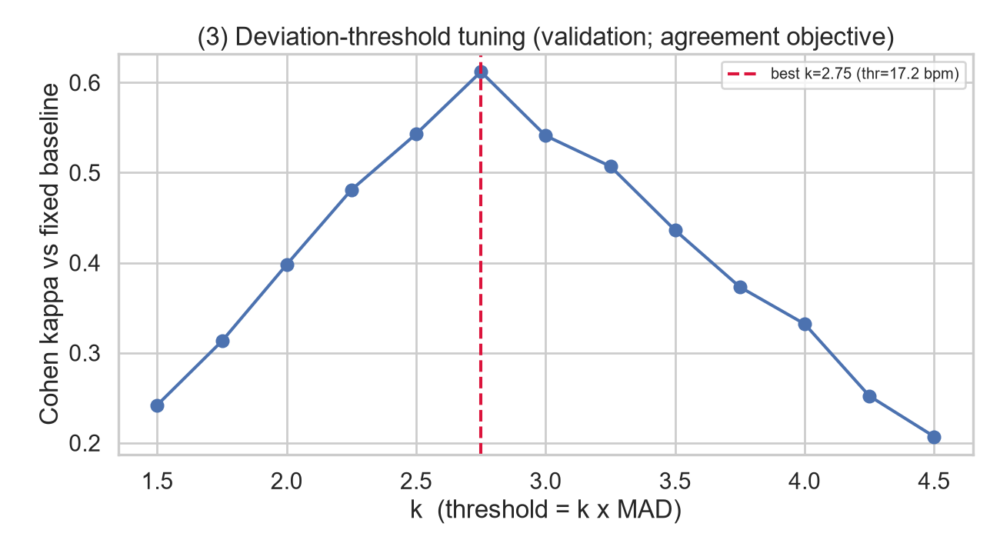

Figure 13: Uploaded XGBoost anomaly agreement matrix: TN=6,657, FP=599, FN=109, TP=557.
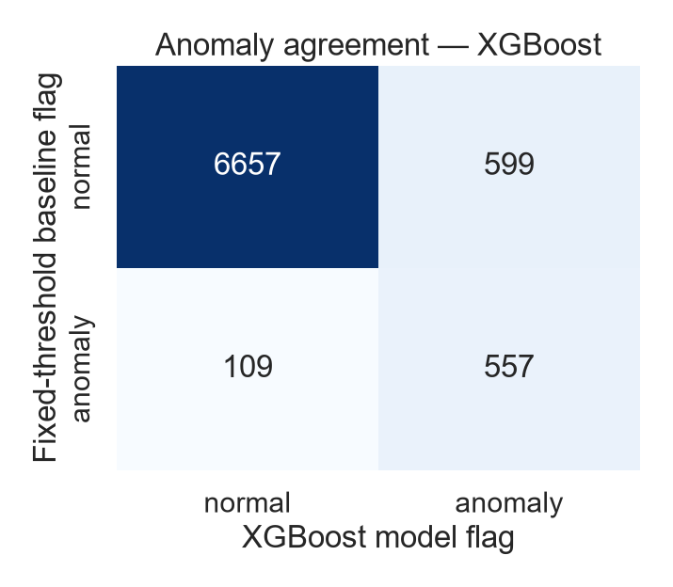

Figure 14: Uploaded test residual distribution with ±17.2 bpm limits.
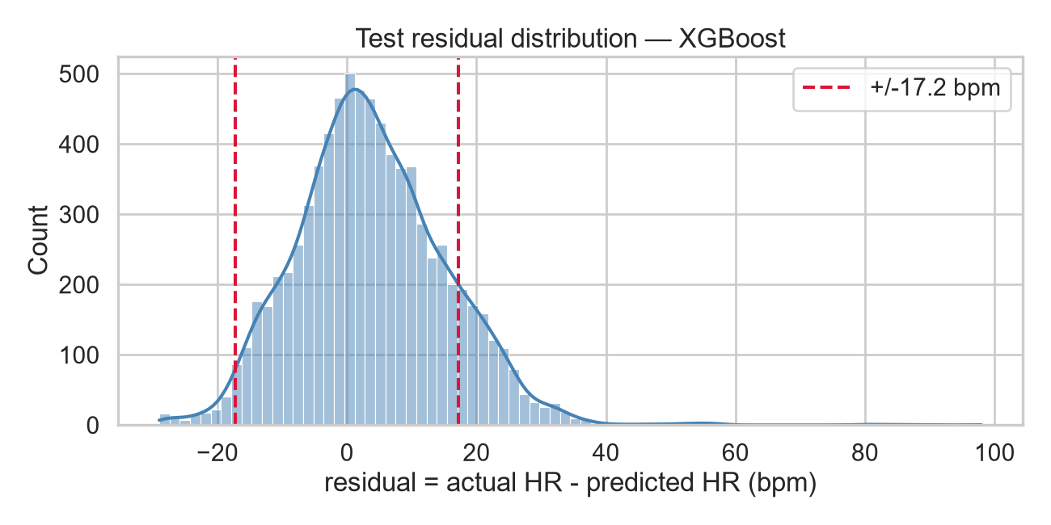
4. Feature importance and SHAP explanations
The results include native tree feature importance for both models, test-set permutation importance for XGBoost, and SHAP global bar and beeswarm explanations. The dominant explanatory features are personal_baseline, wearer_mean_hr, hour_cos, and hour_sin.
XGBoost feature | Importance
wearer_mean_hr | 0.2958
personal_baseline | 0.2635
hour_cos | 0.0937
hour_sin | 0.0920
act_unknown | 0.0672
Figure 15: Native Random Forest and XGBoost feature importance.
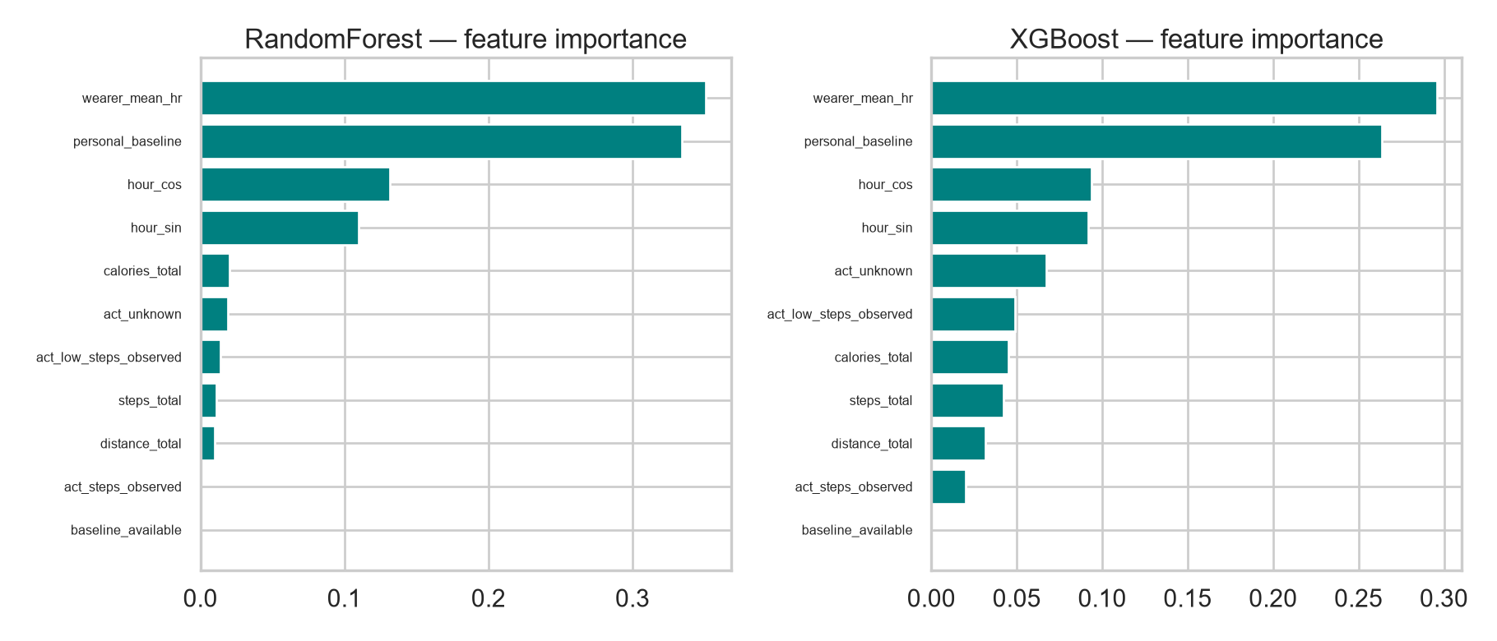

Figure 16: XGBoost test permutation importance; personal_baseline is dominant (mean importance=0.3670).
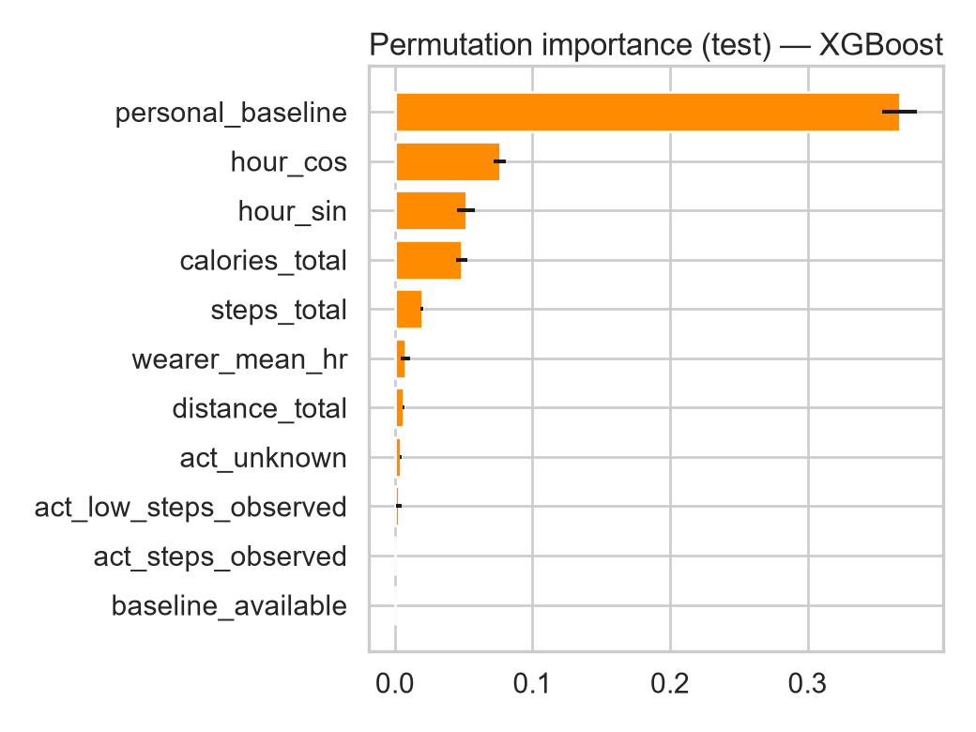

Figure 17: XGBoost mean absolute SHAP impact; personal_baseline is the largest contributor.
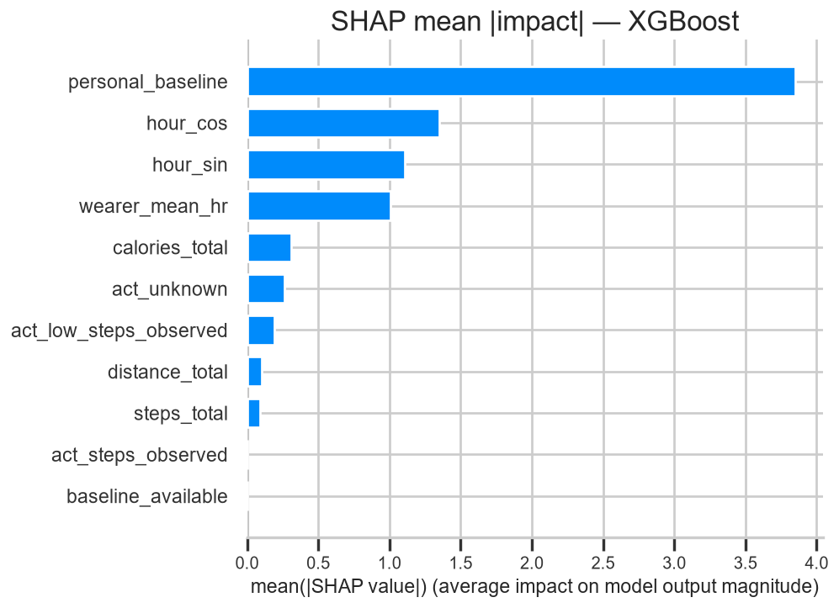

Figure 18: SHAP beeswarm showing impact direction and magnitude.
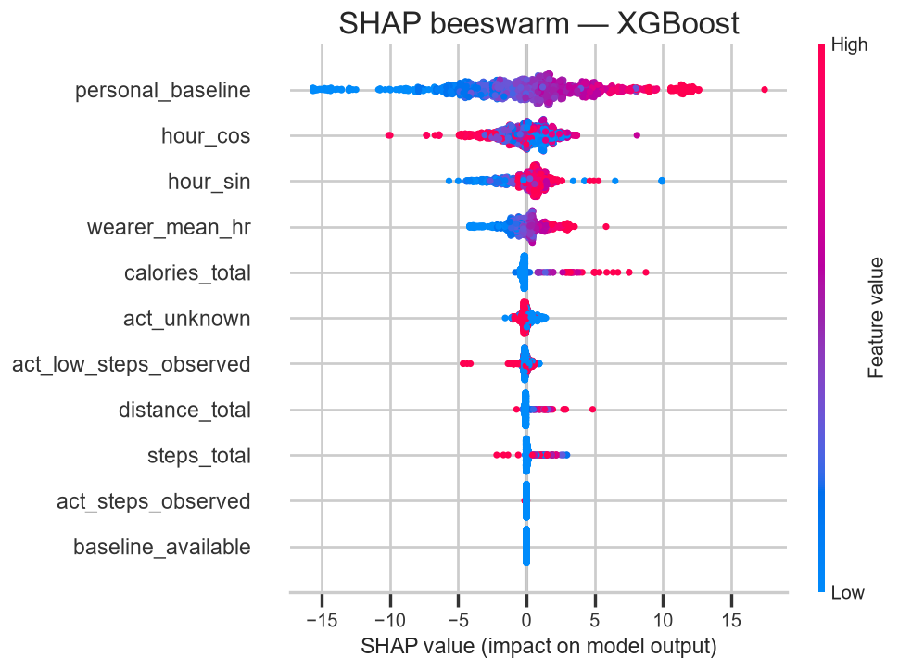

5. Conclusion
Task 10 implemented the fixed-threshold baseline and trained Random Forest and XGBoost for context-aware heart rate anomaly detection. XGBoost achieved the lowest prediction error, while the final anomaly detection evaluation will be completed in Task 13.
Task11: Unsupervised Anomaly Detection (Isolation Forest)
Task 11 involved the training and evaluation of Isolation Forest research models on the processed public and self-collected heart-rate feature datasets. This task entails two global models and 47 eligible personalized first week models with threshold and scoring results included..
1. Training and evaluation design
Training of the public Figshare and GalaxyPPG systems was done on original unlabeled windows from Task 9 training splits, with no generation of synthetic abnormalities during training. Different public teams have been segregated among train, validate, and test data. Candidate contamination levels and score thresholds have been determined based on validation data, and the holdout test data has been scored.
Public source | Train | Validation | Test | Groups by split
Figshare | 22,983 | 8,006 | 7,922 | 29 / 9 / 11
GalaxyPPG | 161 | 94 | 55 | 12 / 7 / 4
In the Figshare model, we considered heart rate, number of steps available, and whether or not steps are missing. In the GalaxyPPG model, we included heart rate, coverage, and time-of-day variables. Missing numerical data was dealt with by the pipelines within the models themselves.
2. Personalization
For each Figshare device group, the first seven days were considered for calibration. Forty-six groups had at least 30 windows across two dates and sufficient later records; three groups were skipped. One model was trained for the Lyan-labeled export using 332 windows in its first seven-day interval, with 1,087 later validation windows and 1,089 test windows. The name of the export does not verify wearer identity.
No personal model was trained for the Nofe-labeled export because its first seven days contained only two windows from one date. GalaxyPPG groups contained short sessions rather than a first week of readings, so no personal GalaxyPPG models were trained. The 47 personalized models therefore comprise 46 Figshare device-group models and one Lyan-export model.
3. Recorded results
Evaluation | Observed result
Figshare selected contamination | 0.05; 4.46% of unlabelled test windows flagged
Figshare injected test abnormalities | 44 / 44 flagged: 22 high and 22 low
GalaxyPPG selected contamination | 0.01; 1.82% of unlabelled test windows flagged
GalaxyPPG test exercise controls | 0 / 7 exercise windows flagged
Lyan-export personal test | 0.46% of unlabelled test windows flagged
4. Interpretation
The 44 identified test windows included artificial anomalies planted with known positions. Original windows were not independently assessed for normality/abnormality in a clinical setting; hence, this percent does not represent the clinically measured false positive rate. Seven windows for exercise controls are far too few to form a false alarm rate. These are experimental results and cannot be presented as diagnostic performance figures..
Task12: Time-Series Model Results (LSTM Autoencoder)
The shared Lyan and Rawan evaluation fixes the decision threshold using validation data and reports results on the held-out test sequences. The LSTM Autoencoder identified two of three synthetic test sequences. This is a research evaluation with sparse synthetic labels, not evidence of clinical diagnostic performance.
1. Data and decision method
Each example contains twelve consecutive 5-minute windows from one Figshare device group (one 60-minute sequence). Label 0 means a reference sequence with no injected change; label 1 means a synthetic anomaly was inserted. Labels do not establish that all reference sequences are clinically normal. The LSTM was trained on the 1,096 unmodified training sequences. Its score is mean squared reconstruction error across all twelve windows and three features.
We fixed the LSTM threshold at the 95th percentile of the 1,011 reference validation errors: 0.43172206. A score strictly greater than the threshold is flagged. There was only one injected validation sequence; we did not tune to that case. We then applied this fixed rule to the existing test errors. Threshold selection uses the validation split only; however, the test results had already been inspected in the supplied Rawan notebook, so the test cannot be described as a pristine first-look holdout.
2. LSTM results
Split | Reference | Injected | TP | FP | FN | F1
Validation | 1,011 | 1 | 0 | 51 | 1 | 0.000
Test | 277 | 3 | 2 | 8 | 1 | 0.308
On test, precision is 0.20 (2 correct alerts among 10 flags), recall is 0.667 (2 of 3 injected sequences), and the reference flag rate is 8/277 = 2.89%. The single validation injection was missed. ROC AUC is 0.827 on test, but its estimate is unstable with just three positives.
3. Comparison with Tasks 10 and 11
We also ran the frozen Task 11 Figshare Isolation Forest on the exact Task 12 sequences. We reversed the Task 12 training scaler, scored the twelve 5-minute windows, and used the most anomalous window as each sequence score. Its sequence threshold (0.65806839) was fixed at the 95th percentile of reference validation sequences. This is a new sequence-level adaptation for comparison, not the original Task 11 threshold. A simple two-consecutive-window heart-rate rule provides another reference; it lacks verified rest and activity context and is not a clinical event definition.
Same test sequences | TP / 3 | FP / 277 | Precision | Recall | F1
LSTM Autoencoder | 2 | 8 | 0.200 | 0.667 | 0.308
Task 11 IF adapted | 0 | 13 | 0.000 | 0.000 | 0.000
Two-window HR rule | 3 | 14 | 0.176 | 1.000 | 0.300
The Task 10 group-split report used an XGBoost heart-rate predictor on 7,922 individual five-minute test windows: MAE 9.322 bpm and F1 0.611 for agreement with its fixed heart-rate rule. Those are different targets and units, and Task 10 did not supply a saved model for scoring the Task 12 synthetic sequences. We therefore do not rank Task 10 by its F1 against the sequence results above. Similarly, Task 11 originally reported 44/44 flagged injected five-minute test windows; that original figure is a different evaluation from the matched sequence comparison.
4. Interpretation and limitations
Only one injected validation sequence and three injected test sequences formed complete twelve-window examples. The performance figures can change markedly with one additional example.
Adjacent 60-minute sequences overlap heavily. Each is counted as a sequence decision, not an independent person or clinical event. Two test injections were made from the same reference sequence.
Synthetic changes were inserted into observed data, but rest status is assumed for the injection experiment. Exercise controls and the self-collected Galaxy Watch exports are not part of this particular matched sequence benchmark.
The simple heart-rate rule omits the required clinical context. Neither the rule nor the synthetic labels establishes real-world false-alarm rates or medical validity.
Task 10 cannot be compared at the same sequence level without its model or a documented rerun. Final model selection, exercise-control evaluation, and deployment belong to Task 13.
Reproducibility: evaluate_shared.py reads the supplied Task 12 and Task 11 ZIP files, checks sequence order and labels, fixes thresholds on validation reference examples, and writes matched_sequence_scores.csv and thresholds_and_metrics.json. The saved LSTM prediction column agrees with the finalized threshold.

