In the case of a player walking on the ground :





We have

With, in , and

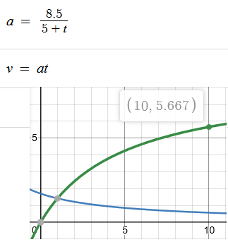

  


If we plot the acceleration and the speed, we see that in theory, we should reach the velocity of 5.66 in 10 ticks, but in reality we do reach a superior speed.

We do reach a superior speed because in our game, the time is far from being continuous.  
If we compute terms the Serie that represent the speed, we find:

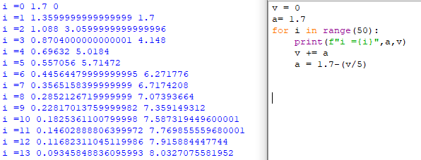

Which is exactly what happens in game