Data
We use the LFW dataset, which contains 13,233 photos of 5,749 people. The number of photos per person ranges from 1 to 530, with George W. Bush having the most. On average, there are 2.32 photos per person, but most people (4,069) have only one photo. The images show faces with varied backgrounds, expressions (some smiling, some mid-speech), and come in different sizes and quality.
For example, there are 2 photos of Orlando Bloom (out of 3 total in the dataset), and you can clearly see differences in both image quality and background.

The train set includes the same person up to 6 times when compared to different individuals, and up to 5 times when compared to other photos of the same person, such as Angelina Jolie.
In the test set, Tang Jiaxuan appears more than any other person, with most of his appearances involving comparisons to other photos of himself.
The test set contains 500 same-person comparisons and 500 different-person comparisons.
The train set includes 1,100 same-person and 1,100 different-person comparisons. We took examples directly from the dataset, where in some cases the differences between individuals are very clear to the human eye.
We took some random examples to examine the train and test sets, and many showed clear differences in appearance, such as gender, complexion, and background. For example, in the train set, two different people compared were Linda Dano and Abdoulaye Wade.
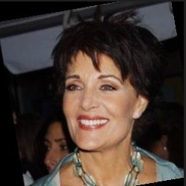
Some of the similar examples appear to have been taken at different times or show noticeable changes in appearance, adding to the challenge of the task. For example, in the test set, King Abdullah II is compared across photos 1, 2, 3, and 4 in various combinations.
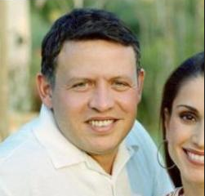

Experiments
Our goal is to explore how different design and training choices affect the performance of a Siamese network on one-shot face recognition. In Homework 1, we explored the influence of batch size, learning rate, and similar hyperparameters. However, in this case, we believe it is more interesting to investigate how factors like network depth, loss functions, optimizers, and data processing impact learning and accuracy. After establishing baseline results, we will analyze failure cases to guide improvements.

Experimental Setup
We used the following parameters across all experiments:
- Epochs: 100
- Batch size: 32
- Learning rate: 1e-3
- Patience: 5 (early stopping)
- Trainset 80% and validation set 20% (50% of the labels are 1 as in original)
- grayscale using PIL.Image.convert("L")
All experiments were conducted on an NVIDIA RTX 4090 GPU.

Baselines
We began with a simple Siamese network as our baseline. Each input image is first passed through a shared convolutional backbone composed of four convolutional layers with ReLU activations and max pooling. These layers progressively extract higher-level features from the input images while reducing spatial resolution. The output of the final convolutional layer is flattened and passed through a fully connected layer of size 4096, which serves as a learned embedding vector representing the image.
The two embeddings (one for each image in the pair) are then compared using the element-wise absolute difference. This difference vector is passed through a final linear layer that outputs a single scalar value representing the similarity between the two images. A sigmoid activation is applied to this output to produce a probability score in the range [0, 1], indicating whether the two images depict the same person.
To assess the model’s basic learning capacity, we evaluated two early stopping strategies:
- Early stopping based on validation loss
- Early stopping based on validation accuracy

Model | Epoch number | Accuracy
Early stopping based on validation loss | 7 | 0.548
Early stopping based on validation accuracy | 6 | 0.614

In the following plot, we visualize the training and validation accuracy (left) alongside the training and validation loss (right) across epochs. These plots correspond to the baseline configuration using early stopping based on validation accuracy.
The plots from early stopping based on validation accuracy indicate overfitting:
Training accuracy continues to increase steadily, reaching over 90%.
Validation accuracy improves initially but plateaus around epoch 6, and then fluctuates.
Meanwhile, validation loss begins increasing after epoch 6, even as training loss decreases - a classic sign of overfitting.
In the next section, we address this issue by introducing generalization techniques including batch normalization, dropout, and weight decay.

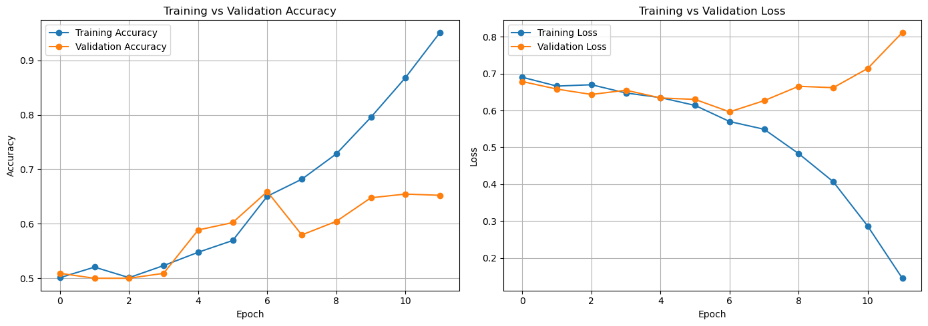

Improving Generalization with Regularization Techniques
To reduce overfitting observed in the baseline configuration, we introduced several regularization techniques. These included batch normalization, dropout, and weight decay. Batch normalization was applied after each convolutional and fully connected layer, which stabilized and accelerated training. Dropout was added after batch normalization layers in deeper parts of the network, and L2 regularization was applied via weight decay in the optimizer.
These changes led to a significant improvement in validation performance. In particular, batch normalization alone resulted in the best generalization so far, improving validation accuracy to approximately 70%. However, the training accuracy still reached nearly 100%, while validation accuracy plateaued well below that. This indicates that the model is still overfitting, despite the improvements of regularization. On the held-out test set, accuracy reached 64.3%, further confirming the need for better generalization.
Given this persistent gap between training and validation performance, we proceed to experiment with deeper architectures. The goal is to build a model with greater representational capacity while continuing to control overfitting through regularization.

Model | Epoch number | Accuracy
Batch norm | 12 | 0.643
Batch norm + dropout | 13 | 0.629
Batch norm + dropout + weight decay | 20 | 0.618

Changing Network Depth
In this section, we evaluate several Siamese neural network configurations designed for one-shot face verification. All models were trained and evaluated using RGB input images resized to 105×105 pixels. We focused on different architectural choices- ranging from custom convolutional designs to pretrained feature extractors-to examine the impact of capacity, feature richness, and regularization on generalization.
The same training protocol was applied across all experiments: models were trained using BCEWithLogitsLoss, the Adam optimizer with lr=1e-3, and early stopping based on validation accuracy. Evaluation was conducted on a held-out test set using accuracy and confusion matrix metrics.
- Smaller CNN – This model is a smaller version of the network presented in the previous section, redesigned to reduce capacity while retaining the same architectural pattern. It includes three convolutional blocks with decreasing channel sizes (64 → 32), followed by a two-layer fully connected embedding module and a small similarity head. Regularization was applied through dropout and batch normalization.
- ResNet18 (Pretrained) – In this experiment, we replaced the custom CNN with a pretrained ResNet18 backbone, using it as a fixed feature extractor. The output embedding was passed through a small projection head and a four-part similarity module combining both embeddings, their absolute difference, and element-wise product.
- MobileNetV2 – Here, we tested a lightweight version of the previous setup using MobileNetV2 as the feature extractor. Like the ResNet-based model, embeddings were generated from the pooled output of the backbone and processed through a similarity head.
Model | Accuracy (%) | True Pos | False Pos | True Neg | False Neg
Model 1 – Compact CNN (Ours) | 68.4 | 398 | 214 | 286 | 102
Model 2 – ResNet18 (Pretrained) | 69.1 | 381 | 190 | 310 | 119
Model 3 – MobileNetV2 (Pretrained) | 60.2 | 268 | 166 | 334 | 232

The ResNet18-based model achieved the highest test accuracy at 69.1%, indicating that deep pretrained features help with generalization in a one-shot setting. However, the Smaller CNN, despite its simplicity, achieved a competitive 68.4%, showing that a well-regularized lightweight model can perform nearly as well with significantly fewer parameters.
The MobileNetV2 model performed the worst, with an accuracy of 60.2%. It suffered from a high false negative rate, suggesting that its compressed feature representations were not expressive enough to capture the fine-grained details required for face verification.
All models used RGB input, which helped preserve color-based facial features and likely contributed to improved performance over grayscale configurations.

Changing Loss
To better align the training objective with the task of learning a similarity metric, we replaced the binary classification loss (BCEWithLogitsLoss) with Contrastive Loss. This loss directly encourages the model to minimize the distance between embeddings of the same identity while maximizing the distance between embeddings of different identities. Although this approach is well-established and theoretically more suitable for Siamese networks, in our case, it led to the worst results. The model consistently failed to learn meaningful separations between pairs, with training and validation accuracy plateauing around 50%, and loss showing no meaningful downward trend. This suggests that, despite using a proper architectural setup and a pretrained ResNet-18 backbone, the model was unable to learn an effective embedding space, possibly due to dataset noise, poor pair quality, or optimization dynamics. A figure below illustrates the stagnation in performance throughout training.
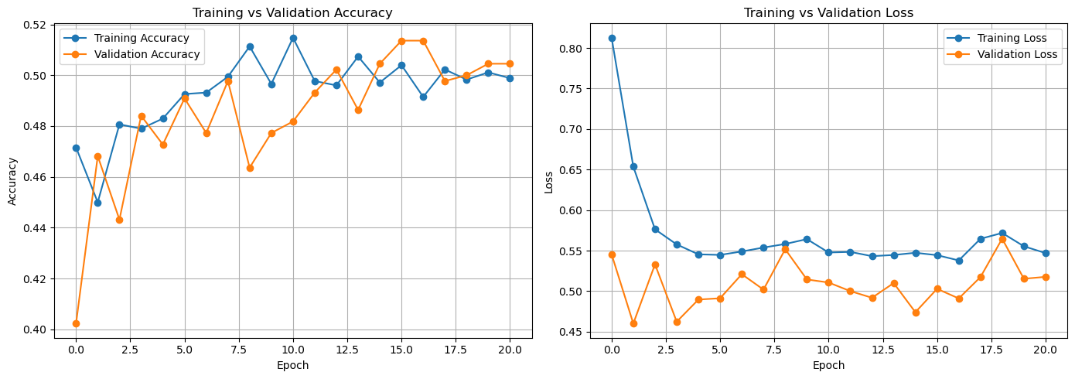

Data Preprocessing Experiments
To investigate the impact of preprocessing on model performance, we conducted three experiments focusing on color space and image noise. All experiments were conducted using the same Siamese architecture, but with varying image input conditions. The goal was to assess how image format and quality affect the ability of the network to learn meaningful representations for facial similarity. We use the smaller RNN.
- Grayscale Images - In this setup, all images were converted to grayscale (1-channel) before being passed to the model. This reduces the input complexity and forces the network to focus on shape, texture, and structure rather than color.
- RGB Images - In this configuration, images were kept in their original RGB format. This provided the model with full color information, potentially improving its ability to distinguish individuals with subtle color differences (e.g., skin tone, hair color).
- This configuration combined RGB inputs with no noise augmentation and standard normalization. It yielded the best results across all preprocessing settings.
Preprocessing | Accuracy | True Pos | False Pos | False Neg | True Neg
RGB | 0.684 | 398 | 214 | 286 | 102
RGB + Noise | 0.651 | 213 | 62 | 287 | 438
Grayscale | 0.662 | 222 | 60 | 278 | 440

The RGB configuration achieved the highest accuracy at 68.4%, but also resulted in a high number of false positives (214), indicating that the model may have been overly sensitive to color information. Adding noise to RGB images degraded performance significantly, with accuracy dropping to 65.1% and a substantial increase in classification errors. Interestingly, the grayscale setup offered the best balance, with 66.2% accuracy and the lowest false positive count (60), suggesting that removing color helped the model focus on structural facial features and improved generalization.

Some Examples
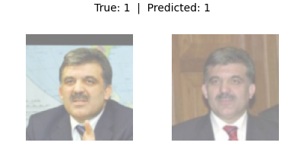
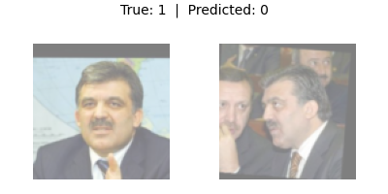
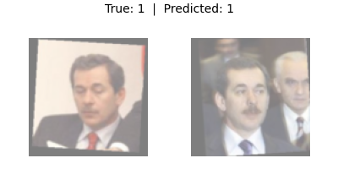
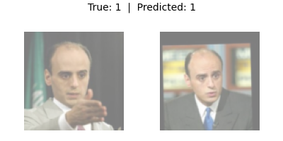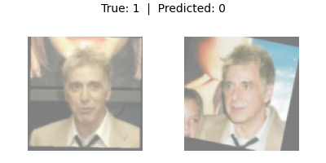

Conclusions
Although our final model did not achieve high accuracy, this assignment provided valuable insights into the key design decisions that influence performance in deep learning systems - particularly for one-shot facial recognition.
We explored how changes in network architecture, loss functions, and data preprocessing directly impacted the model's ability to learn meaningful similarity representations. Each iteration helped us understand the challenges of training Siamese networks, especially on complex datasets like facial images where subtle variations matter.
One of the most important observations came from failure analysis: our model often became confused by side profiles, occlusions, or objects touching the face. These cases highlight how sensitive similarity learning is to pose and noise, and point to the need for stronger feature extractors or more robust data augmentation strategies.
Despite the modest quantitative results, the experience of systematically building, debugging, and evaluating deep models taught us a great deal about the intricacies of model training, data quality, and loss alignment in a real-world setting.
In future work, we would consider applying additional data-level improvements such as random cropping, brightness and contrast adjustments, or other image augmentations to increase variation and robustness.
We would also explore creating more challenging positive and negative pairs (e.g., same person under different conditions), or even leveraging synthetic face generation to enrich the dataset. Although such changes were beyond the scope of the current assignment, they could significantly enhance the model's ability to generalize.

