Họ và tên : Đặng Ngọc Châu

MSSV : 1050080255

LAP6

1. CSDL

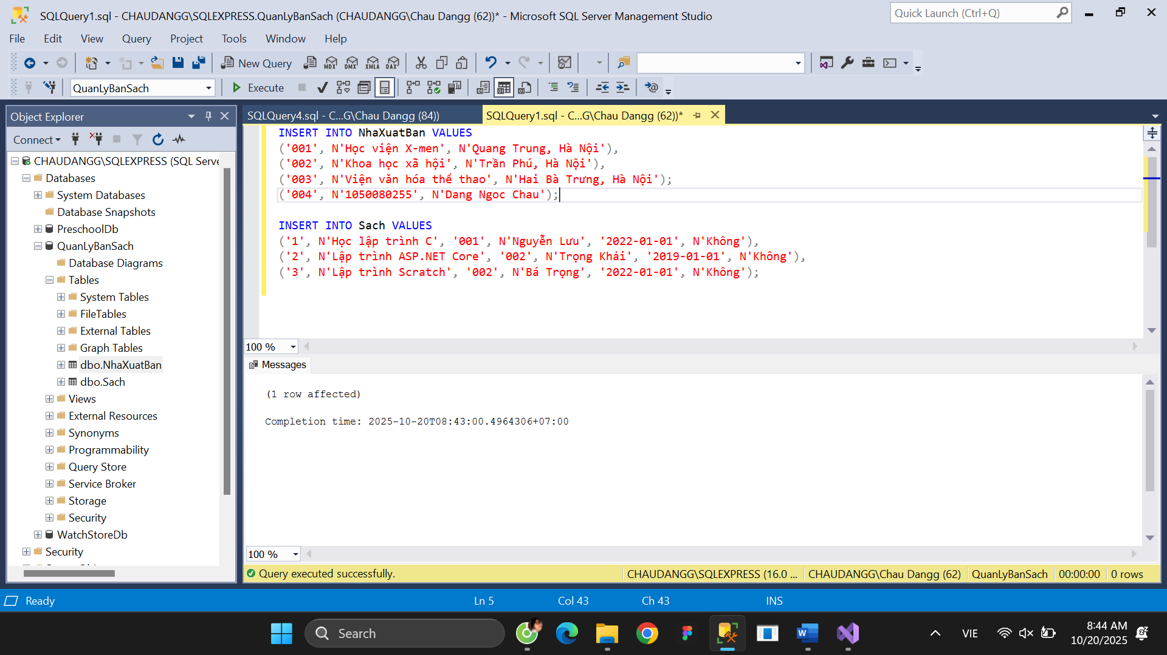

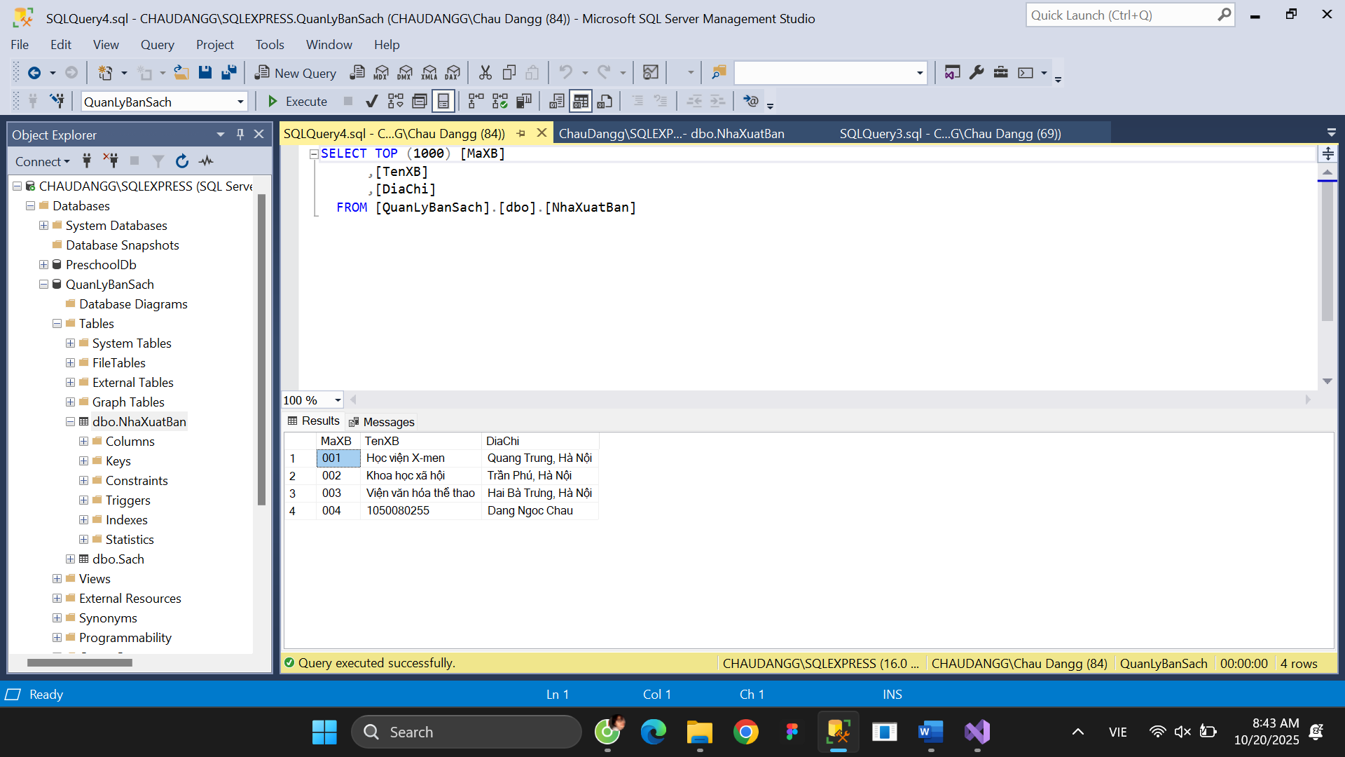

1. **Thực hành**

**Thực hành 1**

Code Form1.cs

using System;

using System.Data;

using System.Data.SqlClient;

using System.Windows.Forms;

namespace _1050080255_NgocChau_QuanLyBanSach

{

public partial class Form1 : Form

{

// 🔹 Chuỗi kết nối SQL Server

string strCon = @"Data Source=CHAUDANGG\SQLEXPRESS;Initial Catalog=QuanLyBanSach;Integrated Security=True";

SqlConnection sqlCon = null;

public Form1()

{

InitializeComponent();

}

// 🔹 Mở kết nối

private void MoKetNoi()

{

if (sqlCon == null)

sqlCon = new SqlConnection(strCon);

if (sqlCon.State == ConnectionState.Closed)

sqlCon.Open();

}

// 🔹 Đóng kết nối

private void DongKetNoi()

{

if (sqlCon != null && sqlCon.State == ConnectionState.Open)

sqlCon.Close();

}

// 🔹 Hiển thị danh sách Nhà xuất bản

private void HienThiDanhSachXB()

{

MoKetNoi();

SqlCommand cmd = new SqlCommand("hienThiXB", sqlCon);

cmd.CommandType = CommandType.StoredProcedure;

SqlDataReader reader = cmd.ExecuteReader();

lsvDanhSach.Items.Clear();

while (reader.Read())

{

string ma = reader.GetString(0);

string ten = reader.GetString(1);

string diaChi = reader.GetString(2);

ListViewItem item = new ListViewItem(ma);

item.SubItems.Add(ten);

item.SubItems.Add(diaChi);

lsvDanhSach.Items.Add(item);

}

reader.Close();

DongKetNoi();

}

// 🔹 Hiển thị chi tiết khi chọn dòng

private void HienThiChiTietXBTheoMa(string maXB)

{

MoKetNoi();

SqlCommand cmd = new SqlCommand("hienThiChiTietXB", sqlCon);

cmd.CommandType = CommandType.StoredProcedure;

cmd.Parameters.Add("@maXB", SqlDbType.Char).Value = maXB;

SqlDataReader reader = cmd.ExecuteReader();

if (reader.Read())

{

txtMaXB.Text = reader.GetString(0);

txtTenXB.Text = reader.GetString(1);

txtDiaChi.Text = reader.GetString(2);

}

reader.Close();

DongKetNoi();

}

// 🔹 Khi Form Load

private void Form1_Load(object sender, EventArgs e)

{

HienThiDanhSachXB();

}

// 🔹 Khi chọn dòng trong ListView

private void lsvDanhSach_SelectedIndexChanged(object sender, EventArgs e)

{

if (lsvDanhSach.SelectedItems.Count == 0) return;

string ma = lsvDanhSach.SelectedItems[0].SubItems[0].Text;

HienThiChiTietXBTheoMa(ma);

}

}

}

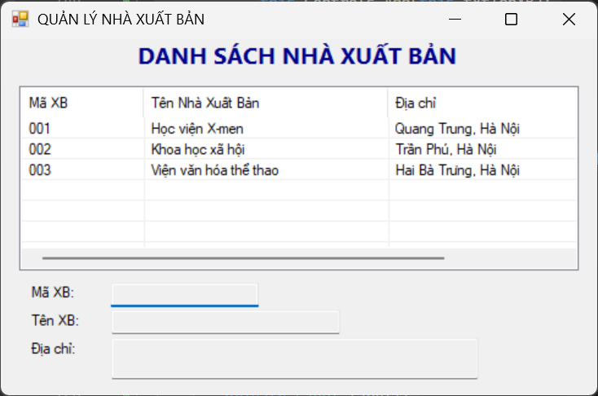

**Thực hành 2**

Code Form2.cs

using System;

using System.Data;

using System.Data.SqlClient;

using System.Windows.Forms;

namespace QuanLyBanSach_BuiHaiDuong_1150080012

{

public partial class Form2 : Form

{

string strCon = @"Data Source=LAPTOP-1OLPGQ5K\SUGAR;

Initial Catalog=QuanLyBanSach;

Integrated Security=True;";

SqlConnection sqlCon = null;

public Form2()

{

InitializeComponent();

}

private void MoKetNoi()

{

if (sqlCon == null)

sqlCon = new SqlConnection(strCon);

if (sqlCon.State == ConnectionState.Closed)

sqlCon.Open();

}

private void DongKetNoi()

{

if (sqlCon != null && sqlCon.State == ConnectionState.Open)

sqlCon.Close();

}

// Hiển thị danh sách sau khi thêm

private void HienThiDanhSachXB()

{

MoKetNoi();

SqlCommand cmd = new SqlCommand("hienThiXB", sqlCon);

cmd.CommandType = CommandType.StoredProcedure;

SqlDataReader reader = cmd.ExecuteReader();

lsvDanhSach.Items.Clear();

while (reader.Read())

{

string ma = reader.GetString(0);

string ten = reader.GetString(1);

string diaChi = reader.GetString(2);

ListViewItem item = new ListViewItem(ma);

item.SubItems.Add(ten);

item.SubItems.Add(diaChi);

lsvDanhSach.Items.Add(item);

}

reader.Close();

DongKetNoi();

}

private void Form2_Load(object sender, EventArgs e)

{

HienThiDanhSachXB();

txtMaXB.Focus();

}

private void btnThem_Click(object sender, EventArgs e)

{

if (txtMaXB.Text.Trim() == "" || txtTenXB.Text.Trim() == "")

{

MessageBox.Show("Vui lòng nhập đầy đủ thông tin!");

return;

}

MoKetNoi();

SqlCommand cmd = new SqlCommand("ThemDuLieu", sqlCon);

cmd.CommandType = CommandType.StoredProcedure;

cmd.Parameters.Add("@maXB", SqlDbType.Char).Value = txtMaXB.Text.Trim();

cmd.Parameters.Add("@tenXB", SqlDbType.NVarChar).Value = txtTenXB.Text.Trim();

cmd.Parameters.Add("@diaChi", SqlDbType.NVarChar).Value = txtDiaChi.Text.Trim();

int kq = cmd.ExecuteNonQuery();

if (kq > 0)

{

MessageBox.Show("✅ Thêm dữ liệu thành công!");

HienThiDanhSachXB();

txtMaXB.Clear();

txtTenXB.Clear();

txtDiaChi.Clear();

txtMaXB.Focus();

}

else

{

MessageBox.Show("❌ Thêm thất bại!");

}

DongKetNoi();

}

}

}

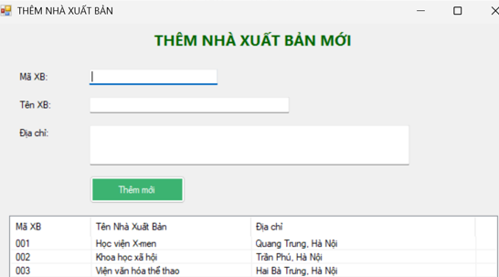

**Thực hành 3**

using System;

using System.Data;

using System.Data.SqlClient;

using System.Windows.Forms;

namespace QuanLyBanSach_BuiHaiDuong_1150080012

{

public partial class Form3 : Form

{

string strCon = @"Data Source=LAPTOP-1OLPGQ5K\SUGAR;

Initial Catalog=QuanLyBanSach;

Integrated Security=True;";

SqlConnection sqlCon = null;

public Form3()

{

InitializeComponent();

}

private void MoKetNoi()

{

if (sqlCon == null)

sqlCon = new SqlConnection(strCon);

if (sqlCon.State == ConnectionState.Closed)

sqlCon.Open();

}

private void DongKetNoi()

{

if (sqlCon != null && sqlCon.State == ConnectionState.Open)

sqlCon.Close();

}

private void HienThiDanhSachXB()

{

MoKetNoi();

SqlCommand cmd = new SqlCommand("hienThiXB", sqlCon);

cmd.CommandType = CommandType.StoredProcedure;

SqlDataReader reader = cmd.ExecuteReader();

lsvDanhSach.Items.Clear();

while (reader.Read())

{

string ma = reader.GetString(0);

string ten = reader.GetString(1);

string diaChi = reader.GetString(2);

ListViewItem item = new ListViewItem(ma);

item.SubItems.Add(ten);

item.SubItems.Add(diaChi);

lsvDanhSach.Items.Add(item);

}

reader.Close();

DongKetNoi();

}

private void Form3_Load(object sender, EventArgs e)

{

HienThiDanhSachXB();

}

private void lsvDanhSach_SelectedIndexChanged(object sender, EventArgs e)

{

if (lsvDanhSach.SelectedItems.Count == 0) return;

var item = lsvDanhSach.SelectedItems[0];

txtMaXB.Text = item.SubItems[0].Text;

txtTenXB.Text = item.SubItems[1].Text;

txtDiaChi.Text = item.SubItems[2].Text;

}

private void btnSua_Click(object sender, EventArgs e)

{

if (txtMaXB.Text.Trim() == "")

{

MessageBox.Show("Vui lòng chọn một nhà xuất bản để sửa!");

return;

}

MoKetNoi();

SqlCommand cmd = new SqlCommand("SuaDuLieu", sqlCon);

cmd.CommandType = CommandType.StoredProcedure;

cmd.Parameters.Add("@maXB", SqlDbType.Char).Value = txtMaXB.Text.Trim();

cmd.Parameters.Add("@tenXB", SqlDbType.NVarChar).Value = txtTenXB.Text.Trim();

cmd.Parameters.Add("@diaChi", SqlDbType.NVarChar).Value = txtDiaChi.Text.Trim();

int kq = cmd.ExecuteNonQuery();

if (kq > 0)

{

MessageBox.Show("✅ Cập nhật thành công!");

HienThiDanhSachXB();

}

else

{

MessageBox.Show("❌ Cập nhật thất bại!");

}

DongKetNoi();

}

private void btnLamMoi_Click(object sender, EventArgs e)

{

txtMaXB.Clear();

txtTenXB.Clear();

txtDiaChi.Clear();

txtMaXB.Focus();

}

}

}