**Anomaly Detection**

**Unsupervised Isolation Forest**

**x_train,x_test,y_train, y_test = train_test_split(df2,labels,test_size=0.2,random_state=42)**

**x_val, y_val = df_validate, df_validate["label"]**

***#################################### model #################################***

**isolation_forest = IsolationForest(n_estimators=100, max_samples=256,contamination=0.1,random_state =42)**

**isolation_forest.fit(x_train)**

**Validation set**

**anomaly_scores = isolation_forest.decision_function(x_val)**

**plt.figure(figsize=(15,10))**

**plt.hist(anomaly_scores, bins =100)**

**plt.xlabel("Average path length",fontsize=14)**

**plt.ylabel('Number of Data Points',fontsize=14)**

**plt.show()**

**anomalies = anomaly_scores > -0.19**

**anomalies = np.array(anomalies).reshape(anomalies.shape[0],-1)**

**matches = y_val == list(encoded.classes_).index("normal.")**

**auc = roc_auc_score(anomalies,matches)**

**print("Validation Set AUC= ",auc)**

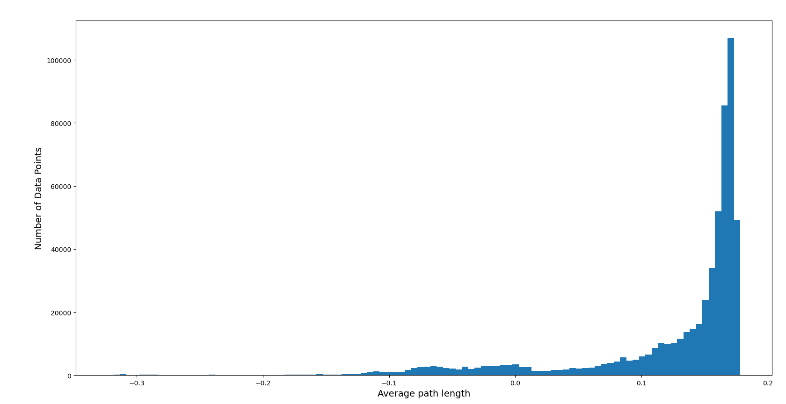

**Testing Set**

**anomaly_scores_test = isolation_forest.decision_function(x_test)**

**plt.figure(figsize=(15,10))**

**plt.hist(anomaly_scores_test,bins=100)**

**plt.xlabel("Average path lengths",fontsize=14)**

**plt.ylabel('Number of Data Points',fontsize=14)**

**plt.show()**

**anomalies_test = anomaly_scores_test > -0.19**

**anomalies_test = np.array(anomalies_test).reshape(anomalies_test.shape[0],-1)**

**matches = y_test == list(encoded.classes_).index("normal.")**

**auc = roc_auc_score(anomalies_test ,matches)**

**print("Testing sesetAUC = ",auc)**

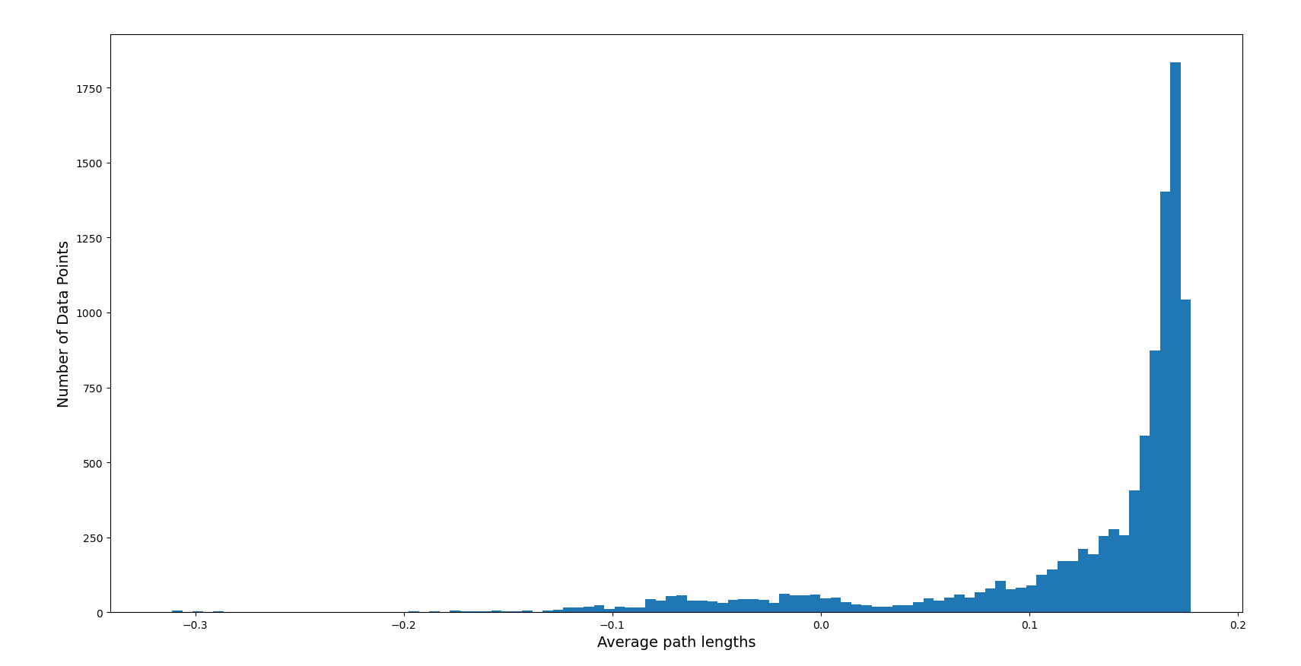

**AUC in Validation set vs Testing Set**

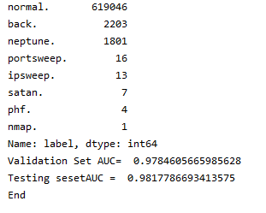

**Semi supervised Deep Autoencoders**

**x_train, x_test,y_train, y_test = train_test_split(df.drop(labels=['Time','Class'],axis=1),df['Class'],test_size=0.2,random_state=42)**

**print(x_train.shape," train_samples")**

**print(x_test.shape, " test_samples")**

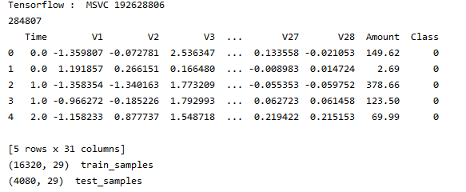

**logfile_name ="deepautoencoder"**

**encoding_dim = 16**

**input_dim =x_train.shape[1]**

**inputArray = Input(shape=(input_dim,))**

**encoded = Dense(encoding_dim,activation='relu')(inputArray)**

**encoded = Dense(8,activation='relu')(encoded)**

**encoded = Dense(4,activation='relu')(encoded)**

**decoded = Dense(8,activation = 'relu')(encoded)**

**decoded = Dense(encoding_dim,activation = 'relu')(decoded)**

**decoded = Dense(input_dim,activation = 'softmax')(decoded)**

**autoencoder = Model(inputArray,decoded)**

**autoencoder.summary()**

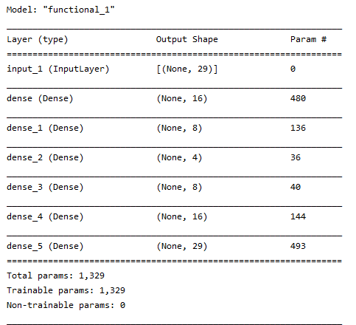

**autoencoder.compile(optimizer=RMSprop(),loss = 'mean_squared_error',metrics=['mae','accuracy'])**

**batch_size = 32**

**epochs =20**

**history = autoencoder.fit(x_train,y_train,batch_size=batch_size,epochs=epochs,verbose=1,validation_data=(x_test,y_test),callbacks=[TensorBoard(log_dir='../logs/autoencoder1')])**

**threshold= [10, 1,5,15]**

**for th in threshold:**

**y_pred = autoencoder.predict(x_test)**

**y_dist = np.linalg.norm(x_test - y_pred,axis = -1)**

**z = zip(y_dist >= th,y_dist)**

**y_label=[]**

**error = []**

**for idx,(is_anomaly,y_dist) in enumerate(z):**

**if is_anomaly:**

**y_label.append(1)**

**else:**

**y_label.append(0)**

**error.append(y_dist)**

**y_label = pd.Series(y_label)**

**print(classification_report(y_test,y_label))**

**print("roc_auc_score = ",roc_auc_score(y_test,y_label))**

**viz = visualization()**

**viz.draw_confusion_matrix(y_test,y_label)**

**viz.draw_anomaly(y_test,error,threshold)**

**print("End Threshold = " ,th)**

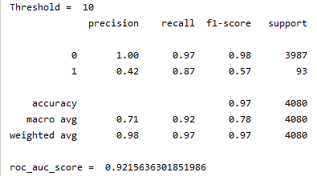

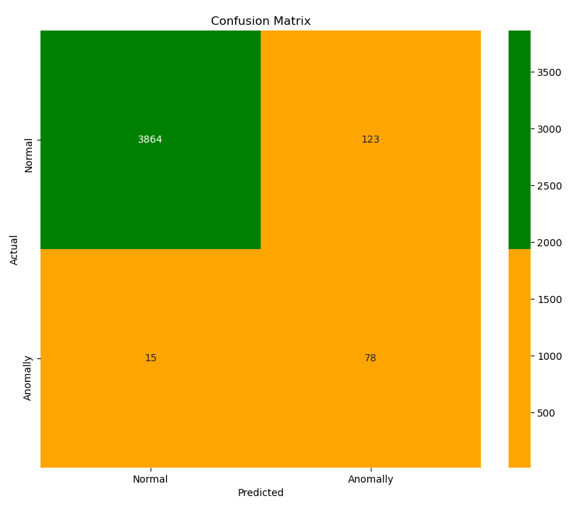

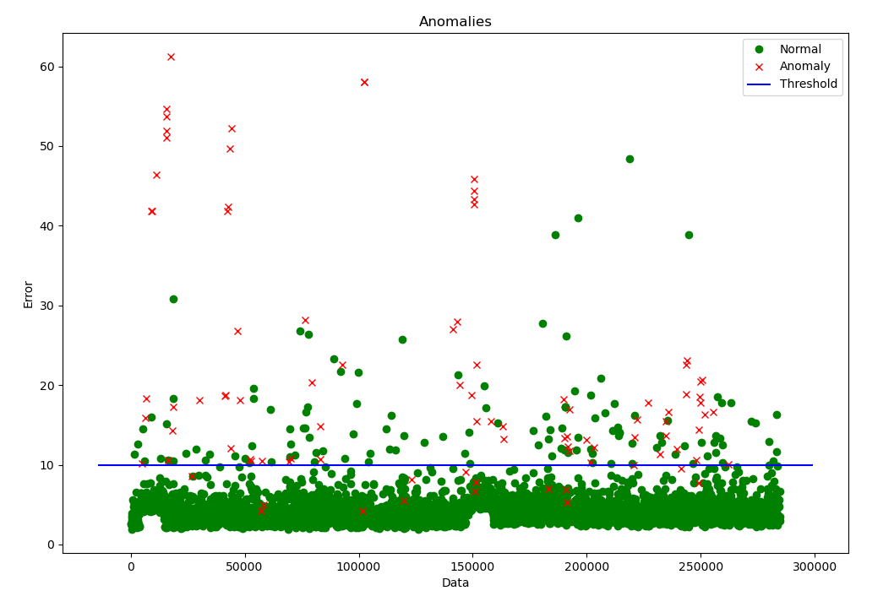

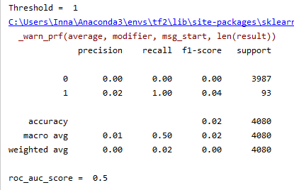

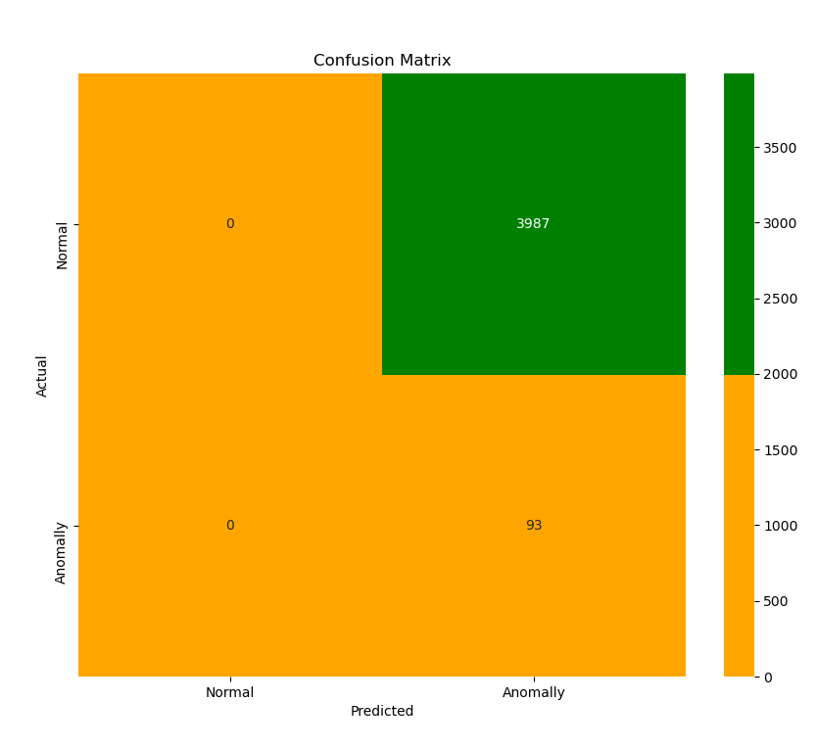

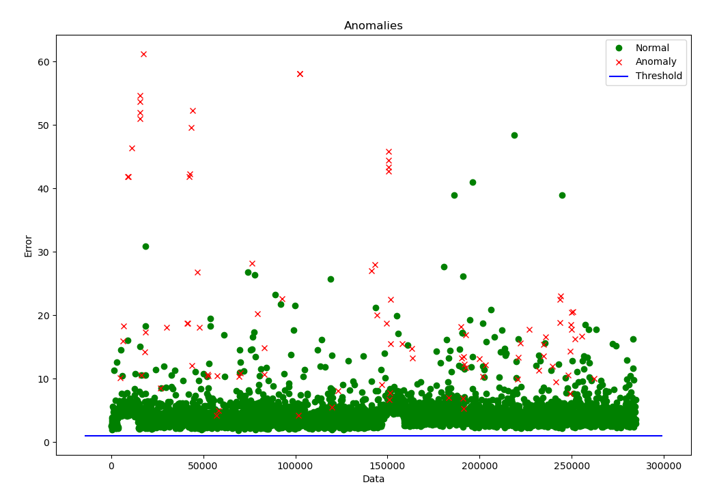

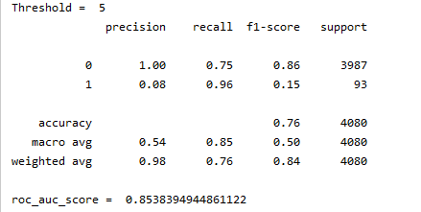

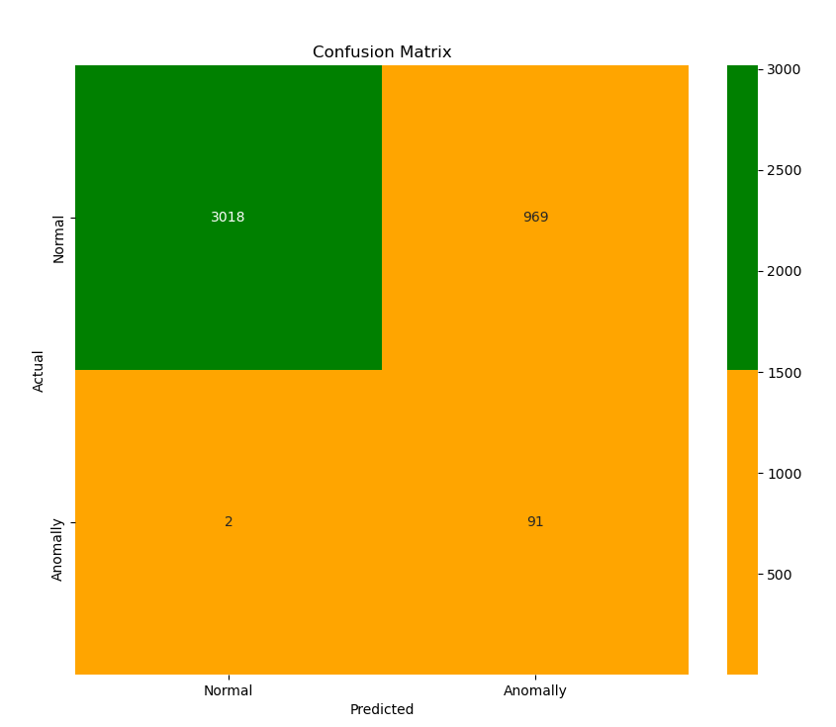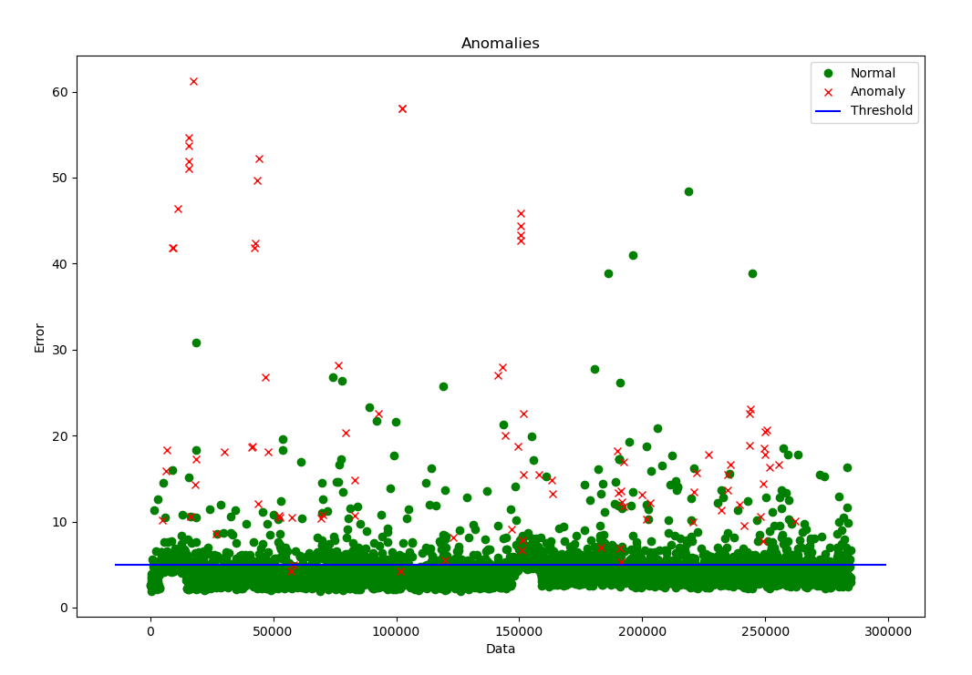

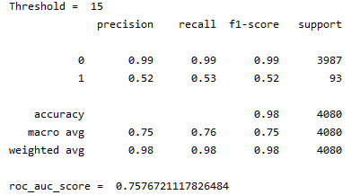

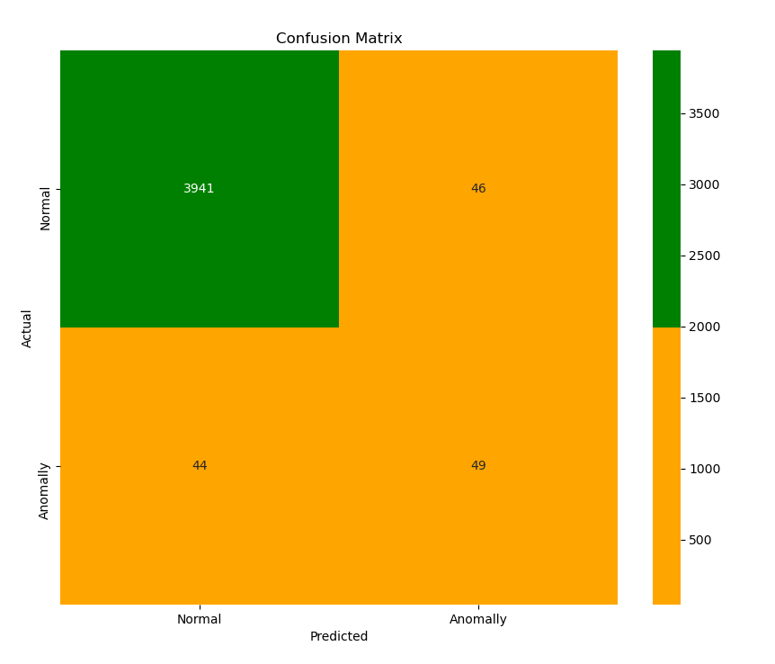

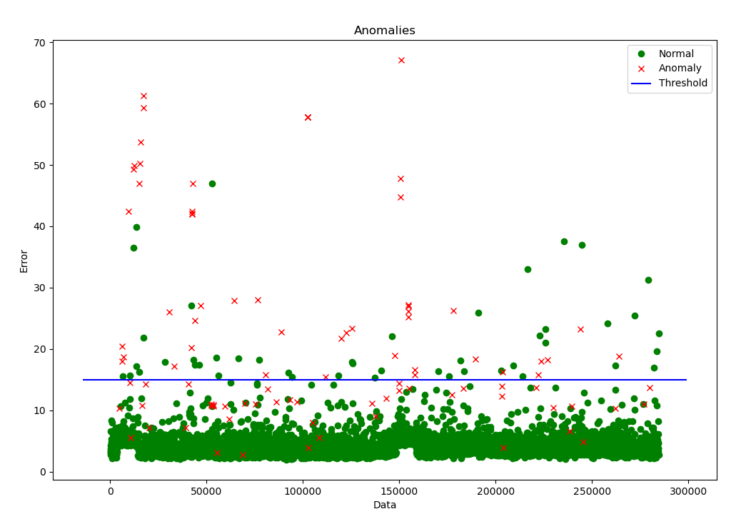

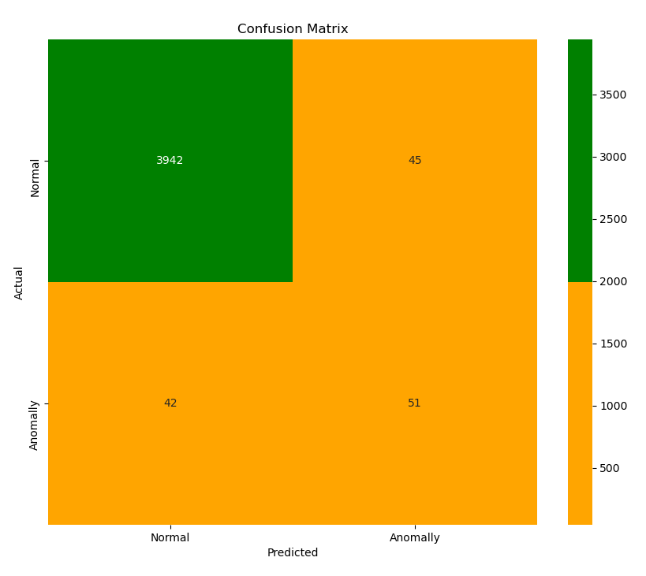

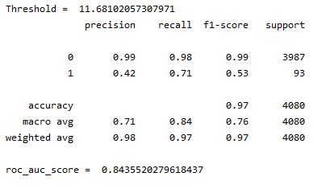

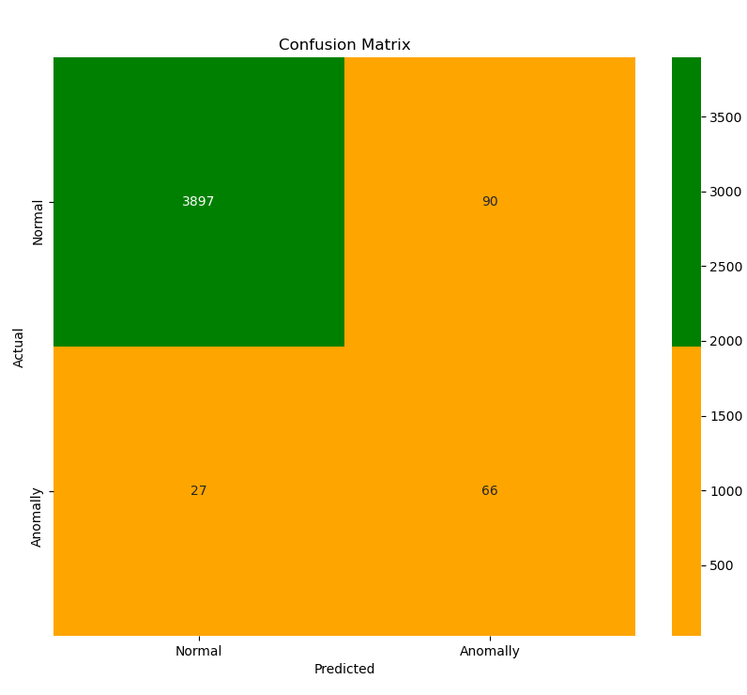

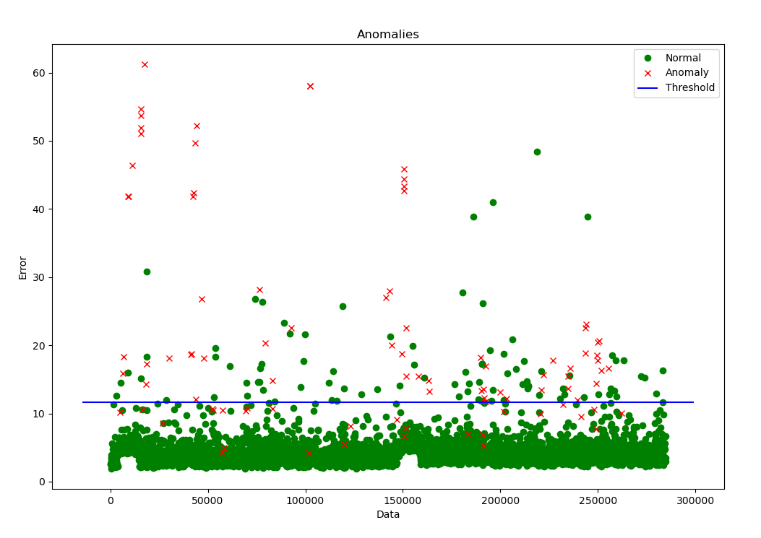

**We can see that the for Thresholds = [1 , 5]**

**precision ,recall is low, f1 and accuracy is low is low**

**But for Thresholds = [10, 11.277, 15] are much better**

**Compare the thresholds 10, 11.277, 15**

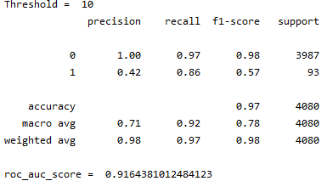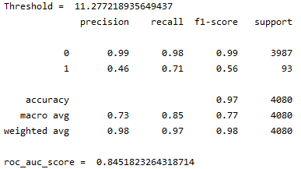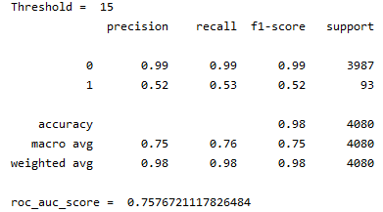

**We can see that the recall value for 1 is the best for Threshold = 11.277**

**This means that the less anomalies will be missed using this threshold and therefore**

**The best model is with threshold = 11.277**