**Solving PDEs with Python and Fenics Libraries.**

**Part 1**

**Installing Fenics software on Ubuntu and running the python code on spyder native Ubuntu or on web services Jupyter notebook**

Fenics project is research software directed on creating mathematical methods and software for automated computational mathematical modeling. Fenics project was created in 2003 by researchers from around the world. It created efficient and intuitive software for solving PDES using finite element method. Fenics contains several blocks or libraries. The main library Dolphin is high performance C++ backend. DOLFIN implements data structures such as meshes, function spaces and functions, compute-intensive algorithms such as finite element assembly and

mesh refinement, and interfaces to linear algebra solvers and data structures such as PETSc. Fenics project implements problem solving environment in C++ and Python.

I will demonstrate a series of examples that show how to solve

1. linear PDE
2. Time dependent PDE
3. Non-linear
4. System of time-dependent nonlinear PDEs

I will demonstrate the software I used to solve the PDE problems as well as how to set and configure the software and how to visualize the results.

The software is located on <https://fenicsproject.org/download/>. It has several different ways how to configure and use Fenics. I was able to install it on VMplayer with Ubuntu 18 and on native Ubuntu 18 installed on my hp computer.

Step 1:

Install Ubuntu on VMware player or workstation if it is available to you.

Alternatively you can use native Ubuntu already installed. I would use

Ubuntu 18.04

Step 2:

Download Anaconda : Anaconda3-5.3.0-Linux-x86_64.sh

**sudo apt-get update**

sudo apt-get install gcc

Run installation script .sh

Step 3:

After Anaconda is installed. Run the following commands:

**conda install -c conda-forge mshr**

**conda install -c conda-forge/label/gcc7 mshr**

**conda install -c conda-forge/label/cf201901 mshr**

**Step 4:**

**Create conda environment using the following command:**

**conda create -n fenics2018_1 -c conda-forge fenics=2018 mshr matplotlib scipy python=3.7 sympy spyder jupyter**

**This command will allow to use 2 ways to run python code**

**within this environment:**

1. Using editor spider

ctrl-alt-T to start the command line.

Type anaconda-navigator

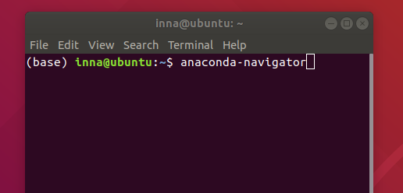

When anaconda starts it will bring you to the following screen:

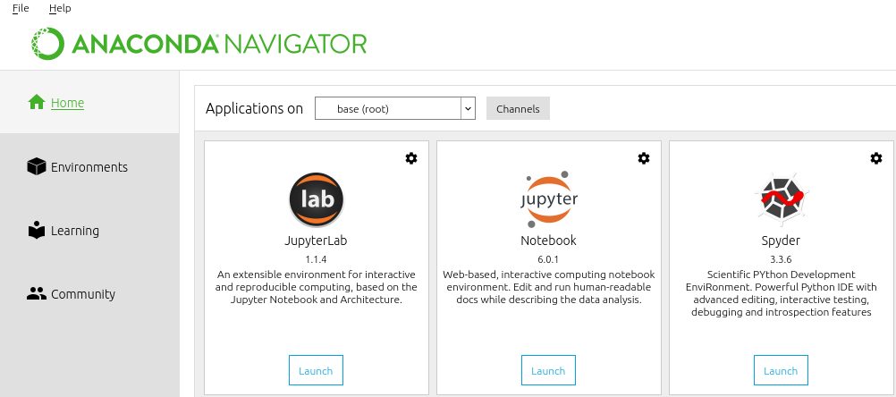

If you do not see launch on spyder icon the you will see install. Click on install and wait until Launch appears.

On the left side of the screen you will see the following tabs:

Home, environments. Click on environments tab.

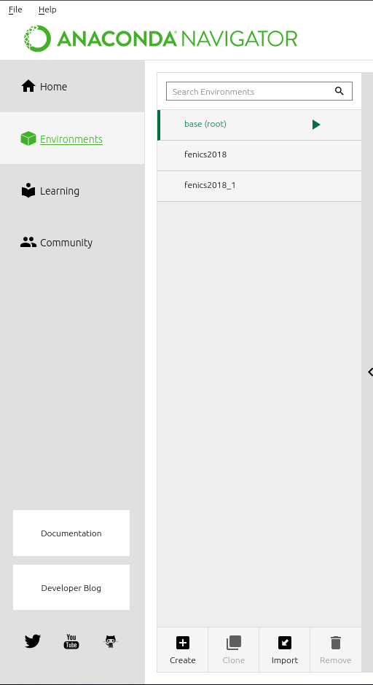

You can observe the current anaconda environments installed. This screen shows the except of the base(root) environment we have 2 others. The environment fenics2018_1 was installed with the above given command and we can observe it on the spyder GUI. Before starting the spyder we have to select the environment (or activate by clicking on it.) Then spyder will use the libraries that we created with the above command running the code that we write within the spyder.

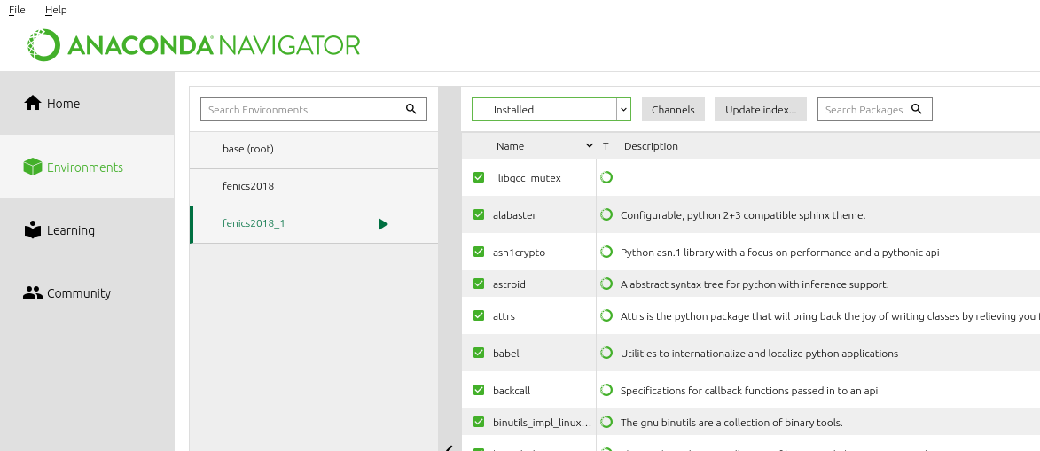

From the screen above we can see that the environment fenics2018_1 has green color . This means that the environment is activated and we can click on the home tab on the left to go back to applications.

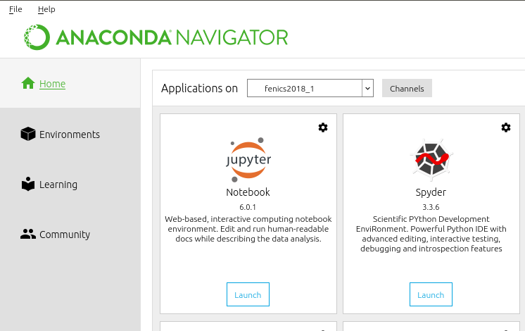

Click on launch spyder.

Now we have the environment where we will create and run the code for solving PDEs.

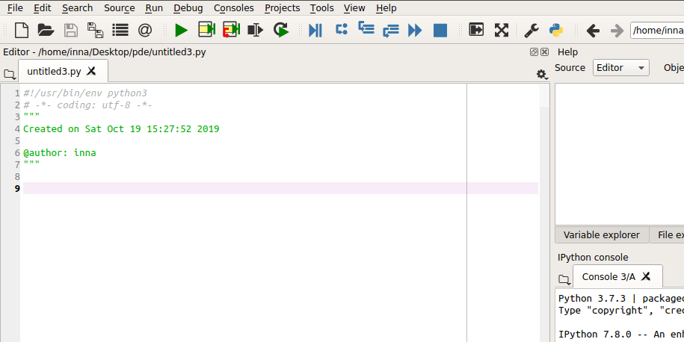

Run test program: poisson.py

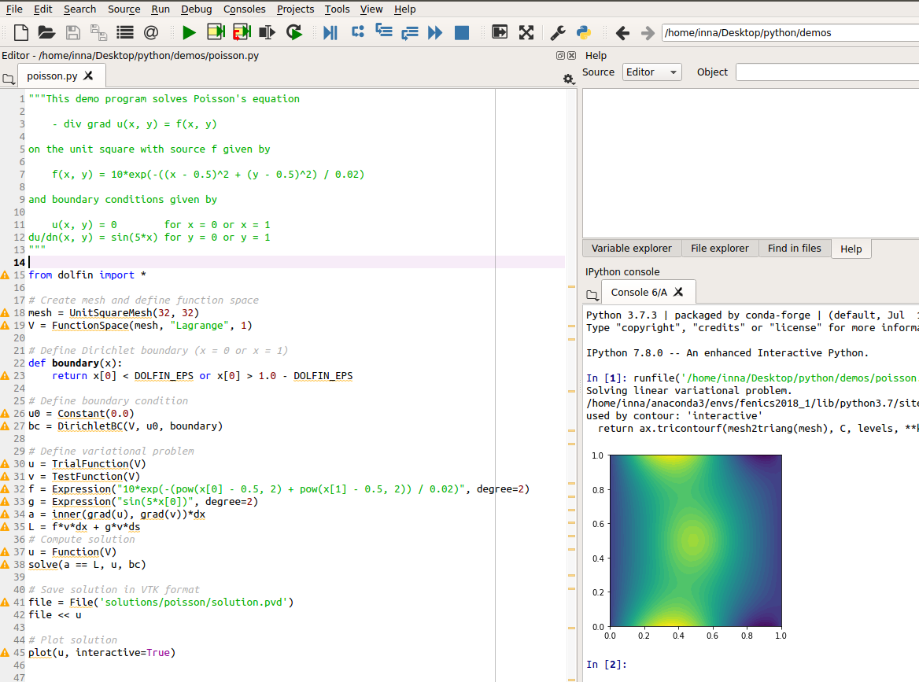

1. Using jupiter services.

Jupyter services can be launched from the command line or from the application inside anaconda.

1. From command line:

Ctrl alt T

Type :

conda activate fenics2018_1

jupyter notebook

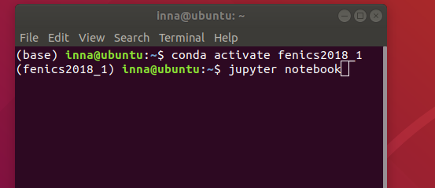

It will open web services where you can see the directory files with your code and it also has the anaconda environment.

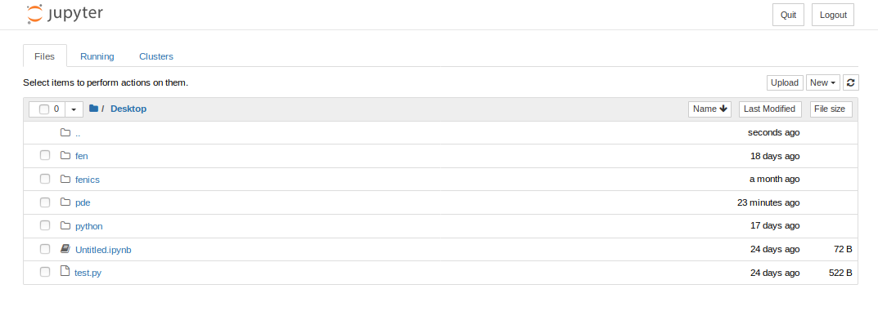

On the right side you can see tab new. Click on new to run the code within python cell.

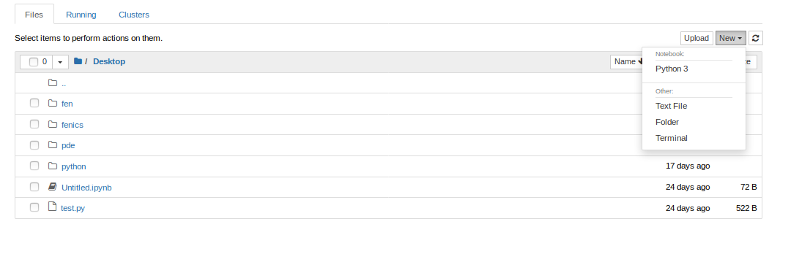

Click on Python 3. The empty python cell will be opened.

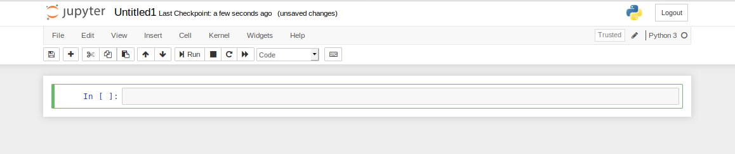

Copy and paste the same code into the python cell. And click run.

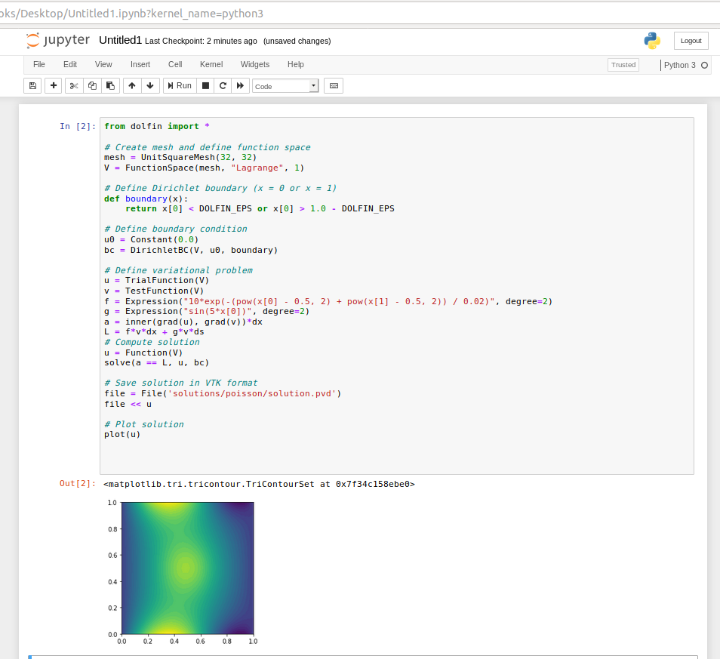

1. From Anaconda navigator

Repeat Step 4 part a) until starting spyder.. Launch Notebook jupyterLab instead.

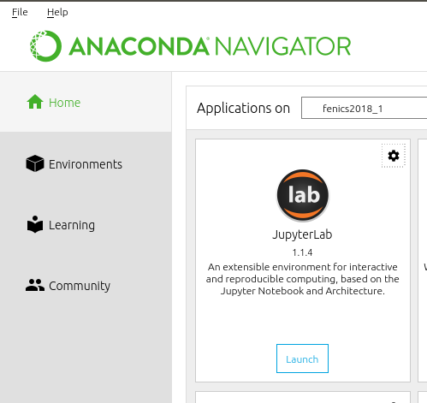

**You will see the following screen**

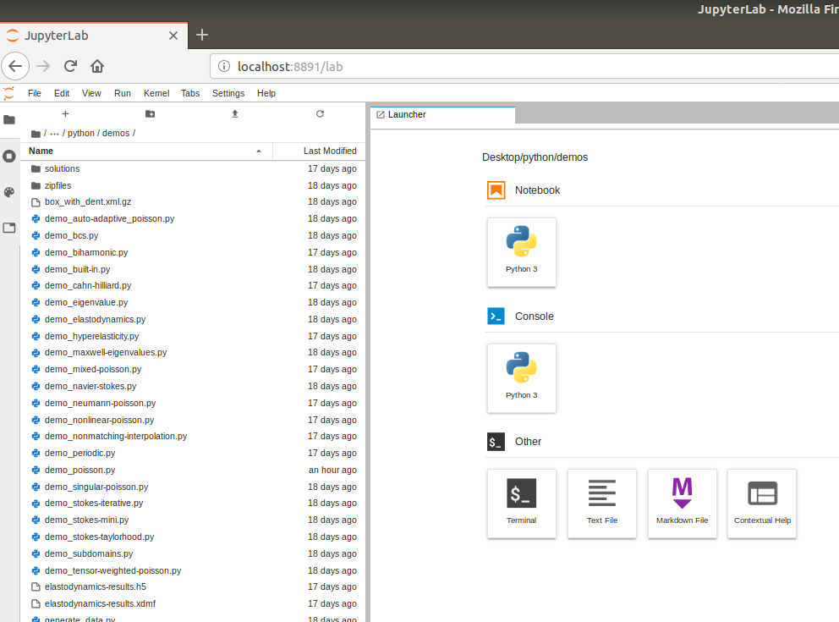

Click on python top tab. Copy the code in to the python cell and click run. You will get the following output:

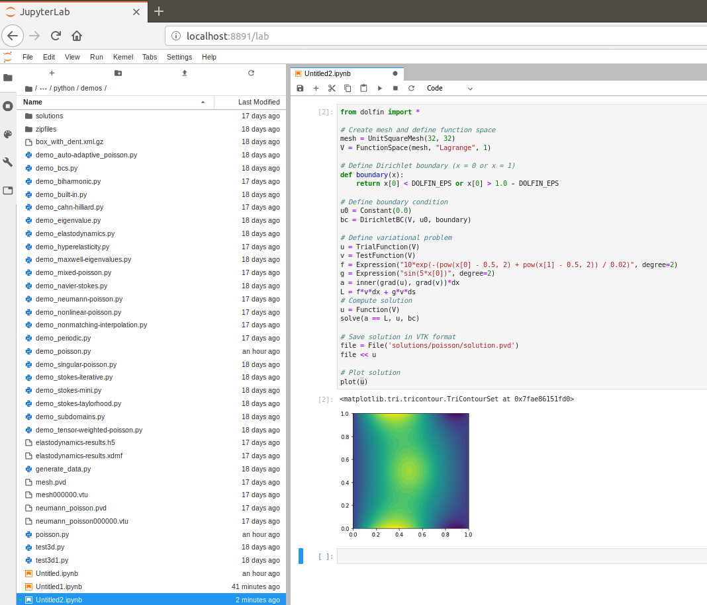

3D visualization with Paraview

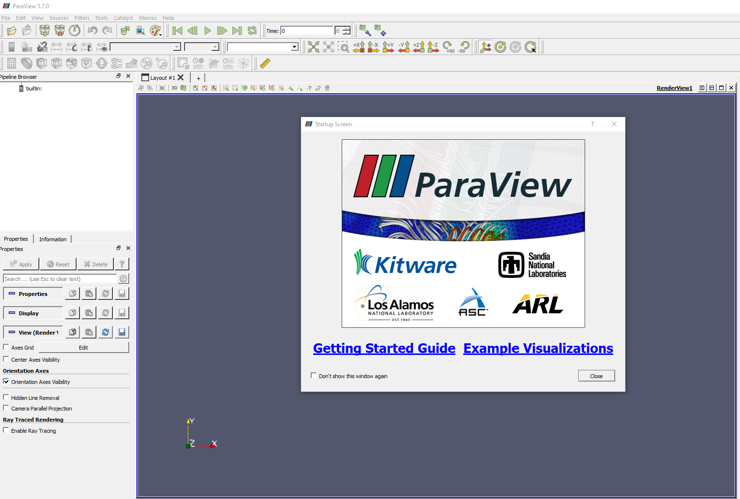

When we run the previous code we output the results into the file

Solution.pvd

Start paraview. File ->open solution.pvd, click Apply.

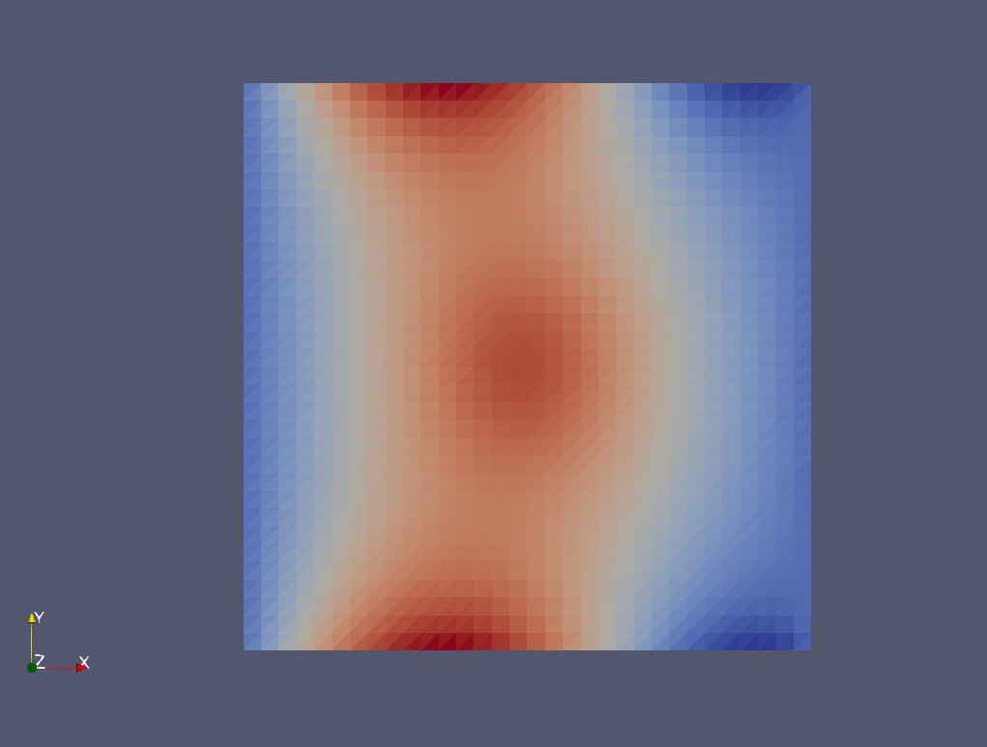

The click Filters-> Alphabetical->Warp by scalar

Click the Apply button on the left.

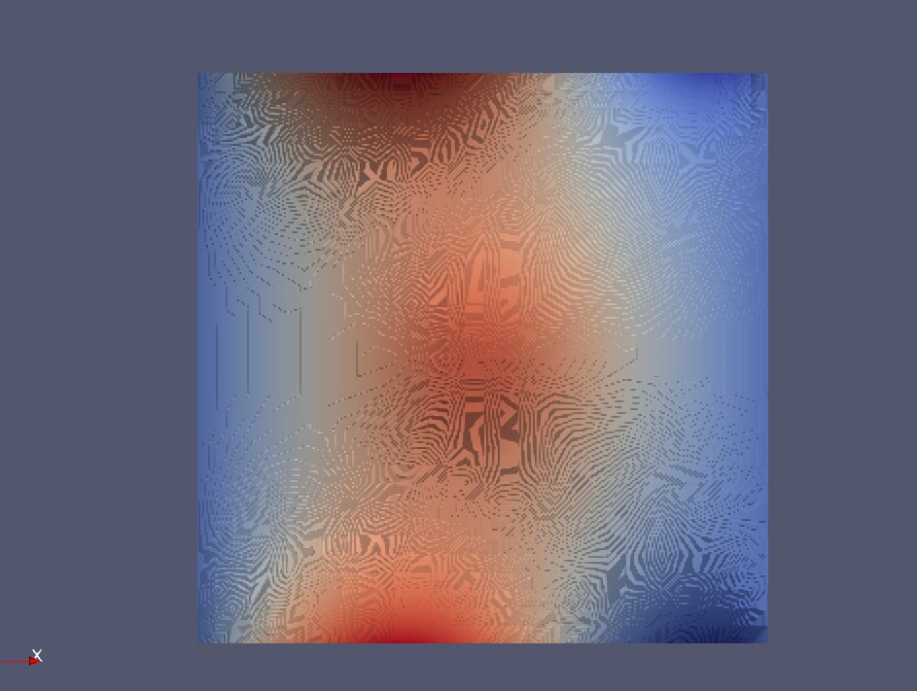

Click eye button left to solution.pvd

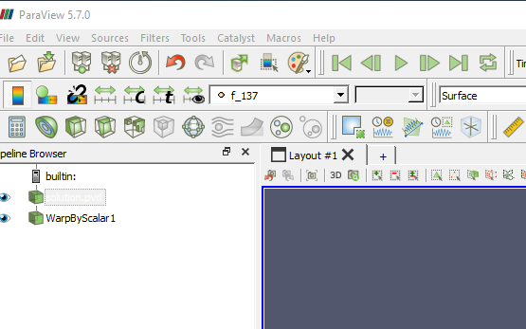

Click 2D button on the layout panel.It will change to 3D

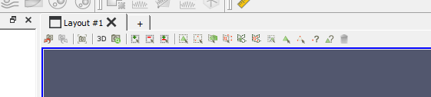

Select Surface with Edges from dropbox representation section

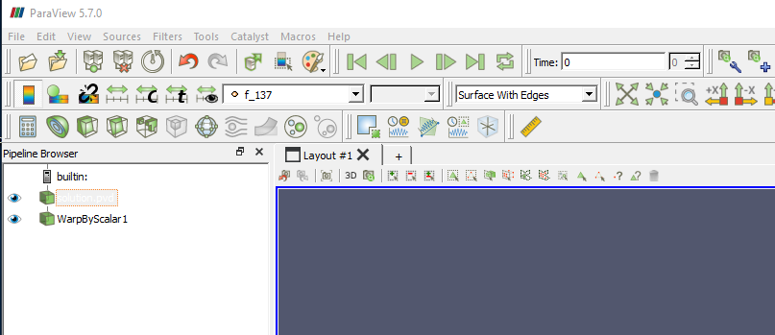

Click on reset button(cross arrows) on the right from drop box



We get the following 3D Image

