#install.packages("tidyverse")

#install.packages("fueleconomy")

library(dplyr)

library(fueleconomy)

library(tidyverse)

library(ggplot2)

#str(mpg)

#str(fueleconomy::vehicles)

library(fueleconomy)

library(corrplot)

library("Hmisc")

library("ggpubr")

library(ggplot2)

library(data.table)

library(corrplot)

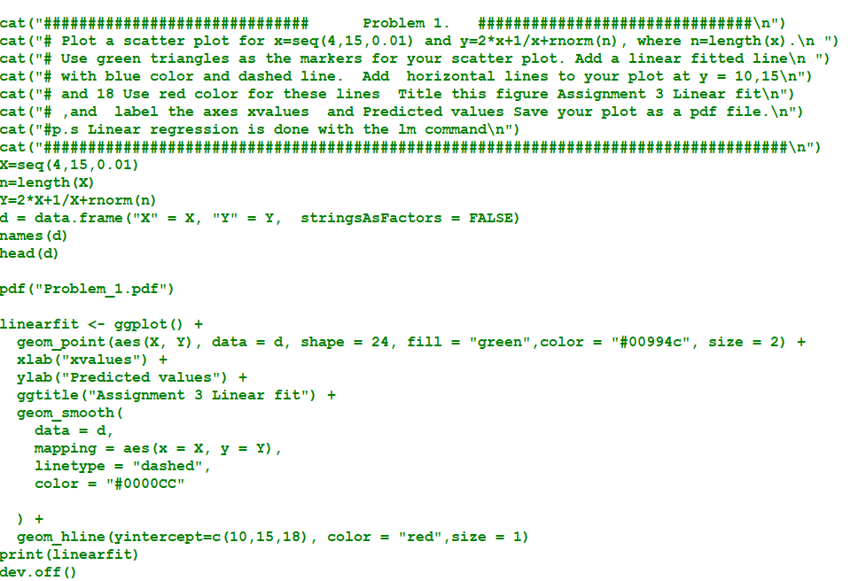

**Problem 1 Output**

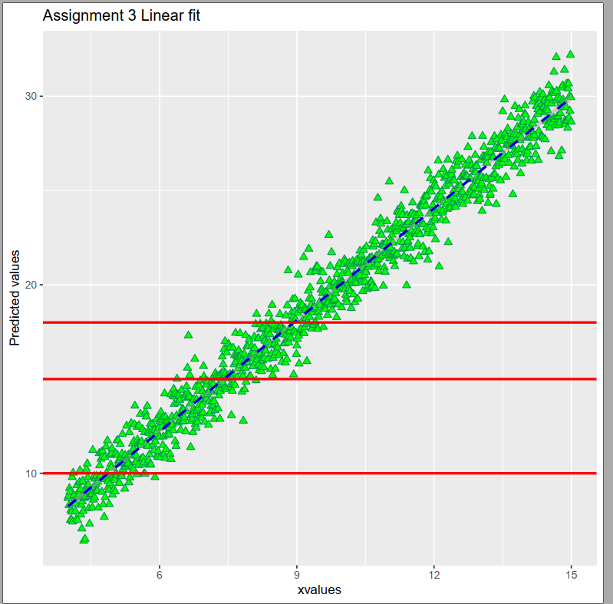

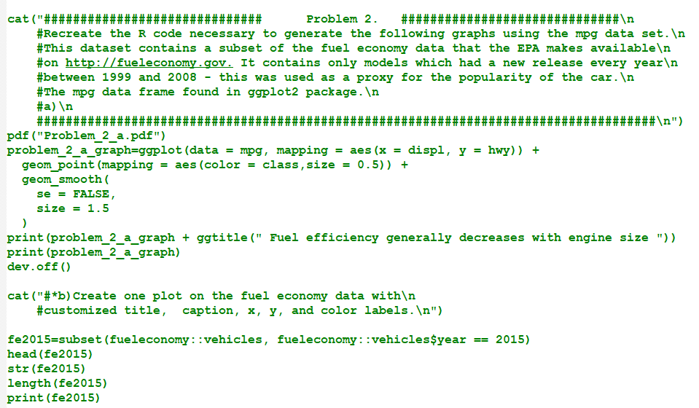

**Problem 2 a) output**

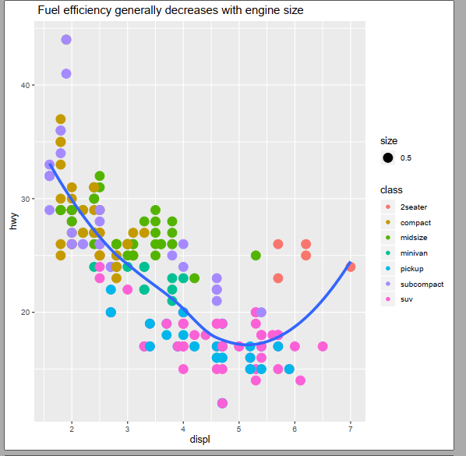

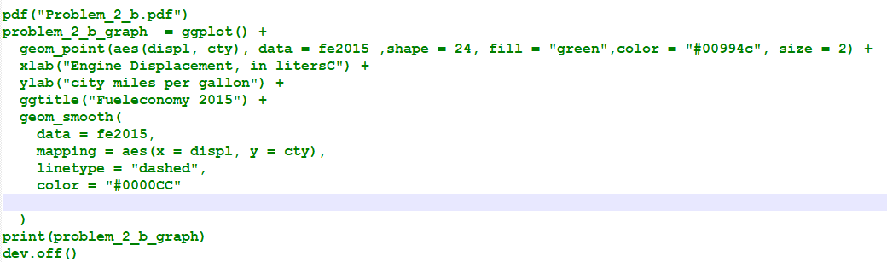

**Problem 2 b) output**

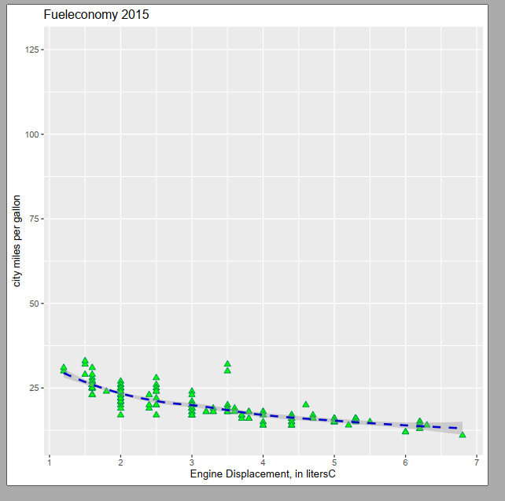

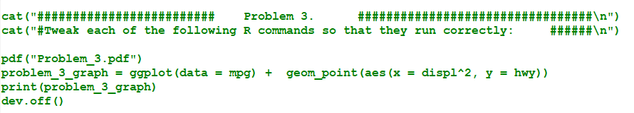

**Output**

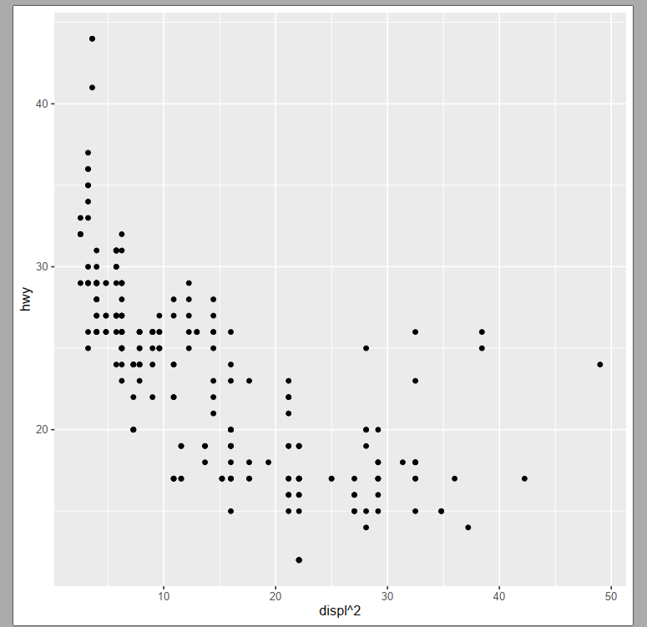

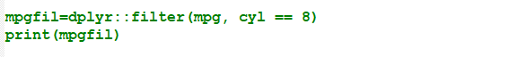

**Output**

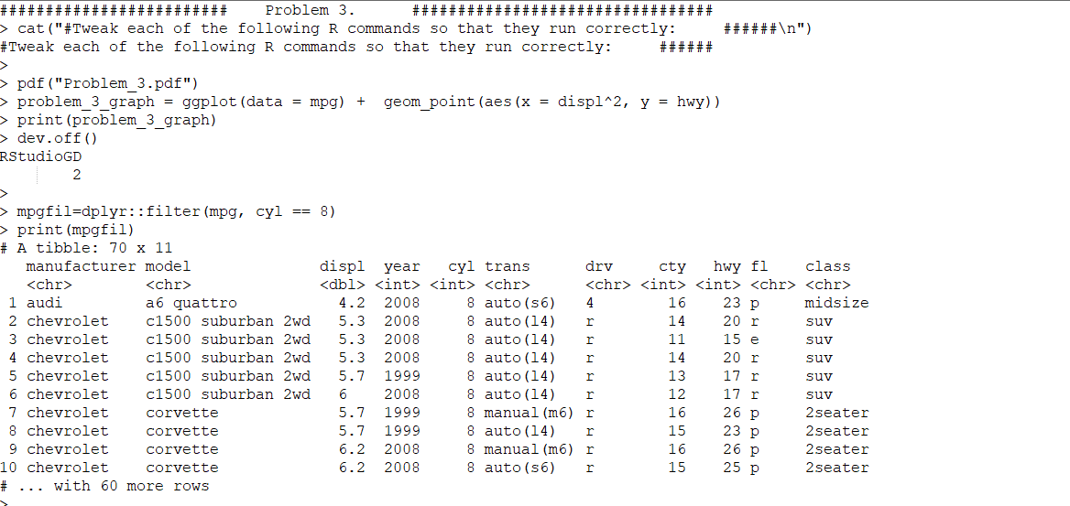



**Output**

