**Analyses of the high frequency time series on**

**example of Circadian rhythms in the**

**Long-Tail Pocket mouse.**

**Inna Williams**

**____________________________________________________________________________**

**Abstract**

**The present study aimed to examine the forecasting performance of various univariate approaches to forecast high-frequency time series which contains more than one seasonal pattern that must be taken into consideration.**

**To achieve the purpose of the study, we performed the following procedures with major findings. First, we investigated different frequencies and produced traditional forecasts for it using ts object. The limitation of ts objects for only low frequency data and also for using multiple seasonalities led us to make additional sets of forecasts by applying non-benchmark approaches with double seasonality using msts object with Fourier terms for each seasonal pattern. This indicates that forecast accuracy was able to be improved by incorporating two different types of seasonal patterns simultaneously.**

**Seasonality is the main component of time series, and the consideration of seasonality has become more important with the increasing frequency of time series produced in industry. Circadian rhythms in the Long-Tail Pocket mouse time series is a representative example of business time series data that has been collected every two minutes for a long period of time. The high frequency data, with time series containing closely spaced time intervals creates a necessity of creating accurate modeling approaches for modeling seasonal patterns of time series.**

**As each seasonal pattern has distinct periods and effects, it is not trivial to design a model that can capture multiple seasonal patterns at once. We found that fourier regression gives more accurate results and can detect multiple seasonalities better then etc and tbats and sarima.**

**_____________________________________________________**

**Introduction**

**The investigating dataset is a temperature recording made at a 2 minutes interval for 83 days on a nocturnal mammal. The Long-tailed pocket mouse live in the South West of the United States and Northern Mexico. The data represents interest because it does contain periodicities in the behaviour of the animals in regards to circadian rhythm. The Circadian is the reaction to light and darkness of their environment. The experiments used separate equipment for each mammal to monitor the environment and so data for each animal could be varied. The data given here are the telemeter frequency temperature recordings for one Long-tailed pocket mouse from the first experiment, with higher counts indicating higher temperature. Since the interest was in periodicity, no effort was made to relate the telemeter frequency to actual temperature.The file that was collected had 59616 observations that correspond to the 83 days. The proportion of outliers in the original data has been 8% and outliers were removed.**

**Typically, multiple seasonality patterns are more likely to occur whenever the series has data with high frequency (for example, daily, hourly, half-hourly, and so on), as there are more options to aggregate the series to a lower frequency. This data is a typical example of multiple seasonality , which could have multiple seasonal patterns, as the observations taken every two minutes of the hours of the day, the day of the week. On the other hand, as the frequency of the series is lower (for example, monthly, quarterly, and so on), it is more likely to have only one dominant seasonal pattern as opposed to a high frequency series, as there are fewer aggregation options for another type of frequencies.**

**Seven last days of data for investigation were selected.**

**Model Specification**

**2days of observations = 30(in one hour) * 24(hours) * 2(days) = 1440 observations**

Having more observations per cycle unit, that is, high-frequency time series data,

could potentially provide more insightful information about the series behavior as opposed

to a lower frequency time series data. However, this comes with the price of additional

complexity, which therefore requires more effort in the analysis process.

Potentially, as mentioned previously, the series can have three different seasonal patterns.

1 week = 30*24 *7 =5040

Daily 30 * 24 = 720

Hourly = 30

2 hourly = 30*2=60

6 hourly = 30*6 = 180

10 hourly = 30 *10 = 330

Time series objects allow maximum frequency =350 and therefore we will use hourly seasonality with frequency = 30 and 1o hourly with frequency = 300. For multiple seasonalities we have to use ms object instead of ts object.

Here is an example of the sarima output for frequency =720

Example of code with f =720 > 350

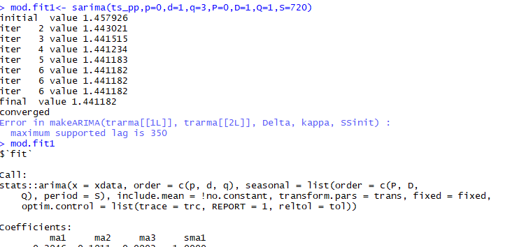

Output telling us that the maximum supported lag = 350.

We can try frequency 300 later when trying to research a best model

**library(astsa)**

**library("forecast")**

**library("lubridate")**

**examine.mod <- function(mod.fit.obj, p, d, q, P=0, D=0, Q=0, S=-1, lag.max=24) {**

**dev.new(width=6, height=6)**

**par(mfrow=c(2,1))**

**pacf(mod.fit.obj$fit$residuals, main="PACF of Residuals", lag.max)**

**if ((P==0)&(D==0)&(Q==0)) {**

**title(paste("Model: (", p, ",", d, ",", q, ")", sep=""), adj=0, cex.main=0.75)**

**}**

**else {**

**title(paste("Model: (", p, ",", d, ",", q, ") (", P, ",", D, ",", Q, ") [", S, "]", sep=""), adj=0, cex.main=0.75)**

**}**

**std.resid <- mod.fit.obj$fit$residuals/sqrt(mod.fit.obj$fit$sigma2)**

**hist(std.resid, main="Histogram of Standardized Residuals", xlab="Standardized Residuals", freq=FALSE)**

**curve(expr=dnorm(x, mean=mean(std.resid), sd=sd(std.resid)), col="red", add=TRUE)**

**}**

**pformosu<-read.table(file = "C:/Users/inna/Desktop/DepaulClasses/ApplyMathClasses/Time_Series/Final Project/pformosu.txt")**

**row =3726**

**col= 16**

**pformosu_dat = numeric(col*row)**

**count = 1**

**for(i in 1:row)**

**{**

**for(j in 1:col)**

**{**

**pformosu_dat[count]=pformosu[i,j]**

**count = count + 1**

**}**

**}**

**ts_p<-ts(pformosu_dat)**

**ength(ts_p)**

**dev.new()**

**par(mfrow=c(2,1))**

**tsplot(ts_p)**

**boxplot(ts_p)$out**

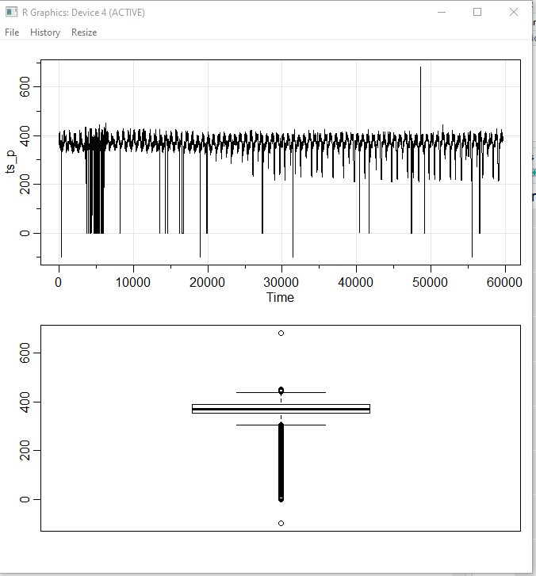

**Taking last 2 days of data = 30*24*2 = 1440 observations**

**Using frequency = 30 observations in an hour**

**ts_p<-ts_p[(length(ts_p)-(two_days_of_data) + 1 ):(length(ts_p))]**

**dev.new()**

**par(mfrow=c(2,1))**

**tsplot(ts_p,xlab="Number Of Observations")**

**boxplot(ts_p)$out**

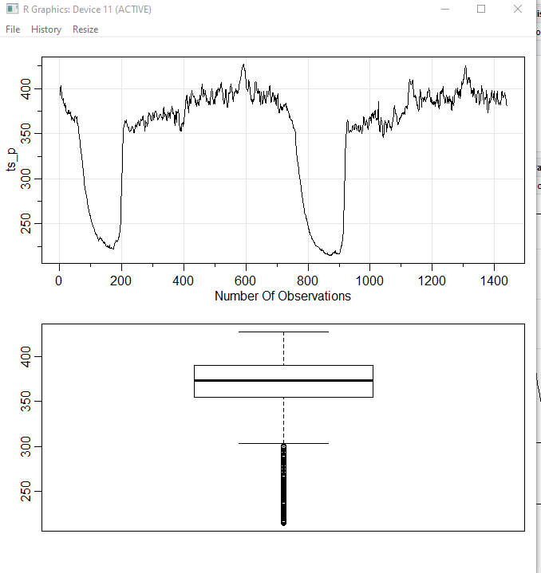

**Getting 2 days of observations with frequency = 30 observations in an hour**

**frequency <- 30**

**one_day<- 30*24**

**two_days_of_data<- 24*30*2**

**ts_pp <- ts(ts_p,frequency = frequency,start=0)**

**dev.new()**

**par(mfrow=c(2,1))**

**tsplot(ts_pp,xlab="Number Of Observations -> 2 Days -> 48 Hours")**

**boxplot(ts_pp)$out**

**dev.new()**

**tsplot(ts_pp,xlab="Number Of Observations -> 2 Days -> 48 Hours",**

**main="Circadian rhythms in the last 2 days Of data")**

**x<-as.numeric(ts_pp)**

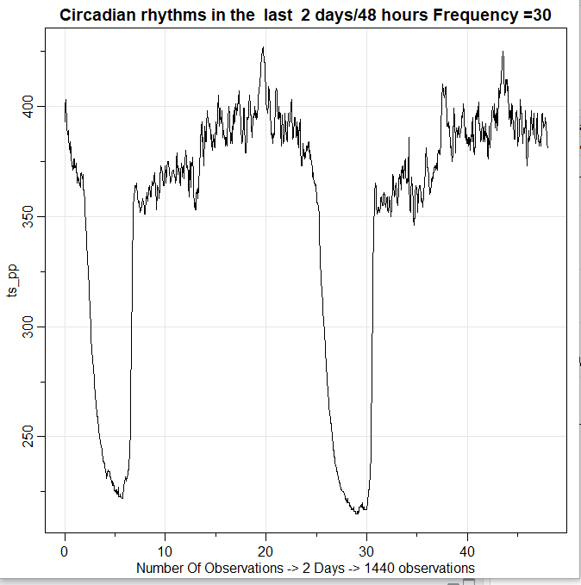

**From the plot we can see the data also have other seasonality equal to 24 hour or 720 observations in 1 hour. F1 = 30, f2 =720**

**dev.new()**

**acf2(x, max.lag = frequency*3,main = "ACF & PACF Of Original ts")**

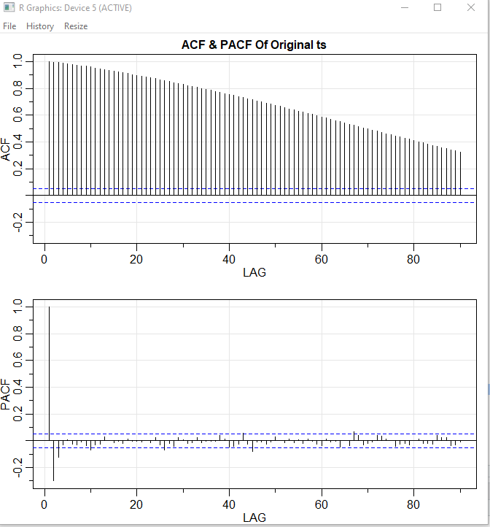

We can see from the plot that ACF is decaying exponentially and PACF has 2 lags but we have to differentiate to get rid of seasonalities (1- B^30)

**# Plot of (1-B^30)*x_t**

**dev.new()**

**tsplot(diff(ts_pp, lag=frequency, differences=1), ylab=expression((1-B^30)*x[t]),**

**xlab="hours", main=expression(paste("Plot of ", (1-B^30)*x[t])))**

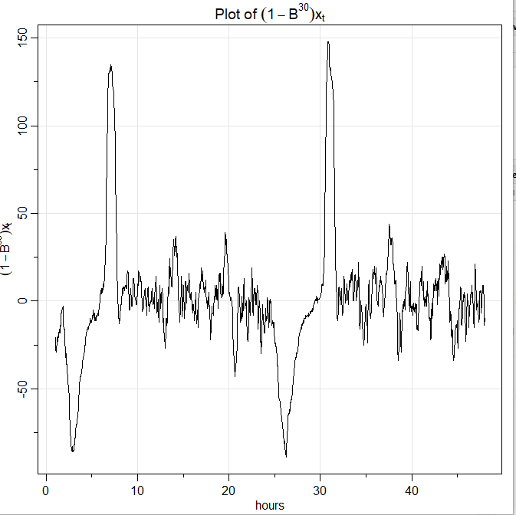

**dev.new()**

**acf2(diff(x, lag=frequency, differences=), max.lag=frequency*6,**

**main=expression(paste("Est. ACF & PACF for ", (1-B^30)*x[t])))**

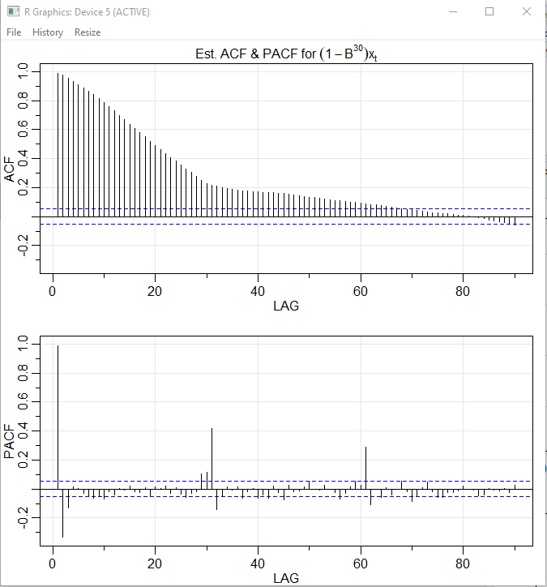

PACF exponentially decaying at lags 30,60 indicating that P = 0

ACF seasonal pick at Lag = 30,60 and no other seasonal picks at lags 90

Indication that Q = 1, giving us the initial estimation for ARIMA(),(0,1,2)30.

ACF also looks non stationary

Plot also shows some little trend so we have to remove the trend using non seasonal difference (1-B)

**dev.new()**

**tsplot(diff(diff(ts_pp, lag=frequency, differences=1)),**

**ylab=expression((1-B)(1-B^30)*x[t]),**

**xlab="Hours", main=expression(paste("Plot of ",**

**(1-B)(1-B^30)*x[t])))**

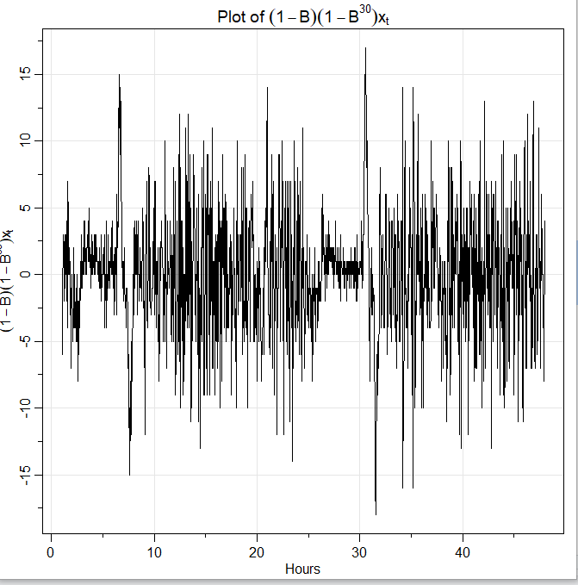

**dev.new()**

**acf2(diff( diff(x, lag=frequency, differences=1)),**

**max.lag=frequency*3,**

**main=expression(paste("Est. ACF & PACF for ", (1-B)(1-B^30)*x[t])))**

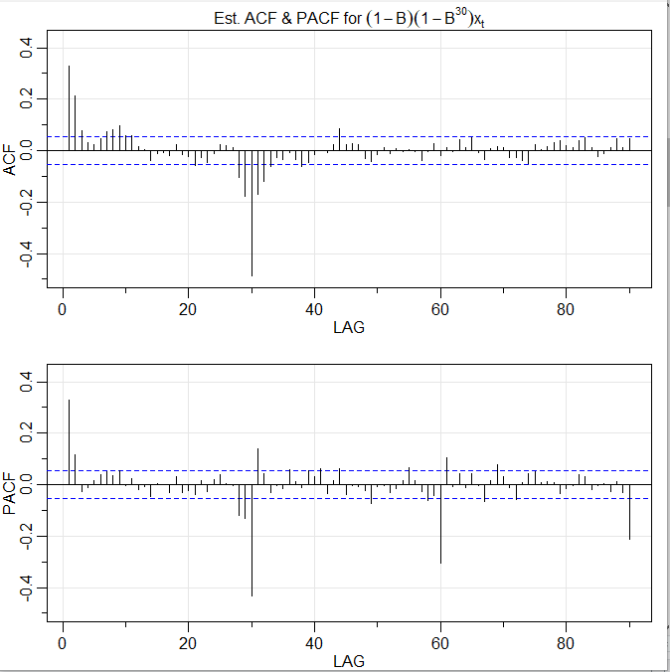

ACF seasonal Q = 1, non-seasonal q = 1-3 (there is cluster around lag = 1

PACF decaying at lags 30,60,90 , and clusters around each lag indication that seasonal P = 0, nonseasonal p = 1-2 (has 2 non seasonal lags)

**ARIMA(p=(0-2),d=1,q=(0-3)),(P=0,D=1,Q=1)[30]**

**Trying ACF frequency = 720**

**dev.new()**

**tsplot(diff(diff(ts_pp, lag=frequency, differences=1)),**

**ylab=expression((1-B)(1-B^720)*x[t]),**

**xlab="Days Frequency = 720", main=expression(paste("Plot of ",**

**(1-B)(1-B^720)*x[t])))**

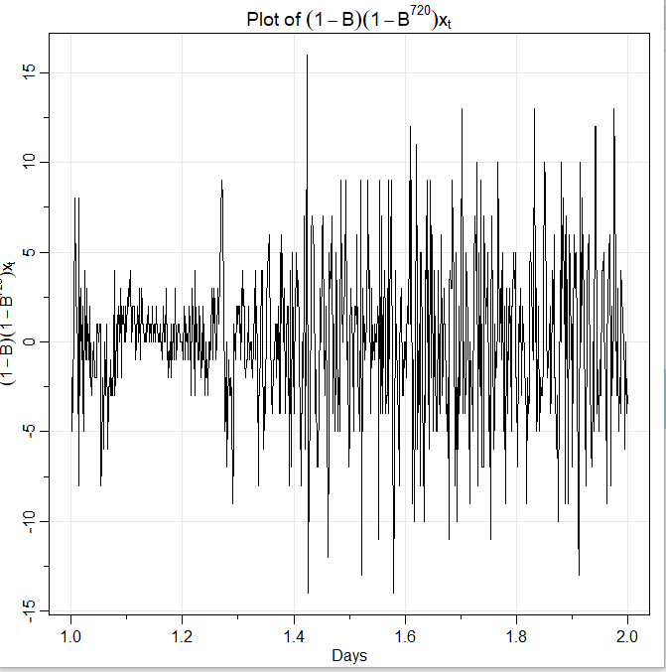

**dev.new()**

**acf2(diff( diff(x, lag=frequency, differences=1)),**

**max.lag=717,**

**main=expression(paste("Est. ACF & PACF for ", (1-B)(1-B^720)*x[t])))**

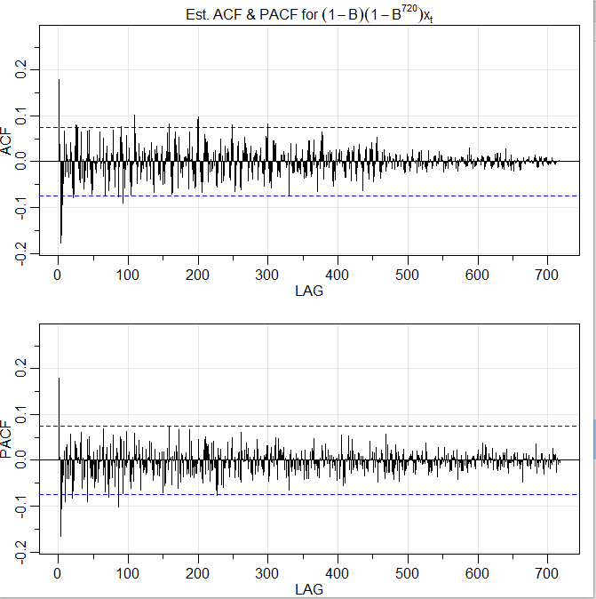

**Both ACF and PACF does does not show any seasonal lags at 720 and after 720 is not defined**

**Indicating on estimated P=0,D=1,Q=0 (random walk)**

**Sarima does not allow more than 350 lags. Run of sarima with S=720 shown below.**



Any other values of p,d,q,P,D,Q, S > 350 results in the same error

**We will try S=30**

**Estimated ARIMA(p=(0-2),d=1,q=(0-3)),(P=0,D=1,Q=1)[30]**

**Fitting and Diagnostics**

**Trying ARIMA(p=(0),d=1,q=(0),P=0,D=1,Q=1,S=30)**

**dev.new()**

**mod.fit1<- sarima(ts_pp,p=0,d=1,q=0,P=0,D=1,Q=1,S=30)**

**mod.fit1**

**dev.new()**

**par(mfrow=c(2,1))**

**pacf(mod.fit1$fit$residuals,main = " PACF Of residuals")**

**title(paste("Model: (",**

**p = 0, ",",**

**d = 1, ",",**

**q = 0, ")(",**

**P = 0, ",",**

**D = 1, ",",**

**Q = 1, ")[30]",**

**sep=""),adj=0,cex.main=0.75)**

**std.resid1 <- mod.fit1$fit$residuals / sqrt(mod.fit1$fit$sigma2)**

**hist(std.resid1,main = " Histogram Of Standardized Residuals",**

**xlab='Standardized Residuals',**

**freq = FALSE**

**)**

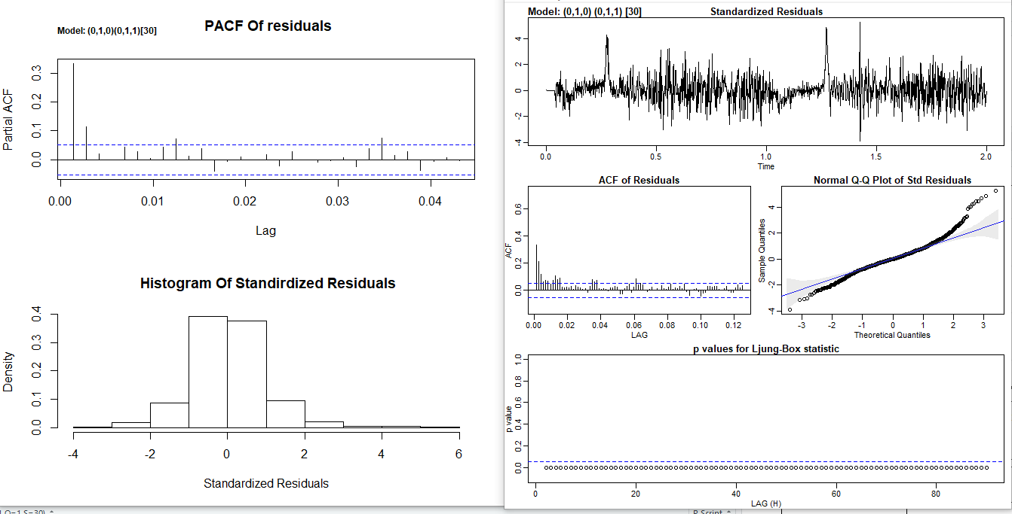

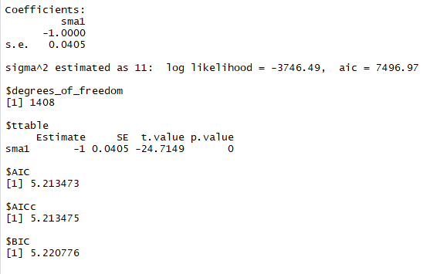

* **Standardized Residuals: They have no significant pattern, so we conclude that they resemble white noise. several outlier above 3 and 3 outliers above 4**
* **The ACF of residuals vs time plot appears to resemble the acf of white noise and so its all good.**
* **The qq plot is not a great fit, specially towards the very end of the tails,**
* **There are 4 variations in PACF of residuals**
* **histogram ofStandardized Residuals appears to be normal**
* **p-value for Ljung-Box statistics are all too small, they are in rejection region, there is sufficient evidence to indicate that there is significant groups of auto correlation**

**Trying ARIMA(p=0,d=1,q=1,P=0,D=1,Q=1,S=30)**

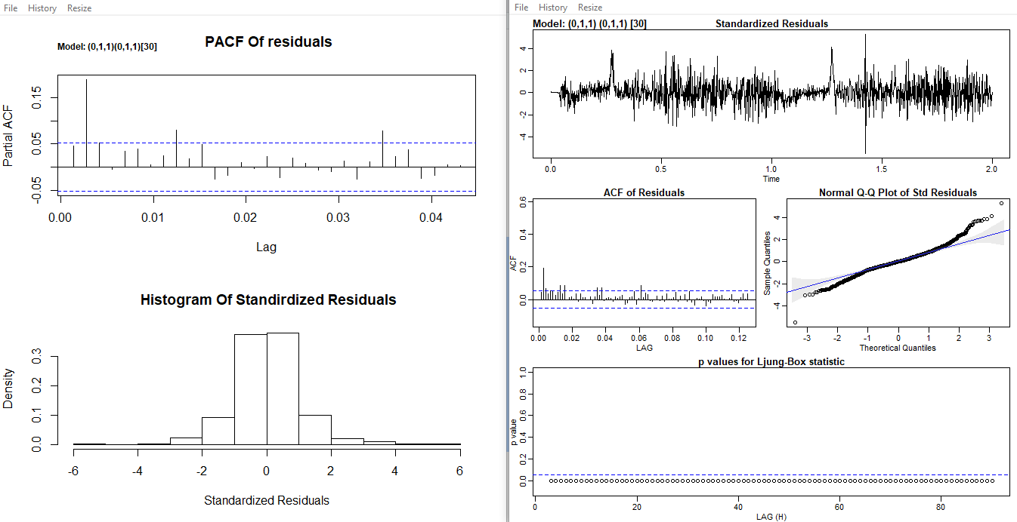

-

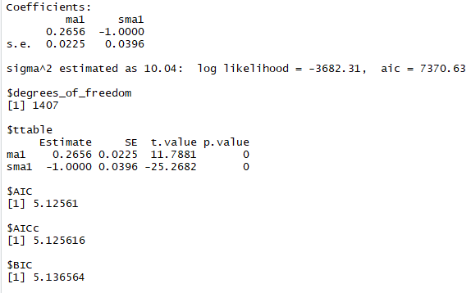

**ARIMA(p=0,d=1,q=1,P=0,D=1,Q=1,S=30)**

model seems like better that the previous because **AIC = 5.12561**

compare to **ARIMA(p=0,d=1,q=0,P=0,D=1,Q=1,S=30) AIC =5.213473**

* **Standardized Residuals: They have no significant pattern, so we conclude that they resemble white noise. several outliers above 3**
* **The ACF of residuals vs time plot appears to resemble the acf of white noise and so its all good.**
* **The qq plot is not a great fit, specially towards the very end of the tails,**
* **There are 3 variations in PACF of residuals**
* **histogram of Standardized Residuals appears to be normal**
* **p-value for Ljung-Box statistics are all too small, they are in rejection region, there is sufficient evidence to indicate that there is significant groups of auto correlation**

**Trying ARIMA(p=1,d=1,q=1,P=0,D=1,Q=1,S=30)**

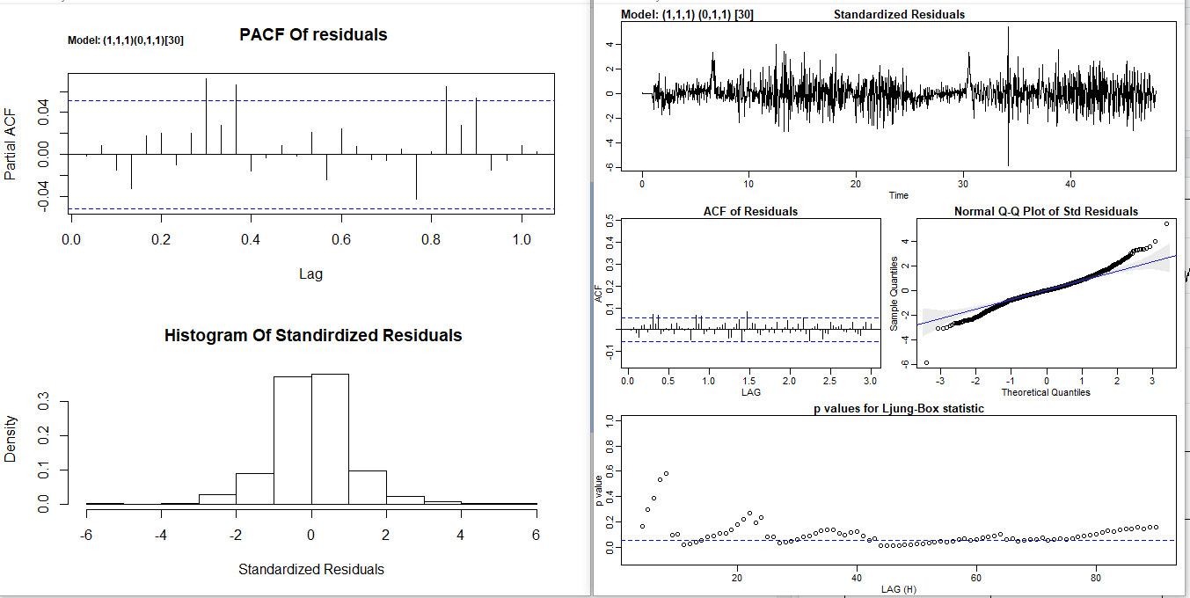

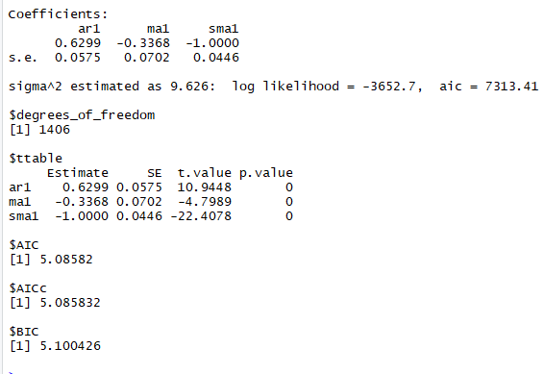

**The ARIMA(p=1,d=1,q=1,P=0,D=1,Q=1,S=30) model has p-values = 0 and this makes and AIC = 5.085<5.125=AIC of ARIMA(p=0,d=1,q=1,P=0,D=1,Q=1,S=30) and therefore ARIMA(p=1,d=1,q=1,P=0,D=1,Q=1,S=30) is better model of all above models**

* **Standardized Residuals: They have no significant pattern, so we conclude that they resemble white noise. there is one outlier above 4 and several above 3**
* **The ACF of residuals vs time plot appears to resemble the acf of white noise and so its all good.**
* **The qq plot is not a great fit, specially towards the very end of the tails, but better compares to previous two model**
* **There are 4 variations in PACF of residuals**
* **histogram ofStandardized Residuals appears to be normal**
* **Some p-value for Ljung-Box statistics are too small, they are in rejection region, there is sufficient evidence to indicate that there is significant groups of auto correlation**

**Trying ARIMA(p=0,d=1,q=2,P=0,D=1,Q=1,S=30)**

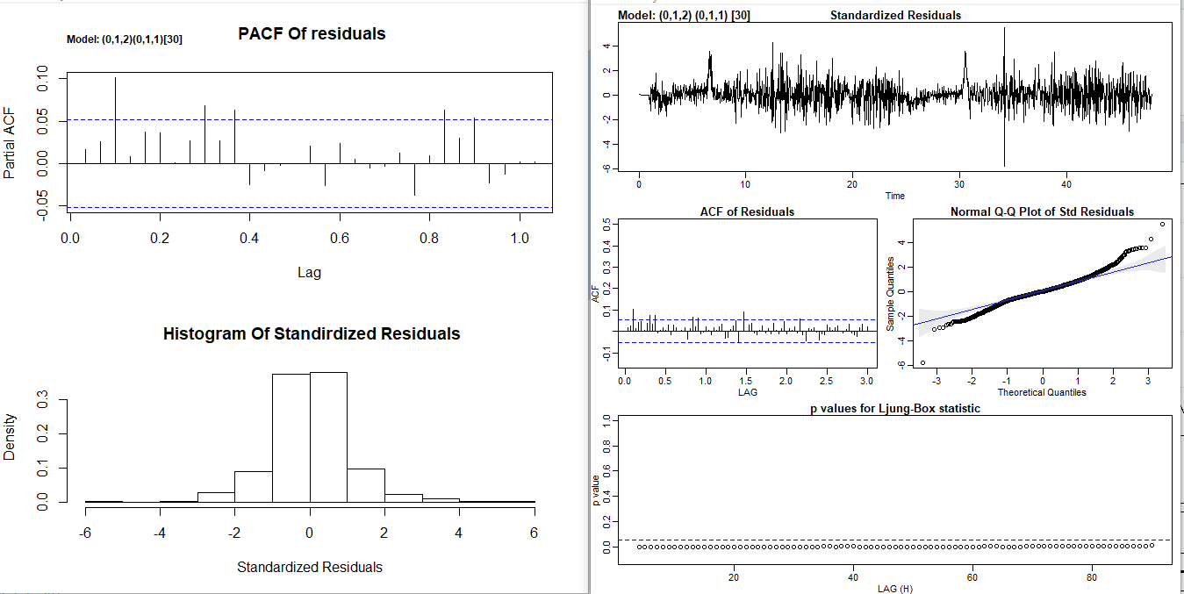

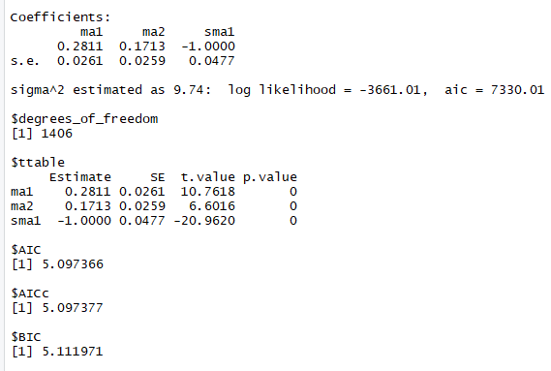

* **Standardized Residuals: They have no significant pattern, so we conclude that they resemble white noise. and there is one outlier above 2**
* **The ACF of residuals vs time plot appears to resemble the acf of white noise and so its all good.**
* **The qq plot is not a great fit, specially towards the very end of the tails,**
* **There are 4 variations in PACF of residuals**
* **histogram ofStandardized Residuals appears to be normal**
* **p-value for Ljung-Box statistics are all too small, they are in rejection region, there is sufficient evidence to indicate that there is significant groups of auto correlation**

**The ARIMA(p=0,d=1,q=2,P=0,D=1,Q=1,S=30) model has al p-values = 0 and AIC = 5.097 > 5.085 = AIC**

**Of ARIMA(p=1,d=1,q=1,P=0,D=1,Q=1,S=30) and there for ARIMA(p=1,d=1,q=1,P=0,D=1,Q=1,S=30)**

**Is better model of all previous models**

**When Trying ARIMA(p=0,d=1,q=(2,3 or 4),P=0,D=1,Q=1,S=30) values of AIC is not decreasing and pvalues are increasing therefore the best model now is still ARIMA(p=1,d=1,q=1,P=0,D=1,Q=1,S=30)**

**Trying ARIMA(p=1,d=1,q=0,P=0,D=1,Q=1,S=30)**

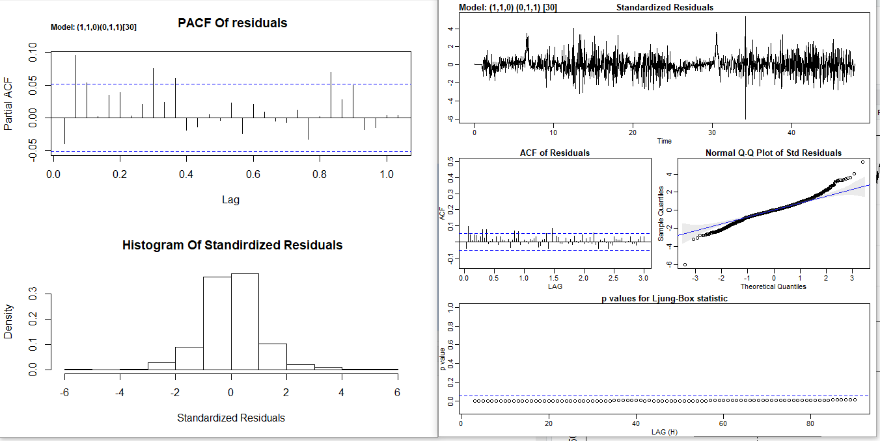

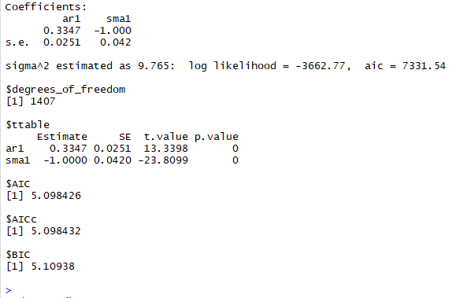

**AIC values are increasing from the best estimated model ARIMA(p=1,d=1,q=1,P=0,D=1,Q=1,S=30)**

**With AIC = 5.085**

* **Standardized Residuals: They have no significant pattern, so we conclude that they resemble white noise. there are several outliers above 3 and 1 outlier above 4**
* **The ACF of residuals vs time plot appears to resemble the acf of white noise and so its all good.**
* **The qq plot is not a great fit, specially towards the very end of the tails,**
* **There are 4 variations in PACF of residuals**
* **histogram ofStandardized Residuals appears to be normal**
* **p-value for Ljung-Box statistics are all too small, they are in rejection region, there is sufficient evidence to indicate that there is significant groups of auto correlation**

**Trying ARIMA(p=2,d=1,q=0,P=0,D=1,Q=1,S=30)**

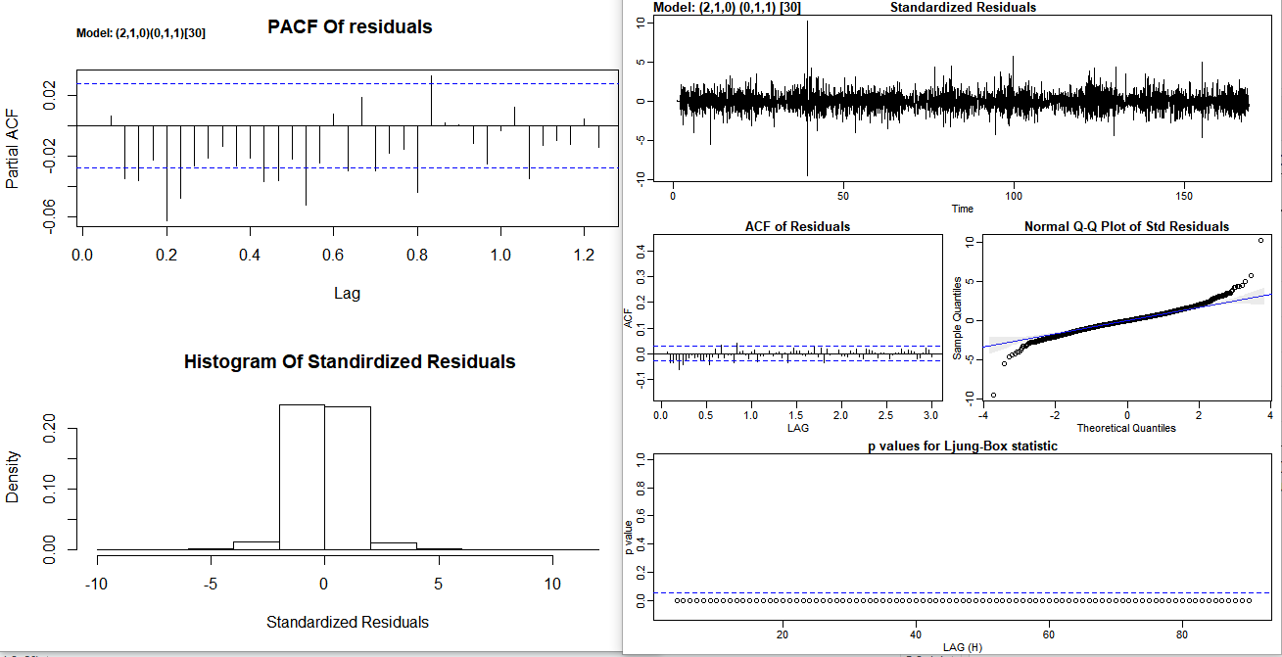

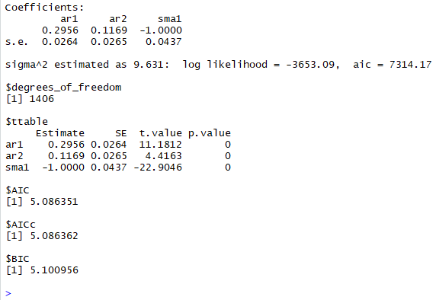

**All pvalues < 0.05 with AIC = 5.0863 > 5.085 of the ARIMA(p=1,d=1,q=1,P=0,D=1,Q=1,S=30)**

**Therefore ARIMA(p=1,d=1,q=1,P=0,D=1,Q=1,S=30) with AIC = 5.085 is better model**

* **Standardized Residuals: They have no significant pattern, so we conclude that they resemble white noise. there are some enormous outliers.**
* **The ACF of residuals vs time plot appears to resemble the acf of white noise and so its all good.**
* **The qq plot is not a great fit, specially towards the very end of the tails,**
* **There are 10 variations in PACF of residuals**
* **histogram of Standardized Residuals appears to be normal**
* **p-value for Ljung-Box statistics are all too small, they are in rejection region, there is sufficient evidence to indicate that there is significant groups of auto correlation**

**Trying ARIMA(p=2,d=1,q=2,P=0,D=1,Q=1,S=30)**

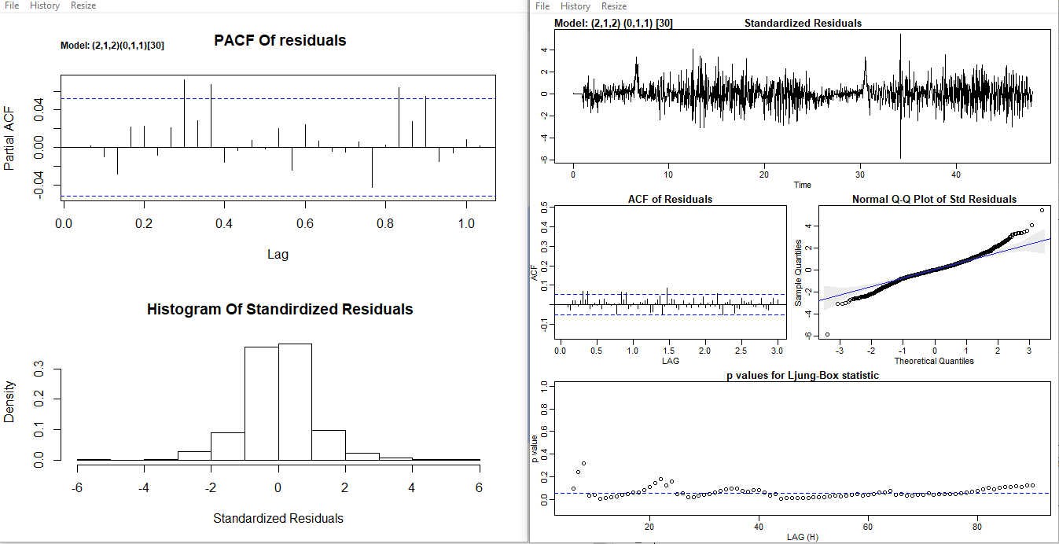

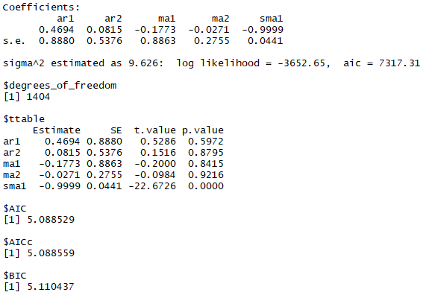

**p values <0.05 with AIC = 5.088 > 5.085 =AIC of ARIMA(p=1,d=1,q=1,P=0,D=1,Q=1,S=30)**

**Therefore ARIMA(p=1,d=1,q=1,P=0,D=1,Q=1,S=30) better than all above models**

* **Standardized Residuals: They have no significant pattern, so we conclude that they resemble white noise.**
* **The ACF of residuals vs time plot appears to resemble the acf of white noise and so its all good.**
* **The qq plot is not a great fit, specially towards the very end of the tails,**
* **There are 4 variations in PACF of residuals**
* **histogram ofStandardized Residuals appears to be normal**
* **p-value for Ljung-Box statistics are mostly okay, except for some, that are in rejection region, there is sufficient evidence to indicate that there is significant groups of auto correlation**

**When**

**Trying ARIMA(p=3,d=1,q=3,P=0,D=1,Q=1,S=30)**

**Trying ARIMA(p=3,d=1,q=2,P=0,D=1,Q=1,S=30)**

**ARIMA(p=2,d=1,q=3,P=0,D=1,Q=1,S=30)**

**P-values > 0.05 and therefore the best selected model is**

**ARIMA(p=1,d=1,q=1,P=0,D=1,Q=1,S=30)**

**Forecasting**

**Model chosen ARIMA(p=1,d=1,q=1,P=0,D=1,Q=1,S=30)**

**Forecasting 1 hour ahead**

**dev.new()**

**mod.fit.110.011 <- sarima(x, p=1,d=1,q=1,P=0,D=1,Q=1,S=30)**

**mod.fit.110.011**

**examine.mod(mod.fit.110.011, 2,1,2, 0,1,1, 30)**

**ahead_1_hours <-30**

**dev.new()**

**fore.mod <- sarima.for(ts_pp, n.ahead=ahead_1_hours, p=1, d=1, q=1, P=0, D=1, Q=1, S=30, plot.all=TRUE)**

**dev.new()**

**tsplot(fore.mod$pred)**

**pred.mod <- ts(x - mod.fit.110.011$fit$residuals)**

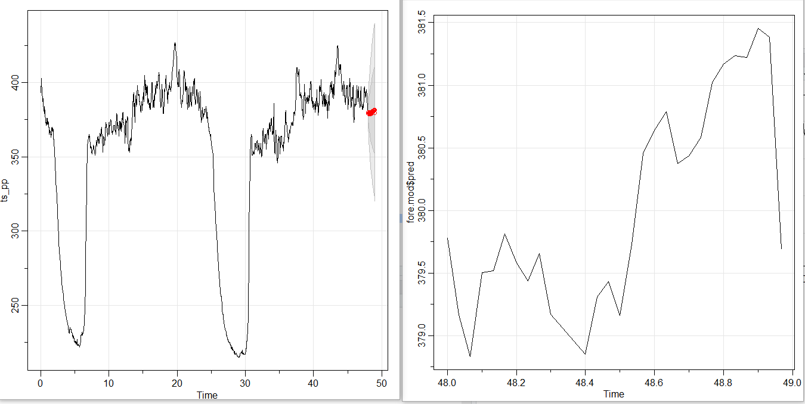

**Forecasting 4 hour ahead**

**ahead_4_hours <- 4*30**

**dev.new()**

**fore.mod <- sarima.for(ts_pp, n.ahead=ahead_4_hours,**

**p=2, d=1, q=2, P=0, D=1, Q=1, S=30, plot.all=TRUE)**

**dev.new()**

**ts_pp_4_hour <- c(ts_pp[(length(ts_pp)-6*ahead_4_hours + 1):(length(ts_pp))],**

**fore.mod$pred[1:length(fore.mod$pred)])**

**tsplot(ts_pp_4_hour,**

**ylab="Data for 4 Hours ahead",**

**xlab="minutes", main=expression("1 day + 2hours ahead"))**

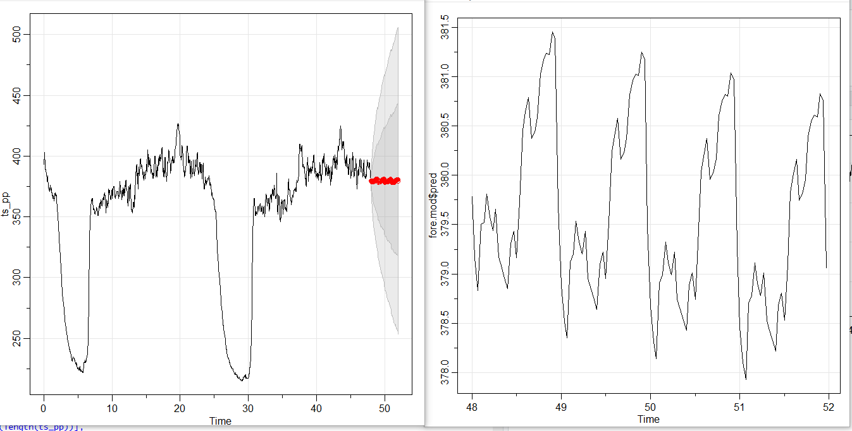

**Forecasting 24 hour ahead /1 day ahead**

**ahead_24_hours <- 24*30**

**dev.new()**

**fore.mod <- sarima.for(ts_pp, n.ahead=ahead_24_hours,**

**p=1, d=1, q=1, P=0, D=1, Q=1, S=30, plot.all=TRUE)**

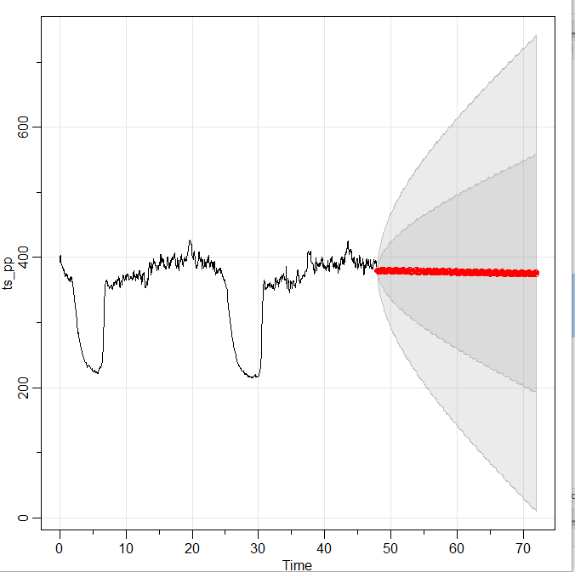

**We have to look how the predicted model fit the data**

**pred.mod <- ts(x - mod.fit.110.011$fit$residuals)**

**dev.new()**

**tsplot(ts_pp[1:length(ts_pp)], ylab="pred", xlab="min", type="o", main="pred")**

**lines(pred.mod, col="red", type="o", pch=17)**

**legend("topleft", legend=c("Observed", "Forecast"), lty=c("solid", "solid"), col=c("black", "red"), pch=c(1, 17), bty="n")**

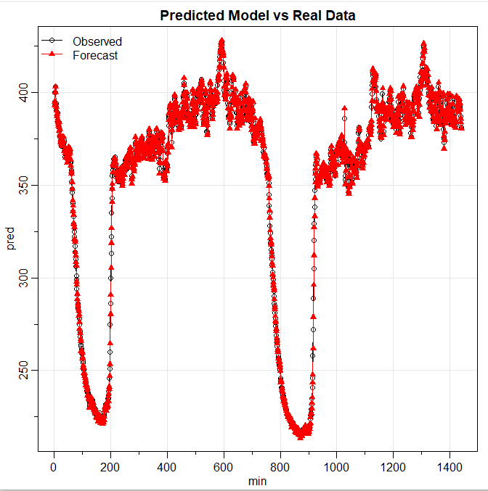

**Discussion**

**Our model does not take into account multiple seasonalities. The following libraries and techniques can be used to handle multiple seasonalities and get better forecasting.**

**library(astsa)**

**library("forecast")**

**library("lubridate")**

**library("ggplot2")**

**library(magrittr)**

**# needs to be run every time you start R and want to use %>%**

**library(dplyr)**

**At least 3 periods need to be in the data for some features to work**

**We will take 3 days**

**On_hour <- 30**

**one_day <- 30*24**

**tree_days <- 30*24*3**

**frequency <- c(On_hour,one_day)**

**msts_pp <- msts(ts_p_3_days,seasonal.periods = frequency,start = 0)**

**dev.new()**

**tsplot(msts_pp,xlab="days",**

**main="Circadian rhythms in the last 3d/72h/2736obs Freq = 30")**

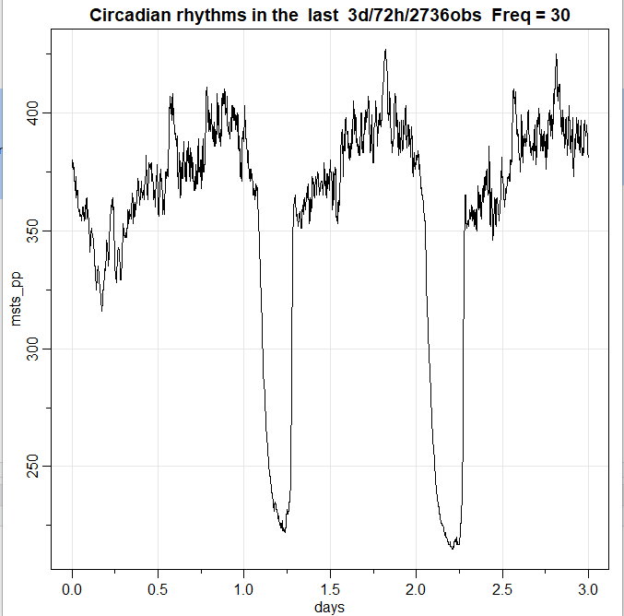

**The mstl() function is a variation on stl() designed to deal with multiple seasonality. It will return multiple seasonal components, as well as a trend and remainder component.**

**msts_pp %>% mstl() %>%autoplot() + xlab("Day")**

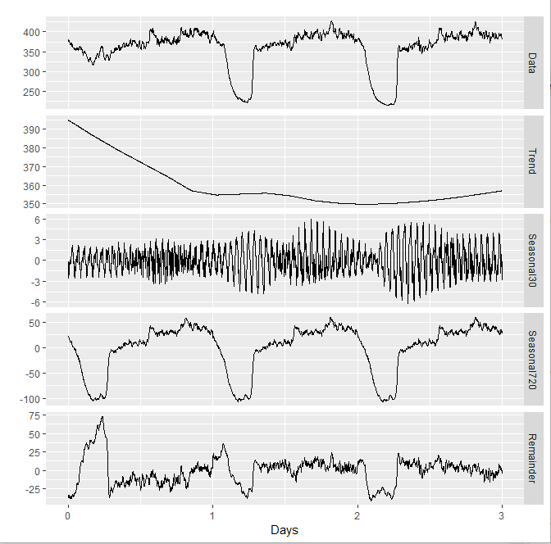

**There are two seasonal patterns shown, one for the time of minutes in hour (the third panel), and one for the time of day (the fourth panel). To properly interpret this graph, it is important to notice the vertical scales. In this case, the trend and the daily seasonality have relatively narrow ranges compared to the other components, because there is little trend seen in the data, and the daily seasonality is weak.**

**The decomposition can also be used in forecasting, with each of the seasonal components forecast using a seasonal naïve method, and the seasonally adjusted data forecasting using ETS (or some other user-specified method). The stlf() function will do this automatically.**

**msts_pp %>% stlf() %>% autoplot() + xlab("Day")**

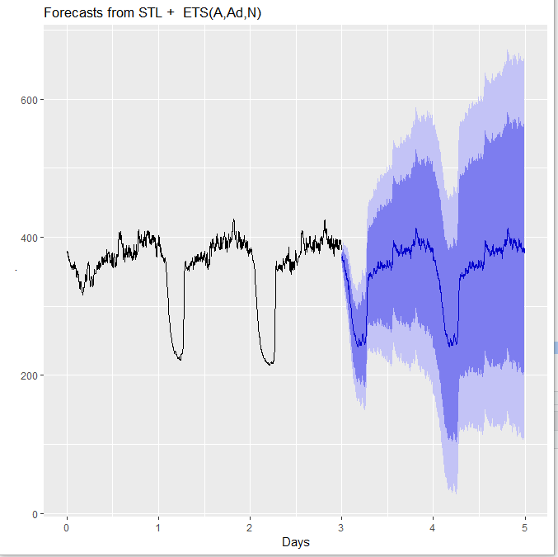

### 

### 

### **Dynamic harmonic regression with multiple seasonal periods**

**Because there are multiple seasonalities, we need to add Fourier terms for each seasonal period. In this case, the seasonal periods are 30 and 656, so the Fourier terms are of the form**

**sin(2πkt/30), cos(2πkt/30), sin(2πkt/656), cos(2πkt/656)**

**For k = 1,2, ...**

**The fourier() function can generate these for you.**

**We will fit a dynamic harmonic regression model with an ARMA error structure. The total number of Fourier terms for each seasonal period have been chosen to minimise the AICc. We will use a log transformation (lambda=0) to ensure the forecasts and prediction intervals remain positive.**

**fit <- auto.arima(msts_pp, seasonal=FALSE, lambda=0,xreg=fourier(msts_pp, K=c(14,65)))**

**fit**

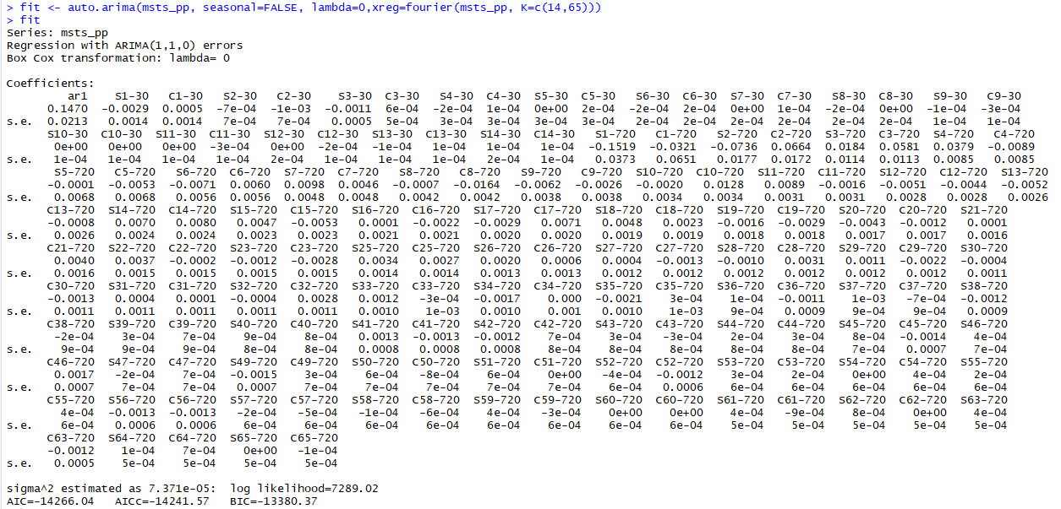

**Forecasting 10 minutes ahead**

**dev.new()**

**minutes_10<- 5**

**fit %>%**

**forecast(xreg=fourier(msts_pp, K=c(14,65), minutes_10)) %>%**

**autoplot(tree_days) + ylab("Circadian Rhythms in the Long-Tail Pocket Mouse 10 minutes ahead") + xlab("Days")**

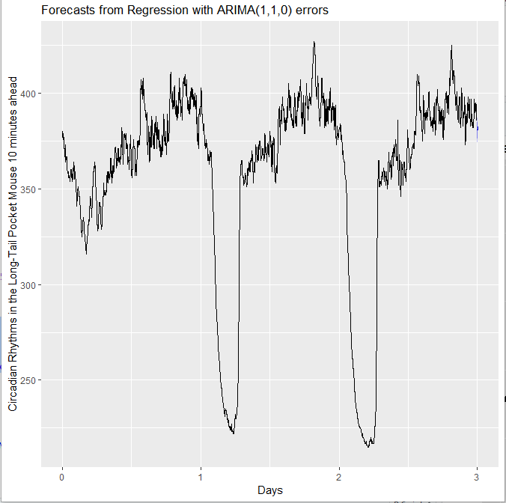

**Forecasting 1 hour ahead**

**dev.new()**

**hour_1<- 30**

**fit %>%**

**forecast(xreg=fourier(msts_pp, K=c(14,65), h=hour_1)) %>%**

**autoplot(include=tree_days) +**

**ylab("Circadian Rhythms in the Long-Tail Pocket Mouse 1 hour ahead") +**

**xlab("Days")**

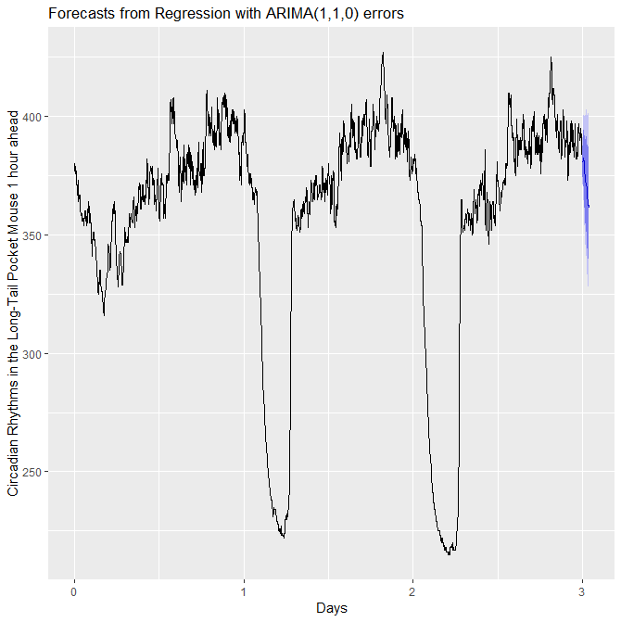

**Forecasting 4 hours ahead**

**dev.new()**

**hours_4<- 30 * 4**

**fit %>%**

**forecast(xreg=fourier(msts_pp, K=c(14,65), h=hours_4)) %>%**

**autoplot(include=tree_days) + ylab("Circadian Rhythms in the Long-Tail Pocket Mouse 4**

**hours ahead") + xlab("Days")**

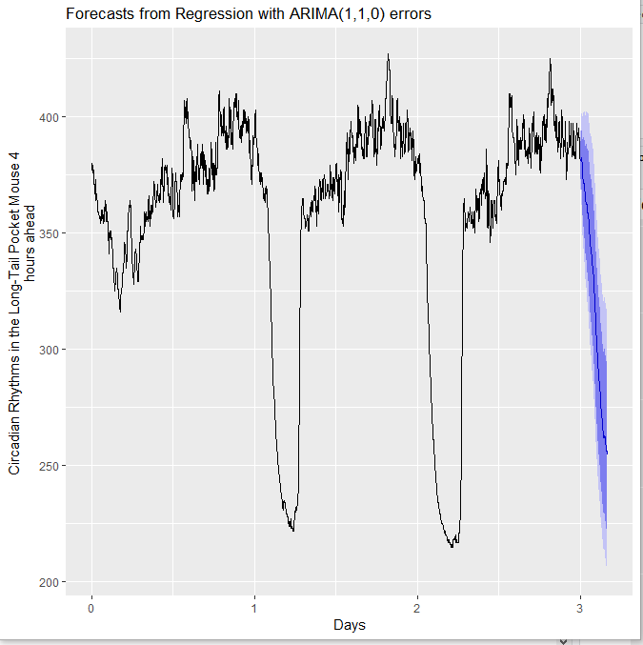

**Forecasting 12 hours ahead**

**dev.new()**

**hours_12<- 30 * 12**

**fit %>%**

**forecast(xreg=fourier(msts_pp, K=c(14,65), h=hours_12)) %>%**

**autoplot(include=tree_days) +**

**ylab("Circadian Rhythms in the Long-Tail Pocket Mouse 12 hours ahead") +**

**xlab("Days")**

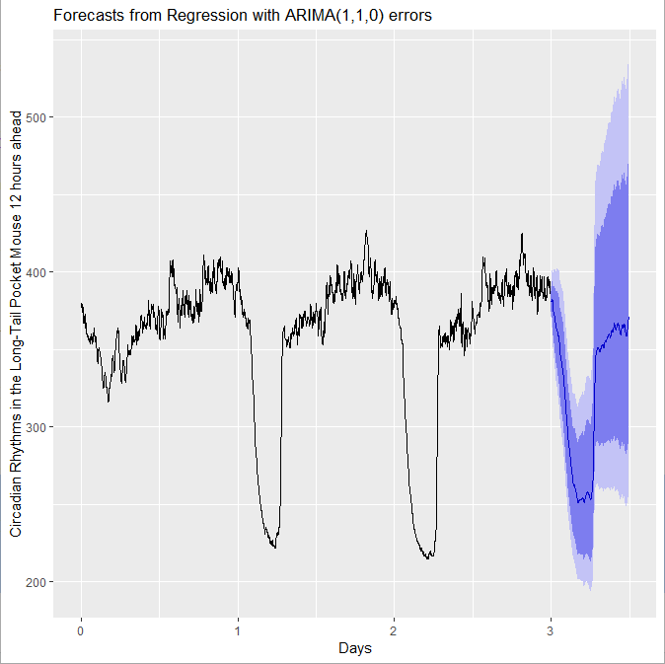

**Forecasting 24 hours ahead**

**dev.new()**

**day_1<- 30 * 24**

**fit %>%**

**forecast(xreg=fourier(msts_pp, K=c(14,65), h=day_1)) %>%**

**autoplot(include=tree_days) +**

**ylab("Circadian Rhythms in the Long-Tail Pocket Mouse 1 day ahead") +**

**xlab("Days")**

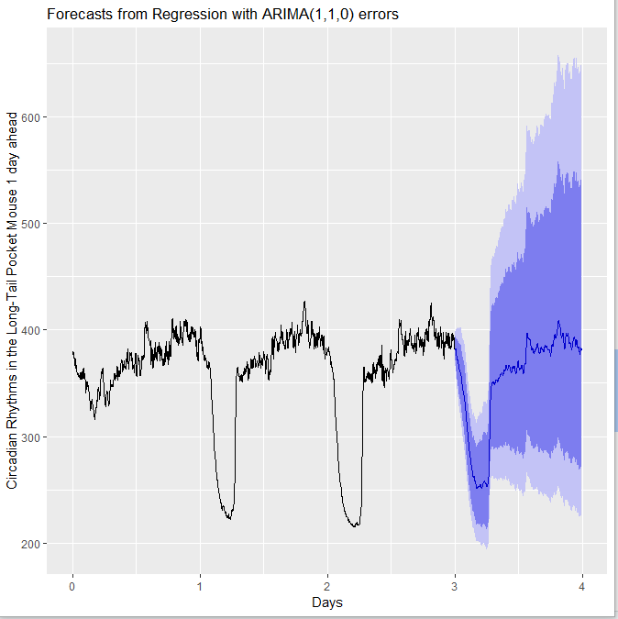

**Forecasting 2 days ahead**

**dev.new()**

**day_2<- 30 * 24 * 2**

**fit %>%**

**forecast(xreg=fourier(msts_pp, K=c(14,65), h=day_2)) %>%**

**autoplot(include=tree_days) +**

**ylab("Circadian Rhythms in the Long-Tail Pocket Mouse 2 days ahead") +**

**xlab("Days")**

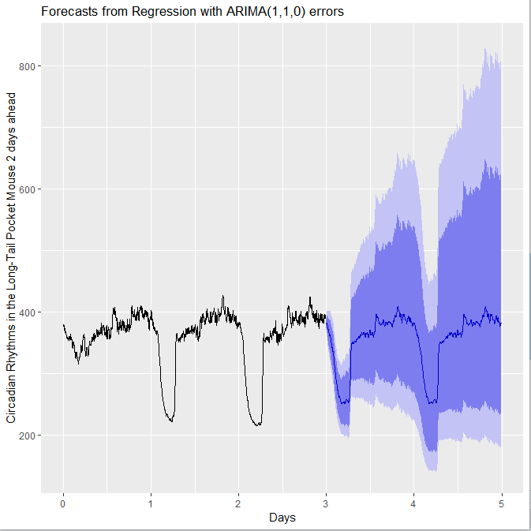

**Forecasting 1 week ahead**

**dev.new()**

**week_1<- 30 * 24 * 7**

**fit %>%**

**forecast(xreg=fourier(msts_pp, K=c(14,65), h=week_1)) %>%**

**autoplot(include=one_week) + ylab("Circadian Rhythms in the Long-Tail Pocket Mouse 7 days ahead") + xlab("days")**

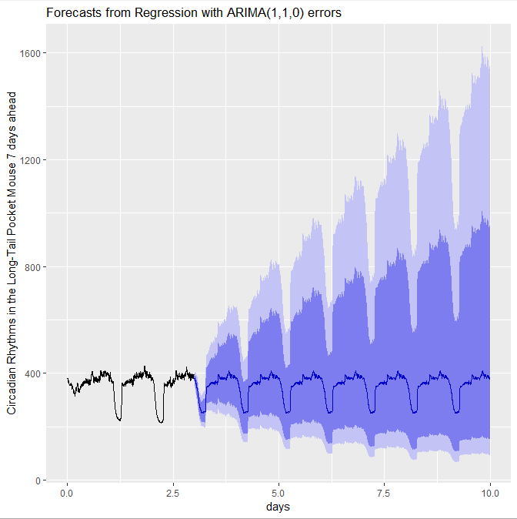

**Appendix also will provide code and results for original data of 7 days / 1 week /5040 observations instead of 3 days for discussion paragraph. Using the above techniques more than 3 days of data can be taken into consideration of forecasting**

**Bibliography**

**David Benson, Forecasting Daily Data with Multiple Seasonality in R**

[**http://www.dbenson.co.uk/Rparts/subpages/forecastR/**](http://www.dbenson.co.uk/Rparts/subpages/forecastR/)

**E. E. Holmes, M.D. Scheuerell, and E. J. Ward 2020-02-03,**

**Analysis for Fisheries and Environmental Sciences**

**Rob J Hyndman, George Athanasopoulos,**

**Forecasting Principles And Practice**

**DataSet** [**http://www.statsci.org/data/general/pformos5.html**](http://www.statsci.org/data/general/pformos5.html)

**Appendix**

**library(astsa)**

**examine.mod <- function(mod.fit.obj, p, d, q, P=0, D=0, Q=0, S=-1, lag.max=24) {**

**dev.new(width=6, height=6)**

**par(mfrow=c(2,1))**

**pacf(mod.fit.obj$fit$residuals, main="PACF of Residuals", lag.max)**

**if ((P==0)&(D==0)&(Q==0)) {**

**title(paste("Model: (", p, ",", d, ",", q, ")", sep=""), adj=0, cex.main=0.75)**

**}**

**else {**

**title(paste("Model: (", p, ",", d, ",", q, ") (", P, ",", D, ",", Q, ") [", S, "]", sep=""), adj=0, cex.main=0.75)**

**}**

**std.resid <- mod.fit.obj$fit$residuals/sqrt(mod.fit.obj$fit$sigma2)**

**hist(std.resid, main="Histogram of Standardized Residuals", xlab="Standardized Residuals", freq=FALSE)**

**curve(expr=dnorm(x, mean=mean(std.resid), sd=sd(std.resid)), col="red", add=TRUE)**

**}**

**pformosu<-read.table(file = "C:/Users/inna/Desktop/Time_Series/course/Project/pformosu.txt")**

**row =3726**

**col= 16**

**pformosu_dat = numeric(col*row)**

**count = 1**

**for(i in 1:row)**

**{**

**for(j in 1:col)**

**{**

**pformosu_dat[count]=pformosu[i,j]**

**count = count + 1**

**}**

**}**

**ts_p<-ts(pformosu_dat)**

**dev.new()**

**par(mfrow=c(2,1))**

**tsplot(ts_p)**

**boxplot(ts_p)$out**

**##############################################################**

**frequency <- 30**

**one_day<- 30*24**

**two_days_of_data<- one_day*2**

**three_days_of_data<-one_day*3**

**ts_p_3_days <- ts_p[(length(ts_p)-(three_days_of_data) + 1 ):(length(ts_p))]**

**ts_p<-ts_p[(length(ts_p)-(two_days_of_data) + 1 ):(length(ts_p))]**

**dev.new()**

**par(mfrow=c(2,1))**

**tsplot(ts_p,xlab="Number Of Observations")**

**boxplot(ts_p)$out**

**#############################################################**

**ts_pp <- ts(ts_p,frequency = frequency,start=0)**

**dev.new()**

**par(mfrow=c(2,1))**

**tsplot(ts_pp,xlab="Number Of Observations -> 2 Days")**

**boxplot(ts_pp)$out**

**dev.new()**

**tsplot(ts_pp,xlab="Number Of Observations -> 2 Days -> 1440 observations",**

**main="Circadian rhythms in the last 2 days/48 hours Frequency =30")**

**x<-as.numeric(ts_pp)**

**tsplot(x)**

**############################################################**

**dev.new()**

**tsplot(ts_pp, ylab=expression(x[t]),**

**xlab="hours", main="Circadian rhythms in the last week Of data")**

**dev.new()**

**acf2(x, max.lag = length(ts_pp) - 1,main = "ACF & PACF Of Original ts")**

**dev.new()**

**acf2(x, max.lag = frequency*3,main = "ACF & PACF Of Original ts")**

**############################################################**

**# Plot of (1-B^30)*x_t**

**dev.new()**

**tsplot(diff(ts_pp, lag=frequency, differences=2), ylab=expression((1-B^30)^2*x[t]),**

**xlab="hours", main=expression(paste("Plot of ", (1-B^30)^2*x[t])))**

**# ACF indicated cut of after 720 lag that suggests that ARIMA Q=1,**

**# PACF exponentially decay that suggests ARIMA P=0**

**# Diff =1 S=30 (1-B^30)*x_t**

**dev.new()**

**acf2(diff(x, lag=frequency, differences=), max.lag=frequency-1,**

**main=expression(paste("Est. ACF & PACF for ", (1-B^30)*x[t])))**

**##########################################################**

**# Plot of (1-B)(1-B^720)*x_t**

**dev.new()**

**tsplot(diff(diff(ts_pp, lag=frequency, differences=1)),**

**ylab=expression((1-B)(1-B^720)*x[t]),**

**xlab="Days Frequency = 720", main=expression(paste("Plot of ",**

**(1-B)(1-B^720)*x[t])))**

**# ACF and PACF of (1-B)(1-B^30)*x_t**

**dev.new()**

**acf2(diff( diff(x, lag=frequency, differences=1)),**

**max.lag=717,**

**main=expression(paste("Est. ACF & PACF for ", (1-B)(1-B^30)*x[t])))**

**#######################################################################**

**#Estimate**

**# First Estimate ARIMA(p=0-2,d=1,q=0-10,P=0,D=1,Q=1,S=30) #######**

**dev.new()**

**mod.fit1<- sarima(ts_pp,p=0,d=1,q=0,P=0,D=1,Q=1,S=300)**

**mod.fit1**

**dev.new()**

**par(mfrow=c(2,1))**

**pacf(mod.fit1$fit$residuals,main = " PACF Of residuals")**

**title(paste("Model: (",**

**p = 0, ",",**

**d = 1, ",",**

**q = 0, ")(",**

**P = 0, ",",**

**D = 1, ",",**

**Q = 1, ")[30]",**

**sep=""),adj=0,cex.main=0.75)**

**std.resid1 <- mod.fit1$fit$residuals / sqrt(mod.fit1$fit$sigma2)**

**hist(std.resid1,main = " Histogram Of Standardized Residuals",**

**xlab='Standardized Residuals',**

**freq = FALSE**

**)**

**### # First Estimate ARIMA(p=0,d=1,q=1,P=0,D=1,Q=1,S=30) #######**

**dev.new()**

**mod.fit1<- sarima(ts_pp,p=0,d=1,q=1,P=0,D=1,Q=1,S=300)**

**mod.fit1**

**dev.new()**

**par(mfrow=c(2,1))**

**pacf(mod.fit1$fit$residuals,main = " PACF Of residuals")**

**title(paste("Model: (",**

**p = 0, ",",**

**d = 1, ",",**

**q = 1, ")(",**

**P = 0, ",",**

**D = 1, ",",**

**Q = 1, ")[30]",**

**sep=""),adj=0,cex.main=0.75)**

**std.resid1 <- mod.fit1$fit$residuals / sqrt(mod.fit1$fit$sigma2)**

**hist(std.resid1,main = " Histogram Of Standardized Residuals",**

**xlab='Standardized Residuals',**

**freq = FALSE**

**)**

**### ARIMA(p=1,d=1,q=1,P=0,D=1,Q=1,S=30)**

**dev.new()**

**mod.fit1<- sarima(ts_pp,p=1,d=1,q=1,P=0,D=1,Q=1,S=720)**

**mod.fit1**

**dev.new()**

**par(mfrow=c(2,1))**

**pacf(mod.fit1$fit$residuals,main = " PACF Of residuals")**

**title(paste("Model: (",**

**p = 1, ",",**

**d = 1, ",",**

**q = 1, ")(",**

**P = 0, ",",**

**D = 1, ",",**

**Q = 1, ")[720]",**

**sep=""),adj=0,cex.main=0.75)**

**std.resid1 <- mod.fit1$fit$residuals / sqrt(mod.fit1$fit$sigma2)**

**hist(std.resid1,main = " Histogram Of Standardized Residuals",**

**xlab='Standardized Residuals',**

**freq = FALSE**

**)**

**#### ARIMA(p=0,d=1,q=2,P=0,D=1,Q=1,S=30)**

**dev.new()**

**mod.fit1<- sarima(ts_pp,p=0,d=1,q=2,P=0,D=1,Q=1,S=720)**

**mod.fit1**

**dev.new()**

**par(mfrow=c(2,1))**

**pacf(mod.fit1$fit$residuals,main = " PACF Of residuals")**

**title(paste("Model: (",**

**p = 0, ",",**

**d = 1, ",",**

**q = 2, ")(",**

**P = 0, ",",**

**D = 1, ",",**

**Q = 1, ")[30]",**

**sep=""),adj=0,cex.main=0.75)**

**std.resid1 <- mod.fit1$fit$residuals / sqrt(mod.fit1$fit$sigma2)**

**hist(std.resid1,main = " Histogram Of Standardized Residuals",**

**xlab='Standardized Residuals',**

**freq = FALSE**

**)**

**#### ARIMA(p=0,d=1,q=3,P=0,D=1,Q=1,S=30)**

**dev.new()**

**mod.fit1<- sarima(ts_pp,p=0,d=1,q=3,P=0,D=1,Q=1,S=720)**

**mod.fit1**

**dev.new()**

**par(mfrow=c(2,1))**

**pacf(mod.fit1$fit$residuals,main = " PACF Of residuals")**

**title(paste("Model: (",**

**p = 0, ",",**

**d = 1, ",",**

**q = 3, ")(",**

**P = 0, ",",**

**D = 1, ",",**

**Q = 1, ")[30]",**

**sep=""),adj=0,cex.main=0.75)**

**std.resid1 <- mod.fit1$fit$residuals / sqrt(mod.fit1$fit$sigma2)**

**hist(std.resid1,main = " Histogram Of Standardized Residuals",**

**xlab='Standardized Residuals',**

**freq = FALSE**

**)**

**#### ARIMA(p=1,d=1,q=0,P=0,D=1,Q=1,S=30)**

**dev.new()**

**mod.fit1<- sarima(ts_pp,p=1,d=1,q=0,P=0,D=1,Q=1,S=30)**

**mod.fit1**

**dev.new()**

**par(mfrow=c(2,1))**

**pacf(mod.fit1$fit$residuals,main = " PACF Of residuals")**

**title(paste("Model: (",**

**p = 1, ",",**

**d = 1, ",",**

**q = 0, ")(",**

**P = 0, ",",**

**D = 1, ",",**

**Q = 1, ")[30]",**

**sep=""),adj=0,cex.main=0.75)**

**std.resid1 <- mod.fit1$fit$residuals / sqrt(mod.fit1$fit$sigma2)**

**hist(std.resid1,main = " Histogram Of Standardized Residuals",**

**xlab='Standardized Residuals',**

**freq = FALSE**

**)**

**#### ARIMA(p=2,d=1,q=0,P=0,D=1,Q=1,S=30)**

**dev.new()**

**mod.fit1<- sarima(ts_pp,p=2,d=1,q=0,P=0,D=1,Q=1,S=30)**

**mod.fit1**

**dev.new()**

**par(mfrow=c(2,1))**

**pacf(mod.fit1$fit$residuals,main = " PACF Of residuals")**

**title(paste("Model: (",**

**p = 2, ",",**

**d = 1, ",",**

**q = 0, ")(",**

**P = 0, ",",**

**D = 1, ",",**

**Q = 1, ")[30]",**

**sep=""),adj=0,cex.main=0.75)**

**std.resid1 <- mod.fit1$fit$residuals / sqrt(mod.fit1$fit$sigma2)**

**hist(std.resid1,main = " Histogram Of Standardized Residuals",**

**xlab='Standardized Residuals',**

**freq = FALSE**

**)**

**#### ARIMA(p=2,d=1,q=2,P=0,D=1,Q=1,S=30)**

**dev.new()**

**mod.fit1<- sarima(ts_pp,p=2,d=1,q=2,P=0,D=1,Q=1,S=30)**

**mod.fit1**

**dev.new()**

**par(mfrow=c(2,1))**

**pacf(mod.fit1$fit$residuals,main = " PACF Of residuals")**

**title(paste("Model: (",**

**p = 2, ",",**

**d = 1, ",",**

**q = 2, ")(",**

**P = 0, ",",**

**D = 1, ",",**

**Q = 1, ")[30]",**

**sep=""),adj=0,cex.main=0.75)**

**std.resid1 <- mod.fit1$fit$residuals / sqrt(mod.fit1$fit$sigma2)**

**hist(std.resid1,main = " Histogram Of Standardized Residuals",**

**xlab='Standardized Residuals',**

**freq = FALSE**

**)**

**#### ARIMA(p=2,d=1,q=3,P=0,D=1,Q=1,S=30)**

**dev.new()**

**mod.fit1<- sarima(ts_pp,p=3,d=1,q=3,P=0,D=1,Q=1,S=30)**

**mod.fit1**

**dev.new()**

**par(mfrow=c(2,1))**

**pacf(mod.fit1$fit$residuals,main = " PACF Of residuals")**

**title(paste("Model: (",**

**p = 3, ",",**

**d = 1, ",",**

**q = 2, ")(",**

**P = 0, ",",**

**D = 1, ",",**

**Q = 1, ")[30]",**

**sep=""),adj=0,cex.main=0.75)**

**std.resid1 <- mod.fit1$fit$residuals / sqrt(mod.fit1$fit$sigma2)**

**hist(std.resid1,main = " Histogram Of Standardized Residuals",**

**xlab='Standardized Residuals',**

**freq = FALSE**

**)**

**######################## Forecasting ####################**

**dev.new()**

**mod.fit.110.011 <- sarima(x, p=1,d=1,q=1,P=0,D=1,Q=1,S=30)**

**mod.fit.110.011**

**examine.mod(mod.fit.110.011, 2,1,2, 0,1,1, 30)**

**##### 1 hour ahead #######################################**

**ahead_1_hours <-30**

**dev.new()**

**fore.mod <- sarima.for(ts_pp, n.ahead=ahead_1_hours,**

**p=1, d=1, q=1, P=0, D=1, Q=1, S=30, plot.all=TRUE)**

**dev.new()**

**tsplot(fore.mod$pred)**

**##### 4 hours ahead ######################################**

**ahead_4_hours <- 4*30**

**dev.new()**

**fore.mod <- sarima.for(ts_pp, n.ahead=ahead_4_hours,**

**p=1, d=1, q=1, P=0, D=1, Q=1, S=30, plot.all=TRUE)**

**dev.new()**

**tsplot(fore.mod$pred)**

**##########################################################**

**#### 24 hours ahead #####################################**

**ahead_24_hours <- 24*30**

**dev.new()**

**fore.mod <- sarima.for(ts_pp, n.ahead=ahead_24_hours,**

**p=1, d=1, q=1, P=0, D=1, Q=1, S=30, plot.all=TRUE)**

**#########################################################**

**pred.mod <- ts(x - mod.fit.110.011$fit$residuals)**

**dev.new()**

**tsplot(ts_pp[1:length(ts_pp)], ylab="pred", xlab="min",**

**type="o", main="Predicted Model vs Real Data")**

**lines(pred.mod, col="red", type="o", pch=17)**

**legend("topleft", legend=c("Observed", "Forecast"),**

**lty=c("solid", "solid"), col=c("black", "red"),**

**pch=c(1, 17), bty="n")**

**############ Discussion code #########################**

**library(astsa)**

**library("forecast")**

**library("lubridate")**

**library("ggplot2")**

**library(magrittr)**

**# needs to be run every time you start R and want to use %>%**

**library(dplyr)**

**#########################################################**

**On_hour <- 30**

**one_day <- 30*24**

**tree_days <- 30*24*3**

**frequency <- c(On_hour,one_day)**

**msts_pp <- msts(ts_p_3_days,seasonal.periods = frequency,start = 0)**

**dev.new()**

**tsplot(msts_pp,xlab="days",**

**main="Circadian rhythms in the last 3d/72h/2736obs Freq = 30")**

**########################################################**

**#install.packages("forecast")**

**#install.packages("lubridate")**

**dev.new()**

**msts_pp %>% mstl() %>%autoplot() + xlab("Days")**

**### Forecast made by stlf ############################**

**dev.new()**

**msts_pp %>% stlf() %>%autoplot() + xlab("Days")**

**#### Fit Multiple seasonalities using fourier ########**

**fit <- auto.arima(msts_pp, seasonal=FALSE, lambda=0,xreg=fourier(msts_pp, K=c(14,65)))**

**fit**

**#### Forecast 10 minutes = 5 observations ahead #####**

**dev.new()**

**minutes_10<- 5**

**fit %>%**

**forecast(xreg=fourier(msts_pp, K=c(14,65), minutes_10)) %>%**

**autoplot(tree_days) + ylab("Circadian Rhythms in the Long-Tail Pocket Mouse 10 minutes ahead") + xlab("Days")**

**# Forecast**

**# 1hour ahead = 30 observations observations ahead #####**

**dev.new()**

**hour_1<- 30**

**fit %>%**

**forecast(xreg=fourier(msts_pp, K=c(14,65), h=hour_1)) %>%**

**autoplot(include=tree_days) +**

**ylab("Circadian Rhythms in the Long-Tail Pocket Mouse 1 hour ahead") +**

**xlab("Days")**

**# Forecast**

**# 4 hours ahead = 120 observations observations ahead #####**

**dev.new()**

**hours_4<- 30 * 4**

**fit %>%**

**forecast(xreg=fourier(msts_pp, K=c(14,65), h=hours_4)) %>%**

**autoplot(include=tree_days) + ylab("Circadian Rhythms in the Long-Tail Pocket Mouse 4**

**hours ahead") + xlab("Days")**

**# Forecast**

**# 12 hours ahead = 360 observations observations ahead #####**

**dev.new()**

**hours_12<- 30 * 12**

**fit %>%**

**forecast(xreg=fourier(msts_pp, K=c(14,65), h=hours_12)) %>%**

**autoplot(include=tree_days) +**

**ylab("Circadian Rhythms in the Long-Tail Pocket Mouse 12 hours ahead") +**

**xlab("Days")**

**# Forecast**

**# 24 hours ahead = 720 observations observations ahead #####**

**dev.new()**

**day_1<- 30 * 24**

**fit %>%**

**forecast(xreg=fourier(msts_pp, K=c(14,65), h=day_1)) %>%**

**autoplot(include=tree_days) +**

**ylab("Circadian Rhythms in the Long-Tail Pocket Mouse 1 day ahead") +**

**xlab("Days")**

**# Forecast**

**# 2 days ahead = 1440 observations observations ahead #####**

**dev.new()**

**day_2<- 30 * 24 * 2**

**fit %>%**

**forecast(xreg=fourier(msts_pp, K=c(14,65), h=day_2)) %>%**

**autoplot(include=tree_days) +**

**ylab("Circadian Rhythms in the Long-Tail Pocket Mouse 2 days ahead") +**

**xlab("Days")**

**# Forecast**

**# 1 week ahead = 5040 observations observations ahead #####**

**dev.new()**

**week_1<- 30 * 24 * 7**

**fit %>%**

**forecast(xreg=fourier(msts_pp, K=c(14,65), h=week_1)) %>%**

**autoplot(include=tree_days) +**

**ylab("Circadian Rhythms in the Long-Tail Pocket Mouse 7 days ahead") +**

**xlab("days")**

**Results for for last 7 days of data**

**On_hour <- 30**

**one_day <- 30*24**

**one_week <- 30*24*7**

**frequency <- c(30,one_day)**

**msts_pp <- msts(ts_p[(length(ts_p)-(one_week) + 1 ):(length(ts_p))],seasonal.periods = frequency)**

**dev.new()tsplot(msts_pp)**

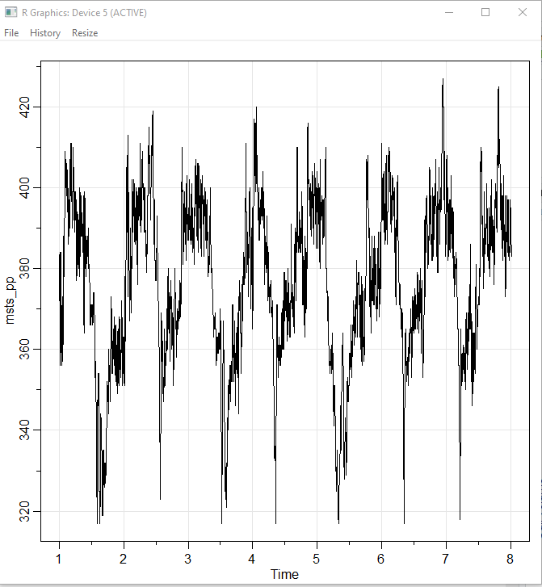

**msts_pp %>% mstl() %>%autoplot() + xlab("Day")**

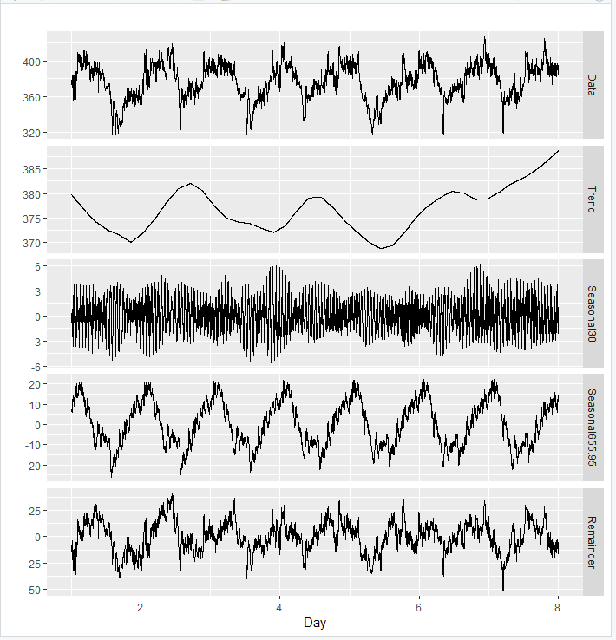

**msts_pp %>% stlf() %>% autoplot() + xlab("Day")**

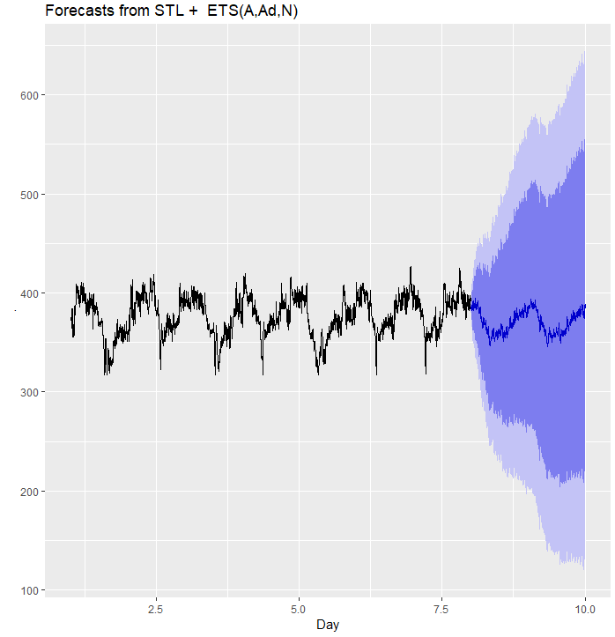

### 

**fit <- auto.arima(msts_pp, seasonal=FALSE, lambda=0,xreg=fourier(msts_pp, K=c(14,65)))**

**fit**

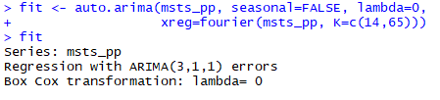



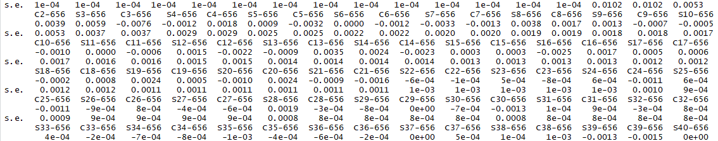

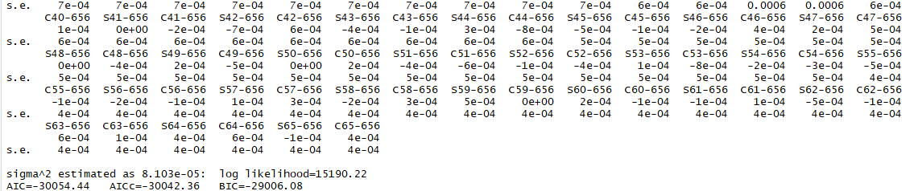

**Forecasting 10 minutes/5 obs ahead**

**dev.new()**

**minutes_10<- 5**

**fit %>%**

**forecast(xreg=fourier(msts_pp, K=c(14,65), minutes_10)) %>%**

**autoplot(include=one_week) + ylab("Circadian Rhythms in the Long-Tail Pocket Mouse 10**

**minutes ahead") + xlab("Days")**

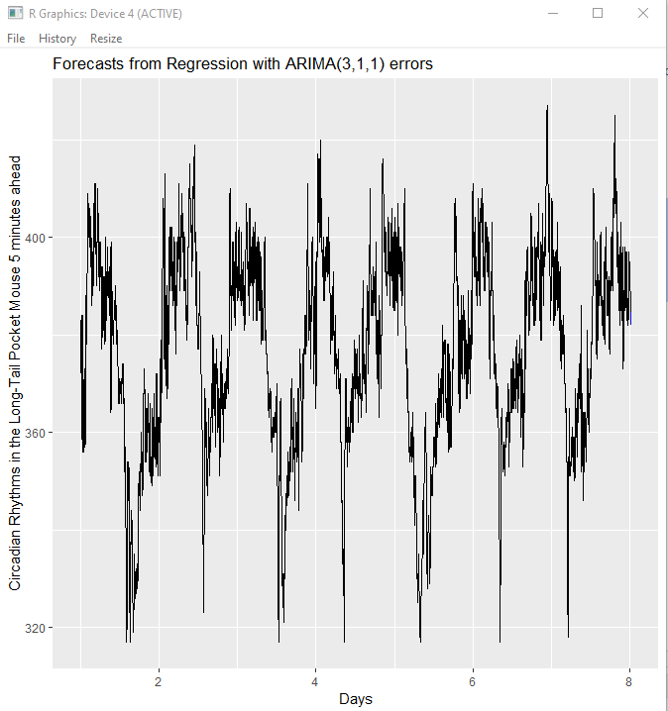

**Forecasting 1 hour/30 obs ahead**

**dev.new()**

**hour_1<- 30**

**fit %>%**

**forecast(xreg=fourier(msts_pp, K=c(14,65), h=hour_1)) %>%**

**autoplot(include=one_week) + ylab("Circadian Rhythms in the Long-Tail Pocket Mouse 1 hour ahead") + xlab("Days")**

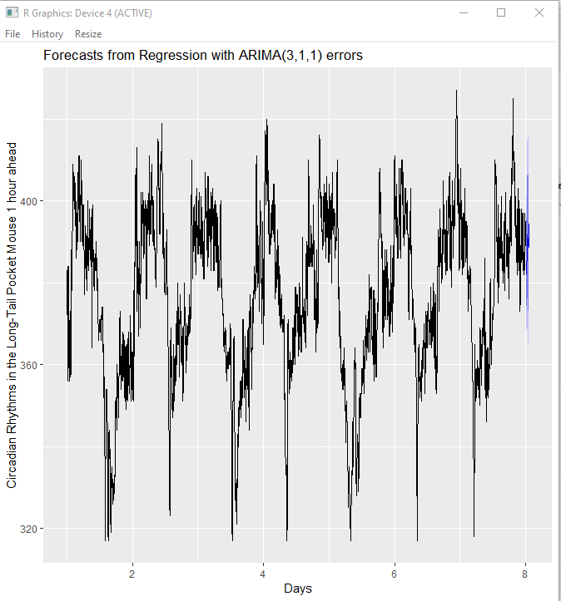

**Forecasting 4 hours/120 obs ahead**

**dev.new()**

**hours_4<- 30 *4**

**fit %>%**

**forecast(xreg=fourier(msts_pp, K=c(14,65), h=hours_4)) %>%**

**autoplot(include=one_week) + ylab("Circadian Rhythms in the Long-Tail Pocket Mouse 4**

**hours ahead") + xlab("Days")**

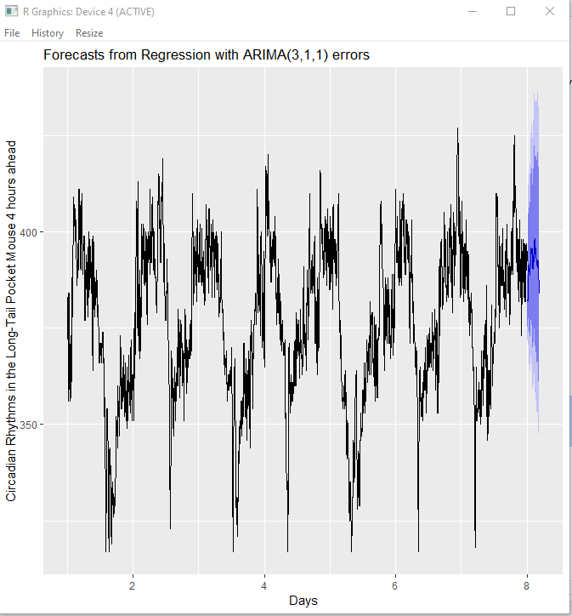

**Forecasting 12 hours/360 obs ahead**

**dev.new()**

**hours_12<- 30 * 12**

**fit %>%**

**forecast(xreg=fourier(msts_pp, K=c(14,65), h=hours_12)) %>%**

**autoplot(include=one_week) + ylab("Circadian Rhythms in the Long-Tail Pocket Mouse 12 hours ahead") + xlab("Days")**

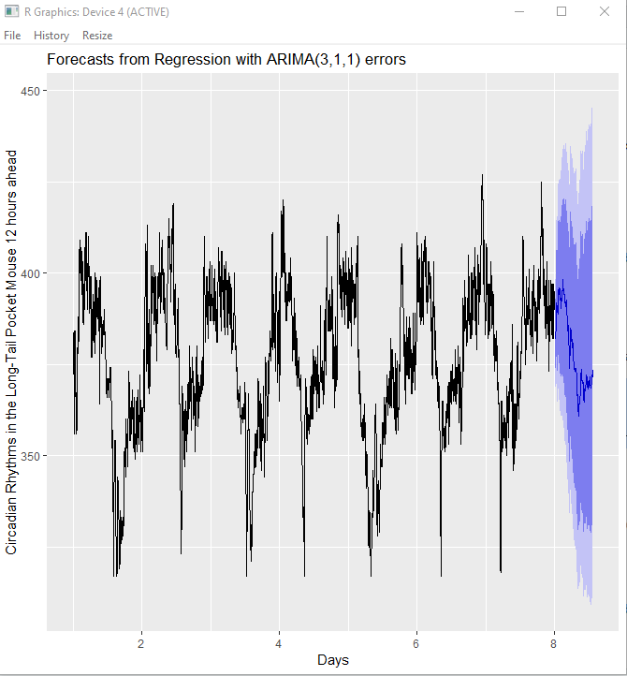

**Forecasting 1 day/720 obs ahead**

**dev.new()**

**day_1<- 30 * 24**

**fit %>%**

**forecast(xreg=fourier(msts_pp, K=c(14,65), h=day_1)) %>%**

**autoplot(include=one_week) + ylab("Circadian Rhythms in the Long-Tail Pocket Mouse 1 day ahead") + xlab("Days")**

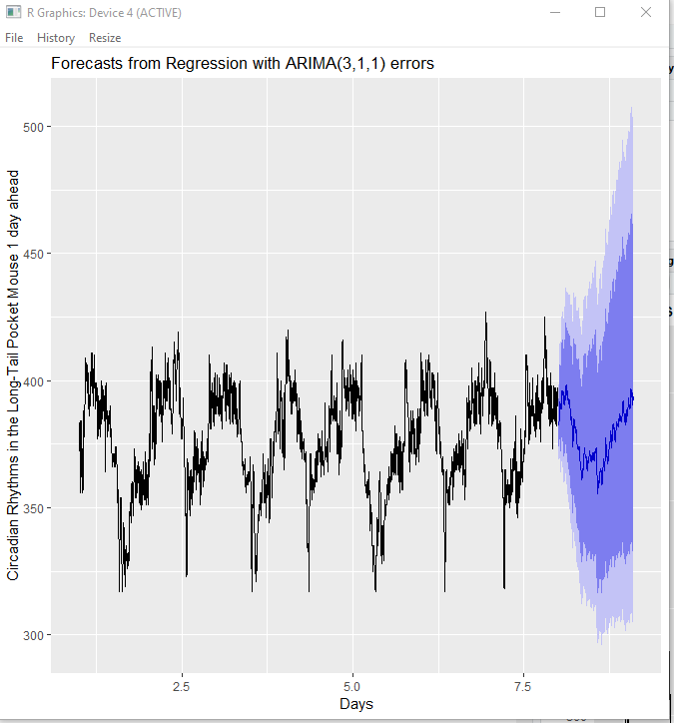

**Forecasting 2 days/1440 obs ahead**

**dev.new()**

**day_2<- 30 * 24 * 2**

**fit %>%**

**forecast(xreg=fourier(msts_pp, K=c(14,65), h=day_2)) %>%**

**autoplot(include=one_week) + ylab("Circadian Rhythms in the Long-Tail Pocket Mouse 2 days ahead") + xlab("Days")**

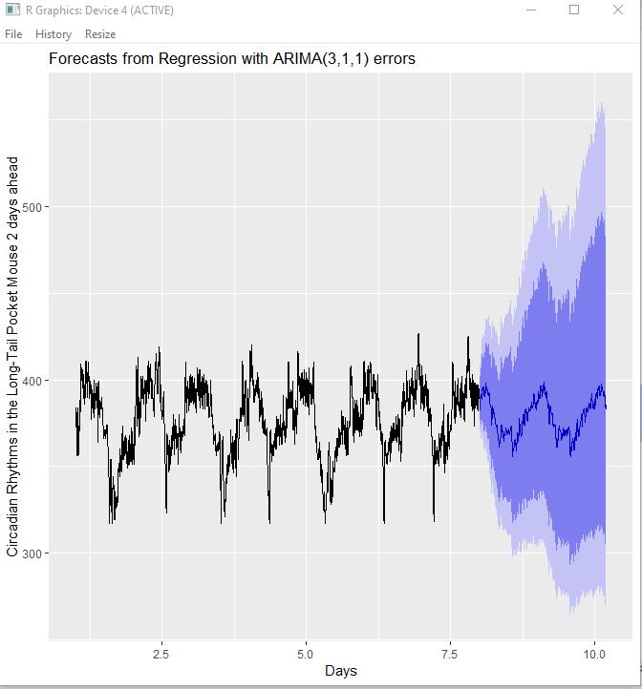

**Forecasting 7days/5040 obs ahead**

**dev.new()**

**week_1<- 30 * 24 * 7**

**fit %>%**

**forecast(xreg=fourier(msts_pp, K=c(14,65), h=week_1)) %>%**

**autoplot(include=one_week) + ylab("Circadian Rhythms in the Long-Tail Pocket Mouse 7 days ahead") + xlab("days")**

