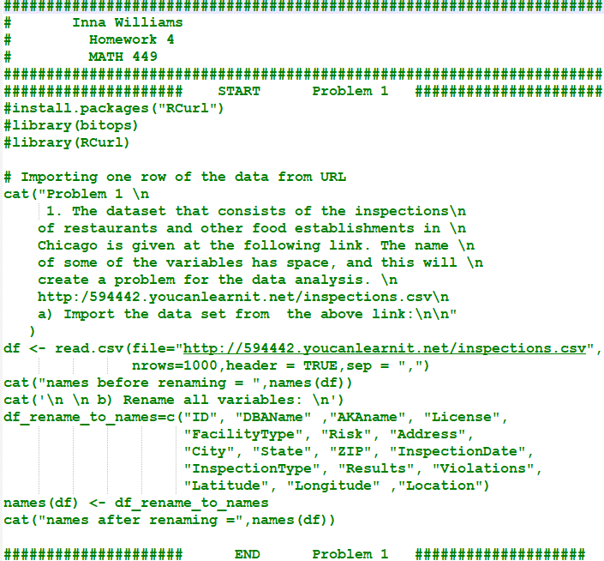
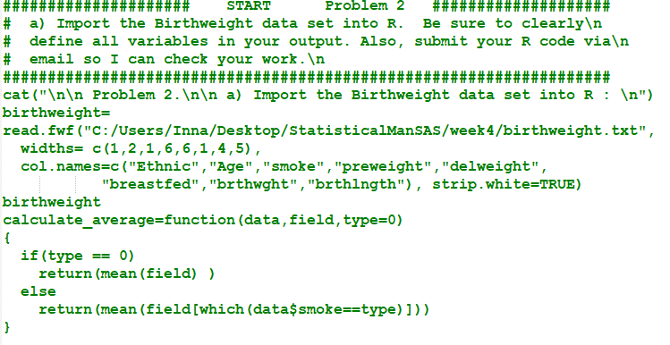
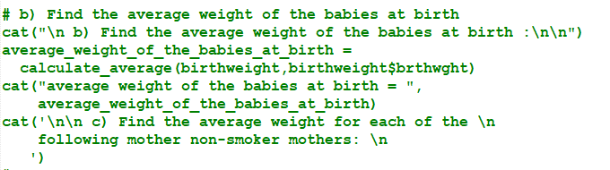
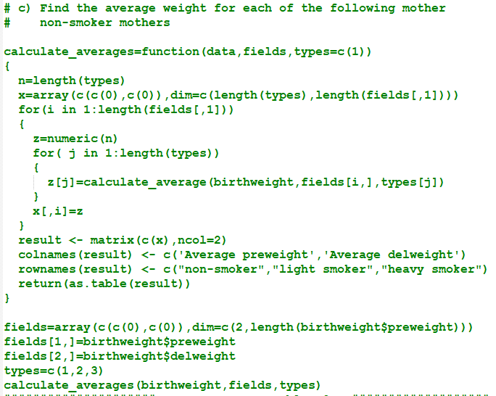
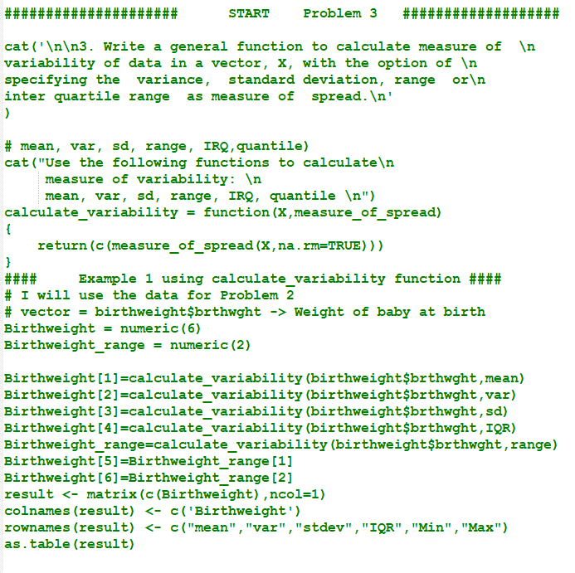
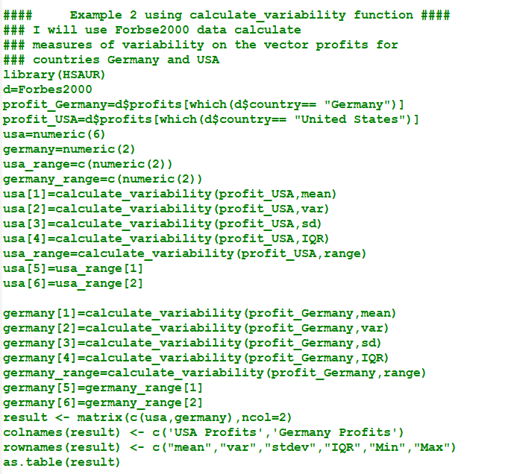
Statistical Data Management
performed by Inna Williams
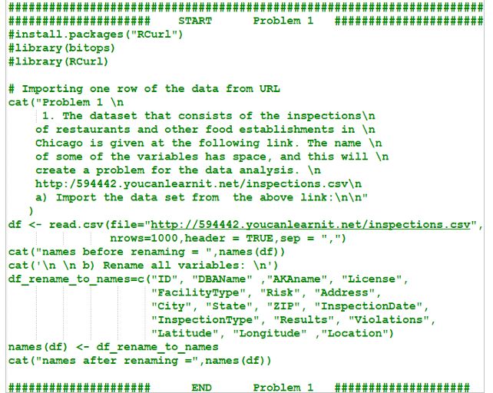

Output Problem 1

Problem 1

1. The dataset that consists of the inspections

of restaurants and other food establishments in

Chicago is given at the following link. The name

of some of the variables has space, and this will

create a problem for the data analysis.

http:/594442.youcanlearnit.net/inspections.csv

a) Import the data set from the above link:

names before renaming = Inspection.ID DBA.Name AKA.Name License.. Facility.Type Risk Address City State Zip Inspection.Date Inspection.Type Results Violations Latitude Longitude Location

b) Rename all variables:
names after renaming = ID DBAName AKAname License FacilityType Risk Address City State ZIP InspectionDate InspectionType Results Violations Latitude Longitude Location

Output Problem 2 a)

a) Import the Birthweight data set into R :
Ethnic Age smoke preweight delweight breastfed brthwght brthlngth
1 1 24 1 105.41 129.97 Y 3170 52.03
2 2 28 2 165.61 187.63 N 3640 51.40
3 2 25 1 175.87 190.72 Y 3664 47.49
4 2 24 3 125.88 150.81 N 2760 45.45
5 3 28 1 92.89 117.68 Y 2950 50.51
6 2 21 1 140.81 165.77 N 3460 53.11
7 1 29 1 125.61 160.61 Y 3350 48.34
8 3 27 3 127.73 148.76 Y 3200 48.04
9 2 19 1 132.22 156.94 N 3360 51.38
10 3 22 1 118.73 161.03 Y 3493 49.52
11 2 34 1 189.01 200.31 Y 3600 48.02
12 1 25 3 144.45 180.96 N 3050 51.51
13 2 25 1 125.19 152.75 N 3050 52.72
14 2 19 2 137.82 172.25 N 2400 46.96
15 3 35 1 140.96 174.85 N 3940 48.09
16 1 23 3 135.08 173.36 Y 2650 49.82
17 1 20 1 112.59 140.75 N 3800 51.25
18 2 20 2 128.19 159.73 N 3070 48.29
19 3 26 1 99.18 141.27 Y 3210 50.12

Output Problem 2 b)

b) Find the average weight of the babies at birth :

average weight of the babies at birth = 3253.526

Output Problem 2 c)

c) Find the average weight for each of the

following mother non-smoker mothers:

Average preweight Average delweight
non-smoker 129.8725 157.7208
light smoker 143.8733 173.2033
heavy smoker 133.2850 163.4725

Output Problem 3

3. Write a general function to calculate measure of

variability of data in a vector, X, with the option of

specifying the variance, standard deviation, range or

inter quartile range as measure of spread.
Use the following functions to calculate

measure of variability:

mean, var, sd, range, IRQ, quantile
Birthweight
mean 3253.5263
var 160283.8187
stdev 400.3546
IQR 496.5000
Min 2400.0000
Max 3940.0000

Output

USA Profits Germany Profits
mean 0.65160428 -0.03815385
var 3.20203624 11.67500279
stdev 1.78942344 3.41687032
IQR 0.45250000 0.44000000
Min -4.45000000 -25.83000000
Max 20.96000000 5.12000000

