Capstone Project Motivations

JUSTFAIR State – North Carolina

Authors: Preet Khowaja​, Dorothy Hou, Chuhan Zhou​, and Clarissa Aché​.

“United States is home to 5 percent of the world’s population but 25 percent of its prisoners. We have more total prisoners than any other country in the world”.

The U.S. has a longstanding history of racial bias in the criminal justice system, depicted by the disproportionate makeup of African American prisoners as opposed to the general populace. The deep-rootedness of this systemic bias makes it a complex and challenging problem to solve, but one without which true justice cannot be served. Investigating this bias requires a robust data-oriented approach based on legal sentencing guidelines and historical sentencing records. According to the U.S. Constitution, citizens have a right to access criminal trial proceedings, but these have been difficult to obtain, and in practice, this right is rarely granted. In other words, “the public does not have access to high quality, large-scale information about the federal criminal justice system, and therefore, much of what happens in criminal courts remains opaque[1]”. While sentencing guidelines inform decision-makers on the corresponding penalties for every processed trial, appointed judges still hold discretion on each case’s outcome, allowing personal biases to obstruct justice.

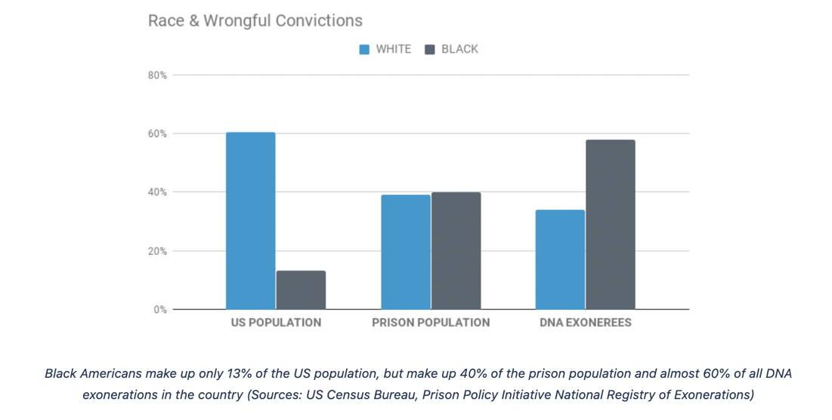

*Source: Georgia Innocence Project*

There have been many recent efforts investigating bias in criminal sentencing. One source that has amalgamated the results of multiple studies over the years is that of The Sentencing Project[2]. Some similar work regarding JUSTFAIR can also be found [here](https://journals.plos.org/plosone/article?id=10.1371/journal.pone.0241381#sec002). However, previous work is either outdated or does not take a data science approach to this problem. This study builds on previous work by focusing on North Carolina and analyzing more recent data.

This project is a subsequent effort of the JUSTFAIR initiative, which aims to bring transparency to the criminal justice system in the United States by making archived court records publicly available in an aggregated format to facilitate analysis. The project described in this document will have the same objective but focuses on the level of state courts, specifically, criminal sentences of the state of North Carolina.

The first output of this project will be the database itself, which will be constructed to the standards of the larger JUSTFAIR initiative. The publication of the database will allow for independent research of the criminal justice system of North Carolina. The possibility of scrutiny can promote accountability to elected and appointed public officials participating in the system.

The second deliverable of this project will be to produce analyses that investigate whether the decisions made in the criminal court system of North Carolina are biased against groups of people of different demographics, including race. We will answer whether people of different demographics are prosecuted the same way, that is, whether justice is being served for all people equally.

Finally, we will provide a playbook as a template project to replicate this analysis in a different state. QSIDE, the organization behind the JUSTFAIR project, intends to expand the initiative to all 50 states and all levels of courts. Our research can not only help bring more transparency to the prosecution system in North Carolina, but help other researchers complete similar work and multiply the impact.

This project intends to expose biases and other faults in the law enforcement system that put groups of people at a disadvantage compared to others. The outcome of this study is useful for both the residents and the appointed and elected officials of North Carolina. Residents can hold the public officials accountable for the responsibility they are given. Additionally, public officials can help remediate potentially biased behaviors and make better decisions and use of their power.

References:

1. Ciocanel M-V, Topaz CM, Santorella R, Sen S, Smith CM, Hufstetler A (2020) JUSTFAIR: Judicial System Transparency through Federal Archive Inferred Records. PLoS ONE 15(10): e0241381. <https://doi.org/10.1371/journal.pone.0241381>

2. The Sentencing Project, “Racial Disparity in Sentencing”, January 2005. <https://www.opensocietyfoundations.org/publications/racial-disparity-sentencing>

3. Bureau, U. S. C. Retrieved September 22, 2022, from <https://www.census.gov/>

1. Ciocanel M-V, Topaz CM, Santorella R, Sen S, Smith CM, Hufstetler A (2020) JUSTFAIR: Judicial System Transparency through Federal Archive Inferred Records. PLoS ONE 15(10): e0241381. https://doi.org/10.1371/journal.pone.0241381
2. The Sentencing Project, *“Racial Disparity in Sentencing”*, January 2005. <https://www.opensocietyfoundations.org/publications/racial-disparity-sentencing>