Nathan Gagné

Yixi Wu

Chang Geng

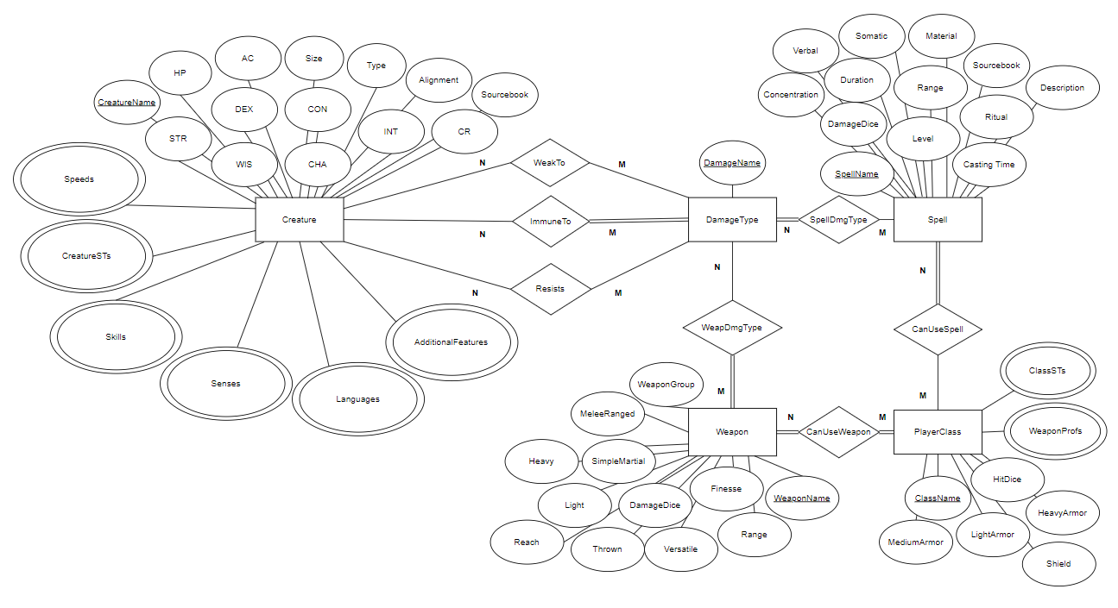**COMP 3380 Project ER Diagram**

**Participation/Cardinality constraints:**

**WeakTo:** WeakTo is partial participation on both sides because some creatures are not weak to any damage types and some damage types will never appear in the WeakTo relationship, since no creature is weak to it. Creatures can be weak to many damage types and many creatures can be weak to the same damage type, so the cardinality is N to M.

**ImmuneTo:** ImmuneTo is partial participation the side of Creature because some creatures are not immune to any damage types, but total participation on the side of DamageType, because for every damage type, there is a creature that is immune to it. Creatures can be immune to many damage types and many creatures can be immune to the same damage type, so the cardinality is N to M.

**Resists:** Resists is partial participation on both sides because some creatures do not resist any damage types and some damage types will never appear in the Resists relationship, since no creature resists it. Creatures can resist many damage types and many creatures can resist the same damage type, so the cardinality is N to M.

**SpellDmgType:** SpellDmgType is total participation on the side of DamageType, but partial participation on the side of Spell, since there exists at least one spell with each of the damage types in the SpellDmgType relationship, but not every Spell has a damage type. Spells can have multiple damage types and many spells share the same damage type, so the cardinality is N to M.

**WeapDmgType:** WeapDmgType is partial participation on the side of DamageType, but total participation on the side Weapon, since some damage types (some elemental ones) won’t appear in the WeapDmgType relationship, but every weapon has a damage type. Every weapon can have one or multiple damage types and many weapons share the same damage type, so the cardinality is N to M.

**CanUseWeapon:** CanUseWeapon is total participation on both sides, because every weapon can be used by at least one class and every player class can wield at least one type of weapon. Every player class can use many weapons, and every weapon can be wielded by many classes, so the cardinality is N to M.

**CanUseSpell:** CanUseSpell is total participation on the side of Spell, but partial participation on the side of PlayerClass. This is because not every player class can use spells, but every spell can be used by at least one class (they must appear in at least one spell list). Player classes have access to many spells and spells can be in multiple classes’ spell lists, so the cardinality is N to M.

**Post-merge and Post-normalization relational model:**

**Creature(CreatureName, Size, Type, Alignment, AC, HP, STR, DEX, CON, INT, WIS, CHA, CR, Sourcebook)**

CreatureName -> Size, Type, Alignment, AC, HP, STR, DEX, CON, INT, WIS, CHA, CR, Sourcebook

**Speeds(CreatureName,Speed)**

**CreatureSTs(CreatureName,SavingThrow)**

**Skills(CreatureName, Skill)**

**Senses(CreatureName,Sense)**

**Languages(CreatureName,Language)**

**AdditionalFeatures(CreatureName,Feature)**

**DamageType(DamageName)**

**Spell(SpellName, Level, Ritual, Casting Time, Range, Verbal, Somatic, Material, Concentration, Duration, DamageDice, Sourcebook, Description)**

SpellName -> Level, Ritual, Casting Time, Range, Verbal, Somatic, Material, Concentration, Duration, DamageDice, Sourcebook, Description.

**Weapon(WeaponName, SimpleMartial, MeleeRanged, WeaponType, WeaponGroup, DamageDice, Versatile, Light, Heavy, Range, Thrown, Finesse, Reach)**

WeaponName -> SimpleMartial, MeleeRanged, WeaponType, WeaponGroup, DamageDice, Versatile, Light, Heavy, Range, Thrown, Finesse, Reach

**PlayerClass(ClassName, HitDice, LightArmor, MediumArmor, HeavyArmor, Shield)**

ClassName -> HitDice, LightArmor, MediumArmor, HeavyArmor, Shield

**WeaponProfs(ClassName,WeaponProf)**

**ClassSTs(ClassName,SavingThrow)**

**WeakTo(CreatureName,DamageName)**

**ImmuneTo(CreatureName,DamageName)**

**Resists(CreatureName,DamageName)**

**SpellDmgType(SpellName,DamageName)**

**WeapDmgType(WeaponName,DamageName­)**

**CanUseWeapon(ClassName,WeaponName)**

**CanUseSpell(ClassName,SpellName­)**

**No tables needed to be merged.**