**Problem Set 7 (Go)**

1. **Mozart Dice Game**

Output is linked as video(“goMozart.mp4”)

1. **Movie Sentiment Analysis**

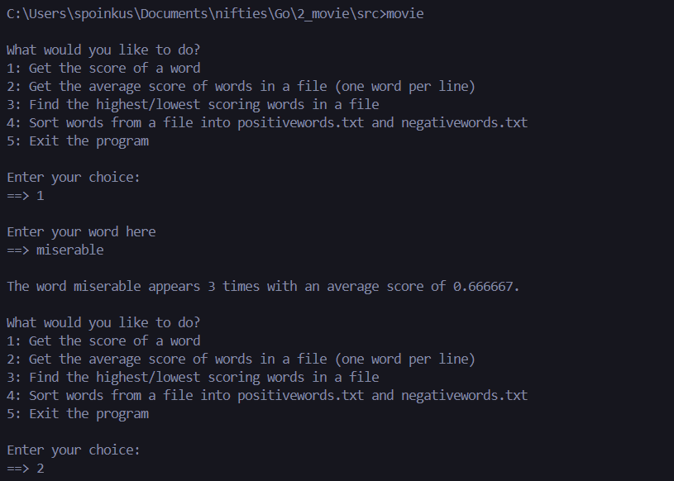

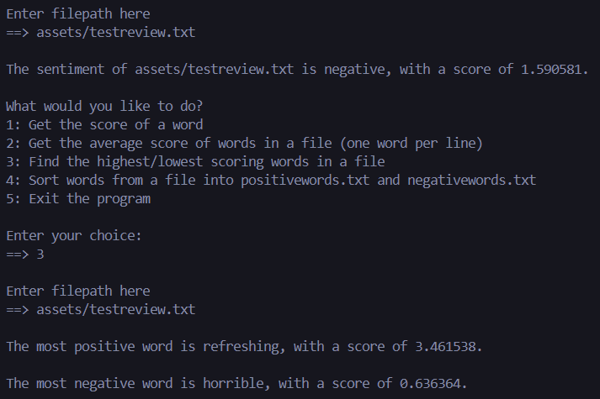

1. **Hawaiian Phonetic Pronunciation**

