**Problem Set 6 (Rust)**

1. **Mozart Dice Game**

Output is linked as video(“rustMozart.mp4”)

1. **Movie Sentiment Analysis**

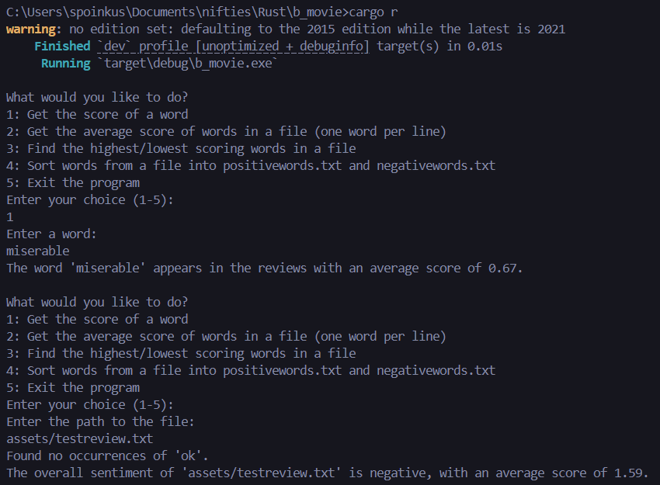

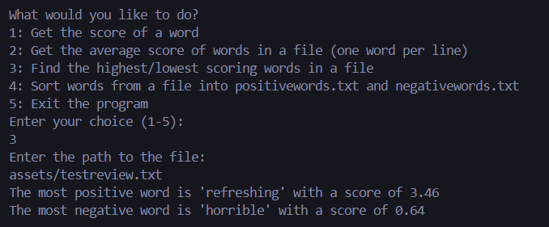

1. **Hawaiian Phonetic Pronunciation**

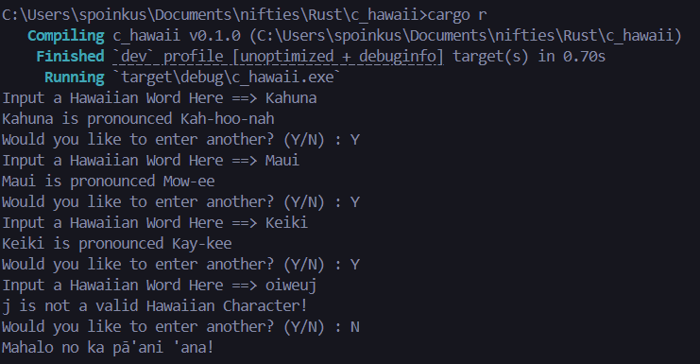

1. **Melody**

Output is linked as (“rustMelody.mp4”)