A CASE-STUDY BASED REPORT
ON
INSIDER THREAT DETECTION USING ELASTIC NET AND RANDOM FOREST
submitted in partial fulfilment of the requirements for the Course
MACHINE LEARNING
BACHELOR OF TECHNOLOGY
in
A.Y.: 2026-27
by
Name: CHAVA NOHITHA Roll No: 2520030130
Name: G. LAASYA Roll No: 2520030118
Name: KALLU SHRESTA PRIYA Roll No: 2520030127
Under the Esteemed guidance of
Gaddam Ravindra Babu
Asst. Professor, Dept. of CSE



INDEX
Abstract
Introduction
Background
Motivation for the Project
Overview of the Work Carried Out
Scope and Responsible-Use Statement
Problem Statement
Case-Study Scenario
Central Case-Study Question
Formal Problem Definition
Objectives that Guide the Study
Assumptions and Limitations
Dataset and Exploratory Data Analysis
About the Dataset
Purpose of EDA
Preparation Steps Actually Performed
EDA Exploration - Implementation
Summary of EDA Findings
Algorithm Selection and Implementation
Conclusion
References
Signature of the Team members

ABSTRACT
Insider threats are security risks that originate from people who already hold authorised access to an organisation’s systems. Because these users operate with legitimate credentials, their harmful actions often resemble ordinary work and are difficult to separate from normal behaviour, and the volume of activity data is too large for manual review. This case study applies machine learning to classify user activity as normal or a potential insider threat.
The study uses a dataset of 1,250 user-activity records with 17 columns, nine behavioural features (login frequency, file access, sensitive-file access, email activity, external recipients, USB usage, after-hours activity, failed logins and data transferred) and a binary label in which 69 records (5.52%) are threats. After exploratory data analysis, a stratified 80/20 split and standardisation fitted on training data only, Elastic Net (an L1 + L2 regularised logistic regression) is used to select features and a Random Forest is trained on the selected features. Score-derived columns (threat_score, risk_level, threat_category) are excluded to prevent label leakage.
On the held-out test set of 250 records (14 threats), the proposed Elastic Net + Random Forest pipeline reached accuracy 0.9960, precision 0.9333, recall 1.0000 and F1-score 0.9655, detecting all 14 threats with one false alarm. Four baseline models performed equally well or slightly better, which shows that this dataset is almost perfectly separable. The report therefore treats these figures with caution and explains why they should not be assumed to carry over to real organisational data.
Keywords: insider threat detection; Elastic Net; Random Forest; feature selection; class imbalance; user behaviour analytics; exploratory data analysis; cybersecurity

INTRODUCTION

Background
Organisations store and exchange sensitive information in digital systems, and much security spending is aimed at external attackers. A user who already has legitimate access, however, can cause equal or greater harm because perimeter defences do not stop them. An insider threat occurs when an employee, contractor or other authorised user misuses access to company resources, intentionally or by mistake. Typical examples are copying confidential files to removable media, sending data to external mailboxes, working at unusual hours to avoid attention, and attempting to access systems beyond the user’s role.
Traditional monitoring raises an alert when a fixed threshold is crossed, for example more than a set number of file accesses in a day. Such rules treat each behaviour in isolation, ignore differences between roles and are easy to evade. Machine learning can instead learn from historical activity which combinations of behaviour are associated with normal and suspicious users.

Motivation for the Project
- Insider activity is hard to distinguish from normal activity because the user is authorised.
- The amount of user activity data makes manual monitoring impractical, so suspicious patterns can be missed.
- With many behavioural variables, irrelevant or redundant features add noise; feature selection keeps the model compact and explainable.
- Automated classification supports earlier identification of potentially suspicious behaviour so that analysts can investigate before data are lost.

Overview of the Work Carried Out
The work followed the pipeline shown in Figure 1: dataset understanding, preprocessing, feature engineering, train/test split, Elastic Net feature selection, Random Forest classification and evaluation. Exploratory analysis and all model training were executed in Python (Pandas, NumPy, Scikit-learn, Matplotlib and Seaborn) on the supplied dataset, and every number reported in this document comes from that run. An interactive dashboard, Insider Guard (React and TypeScript), was also built to present predictions, alerts and analytics.
Note on the dashboard: the coefficients, probabilities and comparison figures currently shown in the Insider Guard demonstration are seeded illustrative values. The results in this report are the real ones and should replace the demonstration values in the interface.
Figure 1: Workflow of the proposed system
1. Dataset (1,250 records) | 2. Preprocessing | 3. Feature engineering | 4. Stratified train / test split
5. Elastic Net feature selection | 6. Random Forest classification | 7. Threat prediction | 8. Evaluation and dashboard
Steps run in order 1 to 8; each step feeds the next.

Scope and Responsible-Use Statement
The scope covers supervised binary classification of tabular behavioural data: exploratory analysis, preprocessing, feature selection, model building, tuning, evaluation and interpretation. Deep learning, sequence models and live integration with enterprise logging systems are outside the present scope and are listed as future work.
Responsible use: a model output is a risk indicator, not evidence of wrongdoing. Every flagged user must be reviewed by a human analyst, and monitoring of employees must follow organisational policy, applicable law and privacy requirements. The dataset used here is simulated and contains no real personal data.

PROBLEM STATEMENT

Case-Study Scenario
A mid-sized organisation with five departments (Engineering, Finance, Human Resources, IT and Sales) records, for each employee session, how many times the user logged in, how many files and sensitive files were accessed, how many emails and external recipients were involved, whether a USB device was used, whether activity occurred after hours, how many logins failed, and how many megabytes of data were transferred. The security team can review only a small fraction of these records by hand. Past reviews have labelled a small share of records as threats (data exfiltration, privilege escalation, unauthorised access and intellectual property theft).

Central Case-Study Question
Can a two-stage machine learning pipeline, with Elastic Net selecting informative behavioural features and a Random Forest classifying the activity, correctly identify the rare threat records among mostly normal activity, and is its performance trustworthy enough to prioritise analyst effort?

Formal Problem Definition
Given a feature vector x of nine behavioural measurements and a department indicator for a user-activity record, learn a function f(x) that outputs y ∈ {0, 1}, where 0 means normal activity and 1 means a potential insider threat, together with a risk probability p = P(y = 1 | x). The classes are highly imbalanced (about 94.5% normal and 5.5% threat), so the function must be evaluated with recall, precision, F1-score and PR-AUC in addition to accuracy, and no information from the test data may influence training.

Objectives that Guide the Study
- Understand the structure, quality and class balance of the dataset through exploratory data analysis.
- Prepare the data without leakage: encode, scale and split correctly.
- Select the important behavioural features using Elastic Net regularisation.
- Classify activity as normal or potential threat using a Random Forest.
- Compare the proposed pipeline with baseline models using accuracy, precision, recall, F1-score, ROC-AUC and PR-AUC.
- Interpret the results honestly and state the limits of what they prove.

Assumptions and Limitations
- The dataset is simulated; behaviour in real organisations is noisier, so results may not transfer.
- Each row is treated as an independent activity record; no sequence of events over time is modelled.
- All records fall within one week (2026-09-21 to 2026-09-28), so long-term behavioural drift cannot be studied.
- Only 69 threat records exist (14 in the test set), so metrics have wide uncertainty.
- The label is assumed to be correct; label noise in real investigations is common.
- A flagged user is not proof of malicious intent; human review is required.

DATASET AND EXPLORATORY DATA ANALYSIS

About the Dataset
The file insider_activity_dataset_1250_records.csv holds 1,250 rows and 17 columns. Each row is one user-activity record with a unique user ID (U001 to U1250) and a timestamp between 2026-09-21 and 2026-09-28. Table 1 describes every column.
Table 1: Dataset columns
Column | Type | Description
user_id | Text | Unique identifier of the record / user (1,250 distinct values); excluded from modelling
timestamp | Datetime | Time of the activity record (UTC)
department | Categorical | Engineering, Finance, Human Resources, IT or Sales
role | Categorical | Job role (19 distinct roles)
login_frequency | Integer | Number of logins in the period (3–18)
file_access_count | Integer | Number of files accessed (6–78)
sensitive_files_accessed | Integer | Number of confidential files accessed (0–36)
email_activity | Integer | Number of emails sent (4–70)
external_recipients | Integer | Number of external email recipients (0–40)
usb_usage | Binary | 1 if a USB device was used, otherwise 0
after_hours_activity | Binary | 1 if activity occurred outside working hours, otherwise 0
failed_logins | Integer | Number of failed login attempts (0–10)
data_transfer_mb | Integer | Data transferred in MB (40–9,489)
threat_score | Float | Risk score between 0.02 and 0.972 (derived; excluded from modelling)
risk_level | Categorical | Low, Medium or High (derived from the score; excluded)
threat_category | Categorical | Data Exfiltration, Privilege Escalation, Unauthorized Access, Intellectual Property Theft or None (excluded)
threat_label | Target | Normal (0) or Threat (1)

The target is strongly imbalanced: 1,181 Normal records (94.48%) and 69 Threat records (5.52%), a ratio of about 17 to 1. Among threats, 26 are Data Exfiltration, 21 Privilege Escalation, 15 Unauthorized Access and 7 Intellectual Property Theft.

Purpose of EDA
Exploratory Data Analysis is carried out before modelling to understand the structure of the data, check quality (missing values, duplicates, data types), study distributions and outliers, measure relationships between features and with the target, and decide which preprocessing steps and metrics are appropriate. In insider-threat data it is especially important not to discard unusual values automatically, because unusual behaviour can itself be the signal.

Preparation Steps Actually Performed
Table 2: Preprocessing steps and results
Step | Action | Result
Load and inspect | pd.read_csv with keep_default_na=False; df.shape, df.info(), df.describe() | 1,250 × 17; 9 numeric behavioural columns
Missing values | df.isnull().sum() | 0 missing values. The string "None" in threat_category is a valid category, not a missing value, and was kept as text
Duplicates | df.duplicated().sum() | 0 duplicate rows (also 0 when user_id is ignored)
Data types | Timestamp converted to datetime; counts confirmed as integers | All types valid
Leakage control | threat_score, risk_level, threat_category, user_id, role and timestamp removed from the feature set | Features: 9 behavioural + department
Encoding | One-hot encoding of department (5 columns) | 14 candidate features in total
Train/test split | 80/20 stratified, random_state = 42 | Train 1000 rows (55 threats); test 250 rows (14 threats)
Scaling | StandardScaler fitted on training data only; applied to test data | Zero mean, unit variance for the 9 numeric features
Outliers | IQR rule inspected; no values removed | All extreme values retained (see below)

Three decisions deserve explanation. First, threat_score is very likely the quantity from which the label was produced: every Normal record has a score of at most 0.52 and every Threat record at least 0.556, so including it (or risk_level, which is derived from it) would let a model read the answer. These columns were therefore excluded. Second, role was not used because it has 19 categories with few rows each and adds little beyond department. Third, the timestamp was not used as a feature: the after_hours_activity flag does not follow the clock time in the file (the average hour is 11.5 for flag 0 and 12.0 for flag 1, as the times appear to be recorded in UTC), so deriving an hour-based feature would be misleading.

EDA Exploration - Implementation
1. Target and risk-level distribution
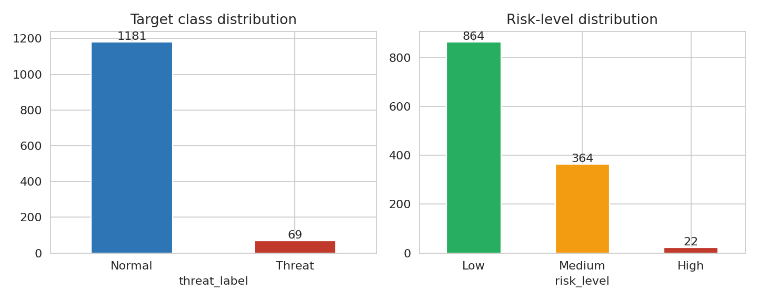
Figure 2: Class distribution (left) and risk-level distribution (right)
Normal records outnumber threats about 17 to 1. A model that always predicts Normal would be 94.5% accurate while detecting nothing, so accuracy alone is not an acceptable metric. Class weighting, stratified splitting and recall/PR-AUC are used. Risk levels are Low 864, Medium 364 and High 22; all 22 High records are threats, and 47 of the 69 threats are Medium.
2. Descriptive statistics
Table 3: Descriptive statistics of behavioural features (n = 1,250)
Feature | Mean | Std | Min | Median | Max | Skewness | IQR outliers
login_frequency | 5.21 | 1.95 | 3 | 5 | 18 | 2.14 | 32
file_access_count | 15.15 | 8.64 | 6 | 14 | 78 | 3.07 | 55
sensitive_files_accessed | 0.93 | 3.67 | 0 | 0 | 36 | 6.11 | 298
email_activity | 11.47 | 6.94 | 4 | 11 | 70 | 3.60 | 44
external_recipients | 2.24 | 4.06 | 0 | 2 | 40 | 5.99 | 61
usb_usage | 0.11 | 0.31 | 0 | 0 | 1 | 2.57 | 132
after_hours_activity | 0.15 | 0.36 | 0 | 0 | 1 | 1.98 | 186
failed_logins | 0.35 | 1.08 | 0 | 0 | 10 | 5.44 | 250
data_transfer_mb | 348.59 | 876.79 | 40 | 190 | 9489 | 6.57 | 70

Every feature is right-skewed (skewness 1.98 to 6.57). The medians of sensitive_files_accessed, usb_usage, after_hours_activity and failed_logins are 0, which means that most records show none of these behaviours, and a small group shows a lot. The mean transfer is 349 MB but the median is 190 MB and the maximum 9,489 MB.
3. Univariate analysis
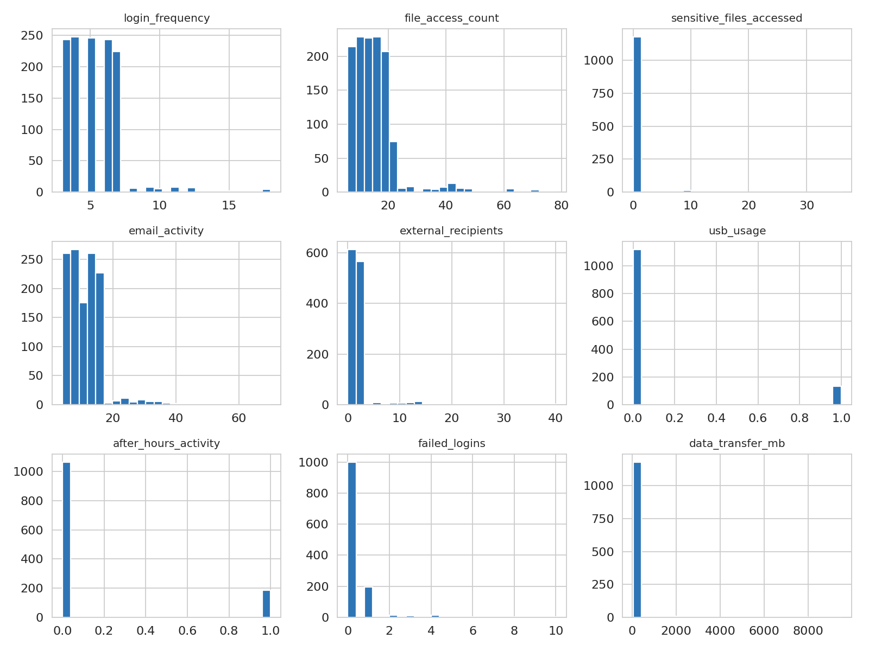
Figure 3: Histograms of the nine behavioural features
The histograms confirm long right tails. login_frequency, file_access_count and email_activity concentrate in a narrow normal range with a thin tail of high values, while usb_usage and after_hours_activity are binary flags with 10.6% and 14.9% of records set to 1.
4. Outlier analysis
By the IQR rule, between 32 (login_frequency) and 298 (sensitive_files_accessed) records are flagged per feature. The very large counts for sparse features such as sensitive_files_accessed, failed_logins and the binary flags arise because the IQR is zero, so any non-zero value is flagged. These values were not removed: the box plots below show that the largest values belong almost entirely to Threat records, so removing them would remove the signal.
5. Feature versus target analysis
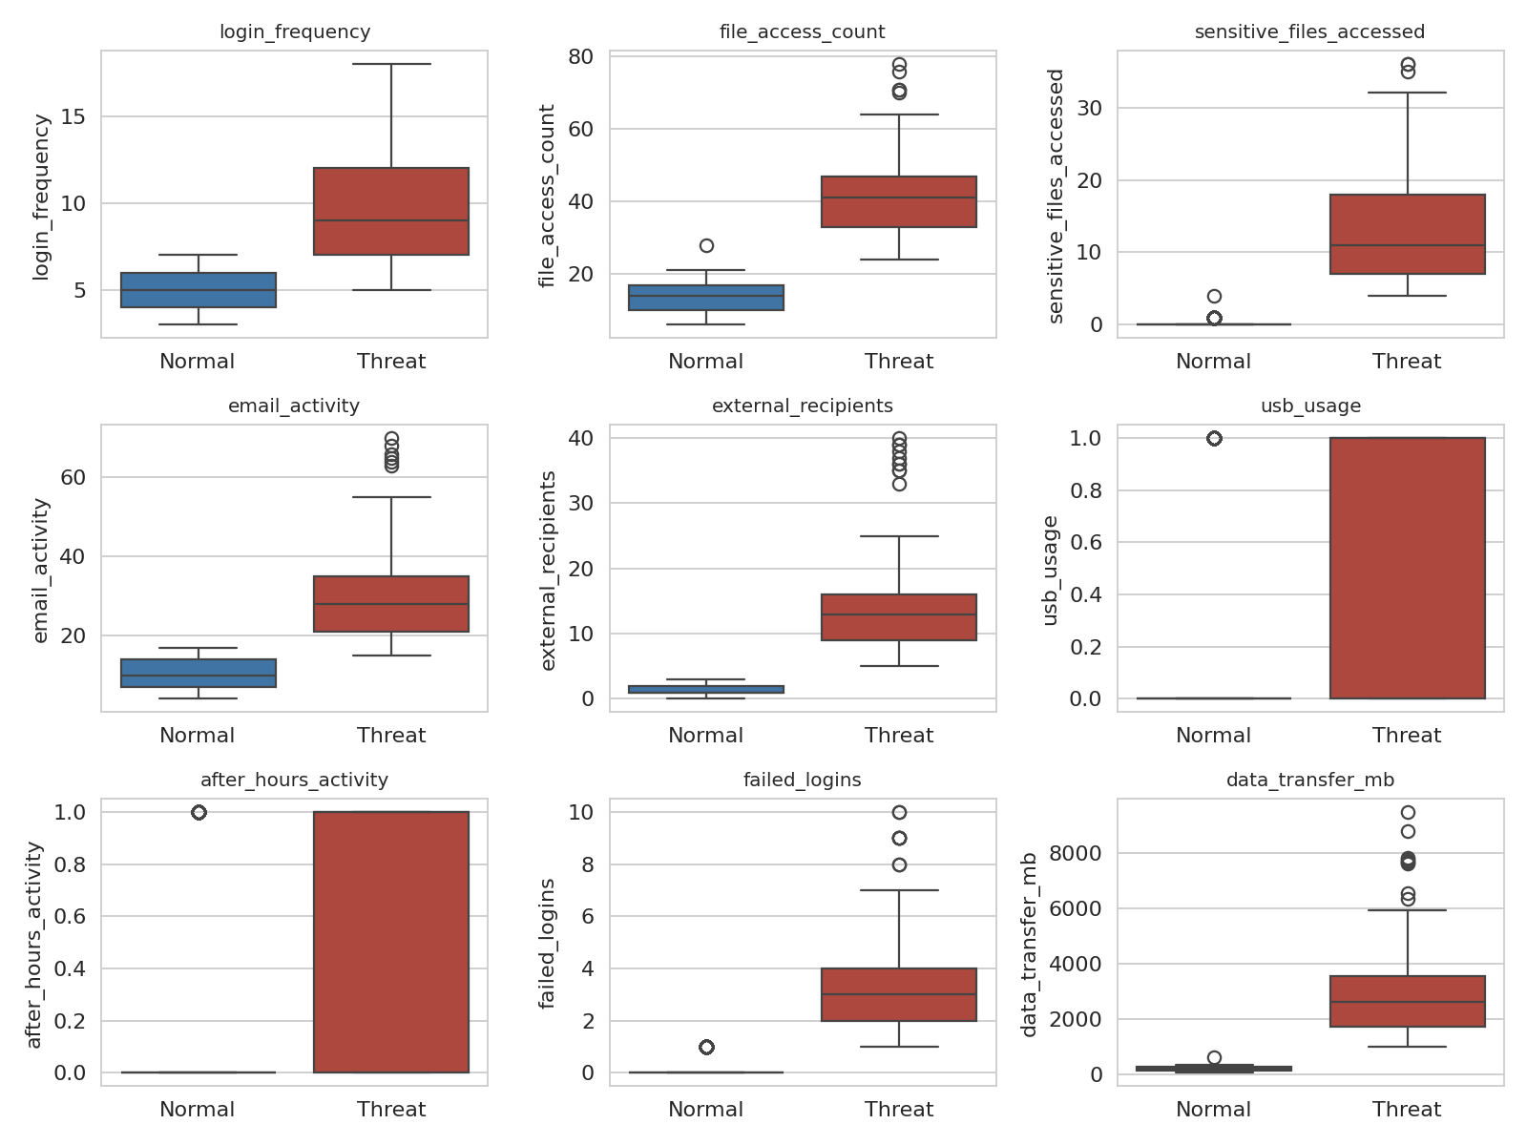
Figure 4: Box plots of each feature for Normal and Threat records
Table 4: Mean and median of each feature by class
Feature | Normal mean | Threat mean | Normal median | Threat median
login_frequency | 4.94 | 9.81 | 5 | 9
file_access_count | 13.53 | 42.99 | 14 | 41
sensitive_files_accessed | 0.2 | 13.48 | 0 | 11
email_activity | 10.31 | 31.26 | 10 | 28
external_recipients | 1.48 | 15.36 | 1 | 13
usb_usage | 0.08 | 0.61 | 0 | 1
after_hours_activity | 0.12 | 0.68 | 0 | 1
failed_logins | 0.15 | 3.75 | 0 | 3
data_transfer_mb | 178.75 | 3,255.7 | 182 | 2608

Threat records show far higher activity on every measure: about 3 times more file access, 67 times more sensitive-file access, 10 times more external recipients, 25 times more failed logins and 18 times more data transferred (3,256 MB against 179 MB on average). The ranges barely overlap: the smallest data_transfer_mb among threats is 972 MB while the largest among Normal records is 620 MB, so this one feature alone separates the two classes in this dataset. Threats by department are IT 18 of 243 (7.4%), Sales 15 of 242 (6.2%), Human Resources 14 of 265 (5.3%), Finance 11 of 232 (4.7%) and Engineering 11 of 268 (4.1%); the differences are small, which is consistent with Elastic Net later removing the department features.
6. Correlation analysis
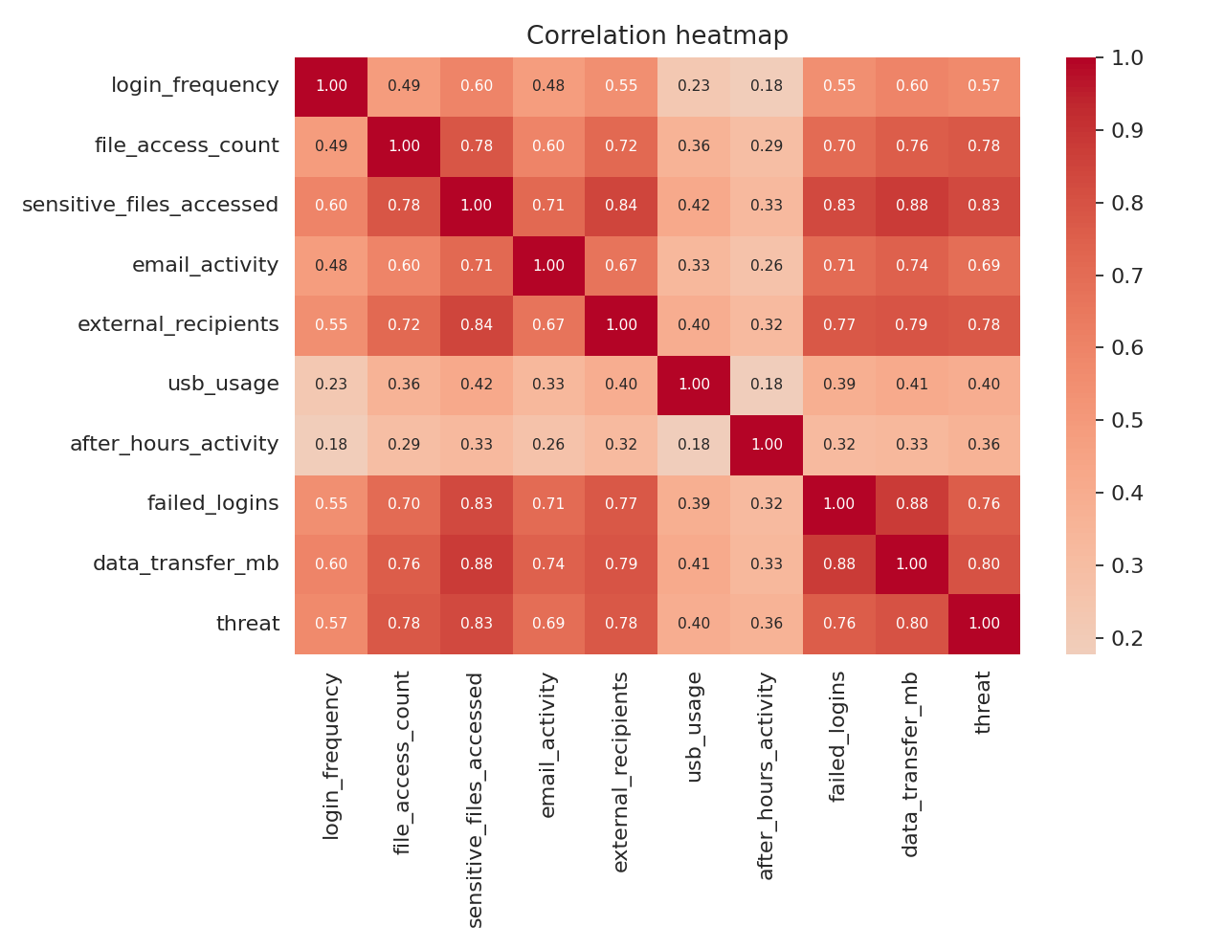
Figure 5: Correlation heatmap of features and the threat label
Correlation with the target is highest for sensitive_files_accessed (0.83), data_transfer_mb (0.80), external_recipients (0.78), file_access_count (0.78) and failed_logins (0.76), and lowest for usb_usage (0.40) and after_hours_activity (0.36). Many features are strongly correlated with each other because threat records raise several measures together; this is the situation in which Elastic Net’s grouping effect is useful. Correlation does not establish causation.

Summary of EDA Findings
- The data are clean: no missing values, no duplicates and correct data types.
- The target is imbalanced (69 threats among 1,250 records, 5.52%), so recall, F1-score and PR-AUC must be reported.
- All behavioural features are right-skewed; extreme values are mostly threats and were retained.
- Sensitive-file access, data transfer, external recipients, file access and failed logins are the strongest indicators; USB use and after-hours activity are weaker on their own.
- Department carries little information about threats.
- threat_score and risk_level leak the label and must not be used as inputs.
- Classes are almost perfectly separable (for example by data_transfer_mb), so very high model scores are expected and are a property of the data, not necessarily proof of a strong detector.
- One record (U002, Human Resources) is labelled Normal but carries the category Unauthorized Access with a medium score of 0.52; this is a small inconsistency in the source data.

ALGORITHM SELECTION AND IMPLEMENTATION

Why Elastic Net and Random Forest
Logistic regression is simple and interpretable, but its coefficients become unstable when predictors are correlated. Ridge (L2) stabilises coefficients but never removes a feature, and Lasso (L1) removes features but keeps only one of a group of correlated features. Elastic Net (Zou and Hastie, 2005) combines both penalties, so it can set weak coefficients to exactly zero while keeping correlated behaviours together. The objective minimised is
(1/2n) ||y − Xβ||² + α [ l1_ratio ||β||₁ + ((1 − l1_ratio)/2) ||β||₂² ]
where α sets the overall strength of regularisation and l1_ratio the share of the L1 penalty. For a class label the same penalty is added to the logistic loss. Random Forest (Breiman, 2001) averages many decision trees trained on bootstrap samples with random feature subsets. It captures non-linear effects and interactions, such as high file access combined with USB use, gives a probability from the share of votes, and provides feature importance. The two stages are complementary: Elastic Net produces a compact feature set and Random Forest does the final non-linear classification.

Implementation
- Stage 1 – Elastic Net selection. An elastic-net penalised logistic regression (solver = saga, class_weight = balanced) was tuned on the scaled training data by 5-fold stratified GridSearchCV over C ∈ {0.01, 0.03, 0.1, 0.3, 1, 3} and l1_ratio ∈ {0.2, 0.5, 0.8}, scored by PR-AUC. The best setting was C = 0.01 and l1_ratio = 0.2. Features with non-zero coefficients were retained.
- Stage 2 – Random Forest. A Random Forest (class_weight = balanced, random_state = 42) was tuned on the selected features by 5-fold stratified GridSearchCV over n_estimators ∈ {100, 300}, max_depth ∈ {None, 6, 10} and min_samples_split ∈ {2, 5}. The best setting was n_estimators = 100, max_depth = None and min_samples_split = 2.
- Baselines. A Random Forest on all 14 features, the Elastic Net logistic regression alone, a depth-6 Decision Tree and an RBF Support Vector Machine were trained on the same split with balanced class weights.
- Leakage prevention. The scaler, the Elastic Net selector and all tuning used only training data; the test set was used once for the final evaluation.

Features Selected by Elastic Net
Table 5: Elastic Net coefficients and Random Forest importance
Feature | Coefficient | Status | RF importance
file_access_count | 0.4595 | Retained | 0.2200
sensitive_files_accessed | 0.4016 | Retained | 0.3131
email_activity | 0.3869 | Retained | 0.0519
external_recipients | 0.3858 | Retained | 0.1827
data_transfer_mb | 0.3463 | Retained | 0.2041
failed_logins | 0.3275 | Retained | 0.0237
login_frequency | 0.2160 | Retained | 0.0045
after_hours_activity | 0.0689 | Retained | 0.0000
usb_usage | 0.0104 | Retained | 0.0000
department_Engineering | 0.0000 | Removed | –
department_Finance | 0.0000 | Removed | –
department_Human Resources | 0.0000 | Removed | –
department_IT | 0.0000 | Removed | –
department_Sales | 0.0000 | Removed | –

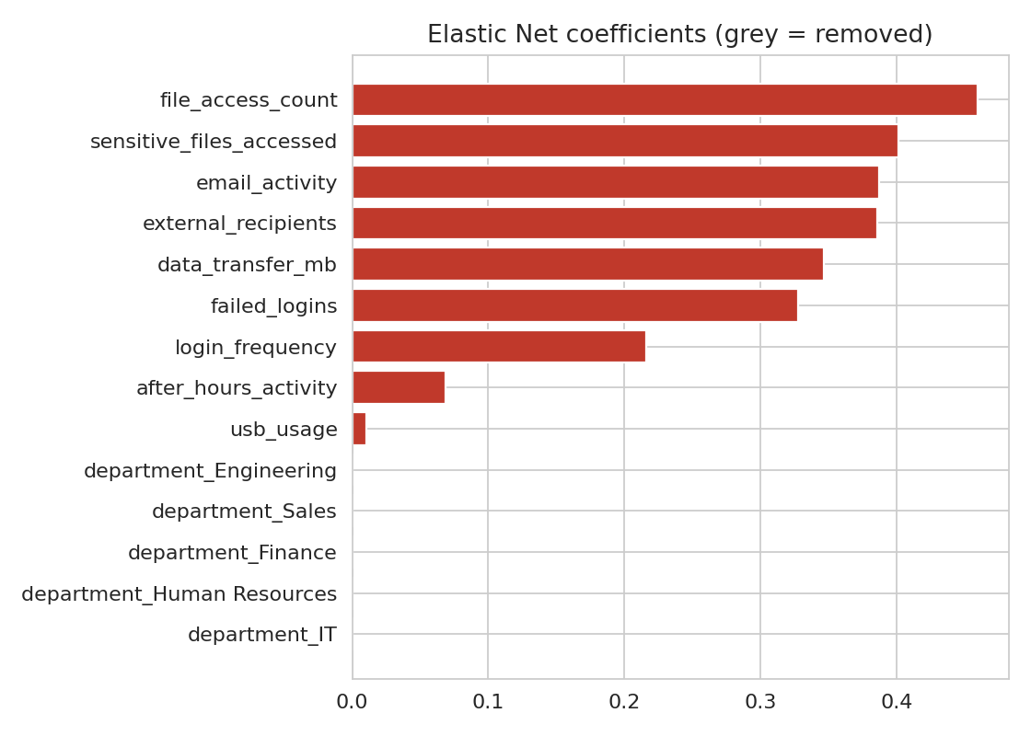
Figure 6: Elastic Net coefficients (grey bars are removed features)
Elastic Net kept all nine behavioural features and set the five department indicators to exactly zero, so department was removed. This agrees with the EDA, where threat rates differed little between departments. The largest coefficients belong to file_access_count (0.460), sensitive_files_accessed (0.402), email_activity (0.387), external_recipients (0.386) and data_transfer_mb (0.346). usb_usage (0.010) and after_hours_activity (0.069) were kept with very small weights.

Random Forest Results
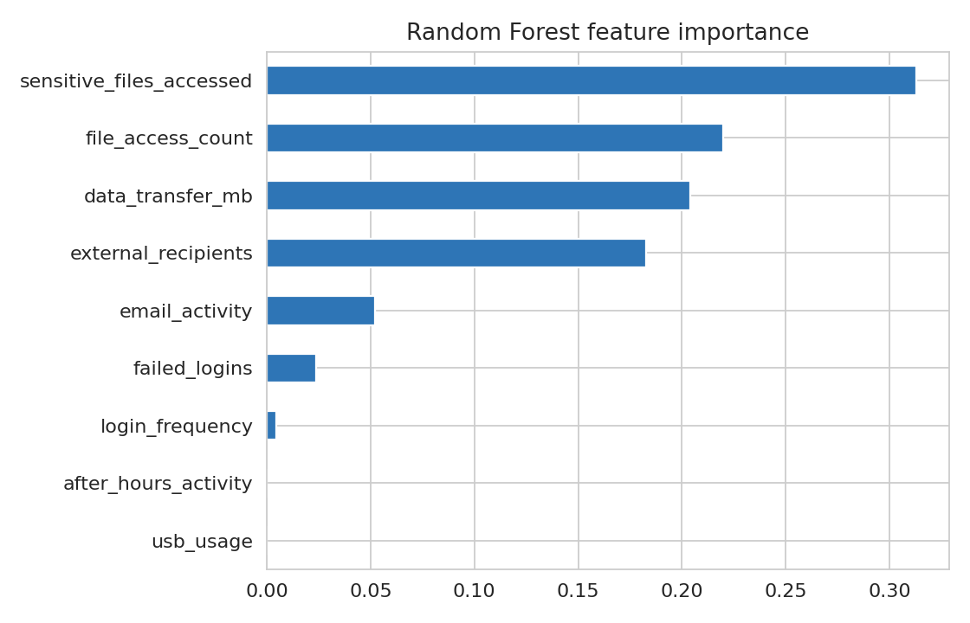
Figure 7: Random Forest feature importance
The Random Forest relies mostly on sensitive_files_accessed (0.313), file_access_count (0.220), data_transfer_mb (0.204) and external_recipients (0.183); together these four account for about 92% of total importance. usb_usage and after_hours_activity have an importance of about zero because the other features already separate the classes.
Table 6: Model comparison on the 250-record test set (14 threats)
Model | Accuracy | Precision | Recall | F1 | ROC-AUC | PR-AUC
Elastic Net + Random Forest (proposed) | 0.9960 | 0.9333 | 1.0000 | 0.9655 | 1.0000 | 1.0000
Random Forest (all features) | 0.9960 | 0.9333 | 1.0000 | 0.9655 | 1.0000 | 1.0000
Elastic Net logistic regression | 1.0000 | 1.0000 | 1.0000 | 1.0000 | 1.0000 | 1.0000
Decision Tree | 1.0000 | 1.0000 | 1.0000 | 1.0000 | 1.0000 | 1.0000
SVM (RBF kernel) | 1.0000 | 1.0000 | 1.0000 | 1.0000 | 1.0000 | 1.0000

Table 7: Confusion matrix of the proposed model (test set)
 | Predicted Normal | Predicted Threat
Actual Normal | TN = 235 | FP = 1
Actual Threat | FN = 0 | TP = 14

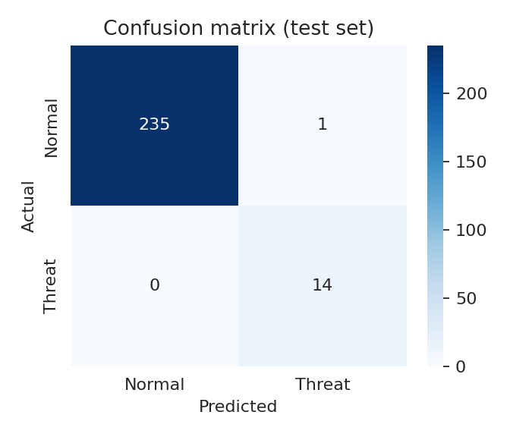
Figure 8: Confusion matrix of the proposed model
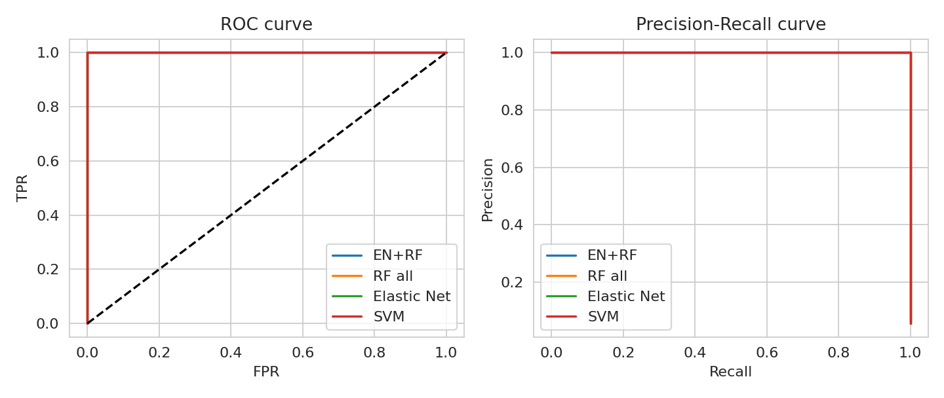
Figure 9: ROC curves (left) and precision-recall curves (right)

Discussion
The proposed pipeline detected all 14 threats in the test set (recall = 1.000) and raised one false alarm among 236 normal records (precision = 0.9333). In security monitoring a missed threat is usually more costly than a false alarm, so zero missed threats is the desired outcome. The cross-validated PR-AUC, F1 and recall on the training data were all 1.000, consistent with the test result.
Elastic Net and Random Forest did not outperform the baselines. The Random Forest on all 14 features gave identical results, and the Elastic Net logistic regression, Decision Tree and SVM each classified all 250 test records correctly. Feature selection therefore did not improve accuracy, but it did remove the five uninformative department columns, producing a smaller and easier-to-explain model.
How far to trust these numbers. Perfect or near-perfect scores from five different algorithms point to the dataset, not the algorithm: the classes barely overlap, and one feature (data_transfer_mb) separates them completely. The test set contains only 14 threats, so one misclassification would change recall by about 7 percentage points. The data are simulated over a single week, and real insiders often stay close to normal behaviour. These results show that the pipeline is implemented correctly and works on well-separated data; they do not show that it would reach 100% on a real organisation. Testing on harder, noisier data such as the CERT r4.2 corpus, or on data with deliberately overlapping classes, is the most important next step.

CONCLUSION
This case study built and evaluated a two-stage insider-threat detector on a 1,250-record user-activity dataset. Exploratory analysis showed clean data, a 17:1 class imbalance, strongly right-skewed activity counts and a clear difference between threat and normal behaviour, particularly in sensitive-file access, data transfer, external recipients, file access and failed logins. It also revealed that threat_score and risk_level leak the label and must be excluded.
Elastic Net retained all nine behavioural features and removed the five department indicators. The Random Forest trained on the retained features achieved accuracy 0.9960, recall 1.0000, precision 0.9333 and F1-score 0.9655 on the held-out test set, detecting every threat with a single false alarm. Because simpler baselines matched this performance, the strong results mainly reflect how separable the simulated data are. The pipeline is sound and leakage-safe, and the next steps are validation on more realistic data, threshold selection from the precision-recall curve, replacing the demonstration values in the Insider Guard dashboard with these results, and adding monitoring, drift detection and explainability tools such as SHAP.

REFERENCES
- Zou, H., & Hastie, T. (2005). Regularization and variable selection via the elastic net. Journal of the Royal Statistical Society: Series B, 67(2), 301–320.
- Tibshirani, R. (1996). Regression shrinkage and selection via the lasso. Journal of the Royal Statistical Society: Series B, 58(1), 267–288.
- Hoerl, A. E., & Kennard, R. W. (1970). Ridge regression: Biased estimation for nonorthogonal problems. Technometrics, 12(1), 55–67.
- Breiman, L. (2001). Random forests. Machine Learning, 45(1), 5–32.
- Pedregosa, F., et al. (2011). Scikit-learn: Machine learning in Python. Journal of Machine Learning Research, 12, 2825–2830.
- Glasser, J., & Lindauer, B. (2013). Bridging the gap: A pragmatic approach to generating insider threat data. IEEE Security and Privacy Workshops, 98–104.
- Cappelli, D., Moore, A., & Trzeciak, R. (2012). The CERT Guide to Insider Threats. Addison-Wesley.
- Chawla, N. V., Bowyer, K. W., Hall, L. O., & Kegelmeyer, W. P. (2002). SMOTE: Synthetic minority over-sampling technique. Journal of Artificial Intelligence Research, 16, 321–357.
Signature of the Team members
______________________  CHAVA NOHITHA | ______________________  G. LAASYA | ______________________  KALLU SHRESTA PRIYA

