PRACTICAL-02
SCREENSHOTS OF OUTPUT COMMANDS:
1.
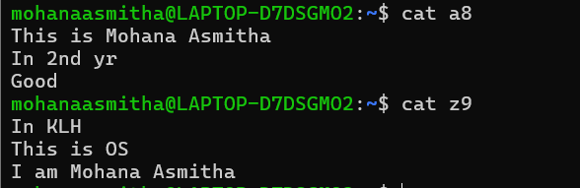
2. 