PRACTICAL-01
SCREENSHOTS OF OUTPUT COMMANDS:
1.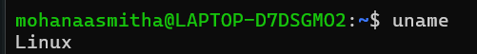
2.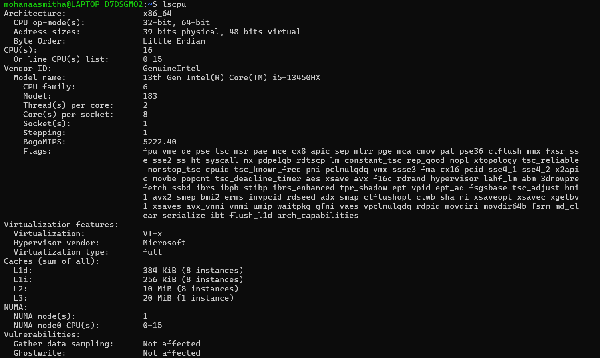
3.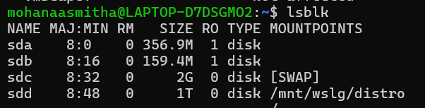
4.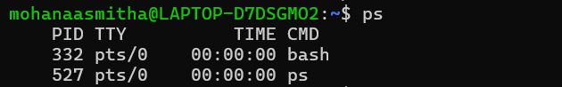
5.