PRACTICAL-03
SCREENSHOTS OF OUTPUT COMMANDS:
1. 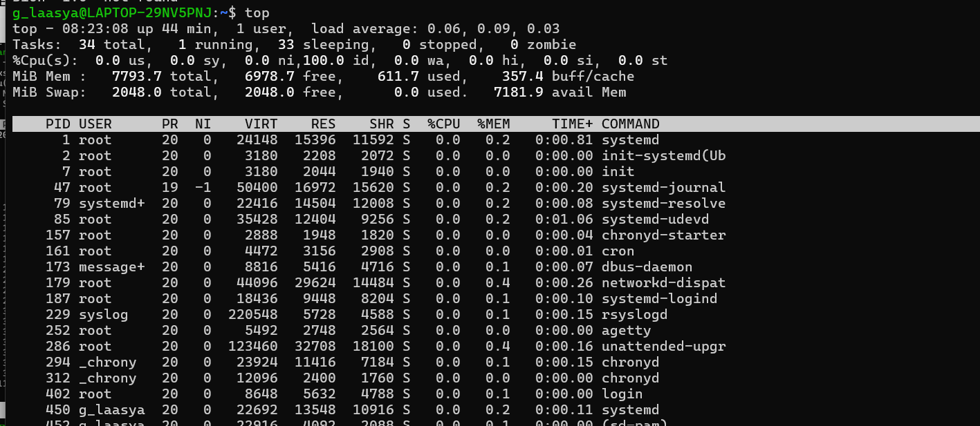
2. 