“Linux Process Monitoring and Control System”
A Project Report Submitted in the partial fulfillment of the requirements for the award of the degree of
BACHELOR OF TECHNOLOGY
In
DEPARTMENT OF COMPUTER SCIENCE ENGINEERING
By
M. MOHANA ASMITHA | 2520030486
G. LAASYA | 2520030118
CH. NOHITHA | 2520030130

Under the Esteemed Guidance of
K. Hema
Faculty Guide
Department of Computer Science and Engineering
Operating Systems and Systems Programming (25CS2104E) | Section 07 | Team 22 | 2026–27, Term-I



K L (Deemed to be) University
DEPARTMENT OF COMPUTER SCIENCE ENGINEERING
&
DEPARTMENT OF COMPUTER SCIENCE AND INFORMATION TECHNOLOGY

Declaration
The Project Report entitled “Linux Process Monitoring and Control System” is a record of Bonafide work of M. MOHANA ASMITHA – 2520030486, G. LAASYA – 2520030118, CH. NOHITHA – 2520030130 submitted in partial fulfillment for the award of B. Tech in Computer Science and Engineering (or) Computer Science and Information Technology to the K L University. The results embodied in this report have not been copied from any other departments/University/Institute.

M. MOHANA ASMITHA | 2520030486
G. LAASYA | 2520030118
CH. NOHITHA | 2520030130

K L (Deemed to be) University
DEPARTMENT OF COMPUTER SCIENCE ENGINEERING

CERTIFICATE
This is to certify that the project based report entitled “Linux Process Monitoring and Control System” is a bonafide work done and submitted by M. Mohana Asmitha – 2520030486, G. Laasya – 2520030118, Ch. Nohitha – 2520030130 in partial fulfillment of the requirements for the award of the degree of BACHELOR OF TECHNOLOGY in Department of Computer Science Engineering, K L (Deemed to be University), during the academic year 2026–2027.

Signature of the Guide

Signature of the Course Coordinator | Signature of the HOD

ACKNOWLEDGEMENT
The success of this project would not have been possible without the timely help and guidance rendered by many people. We wish to express our sincere thanks to all those who have assisted us, in one way or the other, in the completion of our project.
Our greatest appreciation goes to our course faculty and project guide, K. Hema, Department of Computer Science and Engineering, whose tremendous support, encouragement and guidance throughout this project cannot be expressed in words.
We express our gratitude to Dr. P. Venkateshwara Rao (CSE), Head of the Department of Computer Science Engineering, for providing us with adequate facilities, ways and means by which we were able to complete this project-based lab.
We thank all the members of the teaching and non-teaching staff, and everyone who has assisted us directly or indirectly in the successful completion of this project. Finally, we sincerely thank our parents, friends and classmates for their kind help and cooperation during our work.

M. MOHANA ASMITHA | 2520030486
G. LAASYA | 2520030118
CH. NOHITHA | 2520030130

Abstract
The Linux Process Monitoring and Control System is a Linux-based system programming project designed to monitor and manage the processes running on a Linux operating system. Managing multiple processes manually through individual Linux commands can be difficult for beginners and system users. This project provides a simple menu-driven interface through which common process monitoring and control operations can be performed from a single application.
The system allows users to list running processes, view process details, monitor a selected process, search for a process, view CPU and memory information, stop a process, and continue a stopped process. It also provides process statistics and action logging to improve process management and tracking.
The project is implemented in the C programming language on Ubuntu/Linux and uses Linux system calls and POSIX APIs for process identification and process control. Operating Systems concepts such as process creation and management, process IDs, signals, system calls, process states, CPU and memory monitoring, and file handling are applied throughout the implementation.
The outcome is a lightweight and user-friendly Linux application that demonstrates practical Operating Systems and System Programming concepts while providing basic process monitoring and control functionality. By turning textbook ideas such as PIDs and signals into working code, the project bridges the gap between OS theory and hands-on Linux system programming.
Keywords: Linux, Process Management, Process Monitoring, Process Control, Signals, System Calls, POSIX, /proc Filesystem, C Programming.

Index
S. No. | Chapter | Topics / Subtopics | Page No.
 | Acknowledgement |  | i
 | Abstract |  | ii
1 | Introduction |  | 1–3
 |  | 1.1 Background of the Project | 1
 |  | 1.2 Problem Statement | 1
 |  | 1.3 Scope of the Project | 2
 |  | 1.4 Objectives of the Project | 2
 |  | 1.5 Importance of the Application | 2
 |  | 1.6 Target Users / Audience | 3
2 | OS Concepts and Background Study |  | 4–7
 |  | 2.1 Operating System Concepts Related to the Project | 4
 |  | 2.2 Existing Methods / Algorithms | 5
 |  | 2.3 Proposed Approach | 6
 |  | 2.4 Advantages of the Proposed Approach | 6
3 | System Requirements |  | 8–9
 |  | 3.1 Hardware Requirements | 8
 |  | 3.2 Software Requirements | 8
 |  | 3.3 Operating System Environment – Ubuntu / WSL | 8
 |  | 3.4 Development Tools and Compilers | 9
4 | Technology and Tools Used |  | 10–12
 |  | 4.1 C / C++ Programming | 10
 |  | 4.2 GCC Compiler | 10
 |  | 4.3 Linux System Calls | 10
 |  | 4.4 POSIX Threads / Synchronization | 11
 |  | 4.5 Linux Commands and Utilities | 11
 |  | 4.6 Other Tools / Libraries Used | 11
5 | System Architecture and Design |  | 13–17
 |  | 5.1 Overall System Architecture | 13
 |  | 5.2 System Workflow | 13
 |  | 5.3 Flowchart / Data Flow | 14
 |  | 5.4 Module Description | 15
 |  | 5.5 Input and Output Design | 17
6 | Implementation |  | 18–29
 |  | 6.1 Module-wise Implementation | 18
 |  | 6.2 Algorithm / Pseudocode | 19
 |  | 6.3 Core C / C++ Implementation | 19
 |  | 6.4 Linux System Calls / APIs Used | 27
 |  | 6.5 Process / Thread Implementation | 28
 |  | 6.6 IPC / Synchronization Implementation | 28
 |  | 6.7 Memory Management Implementation | 29
 |  | 6.8 Optional User Interface Implementation | 29
7 | Execution and Demonstration |  | 30–36
 |  | 7.1 Compilation in Ubuntu | 30
 |  | 7.2 Execution Commands | 30
 |  | 7.3 Sample Inputs and Outputs | 30
 |  | 7.4 Screenshots of Execution | 34
 |  | 7.5 Demonstration of OS Concepts | 36
8 | Conclusion |  | 37–38
 |  | 8.1 Summary of the Project | 37
 |  | 8.2 Objectives Achieved | 37
 |  | 8.3 Results Achieved | 37
 |  | 8.4 Skills and Learning Outcomes | 38
 |  | 8.5 Limitations and Future Scope | 38
9 | References |  | 39
 |  | 9.1 Books | 39
 |  | 9.2 Research Papers | 39
 |  | 9.3 Linux / GNU Documentation | 39
 |  | 9.4 Online Resources | 39

CHAPTER 1: INTRODUCTION

1.1 Background of the Project
Linux is a multi-process operating system: at any moment dozens or even hundreds of processes execute concurrently, competing for CPU time, memory and I/O resources. A process is a program in execution — it owns an address space, a set of open files, and a unique process identifier (PID), and at any instant it is in one of several states such as running, sleeping or stopped. The Linux kernel schedules these processes, keeps track of their states, and exposes information about them to user programs.
Because so many processes run at the same time, users and administrators regularly need to answer simple questions: Which processes are running? What is this process doing? How much CPU and memory is it using? Can I pause it for a moment and resume it later? Linux answers these questions through a rich collection of commands and kernel interfaces — for example ps, top, pgrep and kill — together with the virtual /proc filesystem, which presents live kernel data about every process as ordinary readable files.
These tools are powerful but they are separate: each has its own syntax, options and output format. For a learner who is studying Operating Systems and System Programming, assembling a complete picture from several different tools is confusing, and the link between classroom theory (PIDs, states, signals, system calls) and what actually happens on a real Linux machine is not obvious. This project was undertaken to close that gap by building one small, guided application that performs the most commonly needed process-monitoring and process-control operations through standard Linux mechanisms.

1.2 Problem Statement
Linux provides several commands and utilities for monitoring and controlling processes, but using them separately can be difficult for beginners and for users who are learning Operating Systems and system programming. A beginner may have to learn several different commands or mechanisms just to list, inspect, monitor and control processes, and must already know the right command and the target PID before acting.
There is therefore a need for a simple application that combines the commonly required process monitoring and control operations into one menu-driven system. The proposed project addresses this problem by developing a Linux-based Process Monitoring and Control System in C. It provides a centralised interface to view running processes, obtain process information, monitor a process, search for processes, check CPU and memory usage, and control processes using appropriate Linux mechanisms.
The problem is a genuine Operating Systems problem, not just command-line trivia: process management, identification, state tracking and control are core OS concepts, and the project demonstrates how they are realised through system calls, signals, POSIX APIs and interaction with the Linux kernel.

1.3 Scope of the Project
The scope of the project is deliberately focused so that every feature can be explained, demonstrated and tested.

Within the scope
- A menu-driven, terminal-based C application for Ubuntu/Linux.
- Listing running processes and viewing the details of a selected process (PID, parent PID, name, state, threads, memory, command line).
- Monitoring a selected process over time, and searching for processes by name or checking a PID.
- Displaying CPU and memory information and overall process statistics.
- Basic process control — stopping and continuing a process by sending signals to its PID.
- Logging important actions performed through the application to a log file.

Outside the scope
- The project does not replace Linux’s native process facilities; it demonstrates and combines basic operations through one guided application.
- A graphical user interface, remote monitoring, and long-term historical data collection (listed as future scope in Chapter 8).
- Operating systems other than Linux (the code relies on the Linux /proc filesystem).

1.4 Objectives of the Project
The objectives of the project, as defined in the project problem statement, are:
- Build a unified menu-driven application. To develop a menu-driven Linux application for monitoring and managing system processes, so that the user selects one operation from a single menu instead of handling every task through a separate command.
- Provide listing, searching, monitoring and detail views. To provide functionalities for listing, searching, monitoring and viewing details of running processes, which together help the user identify a process and understand exactly what it is doing.
- Implement basic process control. To implement basic process control operations such as stopping and continuing a process using Linux mechanisms — a process is identified by its PID and Linux signals are then used to control it in a predictable way.
- Demonstrate core OS and System Programming concepts. To demonstrate concepts such as process IDs, process states, signals, Linux system calls, CPU/memory monitoring and process statistics, connecting classroom theory to working code.

1.5 Importance of the Application
- Academic relevance: it bridges Operating Systems theory with hands-on Linux system programming, turning textbook concepts into running code.
- Simplicity for learners: one centralised interface removes the need to remember several commands, options and output formats.
- Practical utility: the operations offered — list, inspect, monitor, search, pause and resume — are exactly those needed in everyday process management.
- Traceability: the action log records what was done and when, which supports auditing and debugging of a session.
- Lightweight design: the application is a single C program that needs only the standard C library and a Linux kernel, so it runs on any ordinary Ubuntu installation.

1.6 Target Users / Audience
Target user | How the application helps
Students of Operating Systems and System Programming | Shows PIDs, process states, signals and system calls working together in real code.
Beginners to Linux | Provides process monitoring and control without memorising separate commands.
Instructors and lab evaluators | Offers a compact, live demonstration of process-management concepts.
Junior system users and administrators | Gives a quick way to find a process, check its resource use, and pause or resume it.

CHAPTER 2: OS CONCEPTS AND BACKGROUND STUDY

2.1 Operating System Concepts Related to the Project
The project is built on a small group of fundamental Operating Systems concepts. Each is summarised below together with the role it plays in the application.
Table 2.1: Operating System concepts and Linux APIs used in the project
OS Concept / Linux API | Description | Purpose in the project
Process management | Handling and monitoring executing processes throughout their life-cycle. | Managing and monitoring processes running in Linux.
Process ID (PID) | A unique integer identifier assigned to each process by the kernel. | Identifying individual processes for monitoring and control.
Process states | The current status of a process — running, sleeping, stopped, zombie, etc. | Identifying and displaying the current state of a process.
Signals | Lightweight, asynchronous notifications used to request actions from a process. | Sending SIGSTOP / SIGCONT to pause and resume processes.
System calls / POSIX APIs | Interfaces through which programs request services from the kernel. | Calling kill(), getpid(), getppid() and file/directory APIs.
CPU and memory monitoring | Observing how a process uses processor time and physical memory. | Computing CPU % and showing resident memory (RSS) and system memory.
/proc filesystem | A virtual filesystem through which the kernel exposes process and system data. | Obtaining process and system information in a readable form.
File handling | Reading and writing files through the standard I/O library. | Reading /proc entries and maintaining the action log file.

Process, PID and process states
Every process is represented inside the kernel by a task structure and is identified by its PID; the PID of the process that created it is its parent PID (PPID). During its life a process moves between states. In Linux the one-letter codes seen in /proc/<pid>/stat include R (running or runnable), S (interruptible sleep, waiting for an event), D (uninterruptible disk wait), T (stopped), Z (zombie — terminated but not yet reaped by its parent) and I (idle kernel thread). The application reads this code and translates it into a readable label.
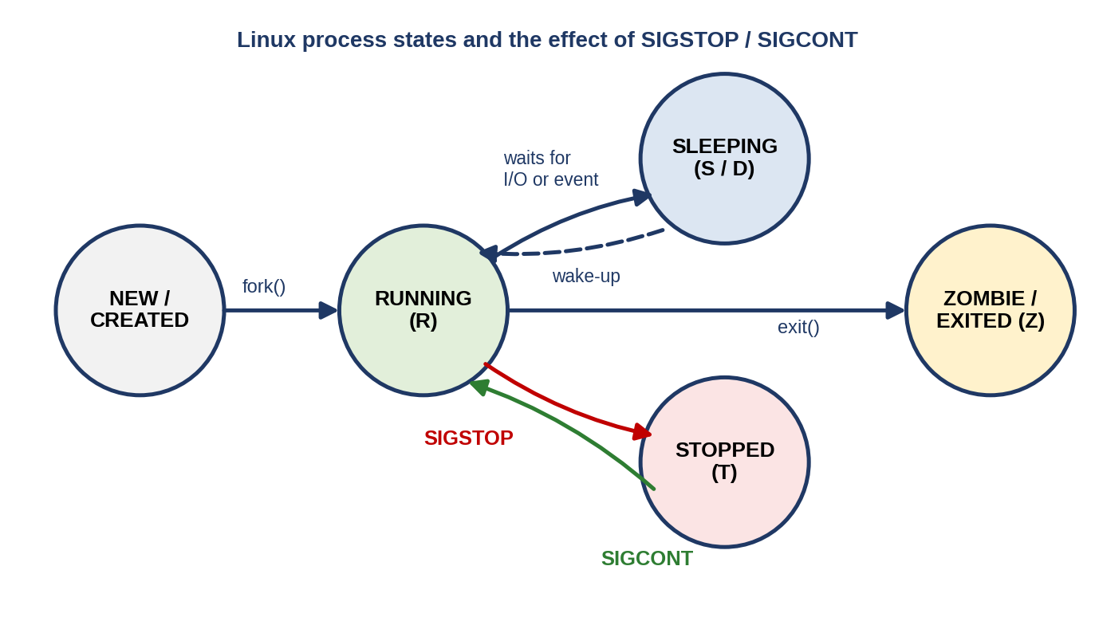
Figure 2.1: Linux process states and the effect of SIGSTOP / SIGCONT

Signals
A signal is a software interrupt delivered to a process. Most signals can be caught or ignored by the receiving process, but SIGSTOP and SIGCONT have a special property: SIGSTOP cannot be caught, blocked or ignored, and always moves the target process into the stopped (T) state, while SIGCONT resumes a stopped process. This makes the pair ideal for a safe, reversible “pause and resume” control operation — nothing is destroyed, and the process continues exactly where it left off.

System calls and the /proc filesystem
A system call is the controlled entry point from user programs into the kernel. The project uses kill() to deliver signals and getpid() / getppid() to obtain identifiers. For information retrieval it uses /proc, a virtual filesystem whose files are generated on demand by the kernel: /proc/<pid>/stat and /proc/<pid>/status describe a process, /proc/<pid>/cmdline holds its command line, and /proc/meminfo, /proc/cpuinfo and /proc/loadavg describe the system as a whole. Reading these files with ordinary file I/O is how almost every Linux monitoring tool — including ps and top — obtains its data.

2.2 Existing Methods / Algorithms
Linux already ships mature commands and mechanisms for process management, refined over decades of development. The most common are summarised below.
Table 2.2: Existing Linux methods for process monitoring and control
Command / mechanism | What it does | Limitation for a beginner
ps | Prints a snapshot of current processes. | Many option combinations (aux, -ef, -o) with different output formats.
top / htop | Continuously refreshing view of processes and resource use. | Interactive screen with its own key commands; not designed for step-by-step learning.
pgrep / pidof | Finds PIDs by process name. | A separate tool with a separate syntax from the listing tool.
kill / killall | Sends a signal to a process by PID or name. | The user must already know the PID and the signal name or number.
free, uptime, /proc/* | Show memory, load and kernel data. | Raw /proc files are unformatted; each command shows a different slice.

Internally these tools follow the same basic algorithm: scan the numeric directories under /proc, read the relevant files for each PID, and format the result. CPU usage is derived by sampling a process’s accumulated user and system CPU time (the utime and stime fields of /proc/<pid>/stat) at two instants and dividing the difference by the elapsed time. The project re-uses exactly these well-established techniques.
The weakness of the existing approach, for an academic and beginner-oriented setting, is fragmentation: different operations need different commands or interfaces, each with its own flags, syntax and output format, and the user must already know which one to use and which PID to target. This makes the overall workflow harder to follow and harder to teach.

2.3 Proposed Approach
The proposed system is a C-based, menu-driven application designed to run on Ubuntu/Linux using standard system libraries. It uses the same Linux capabilities listed above as its foundation, but wraps them in a single, guided interface:
- The user launches the application and sees one main menu listing every available operation.
- The user selects an operation by number; the application asks only for the extra input that operation needs (for example a PID or a name).
- The application interacts with Linux — reading /proc or issuing a system call — and displays the result clearly in the terminal.
- Important actions are written to a log file, and control returns to the menu so that operations can be repeated in any order until the user exits.
The design keeps a clear separation of concerns: monitoring functions only read and present process information, while control functions only apply Linux process-control mechanisms such as signals. This separation keeps the code easy to understand and safe to extend.

2.4 Advantages of the Proposed Approach
- Single interface: one menu replaces several separate commands.
- Guided workflow: the application prompts for exactly the input required, so no prior command knowledge is needed.
- Reversible control: stop/continue uses SIGSTOP/SIGCONT, which pauses a process without terminating it.
- Safety checks: PID input is validated, non-existent PIDs are reported, and protected targets (PID 1 and the application itself) are refused.
- Educational value: each menu option maps directly onto a named OS concept, making the project a live demonstration of theory.
- Accountability: every significant action is recorded with a timestamp in the action log.
- Low overhead: no external libraries or daemons are required; the application is a single compiled C program.

CHAPTER 3: SYSTEM REQUIREMENTS

3.1 Hardware Requirements
The application is lightweight and runs comfortably on ordinary student hardware. The following figures are the minimum and recommended configurations for development and demonstration.
Table 3.1: Hardware requirements
Component | Minimum | Recommended
Processor | Dual-core, 64-bit (x86-64) CPU, 1 GHz | Quad-core 64-bit CPU, 2 GHz or higher
Memory (RAM) | 2 GB | 4 GB or more (needed when running Ubuntu in a virtual machine or WSL)
Storage | 500 MB free space for tools, source and logs | 5 GB or more free space
Display | Any display capable of showing a terminal window | 1366 × 768 or higher, to view wide process listings
Input devices | Keyboard | Keyboard and mouse

3.2 Software Requirements
Table 3.2: Software requirements
Software | Version / details | Purpose
Operating system | Ubuntu 22.04 LTS or later (or Ubuntu on WSL 2) | Development and execution platform
C compiler | GCC 9 or later (package build-essential) | Compiling the C source code
Terminal | GNOME Terminal / Windows Terminal with bash | Compilation, execution and live demonstration
Source editor | Visual Studio Code (or any text editor) | Writing and editing the source code
Version control | Git and a GitHub account | Hosting the source repository for version control and collaboration

3.3 Operating System Environment – Ubuntu / WSL
The application targets Ubuntu Linux because it exposes the real Linux kernel interfaces — the /proc filesystem, POSIX signals and system calls — that the project demonstrates. Two ways of obtaining such an environment are common among students:
- Native Ubuntu or an Ubuntu virtual machine — gives a complete Linux system with all /proc files.
- Windows Subsystem for Linux (WSL 2) — runs a genuine Linux kernel inside Windows, so /proc, signals and GCC behave as on Ubuntu. WSL 2 is therefore a suitable environment for building and running this project on a Windows laptop.
The required toolchain is installed with two commands:
sudo apt update
sudo apt install build-essential git

Process-control operations act only on processes that the current user is permitted to signal. Ordinary users can stop and continue their own processes; signalling processes owned by other users requires elevated privileges and is intentionally not attempted by the application.

3.4 Development Tools and Compilers
Table 3.3: Development tools and compilers
Tool | Use in the project
GCC (GNU Compiler Collection) | Compiles and links the C source into the process_monitor executable; -Wall -Wextra enable additional warnings.
GNU Make (optional) | Automates the build with a one-line Makefile.
GDB (optional) | Step-by-step debugging of the program when a defect is investigated.
Visual Studio Code | Source-code editing environment used throughout development.
Git / GitHub | Version control and shared repository for the three team members.
Linux utilities (ps, kill, cat) | Used to cross-check the application’s output during testing.

CHAPTER 4: TECHNOLOGY AND TOOLS USED

4.1 C / C++ Programming
The application is written in C, the language in which Unix and Linux themselves are implemented. C was chosen because it gives direct, low-overhead access to system calls and POSIX APIs, makes memory usage explicit, and produces small, fast executables — all of which suit a system-programming project. Every Linux system call is documented with a C interface, so the code in this project maps one-to-one onto the concepts taught in the OS course.
C++ was not required: the program is procedural, organised into small functions with a single struct (ProcInfo) that holds the data describing one process.

4.2 GCC Compiler
The GNU Compiler Collection (GCC) translates the source code into an executable. The build command used throughout the project is:
gcc -Wall -Wextra -o process_monitor process_monitor.c

Table 4.1: GCC options used
Option | Meaning
-Wall | Enable the most commonly useful compiler warnings.
-Wextra | Enable additional warnings (unused parameters, sign comparisons, etc.).
-o process_monitor | Name the output executable process_monitor.
process_monitor.c | The single C source file containing the entire application.

4.3 Linux System Calls
System calls are the interface between the program and the kernel. The calls and closely related library functions used by the application are listed below; their exact use in the code is explained in Section 6.4.
Table 4.2: Linux system calls and APIs
Call / API | Purpose
getpid() | Returns the PID of the currently running process (the application itself).
getppid() | Returns the PID of the parent process that created the current one.
kill(pid, sig) | Sends a signal to a process identified by its PID; with signal 0 it only tests whether the process exists.
SIGSTOP / SIGCONT | Signals that pause a running process and resume a stopped one.
opendir() / readdir() | Iterate over the entries of /proc to discover running processes.
fopen() / fgets() | Read the /proc files and write the action log.
sysconf(_SC_CLK_TCK) | Gives the number of clock ticks per second, needed to convert CPU ticks into seconds.
sleep(), time() | Pause between monitoring samples and obtain timestamps for the log.

4.4 POSIX Threads / Synchronization
The application is single-threaded and does not create threads or use POSIX thread synchronisation primitives (mutexes, semaphores, condition variables). All operations run sequentially inside the main menu loop, so there is no shared mutable data between threads and therefore no need for locks.
Threads are nevertheless relevant to the subject matter: the application reads the number of threads of every process from the Threads: field of /proc/<pid>/status and shows it in the process list, so a user can see which processes are multi-threaded. Introducing POSIX threads — for example to refresh the monitor display on one thread while accepting commands on another — is identified as a possible extension in Section 8.5.

4.5 Linux Commands and Utilities
Standard Linux commands are used alongside the application, mainly to verify that its output is correct:
Table 4.3: Linux commands and utilities
Command | Use
ps -o pid,stat,cmd -p <pid> | Cross-check the state code (S, T, R…) reported by the application.
sleep 600 & | Start a harmless long-running background process to use as a test target.
echo $! | Print the PID of the most recently started background process.
kill -STOP <pid> / kill -CONT <pid> | Shell equivalents of the application’s stop and continue operations.
cat /proc/meminfo, free -m | Verify the memory figures displayed by the application.
cat process_log.txt | Inspect the action log written by the application.

4.6 Other Tools / Libraries Used
Table 4.4: Other tools and libraries
Tool / library | Purpose
Standard C library (stdio.h, stdlib.h, string.h) | Input/output, memory-independent utilities, string handling.
unistd.h, signal.h, sys/types.h | POSIX process identification, signals and basic types.
dirent.h | Directory traversal of /proc.
time.h, ctype.h, errno.h, stdarg.h | Timestamps, character tests, error reporting and a variadic log function.
Visual Studio Code | Source-code editing.
GitHub | Version control and hosting of the project repository.

CHAPTER 5: SYSTEM ARCHITECTURE AND DESIGN

5.1 Overall System Architecture
The system follows a simple layered design. The user interacts only with the main menu; the menu controller dispatches each request either to the process-monitoring functions or to the process-control functions; both groups talk to the Linux OS through PIDs, signals, system calls and the /proc filesystem; and the results are displayed back to the user while the logging module records the action.
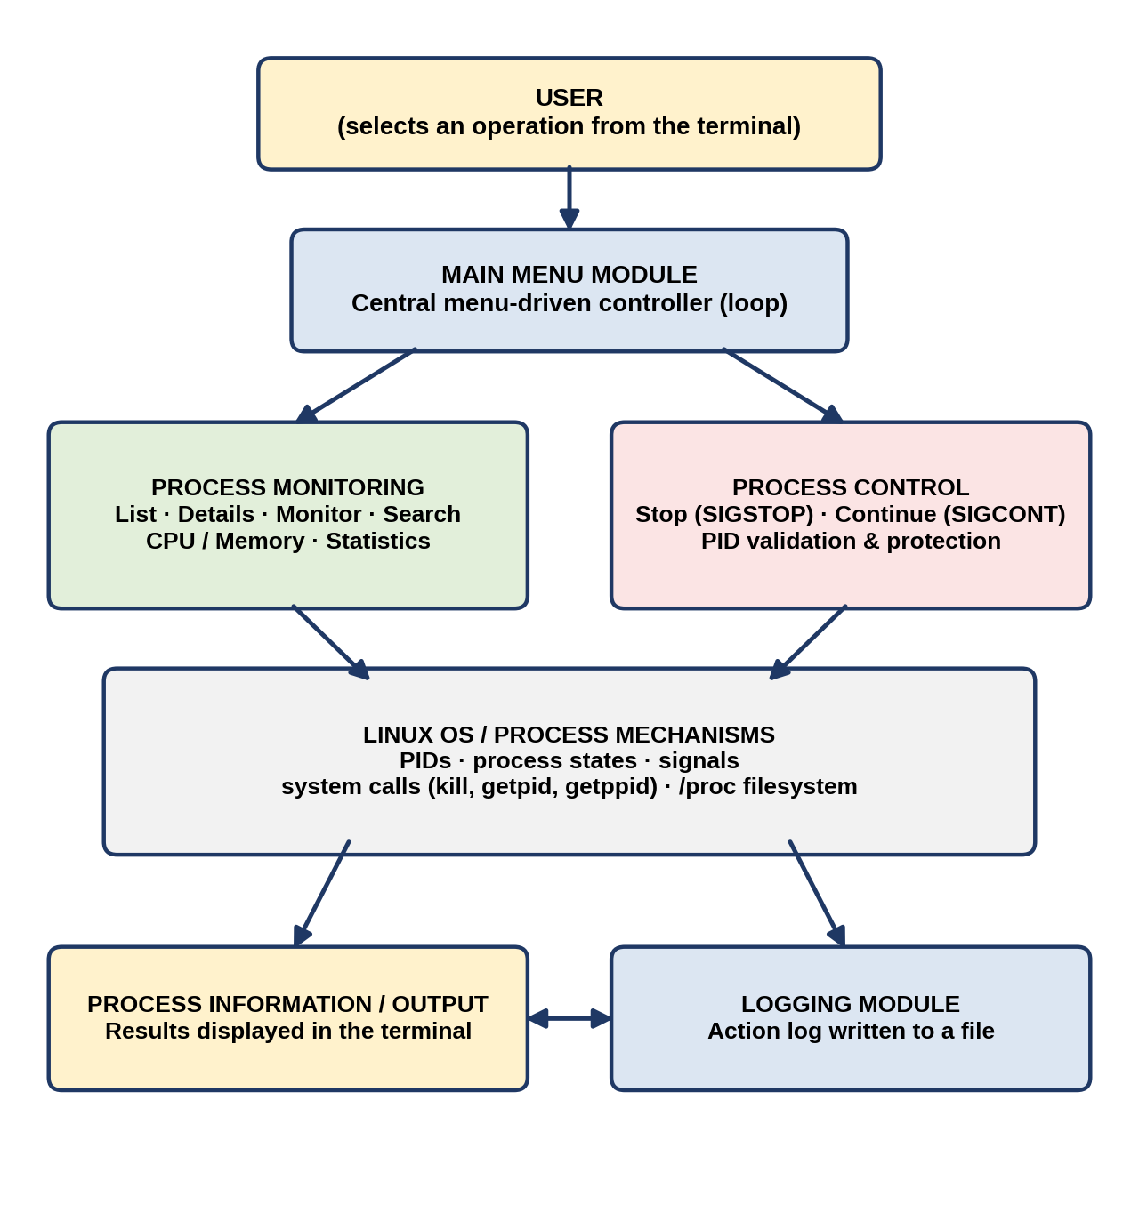
Figure 5.1: Overall system architecture
Each layer has a single responsibility. The menu layer deals only with input and dispatch; the monitoring and control layers contain the process logic; the operating-system layer is not modified — it is only consulted (through /proc) or instructed (through signals).

5.2 System Workflow
The application runs as a continuous loop. Its workflow has six steps:
- Start — the application launches and initialises (the log file is opened and a start entry is written).
- Display main menu — all 14 available operations are listed for the user.
- Enter user choice — the user selects the desired operation by number; invalid input is rejected with a message.
- Perform selected operation — the program calls the matching Linux mechanism (a system call or a /proc read).
- Display result — output is formatted and shown clearly in the terminal, and the action is logged.
- Return to menu / exit — the user loops back to the menu or chooses Exit to end the application.
Because every operation returns to the main menu, monitoring and control tasks can be repeated in any order until the user chooses to exit.

5.3 Flowchart / Data Flow
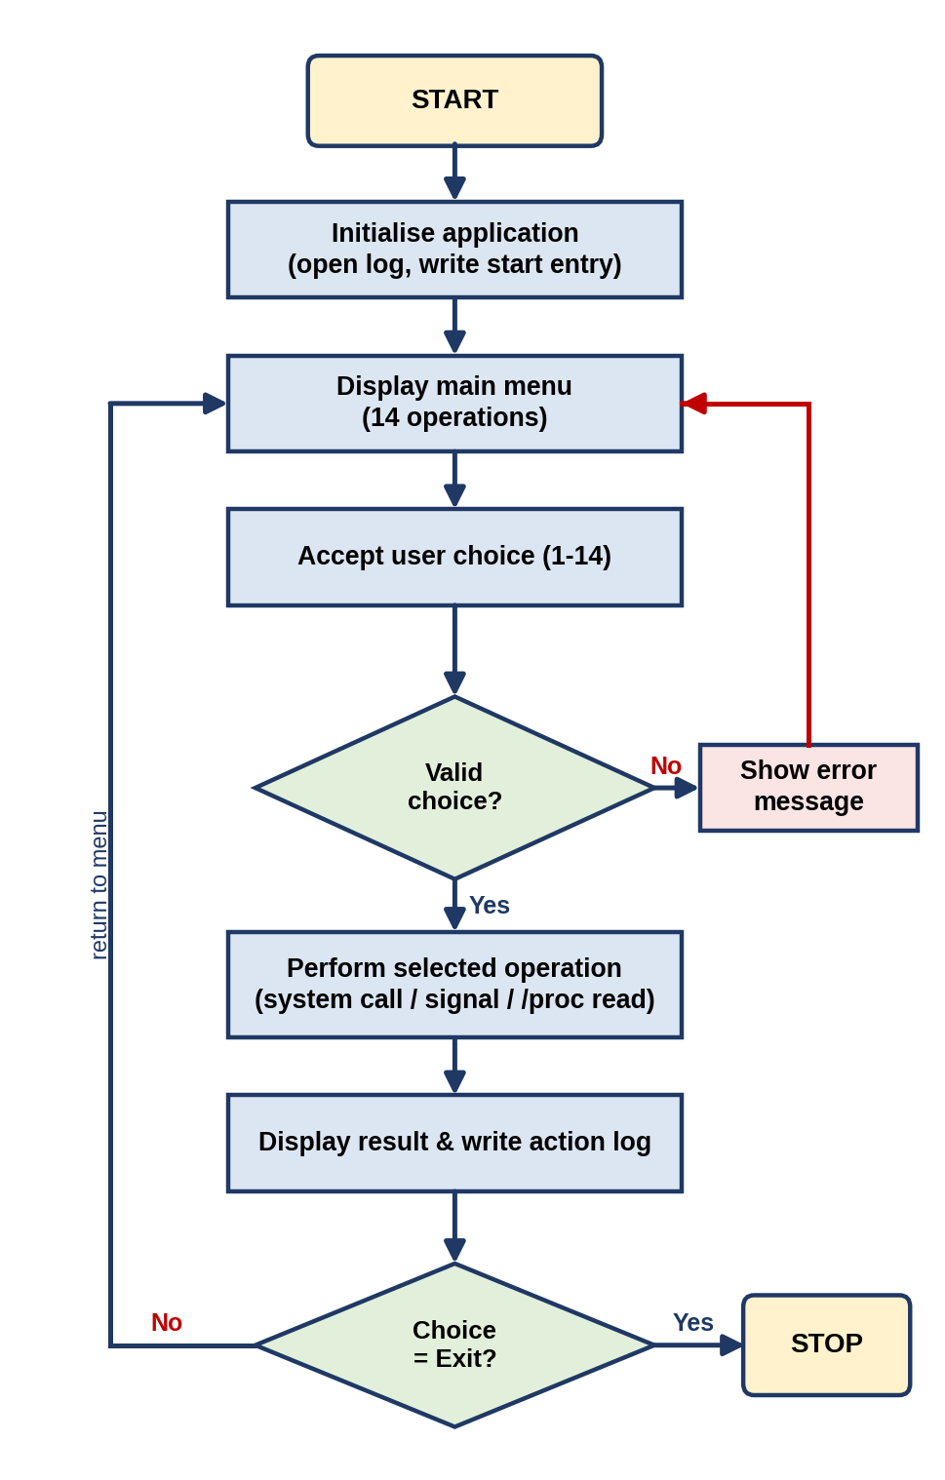
Figure 5.2: Flowchart of the Process Monitoring and Control System
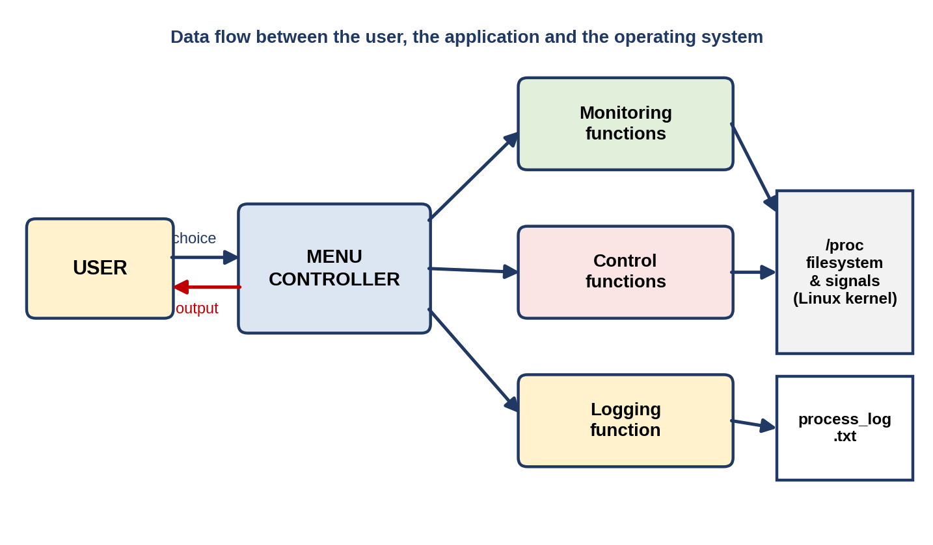
Figure 5.3: Data flow between the user, the application and the operating system
In the data-flow view, the user supplies a choice (and, where needed, a PID, a name or a sample count) to the menu controller. The controller forwards the request to the monitoring, control or logging functions. Monitoring functions read the /proc filesystem; control functions send signals to the kernel; every function’s outcome is written to the log file, and the formatted output is returned to the user’s terminal.

5.4 Module Description
The application is divided into the following modules. Each corresponds to a group of functions in the source code (Chapter 6).
Table 5.1: Module description
Module | Responsibility
Main Menu Module | Displays the menu, accepts the user’s operation choice and routes it to the correct function.
Process Information Module | Obtains and displays process-related details such as PID, parent PID, state, threads, memory and command line.
Monitoring Module | Continuously follows a selected process over a number of samples, showing its state, CPU % and memory.
Search Module | Locates a required process quickly by name (or checks whether a PID exists) instead of scanning a full list.
Resource / Statistics Module | Displays CPU information, memory information, per-state process counts and the top memory consumers.
Process Control Module | Performs stop and continue operations using the SIGSTOP and SIGCONT signals, with PID validation.
Logging Module | Records important actions with timestamps in process_log.txt.

Menu of operations
Table 5.2: The 14 menu operations and the module that implements each
No. | Operation | Module
1 | List all running processes | Process Information
2 | View process details (by PID) | Process Information
3 | Monitor a process (live) | Monitoring
4 | Search a process by name | Search
5 | Check whether a PID exists | Search
6 | Show CPU information | Resource / Statistics
7 | Show memory information | Resource / Statistics
8 | Stop a process (SIGSTOP) | Process Control
9 | Continue a stopped process (SIGCONT) | Process Control
10 | Show process statistics | Resource / Statistics
11 | Show top 5 processes by memory | Resource / Statistics
12 | View action log | Logging
13 | Show this application’s PID and parent PID | Process Information
14 | Exit | Main Menu

Individual contribution
Table 5.3: Division of work among team members
Roll Number | Student Name | Individual Responsibility
2520030486 | M. Mohana Asmitha | CPU/memory monitoring, process statistics, testing and documentation
2520030118 | G. Laasya | Process monitoring, process listing and process information module
2520030130 | Ch. Nohitha | Process control, signal handling and process management module

5.5 Input and Output Design

Input design
Table 5.4: Inputs accepted by the application
Input | Used by | Validation
Menu choice (1–14) | Main menu | Must be a whole number; any other text → “Invalid input”; a number outside 1–14 → “Invalid choice”.
PID | Details, monitor, PID check, stop, continue | Must be numeric; PIDs that do not exist are reported; PID 1 and the application’s own PID are refused for control operations.
Process name (or part of it) | Search | Case-insensitive substring match against the process name.
Number of samples | Monitor | Whole number, limited to the range 1–60.

Output design
All output is plain text in the terminal. Process listings use fixed-width columns (PID, PPID, STATE, THREADS, RSS in KB, NAME) so that rows align; detail views use a labelled “name : value” layout; control operations print a one-line success or error message; and the log viewer prints the timestamped entries exactly as stored. Every message is self-explanatory so that a new user can understand the result without consulting documentation.

CHAPTER 6: IMPLEMENTATION

6.1 Module-wise Implementation
The application is implemented as one C source file, process_monitor.c, organised into small functions grouped by module. The table below shows how the modules of Chapter 5 map onto functions.
Table 6.1: Module-to-function mapping
Module | Functions
Main Menu | print_menu(), main(), read_int(), read_line_input()
Process Information | list_processes(), view_details(), own_ids(), read_proc(), load_all(), state_name()
Monitoring | monitor_process(), cpu_ticks()
Search | search_by_name(), process_exists()
Resource / Statistics | cpu_information(), memory_information(), process_statistics(), top_memory()
Process Control | send_control()
Logging | log_action(), view_log()

Process Information. load_all() opens /proc and, for every directory whose name is a number, calls read_proc(). read_proc() parses /proc/<pid>/stat to obtain the process name (the text between the first ( and the last ), because names may contain spaces or parentheses), the state letter and the parent PID, and then scans /proc/<pid>/status for the Threads: and VmRSS: lines. The results are stored in a ProcInfo structure.
Monitoring. monitor_process() takes a first reading of the process’s accumulated CPU ticks (utime + stime from /proc/<pid>/stat), then, once per second, takes a new reading, converts the difference to a percentage using sysconf(_SC_CLK_TCK), and prints the state, CPU % and resident memory. If the process disappears during monitoring, the loop ends gracefully.
Search. search_by_name() lower-cases both the pattern and each process name and uses strstr() for a case-insensitive substring match. process_exists() uses kill(pid, 0), which sends no signal but reports whether the PID exists (and whether the caller may signal it).
Resource and statistics. cpu_information() reads the model name and logical CPU count from /proc/cpuinfo and the load averages from /proc/loadavg. memory_information() reads MemTotal, MemFree, MemAvailable and swap figures from /proc/meminfo. process_statistics() counts processes per state and totals threads and resident memory, and top_memory() sorts processes by RSS with qsort().
Process control. send_control() validates the PID, refuses PID 1 and the application’s own PID, checks that the target exists, and then calls kill(pid, sig) with SIGSTOP or SIGCONT, reporting success or the system error text (strerror(errno)).
Logging. log_action() is a variadic function that appends a timestamped line to process_log.txt; every other module calls it after completing an action.

6.2 Algorithm / Pseudocode
The pseudocode below summarises the main algorithms.

Main loop
START
open log; write "Application started"
LOOP forever
display menu
read choice
IF choice is not a number THEN print error; CONTINUE
SWITCH choice
1..13 : run the matching operation (prompt for PID / name if needed)
14 : write "Application exited"; STOP
other : print "Invalid choice"
END SWITCH
END LOOP

Listing processes
open directory /proc
FOR each entry in /proc
IF name consists only of digits THEN
parse /proc/<pid>/stat -> name, state, ppid
parse /proc/<pid>/status -> threads, VmRSS
store in list
print table header
FOR each stored process: print PID, PPID, state, threads, RSS, name
print total; write log entry

Monitoring a process (CPU %)
prev <- utime + stime of PID (clock ticks)
REPEAT samples times
sleep 1 second
now <- utime + stime of PID
IF PID no longer exists THEN print "Process ended"; STOP
cpu% <- 100 * (now - prev) / ticks_per_second
print state, cpu%, RSS
prev <- now

Stopping / continuing a process
INPUT pid, signal (SIGSTOP or SIGCONT)
IF pid <= 1 OR pid == own PID THEN refuse; log; STOP
IF kill(pid, 0) fails with "no such process" THEN print "not found"; STOP
IF kill(pid, signal) == 0 THEN print success; log
ELSE print strerror(errno); log failure

6.3 Core C / C++ Implementation
The complete source code of the application is reproduced below in five parts. It compiles cleanly with gcc -Wall -Wextra and is also available in the project’s GitHub repository.

Part 1 – File header, includes, constants and the ProcInfo structure
/*
* Linux Process Monitoring and Control System
* Operating Systems and Systems Programming (25CS2104E)
* Menu-driven C application for Ubuntu/Linux.
*
* Compile : gcc -Wall -Wextra -o process_monitor process_monitor.c
* Run : ./process_monitor
*/
#define _GNU_SOURCE
#include <stdio.h>
#include <stdlib.h>
#include <string.h>
#include <ctype.h>
#include <errno.h>
#include <time.h>
#include <stdarg.h>
#include <unistd.h>
#include <signal.h>
#include <dirent.h>
#include <sys/types.h>

#define LOG_FILE "process_log.txt"
#define MAX_PROCS 4096

typedef struct {
int pid;
int ppid;
char name[64];
char state;
long threads;
long rss_kb;
} ProcInfo;

Part 2 – Logging
/* ---------------------------------------------------------- logging */
static void log_action(const char *fmt, ...)
{
FILE *fp = fopen(LOG_FILE, "a");
if (!fp) return;
time_t now = time(NULL);
char ts[32];
strftime(ts, sizeof ts, "%Y-%m-%d %H:%M:%S", localtime(&now));
fprintf(fp, "[%s] ", ts);
va_list ap;
va_start(ap, fmt);
vfprintf(fp, fmt, ap);
va_end(ap);
fputc('\n', fp);
fclose(fp);
}

Part 3 – Helper functions (validation, /proc parsing, state names)
/* ---------------------------------------------------------- helpers */
static int is_number(const char *s)
{
if (!*s) return 0;
for (; *s; s++)
if (!isdigit((unsigned char)*s)) return 0;
return 1;
}

static int read_line_input(const char *prompt, char *buf, size_t n)
{
printf("%s", prompt);
fflush(stdout);
if (!fgets(buf, (int)n, stdin)) return 0;
buf[strcspn(buf, "\n")] = '\0';
return 1;
}

static int read_int(const char *prompt, int *out)
{
char buf[64];
if (!read_line_input(prompt, buf, sizeof buf)) return 0;
if (!is_number(buf)) { printf("Invalid input: please enter a number.\n"); return 0; }
*out = atoi(buf);
return 1;
}

static int process_exists(int pid)
{
return kill(pid, 0) == 0 || errno == EPERM;
}

/* Parse /proc/<pid>/stat and /proc/<pid>/status into a ProcInfo. */
static int read_proc(int pid, ProcInfo *p)
{
char path[64], line[512];
FILE *fp;

memset(p, 0, sizeof *p);
p->pid = pid;

snprintf(path, sizeof path, "/proc/%d/stat", pid);
if (!(fp = fopen(path, "r"))) return -1;
if (!fgets(line, sizeof line, fp)) { fclose(fp); return -1; }
fclose(fp);

char *open = strchr(line, '(');
char *close = strrchr(line, ')');
if (!open || !close) return -1;
size_t len = (size_t)(close - open - 1);
if (len >= sizeof p->name) len = sizeof p->name - 1;
memcpy(p->name, open + 1, len);
p->name[len] = '\0';
sscanf(close + 2, "%c %d", &p->state, &p->ppid);

snprintf(path, sizeof path, "/proc/%d/status", pid);
if ((fp = fopen(path, "r"))) {
while (fgets(line, sizeof line, fp)) {
if (!strncmp(line, "Threads:", 8)) p->threads = atol(line + 8);
else if (!strncmp(line, "VmRSS:", 6)) p->rss_kb = atol(line + 6);
}
fclose(fp);
}
return 0;
}

static const char *state_name(char s)
{
switch (s) {
case 'R': return "Running";
case 'S': return "Sleeping";
case 'D': return "Disk wait";
case 'T': return "Stopped";
case 't': return "Tracing stop";
case 'Z': return "Zombie";
case 'I': return "Idle";
default: return "Unknown";
}
}

/* Collect every process currently listed in /proc. */
static int load_all(ProcInfo *list, int max)
{
DIR *d = opendir("/proc");
struct dirent *e;
int n = 0;
if (!d) return 0;
while ((e = readdir(d)) && n < max)
if (is_number(e->d_name) && read_proc(atoi(e->d_name), &list[n]) == 0)
n++;
closedir(d);
return n;
}

Part 4 – Process operations (monitoring, information, statistics and control)
/* ------------------------------------------------------- operations */
static void list_processes(void)
{
static ProcInfo list[MAX_PROCS];
int n = load_all(list, MAX_PROCS);
printf("\n%-8s %-8s %-10s %-8s %-10s %s\n",
"PID", "PPID", "STATE", "THREADS", "RSS(KB)", "NAME");
printf("-----------------------------------------------------------------\n");
for (int i = 0; i < n; i++)
printf("%-8d %-8d %-10s %-8ld %-10ld %s\n", list[i].pid, list[i].ppid,
state_name(list[i].state), list[i].threads, list[i].rss_kb, list[i].name);
printf("\nTotal processes: %d\n", n);
log_action("Listed %d processes", n);
}

static void view_details(int pid)
{
ProcInfo p;
char path[64], cmd[256] = "";
if (read_proc(pid, &p) != 0) { printf("Process %d not found.\n", pid); return; }

snprintf(path, sizeof path, "/proc/%d/cmdline", pid);
FILE *fp = fopen(path, "r");
if (fp) {
size_t r = fread(cmd, 1, sizeof cmd - 1, fp);
for (size_t i = 0; i < r; i++) if (cmd[i] == '\0') cmd[i] = ' ';
cmd[r] = '\0';
fclose(fp);
}
printf("\n----- Process Details -----\n");
printf("PID : %d\n", p.pid);
printf("Parent PID : %d\n", p.ppid);
printf("Name : %s\n", p.name);
printf("State : %c (%s)\n", p.state, state_name(p.state));
printf("Threads : %ld\n", p.threads);
printf("Memory (RSS) : %ld KB\n", p.rss_kb);
printf("Command line : %s\n", cmd[0] ? cmd : "(kernel thread / none)");
log_action("Viewed details of PID %d (%s)", pid, p.name);
}

static long cpu_ticks(int pid) /* utime + stime in clock ticks */
{
char path[64], line[512];
snprintf(path, sizeof path, "/proc/%d/stat", pid);
FILE *fp = fopen(path, "r");
if (!fp) return -1;
if (!fgets(line, sizeof line, fp)) { fclose(fp); return -1; }
fclose(fp);
char *close = strrchr(line, ')');
long utime = 0, stime = 0;
/* fields after ')' : state(3) ... utime is field 14, stime is field 15 */
sscanf(close + 2,
"%*c %*d %*d %*d %*d %*d %*u %*u %*u %*u %*u %ld %ld",
&utime, &stime);
return utime + stime;
}

static void monitor_process(int pid, int samples)
{
long hz = sysconf(_SC_CLK_TCK);
long prev = cpu_ticks(pid);
if (prev < 0) { printf("Process %d not found.\n", pid); return; }
printf("\nMonitoring PID %d for %d samples (1 second interval)\n", pid, samples);
printf("%-8s %-10s %-8s %-10s\n", "SAMPLE", "STATE", "CPU(%)", "RSS(KB)");
for (int i = 1; i <= samples; i++) {
sleep(1);
ProcInfo p;
long now = cpu_ticks(pid);
if (now < 0 || read_proc(pid, &p) != 0) { printf("Process ended.\n"); break; }
double cpu = 100.0 * (double)(now - prev) / (double)hz;
printf("%-8d %-10s %-8.1f %-10ld\n", i, state_name(p.state), cpu, p.rss_kb);
prev = now;
}
log_action("Monitored PID %d for %d samples", pid, samples);
}

static void search_by_name(const char *pattern)
{
static ProcInfo list[MAX_PROCS];
int n = load_all(list, MAX_PROCS), found = 0;
char lp[64], ln[64];
size_t i;
for (i = 0; pattern[i] && i < sizeof lp - 1; i++)
lp[i] = (char)tolower((unsigned char)pattern[i]);
lp[i] = '\0';
printf("\n%-8s %-8s %-10s %s\n", "PID", "PPID", "STATE", "NAME");
for (int k = 0; k < n; k++) {
for (i = 0; list[k].name[i]; i++)
ln[i] = (char)tolower((unsigned char)list[k].name[i]);
ln[i] = '\0';
if (strstr(ln, lp)) {
printf("%-8d %-8d %-10s %s\n", list[k].pid, list[k].ppid,
state_name(list[k].state), list[k].name);
found++;
}
}
printf("\n%d match(es) found for \"%s\".\n", found, pattern);
log_action("Searched for \"%s\": %d match(es)", pattern, found);
}

static void cpu_information(void)
{
char line[256], model[128] = "unknown";
int cores = 0;
FILE *fp = fopen("/proc/cpuinfo", "r");
if (fp) {
while (fgets(line, sizeof line, fp)) {
if (!strncmp(line, "model name", 10) && model[0] == 'u') {
char *c = strchr(line, ':');
if (c) {
snprintf(model, sizeof model, "%s", c + 2);
model[strcspn(model, "\n")] = 0;
}
}
if (!strncmp(line, "processor", 9)) cores++;
}
fclose(fp);
}
double l1 = 0, l5 = 0, l15 = 0;
if ((fp = fopen("/proc/loadavg", "r"))) {
fscanf(fp, "%lf %lf %lf", &l1, &l5, &l15);
fclose(fp);
}
printf("\n----- CPU Information -----\n");
printf("Model : %s\n", model);
printf("Logical CPUs : %d\n", cores);
printf("Load average : %.2f (1 min) %.2f (5 min) %.2f (15 min)\n", l1, l5, l15);
log_action("Viewed CPU information");
}

static void memory_information(void)
{
char line[128];
long total = 0, freem = 0, avail = 0, swt = 0, swf = 0;
FILE *fp = fopen("/proc/meminfo", "r");
if (!fp) { perror("meminfo"); return; }
while (fgets(line, sizeof line, fp)) {
sscanf(line, "MemTotal: %ld", &total);
sscanf(line, "MemFree: %ld", &freem);
sscanf(line, "MemAvailable: %ld", &avail);
sscanf(line, "SwapTotal: %ld", &swt);
sscanf(line, "SwapFree: %ld", &swf);
}
fclose(fp);
printf("\n----- Memory Information -----\n");
printf("Total memory : %ld MB\n", total / 1024);
printf("Free memory : %ld MB\n", freem / 1024);
printf("Available memory : %ld MB\n", avail / 1024);
printf("Used (approx.) : %ld MB (%.1f%%)\n", (total - avail) / 1024,
total ? 100.0 * (double)(total - avail) / (double)total : 0.0);
printf("Swap total/free : %ld MB / %ld MB\n", swt / 1024, swf / 1024);
log_action("Viewed memory information");
}

static void send_control(int pid, int sig, const char *label)
{
if (pid <= 1 || pid == getpid()) {
printf("Refused: PID %d is protected (init or this application).\n", pid);
log_action("Refused to send %s to protected PID %d", label, pid);
return;
}
if (!process_exists(pid)) { printf("Process %d not found.\n", pid); return; }
if (kill(pid, sig) == 0) {
printf("%s sent to PID %d successfully.\n", label, pid);
log_action("%s sent to PID %d", label, pid);
} else {
printf("Could not send %s to PID %d: %s\n", label, pid, strerror(errno));
log_action("FAILED %s to PID %d (%s)", label, pid, strerror(errno));
}
}

static void process_statistics(void)
{
static ProcInfo list[MAX_PROCS];
int n = load_all(list, MAX_PROCS);
int run = 0, slp = 0, stp = 0, zom = 0, oth = 0;
long threads = 0, rss = 0;
for (int i = 0; i < n; i++) {
switch (list[i].state) {
case 'R': run++; break;
case 'S': case 'D': case 'I': slp++; break;
case 'T': case 't': stp++; break;
case 'Z': zom++; break;
default: oth++;
}
threads += list[i].threads;
rss += list[i].rss_kb;
}
printf("\n----- Process Statistics -----\n");
printf("Total processes : %d\n", n);
printf("Running : %d\n", run);
printf("Sleeping/Idle : %d\n", slp);
printf("Stopped : %d\n", stp);
printf("Zombie : %d\n", zom);
printf("Other : %d\n", oth);
printf("Total threads : %ld\n", threads);
printf("Total RSS : %ld MB\n", rss / 1024);
log_action("Viewed process statistics (%d processes)", n);
}

static int by_rss_desc(const void *a, const void *b)
{
long x = ((const ProcInfo *)a)->rss_kb, y = ((const ProcInfo *)b)->rss_kb;
return (y > x) - (y < x);
}

static void top_memory(void)
{
static ProcInfo list[MAX_PROCS];
int n = load_all(list, MAX_PROCS);
qsort(list, (size_t)n, sizeof list[0], by_rss_desc);
printf("\n----- Top 5 Processes by Memory -----\n");
printf("%-8s %-10s %s\n", "PID", "RSS(KB)", "NAME");
for (int i = 0; i < n && i < 5; i++)
printf("%-8d %-10ld %s\n", list[i].pid, list[i].rss_kb, list[i].name);
log_action("Viewed top 5 processes by memory");
}

static void view_log(void)
{
char line[256];
FILE *fp = fopen(LOG_FILE, "r");
if (!fp) { printf("Log is empty.\n"); return; }
printf("\n----- Action Log (%s) -----\n", LOG_FILE);
while (fgets(line, sizeof line, fp)) fputs(line, stdout);
fclose(fp);
}

static void own_ids(void)
{
printf("\nThis application : PID %d\n", (int)getpid());
printf("Its parent (shell): PID %d\n", (int)getppid());
log_action("Displayed own PID %d and parent PID %d", (int)getpid(), (int)getppid());
}

Part 5 – Menu and main()
/* -------------------------------------------------------------- menu */
static void print_menu(void)
{
printf("\n=========================================================\n");
printf(" LINUX PROCESS MONITORING AND CONTROL SYSTEM\n");
printf("=========================================================\n");
printf(" 1. List all running processes\n");
printf(" 2. View process details (by PID)\n");
printf(" 3. Monitor a process (live)\n");
printf(" 4. Search a process by name\n");
printf(" 5. Check whether a PID exists\n");
printf(" 6. Show CPU information\n");
printf(" 7. Show memory information\n");
printf(" 8. Stop a process (SIGSTOP)\n");
printf(" 9. Continue a stopped process (SIGCONT)\n");
printf(" 10. Show process statistics\n");
printf(" 11. Show top 5 processes by memory\n");
printf(" 12. View action log\n");
printf(" 13. Show this application's PID and parent PID\n");
printf(" 14. Exit\n");
printf("---------------------------------------------------------\n");
}

int main(void)
{
int choice, pid, samples;
char name[64];

log_action("Application started (PID %d)", (int)getpid());
for (;;) {
print_menu();
if (!read_int("Enter your choice (1-14): ", &choice)) {
if (feof(stdin)) break;
continue;
}
switch (choice) {
case 1: list_processes(); break;
case 2: if (read_int("Enter PID: ", &pid)) view_details(pid); break;
case 3:
if (read_int("Enter PID: ", &pid) &&
read_int("Number of samples: ", &samples)) {
if (samples < 1) samples = 1;
if (samples > 60) samples = 60;
monitor_process(pid, samples);
}
break;
case 4:
if (read_line_input("Enter process name (or part of it): ",
name, sizeof name) && name[0])
search_by_name(name);
break;
case 5:
if (read_int("Enter PID: ", &pid)) {
printf("PID %d %s.\n", pid,
process_exists(pid) ? "exists" : "does not exist");
log_action("Checked existence of PID %d", pid);
}
break;
case 6: cpu_information(); break;
case 7: memory_information(); break;
case 8:
if (read_int("Enter PID to stop: ", &pid))
send_control(pid, SIGSTOP, "SIGSTOP");
break;
case 9:
if (read_int("Enter PID to continue: ", &pid))
send_control(pid, SIGCONT, "SIGCONT");
break;
case 10: process_statistics(); break;
case 11: top_memory(); break;
case 12: view_log(); break;
case 13: own_ids(); break;
case 14:
log_action("Application exited normally");
printf("Exiting. Goodbye!\n");
return 0;
default: printf("Invalid choice. Please select 1-14.\n");
}
}
log_action("Application ended (end of input)");
return 0;
}

6.4 Linux System Calls / APIs Used
Table 6.2 lists every system call and API function used and where it appears in the code.
Table 6.2: System calls and APIs in the source code
Call / API | Header | Used in | Purpose
getpid() | unistd.h | send_control(), main(), own_ids() | Identify the application’s own process so it can protect itself.
getppid() | unistd.h | own_ids() | Display the parent (shell) PID.
kill(pid, sig) | signal.h | send_control(), process_exists() | Send SIGSTOP / SIGCONT, or test existence with signal 0.
opendir(), readdir(), closedir() | dirent.h | load_all() | Enumerate PIDs under /proc.
fopen(), fgets(), fclose() | stdio.h | read_proc(), cpu_*(), memory_information(), logging | Read /proc files and write the log.
sysconf(_SC_CLK_TCK) | unistd.h | monitor_process() | Convert CPU ticks to seconds.
sleep() | unistd.h | monitor_process() | One-second interval between samples.
time(), strftime(), localtime() | time.h | log_action() | Timestamp every log entry.
qsort() | stdlib.h | top_memory() | Sort processes by resident memory.
strerror(errno) | string.h, errno.h | send_control() | Report why a signal could not be delivered.

6.5 Process / Thread Implementation
Process implementation. The program does not create child processes; instead it observes and controls other processes. Its own identity is obtained with getpid() and getppid() (menu option 13), which also demonstrates the parent–child relationship: the application’s parent is the shell that launched it. For every other process the application builds a snapshot from /proc, and states are translated from the single-letter kernel code into a readable label by state_name().
Thread implementation. The application is single-threaded, so it contains no thread-creation code. It does, however, report the thread count of each observed process, read from the Threads: field of /proc/<pid>/status — a multi-threaded process such as a browser shows a high value while a simple sleep shows 1.

6.6 IPC / Synchronization Implementation
Signals as inter-process communication. The only IPC mechanism used between the application and the processes it manages is the signal. kill() delivers SIGSTOP or SIGCONT asynchronously to the target process; the kernel — not the target — performs the state change, which is why SIGSTOP cannot be ignored. The application then confirms the effect by re-reading the target’s state from /proc.
File-based logging. The log file is opened in append mode for each entry and closed immediately, so entries are never lost if the application is interrupted and no file handle is shared.
Synchronisation and race conditions. Because the program is single-threaded no locks are needed, but one race exists in principle: a process may exit between the existence check and the kill() call, or between listing and inspection. The code handles this by never trusting an earlier check — every kill() and every /proc read has its return value tested, and failures are reported as “not found” or with strerror(errno) instead of crashing.

6.7 Memory Management Implementation
Reading memory information. Process memory is reported as RSS (resident set size) — the amount of physical RAM currently held by the process — taken from the VmRSS: field of /proc/<pid>/status. System memory is read from /proc/meminfo: total, free and available memory and swap. “Used” memory is computed as MemTotal − MemAvailable, which is more meaningful than MemTotal − MemFree because it accounts for reclaimable cache.
Memory used by the program itself. The process table is held in a statically allocated array (static ProcInfo list[MAX_PROCS] with MAX_PROCS = 4096) declared static inside each function so that the roughly 400 KB array lives in the data segment instead of overflowing the limited stack. All strings are copied into fixed-size buffers with explicit bounds (snprintf, length checks), so the program performs no dynamic allocation and cannot leak memory.

6.8 Optional User Interface Implementation
The user interface is a text-based, menu-driven terminal interface. The main menu is redisplayed after every operation:
=========================================================
LINUX PROCESS MONITORING AND CONTROL SYSTEM
=========================================================
1. List all running processes
2. View process details (by PID)
3. Monitor a process (live)
4. Search a process by name
5. Check whether a PID exists
6. Show CPU information
7. Show memory information
8. Stop a process (SIGSTOP)
9. Continue a stopped process (SIGCONT)
10. Show process statistics
11. Show top 5 processes by memory
12. View action log
13. Show this application's PID and parent PID
14. Exit
---------------------------------------------------------
Enter your choice (1-14):

Input is read line by line with fgets() and validated before use, so stray characters or an empty line cannot corrupt later input. A graphical interface is outside the scope of this version and is listed as future scope in Section 8.5.

CHAPTER 7: EXECUTION AND DEMONSTRATION

7.1 Compilation in Ubuntu
The program is compiled on Ubuntu with GCC. Open a terminal in the project directory and run:
gcc -Wall -Wextra -o process_monitor process_monitor.c

A successful build prints nothing and creates the executable process_monitor. The sample run reported in this chapter was compiled with GCC 13.3 on Ubuntu 24.04 and produced no warnings.

7.2 Execution Commands
To demonstrate process control safely, first start a harmless background process to act as the target:
sleep 600 & # start a test process in the background
echo $! # print its PID, for example 372

Then run the application and use the PID when prompted:
./process_monitor

The state of the target can be cross-checked from a second terminal, and the log can be read after the session:
ps -o pid,stat,cmd -p 372 # STAT shows S, or T when stopped
cat process_log.txt # action log written by the application

7.3 Sample Inputs and Outputs
The following session was recorded by running the application against a sleep 600 target process (PID 372). Menu redisplays between operations are omitted for brevity.

Option 13 – Application PID and parent PID
Enter your choice (1-14): 13

This application : PID 375
Its parent (shell): PID 371

Option 5 – Check whether a PID exists
Enter your choice (1-14): 5
Enter PID: 372
PID 372 exists.

Option 1 – List all running processes (excerpt)
Enter your choice (1-14): 1

PID PPID STATE THREADS RSS(KB) NAME
-----------------------------------------------------------------
2 0 Sleeping 1 0 kthreadd
14 2 Sleeping 1 0 ksoftirqd/0
...
288 285 Sleeping 1 3408 bash
289 288 Sleeping 1 1736 sleep
292 288 Running 1 1936 process_monitor

Total processes: 54

Option 2 – View process details
Enter your choice (1-14): 2
Enter PID: 372

----- Process Details -----
PID : 372
Parent PID : 371
Name : sleep
State : S (Sleeping)
Threads : 1
Memory (RSS) : 1740 KB
Command line : sleep 600

Option 4 – Search a process by name
Enter your choice (1-14): 4
Enter process name (or part of it): sleep

PID PPID STATE NAME
372 371 Sleeping sleep

1 match(es) found for "sleep".

Option 8 and Option 2 – Stop a process and verify its state
Enter your choice (1-14): 8
Enter PID to stop: 372
SIGSTOP sent to PID 372 successfully.

Enter your choice (1-14): 2
Enter PID: 372

----- Process Details -----
PID : 372
Parent PID : 371
Name : sleep
State : T (Stopped)
Threads : 1
Memory (RSS) : 1740 KB
Command line : sleep 600

Option 9 and Option 2 – Continue the process and verify its state
Enter your choice (1-14): 9
Enter PID to continue: 372
SIGCONT sent to PID 372 successfully.

Enter your choice (1-14): 2
Enter PID: 372

----- Process Details -----
PID : 372
Parent PID : 371
Name : sleep
State : S (Sleeping)
Threads : 1
Memory (RSS) : 1740 KB
Command line : sleep 600

Option 3 – Monitor a process
Enter your choice (1-14): 3
Enter PID: 372
Number of samples: 3

Monitoring PID 372 for 3 samples (1 second interval)
SAMPLE STATE CPU(%) RSS(KB)
1 Sleeping 0.0 1740
2 Sleeping 0.0 1740
3 Sleeping 0.0 1740

Option 6 – CPU information
Enter your choice (1-14): 6

----- CPU Information -----
Model : Intel(R) Xeon(R) Processor @ 2.10GHz
Logical CPUs : 1
Load average : 0.00 (1 min) 0.00 (5 min) 0.00 (15 min)

Option 7 – Memory information
Enter your choice (1-14): 7

----- Memory Information -----
Total memory : 3999 MB
Free memory : 3386 MB
Available memory : 3724 MB
Used (approx.) : 274 MB (6.9%)
Swap total/free : 0 MB / 0 MB

Option 10 – Process statistics
Enter your choice (1-14): 10

----- Process Statistics -----
Total processes : 54
Running : 1
Sleeping/Idle : 53
Stopped : 0
Zombie : 0
Other : 0
Total threads : 80
Total RSS : 54 MB

Error handling – protected PID, missing PID, invalid input
Enter your choice (1-14): 8
Enter PID to stop: 1
Refused: PID 1 is protected (init or this application).

Enter your choice (1-14): 2
Enter PID: 99999
Process 99999 not found.

Enter your choice (1-14): abc
Invalid input: please enter a number.

Enter your choice (1-14): 99
Invalid choice. Please select 1-14.

Option 12 – Action log
Enter your choice (1-14): 12

----- Action Log (process_log.txt) -----
[2026-10-05 08:32:59] Application started (PID 375)
[2026-10-05 08:32:59] Displayed own PID 375 and parent PID 371
[2026-10-05 08:32:59] Checked existence of PID 372
[2026-10-05 08:33:00] Viewed details of PID 372 (sleep)
[2026-10-05 08:33:01] Searched for "sleep": 1 match(es)
[2026-10-05 08:33:02] SIGSTOP sent to PID 372
[2026-10-05 08:33:03] Viewed details of PID 372 (sleep)
[2026-10-05 08:33:03] SIGCONT sent to PID 372
[2026-10-05 08:33:04] Viewed details of PID 372 (sleep)
[2026-10-05 08:33:09] Monitored PID 372 for 3 samples
[2026-10-05 08:33:09] Viewed CPU information
[2026-10-05 08:33:09] Viewed memory information
[2026-10-05 08:33:09] Viewed process statistics (54 processes)
[2026-10-05 08:33:09] Refused to send SIGSTOP to protected PID 1

Table 7.1: Test cases and results
TC | Operation and input | Expected result | Result
1 | Option 13 | Displays the application’s PID and its parent (shell) PID | Pass
2 | Option 5, PID of the test process | Reports that the PID exists | Pass
3 | Option 2, PID of the test process | Shows PID, PPID, name, state S, threads, RSS, command line | Pass
4 | Option 4, name “sleep” | Lists the matching process; “1 match(es) found” | Pass
5 | Option 8, PID of the test process; then option 2 | SIGSTOP sent; state changes to T (Stopped) | Pass
6 | Option 9, same PID; then option 2 | SIGCONT sent; state returns to S (Sleeping) | Pass
7 | Option 3, PID, 3 samples | Three rows of state, CPU % and RSS, one per second | Pass
8 | Options 1, 6, 7, 10 | Process list, CPU info, memory info and statistics displayed | Pass
9 | Option 8, PID 1 | Refused: protected PID | Pass
10 | Option 2, PID 99999 | “Process 99999 not found.” | Pass
11 | Menu choice “abc” | “Invalid input: please enter a number.” | Pass
12 | Menu choice 99 | “Invalid choice. Please select 1-14.” | Pass
13 | Option 12 | Timestamped entries for every action performed | Pass

7.4 Screenshots of Execution
Replace each placeholder below with a screenshot of the corresponding step from your own terminal. Suggested content is given in each box.
[ INSERT SCREENSHOT HERE ]
gcc command with no warnings, then ./process_monitor showing the 14-option menu
Figure 7.1: Compilation of process_monitor.c and the main menu
[ INSERT SCREENSHOT HERE ]
process table with PID, PPID, STATE, THREADS, RSS and NAME columns
Figure 7.2: Listing running processes (option 1)
[ INSERT SCREENSHOT HERE ]
details of the sleep process and the search results
Figure 7.3: Process details and search (options 2 and 4)
[ INSERT SCREENSHOT HERE ]
three or more one-second samples with state, CPU % and RSS
Figure 7.4: Monitoring a process (option 3)
[ INSERT SCREENSHOT HERE ]
SIGSTOP message followed by option 2 showing State: T (Stopped)
Figure 7.5: Stopping a process (option 8) and verifying the T state
[ INSERT SCREENSHOT HERE ]
SIGCONT message followed by option 2 showing State: S (Sleeping)
Figure 7.6: Continuing the process (option 9) and verifying the S state
[ INSERT SCREENSHOT HERE ]
the three information screens
Figure 7.7: CPU, memory and process statistics (options 6, 7, 10)
[ INSERT SCREENSHOT HERE ]
protected-PID refusal, invalid input messages, and the timestamped log
Figure 7.8: Error handling and the action log (option 12)

7.5 Demonstration of OS Concepts
The demonstration exercises each OS concept in turn; the table links what the user does to what can be observed.
Table 7.2: OS concepts demonstrated
OS concept | Demonstration step | Observable evidence
Process ID and parent PID | Menu option 13; option 2 on the test process | Application PID differs from its parent’s PID; the test process’s PPID is the shell’s PID.
Process management / /proc | Option 1 lists every process | Rows for kernel threads, the shell, sleep and the application itself.
Process states | Options 8 and 9 around option 2 | State changes S → T → S for the same PID.
Signals | Stop and continue the test process | SIGSTOP sent … / SIGCONT sent … messages; ps shows STAT = T while stopped.
System calls | Every control and identification operation | kill(), getpid() and getppid() produce the displayed results.
CPU and memory monitoring | Options 3, 6, 7, 10, 11 | CPU % per sample, RSS in KB, system memory totals and load averages.
File handling | Option 12 after a session | Timestamped entries match the actions performed, and process_log.txt exists on disk.

CHAPTER 8: CONCLUSION

8.1 Summary of the Project
The Linux Process Monitoring and Control System brings the most commonly needed process operations — listing, inspecting, monitoring, searching, resource reporting, stopping and continuing — into a single menu-driven C application for Ubuntu/Linux. Instead of juggling separate commands, a user chooses one numbered operation and receives a clear, formatted result.
Technically, the application relies entirely on standard Linux mechanisms: PIDs to identify processes, the /proc filesystem to read process and system data, and the kill() system call with SIGSTOP and SIGCONT to control processes. Safety checks, input validation and a timestamped action log make the tool dependable, and the single-file design keeps it simple to build, run and understand.

8.2 Objectives Achieved
Table 8.1: Objectives and how they were achieved
Objective | How it was achieved | Status
Unified menu-driven application | One 14-option main menu in a continuous loop; each operation returns to the menu. | Achieved
Listing, searching, monitoring and detail views | Options 1–5 list processes, show details, monitor over time, and search by name or PID. | Achieved
Basic process control | Options 8 and 9 stop and continue a process by PID using SIGSTOP and SIGCONT, with protective checks. | Achieved
Demonstration of OS and System Programming concepts | PIDs, states, signals, system calls, CPU/memory monitoring, statistics and file handling are all exercised and traceable in the code and the demonstration. | Achieved

8.3 Results Achieved
- A working Linux-based process monitoring and control application, compiled without warnings under -Wall -Wextra on Ubuntu.
- A simple interface that covers the commonly required process operations in one place.
- Core monitoring features: process listing, searching, detail viewing and monitoring.
- Basic control features: reliable stop and continue operations through native Linux signals.
- Resource insight and logging: CPU, memory and statistics information plus a timestamped action log.
- A passing result for all 13 test cases listed in Table 7.1, including the error-handling cases.
- A practical demonstration that connects Operating Systems theory to real System Programming practice.

8.4 Skills and Learning Outcomes
- Operating Systems concepts: a working understanding of processes, PIDs, process states, signals, and the relationship between a parent process and its children.
- Linux system programming: use of kill(), getpid(), getppid(), directory and file APIs, and the /proc filesystem from C.
- Defensive programming: input validation, bounded buffers, return-value checking, and handling of races such as a process exiting mid-operation.
- Software engineering practice: modular design, separation of monitoring and control, logging, testing against a defined set of cases, and version control with Git/GitHub.
- Teamwork and documentation: dividing a project into modules among three members, integrating them, and documenting the design and results.

8.5 Limitations and Future Scope

Limitations
- The interface is text-only and the monitor view refreshes line by line rather than as a live full-screen display.
- Control is limited to stop and continue; terminating a process and changing priorities are not offered.
- Only processes the current user is permitted to signal can be controlled.
- The application is Linux-specific because it depends on the /proc filesystem.

Future scope
- Graphical user interface: add a GUI layer while keeping the same underlying process-management logic intact.
- Richer resource monitoring: extend monitoring with performance visualisation such as live graphs.
- Condition-based alerts: raise alerts for selected conditions, such as high CPU or memory usage.
- Historical data: maintain historical process information over time to support later analysis.
- Broader feature set: add further process-management features such as priority changes (nice) and a multi-threaded refresh loop, as needs grow.

CHAPTER 9: REFERENCES

9.1 Books
- A. Silberschatz, P. B. Galvin and G. Gagne, Operating System Concepts, 10th ed., Wiley, 2018.
- M. Kerrisk, The Linux Programming Interface: A Linux and UNIX System Programming Handbook, No Starch Press, 2010.
- W. R. Stevens and S. A. Rago, Advanced Programming in the UNIX Environment, 3rd ed., Addison-Wesley, 2013.
- A. S. Tanenbaum and H. Bos, Modern Operating Systems, 4th ed., Pearson, 2014.
- B. W. Kernighan and D. M. Ritchie, The C Programming Language, 2nd ed., Prentice Hall, 1988.
- R. Love, Linux System Programming, 2nd ed., O’Reilly Media, 2013.

9.2 Research Papers
- D. M. Ritchie and K. Thompson, “The UNIX Time-Sharing System,” Communications of the ACM, vol. 17, no. 7, pp. 365–375, 1974.
- J. B. Dennis and E. C. Van Horn, “Programming Semantics for Multiprogrammed Computations,” Communications of the ACM, vol. 9, no. 3, pp. 143–155, 1966.

9.3 Linux / GNU Documentation
- Linux man-pages: proc(5), kill(2), signal(7), getpid(2), sysconf(3), opendir(3), strftime(3).
- The Linux Kernel documentation: “The /proc Filesystem”.
- GCC, the GNU Compiler Collection – Online Documentation.
- The GNU C Library (glibc) Reference Manual.

9.4 Online Resources
- Linux man-pages project – https://man7.org/linux/man-pages/
- Linux kernel documentation, /proc filesystem – https://www.kernel.org/doc/html/latest/filesystems/proc.html
- GCC online documentation – https://gcc.gnu.org/onlinedocs/
- GNU C Library manual – https://www.gnu.org/software/libc/manual/
- Ubuntu documentation – https://ubuntu.com/tutorials
- Project source repository (GitHub) – [add repository link here].

