PRACTICAL-03
SCREENSHOTS OF OUTPUT COMMANDS:
1.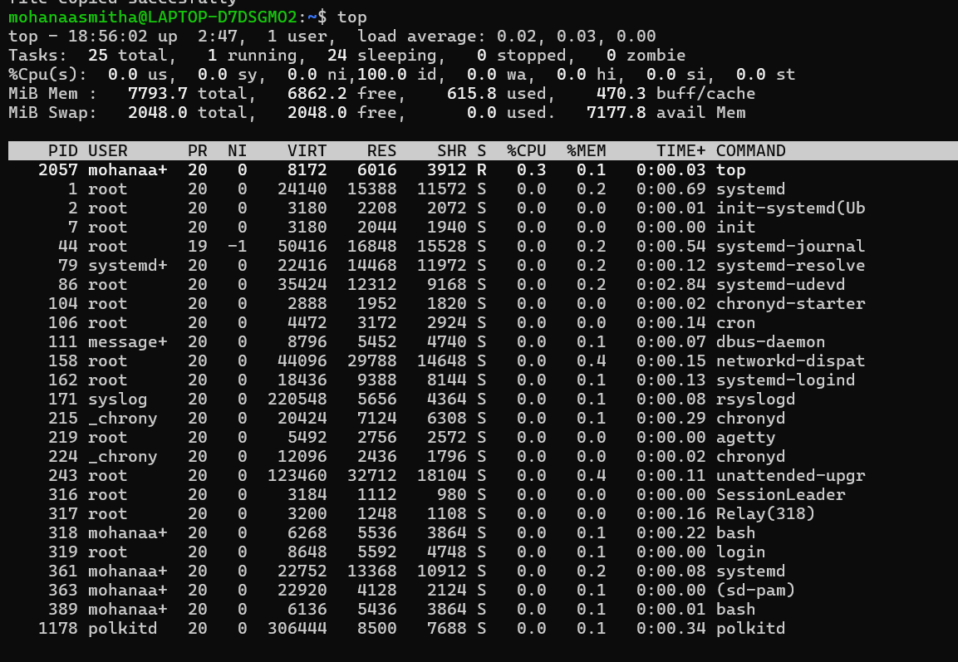
2. 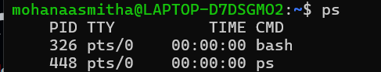

3.

