**Section A**

#!/bin/bash

# internsctl - Custom Linux Command v0.1.0

# Function to display the manual page

display_manual() {

echo "internsctl - Custom Linux Command v0.1.0"

echo "Usage: internsctl [OPTIONS]"

echo

echo "Options:"

echo " --help Display help information"

echo " --version Display version information"

echo

echo "Description:"

echo " This is a custom Linux command created for specific operations."

echo " Add your detailed command usage guidelines here."

}

# Function to display help information

display_help() {

echo "Usage: internsctl [OPTIONS]"

echo

echo "Options:"

echo " --help Display this help message"

echo " --version Display version information"

echo

echo "Examples:"

echo " internsctl [options] # Execute the internsctl command with options"

echo " internsctl --help # Display help information"

}

# Function to display version information

display_version() {

echo "internsctl v0.1.0"

}

# Main script logic

case "$1" in

--help)

display_help

;;

--version)

display_version

;;

*)

display_manual

;;

esac

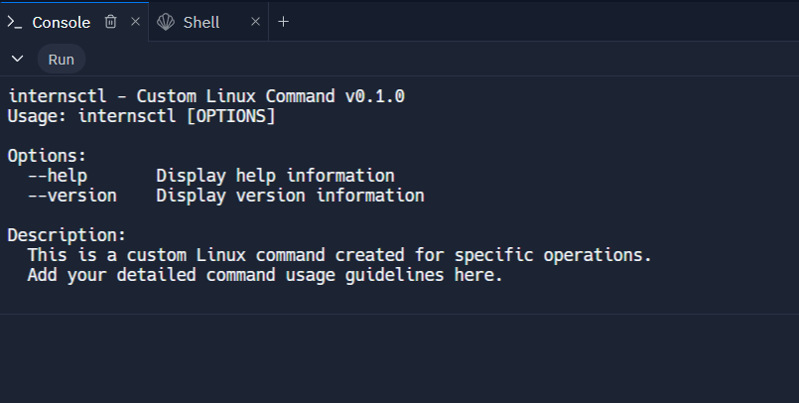

**SECTION B**

**PART 1**

#!/bin/bash

# internsctl - Custom Linux Command v0.1.0

# Function to display the manual page

display_manual() {

echo "internsctl - Custom Linux Command v0.1.0"

echo "Usage: internsctl [OPTIONS]"

echo

echo "Options:"

echo " --help Display help information"

echo " --version Display version information"

echo " cpu getinfo Display CPU information"

echo " memory getinfo Display Memory information"

echo

echo "Description:"

echo " This is a custom Linux command created for specific operations."

echo " Add your detailed command usage guidelines here."

}

# Function to display help information

display_help() {

echo "Usage: internsctl [OPTIONS]"

echo

echo "Options:"

echo " --help Display this help message"

echo " --version Display version information"

echo " cpu getinfo Display CPU information"

echo " memory getinfo Display Memory information"

echo

echo "Examples:"

echo " internsctl cpu getinfo # Display CPU information"

echo " internsctl memory getinfo # Display Memory information"

echo " internsctl --help # Display help information"

}

# Function to display version information

display_version() {

echo "internsctl v0.1.0"

}

# Function to display CPU information

get_cpu_info() {

lscpu

}

# Function to display memory information

get_memory_info() {

free

}

# Main script logic

case "$1" in

--help)

display_help

;;

--version)

display_version

;;

cpu)

case "$2" in

getinfo)

get_cpu_info

;;

*)

echo "Invalid CPU command. Use 'internsctl cpu getinfo' to display CPU information."

;;

esac

;;

memory)

case "$2" in

getinfo)

get_memory_info

;;

*)

echo "Invalid Memory command. Use 'internsctl memory getinfo' to display Memory information."

;;

esac

;;

*)

display_manual

;;

esac

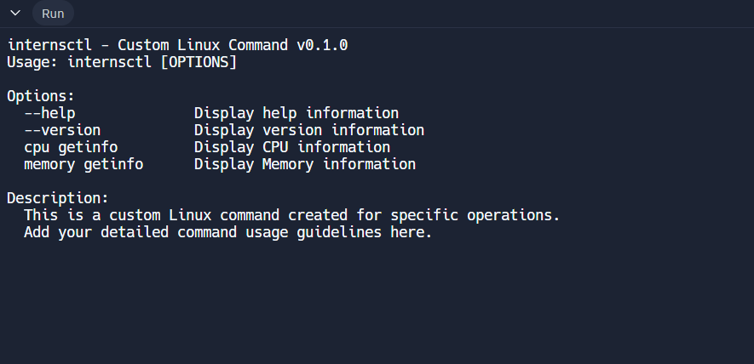

**PART B**

#!/bin/bash

# internsctl - Custom Linux Command v0.1.0

# Function to display the manual page

display_manual() {

echo "internsctl - Custom Linux Command v0.1.0"

echo "Usage: internsctl [OPTIONS]"

echo

echo "Options:"

echo " --help Display help information"

echo " --version Display version information"

echo " cpu getinfo Display CPU information"

echo " memory getinfo Display Memory information"

echo " user create Create a new user"

echo " user list List all regular users"

echo " user list --sudo-only List users with sudo permissions"

echo

echo "Description:"

echo " This is a custom Linux command created for specific operations."

echo " Add your detailed command usage guidelines here."

}

# Function to display help information

display_help() {

echo "Usage: internsctl [OPTIONS]"

echo

echo "Options:"

echo " --help Display this help message"

echo " --version Display version information"

echo " cpu getinfo Display CPU information"

echo " memory getinfo Display Memory information"

echo " user create Create a new user"

echo " user list List all regular users"

echo " user list --sudo-only List users with sudo permissions"

echo

echo "Examples:"

echo " internsctl cpu getinfo # Display CPU information"

echo " internsctl memory getinfo # Display Memory information"

echo " internsctl user create <username># Create a new user"

echo " internsctl user list # List all regular users"

echo " internsctl user list --sudo-only # List users with sudo permissions"

echo " internsctl --help # Display help information"

}

# Function to display version information

display_version() {

echo "internsctl v0.1.0"

}

# Function to create a new user

create_user() {

if [ -z "$1" ]; then

echo "Error: Missing username. Usage: internsctl user create <username>"

else

sudo useradd -m "$1"

sudo passwd "$1"

echo "User '$1' created successfully."

fi

}

# Function to list all regular users

list_users() {

cut -d: -f1,3 /etc/passwd | awk -F: '$2 >= 1000 && $2 != 65534 {print $1}'

}

# Function to list users with sudo permissions

list_sudo_users() {

grep -Po '^sudo.+:\K.*$' /etc/group | tr ',' '\n'

}

# Main script logic

case "$1" in

--help)

display_help

;;

--version)

display_version

;;

user)

case "$2" in

create)

create_user "$3"

;;

list)

if [ "$3" == "--sudo-only" ]; then

list_sudo_users

else

list_users

fi

;;

*)

echo "Invalid user command. Use 'internsctl user create <username>' or 'internsctl user list [--sudo-only]'"

;;

esac

;;

*)

display_manual

;;

esac

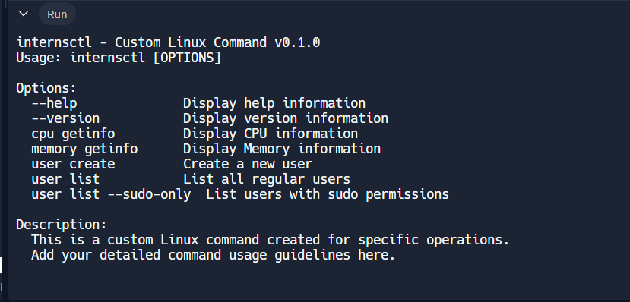

**PART C**

#!/bin/bash

# internsctl - Custom Linux Command v0.1.0

# Function to display the manual page

display_manual() {

echo "internsctl - Custom Linux Command v0.1.0"

echo "Usage: internsctl [OPTIONS]"

echo

echo "Options:"

echo " --help Display help information"

echo " --version Display version information"

echo " cpu getinfo Display CPU information"

echo " memory getinfo Display Memory information"

echo " user create Create a new user"

echo " user list List all regular users"

echo " user list --sudo-only List users with sudo permissions"

echo " file getinfo [options] <file> Get information about a file"

echo "Options for file getinfo:"

echo " --size, -s Print file size"

echo " --permissions, -p Print file permissions"

echo " --owner, -o Print file owner"

echo " --last-modified, -m Print last modified time"

echo

echo "Examples:"

echo " internsctl cpu getinfo # Display CPU information"

echo " internsctl memory getinfo # Display Memory information"

echo " internsctl user create <username> # Create a new user"

echo " internsctl user list # List all regular users"

echo " internsctl user list --sudo-only # List users with sudo permissions"

echo " internsctl file getinfo --size hello.txt # Get file size"

echo " internsctl file getinfo --permissions hello.txt # Get file permissions"

echo " internsctl file getinfo --owner hello.txt # Get file owner"

echo " internsctl file getinfo --last-modified hello.txt # Get last modified time"

echo " internsctl --help # Display help information"

}

# Function to display help information

display_help() {

echo "Usage: internsctl [OPTIONS]"

echo

echo "Options:"

echo " --help Display this help message"

echo " --version Display version information"

echo " cpu getinfo Display CPU information"

echo " memory getinfo Display Memory information"

echo " user create Create a new user"

echo " user list List all regular users"

echo " user list --sudo-only List users with sudo permissions"

echo " file getinfo [options] <file> Get information about a file"

echo "Options for file getinfo:"

echo " --size, -s Print file size"

echo " --permissions, -p Print file permissions"

echo " --owner, -o Print file owner"

echo " --last-modified, -m Print last modified time"

echo

echo "Examples:"

echo " internsctl cpu getinfo # Display CPU information"

echo " internsctl memory getinfo # Display Memory information"

echo " internsctl user create <username> # Create a new user"

echo " internsctl user list # List all regular users"

echo " internsctl user list --sudo-only # List users with sudo permissions"

echo " internsctl file getinfo --size hello.txt # Get file size"

echo " internsctl file getinfo --permissions hello.txt # Get file permissions"

echo " internsctl file getinfo --owner hello.txt # Get file owner"

echo " internsctl file getinfo --last-modified hello.txt # Get last modified time"

echo " internsctl --help # Display help information"

}

# Function to display version information

display_version() {

echo "internsctl v0.1.0"

}

# Function to get file information

get_file_info() {

local file="$2"

if [ -z "$file" ]; then

echo "Error: Missing file name. Usage: internsctl file getinfo [options] <file>"

return 1

fi

if [ ! -e "$file" ]; then

echo "Error: File '$file' does not exist."

return 1

fi

local size=""

local permissions=""

local owner=""

local last_modified=""

while [[ "$#" -gt 0 ]]; do

case $1 in

--size|-s)

size=$(stat -c %s "$file")

;;

--permissions|-p)

permissions=$(stat -c %A "$file")

;;

--owner|-o)

owner=$(stat -c %U "$file")

;;

--last-modified|-m)

last_modified=$(stat -c %y "$file")

;;

*)

# Ignore unknown options

;;

esac

shift

done

echo "File: $file"

[ -n "$permissions" ] && echo "Access: $permissions"

[ -n "$size" ] && echo "Size(B): $size"

[ -n "$owner" ] && echo "Owner: $owner"

[ -n "$last_modified" ] && echo "Modify: $last_modified"

}

# Main script logic

case "$1" in

--help)

display_help

;;

--version)

display_version

;;

file)

shift

get_file_info "$@"

;;

*)

display_manual

;;

esac

