ODH testing with soapUI

Create a new project from scratch and save it
- Create a new project: File -> Create Empty project
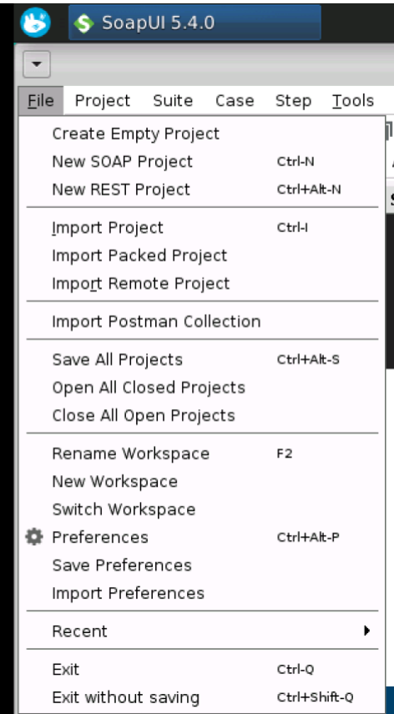

Right click on the project -> Save project as -> Specify the path and click OK

- Add a new test suite:
Right click on the project -> New TestSuite -> Enter the name of the TestSuite -> click OK
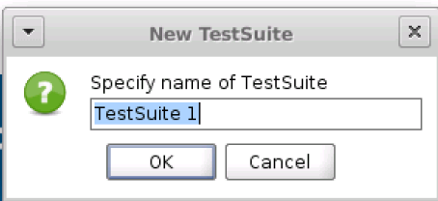

- Add a new test case:
Right click on the TestSuite -> New TestCase -> Enter the name of the TestCase -> click OK
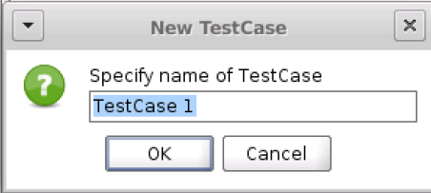

- Add a new step to a TestCase:
Right click on the TestCase -> Add Step -> Choose between different types, e.g. HTTP Request -> Specify the name for new step -> Click OK -> Specify the HTTP endpoint and enter parameters if needed -> Click OK

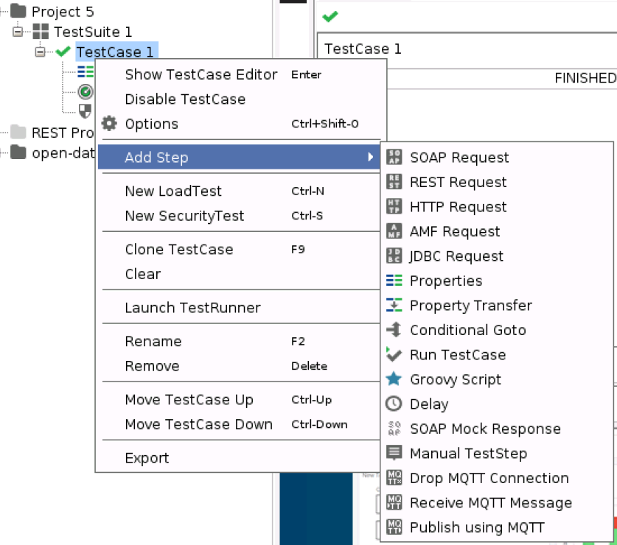
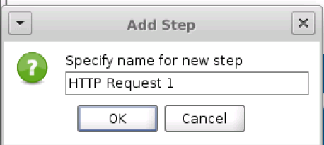

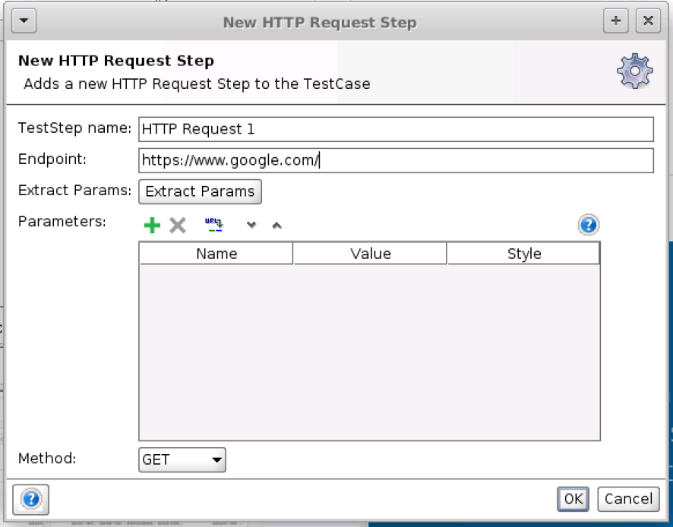

- Add Assertions to the step:
Click on “Asserstions” at the bottom of the popup
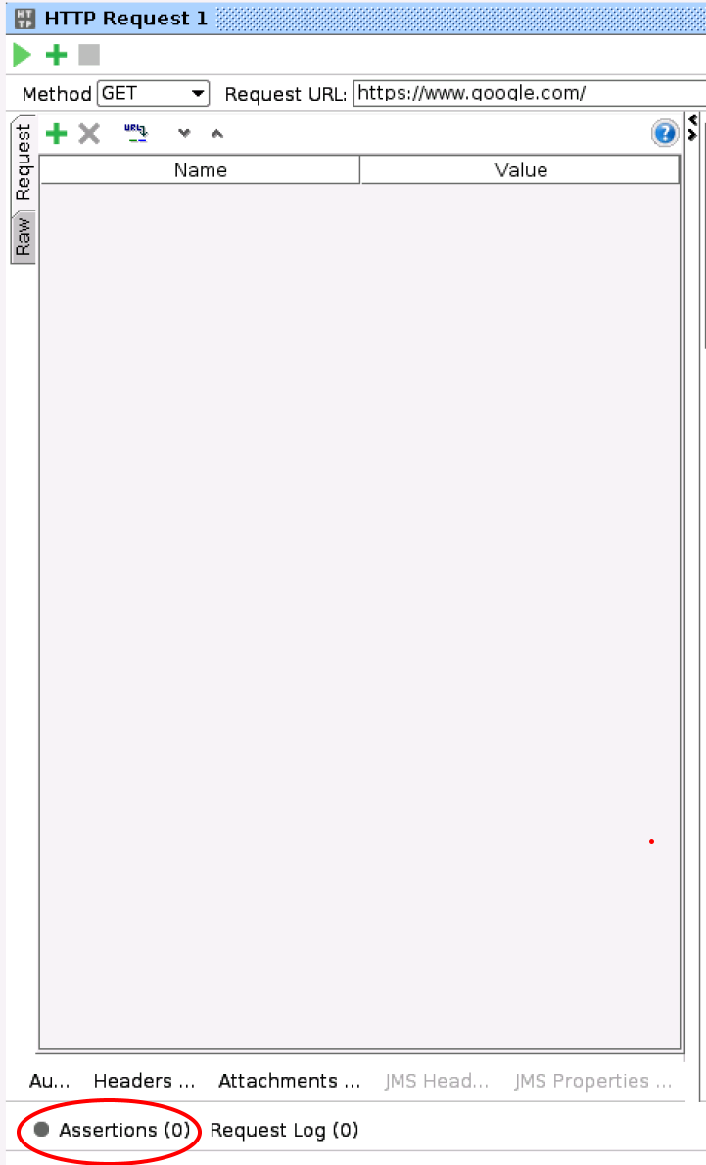

Click on the green + on the popup
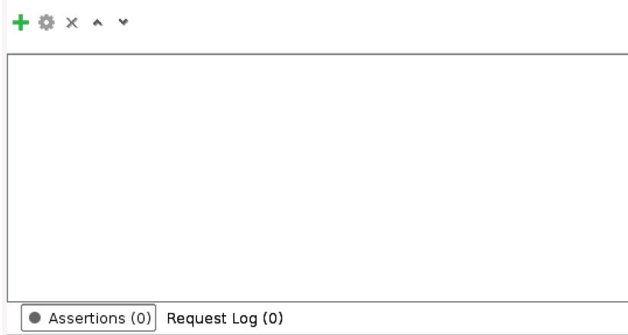

Then click the type of assertion you want to add:

HTTP Status Code
If you want to check HTTP status then click Compliance, Status and Standard and then select Valid HTTP Status Codes or Invalid HTTP Status Codes.
The enter the HTTP status codes you want to check.
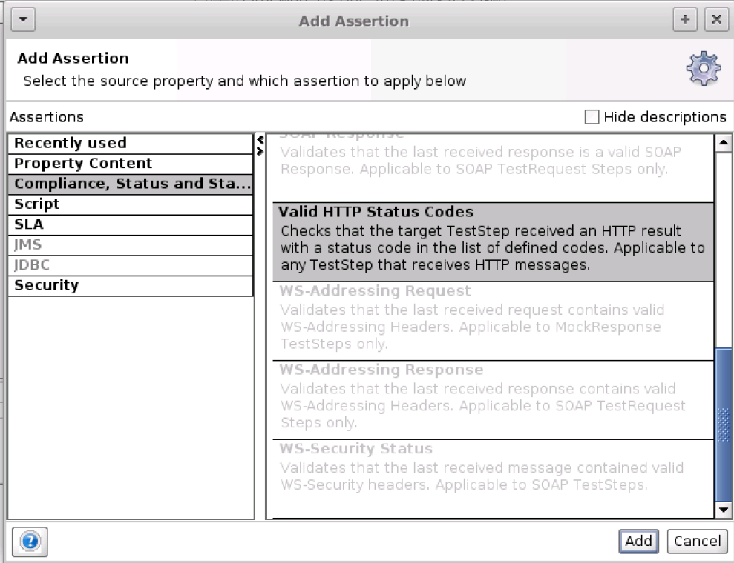

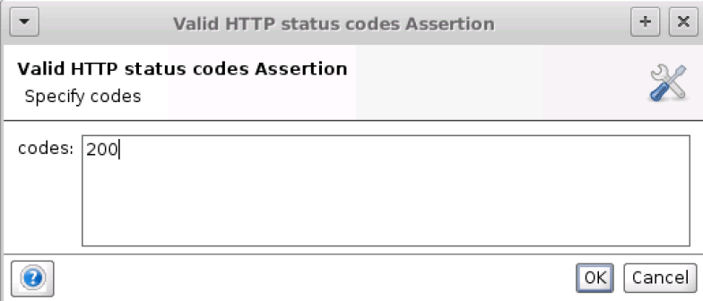

Response time:
Select Response SLA if you want to check if the response time is within a limit.
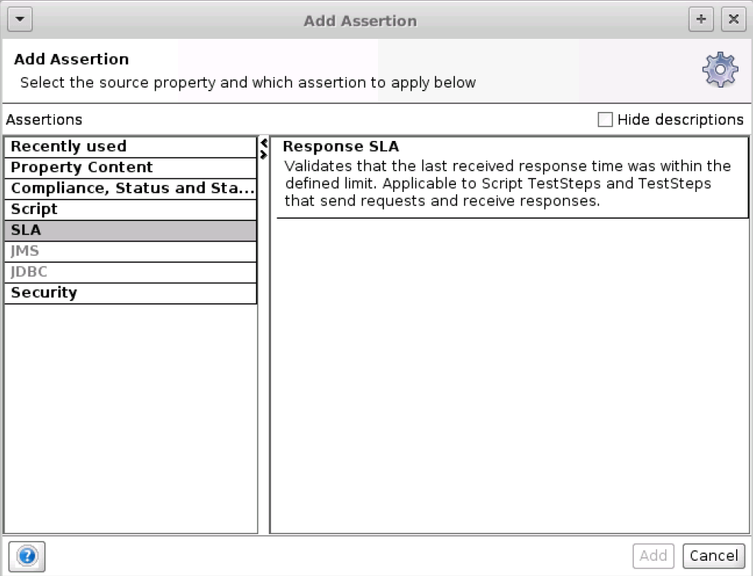

Then specify the maximum response time in ms and click ok

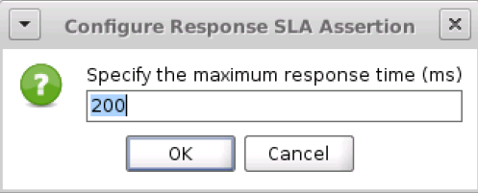

- Run a step manually:
Click on the top left corner of the play button, then the test starts
On the bottom you can see if the assertions were successfully or not: if they are successful they have a green dot and it is written VALID after the name of the assertion. If they are not successful they have a red dot and it is written FAILED after the name of the assertion.
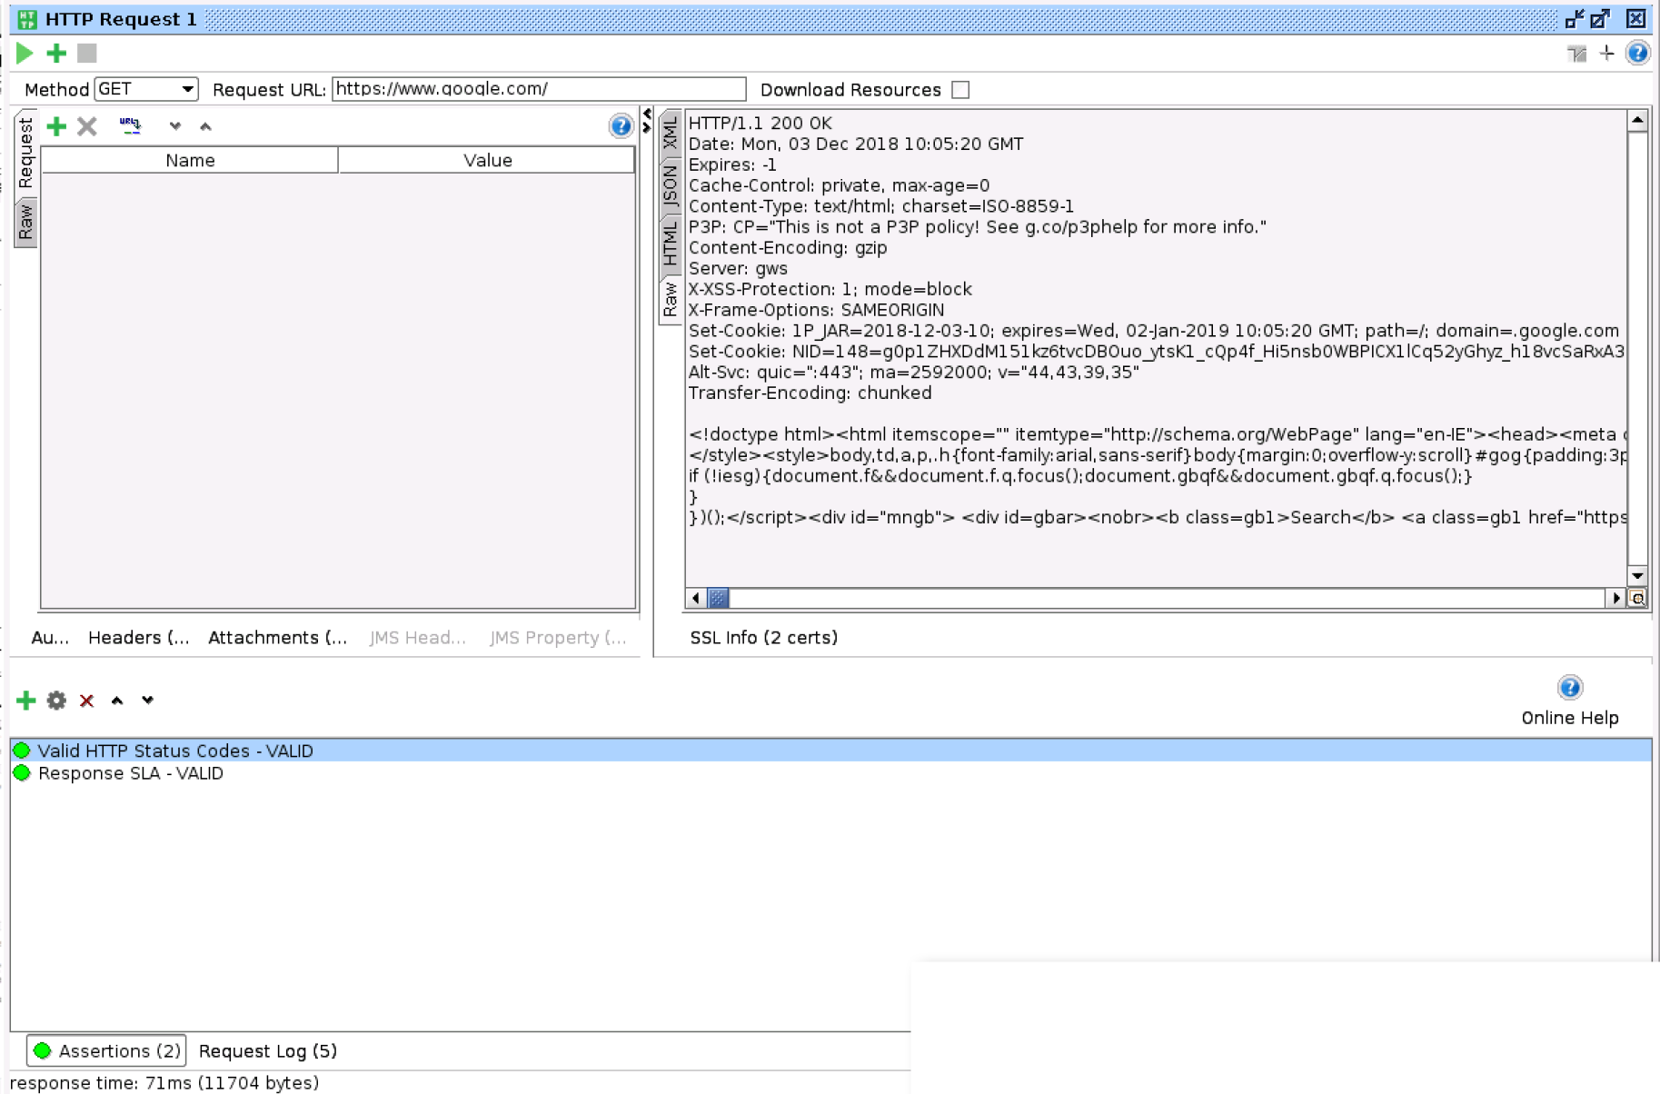

Import a project from Swagger
- Create a new project: File -> Create Empty project
- Right click on the project -> Import swagger
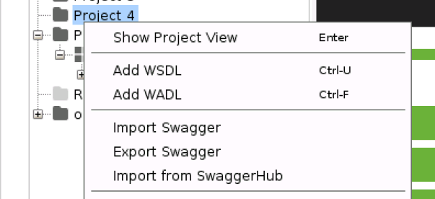

- Insert the json url of your swagger in the input field “Swagger Definition”, e.g. https://petstore.swagger.io/v2/swagger.json

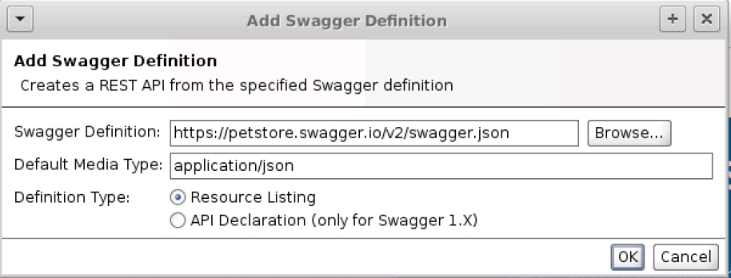
- Then you should see all API’s in your project
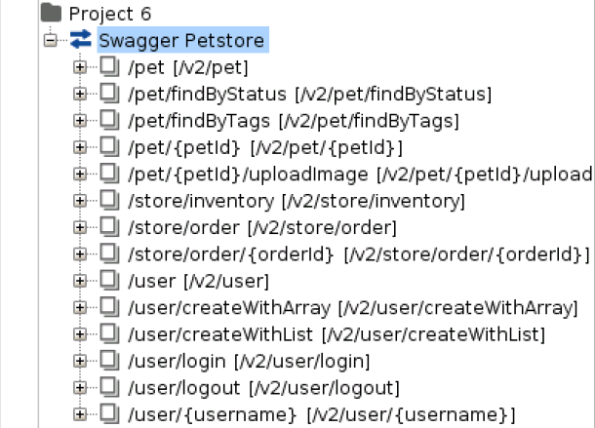
- Then right click on the container of all API’s -> Select Generate Test Suite
- Select all API’s that you want to test -> click OK -> Enter the name of your Test Suite -> Click OK -> Enter the test steps names
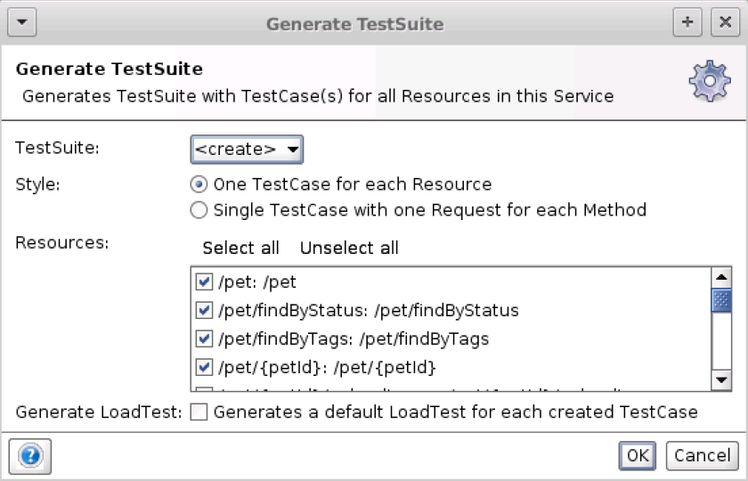

- Add assertions as in the first step when you create a project from scratch

- Add parameters to a request
Click on the request -> It shows a list of parameters on the left side -> enter a value -> click the play button -> on the right you can select the output type of API e.g. JSON -> then you can see the output value of the API
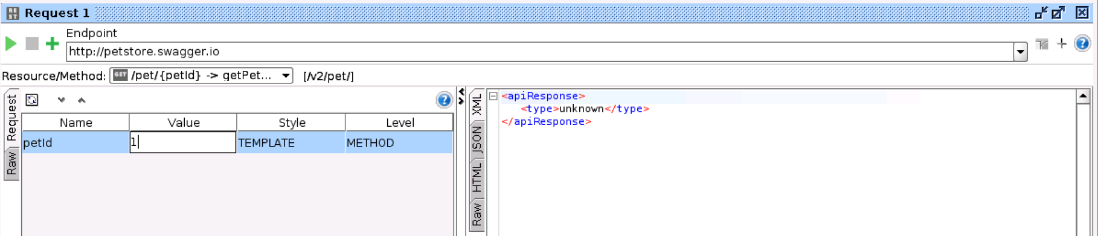

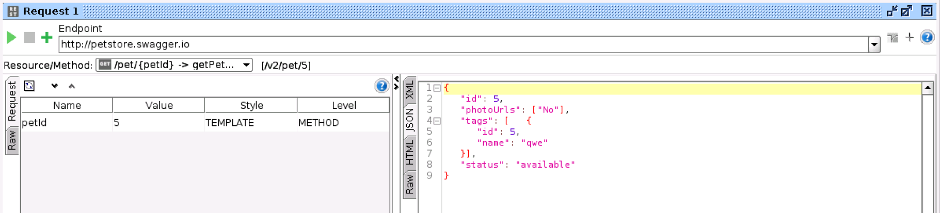

JSON Validation

JsonPath Existence Match
- Add a new Assertion to a Request
- Select JsonPath Match under Property Content
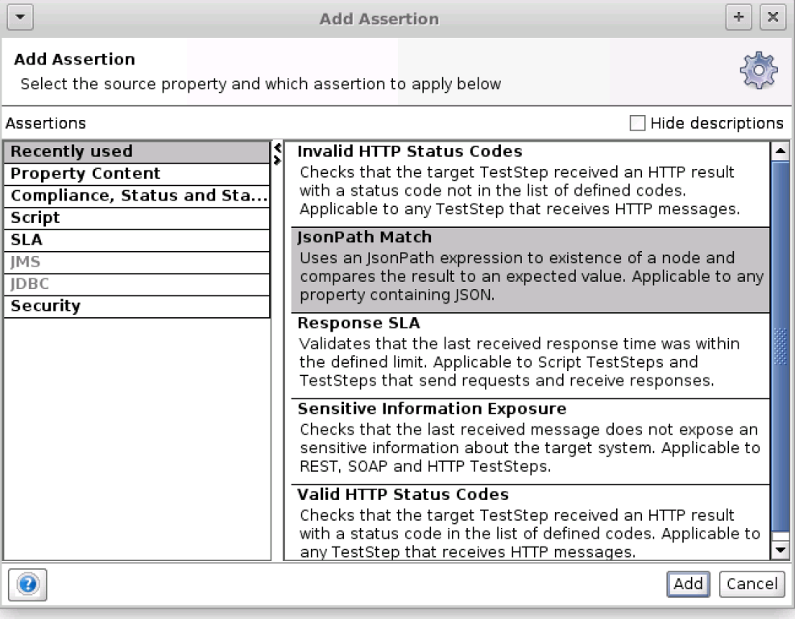

- Enter the JSONPath in the first text box. $ is the root element, then add a ‘.’ to go inside a JSON object, or select a element from a Json array using the number of the element inside square brackets, e.g. ‘[0]’. In this example the id inside the root element is tested. Then add in the second text box the value that you are expecting.
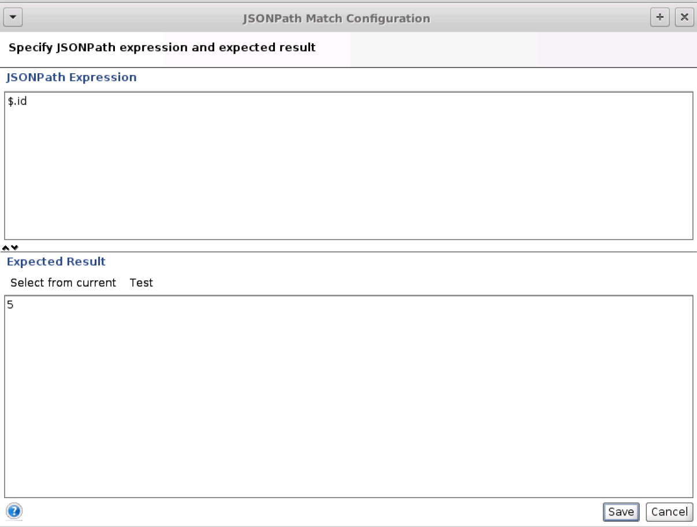

- The result of the assertion is Valid if the expected value is inside the result of the API

JsonPath Count
- Add a new Assertion to a Request
- Select JsonPath Count under Property Content
- Enter the JSON path in the first text box and the in the second text box the expected result of the number of occurrences of an element
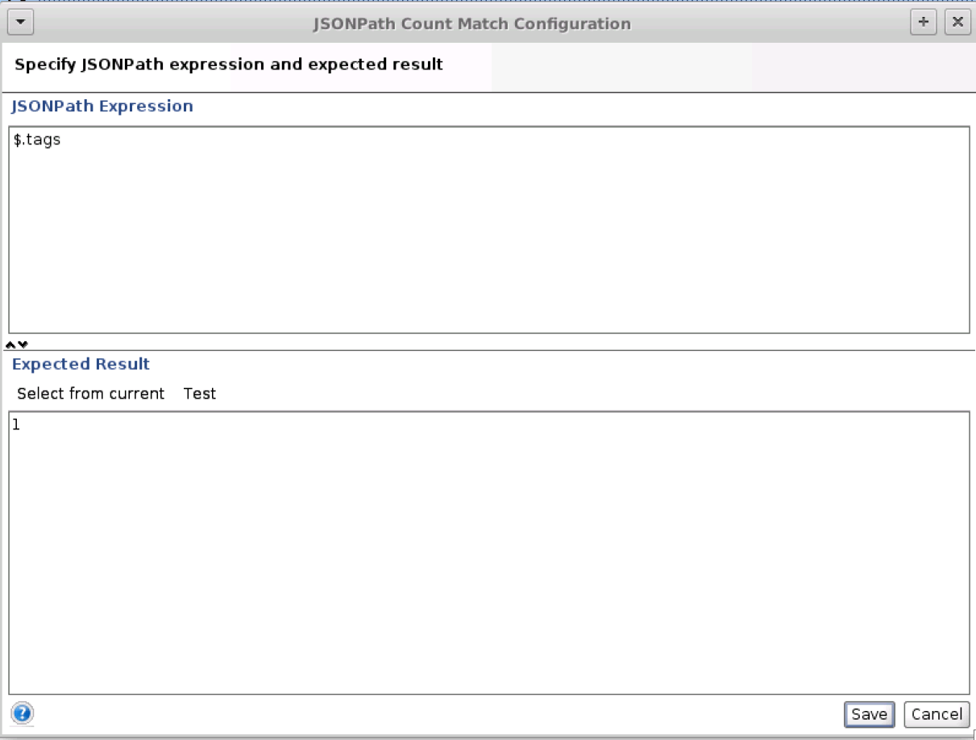

JsonPath Existence Match
- Add a new Assertion to a Request
- Select JsonPath Existence Match under Property Content
- Enter the JSON path in the first text box and the in the second text box the expected result: true if a JsonPath should exist and false if it should not exist
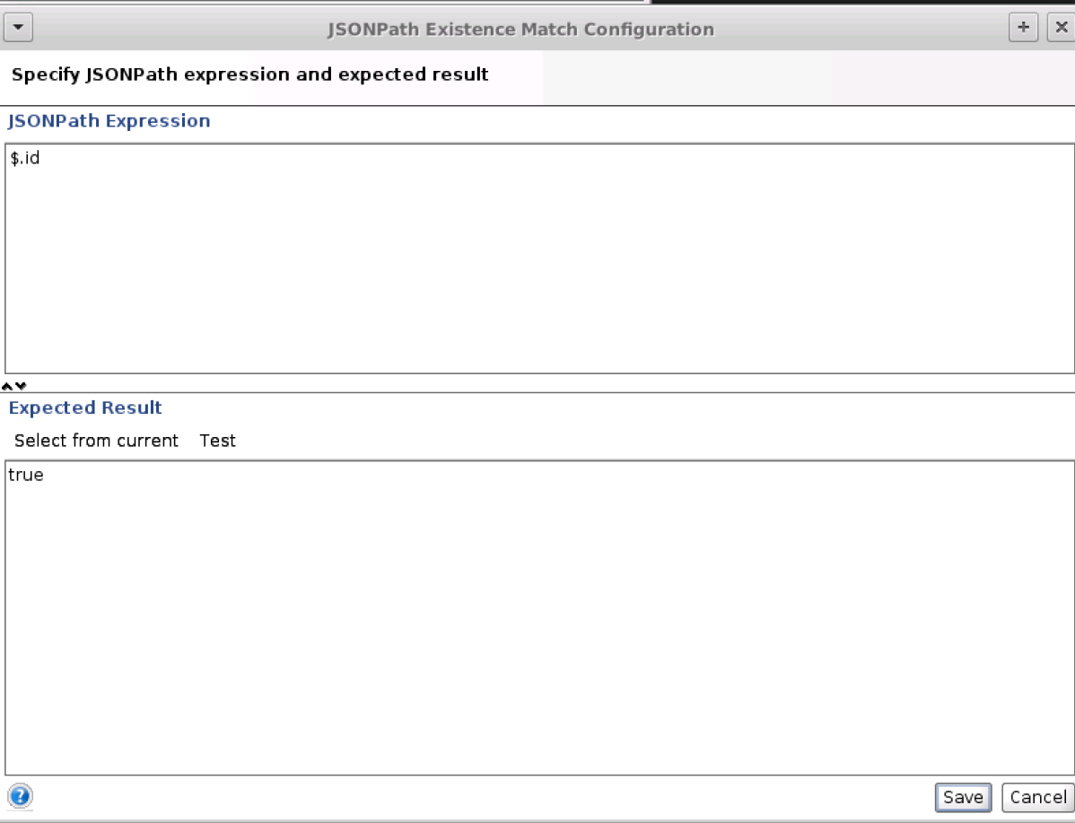

JsonPath RegEx Match
- Add a new Assertion to a Request
- Select JsonPath Count under Property Content
- Enter the JSON path in the first text box, in the second text box a Regular Expression which is compared with the result and in the third text box the expected result (true, false)
