**Module 2 Homework**

Chengbo Gu

**Problem 1. (30 points)**

Computations on gene means of the Golub data set.

**(a)** Compute the mean expression values for every gene among “ALL” patients.

library(multtest)

data(golub)

gol.fac **<-** factor(golub.cl, levels=0:1, labels = c("ALL", "AML"))

meanALL **<-** apply(golub[,gol.fac=="ALL"], 1, mean)

**(b)** Compute the mean expression values for every gene among “AML” patients.

meanAML **<-** apply(golub[,gol.fac=="AML"], 1, mean)

**(c)** Give the biological names of the three genes with the largest mean expression

value among “ALL” patients.

orderALL = order(meanALL, decreasing = TRUE)

print(golub.gnames[orderALL[1:3],2])

[1] "GB DEF = Chromosome 1q subtelomeric sequence D1S553"

[2] "37 kD laminin receptor precursor/p40 ribosome associated protein gene"

[3] "RPS14 gene (ribosomal protein S14) extracted from Human ribosomal protein S14 gene"

**(d)** Give the biological names of the three genes with the largest mean expression

value among “AML” patients.

orderAML = order(meanAML, decreasing = TRUE)

print(golub.gnames[orderAML[1:3],2])

[1] "GB DEF = mRNA fragment for elongation factor TU (N-terminus)"

[2] "GB DEF = HLA-B null allele mRNA"

[3] "Globin, Beta"

**Problem 2. (30 points)**

More work on the Golub data set.

**(a)** Save the expression values of the first five genes (in the first five rows) for the

AML patients in a csv file “AML5.csv”.

AML5 **<-** golub[1:5, gol.fac == "AML"]

write.csv(AML5, file="AML5.csv")

**(b)** Save the expression values of the first five genes for the ALL patients in a plain

text file “ALL5.txt”.

ALL5 **<-** golub[1:5, gol.fac == "ALL"]

write.table(ALL5, file="ALL5.txt")

**(c)** Compute the standard deviation of the expression values on the first patient,

of the 100th to 200th genes (total 101 genes).

exp100To200 **<-** golub[100:200,1]

print(sd(exp100To200))

[1] 0.9174976

**(d)** Compute the standard deviation of the expression values of every gene, across

all patients. Find the number of genes with standard deviation greater than 1.

print(sum(apply(golub, 1, sd)>1))

[1] 123

**(e)** Do a scatter plot of the 101th gene expressions against the 102th gene

expressions, label the x-axis and the y-axis with the genes’ biological names using

xlab= and ylab= control options.

exp101th = golub[101,]

exp102th = golub[102,]

windows()

plot(exp101th, exp102th, xlab=golub.gnames[101,2], ylab=golub.gnames[102,2])

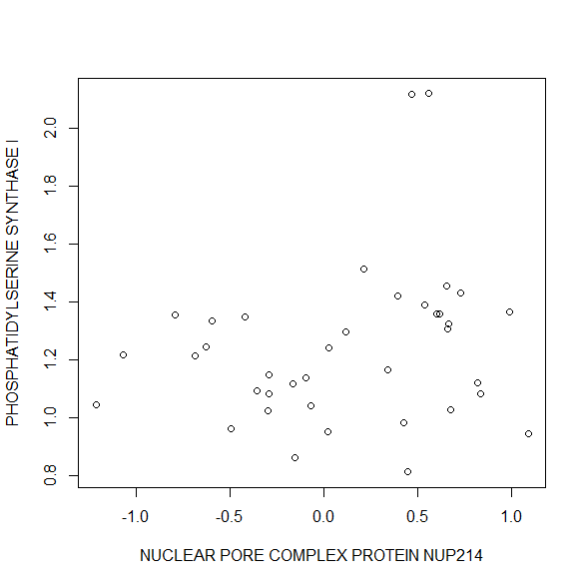

**Problem 3. (20 points)**

Work with the ALL data set. Load the ALL data from the ALL library and use str

and openVignette() for a further orientation.

**(a)** Use exprs(ALL[,ALL$BT=="B1"] to extract the gene expressions from the

patients in disease stage B1. Produce one histogram of these gene expressions in

the this matrix.

rm(list=ls())

library(ALL)

data(ALL)

windows()

hist(exprs(ALL[,ALL$BT=="B1"]),ylim=c(0,25000), xlab="Expression level", main="Histogram of gene expressions in ALL dataset")

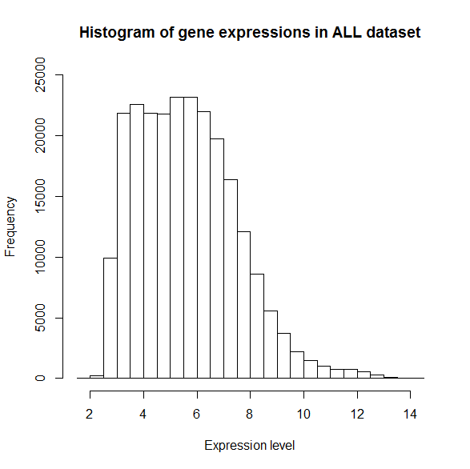

**(b)** Compute the mean gene expressions for every gene over these B1 patients.

meanExp **<-** apply(exprs(ALL[,ALL$BT=="B1"]), 1, mean)

**(c)** Give the gene identifiers of the three genes with the largest mean.

orderB1 **<-** order(meanExp, decreasing = TRUE)

print(meanExp[orderB1[1:3]])

AFFX-hum_alu_at 31962_at 31957_r_at

13.41648 13.16671 13.15995

**Problem 4. (20 points)**

We work with the “trees” data set that comes with R.

**(a)** Find the type of the trees data object.

rm(list=ls())

data(trees)

print(class(trees))

[1] "data.frame"

**(b)** Produce a figure with two overlaid scatterplots: Height versus Girth, Volume

versus Girth(The Girth is on the x-axis). Do the Height plot with blue “+” symbols,

and do the Volume plot with red “o” symbols. You need to learn to set the ylim=

control option so that all points from the two plots can all show up on the merged

figure.

windows()

plot(trees$Height~trees$Girth, xlab="Girth", ylab="Height and Volume", col="blue", pch="+", ylim = c(0,90))

points(trees$Volume~trees$Girth, col = "red" , pch="o")

legend(18,20, c("Height", "Volume"), pch=c("+","o"), col = c("blue","red"))

