**Module 4 Homework**

Chengbo Gu

**Problem 1. (20 points)**

are independent random samples from a distribution with mean 5 and standard deviation 3. Complete the following:

**(a)** For the sample mean, find its mean  and standard deviation **.







**(b)** Can you find the  approximately using CLT? If yes, what is your estimate for ? If no, why not?

No, we can’t use CLT to find  here because the  here is too small.

Generally, it is OK to use CLT when .

**Problem 2. (20 points)**

Suppose that for certain microRNA of size 20 the probability of a purine is binomially distributed with probability 0.7. Say there are 100 such microRNAs, each independent of the other. Let Y denote the average number of purine in these microRNAs. Find the probability that Y is great than 15. Please give a theoretical calculation, do NOT use Monte Carlo simulation to approximate. Show all the steps and formulas in your calculation.

Let  denote the number of purine in the 20 microRNAs.

Then we have .

Thus,





According to CLT, 



**R code:**

meanX **<-** 20*0.7

VarX **<-** 20*0.7*0.3

print(1-pnorm(15, mean=meanX, sd=sqrt(VarX)/10))

[1] 5.317746e-07

**Problem 3. (20 points)**

Two genes’ expression values follow a bivariate normal distribution. Let X and Y denote their expression values respectively. Also assume that X has mean 9 and variance 3; Y has mean 10 and variance 5; and the covariance between X and Y is 2.

In a trial, 50 independent measurements of the expression values of the two genes are collected, and denoted as , …,. We wish to find the probability, that is, the probability that the sample mean for the second gene exceeds the sample mean of the first gene by more than 0.5.  

Conduct a Monte Carlo simulation to approximate this probability, providing a 95% confidence interval for your estimation.

**One loop solution:**

require(mvtnorm)

sim **<-** 100000

blah **<-** rep(NA, sim)

**for** (i **in** 1:sim){

matrix **<-** rmvnorm(50, mean=c(9,10), sigma=matrix(c(3,2,2,5), nrow=2))

meanX **<-** mean(matrix[,1])

meanY **<-** mean(matrix[,2])

blah[i] **<-** meanX + 0.5 < meanY

}

p **<-** mean(blah)

print(p)

[1] 0.96149

print( p + c(-1, 1)*1.96*sqrt(var(blah)/sim))

[1] 0.9602973 0.9626827

**Two loops solution:**

sim **<-** 1000

res **<-** rep(NA, sim)

n **<-** 100

zeroOnes **<-** rep(NA, n)

**for** (i **in** 1:sim){

**for** (j **in** 1:n){

matrix **<-** rmvnorm(50, mean=c(9,10), sigma=matrix(c(3,2,2,5), nrow=2))

meanX **<-** mean(matrix[,1])

meanY **<-** mean(matrix[,2])

zeroOnes[j] **<-** meanX + 0.5 < meanY

}

p **<-** mean(zeroOnes)

res[i] **<-** p

}

print( mean(res) )

[1] 0.96146

print( mean(res) + c(-1, 1)*1.96*sqrt(var(res)/sim))

[1] 0.9602833 0.9626367

**Summary:**

Even though the answers from one and two loops solutions are similar, I still stick on my idea that two loops solution is statistically meaningful. To get confidence interval, we need lots of observed value of. One loop solution treats 0s and 1s as one single , which is wrong from my point of view, while there are lots of observed value around 0.96 in the res array in two loops solution.

And actually after playing with one loop solution several times, I found that there are cases when the theoretical value doesn’t fall into the confidence interval which is abnormal.

**Theoretical Calculation:**





Then we have







Thus,



**R code:**

1-pnorm(0.5, 1, sqrt(0.08))

[1] 0.9614501

**Problem 4. (20 points)**

Assume there are three independent random variables,, with m=3 degrees of freedom.

Define a new random variable Y as .  

Use Monte Carlo simulation to find the mean of Y. Submit your R script for the Monte Carlo simulation, and a brief summary of the actual simulation results.

x1 **<-** rchisq(100000, df = 10)

x2 **<-** rgamma(100000, shape = 1, scale = 2)

x3 **<-** rt(100000, df = 3)

y **<-** sqrt(x1)*x2+4*(x3^2)

print(mean(y))

[1] 18.26831

**Summary**:

Theoretically,









Thus,

Esqrtx1 **<-** integrate(**function**(x) sqrt(x)*dchisq(x, df = 10), lower=0, upper=Inf)$value

Ex2 **<-** 1*2

Esquarex3 **<-** integrate(**function**(x) x^2 *dt(x, df = 3), lower=-Inf, upper=Inf)$value

Ey **<-** Esqrtx1*Ex2 + 4*Esquarex3

print(Ey)

[1] 18.16866

So the theoretical expectation of Y is 18.6866.

print( abs(mean(y)-Ey)/Ey * 100 )

[1] 0.5484747

And the percentage error of this exact Monte Carlo simulation is only 0.55%.

**Problem 5. (20 points)**

Complete exercise 10 in Chapter 3 of *Applied Statistics for Bioinformatics using R* (page 45-46). Submit the plot, and a brief explanation of your observation.

n **<-** 1000

a **<-** **function**(n) {sqrt(2*log(n)) - 0.5*(log(log(n)) + log(4*pi)) * (2*log(n))^(-1/2)}

b **<-** **function**(n) {(2*log(n))^(-1/2)}

an **<-** a(n)

bn **<-** b(n)

res **<-** rep(NA, n)

**for** (i **in** 1:n){

res[i] = (max(rnorm(n, 0, 1))-an)/bn

}

plot(density(res), ylim=c(0,0.5), xlab="range of X", main="Extreme Value investigation")

f **<-** **function**(x) {exp(-x)*exp(-exp(-x))}

curve(f, range(density(res)$x), add=TRUE, col = "blue")

curve(dnorm, add=TRUE, col = "red")

legend(1.5,0.5, c("generated extreme data", "extreme value", "normal distribution"), lty = "solid", col = c("black","blue","red"))

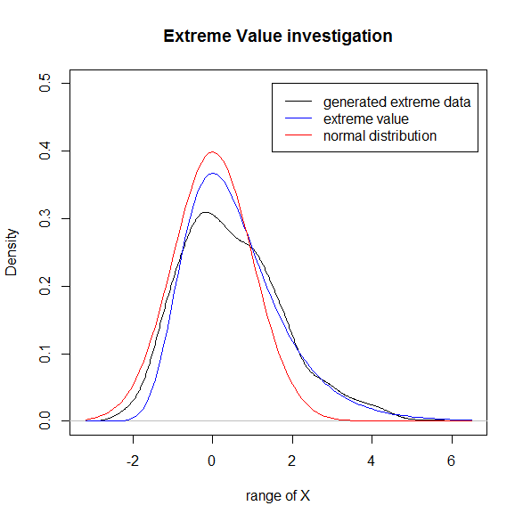

**Summary**:

The extreme value (blue line) fits to the density of generated extreme data (black line) much better than normal distribution (read line).