**A NARRATIVE REPORT: STUDENT TRAINING EXPERIENCES AT EMILIO AGUINALDO COLLEGE MEDICAL CENTER - CAVITE AT BARANGAY SALITRAN II, CITY OF DASMARIÑAS, PROVINCE OF CAVITE.**

1

2

3

4

5

6

7

8

9

10

11

Narrative Report to the Faculty

of the Department of Information Technology

Cavite State University

General Trias City, Cavite

1

2

3

4

5

6

7

8

9

10

11

12

13

In Partial Fulfillment

Of the requirements for the degree

Bachelor of Science in Information Technology

1

2

3

4

5

6

7

8

9

10

11

12

13

14

15

**MICHAEL F. ORACION**

July 2023

Republic of the Philippines

**CAVITE STATE UNIVERSITY**

General Trias City Campus

Town Proper, City of General Trias, Cavite, 4107

🕾 (046) 437-0693

cvsugeneraltrias@cvsu.edu.ph

**DEPARTMENT OF INFORMATION TECHNOLOGY**

## Author: MICHAEL F. ORACION

Title: **A NARRATIVE REPORT: STUDENT TRAINING EXPERIENCES AT EMILIO AGUINALDO COLLEGE MEDICAL CENTER - CAVITE AT BARANGAY SALITRAN II, CITY OF DASMARIÑAS, PROVINCE OF CAVITE.**

**APPROVED**

1

2

3

|  |  |  |  |
| --- | --- | --- | --- |
| **EDISON DE LOS SANTOS**  OJT Adviser | Date | **CLEAFERE L. NOCON**  OJT Coordinator | Date |

11

2

3

4

5

6

7

|  |  |  |  |
| --- | --- | --- | --- |
| **MICHAEL E. PAREJA** Department Chairperson | Date | **PROF. MARILOU P. LUSECO**  Campus Administrator | Date |

6

7

**BIOGRAPHICAL DATA**

Michael F. Oracion was born on December 08, 1988, in General Trias City, Cavite. He is the youngest among his siblings. His parents are Martiniano Q. Oracion and Angelita F. Oracion.

He completed his elementary education at Memorial Elementary School in General Trias, Cavite. Then he continued his educational journey and enrolled in Rosario Institute and transferred and graduated at Colegio de San Francisco.

After graduating from high school, Michael started to work in Jollibee Tanza as a service crew from 2007-2008. Then he transition a work job as a Computer technician and Computer attendant in Noicaro Internet café from 2009-2017. Then he decided to pursue his studying and currently taking a Bachelor of Science in Information Technology in Cavite State University General Trias City, Campus.

**ACKNOWLEDGEMENT**

**1**

**2**

**3**

The realization of this achievement would not have been possible without the assistance of the individuals who supported the student.

Firstly, the student expresses gratitude to God for granting knowledge, wisdom, strength, and daily guidance.

The OJT Adviser, Ms. Lana Angela Yambao, is commended for her role in providing clear instructions, guiding the growth of the responsible student trainee, and serving as an excellent OJT Adviser without applying undue pressure.

The OJT Coordinator, Ms. Cleafere L. Nocon helped the students by giving an opportunity to accomplish the internship at Emilio Aguinaldo College Medical Center – Cavite.

Prof. Marilou P. Luseco, the Campus Administrator of Cavite State University- General Trias City Campus, for her support and permission to render my On-the-Job training at Emilio Aguinaldo College Medical Center – Cavite.

Dr. Genalin P. Trias, MMHoA, FPOGS (Hospital Director), along with the staff of Emilio Aguinaldo College Medical Center – Cavite, deserve recognition for granting the student the opportunity to be their OJT trainee.

The student expresses gratitude to their companions during the practicum training, namely Ms. Kristine Hinayon, Sir Arnulfo Abaya, and Sir Mark Reyes. Their company and support throughout the journey were truly appreciated.

Heartfelt appreciation is extended to friends and classmates for their unwavering support throughout the entire journey. Their shared laughter and tears made each day of this narrative report enjoyable.

The student expresses sincere gratitude to her beloved mother, Lerma Bella, for providing financial support, love, and constant encouragement throughout this experience.

**MICHAEL F. ORACION**

**TABLE OF CONTENTS**

1

**Page**

**BIOGRAPHICAL DATA** ...................................................................................... iii

**ACKNOWLEDGEMENT**...................................................................................... iv

**LIST OF FIGURES** .............................................................................................. vii

**LIST OF APPENDICES** ..................................................................................... viii

**LIST OF APPENDIX FIGURES** .......................................................................... ix

**INTRODUCTION** ................................................................................................ 1

Objective of the On-The-Job Training .................................................. 2

Significance of On-The-Job Training .................................................... 2

Time and Place of On-The-Job Training ............................................... 3

**THE LINKAGE ESTABLISHMENT** .................................................................... 4

Background/Profile of the Establishment .............................................. 4

Location ............................................................................................... 6

Mission, Vision, and Goal ..................................................................... 6

Quality Policy ....................................................................................... 6

Privacy Policy....................................................................................... 7

**THE TRAINING AREA** ....................................................................................... 8

Department Functions .......................................................................... 8

Organizational Structure of Partner Management Office ...................... 9

Facilities .............................................................................................. 10

Equipment ........................................................................................... 10 **THE TRAINING EXPERIENCE** ......................................................................... 11 Task Performed/ Specific Activities Assigned .................................................... 11

Observed Strength of the Training Area .............................................. 11

Problem Encountered ......................................................................... 11

**SUMMARY** ........................................................................................................ 12

**REFERENCES** .................................................................................................. 13

**APPENDICES** ................................................................................................... 14

**LIST OF FIGURES**

## Figure Page

1. Logo ................................................................................................. 4
2. Branding Logo .................................................................................. 4
3. Location and the Establishment ....................................................... 6
4. Department Function of IT Department ............................................ 8
5. Organizational Structure ................................................................... 9

**LIST OF APPENDICES**

## Appendix Page

1. Application Letter ........................................................................ 15
2. Curriculum Vitae ......................................................................... 16
3. Curriculum Checklist ................................................................... 17
4. Certificate of Class Standing ....................................................... 19
5. Student Internship Pledge .......................................................... 20
6. Recommendation Letter ............................................................. 21
7. Memorandum of Agreement ....................................................... 22
8. Location of Linkage Establishment ............................................. 26
9. Certificate of Completion ............................................................ 27
10. Accomplished Evaluation Form .................................................. 28
11. Daily Time Record ...................................................................... 32
12. Identification Card ....................................................................... 36
13. Certificate of Recognition ............................................................ 37
14. Daily Journal ............................................................................... 38
15. Photo Documentation ................................................................. 48
16. Routing Slip ................................................................................ 61

**LIST OF APPENDIX FIGURES**

## Appendix Figure

**Page**

1. Interview Schedule for IT Intern position ................................... 48
2. OJT Orientation (March 2, 2023, via Google Meet) ................... 48
3. Pre-Orientation Seminar ........................................................... 49
4. IT Department Team ................................................................ 49
5. Visit of our OJT Adviser ............................................................ 50
6. Work Area ................................................................................ 50
7. Discussion on how Active Directory works ................................ 51
8. Formatting and Installation of Operating System ...................... 51
9. UPS troubleshooting at Human Resource Department ............. 52
10. Organizing Stock Room ............................................................ 52
11. Creating a LAN cable ............................................................... 53
12. Network Cable termination at Third Floor ................................. 53
13. Graphic Design for MHCD poster ............................................. 54
14. Discussion about Work Order Request Form System ............... 54
15. Printer troubleshooting at Accounting Department .................... 55
16. Printer and System Unit Deployment ........................................ 55
17. Creating Icons for each department .......................................... 56
18. Coding of Work Order Request Form System ........................... 56
19. Computer set up at Quality Assurance ..................................... 57
20. Printer Sharing in Claims .......................................................... 57
21. Creating the Patient Information System .................................. 58
22. Activating items in BizBox ......................................................... 58
23. Encoding of computer peripherals ............................................ 59
24. Designing the Department of Surgery Logo .............................. 59
25. Printer cleaning ........................................................................ 60
26. Department of Surgery Logo Documentation ............................ 60

**A NARRATIVE REPORT: STUDENT TRAINING EXPERIENCES AT EMILIO AGUINALDO COLLEGE MEDICAL CENTER - CAVITE AT BARANGAY SALITRAN II, CITY OF DASMARIÑAS, PROVINCE OF CAVITE.**

**Michael F. Oracion**

A Narrative report submitted to the faculty of the Department of Information Technology, Cavite State University – General Trias City, Campus, General Trias City, Cavite in Partial fulfillment of the requirements for the degree of Bachelor of Science in Information Technology with Contribution No. Prepared under the supervision of Ms. Lana-Angela Y. Yambao.

**INTRODUCTION**

On-the-job training is a requirement for university students pursuing their bachelor's degrees. This training provides students with the opportunity to work in a specific field and gain experience in a company. They get a taste of corporate life and what it is like to work in their desired field. During their training, students can apply the knowledge and skills they learned at university. They also undergo job training to prepare them for future employment. In on-the-job training, students work with actual materials, tools, and follow the company's standard processes and procedures.

On-the-job training is important as it helps students enhance their skills and expand their knowledge. Gaining experience in a work environment allows them to grow individually and discover their career aspirations. Working with experienced employees provides an advantage, enabling students to learn more about the work itself and life lessons. This experience serves as an eye-opener, highlighting the differences between working and studying. After completing their on-the-job training, students have a better understanding of working in a company, making it easier for them to transition into their professional careers.

2

Emilio Aguinaldo College Medical Center - Cavite, also known as EACMed

Cavite, is a well-known hospital in Cavite province, founded by Dr. Paulo C. Campos. The hospital is a 154-private tertiary Philhealth-accredited facility, dedicated to providing advanced, accessible, and affordable medical and paramedical care to the community.

Michael Oracion, a student from Cavite State University - General Trias City Campus pursuing a Bachelor of Science in Information Technology, is currently in his fourth year of college. He began his on-the-job training at Emilio Aguinaldo College Medical Center - Cavite's Information Technology (IT) Department on March 18,

2024.

## Objective of the On-The-Job Training

This On-The-Job Training's main objective was to help the students gain technical knowledge and enhance their skills to prepare them for their future careers or environment. This training primarily aimed to:

1. provide students an experience in working in their desired field.
2. gain more knowledge and skills for their growth.
3. prepare themselves in working in a real-life working environment.

## Significance of On-The-Job Training

The primary beneficiaries of on-the-job training are the students, as it enhances their knowledge and skills in their chosen field. It also helps them improve themselves by experiencing real-life situations they will encounter during their training. This training further aids in the development and utilization of skills that will be valuable in their future endeavors.

The Information Technology (IT) Department of Emilio Aguinaldo College Medical Center - Cavite is the second beneficiary of this on-the-job training. The students can assist the IT professionals with their tasks and responsibilities, allowing them to complete their assignments more efficiently.

## Time and Place of On-The-Job Training

The On-The-Job Training was conducted on-site at the Emilio Aguinaldo College Medical Center – Cavite, Brgy. Salitran II, Dasmarinas City, Cavite, and 486 hours were fulfilled.

**THE LINKAGE ESTABLISHMENT**

**1**

**2**

**3**

This section presents the company where the trainee completes their On-The-

Job Training identified by the linkage establishment.

## Background/Profile of the Establishment



Figure 1. Logo



Figure 2. Branding Logo

EAC Medical Center - Cavite was created and established by Dr. Paulo C. Campos, a Filipino physician and educator noted for his promotion of wider community health care and his achievements in the field of nuclear medicine for which he was dubbed as “The Father of Nuclear Medicine in the Philippines” and

National Scientist in 1980. He was inspired by his great fondness for and commitment to the welfare of his province-mates. It all began in 2002 with a fiveyear development program for Emilio Aguinaldo College's health allied program. On July 27, 2006, the hospital was established as Emilio Aguinaldo College Medical Center- Cavite. Francisco Duque, the secretary of the Department of Health, former president Fidel V. Ramos, and representatives from Dasmariñas City, Cavite's local government attended the opening of the facility, which offered services like an outpatient department maternity clinic, X-ray, laboratory, and physical therapy. As the first Medical Director, Dr. Emmanuel Campaa was appointed.

With 154 private beds and a triple-A mission to offer the community Advanced, Accessible, and Affordable medical and paramedical care, EACMed is currently a tertiary Philhealth accredited private hospital. It is ideally positioned to meet the industrial demands of those working for multinational corporations, factories, and processing facilities in the CALABARZON region. To support the present emphasis on prevention and health maintenance, health packages for businesses, offices, and schools are also available. All of these services are provided by highly skilled and compassionate individuals.

## Location of Emilio Aguinaldo College Medical Center – Cavite

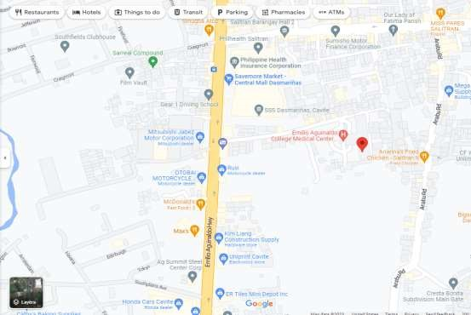

Figure 3. Location and the Establishment

## Mission, Vision, and Goal of Emilio Aguinaldo College Medical Center – Cavite

**Mission.** To provide accessible quality health care services and ensure continuous professional development of well-trained and competent personnel.

**Vision.** To be a leading medical center and training hospital by providing total patient care of the highest quality through the help of EAC - College of Medicine.

**Goal.** Deliver cost effective, high–quality healthcare by providing prompt, courteous, expert and compassionate service to our patients and consulting physicians.

## Quality Policy

EAC Med is committed to continuous improvement in order to provide our employees with the tools and resources necessary to deliver quality services that meet the expectations of our patients and clients.

## Privacy Policy

Respecting your Data Privacy, we at EAC Med are committed to handling with care your data and our obligation to you with respect on how we collect and manage your Personal Information. This aims to ensure that all appropriate standards for

Personal Information protection in compliance with Republic Act No. 10173 (or the Data Privacy Act of 2012 or DPA), its implementing rules and regulations and other applicable and related laws and regulations, including the issuances of the National Privacy Commission (NPC), collectively, the Privacy Laws, are put in place and implemented efficiently and effectively.

**THE TRAINING AREA**

**1**

**2**

**3**

The Training area includes the facilities and equipment of the company— moreover, the management who trained the student and assigned their workplace.

## Department Functions

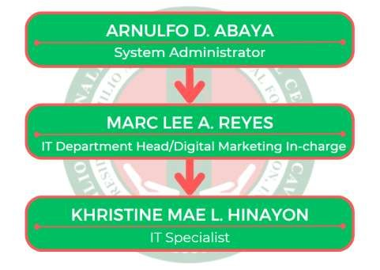

Figure 4. Department Function of IT Department

**System Administrator:** Mr.Arnulfo D. Abaya has responsibility for ensuring their organization’s computer systems are well maintained and operate reliably. The System Administrator function oversees IT initiatives to ensure that all technology related projects run smoothly and align with the overall company strategy. They perform strategy planning and recommend courses of action for technology-related improvements. They create schedules, define the scope and budget (usual project management tasks), and oversee IT project from end-to-end. Performs such other functions as may be provided by law, rules, and regulations.

9

**IT Department Head/ Digital Marketing In-Charge:** Mr. Marc Lee L. Reyes oversees all technology operations and evaluates them according to established goals. Devising and establishing IT policies and systems to support the implementation of strategies set by upper management. Analyzing the business requirements of all departments to determine their technology needs. Performs such other functions as may be provided by law, rules, and regulations.

**IT Specialist:** Ms. Khristine Mae L. Hinayon provides IT Support to endusers/employees and other duties as assigned from time to time.

## Organizational Structure of Partner Management Office

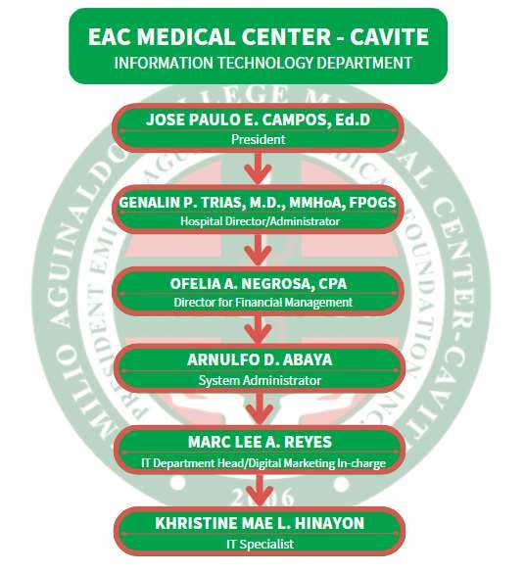

Figure 5. Organizational Structure

10

## Facilities

The facility is located in the IT Department Office on the hospital's second floor. Interns are able to work quietly and productively. If we were able to solve the issue at the department office we visited, we can visit every hospital department. Our office has its own internet connection, and the professional gives us instructions on the tasks we might complete as interns.

## Equipment

There is a lot of office equipment in the IT department, it has three areas: the repair area, the office desks and the server room. The repair area has the desktop computers, laptops, printers, power cords, labelers, Wi-Fi, small form factor or compact computers, crimping tools, LAN cables, system units, and many others. While the office desks have the documents as well as the desktop computers of the employees. The server room contains the server computers, server racks, switch racks, patch panels, network switches, routers, NAS Synology backup, and UPS (uninterruptible power supply).

**THE TRAINING EXPERIENCE**

**1**

**2**

**3**

The training experience includes the tasks performed or activities assigned, also the observed strength, and the problem encountered by the trainee.

## Task Performed/ Specific Activities Assigned

The main tasks of the student trainee are to troubleshoot hardware and software. For hardware, these include troubleshooting computer peripherals, network termination, making LAN cables, sharing printers, conducting computer inventory, and deploying computer peripherals in different departments of the establishment. For software, the tasks involve building and developing systems to be used in the establishment, graphic designing, and installing or checking the computer's system.

## Observed Strength of the Training Area

The staff of the IT department and the overall staff of Emilio Aguinaldo College Medical Center - Cavite are friendly, enjoyable to be around, and consistently guide the OJT trainees. They provide clear instructions for each task, and you can learn a lot from them, not only about the job but also from their experiences. Additionally, they offer helpful tips.

## Problem Encountered

The only problem encountered by the OJT trainees was the cramped office space of the IT department due to the large number of senior high school immersion students. Because of the limited space, they could not all fit in the office and had to temporarily stay in the stock room. This resulted in delays in completing tasks due to the high student volume.

**SUMMARY**

**1**

**2**

**3**

The trainee started his internship training on the 18th day of March. He was so excited yet so nervous to be an on the job training student of one of the known hospitals in the province of Cavite. They were escorted by HR, Sir V-Jay, to the office of the IT department where they were endorsed to Ma'am Kristine Hinayon. They immediately introduced themselves to each other, and Ma’am Kristine also introduced them to Sir Al and Sir Mark. They had a brief discussion about the hospital policies and the tasks that they would be assigned. They were given the option to choose whether to focus on hardware or software, and they both chose the same preference.

During his internship, he enhanced his technical skills and knowledge, which are important for the future. This internship was significant in providing with valuable experience and knowledge that will benefit in his future career.

The trainee acquired new skills and knowledge in troubleshooting technology hardware and software, as well as programming. It was a gratifying experience for him

to realize that he can apply these skills in his future job.

**REFERENCES**

**1**

**2**

**3**

EACMed (2022). EAC Med About Us. Retrieved from [EAC Medical Center - Cavite - About Us](https://www.eacmed.org.ph/about-us)

EACMed (2022). EAC Med Mission, Vision and Goal. Retrieved from [EAC Medical Center - Cavite - Mission, Vision and Goal](https://www.eacmed.org.ph/about-us/mission-vision-and-goal)

EACMed (2022). EAC Med Privacy Policy. Retrieved from [EAC Medical Center - Cavite - Privacy Policy](https://www.eacmed.org.ph/about-us/privacy-policy)

EACMed (2022). EAC Med Quality Policy. Retrieved fro[m EAC Medical Center - Cavite - Quality Policy](https://www.eacmed.org.ph/about-us/quality-policy)

Facebook, (n.d.). Logo of Emilio Aguinaldo College Medical Center – Cavite Retrieved from[EAC Medical Center-Cavite | Dasmariñas | Facebook](https://www.facebook.com/EACMed/)

Google, (n.d.), Google Map of EAC Med. Retrieved from [Emilio Aguinaldo College Medical Center - Cavite - Google Maps](https://www.google.com/maps/place/Emilio+Aguinaldo+College+Medical+Center+-+Cavite/@14.3485113,120.9394479,473m/data=!3m1!1e3!4m6!3m5!1s0x3397d48ac6a58f0f:0x916466355c48cfcc!8m2!3d14.3486321!4d120.9397657!16s%2Fg%2F11b6p7hn9f?hl=en-US)

History of Emilio Aguinaldo College Medical Center – Cavite., [EAC Medical Center - Cavite - History](https://www.eacmed.org.ph/about-us/history)

Solutions, A. (2007). Manila Bulletin Online. Copyright (C) 2005 Alchemy Solutions,

Tridel Technologies, Inc., All Rights Reserved.

http://web.archive.org/web/20070914101126/http://www.mb.com.ph/issues/20

07/06/05/MAIN2007060595261.html

**APPENDICES**

Appendix 1. Application Letter

February 12, 2023.

**MR. V-JAY C. DELA VEGA**

HR Assistant

Emilio Aguinaldo College Medical Center

Brgy. Salitran II, City of Dasmariñas, Cavite 4114

Respected Mr. Dela Vega:

I am Marriel J. Bella, a 4th-year College Student of Cavite State University – General Trias City Campus taking up a program of Bachelor of Science in Information Technology, I am currently looking for a company to help me complete my internship requirement. I am required to undergo 486 hours of Onthe-Job Training. I look forward to have my On-the-Job Training at Emilio Aguinaldo College Medical Center-Cavite. I am confident that under your company, I can obtain valuable skills and knowledge to add to what I've learned in university. In return, I offer to work hard during my training period to contribute to your company and be a responsible intern.

I am hoping for your kind consideration.

Thank you.

Sincerely yours,

**MARRIEL J. BELLA** OJT Applicant

Appendix 2. Curriculum Vitae

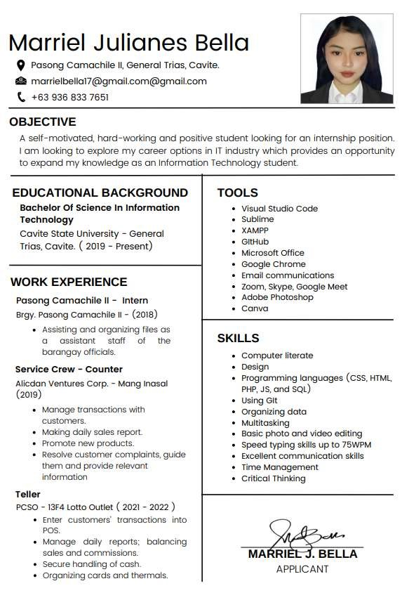

Appendix 3. Curriculum Checklist

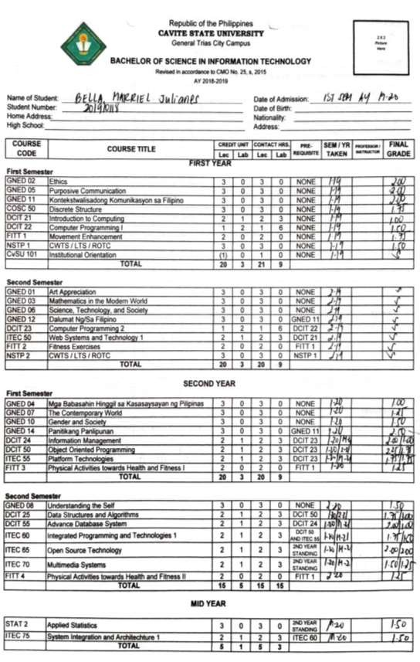

1. Continued

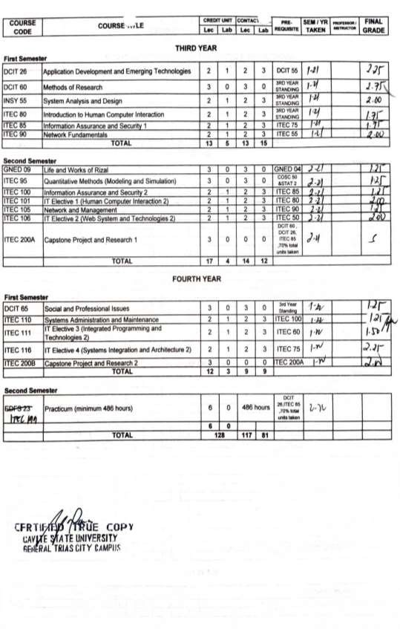

1. Certificate of Class Standing



1. Student Internship Pledge

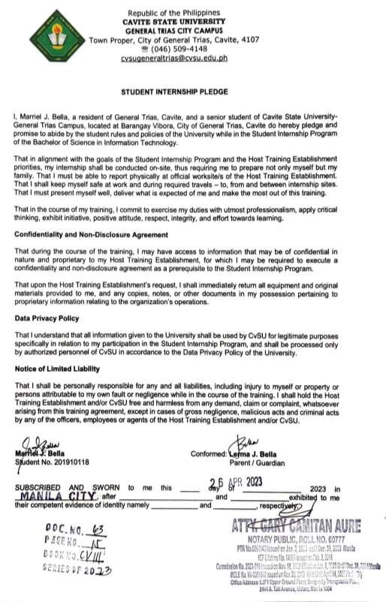

1. Recommendation Letter

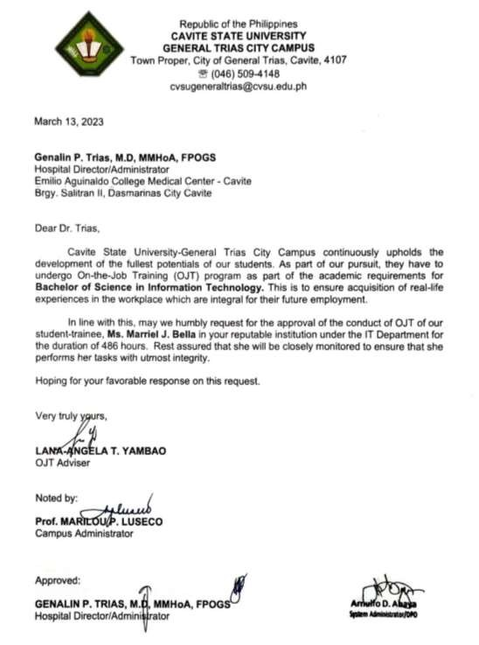

1. Memorandum of Agreement

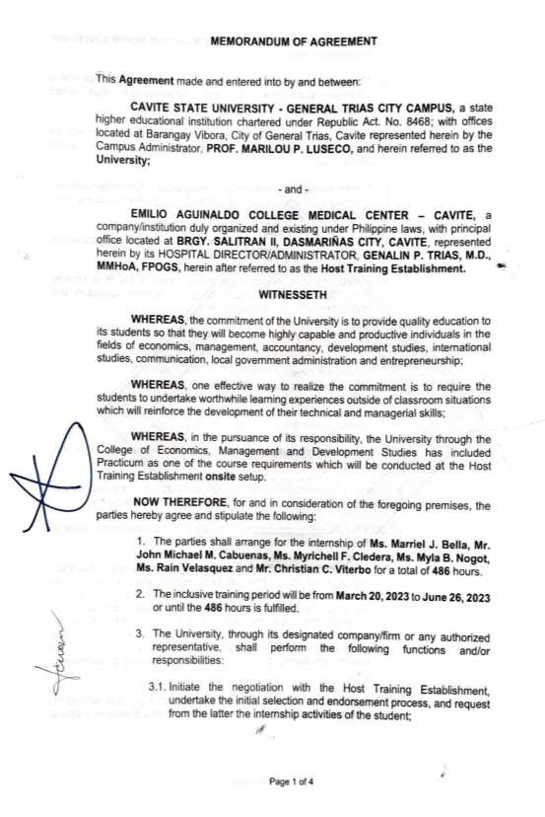

7.

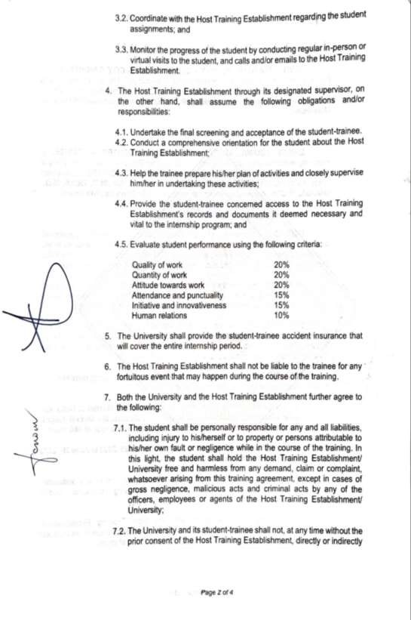

7.

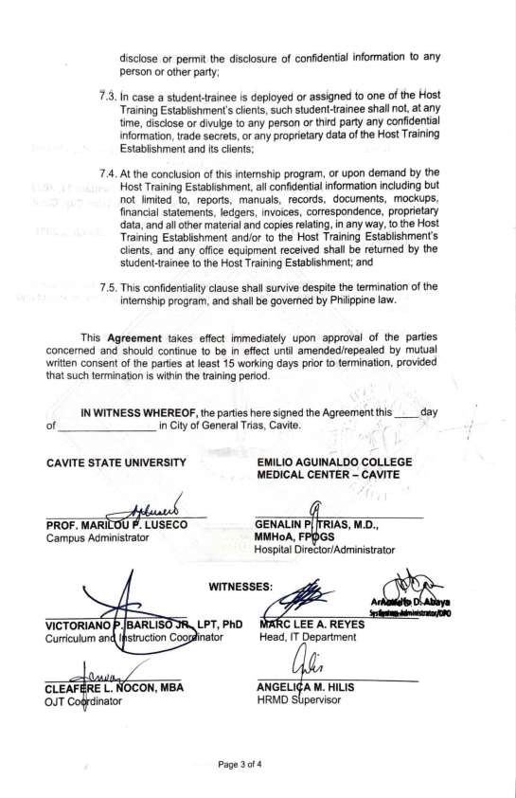

7.



1. Location of Linkage Establishment

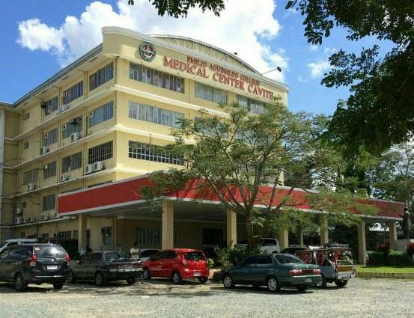

Appendix 9. Certificate of Completion

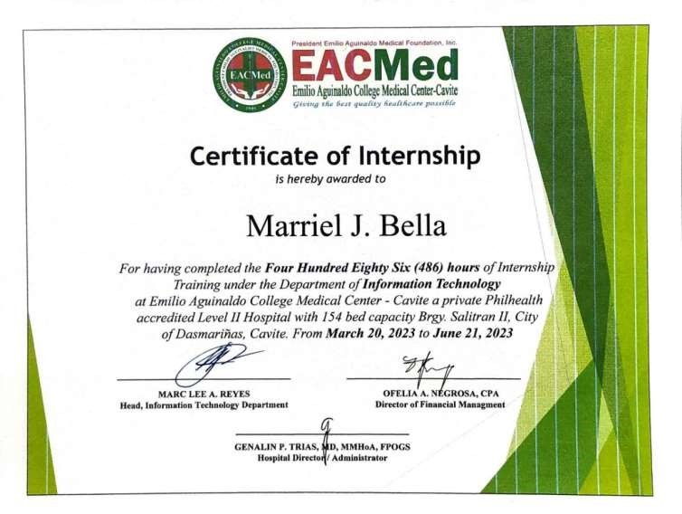

Appendix 10. Accomplished Evaluation Form

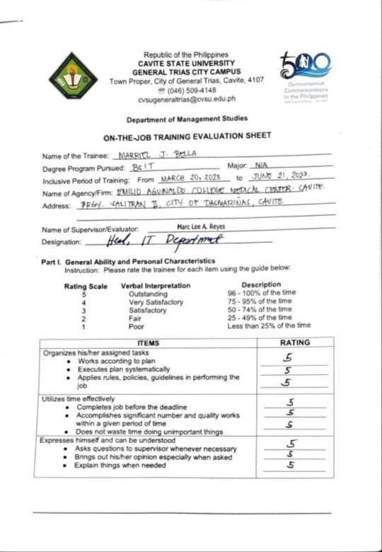

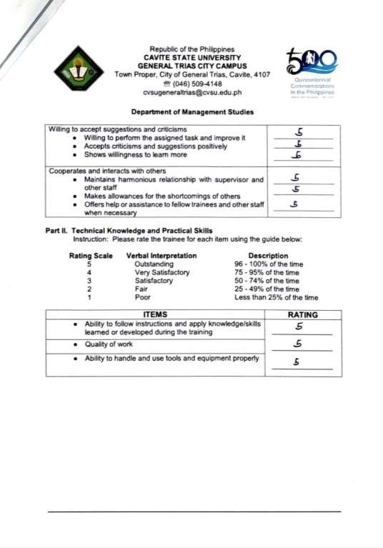

Continued

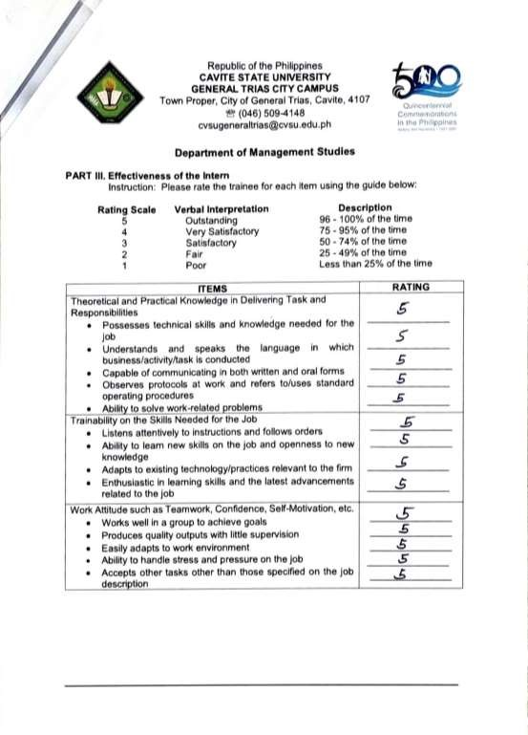

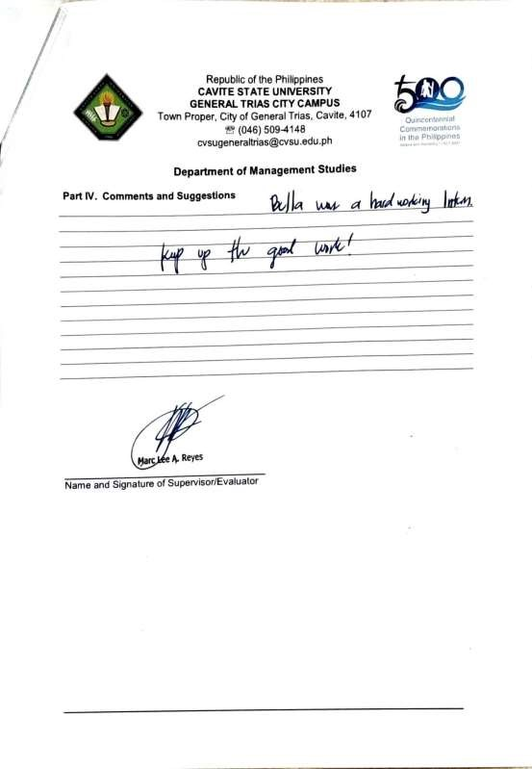

Appendix 11. Daily Time Record

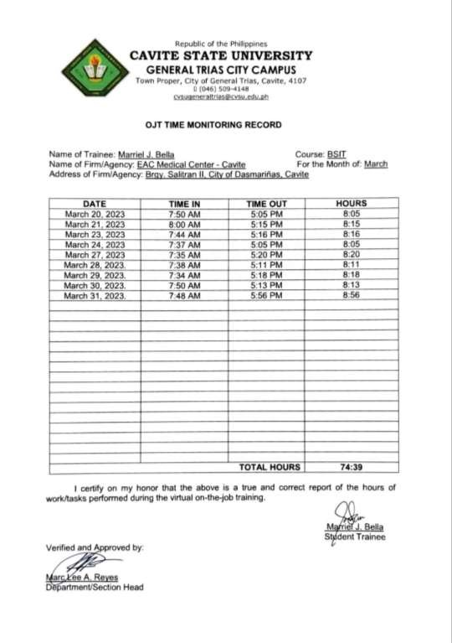

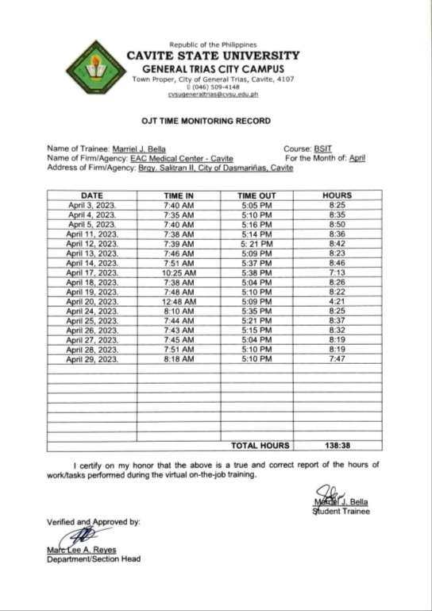

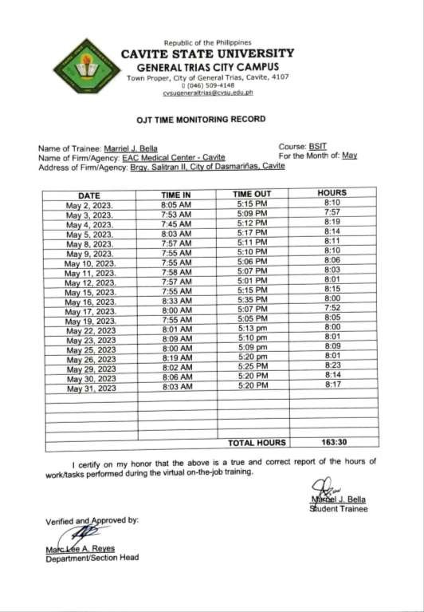

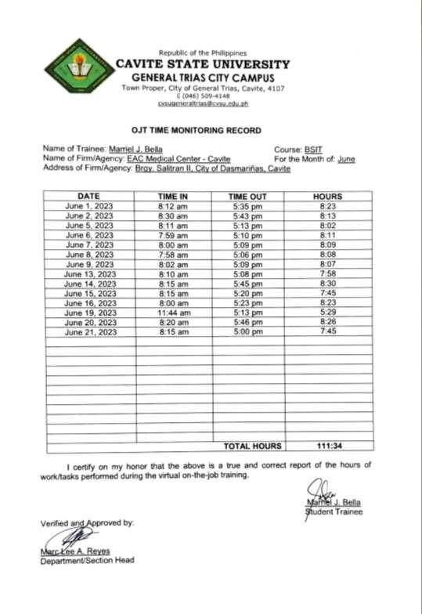

Appendix 12. Identification Card



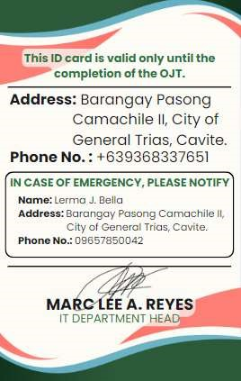

Appendix 13. Certificate of Recognition

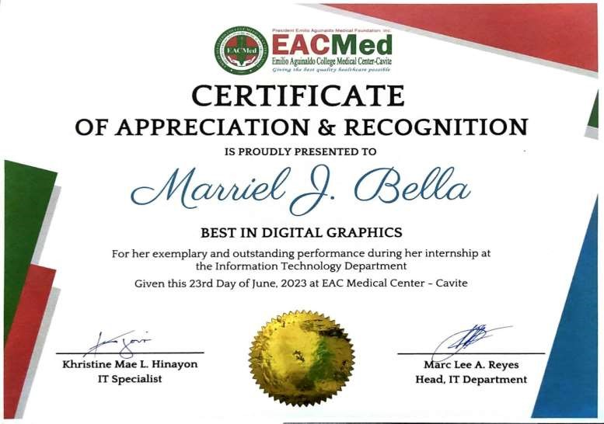

Appendix 14. Daily Journal

## Day 1: 20 March 2023

Today is the first day of our on the job training, we introduced ourselves to the System Administrator and IT support staff. Briefing about the ticketing system, and we made a network cable.

## Day 2: 21 March 2023

Sir Marc, the head of the IT department, took us on a tour of the hospital. He familiarized us with the ticketing system and provided a brief orientation. During our training, we troubleshooted a UPS at the human resource department and resolved printer sharing issues at the Purchasing Department. We also assisted with filing important documents and deployed and set up printers in various departments throughout the hospital.

## Day 3: March 22, 2023

Today, we troubleshooted printer toner issues at the Emergency Room and

Health Information Management, and cleared the application cache at the Claiming

Office.

## Day 4: March 24, 2023

On our fourth day, we troubleshooted printers at Health Information

Management and removed a small PC from the Blood Bank.

## Day 5: March 27, 2023

We observed Sir Mark, the head of the IT department, as he fixed a laptop and explained its components, including memory and its types. Additionally, immersion students from ICA joined us. Sir Mark and Ma'am Tine assigned us, the on-the-job trainees, to guide the immersion students. After lunch, together with our buddies, the immersion students, we deployed a computer set to the Credits Department. However, we encountered a problem with the UPS, so we returned to the IT department to

4. Continued

replace its battery. After resolving the issue, we successfully deployed the computer at the Credits Department.

## Day 6: March 28, 2023

Today, we taught the immersion students how to use Canva and guided them in creating designs. We fixed a shared printer at the Medical Social Service and resolved a printer paper jam at the Health Information Management. After lunch, we assisted in connecting cables to three rooms on the third floor and organized LAN cables.

## Day 7: March 29, 2023

Today, I deployed printers at the Chief of Clinics, installed apps at the Credit

Department, and designed a logo for the Surgery Department.

## Day 8: March 30, 2023

Today, we resumed the network cable connection to the 3rd floor of the hospital. Afterwards, we also removed the system unit of the Medical Director.

## Day 9: March 31, 2023

My task for today was to continue and finalize the various variations and designs of the logo for the Surgery Department.

## Day 10: April 3, 2023

Today, we deployed a printer and system unit at the Medical Directors' office. We terminated a network cable and removed a printer at the Accounting Department.

Additionally, we performed some clerical tasks.

## Day 11: April 4, 2023

Today, we brainstormed ideas for a potential system project that we could develop for the hospital. I also worked on designing icons for each department.

## Day 12: April 5, 2023

Today, we uninstalled duplicate apps at the Accounting Department, created posters for the Internal Medicine Department, and I continued designing icons for each department.

**Day 13: April 11, 2023**

Today, I dedicated my time to continue designing icons for each department.

## Day 14: April 12, 2023

Continuing from yesterday, I worked on designing icons for each department.

Additionally, we discussed the database and planned a work order system project.

## Day 15: April 13, 2023

We attended the Employee's General Orientation Day 1 at the Auditorium. In addition, we terminated a network cable at the Communication Booth. I also continued designing icons for each department.

## Day 16: April 14, 2023

I focused on designing icons for each department throughout the day. We also deployed a printer at the IT Department and attended Employee's General Orientation

Day 2 with Sir Marc, Sir Al, and Ma'am Tine.

## Day 17: April 17, 2023

Our tasks included deploying and troubleshooting a printer at the Accounting Department. We also conducted project planning for the Work Order Request Form

System. Meanwhile, I continued designing icons for each department.

## Day 18: April 18, 2023

My work today primarily involved designing icons for each department. Additionally, we terminated and connected a network cable at the Communication

Booth. We also addressed UPS troubleshooting at the HR Department.

## Day 19: April 19, 2023

Continuing with my design work, I focused on creating icons for each department. We also created graphic design posters for MHCD. Troubleshooting a printer at the Purchasing Department and completing some clerical tasks were also part of our day.

## Day 20: April 20, 2023

Today, we removed printers from the Surgery, Accounting, and CRS

(Customer Relation) departments.

## Day 21: April 24, 2023

Our tasks for today involved deploying system units from the 3rd floor to the 2nd floor. Additionally, we terminated a network cable at the Quality Assurance department.

## Day 22: April 25, 2023

Today, we installed WebEx at the Medical Records Department and conducted an inventory of PC sets at the Quality Assurance Department. After lunch, I focused on graphic design work for the MCHD poster.

## Day 23: April 26, 2023

We began coding for our project, the Work Order Request Form System, and I continued designing icons for each department.

## Day 24: April 27, 2023

Our day started with the installation of a HIS (Hospital Information System) App at the Ophthalmology Clinic. We then proceeded with coding for the Work Order

Request Form System.

## Day 25: April 28, 2023

We deployed printers at the Credit and Collection Department and Claims

Sections. After lunch, we continued designing the MHCD poster.

## Day 26: April 29, 2023

As it was the weekend, our tasks were minimal. We took the opportunity to clean and organize our working station or office. We also organized the cabinets where

IT tools are stored.

## Day 27: May 2, 2023

Today, my focus was on graphic design work, specifically the revision of MHCD and ID designs. Additionally, I monitored the ticketing system.

## Day 28: May 3, 2023

Our tasks for today involved deploying and setting up a printer at the Admitting

Department. Additionally, we fixed a paper jam issue at the credits department.

## Day 29: May 4, 2023

Today, we attended a seminar on Fire Safety at the Auditorium conducted by

BFP (Bureau of Fire Protection). We also continued programming the Work Order

Request Form System.

## Day 30: May 5, 2023

My main focus today was designing the Work Order Request Form System using HTML, CSS, and JavaScript programming languages. I also performed checks on every printer in all departments, fixed a mouse issue at the laboratory, and organized labels at the IT department office.

## Day 31: May 8, 2023

Our tasks involved replacing a computer peripheral at the Claims Department and troubleshooting a UPS.

## Day 32: May 9, 2023

Today, we deployed network routers at the Doctor’s Quarter, Intensive

Management Unit, Hemodialysis Unit, and Outpatient Department. We also did printer troubleshooting and router deployment at the Accounting Department.

Additionally, I made modifications to the MHCD design poster.

## Day 33: May 10, 2023

Our tasks for today included connecting network lines or cables at the IM

Quarters and performing some clerical work.

## Day 34: May 11, 2023

Today, we did printer troubleshooting at the Property Department, deployed a VGA cable at the Laboratory, performed clerical work at CSR, attached a LAN cable for connection to the network on the 3rd Floor (IM), and troubleshooted a UPS at the

HR Department.

## Day 35: May 12, 2023

Our tasks for today involved pulling out and troubleshooting a system unit and monitor at the Laboratory. Additionally, I continued coding the WORF system and activated and deactivated items in BizBox.

## Day 36: 15 May 2023

Today, we continued encoding in the WORF system, did some clerical works and monitored the Ticketing System.

## Day 37: 16 May 2023

Today, we did some clerical works again and monitored the Ticketing System.  **Day 38: 17 May 2023**

Today, we continued coding in the WORF system, some clerical works and monitored the Ticketing System.

## Day 39: 19 May 2023

Today, we did network troubleshooting on the 1stat 1st Floor and deployed a network router on the 2nd Floor.

## Day 40: 22 May 2023

Today, we set up a Laptop at Human Resource (HR) Department and monitored the IT helpdesk ticketing system.

## Day 41: 23 May 2023

Today, we cleaned and organized the IT department stock room and monitored the IT helpdesk ticketing system.

## Day 42: 25 May 2023

Today, we did the inventory of computers and peripherals at Information,

Pharmacy, HMO, Central Registration, Billing, Admitting, PhilHealth, MHCD, Imaging

Department, OPD, Linen, CRS, Laboratory, PT, and Dietary.

## Day 43: 26 May 2023

Today, we did continue the inventory of computers and peripherals at Customer

Experience Department (CED), Media Social Service, Property, Nursing Service Office

(NSO), Quality Assurance (QA), Credit & Collection Extension, Chief of Clinic (COC),

OB Ultrasound, Centre Supply Room (CSR), Accounting-Budget Department, Procurement Department, Blood Bank and encoded the done inventory of computers and peripherals.

## Day 44: 29 May 2023

Today, we fix a printer sharing at Claims Department and encoded the inventoried computer and peripherals of the previous departments. We also did inventory of computers and peripherals at Medical Records, MHCD - Industrial Clinic, Dietary Office, Surgery, IM Office, COC - Continuation, Pedia. Monitored the IT helpdesk ticketing system and some clerical works.

## Day 45: 30 May 2023

Today, we started developing a new project called “patient’s information system” that will be used in the PhilHealth department. Paper jam occurred at the Credit and Collection - Claims Section with the immersion students. Afterwards we did printer troubleshooting at the Foundation.

## Day 46: 31 May 2023

Today, we continue developing the patient’s information system that will be used in the PhilHealth department. Monitored the IT helpdesk ticketing system and some clerical works.

## Day 47: 1 June 2023

Today, we continued developing the patient’s information system that will be used in the PhilHealth department and cleaned the printer of the Laboratory. Monitored the IT helpdesk ticketing system and some clerical works.

## Day 48: 2 June 2023

Today, we fixed a paper jam at the HR Department, monitored the IT helpdesk ticketing system and some clerical work.

## Day 49: 5 June 2023

Today, our focus is on the ongoing development of the patient information system intended for use in the PhilHealth department. Additionally, we monitored the

IT helpdesk ticketing system, and carried out some clerical tasks.

## Day 50: 6 June 2023

Today, I engaged in clerical tasks, monitored the ticketing system for our IT helpdesk, and undertook the assignment given by Sir Al to categorize age brackets in an Excel file using Python programming language.

## Day 51: 7 June 2023

Today, I handled some clerical tasks, closely monitored the ticketing system for our IT helpdesk, and successfully deployed a system unit at the Credit and

Collection - Claims Section.

## Day 52: 8 June 2023

Today, I assisted in setting up a laptop and projector at the HR department, did some clerical tasks, and monitored the ticketing system for our IT helpdesk.

## Day 53: 9 June 2023

Today, we set up and shared a printer at the Accounting Department, fixed a problem with a printer scanner at the IT Department office, kept a close eye on the IT helpdesk ticketing system, and completed some clerical works.

## Day 54: 13 June 2023

Today, we continue developing the patient’s information system that will be used in PhilHealth department and troubleshoot a printer at claims department. Monitored the IT helpdesk ticketing system and some clerical works.

## Day 55: 14 June 2023

Today, I helped deploy a printer at the X-Ray Department and pulled out their old printer and brought it to the IT Department office. After that, we did some clerical work and monitored the IT Helpdesk Ticketing System.

## Day 56: 15 June 2023

Today, we helped and taught the immersion students from EAC how to conduct inventory in the stock room. After that, they started to inventory the computer peripherals. After lunch, we did some clerical work and monitored the IT Helpdesk

Ticketing System.

## Day 57: 16 June 2023

Today, I spent time troubleshooting a printer issue at the OPD. I also worked on resolving printer sharing problems at the Property. Additionally, I reported a defective toner that needed attention at the Property.

## Day 58: 19 June 2023

Today, we performed switch network troubleshooting on the fifth floor, Credits and Collections Department and HR department. Additionally, we spent the rest of the day monitoring the IT Helpdesk Ticketing System.

## Day 59: 20 June 2023

Today, we conducted Internet troubleshooting at the HR, Budget Department,

MHCD, and X-ray department. I also completed the required documents for the Department of Surgery logo that I designed. Our IT Department head, Sir Mark, successfully deployed the new network firewall for the hospital. Consequently, we performed network troubleshooting at various locations, including the HR, MHCD

(Psychiatric), MHCD (Industrial Clinic), Procurement Office, Engineering Office, and

Nurse stations on the fourth and fifth floors.

## Day 60: 21 June 2023

Today, I continued and finished the documentation of Department of Surgery Logo. We also monitored the IT Helpdesk Ticketing System and did some clerical works. We tested the hidden hard drives in the IT department and separated the good ones from the bad ones.

Appendix 15. Photo Documentation



Figure 1. Interview Schedule for IT Intern position



Figure 2. OJT Orientation (March 2, 2023, via Google Meet)

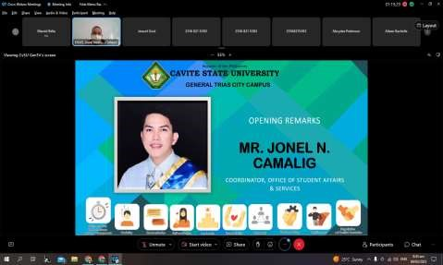

Figure 3. Pre-Orientation Seminar/Workshop for OJT Students

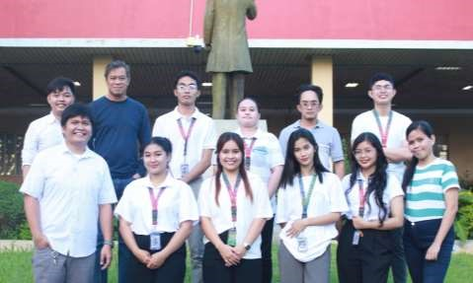

Figure 4. IT Department Team

Appendix 1

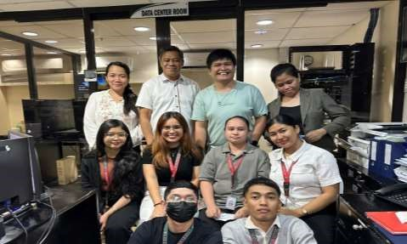

Figure 5. Visit of our OJT Adviser

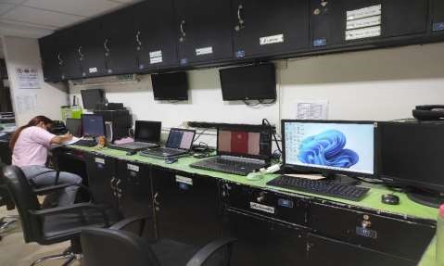

Figure 6. Work Area

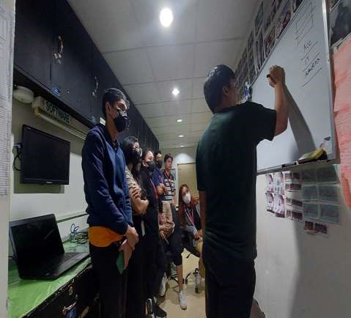

Figure 7. Discussion on how Active Directory, DNS, Servers, and Group Sharing works

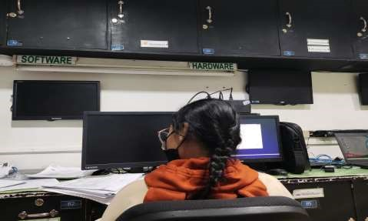

Figure 8. Formatting and Installation of Operating System

Appendix 1

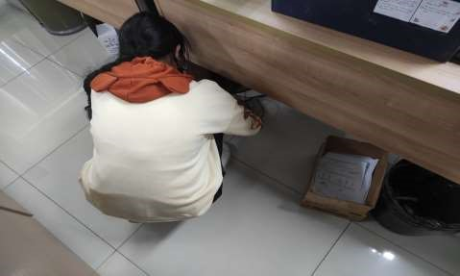

Figure 9. UPS troubleshooting at Human Resource Department

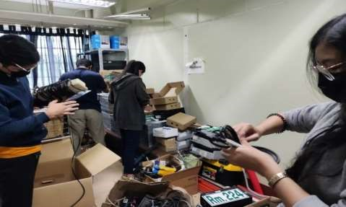

Figure 10. Organizing Stock Room

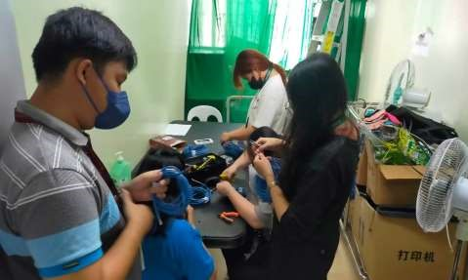

Figure 11. Creating a LAN cable

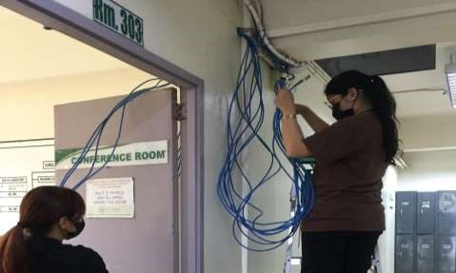

Figure 12. Network Cable termination at Third Floor

Appendix 1

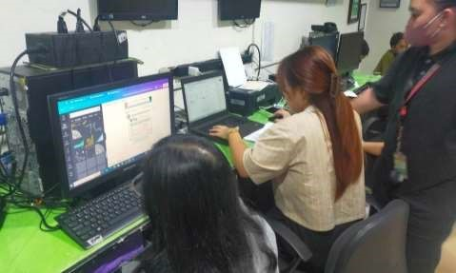

Figure 13. Graphic Design for MHCD poster

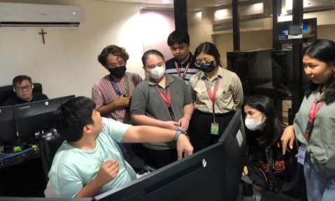

Figure 14. Discussion about Work Order Request Form System

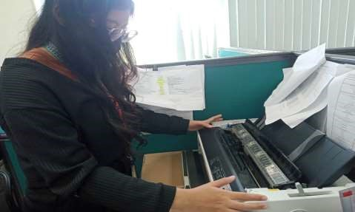

Figure 15. Printer troubleshooting at Accounting Department

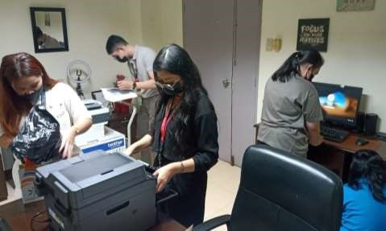

Figure 16. Printer and System Unit Deployment at Medical Director’s office

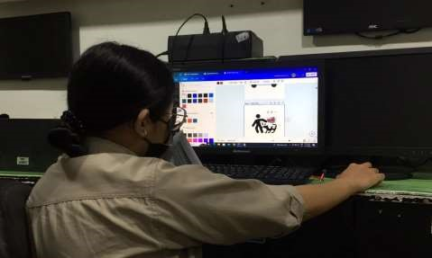

Figure 17. Creating Icons for each department

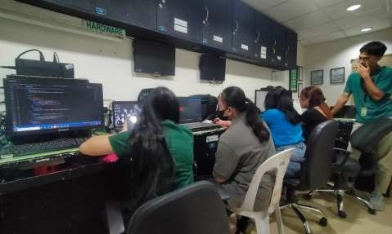

Figure 18. Coding of Work Order Request Form System



Figure 19. Computer set up at Quality Assurance

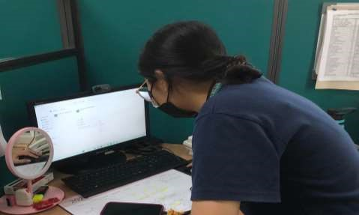

Figure 20. Printer Sharing in Claims

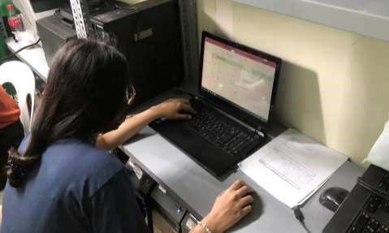

Figure 21. Creating the Patient Information System using MS Access

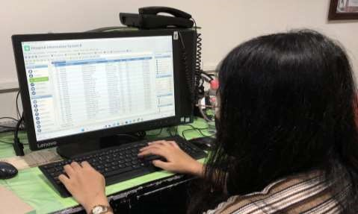

Figure 22. Activating items in BizBox

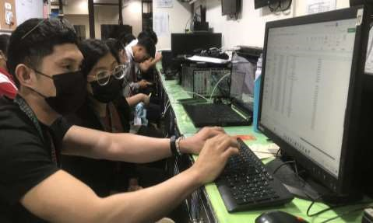

Figure 23. Encoding of computer peripherals

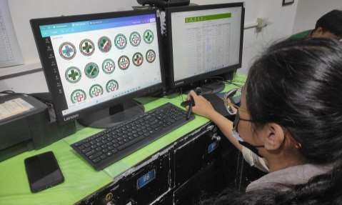

Figure 24. Designing the Department of Surgery Logo

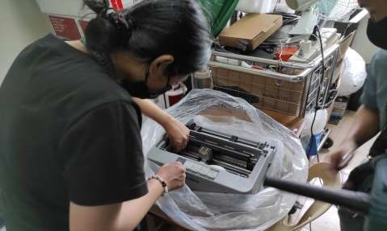

Figure 25. Printer cleaning

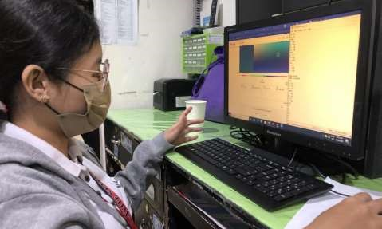

Figure 26. Department of Surgery Logo Documentation

Appendix 16. Routing Slip

Republic of the Philippines

## CAVITE STATE UNIVERSITY

**GENERAL TRIAS CITY CAMPUS**

Town Proper, City of General Trias, Cavite, 4107

 (046) 509-4148 cvsugeneraltrias@cvsu.edu.ph

|  |  |
| --- | --- |
|  | **Department of Information Technology**      **ROUTING SLIP** |
| **Name of student** | **: MARRIEL J. BELLA** |

**Type of Study :** Thesis Narrative EDP Design Project Case Study Teaching Portfolio

|  |  |
| --- | --- |
|  |  |
| **Title of Study** | **: A NARRATIVE REPORT: STUDENT TRAINING EXPERIENCES**  **AT EMILIO AGUINALDO COLLEGE MEDICAL CENTER CAVITE AT BARANGAY SALITRAN II, CITY OF DASMARIÑAS, PROVINCE OF CAVITE.** |

|  |  |  |  |
| --- | --- | --- | --- |
|  | DATE RECEIVED | DATE RELEASED | REMARKS |
| **LANA ANGELA T. YAMBAO**  Practicum Adviser |  |  |  |
|  |  |  |
|  |  |  |
| **CLEAFERE L. NOCON**  OJT Coordinator |  |  |  |
|  |  |  |
|  |  |  |
| **MICHAEL E. PAREJA**  Department Chairperson |  |  |  |
|  |  |  |
|  |  |  |
| English Critic |  |  |  |
|  |  |  |
|  |  |  |
| **PROF. MARILOU P. LUSECO** Campus Administrator |  |  |  |