電通二乙微處理器實驗 實驗結報

實驗名稱 | 4*4鍵盤
組別 |  | 組員 | 詹恆瑋

- 實驗目的
了解4*4鍵盤的工作原理
1. 4*4鍵盤如何接線
2. 如何使用 Arduino keyboard library?
3. 如何讀取鍵盤的顯示數值?
4. 如何讓七段顯示器顯示鍵盤的輸入值?
- 實驗步驟
(1)4*4鍵盤之按鍵值經由串列傳輸，顯示在pc上
(2)4*4鍵盤之按鍵值顯示在七段顯示器上
- 程式碼
(1)
#include <Keypad.h>
const byte ROWS = 4;
const byte COLS = 4;

byte rowPins[ROWS] = {5,4,3,12};
byte colPins[COLS] = {9,8,7,11};
char keys[ROWS][COLS] = {{'0','4','8','C'},{'1','5','9','D'},{'2','6','A','E'},{'3','7','B','F'}};
Keypad keypad = Keypad(makeKeymap(keys),rowPins,colPins,ROWS,COLS);

void setup() {
Serial.begin(9600);
}

void loop() {
char key = keypad.getKey();

if(key!=NO_KEY)
{
Serial.println(key);
}
}

(2)
#include <Keypad.h>
#include <SevSeg.h>
SevSeg sevseg;
const byte ROWS = 4;
const byte COLS = 4;

byte rowPins[ROWS] = {5,4,3,12};
byte colPins[COLS] = {9,8,7,11};
char keys[ROWS][COLS] = {{'0','4','8','C'},{'1','5','9','D'},{'2','6','A','E'},{'3','7','B','F'}};
Keypad keypad = Keypad(makeKeymap(keys),rowPins,colPins,ROWS,COLS);

void setup() {
byte numDigits = 1;
byte digiPins[]={2};
byte segmentPins[]={17,16,15,14,13,6,10};
sevseg.begin(COMMON_CATHODE,numDigits,digiPins,segmentPins);
Serial.begin(9600);
}

void loop() {
char key = keypad.getKey();

if(key!=NO_KEY)
{
Serial.println(key);
if(key<='9' && key>='0')
{
sevseg.setNumber(key-'0',0);
}
}
sevseg.refreshDisplay();
}

- 實驗結果及分析
第一個實驗當我按鍵盤時
他會根據你所案的鍵去顯示那個案鍵
第二個實驗當我按下按鍵時
七段顯示器會顯示數字
- 心得討論

這次實驗完後
就是期中考了
真的非常刺激
不過從之前實驗到現在
真的還蠻有成就感
希望下次能考很好
- 修正電路圖
- 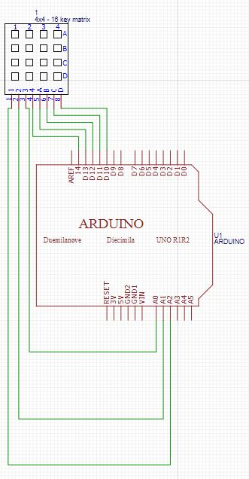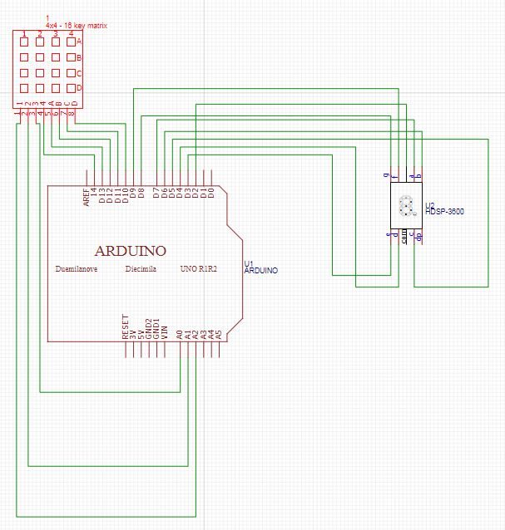
修正程式碼

(1)
#include <Keypad.h>
const byte ROWS = 4;
const byte COLS = 4;

byte rowPins[ROWS] = {5,4,3,12};
byte colPins[COLS] = {9,8,7,11};
char keys[ROWS][COLS] = {{'0','4','8','C'},{'1','5','9','D'},{'2','6','A','E'},{'3','7','B','F'}};
Keypad keypad = Keypad(makeKeymap(keys),rowPins,colPins,ROWS,COLS);

void setup() {
Serial.begin(9600);
}

void loop() {
char key = keypad.getKey();

if(key!=NO_KEY)
{
Serial.println(key);
}
}

(2)
#include <Keypad.h>
#include <SevSeg.h>
SevSeg sevseg;
const byte ROWS = 4;
const byte COLS = 4;

byte rowPins[ROWS] = {5,4,3,12};
byte colPins[COLS] = {9,8,7,11};
char keys[ROWS][COLS] = {{'0','4','8','C'},{'1','5','9','D'},{'2','6','A','E'},{'3','7','B','F'}};
Keypad keypad = Keypad(makeKeymap(keys),rowPins,colPins,ROWS,COLS);

void setup() {
byte numDigits = 1;
byte digiPins[]={2};
byte segmentPins[]={17,16,15,14,13,6,10};
sevseg.begin(COMMON_CATHODE,numDigits,digiPins,segmentPins);
Serial.begin(9600);
}

void loop() {
char key = keypad.getKey();

if(key!=NO_KEY)
{
Serial.println(key);
if(key<='9' && key>='0')
{
sevseg.setNumber(key-'0',0);
}
}
sevseg.refreshDisplay();
}

